Full Name: Prajapati ashish J.
Enrollment Number / Roll Number: 25084341031
Course: M. Sc.IT (AI & ML)
Semester: 1
Subject Code: P81A1PYT
Name of Subject: Python Programming

Unit 1: Introduction to Python Programming
Q. 1. Write a Python program to display “Hello World” and your name.
(Remember)
ANS. INPUT:
name="prajapati ashishkumar jayantibhai"
eno="05"
print("Hello world")
print(f"my name is:{name}")
print(f"enrollment no:{eno}")

OUTPUT:
Hello world
my name is:prajapati ashishkumar jayantibhai
enrollment no:05
Q. 2. Write a program to swap two numbers without using a third variable. (Apply)
ANS. INPUT:
a=10
b=20
print("before swap:")
print(f"a={a}\nb={b}")
b,a=a,b
print("after swap")
print(f"a={a}\nb={b}")
OUTPUT:
before swap:
a=10
b=20
after swap
a=20
b=10
Q. 3. Write a program to calculate the area of a circle using operators and data types. (Apply)
ANS. INPUT:
pi=22/7
r=int(input("enter the radius of circle:"))
area=pi*r*r
print(f"area of circle is={area}")
OUTPUT:
enter the radius of circle:5
area of circle is=78.57142857142857
Q. 4. Demonstrate the use of Boolean expressions with logical operators (and, or, not). (Understand)
ANS. INPUT:
a=50
b=40
c=30
if a<b and b<c:
print(f"{c} is gratest")
elif a<b and b>c:
print(f"{b} is greatest")
else:
print(f"{a} is greatest")

payment="card"
if payment=='online' or payment=='cash':
print("you can purchase the product ")
else:
print("you can't purchase the product")

OUTPUT:
you can't purchase the product
Q. 5. Write a program to check whether a number is even or odd using if/else.
(Apply)
ANS. INPUT:
no=18
if no%2==0:
print(f"{no} is even")
else:
print(f"{no} is odd")
OUTPUT:
18 is even
Q. 6. Write a program to find the largest of three numbers using nested conditionals. (Apply)
ANS. INPUT:
x=30
y=60
z=80
if x<y:
if y<z:
print(f"{z} is larhest no")
else:
print(f"{y} is largest no")
elif(x>y):
if(x>z):
print(f"{x} is largest no")
else:
print(f"{z} is largest no")
OUTPUT:
80 is larhest no

Q. 7. Write a program to calculate grade of a student using conditional expressions. (Apply)
ANS. INPUT:
sub_mark={'java':90,
'python':89,
'cpp':99,
'java scripts':85}
print(type(sub_mark.values()))
total_marks=sum(sub_mark.values())
percentage=total_marks/400*100

print(percentage)
grade=""
if(percentage>90):
grade="A"
elif percentage>70:
grade="B"
elif percentage>50:
grade="C"
elif percentage>33:
grade="D"
else:
grade="fail"
for mark in sub_mark.values():
if mark<33:
grade="fail"
print(f"total mark is={total_marks}")
print(f"percentage is={percentage}")
print(f"grade is={grade}")

OUTPUT:90.75
total mark is=363
percentage is=90.75
grade is=A

Q. 8. Write a program to display multiplication table of a number using while loop. (Apply)
ANS. INPUT:
no=int(input("enter the no for multiplication table"))
i=1
while(i<=10):
print(f"{no} X {i} =={no*i}")
i+=1
OUTPUT:
enter the no for multiplication table:7
7 x 1 = 7
7 x 2 = 14
7 x 3 = 21
7 x 4 = 28
7 x 5 = 35
7 x 6 = 42
7 x 7 = 49
7 x 8 = 56
7 x 9 = 63
7 x 10 = 70

Q. 9. Write a program to generate prime numbers within a given range using for loop. (Apply)
ANS. INPUT:
start=1
end=10
for i in range(start,end):
for j in range(2,i):
if i%j==0:
break
else:
print(f"{i}",end="\t")
OUTPUT:
1 2 3 5 7
Q. 10. Write a program to print Fibonacci series using for loop. (Apply)
ANS. INPUT:
n = int(input("Enter limit: "))
a, b = 0, 1
for _ in range(n):
print(a, end=" ")
a, b = b, a + b
OUTPUT:
Enter limit: 8
0 1 1 2 3 5 8 13

Q. 11. Demonstrate the use of break, continue, and pass with examples.
(Understand)
ANS. INPUT:
# break
for i in range(1,10):
if i==5:
break
print(i)
# continue
for i in range(1,10):
if i%3==0:
continue
print(i)
# pass
def test():
pass
OUTPUT:
1
2
4
5
7
8
Unit 2: Functions, Modules, and Data Structures
Q. 12. Write a program to find factorial of a number using a user-defined function. (Apply)
ANS. INPUT:
def factorial(no):
if no==1:
return 1
return no*factorial(no-1)
print(factorial(5))
print(sum(5))
OUTPUT:
120

Q. 13. Write a recursive function to calculate the sum of natural numbers up to n. (Apply)
ANS. INPUT:
def rec_sum(n):
if n == 0:
return 0
return n + rec_sum(n - 1)
print(rec_sum(10))
OUTPUT:
55

Q. 14. Write a program to demonstrate default, keyword, and variable-length arguments. (Understand)
ANS. INPUT:
def func(language="python",*args):
print("your language:",language)
print(len(args))
print(type(args))
print(args)
func("java",10,20,30,40,50)
OUTPUT:
your language: java
5
<class 'tuple'>
(10, 20, 30, 40, 50)
Q. 15. Write a program to demonstrate the use of a lambda function for square and cube calculation. (Apply)
ANS. INPUT:
square = lambda x: x ** 2
cube = lambda x: x ** 3
print(square(5))
print(cube(3))
OUTPUT:
25
27

Q. 16. Create a list of student names, access specific elements, and remove an element. (Apply)
ANS. INPUT:
names=["amit","ashish","nandish","jay","hitansu"]
print(names)
names.pop(1)
print(names)
print(names[2])
OUTPUT:
['amit', 'ashish', 'nandish', 'jay', 'hitansu']
['amit', 'nandish', 'jay', 'hitansu']
jay
Q. 17. Write a program to find the maximum, minimum, and average from a list of numbers. (Apply)
ANS. INPUT:
nums=[10,40,20,50,3,70]
print(f"minimum no:{min(nums)}")
print(f"maximum no:{max(nums)}")
print(f"average {sum(nums)/len(nums)}")
OUTPUT:
minimum no:3
maximum no:70
average 32.166666666666664
Q. 18. Demonstrate slicing operations on a list and tuple. (Understand)
ANS. INPUT:
lst = [10, 20, 30, 40, 50]
tup = (10, 20, 30, 40, 50)
print(lst[1:4])
print(tup[:3])
OUTPUT:
[20, 30, 40]
(10, 20, 30)

Q. 19. Create a tuple of numbers and show how immutability differentiates it from a list. (Analyze)
ANS. INPUT:
my_list = [1, 2, 3]
my_tuple = (1, 2, 3)
my_list[0] = 99 # allowed
# my_tuple[0] = 99 # ERROR: tuples cannot be changed
print(my_list)
print(my_tuple)
OUTPUT:
[99, 2, 3]
(1, 2, 3)
Q. 20. Write a program to create a set and perform union, intersection, and difference operations. (Apply)
ANS. INPUT:
a={5,7,2,3}
b={4,7,9,3}
print(f"a|b: {a|b}")
print(f"a&b: {a&b}")
print(f"a^b: {a^b}")
print(f"a-b: {a-b}")
OUTPUT:
a|b: {2, 3, 4, 5, 7, 9}
a&b: {3, 7}
a^b: {2, 4, 5, 9}
a-b: {2, 5}
Q. 21. Write a program to create a dictionary of students (Name: Marks), add new entries, and delete one entry. (Apply)
ANS. INPUT:
students = {"Amit": 85, "Riya": 90}
students["Karan"] = 88 # add
del students["Amit"] # delete
print(students)
OUTPUT:
{'Riya': 90, 'Karan': 88}

Q. 22. Write a program to count the frequency of each word in a given string using a dictionary. (Apply)
ANS. INPUT:
text = "python is easy and python is powerful"
words = text.split()
freq = {}
for w in words:
freq[w] = freq.get(w, 0) + 1
print(freq)
OUTPUT:
{'python': 2, 'is': 2, 'easy': 1, 'and': 1, 'powerful': 1}

Q. 23. Develop a Python program that imports a custom module and demonstrates reusability. (Create)
ANS. INPUT:
custom module: mymodule.py
def greet(name):
return "Hello " + name
main program
import mymodule
print(mymodule.greet("Nandish"))
OUTPUT:
Hello Nandish

Unit 3: Exception Handling and File Handling
25. Write a program to handle division by zero using try/except. (Apply)
ANS. INPUT:
try:
x=int(input("enter the x :"))
y=int(input("enter the y"))
ans=x/y
print(f"answer is :{ans}")
except ZeroDivisionError as e:
print(e)
except Exception as e:
print(e)
OUTPUT:
enter the x :10
enter the y0
division by zero
26. Write a program to demonstrate the use of finally block in exception handling. (Understand)
ANS. INPUT:
file=None
try:
file=open("p26.txt","r+")
print(file.readlines())
except Exception as e:
print(e)
finally:
if file:
file.close()
OUTPUT:
No such file or directory: 'p26.txt'
27. Write a program to handle multiple exceptions (e.g., IndexError, ValueError). (Apply)
ANS. INPUT:
try:
lst = [10, 20, 30]
idx = int(input("Enter index: "))
print("Value =", lst[idx])
except IndexError:
print("Error: Index out of range!")
except ValueError:
print("Error: Invalid input! Enter a number.")
OUTPUT:
Enter index: 10
Error: Index out of range!

28. Define a class Student with attributes and methods to display details. (Apply)
ANS. INPUT:
class Student:
def __init__(self, name, roll, marks):
self.name = name
self.roll = roll
self.marks = marks
def display(self):
print("Name:", self.name)
print("Roll No:", self.roll)
print("Marks:", self.marks)
s = Student("Nandish", 101, 95)
s.display()
OUTPUT:
Name: Nandish
Roll No: 101
Marks: 95

29. Write a program to demonstrate single inheritance (Base: Person, Derived: Student). (Apply)
ANS. INPUT:
class Person:
def __init__(self, name):
self.name = name
def show(self):
print("Name:", self.name)
class Student(Person):
def __init__(self, name, roll):
super().__init__(name)
self.roll = roll
def show_info(self):
self.show()
print("Roll No:", self.roll)
s = Student("Amit", 21)
s.show_info()
OUTPUT:
Name: Amit
Roll No: 21

30. Write a program to demonstrate multiple inheritance with real-world entities. (Apply)
ANS. INPUT:
class Father:
def car(self):
print("Father's car")
class Mother:
def house(self):
print("Mother's house")
class Child(Father, Mother):
def own(self):
print("Child's bike")
c = Child()
c.car()
c.house()
c.own()
OUTPUT:
Father's car
Mother's house
Child's bike
31. Write a program to implement polymorphism using method overriding. (Apply)
ANS. INPUT:
class Animal:
def sound(self):
print("Animal makes a sound")
class Dog(Animal):
def sound(self):
print("Dog barks")
obj = Dog()
obj.sound()
OUTPUT:
Dog barks

32. Write a program to overload the + operator for a custom class. (Apply)
ANS. INPUT:
class Number:
def __init__(self, x):
self.x = x
def __add__(self, other):
return Number(self.x + other.x)
n1 = Number(10)
n2 = Number(20)
n3 = n1 + n2
print("Result =", n3.x)
OUTPUT:
Result = 30
33. Write a program to open a text file, write data into it, and read the contents. (Apply)
ANS. INPUT:
# Write data
with open("info.txt", "w") as f:
f.write("Hello Students!\nWelcome to Python File Handling.")
# Read data
with open("info.txt", "r") as f:
data = f.read()
print(data)
OUTPUT:
Hello Students!
Welcome to Python File Handling.

34. Write a program to count the number of lines, words, and characters in a text file. (Apply)
ANS. INPUT:
with open("sample.txt", "r") as f:
text = f.read()
lines = text.count("\n") + 1
words = len(text.split())
chars = len(text)
print("Lines:", lines)
print("Words:", words)
print("Characters:", chars)
OUTPUT:
Lines: 2
Words: 6
Characters: 48

35. Write a program to copy contents from one file to another. (Apply)
ANS. INPUT:
with open("source.txt", "r") as src:
data = src.read()
with open("destination.txt", "w") as dst:
dst.write(data)
print("File copied successfully.")
OUTPUT:
File copied successfully.

36. Write a program to check whether a file exists or not using os module. (Apply)
ANS. INPUT:
import os
filename = "info.txt"
if os.path.exists(filename):
print("File exists")
else:
print("File does not exist")
OUTPUT:
File exists

37. Write a program to store and retrieve student records using binary file handling. (Create)
ANS. INPUT:
import pickle
# --- Store records ---
students = [
{"name": "Amit", "marks": 85},
{"name": "Riya", "marks": 90},
]
with open("students.dat", "wb") as f:
pickle.dump(students, f)
# --- Retrieve records ---
with open("students.dat", "rb") as f:
data = pickle.load(f)
print("Stored Student Records:")
for s in data:
print(s)
OUTPUT:
Stored Student Records:
{'name': 'Amit', 'marks': 85}
{'name': 'Riya', 'marks': 90}

Unit 4: Regular Expressions and Data Frames
38. Write a program to validate an email address using regular expressions. (Apply)
ANS. INPUT:
import re
email = input("Enter email: ")
pattern = r'^[a-zA-Z0-9._%+-]+@[a-zA-Z0-9.-]+\.[a-zA-Z]{2,}$'
if re.match(pattern, email):
print("Valid Email")
else:
print("Invalid Email")
OUTPUT:
Enter email: test@example.com
Valid Email

39. Write a program to extract all phone numbers from a text using regex. (Apply)
ANS. INPUT:
import re
text = """Contact us at 9876543210 or 123-456-7890.
Office: 9087654321."""
pattern = r'\b\d{10}\b|\b\d{3}-\d{3}-\d{4}\b'
numbers = re.findall(pattern, text)
print("Phone Numbers Found:", numbers)
OUTPUT:
Phone Numbers Found: ['9876543210', '123-456-7890', '9087654321']

40. Write a program to count the number of words starting with a vowel in a text file using regex. (Apply)
ANS. INPUT:
sample.txt
Apple is a useful fruit and orange is healthy.
Program
import re
with open("sample.txt", "r") as f:
text = f.read()
pattern = r'\b[aeiouAEIOU]\w*'
words = re.findall(pattern, text)
print("Words starting with vowels:", len(words))
print(words)
OUTPUT:
Words starting with vowels: 3
['Apple', 'a', 'orange']

41. Write a program to read data from a CSV file into a Pandas DataFrame and display the first 10 rows. (Apply)
ANS. INPUT:
students.csv
Name,Marks
Amit,85
Riya,90
Karan,70
Program
import pandas as pd
df = pd.read_csv("students.csv")
print(df.head(10))
OUTPUT:
Name Marks
0 Amit 85
1 Riya 90
2 Karan 70

42. Write a program to create a Pandas DataFrame from a dictionary. (Apply)
ANS. INPUT:
import pandas as pd
data = {
"Name": ["Amit", "Riya", "Karan"],
"Marks": [85, 90, 75],
"Age": [20, 21, 19]
}
df = pd.DataFrame(data)
print(df)
OUTPUT:
Name Marks Age
0 Amit 85 20
1 Riya 90 21
2 Karan 75 19

43. Write a program to create a DataFrame from a list of tuples and perform row/column operations. (Apply)
ANS. INPUT:
import pandas as pd
data = [
("Amit", 85),
("Riya", 90),
("Karan", 70)
]
df = pd.DataFrame(data, columns=["Name", "Marks"])
# Add a column
df["Grade"] = ["A", "A", "B"]
# Access a row
print("Row 1 Data:\n", df.loc[0])
# Drop a column
df2 = df.drop(columns=["Grade"])
print("\nDataFrame after column drop:")
print(df2)
OUTPUT:
Row 1 Data:
Name Amit
Marks 85
Grade A
Name: 0, dtype: object
DataFrame after column drop:
Name Marks
0 Amit 85
1 Riya 90
2 Karan 70

44. Write a program to filter rows of a DataFrame based on conditions (e.g., marks > 50). (Apply)
ANS. INPUT:
import pandas as pd
data = {
"Name": ["Amit", "Riya", "Karan", "Sahil"],
"Marks": [45, 88, 52, 30]
}
df = pd.DataFrame(data)
filtered = df[df["Marks"] > 50]
print(filtered)
OUTPUT:
Name Marks
1 Riya 88
2 Karan 52

Unit 5: Scientific and Numerical Computing with Python
45. Write a program to create NumPy arrays and perform basic arithmetic operations. (Apply)
ANS. INPUT:
import numpy as np
# Creating NumPy arrays
a = np.array([10, 20, 30])
b = np.array([1, 2, 3])
# Arithmetic operations
print("Addition:", a + b)
print("Subtraction:", a - b)
print("Multiplication:", a * b)
print("Division:", a / b)
OUTPUT:
Addition: [11 22 33]
Subtraction: [9 18 27]
Multiplication: [10 40 90]
Division: [10. 10. 10.]

46. Write a program to generate a 5x5 matrix of random integers using NumPy. (Apply)
ANS. INPUT:
import numpy as np
matrix = np.random.randint(1, 100, (5, 5))
print("5x5 Random Matrix:\n", matrix)
OUTPUT:
[[45 12 78 34 90]
[23 56 11 89 67]
[12 98 44 21 55]
[76 54 33 10 8]
[67 18 92 14 60]]

47. Write a program to calculate mean, median, and standard deviation using NumPy. (Apply)
ANS. INPUT:
import numpy as np
data = np.array([10, 20, 30, 40, 50])
print("Mean:", np.mean(data))
print("Median:", np.median(data))
print("Standard Deviation:", np.std(data))
OUTPUT:
Mean: 30.0
Median: 30.0
Standard Deviation: 14.1421356237

48. Write a program to plot a bar chart showing student marks using Matplotlib. (Apply)
ANS. INPUT:
import matplotlib.pyplot as plt
students = ["A", "B", "C", "D", "E"]
marks = [78, 85, 66, 90, 72]
plt.bar(students, marks)
plt.xlabel("Students")
plt.ylabel("Marks")
plt.title("Student Marks Bar Chart")
plt.show()
OUTPUT:
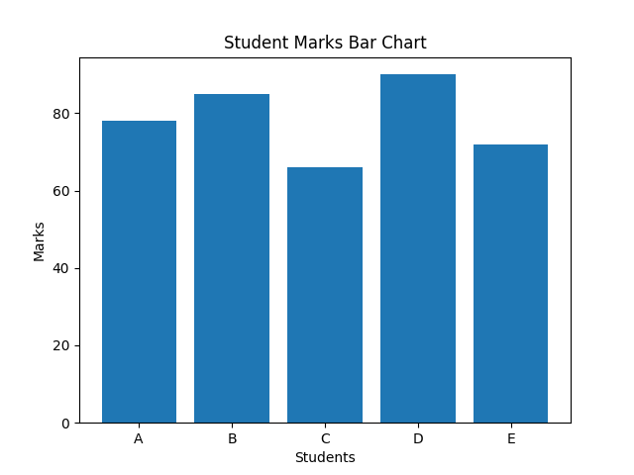

49. Write a program to create a line plot of sine and cosine waves using Matplotlib. (Apply)
ANS. INPUT:
import numpy as np
import matplotlib.pyplot as plt
x = np.linspace(0, 10, 100)
plt.plot(x, np.sin(x), label="Sine Wave")
plt.plot(x, np.cos(x), label="Cosine Wave")
plt.xlabel("X-axis")
plt.ylabel("Y-axis")
plt.title("Sine and Cosine Waves")
plt.legend()
plt.show()
OUTPUT:
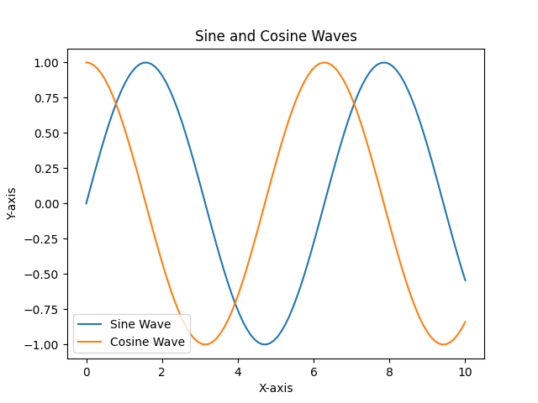

50. Write a program to create a scatter plot using Seaborn. (Apply)
ANS. INPUT:
import seaborn as sns
import matplotlib.pyplot as plt
# Sample data
data = sns.load_dataset("iris")
sns.scatterplot(x="sepal_length", y="sepal_width", hue="species", data=data)
plt.title("Iris Dataset Scatter Plot")
plt.show()
OUTPUT:
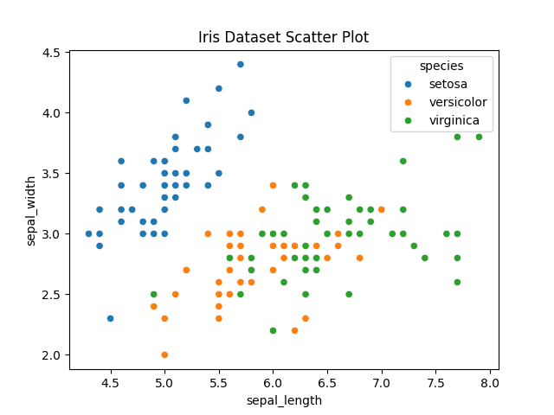

51. Write a Python program using Scikit-learn to perform simple linear regression. (Create)
ANS. INPUT:
from sklearn.linear_model import LinearRegression
import numpy as np
# Training data
X = np.array([[1], [2], [3], [4], [5]]) # Hours studied
y = np.array([40, 50, 60, 70, 80]) # Marks scored
# Creating model
model = LinearRegression()
model.fit(X, y)
# Predict marks for 6 hours
prediction = model.predict([[6]])
print("Coefficient (Slope):", model.coef_[0])
print("Intercept:", model.intercept__)
print("Prediction for 6 hours study:", prediction[0])
OUTPUT:
Coefficient (Slope): 9.999999999999998
Intercept: 30.000000000000007
Prediction for 6 hours study: 90.0

