LEOZ Project Management & CRM
Executive Operational Workflow & Module Guide (2–3 Page Reference)

1. System Overview
LEOZ is an integrated project management and client portal platform designed specifically for interior design, architecture, and construction firms. It connects Vendors (Business Admins), Employees (Field & Studio Team), and Customers (Clients) into an end-to-end execution workflow.

2. End-to-End System Workflow
The diagram below illustrates the sequential lifecycle from initial role permission setup, employee creation, and project assignment to client onboarding, field execution, and completion sign-off:
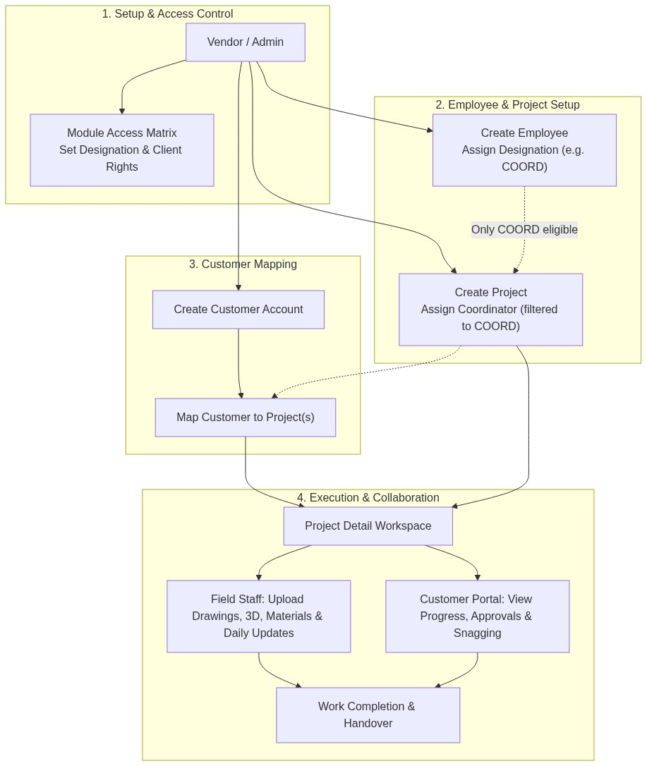
Figure 1: Complete Operational Workflow — Configuration to Handover

3. Core Menus & Critical Business Rules

Configuration
- Change Password: Requires entering and verifying the Old Password before allowing any password changes.
- Module Access: Permission matrix governing what each Employee Designation and Customer can access inside Project Details (VIEW, ADD, EDIT, APPROVE, REJECT, COMPLETE, ORDER, RECEIVE). Disabling VIEW completely hides the module tab.

Employee
- Designation (User Type): Core driver of system access. Dictates which Project Detail tabs and actions the employee can view and execute.
- Multi-Project Assignment: An employee can be assigned to multiple projects simultaneously at creation or edit time.
- Coordinator Eligibility: Only employees with designation Coordinator (COORD) can be selected as a Project Coordinator.
- Coordinator Lock: If an employee is an active Project Coordinator, their designation cannot be changed, and that project cannot be removed from their assigned list until re-assigned in the Project screen.
- History Protection: If an employee has logged work (Daily Updates, Site Documents, Site Materials, or Pending Work) for a project, that project cannot be removed from them.

Customer
- Purpose: Creates client portal accounts allowing clients to monitor progress and approve deliverables.
- Multi-Project Mapping: One customer can have multiple projects mapped to their profile.
- Client Visibility: Customers only see data and tabs for projects explicitly mapped and permitted to them.
- Work History Lock: Projects where work has already started cannot be unmapped from a customer.

Projects
- Coordinator Assignment: Optional selection. Dropdown strictly filters to employees having the Coordinator (COORD) designation. Each project has exactly one primary coordinator.
- Subscription Limit: New project creation is automatically validated against the Vendor’s active subscription plan quota.
- In-Use Protection: Projects linked to active site documents, customer mappings, or daily updates cannot be deleted.

Inside Project Details (9 Modular Tabs)
The 9 functional sections available inside each project, governed by Module Access:
Code | Tab Name | Key Purpose
EPM | Estimate & Payment Terms | Commercial cost estimates, stage billing milestones, and payment schedule terms.
F3D | Final 3D | Approved 3D visual renders of spaces; stores the latest active version for client review.
DRW | Drawings | Architectural layouts, MEP, electrical, and carpentry working drawings.
WCLTSC | Scope & Material Specs | Formal client scope of work deliverables and approved material specifications.
MB | Mood Board | Theme visuals, color palettes, finishes, and sample board references.
SITE | Site Updates | Progress snapshots, stage verification records, and site documentation photos.
WPEND | Pending Selection & Work | Punch-list tracking pending client material selections, snagging, and rectification items.
MPRO | Material Procurement | Material indents, purchase orders, vendor assignments, and delivery receipts.
WCOMP | Work Completion Report | Room-by-room completion sign-off reports and final handover documents.

Daily Update
- Purpose: Fast daily field reporting for site coordinators, supervisors, and site engineers.
- Workflow: Select Project → Select Date → Enter Work Notes → Upload multiple Site Photos → View/Audit gallery.

