Attendance Automation System

Sai Preetham Bonthula, Varun Reddy Kalvakolu, Sashwat Madaan, Shiva Shanker Pandiri, Ashish Pulluri, Hemanth Uppuluri

*Seidenberg School of Computer Science and Information Systems Pace University*

New York, USA

[sp11616n@pace.edu,](mailto:sp11616n@pace.edu) [vk21164n@pace.edu,](mailto:vk21164n@pace.edu) [ms59997n@pace.edu](mailto:ms59997n@pace.edu), [sb08172n@pace.edu](mailto:sb08172n@pace.edu), [ap65397n@pace.edu,](mailto:ap65397n@pace.edu) [hu43813n@pace.edu](mailto:hu43813n@pace.edu)

# *Abstract---* Attendance automation system is an application that can be used as a platform to replace the existing manual attendance system, which is usually a long- time consuming process for both the instructors and students. With the help of an attendance automation system application, this manual attendance process can be automated using machine learning algorithms and face recognition technology. However, many other alternative processes use Biometrics. Face recognition would be the best method. This paper would like to describe how the manual attendance process will replace using face recognition. In our application, the camera is the primary tool that captures an image and faces are detected and recognized by the system. It compares it with the images of students stored in the database. Finally, student attendance is recorded in the system.

1. **INTRODUCTION**

The attendance automation system is developed to help the educational institutions and the instructors maintain automated student attendance details without much human interference and reduce manual errors, which can be possible with the manual

attendance collection process. Educational institutions have their way of collecting attendance like using attendance sheet or biometric methods, and most of the universities use these methods, which consumes a significant amount of time. Nowadays, student attendance plays a crucial role in many schools, colleges, and universities and has a strict policy to maintain attendance. The attendance automation system uses to mark the attendance of a student when they enter into the class. On the other hand, manual attendance will have to make sure that every student responds and maintains the details on the paper, which consumes a lot of time and effort of the faculty or staff. During this manual process, there are vast chances of proxies in the manual attendance process. This application can provide an attendance automation system that recognizes the students using face recognition. Face detection, the face in the images marks with the rectangle box, is detected after subtracting the background, and the detected face is cropped. Finally, cropped image all the face of individuals is recognized from the image. It is compared with the image in the database after this process, the attendance will be marked for all the individuals. This attendance automation system will be more efficient and user- friendly with its easy to use interface and will

make life easier for the students, educational institutions, and faculty.

# LITERATURE SURVEY

In human interactions, a person's face is considered the most crucial factor as it contains essential information about the person or an individual's identity. Every human can recognize the other person based on their facial features. In recent years, a significant amount of research on face recognition is carried out. Nowadays, face recognition technology is being widely used across various platforms such as banking apps, social media platforms and applications, government offices, etc. In the previous face recognition systems, some disadvantages such as head pose problems and light intensity, etc. To overcome these problems, some techniques like principal component analysis, viola jones algorithm, and illumination invariant are used, and research is being carried to overcome these various issues. The primary step would be to detect the faces and recognize them. After detection, a comparison would be made by cross checking with the database of students faces. Hence, after studying various research papers on face recognition in our application, we implement this technology using various machine learning algorithms by building, training, and testing the model to provide high accuracy to recognize an individual. This smart face recognition system will be the best method to maintain the student's attendance records, and it can also resolve various issues like proxies in attendance.

# PROJECT REQUIREMENTS

## Functional Requirements

* + Admin should be able to log in and add student details into the database, View the student details and reports generated after the attendance.
  + The Faculty/Instructor should register using the name, username, password, email address, and mobile number.
  + The Faculty/Instructor should be able to login using a username and password.
  + The Faculty/Instructor should be provided with options to take the camera option/ upload an image or view the previous attendance records/reports.
  + The Faculty/Instructor should see the system detect and recognize the student's face along with their names registered on the database.
  + The Faculty/Instructor should be able to see the students present and absent on the home page of the application.
  + The Faculty/Instructor should receive email notification with attendance results to their registered email address.

## Technical Requirements

* + For this application development, we are using HTML, CSS, and Python PyQt to build the application's front end.
  + PyQt is a python binding cross- platform GUI toolkit and is also one of the most used modules in building complex GUI apps in python.
  + Pyqt contains various python modules like QtGui, which contains the majority of GUI classes

,QtCore for non-GUI classes, QtWidgets, which contain primary elements for the user interface.

* + HTML, CSS, Javascript are web technologies that can be interpreted by most web browsers, and we use it to render the results of attendance details on the attendance results page.
  + We will be using a Python programming language, a high-level, general-purpose, interpreted programming language. It has a collection of standard libraries, which makes python a high-level language. It has the libraries required for deep learning and machine learning, which can be used to recognize images.
  + We use machine learning algorithms like K-Nearest Neighbors, Principal Component Analysis, and use the algorithm, which provides high accuracy results when viewed from various angles for face detection and recognition.
  + For the data storage, we will be using MySQL.
  + MySQL is one of the popular open- source relational database management systems (RDBMS), a database that runs on the server. It is effortless to use as well as it is swift and reliable. The data is stored in rows and columns, and it uses standard SQL (Structured Query Language).
  + We will be building this application using agile methodologies.
  + The attendance automation system application will be very user friendly

# AGILE METHODOLOGIES:

As we notice, software development is expanding. The software has merged into many diverse fields and is becoming more complex. Changing requirements from customers are making it even more difficult. Old software development approaches cannot satisfy the new requirements of the market in the best way anymore. As a result, new software development approaches are evolved, like agile methodologies, mainly to solve such a problem.

Characteristics of agile methodology

* + Deliver frequently
  + More iteration
  + Fewer defects
  + Test frequently
  + Collaborative approach.
  + Maximum ROI

Agile processes support process "management in the small" in that the coordination, control, and communication mechanisms used apply to small to medium- sized teams.

There are a few agile methods:

## Extreme Programming (XP)

XP is the most successful method of developing agile software because of its focus on customer satisfaction. XP requires maximum customer interaction to develop the software. It divides the entire software development life cycle into several short development cycles. It welcomes and incorporates changes or requirements from the customers at any phase of the development life cycle.

Project tracing

Bug

New

and easy to use.

Requirements

User Requirements

Iteration Planning

requirements

Iteration plan

Development (Iteration)

Acceptance testing

Latest developed version

Releaseof the latest version

Priority checking

Effort estimation

New user requirements

## Scrum

Scrum is another popular method of agile development through which productivity becomes very high. It is basically based on the incremental software development process. In the scrum method, the entire development cycle is divided into a series of iteration where each iteration is called a sprint. The maximum duration of a sprint is 30 days.

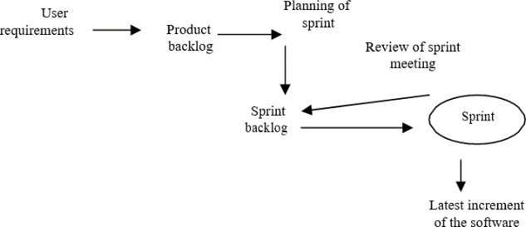

## Feature Driven Development (FDD)

FDD is one of the agile development methods. This method's key advantage is to design the domain of the software to be produced before development.

User requirements

Developing overall model

Preparing list of features

Planning by features

Modeling iteration

Designing UML

model for each feature



Developing by features



Successful and properly developed feature

Modeling iteration

Complete working software

ADVANTAGES:

* Adaptive to the changing environment
* Ensures customer satisfaction
* Least documentation
* Reduces risks of development DISADVANTAGES:
* Lack of documentation.
* Customer interaction is a critical factor in developing successful software.
* Time consuming and wastage of resources due to the constant change of requirements.
* More helpful for management than a developer:

# ARCHITECTURE

Attendance automation system architectures with the front end and backend database. We are using the following technologies for building the application are as follows:

**Frontend:** We are using HTML, CSS, JavaScript, Python PyQt web GUI toolkit to build the frontend pages of the application. The attendance results use HTML, CSS, and JavaScript to render the browser results, and all the browsers that support HTML can view the results, and all the desktops can be used to run the application. We use the PyQt GUI toolkit to build the interface and using PyCharm as our IDE.

**PyCharm:** It is an integrated development environment used for computer programming, especially for python. It is used for building the application. It makes building and maintaining applications more comfortable and faster.

**PyQt GUI toolkit:** PyQt is a GUI widgets toolkit in python, a set of C++ libraries and development tools that include abstractions for Graphical User Interface (GUI) as well as SQL databases, OpenGL, and many more.

**Graphical User Interface**: It is an interface through which the user communicates with devices. It uses symbols and other graphical images to display information.

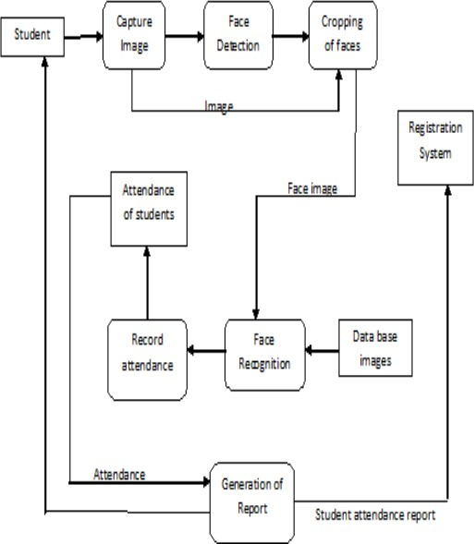

Fig. 1. System Architecture

* **Database:** We are using a MySQL database for the storage

and authentication of our application. MySQL is one of the most popular open-source relational databases worldwide, and there are so many reasons for its popularity. However, the main reason is its architecture, which makes it unique and preferred by most developers. MySQL architecture is a client-server system. It is used for a wide range of purposes, which include Data warehousing, login applications, and many more. It is mostly used in web databases. In this application, we store student and faculty details in the SQL database. The architecture of MySQL contains the following major component

Fig. 2. MySQL Architecture

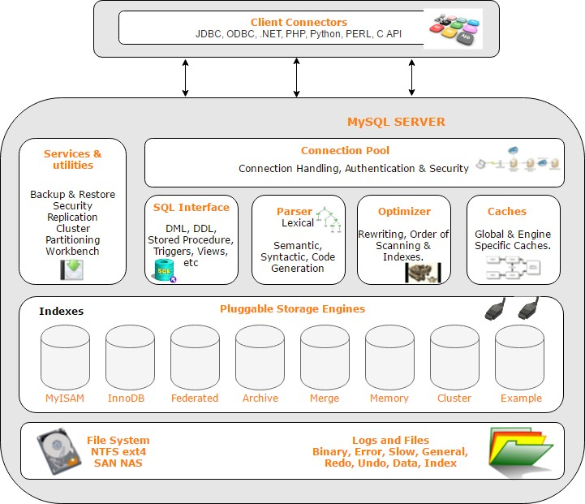

**Application Layer:** It is the top layer on MySQL architecture, which provides standard services to most client-server applications. It has services, as mentioned below:

**Connection handling:** When the client gets connected to the server, they get the own thread for its connection. The thread will be caught by the server and need not be created and destroyed for every new connection.

**Authentication:** When the client connects to the MySQL server, the server will perform authentication on the server-side based on the username, host client, and password of the user.

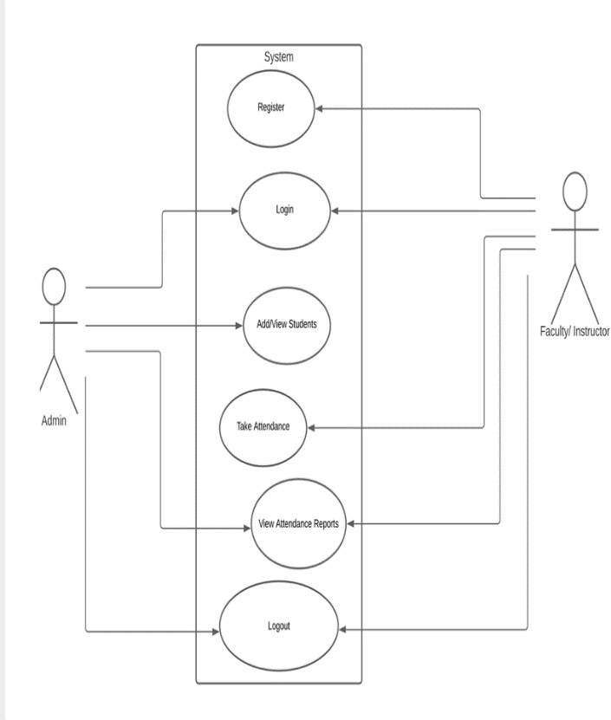

Fig.3 Use Case Diagram

**Authorization:** It is the function of specifying access to resources related to information security and computer security in general and access control. Furthermore, "to authorize" is to define an access policy.

**Security:** As the client gets successfully connected to the server, it will check whether the client has the privileges to provide queries against the MySQL server.

**Face detection:** During face detection, the face in images will be marked using a rectangle, and the image can be used for face detection after the background subtraction. This background-subtracted image will be accurate for face detection compared to using the image that is not background subtracted.

**Face Recognition:** The detected faces after background subtraction will be used for recognizing the faces. There are many methods to detect faces in which the eigenvalue method is considered the best method due to its speed.

**Flowchart:** The flowchart illustrates the face recognition in the attendance automation system.

* Initially, the image will be captured and stored as an input from the camera.
* Next, all the individuals' faces are cropped after subtracting the background and perform the preprocessing to detect the faces.
* The feature extraction process will be performed based on the cropped faces after the preprocessing process.
* In the next part, the trained algorithm will classify the images and recognize the individuals based on students' images stored in the database.
* After this process, the student's attendance details will be generate and stored in the database accordingly.
* Reports of students' attendance will be displayed and sent as an email to the instructor for that day.

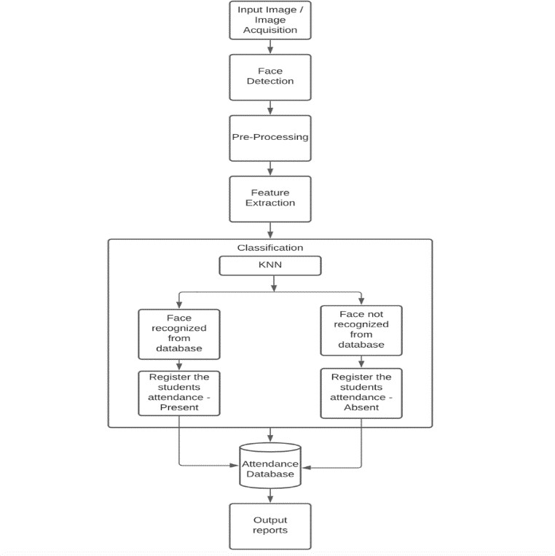

Fig.4 Flow Chart

# Sequence Diagram

# 

# PRODUCT RESULTS:

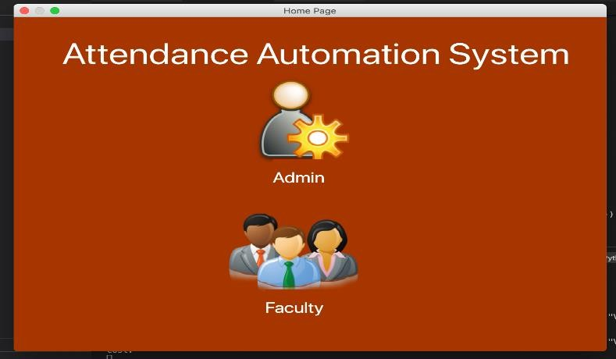

Figure 5.1 Landing Page

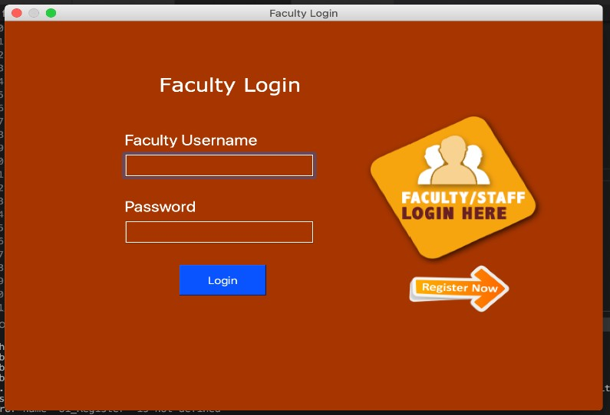

Figure 5.2 Faculty Login Page

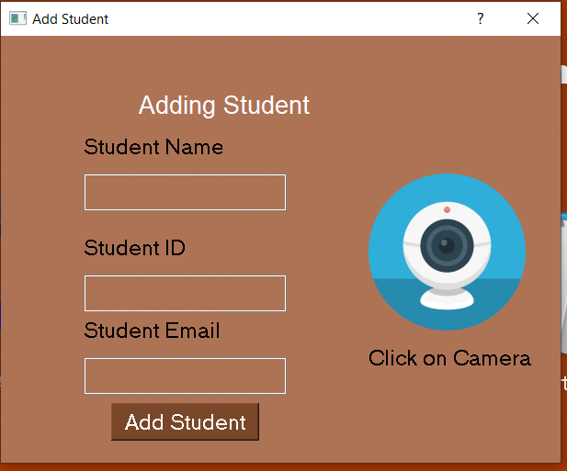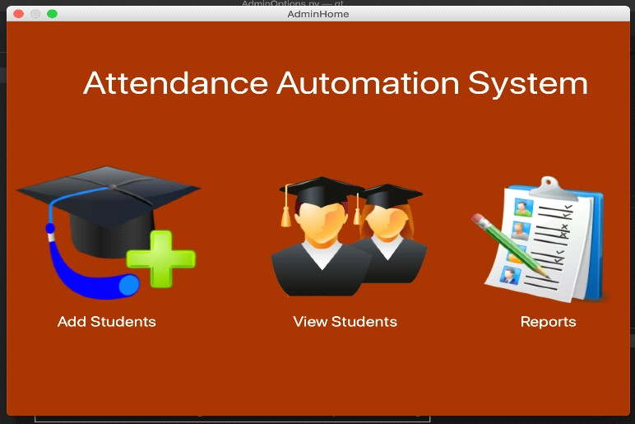

Figure 5.3 Admin Options Page

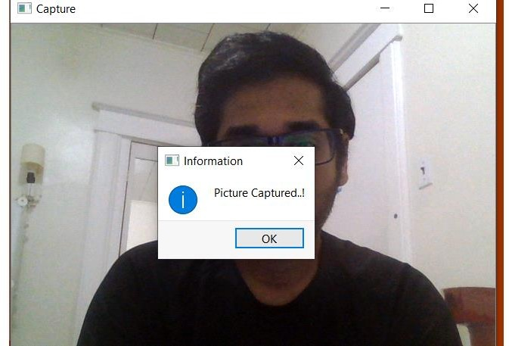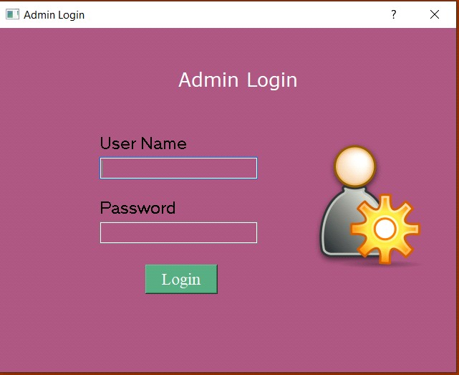

Figure 5.4 Admin Login page

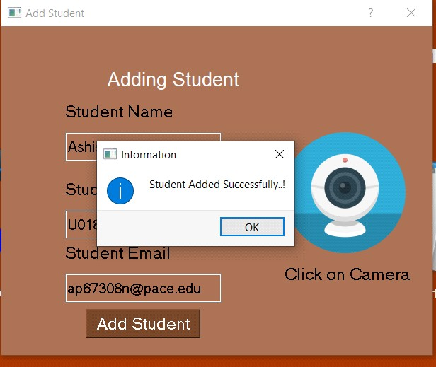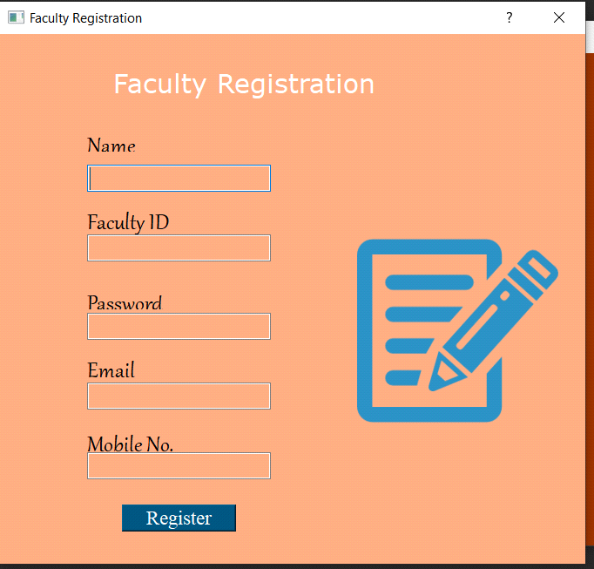

Figure 5.5 Faculty registration page

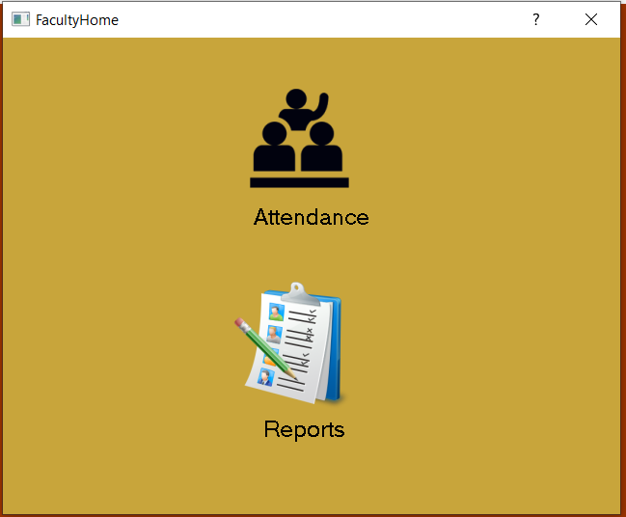

Figure 5.9 Faculty Home

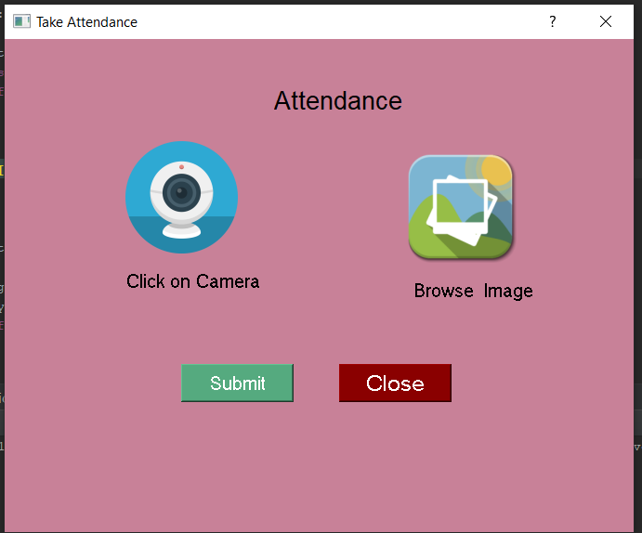

Figure 5.10 Faculty Options

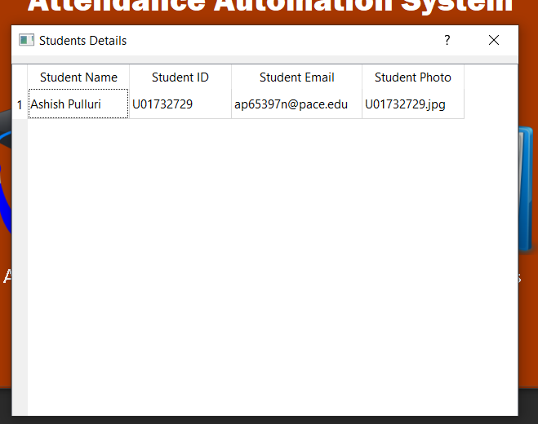

Figure 5.11 Admin View Students GUI

So far, we have implemented the front end of our application and added student details into the database. Fig 5.1- 5.11 illustrates the screenshots of the application.

**KNN Machine Learning Algorithm:**

Face identification Using the K-Nearest Neighbor Method consists of two phases namely the training phase and the testing phase. The dataset used in the training phase images consisting of 158 classes with each class consisting of three training images and two for testing images. The following will explain the chart or scheme in stages from each phase on flowchart below.

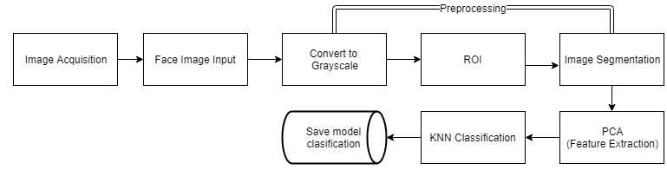

Figure 1. Phase Training Scheme Face identification

While the testing or testing phase involves a database of features that have been obtained from the results of training. The testing scheme is as follows.

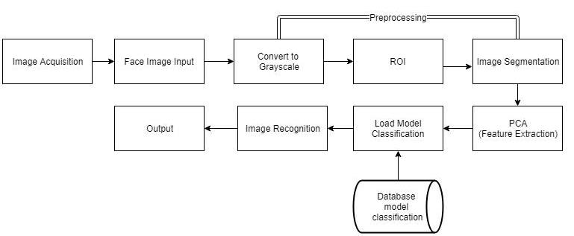

Figure 2. Testing Phase Scheme

Image Enhancement is an accentuation or sharpening of the elements of an image such as edge and boundaries or contrast levels that can make the graphic display of the image more useful for analysis and display [9]. Stages of image enhancement in the face identification system using the K-Nearest Neighbor (KNN) method consists of ROI (Region of Image), image conversion to grayscale color space and contrast stretching. An image enhancement technique that seeks to increase contrast in the image by stretching called Contrast stretching. The concept of contrast stretching is to maintain the range of values of intensity it contains to reach the desired range of values. This is used to enhance the information in the image and maintain other details

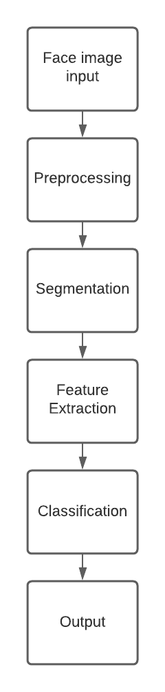

Feature extraction is a stage to find the characteristic features of an inputted image. Feature extraction is a process which is extracted features to encourage the classifier to make decisions when classifying.

The Principal Component Analysis feature extraction method used in this paper is one of the popular extraction methods [11]. The PCA method is one way to reduce the dimensions of data with the least amount of information loss [12]. This method is used in many fields, such as biometrics, feature extraction, image processing, data compression, etc. In the PCA method, faces are described as linear combinations of eigenvector weights called Eigenfaces. This eigenvector is a covariance matrix from the image database. the number of images in the database will be the same as the number of Eigenfaces received

Face classification is a stage for the process of matching testing data and training data from face datasets. KNN is one of the simple algorithms that can be used for classification. Regardless of its simplicity, this method is quite effective as a classification.

# ADVANTAGES

1. The application will replace the manual attendance process with face recognition.
2. Faculty, educational institutions, and students can save a lot of time.
3. The faculty can view the consolidated student attendance details.
4. An email will be sent automatically to the registered faculty of class after the attendance process with the student's attendance data list.

# CONCLUSION

This framework has been proposed to keep a track record of the attendance. Principal thought process behind building up this framework is to wipe out all the downsides related to the manual Attendance system. Utilizing this strategy, we can supplant older strategies. Efficient and automatic attendance management is introduced in the paper. This technique requires essential equipment for establishment. Attendance recording is less complicated, and the participation is taken precisely. We have created an admin and login page and administered associated databases required for this project.

# REFERENCES

1. Seema Rao and Prof.K.J.Satoa, "An Attendance Monitoring System Using Biometrics Authentication," International Journal of advanced research in Computer Science and Software Engineering, Volume 3, Issue 4, April 2013, ISSN:2277 128X.
2. O. Shown Development of Attendance Management System using Biometrics. The Pacific Journal of Science and Technology Volume 13, No 1, May 2012
3. Arulogun O. T., Olatunbosun A., Fakolujo O.A., and Olaniyi O. M, “RFID Based Students Attendance Management System ” InternationalJournal of Scientific & Engineering Research," Volume 4, Issue 2, February-2013; ISSN2229- 5518.
4. UnnatiA.Patel and Dr. SawminarayanPriya R.2014. “Development of a Student Attendance Management System Using RFID and FaceRecognition: A Review”, International Journal ofAdvance Research in Computer Science andManagement Studies, Volume 2, Issue 8, August 2014; Online ISSN: 2321-7782.
5. R.L. Hsu, Mottalec M.A and A.K.Jain,”Face Detection in colour images”, Proceedings International Conference on ImageProcessing, Oct 2001,pp. 1046-1049