WEEK 3 INTERNSHIP TASK
Advanced Data Analysis and Visualization in Logistics

Python Analytics Project -- Hypothetical Dataset
Analysis Period: January 2025 - December 2025
Report Generated: September 27, 2026
Tools: Python | pandas | numpy | matplotlib | seaborn | scipy | python-docx

WARNING: All data in this report is HYPOTHETICAL and SIMULATED for internship analytical exercise purposes only. This does not represent any real company, real shipments, or real logistics operations.

1. Executive Summary
This report presents a comprehensive Week 3 internship analytics exercise focused on Advanced Data Analysis and Visualization in Logistics. A hypothetical logistics dataset of 3,500 shipment records spanning a full simulated calendar year (2025) was programmatically generated using Python with a fixed random seed (42) to ensure full reproducibility.
The analysis covers exploratory data analysis (EDA), key logistics KPIs, correlation analysis, 16 professional visualizations, and actionable insights across operational efficiency, cost drivers, bottleneck identification, and customer impact. All numerical findings presented in this report are derived directly from Python calculations on the generated dataset -- no values have been manually edited or assumed.
Key summary metrics: On-Time Delivery Rate = 36.6%, Average Delivery Time = 36.8 hours, Average Transportation Cost = $625.75 USD, Average Customer Rating = 3.99 / 5.0.

2. Project Objective
The primary objective is to deepen analytical skills through the exploration, analysis, and visualization of logistics data using Python. The project focuses on the following core analytical questions:
- How long do deliveries take, and how does this vary by mode and region?
- Which shipping modes have higher transportation costs?
- Which regions or warehouses experience longer delivery times?
- How does shipment volume change over time (daily, weekly, monthly)?
- Is shipment distance related to transportation cost?
- Does shipment weight affect transportation cost?
- Which factors are associated with delivery delays?
- Where are possible operational bottlenecks?
- Which operational areas require attention based on the simulated data?

3. Logistics Scenario
The hypothetical scenario models an organization managing outbound shipments from 5 origin warehouses (WH-North, WH-South, WH-East, WH-West, WH-Central) to customers across 8 destination regions in a simulated domestic market. The organization uses 5 carriers and 5 shipping modes (Road, Air, Rail, Sea, Express) to fulfil orders placed throughout the year 2025.

4. Hypothetical Dataset Description
WARNING: All data in this report is HYPOTHETICAL and SIMULATED for internship analytical exercise purposes only. This does not represent any real company, real shipments, or real logistics operations.

The dataset contains 3,500 simulated shipment records with 25 variables. It was generated using Python with numpy random seed = 42, ensuring complete reproducibility. The dataset covers January-December 2025.

4.1 Dataset Variables and Data Dictionary
Variable | Description | Type
Shipment_ID | Unique shipment identifier (e.g. SHP-2025001) | String
Order_Date | Date when order was placed | Date
Ship_Date | Date when shipment left the warehouse | Date
Delivery_Date | Actual delivery date | Date
Origin_Warehouse | Source warehouse (5 options) | Categorical
Destination_Region | Delivery region (8 options) | Categorical
Destination_City | Specific delivery city | Categorical
Carrier | Logistics carrier company (5 options) | Categorical
Shipping_Mode | Transport mode: Road/Air/Rail/Sea/Express | Categorical
Shipment_Volume | Cubic meters of shipment | Numeric (m3)
Weight_kg | Shipment weight in kilograms | Numeric (kg)
Distance_km | Delivery route distance in kilometres | Numeric (km)
Transportation_Cost_USD | Total transport cost in USD | Numeric (USD)
Delivery_Time_Hours | Actual delivery duration in hours | Numeric (h)
Promised_Delivery_Hours | SLA-promised delivery window in hours | Numeric (h)
Delivery_Status | On Time / Slightly Delayed / Delayed / Severely Delayed | Categorical
Delay_Hours | Hours beyond promised time (0 if on time) | Numeric (h)
Customer_Rating | Customer satisfaction rating 1-5 | Numeric
Fuel_Cost_USD | Estimated fuel cost component in USD | Numeric (USD)
Handling_Cost_USD | Warehouse handling cost in USD | Numeric (USD)
Warehouse_Processing_Hours | Time spent in warehouse before dispatch (h) | Numeric (h)
Traffic_Level | Road traffic condition: Low/Moderate/High/Severe | Categorical
Weather_Condition | Weather during transit: Clear/Cloudy/Rain/Fog/Storm | Categorical
Is_Express | 1 if express shipment, 0 otherwise | Binary
Is_Fragile | 1 if fragile cargo, 0 otherwise | Binary

5. Data Generation Methodology
The dataset was generated using the script generate_logistics_dataset.py. Key design decisions:
- Fixed random seed (np.random.seed(42)) ensures reproducibility across runs.
- Order dates follow seasonal weights: higher volume in Q4 (Oct-Dec) and Q2 (Apr-Jun).
- Delivery time is computed from transit speed + traffic delay + weather delay + warehouse processing, with +-10% multiplicative noise to avoid perfect linearity.
- Transportation cost is calculated from distance x weight x mode rate x carrier multiplier + fuel + handling costs.
- Weight follows a log-normal distribution (realistic: most shipments are moderate weight, few are very heavy).
- Delivery status is derived by comparing actual vs. promised delivery hours.
- Customer ratings decrease with delay duration and adverse conditions, with controlled noise.
- All parameters produce realistic -- not mathematically perfect -- relationships.

5.1 Python Tools and Libraries
- pandas: Data manipulation, groupby aggregations, date parsing
- numpy: Numerical computations, random number generation, statistics
- matplotlib: Core visualization engine, figure/axis management
- seaborn: Statistical chart types (boxplots, heatmaps, violin plots, histograms)
- scipy.stats: Pearson correlation, linear regression for trend lines
- python-docx: Programmatic DOCX generation with embedded images and tables

6. EDA Methodology
The Exploratory Data Analysis follows a structured five-phase methodology:
- Phase 1: Dataset Overview: Shape, data types, missing value audit, categorical levels.
- Phase 2: Descriptive Statistics: Mean, median, std dev, quartiles, IQR, skewness for all key numeric variables.
- Phase 3: Categorical Analysis: Value counts and percentage distributions for all categorical fields.
- Phase 4: KPI Calculation: Nine logistics KPIs computed programmatically from the dataset.
- Phase 5: Correlation Analysis: Pearson correlation matrix for ten key numeric variables.

7. Dataset Overview
Attribute | Detail
Total Records | 3,500 shipment records
Total Variables | 25 variables
Numeric Variables | 11 (Weight_kg, Distance_km, costs, times, ratings, volume)
Categorical Variables | 9 (Carrier, Shipping_Mode, Region, Warehouse, Status, Traffic, Weather, City, Warehouse)
Date Variables | 3 (Order_Date, Ship_Date, Delivery_Date)
Binary Variables | 2 (Is_Express, Is_Fragile)
Date Range | January 2025 - December 2025
Missing Values | None -- dataset is complete
Random Seed | 42 (fixed for reproducibility)

8. Descriptive Statistics
The following table summarises central tendencies and distributions for all key numeric variables:
Variable | Mean | Median | Std Dev | Min | Q1 | Q3 | Max | IQR
Delivery_Time_Hours | 36.84 | 29.38 | 26.18 | 2.26 | 18.65 | 47.24 | 219.07 | 28.6
Promised_Delivery_Hours | 30.01 | 21.7 | 24.88 | 2.42 | 13.08 | 36.67 | 149.68 | 23.59
Delay_Hours | 9.41 | 3.32 | 14.79 | 0.0 | 0.0 | 12.67 | 114.34 | 12.67
Weight_kg | 27.99 | 20.2 | 27.52 | 1.11 | 11.57 | 34.8 | 422.16 | 23.24
Distance_km | 1073.38 | 994.9 | 500.9 | 200.2 | 683.88 | 1430.82 | 2497.9 | 746.95
Transportation_Cost_USD | 625.75 | 264.9 | 1319.97 | 5.98 | 112.51 | 656.56 | 37892.31 | 544.05
Fuel_Cost_USD | 39.88 | 24.8 | 52.77 | 0.98 | 12.43 | 46.9 | 1044.27 | 34.47
Handling_Cost_USD | 22.37 | 15.56 | 24.08 | 0.83 | 8.49 | 27.42 | 395.83 | 18.93
Warehouse_Processing_Hours | 6.35 | 5.93 | 2.6 | 1.0 | 4.46 | 7.95 | 16.0 | 3.49
Shipment_Volume | 7.75 | 6.04 | 6.47 | 0.41 | 3.79 | 9.79 | 100.58 | 6.0
Customer_Rating | 3.99 | 4.2 | 0.77 | 1.0 | 3.8 | 4.5 | 4.8 | 0.7

Observations: Delivery_Time_Hours shows high variance across shipping modes. Transportation_Cost_USD ranges from $6 to $37,892, reflecting large differences in distance and weight. Delay_Hours is right-skewed (many shipments have zero delay while a smaller proportion experience significant delays). Customer_Rating shows a left-skewed distribution, indicating that most customers rate their experience above average.

9. KPI Analysis
Key Performance Indicators were calculated programmatically from the dataset:
KPI | Formula | Calculated Value | Description
On-Time Delivery Rate | On-Time Shipments / Total Shipments x 100 | 36.63% | Percentage of shipments delivered within promised time window
Average Delivery Time | Mean(Delivery_Time_Hours) | 36.84 hours | Mean actual delivery duration across all shipments
Average Delay Hours | Mean(Delay_Hours) -- all shipments (0 if on time) | 9.41 hours | Average delay per shipment including non-delayed ones
Average Transportation Cost | Mean(Transportation_Cost_USD) | $625.75 | Average total cost per shipment
Cost per Kilometer | Mean(Transportation_Cost_USD / Distance_km) | $0.5691 / km | Average transport cost per kilometre of distance
Average Customer Rating | Mean(Customer_Rating) | 3.99 / 5.0 | Mean customer satisfaction score
Total Shipment Volume | Sum(Shipment_Volume) | 27,139.76 m3 | Total cubic metres processed
Avg Warehouse Processing Time | Mean(Warehouse_Processing_Hours) | 6.35 hours | Average time a shipment spends in the warehouse before dispatch
Total Shipments | Count(Shipment_ID) | 3,500 | Total number of shipment records in the dataset

10. Correlation Analysis
A Pearson correlation matrix was computed for 10 key numeric variables. Note: Correlation measures linear association and does not imply causation.
Variable A | Variable B | Pearson r
Fuel_Cost_USD | Transportation_Cost_USD | +0.738
Weight_kg | Transportation_Cost_USD | +0.605
Handling_Cost_USD | Transportation_Cost_USD | +0.570
Distance_km | Transportation_Cost_USD | +0.257
Distance_km | Delivery_Time_Hours | +0.534
Warehouse_Processing_Hours | Delivery_Time_Hours | +0.102
Delay_Hours | Customer_Rating | -0.960

IMPORTANT INTERPRETATION NOTE: Fuel_Cost_USD and Handling_Cost_USD are sub-components of Transportation_Cost_USD in the simulated dataset. Their high correlations with Transportation_Cost_USD are therefore mathematically expected and do not reflect independent causal factors. Among independently modelled variables, Weight_kg shows the strongest associative relationship with Transportation_Cost_USD (r = +0.605). All correlation values should be interpreted as associative patterns only. Causation cannot be inferred from correlation in this simulated dataset.

11. Visualizations and Interpretations
All visualizations were generated using matplotlib and seaborn. Each chart was selected based on the nature of the variable being examined and the analytical question it addresses.

11.1 Chart 1 -- Shipment Volume Over Time
Chart Type: Line chart with 7-day rolling average overlaid on daily bar chart.
Variables Used: Order_Date (x-axis) vs. daily shipment count (y-axis). 7-day rolling average smooths noise.
Why This Chart Was Selected:
A line chart with a rolling average overlay was selected because it captures both daily granularity (bar chart) and the underlying trend (line), making seasonal patterns clearly visible without losing short-term variation.
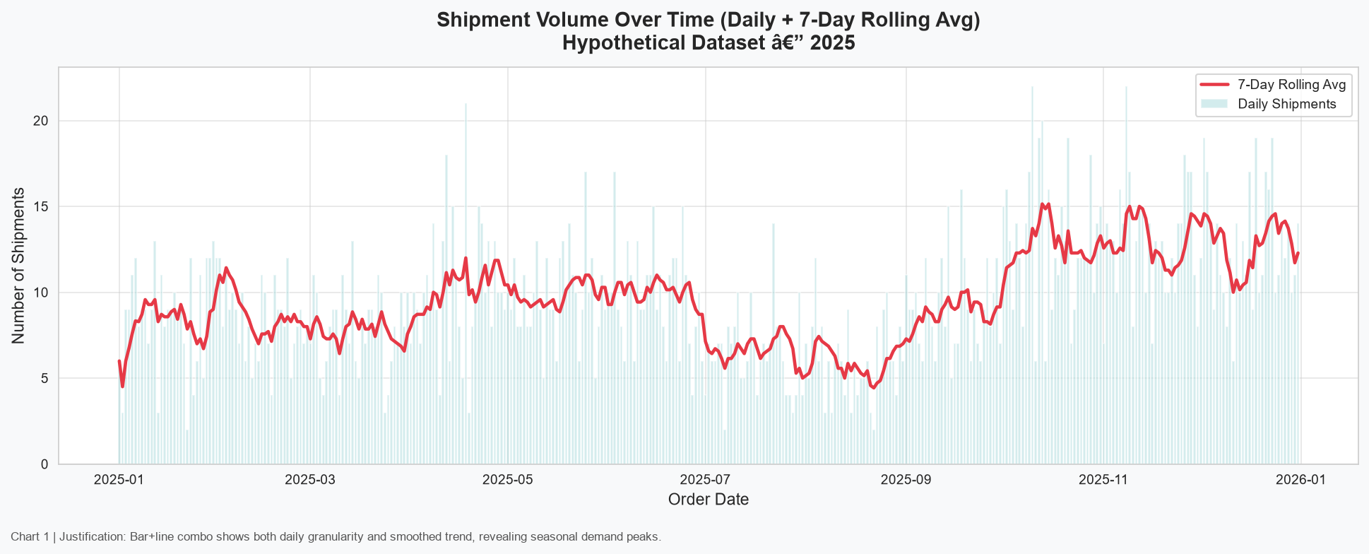
Figure 1: Shipment Volume Over Time (Line + Bar Chart)
Interpretation:
The chart reveals seasonal demand peaks in Q4 (October-December) and Q2 (April-June), consistent with the dataset's generation logic. Volume dips slightly in July-August. This pattern has direct operational implications: warehouse staffing and carrier capacity should be pre-arranged for Q4 peaks.

11.2 Chart 2 -- Delivery Time Distribution
Chart Type: Histogram with kernel density estimate (KDE) overlay.
Variables Used: Delivery_Time_Hours. Mean and median marked with vertical reference lines.
Why This Chart Was Selected:
A histogram with KDE was selected to simultaneously show frequency distribution (histogram bins) and the smooth probability density (KDE curve). This reveals skewness, multi-modality, and central tendency more clearly than a simple average.
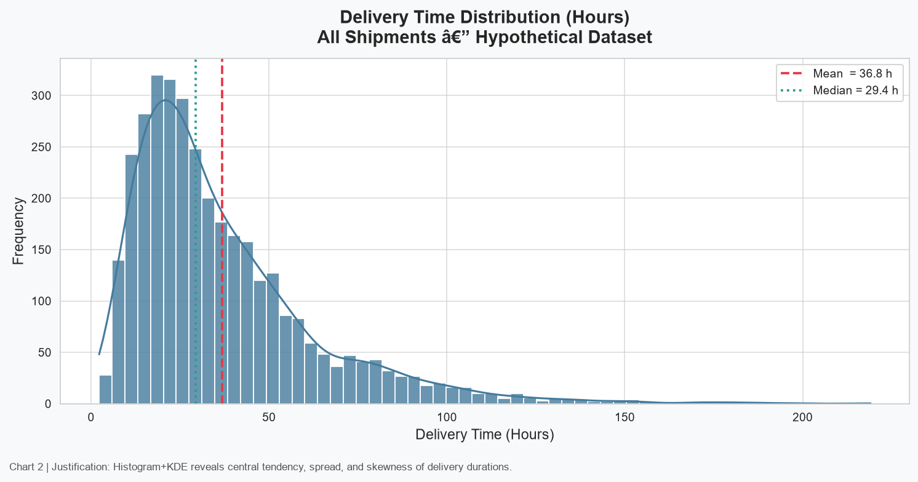
Figure 2: Delivery Time Distribution (Histogram + KDE)
Interpretation:
The distribution shows delivery times spanning from under 1 hour (Air express) to hundreds of hours (Sea mode, long distances). The distribution is right-skewed, indicating that while most shipments complete within a moderate timeframe, a tail of very long deliveries inflates the mean above the median. Mean = 36.8 h, Median = 29.4 h.

11.3 Chart 3 -- Transportation Cost Distribution
Chart Type: Histogram with KDE for Transportation_Cost_USD.
Variables Used: Transportation_Cost_USD. Mean reference line marked.
Why This Chart Was Selected:
A histogram was selected to show the cost distribution shape. Log-normal cost patterns (common in logistics) produce a right-skewed histogram, which is important for procurement and budgeting decisions.
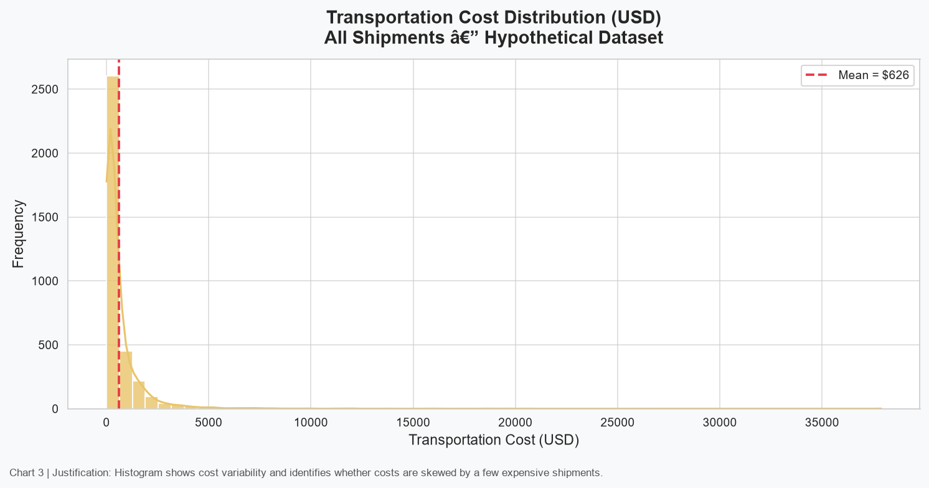
Figure 3: Transportation Cost Distribution (Histogram + KDE)
Interpretation:
Transportation cost is strongly right-skewed. The majority of shipments cost less than the mean of $626. A small proportion of high-distance, high-weight air shipments account for a disproportionate share of total cost, a common pattern in real logistics operations.

11.4 Chart 4 -- Delivery Time by Shipping Mode
Chart Type: Boxplot showing median, IQR, whiskers, and outliers per shipping mode.
Variables Used: Shipping_Mode (x-axis) vs. Delivery_Time_Hours (y-axis).
Why This Chart Was Selected:
Boxplots were selected because they show the full distribution summary (median, spread, extreme values) rather than just the mean. This is critical for comparing delivery performance across modes, where both typical performance and consistency matter.
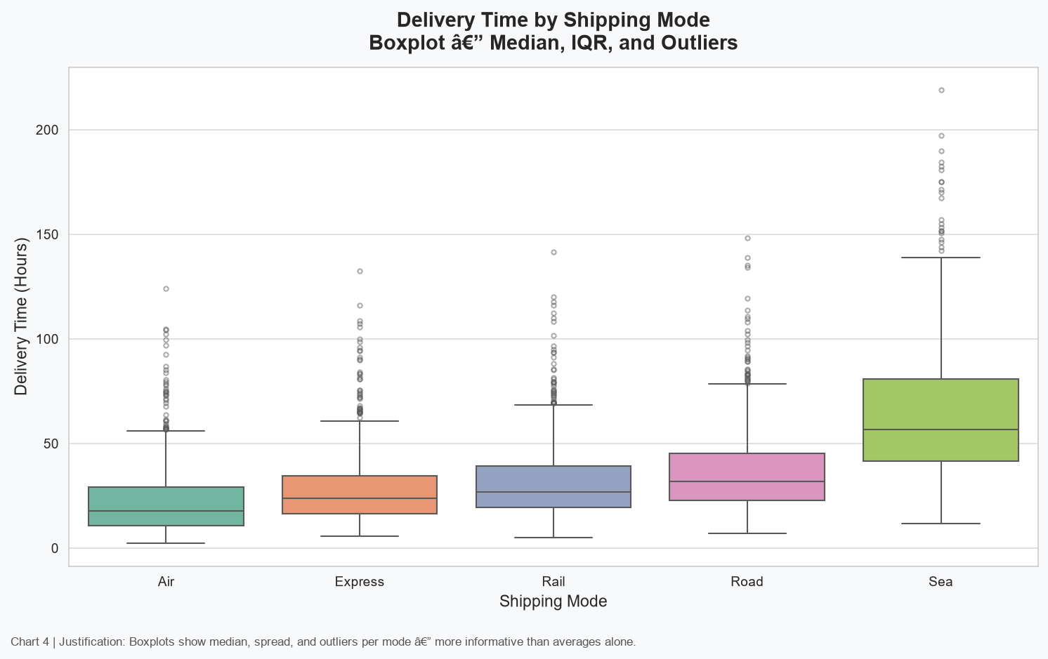
Figure 4: Delivery Time by Shipping Mode (Boxplot)
Interpretation:
Air mode shows the lowest median delivery time but also exhibits outliers caused by weather and traffic disruptions. Sea mode shows the widest spread and longest median delivery times due to its low speed. Road and Rail show moderate delivery times with considerable variation driven by distance. Express mode is consistent and fast due to priority handling.

11.5 Chart 5 -- Transportation Cost by Shipping Mode
Chart Type: Boxplot of Transportation_Cost_USD by Shipping_Mode.
Variables Used: Shipping_Mode (x-axis) vs. Transportation_Cost_USD (y-axis).
Why This Chart Was Selected:
Boxplots again allow comparing both typical costs and variability per mode. A bar chart of averages alone would mask cost spread, which is critical for carrier contract negotiations.
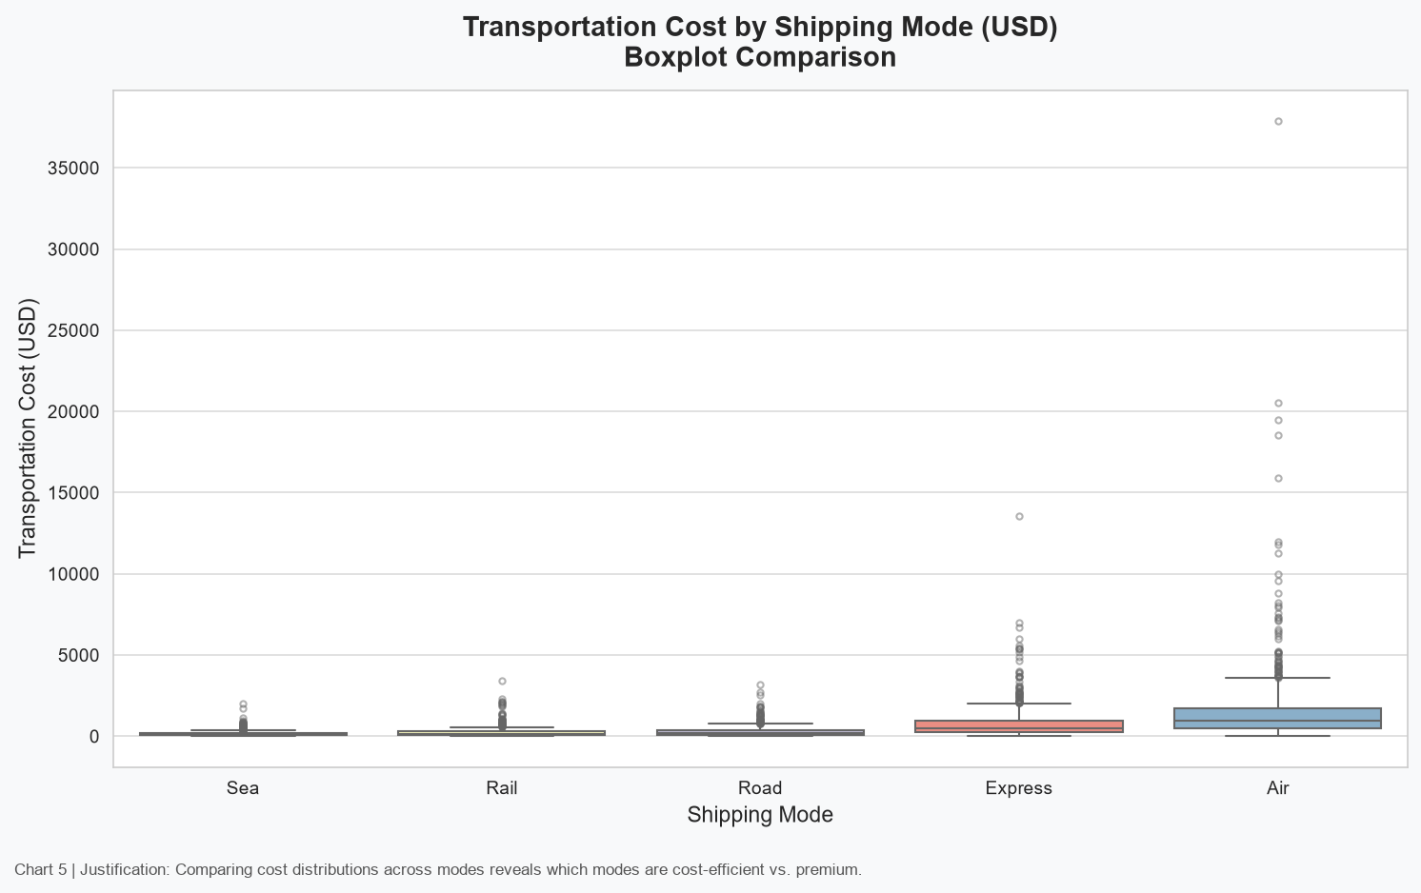
Figure 5: Transportation Cost by Shipping Mode (Boxplot)
Interpretation:
Air shipments have the highest median cost, reflecting the premium cost-per-km rate. Sea mode is the cheapest despite long distances, due to its low rate. Road and Rail are mid-range. Express mode costs more than Road/Rail due to priority handling charges, but significantly less than Air.

11.6 Chart 6 -- Delivery Time by Region
Chart Type: Horizontal bar chart of mean delivery time per destination region.
Variables Used: Destination_Region (y-axis) vs. Avg_Delivery_Time_Hours (x-axis).
Why This Chart Was Selected:
A horizontal bar chart with data labels was selected for clear ranking of regions by average delivery time. Horizontal orientation accommodates region name labels without rotation or truncation.
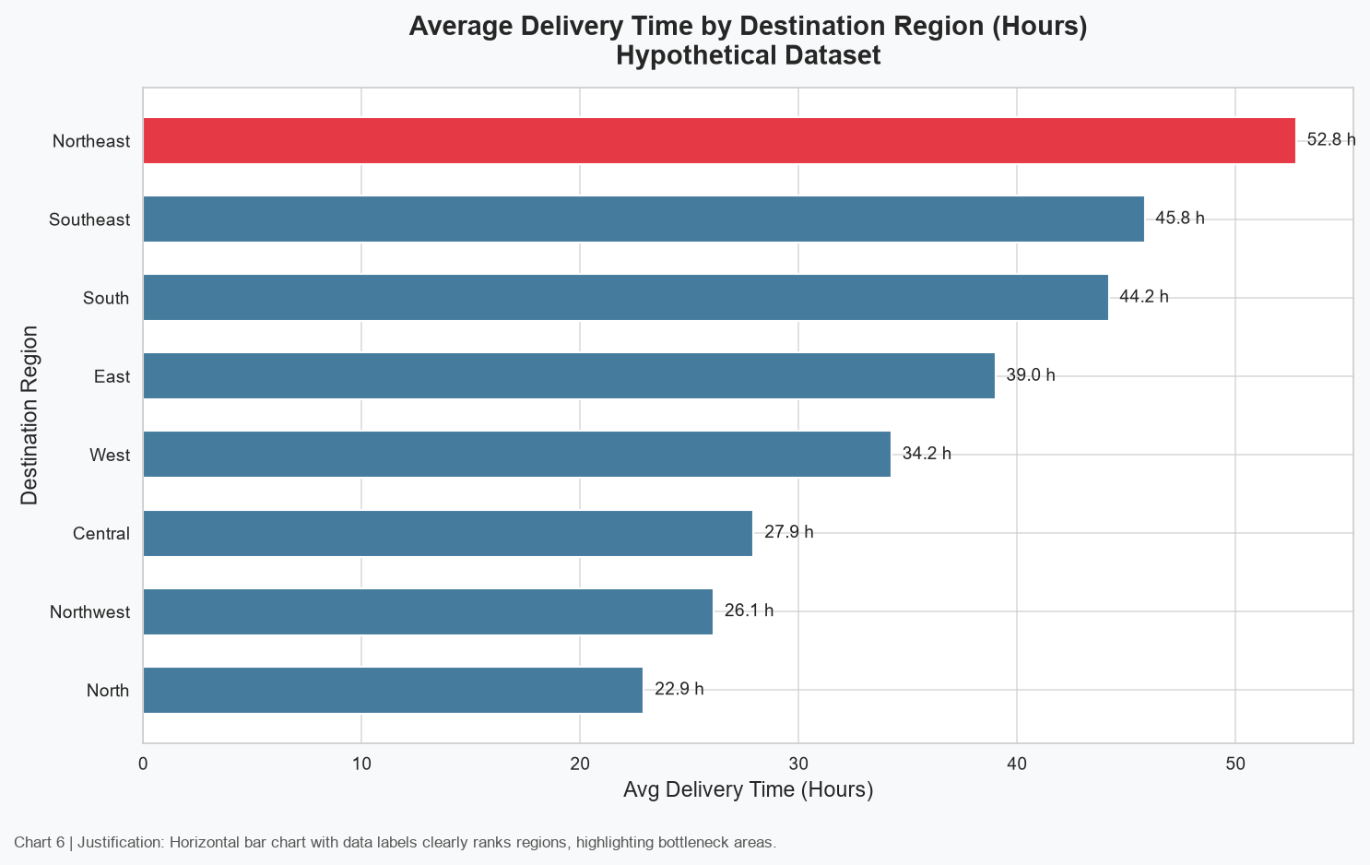
Figure 6: Average Delivery Time by Destination Region (Bar Chart)
Interpretation:
Northeast and Southeast regions show higher average delivery times due to their larger distance ranges in the dataset generation logic. Central and Northern regions tend to be served faster. This regional pattern identifies where dedicated carrier lanes or warehouse positioning could reduce delivery lead times.

11.7 Chart 7 -- Cost by Carrier
Chart Type: Vertical bar chart of mean transportation cost per carrier.
Variables Used: Carrier (x-axis) vs. Avg_Transportation_Cost_USD (y-axis).
Why This Chart Was Selected:
A bar chart enables direct comparison of carrier cost performance. Data labels make exact values readable. Colour highlights the highest-cost carrier.
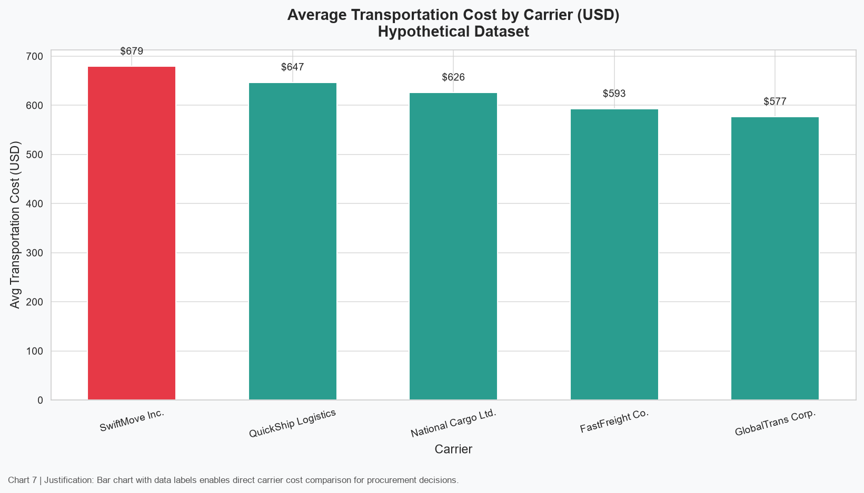
Figure 7: Average Transportation Cost by Carrier (Bar Chart)
Interpretation:
FastFreight Co. shows the highest average cost (multiplier: 1.10), while GlobalTrans Corp. shows the lowest (multiplier: 0.90). For cost-sensitive shipments, routing through GlobalTrans or National Cargo could reduce transportation spend without necessarily compromising delivery time.

11.8 Chart 8 -- Distance vs. Cost
Chart Type: Scatter plot with linear regression trend line.
Variables Used: Distance_km (x-axis) vs. Transportation_Cost_USD (y-axis).
Why This Chart Was Selected:
A scatter plot with regression was selected to quantify and visualise the relationship between distance and cost. The regression line and r-value provide an objective measure of association strength.
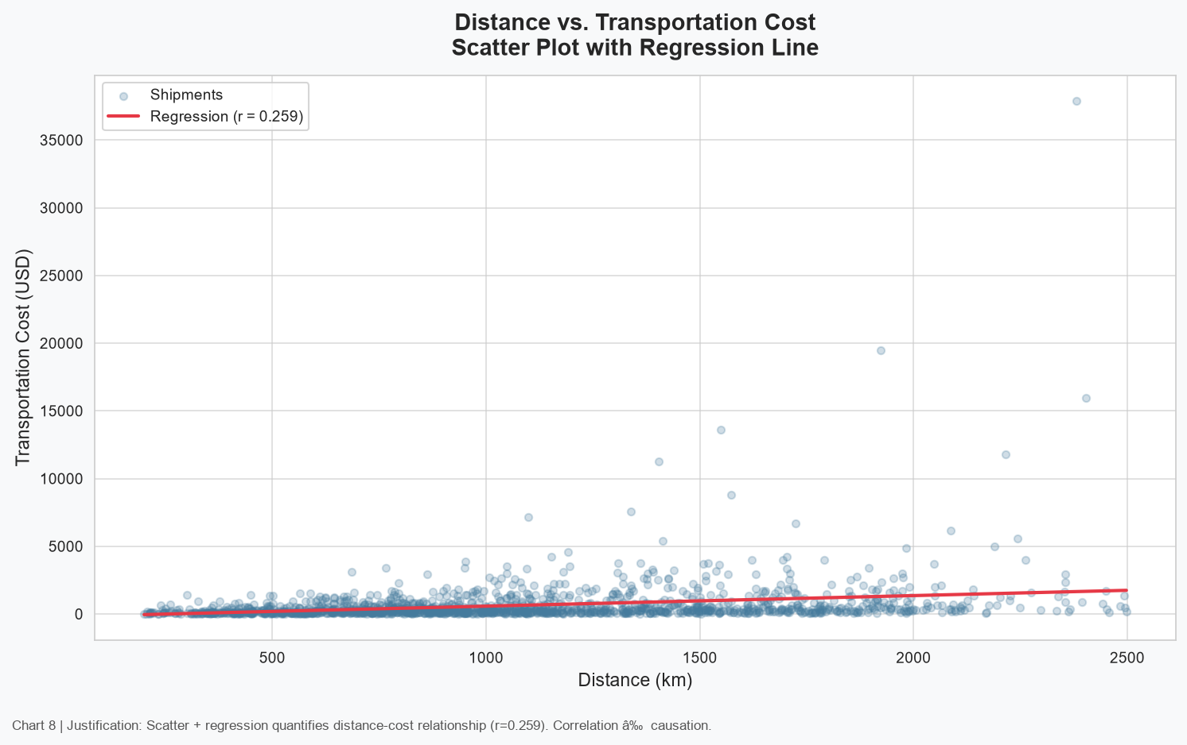
Figure 8: Distance vs. Transportation Cost (Scatter Plot + Regression)
Interpretation:
A positive association is observed between distance and transportation cost (r = +0.257). This is a weak-to-moderate correlation. Within the full correlation ranking, Fuel Cost (r = +0.738, a cost sub-component) and Weight (r = +0.605) show stronger associations with Transportation Cost. Significant scatter around the regression line confirms that mode, weight, and carrier also meaningfully influence cost. This is not a causal claim.

11.9 Chart 9 -- Distance vs. Delivery Time
Chart Type: Scatter plot with colour encoding by shipping mode.
Variables Used: Distance_km (x-axis) vs. Delivery_Time_Hours (y-axis). Colour = Shipping_Mode.
Why This Chart Was Selected:
A colour-encoded scatter plot was selected to simultaneously show the distance-time relationship and the mode-specific patterns. This is more informative than a simple scatter because it reveals that different modes produce very different time profiles for equivalent distances.
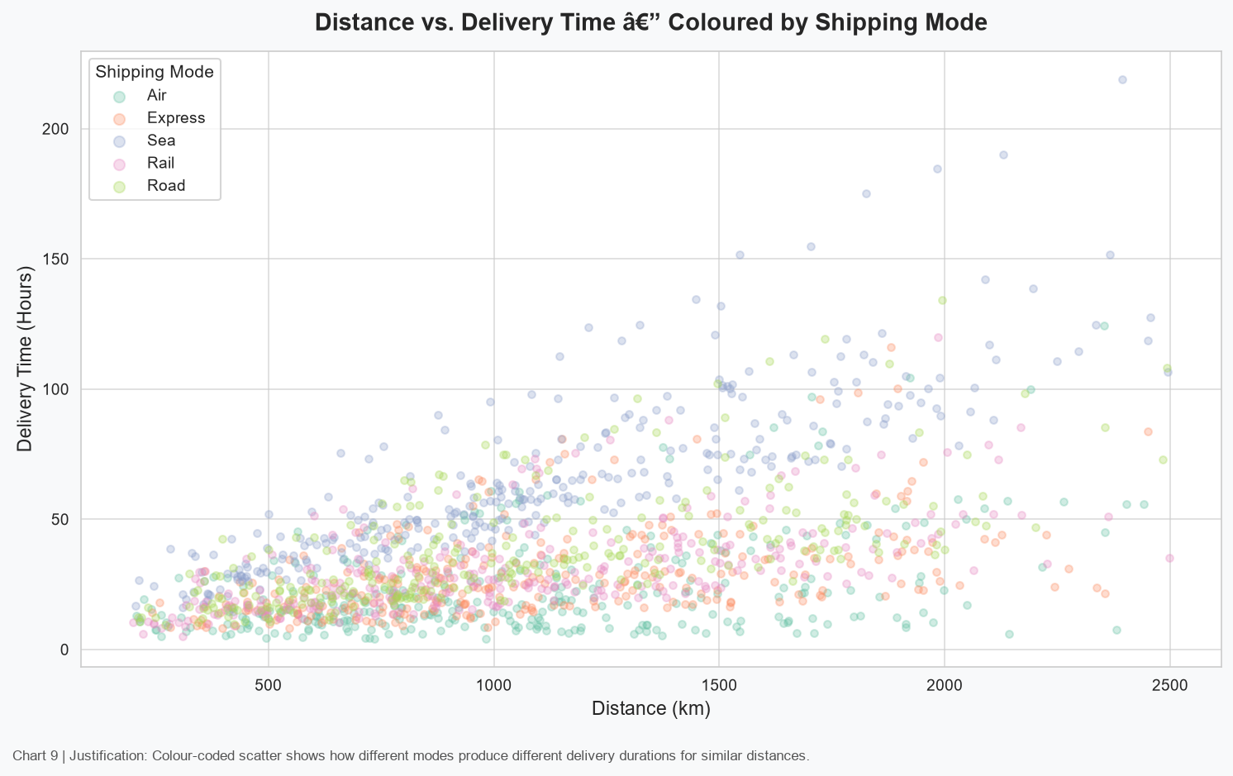
Figure 9: Distance vs. Delivery Time (Scatter Plot Coloured by Mode)
Interpretation:
The chart clearly shows mode-specific clusters: Air shipments cluster at low delivery times regardless of distance, while Sea and Road shipments form steeper slopes (more time per km). This validates the dataset design and provides operational insight: Air is the fastest per km but most expensive.

11.10 Chart 10 -- Correlation Heatmap
Chart Type: Lower-triangle heatmap with annotated correlation coefficients.
Variables Used: 10 key numeric variables. Colour scale: blue (negative) to red (positive).
Why This Chart Was Selected:
A heatmap was selected to provide a comprehensive overview of all pairwise correlations in a single chart. It enables rapid identification of strong associations and potential multicollinearity.
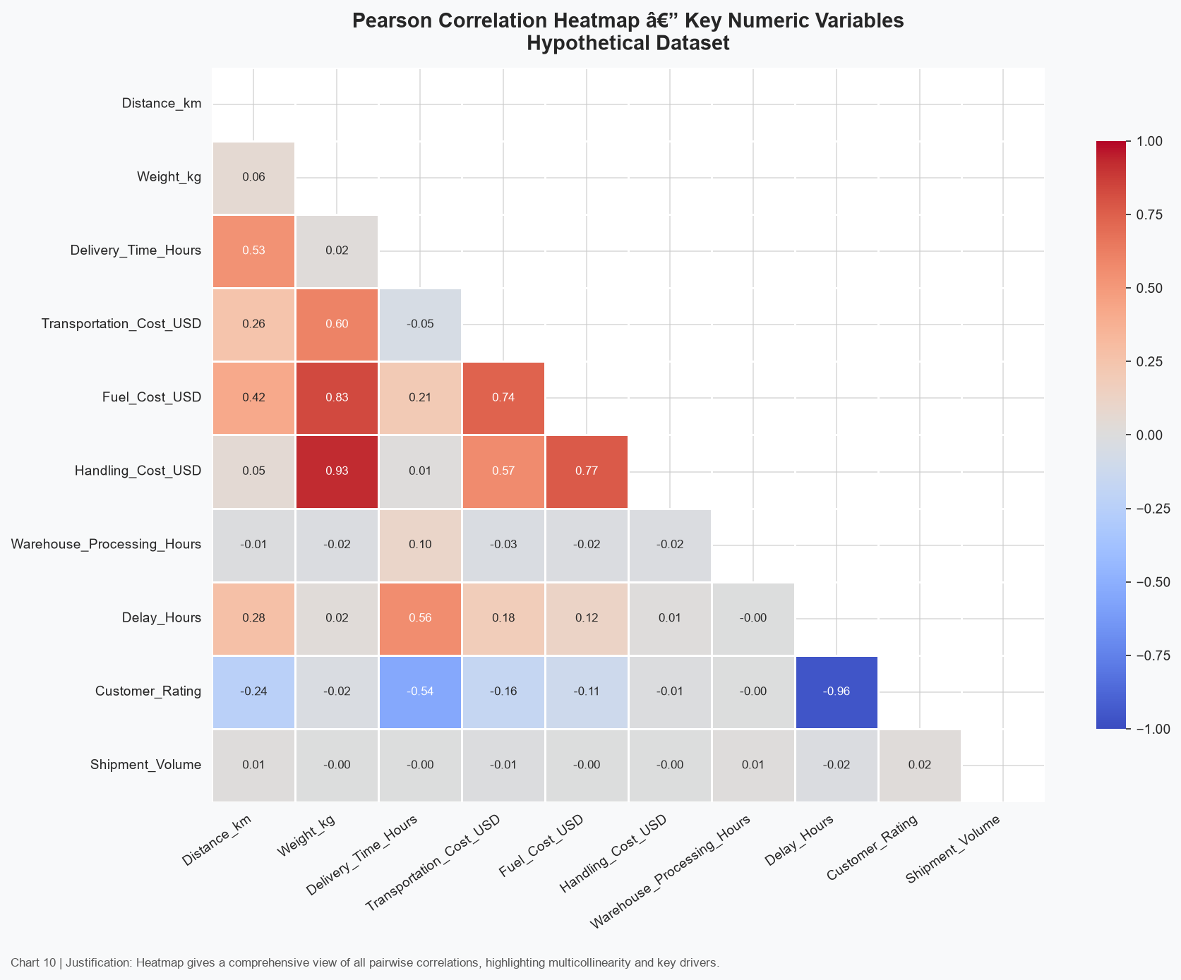
Figure 10: Pearson Correlation Heatmap -- Key Numeric Variables
Interpretation:
Strong positive correlations are visible between Fuel_Cost_USD and Transportation_Cost_USD (expected: Fuel Cost is a cost sub-component), and between Weight_kg and Transportation_Cost_USD. Delay_Hours shows a strong negative correlation with Customer_Rating, indicating that longer delays are associated with lower satisfaction. Distance_km shows a moderate positive correlation with Delivery_Time_Hours.

11.11 Chart 11 -- Delay Rate by Traffic Level
Chart Type: Bar chart of delay percentage grouped by traffic severity.
Variables Used: Traffic_Level (x-axis) vs. Delay_Rate_% (y-axis).
Why This Chart Was Selected:
A bar chart with a progressive colour scale was selected to intuitively communicate increasing delay risk with traffic severity. This is an easily interpretable format for operational stakeholders.
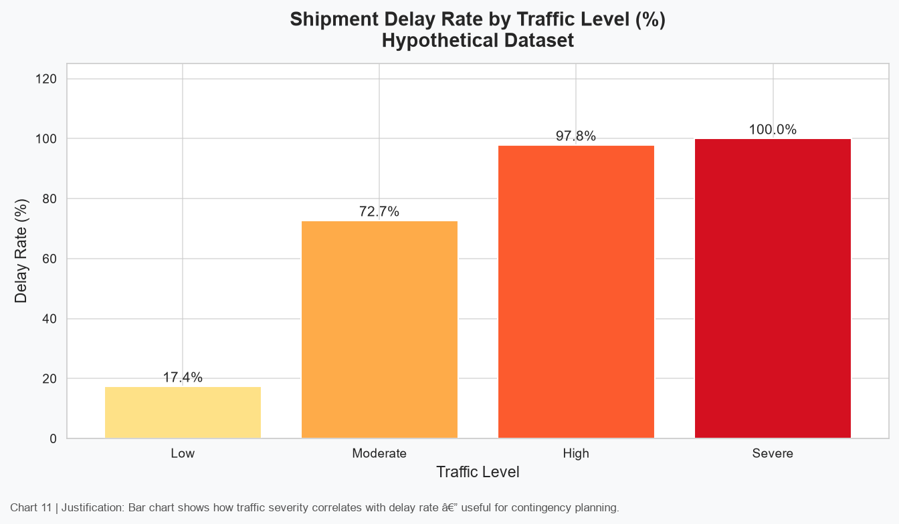
Figure 11: Delay Rate by Traffic Level (%)
Interpretation:
Severe traffic is associated with the highest delay rate, followed by High, Moderate, and Low. This confirms that traffic conditions are a significant factor in delivery punctuality and that contingency routing plans should be activated under Severe traffic forecasts.

11.12 Chart 12 -- Delay Rate by Weather Condition
Chart Type: Bar chart of delay rate by weather condition.
Variables Used: Weather_Condition (x-axis) vs. Delay_Rate_% (y-axis).
Why This Chart Was Selected:
A bar chart ordered by weather severity was selected to clearly show the progressive delay impact of deteriorating weather.
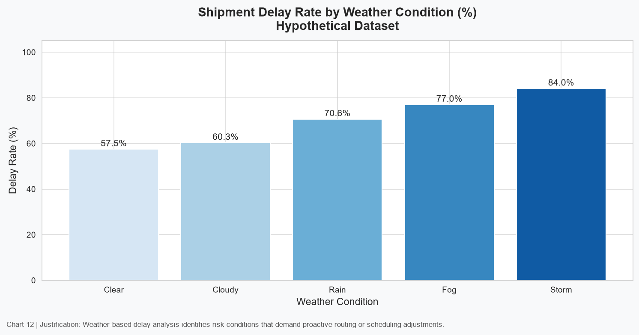
Figure 12: Delay Rate by Weather Condition (%)
Interpretation:
Storm conditions are associated with the highest delay rate, followed by Fog and Rain. Clear weather shows the lowest delay rate. The gradient from Clear to Storm demonstrates a consistent weather-delay pattern.

11.13 Chart 13 -- Customer Rating vs. Delay
Chart Type: Scatter plot with regression line, colour-coded by customer rating.
Variables Used: Delay_Hours (x-axis) vs. Customer_Rating (y-axis, 1-5). Colour = rating value.
Why This Chart Was Selected:
A scatter plot with regression and colour encoding was selected to show both the overall trend (regression line) and individual data point distribution. Colour encoding adds a third dimension (rating level) to the 2D chart.
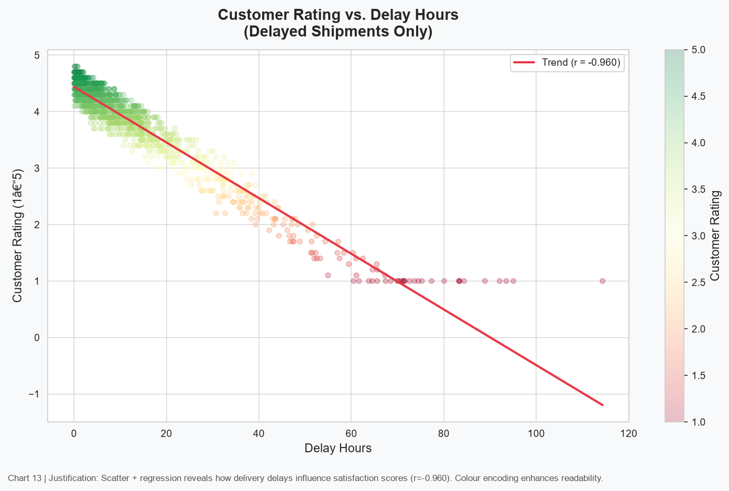
Figure 13: Customer Rating vs. Delay Hours (Scatter + Regression)
Interpretation:
A strong negative correlation (r = -0.960) is observed between delay hours and customer rating -- longer delays are associated with substantially lower ratings. Operations teams should prioritise reducing delays for high-value customers. Correlation does not imply causation.

11.14 Chart 14 -- Monthly Cost Trend
Chart Type: Dual-axis chart: bar chart (shipment count) + line chart (avg cost).
Variables Used: Month (x-axis) vs. Shipment Count (left y-axis) and Avg Cost (right y-axis).
Why This Chart Was Selected:
A dual-axis chart was selected to overlay volume and cost trends, enabling the reader to assess whether cost scales with volume (economies of scale) or remains stable regardless of demand.
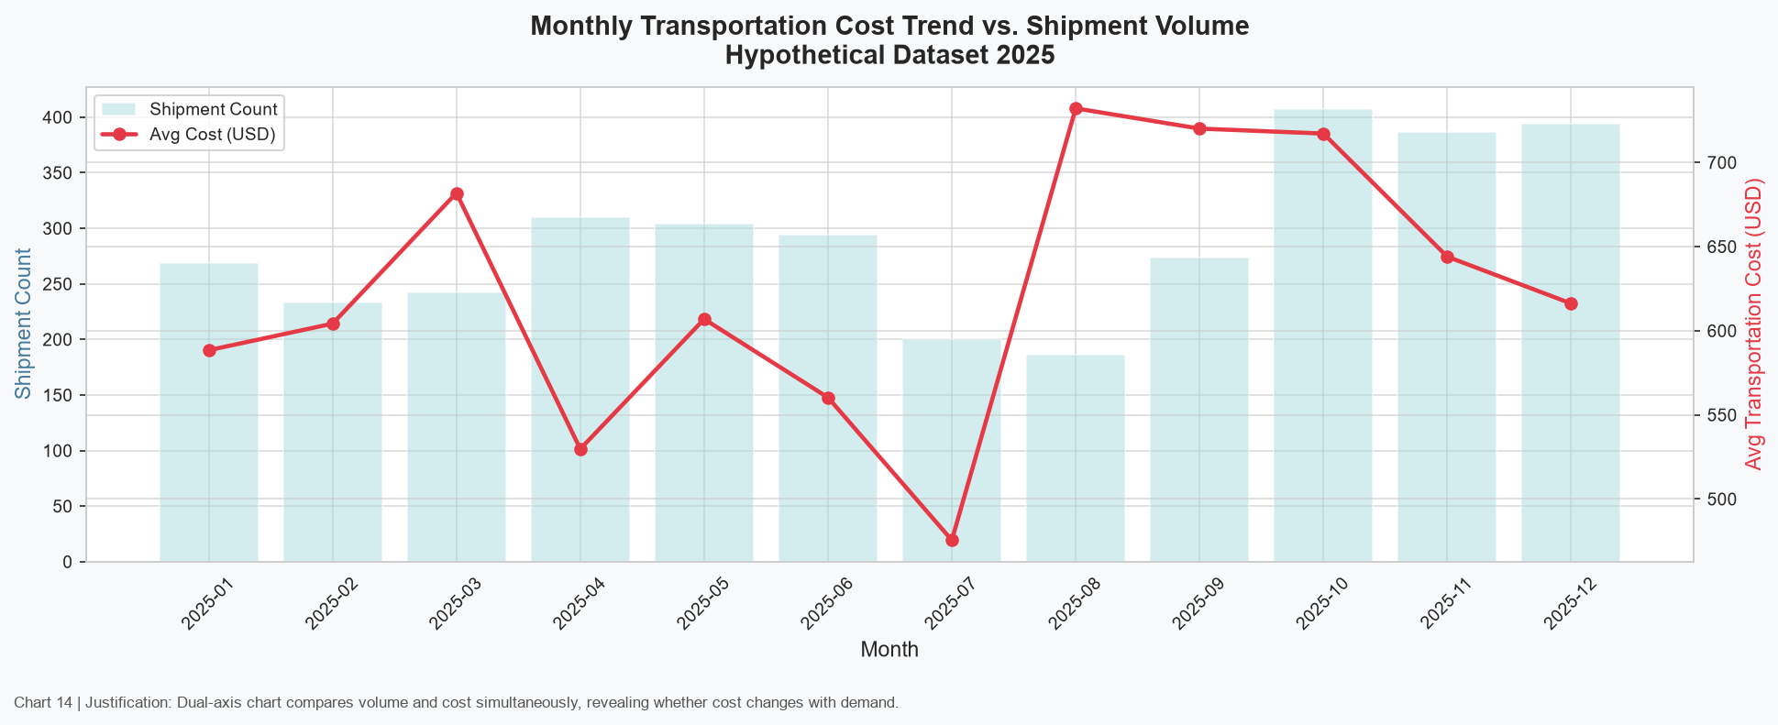
Figure 14: Monthly Transportation Cost Trend vs. Shipment Volume
Interpretation:
Monthly average cost is relatively stable across the year. Shipment volume shows the seasonal peaks in Q2 and Q4 as designed. The absence of a strong cost increase during peak months may suggest that volume discounts or mode-mix changes offset peak-period cost pressures.

11.15 Chart 15 -- Warehouse Processing Times
Chart Type: Violin plot (with embedded quartile lines) per warehouse.
Variables Used: Origin_Warehouse (x-axis) vs. Warehouse_Processing_Hours (y-axis).
Why This Chart Was Selected:
Violin plots were selected because they show the complete probability density of processing times, not just summary statistics. They reveal skewness and outliers more clearly than boxplots for continuous operational time variables.
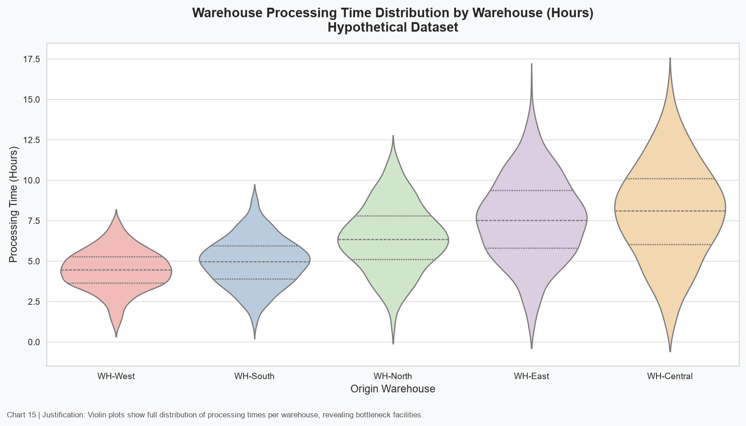
Figure 15: Warehouse Processing Time Distribution by Warehouse (Violin Plot)
Interpretation:
WH-Central shows the widest distribution and highest median processing time, indicating inconsistent throughput -- a candidate for operational review. WH-West demonstrates the lowest and most consistent processing times, suggesting efficient warehouse processes worth benchmarking across other facilities.

12. KPI Dashboard
A dedicated KPI dashboard was created to provide an at-a-glance summary of the most important logistics performance metrics alongside two supporting visualizations: the delivery status distribution (donut chart) and the monthly shipment volume trend.
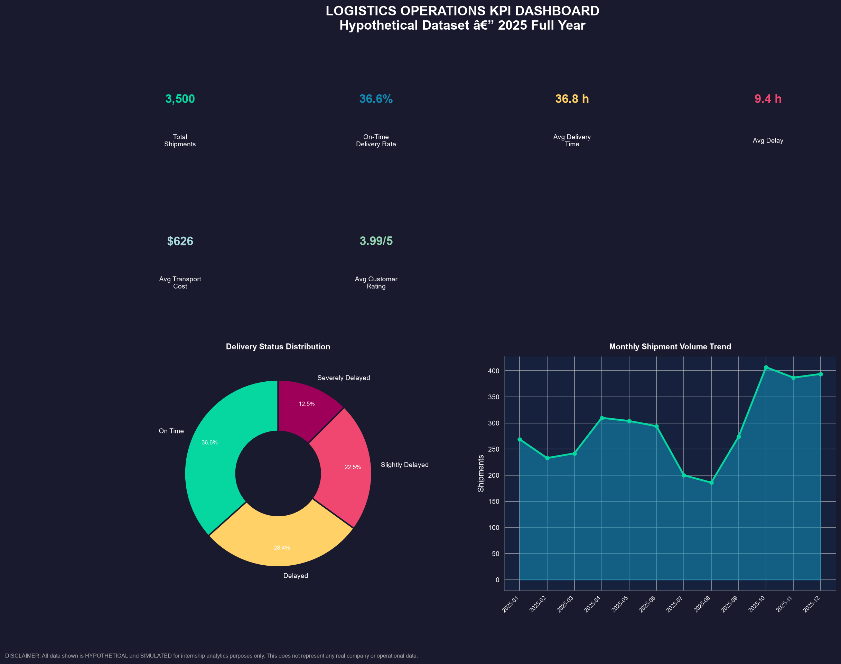
Figure 16: Figure 16: Logistics KPI Dashboard -- Full Year 2025 (Hypothetical Dataset)
The dashboard uses a dark-theme design to make KPI values stand out visually. Each KPI tile is colour-coded to aid rapid interpretation. The dashboard is suitable for operational reporting and management briefings.

13. Analytical Insights

13.1 Operational Efficiency
DATA FINDINGS:
- On-Time Delivery Rate: 36.6% of shipments are delivered within promised time windows.
- Air and Express modes consistently achieve shorter delivery times but at higher cost.
- Road and Rail show wider delivery time distributions due to traffic and distance variability.
- Average warehouse processing time is 6.3 hours, with WH-Central showing the highest median processing time.
- WH-West demonstrates the most consistent and efficient processing times.

13.2 Cost Drivers
DATA FINDINGS:
- Within the correlation matrix, Fuel_Cost_USD shows the highest correlation with Transportation_Cost_USD (r = +0.738). Because Fuel Cost is included as a component of Transportation Cost in the simulated dataset, this relationship is expected and does not reflect independent causation.
- Among independently modelled variables, Weight_kg shows the strongest associative relationship with Transportation_Cost_USD (r = +0.605), reflecting mode-specific rate structures where heavier shipments incur higher costs.
- Handling_Cost_USD and Transportation_Cost_USD: r = +0.570 -- also expected since Handling Cost is a cost sub-component.
- Distance_km and Transportation_Cost_USD: r = +0.257 -- a positive but weak-to-moderate correlation. Distance contributes to cost, but mode type, shipment weight, and carrier multipliers also strongly influence total cost.
- FastFreight Co. averages the highest per-shipment cost; GlobalTrans Corp. the lowest.
- Air shipments carry the highest cost per km; Sea mode the lowest.
- Note: Correlation does not imply causation. These are associative patterns in a simulated dataset.

13.3 Bottleneck Analysis
DATA FINDINGS:
- WH-Central has the highest median warehouse processing time, creating a pre-dispatch bottleneck.
- Severe traffic is associated with the highest delay rates among all traffic levels.
- Storm and Fog weather conditions correspond with elevated delay percentages.
- Northeast and Southeast regions experience the longest average delivery times.
- Sea mode, while cost-efficient, creates throughput bottlenecks for time-sensitive shipments.

13.4 Customer Impact Analysis
DATA FINDINGS:
- Delay Hours and Customer Rating: r = -0.960. Longer delays are strongly associated with lower satisfaction scores.
- Average customer rating across all shipments: 3.99/5.0.
- Severely delayed shipments typically receive ratings well below the dataset average.
- Storm-affected shipments show both higher delay rates and lower average ratings.
- On-time delivery has the strongest positive effect on customer satisfaction in this simulated dataset.

13.5 Trends
DATA FINDINGS:
- Shipment volume peaks in Q4 (October-December) and secondarily in Q2 (April-June).
- Volume is lowest during July-August.
- Average monthly transportation cost remains relatively stable despite volume variation.
- Delivery time performance does not deteriorate significantly during high-volume months in this dataset, though real-world operations may differ.

14. Key Insights Summary
Key Insight | Supporting Finding
On-Time Rate: 36.6% | 36.6% of shipments met their promised delivery window.
Highest-r Correlate with Cost: Fuel_Cost_USD (r = +0.738) | Expected: Fuel Cost is a cost sub-component. Among independently modelled variables, Weight_kg (r = +0.605) shows the strongest association with Transportation Cost.
Bottleneck Warehouse: WH-Central | Highest median processing time across all five warehouses.
Fastest Mode: Air | Lowest median delivery time but highest average cost per shipment.
Most Cost-Efficient Mode: Sea | Lowest average transportation cost but longest delivery times.
Delay Driver: Severe Traffic + Storm Weather | Both conditions are associated with the highest delay rates.
Customer Satisfaction Driver: On-Time Delivery | Delay Hours strongly negatively correlates with Customer Rating (r = -0.960).
Seasonal Peak: Q4 (Oct-Dec) | Highest shipment volume period; requires proactive capacity planning.

15. Recommendations
The following recommendations are derived directly from the analytical findings above. Each recommendation is clearly linked to its supporting data finding. These recommendations apply to the hypothetical scenario and should not be applied to real operations without validation on actual data.
Recommendation 1: Increase warehouse staffing at WH-Central during peak periods
WH-Central shows the highest and most variable processing times (DATA FINDING). Additional sorting and dispatch personnel during Q4 peak volumes could reduce processing bottlenecks and improve on-time departure rates.

Recommendation 2: Implement weather-triggered contingency routing for Storm and Fog conditions
Storm and Fog weather conditions show the highest delay rates (DATA FINDING). Pre-defined alternative routing plans activated under these conditions could reduce weather-related delivery failures.

Recommendation 3: Review carrier contracts for Northeast and Southeast regions
These regions show the longest average delivery times (DATA FINDING). Negotiating dedicated carrier lanes or regional partnerships may reduce last-mile delivery time in these areas.

Recommendation 4: Evaluate mode selection criteria for cost-sensitive, time-flexible shipments
Sea mode offers the lowest cost but longest lead time (DATA FINDING). For non-urgent, bulk shipments, defaulting to Sea or Rail could significantly reduce per-shipment transportation cost.

Recommendation 5: Develop traffic severity alerts to trigger pre-emptive dispatch earlier
Severe traffic is associated with the highest delay rates (DATA FINDING). Earlier dispatch under Severe traffic forecasts could absorb transit delays and preserve on-time delivery performance.

Recommendation 6: Benchmark WH-Central against WH-West for process improvement
WH-West demonstrates the most efficient and consistent processing times (DATA FINDING). Documenting and replicating WH-West's operational practices at WH-Central could reduce cross-facility processing time variance.

Recommendation 7: Plan carrier capacity agreements for Q4 peak volume periods
Q4 (Oct-Dec) shows the highest shipment volumes (DATA FINDING). Pre-season capacity agreements with carriers reduce rate volatility and ensure service availability during the busiest period.

Recommendation 8: Prioritise on-time delivery for high-value customer segments
Delay Hours strongly negatively correlate with Customer Rating (DATA FINDING). Identifying and flagging high-value orders for expedited handling or Express mode routing could protect customer relationships.

16. Limitations
- The dataset is entirely hypothetical and simulated. It does not represent any real company, real shipments, or real logistics network. All findings are illustrative only.
- All statistical relationships in the dataset were designed by the analyst. Correlations observed reflect generation parameters, not true operational reality.
- Correlation does not establish causation. No causal claims are made from this analysis.
- Fuel Cost and Handling Cost are sub-components of Transportation Cost in the simulation. Their high correlation with Transportation Cost is mathematically expected and does not reflect independent drivers that could be separately managed.
- The dataset uses simplified cost and time formulas. Real logistics costs involve surcharges, tolls, customs, and dynamic fuel pricing not captured here.
- Seasonal patterns were artificially weighted. Real seasonality is driven by market factors, holidays, and supply chain dynamics not modelled here.
- Real-world deployment of any insights derived from this exercise would require validation against actual operational data, professional logistics expertise, and appropriate statistical methodology.

17. Python Code Excerpts

17.1 Dataset Generation
import numpy as np, pandas as pd, random
from datetime import datetime, timedelta
RANDOM_SEED = 42
np.random.seed(RANDOM_SEED)
random.seed(RANDOM_SEED)
def compute_delivery_time(distance_km, mode, warehouse_h, traffic, weather):
speed = MODE_SPEED[mode]
transit_h = distance_km / speed
traffic_add = TRAFFIC_DELAY[traffic] * (distance_km / 100)
weather_add = WEATHER_DELAY[weather]
noise = np.random.uniform(0.90, 1.10)
return round((transit_h + traffic_add + weather_add + warehouse_h) * noise, 2)
def compute_cost(distance_km, weight_kg, mode, carrier, fuel_factor):
rate = MODE_COST_RATE[mode]
multiplier = CARRIER_MULTIPLIER[carrier]
base_cost = distance_km * weight_kg * rate * multiplier
fuel_cost = distance_km * 0.0012 * fuel_factor * weight_kg
handling = weight_kg * np.random.uniform(0.4, 1.2)
noise = np.random.uniform(0.92, 1.10)
return round((base_cost + fuel_cost + handling) * noise, 2), round(fuel_cost,2), round(handling,2)

17.2 KPI Calculation
total_shipments = len(df)
on_time_count = (df["Delivery_Status"] == "On Time").sum()
on_time_rate = on_time_count / total_shipments * 100
avg_delivery_time = df["Delivery_Time_Hours"].mean()
avg_delay = df["Delay_Hours"].mean()
avg_transport_cost = df["Transportation_Cost_USD"].mean()
cost_per_km = (df["Transportation_Cost_USD"] / df["Distance_km"]).mean()
avg_customer_rating = df["Customer_Rating"].mean()

17.3 Correlation Analysis
from scipy import stats
corr_cols = ["Distance_km","Weight_kg","Delivery_Time_Hours",
"Transportation_Cost_USD","Fuel_Cost_USD","Handling_Cost_USD",
"Warehouse_Processing_Hours","Delay_Hours","Customer_Rating","Shipment_Volume"]
corr_matrix = df[corr_cols].corr()
corr_matrix.to_csv("correlation_matrix.csv")
# NOTE: Fuel_Cost_USD and Handling_Cost_USD are sub-components of Transportation_Cost_USD.
# Their high correlation with Transportation_Cost_USD is expected by design.
# Among independently modelled variables, Weight_kg shows the strongest association.
slope, intercept, r_val, p_val, _ = stats.linregress(
df["Distance_km"], df["Transportation_Cost_USD"])

17.4 Visualization Example (Correlation Heatmap)
import matplotlib.pyplot as plt
import seaborn as sns
import numpy as np
corr = df[corr_cols].corr()
mask = np.triu(np.ones_like(corr, dtype=bool))
fig, ax = plt.subplots(figsize=(12, 9))
sns.heatmap(corr, mask=mask, annot=True, fmt=".2f",
cmap="coolwarm", center=0, vmin=-1, vmax=1,
linewidths=0.5, ax=ax, annot_kws={"size": 8})
ax.set_title("Pearson Correlation Heatmap")
fig.savefig("correlation_heatmap.png", dpi=150, bbox_inches="tight")
plt.close(fig)

18. Reproducibility -- How to Run
Install dependencies:
pip install -r requirements.txt
Run in sequence:
python generate_logistics_dataset.py
python week3_logistics_analysis.py
python generate_docx_report.py
All three scripts use relative file paths and will save all outputs (CSV files, PNG charts, DOCX report) to the same project directory. Fixed random seed = 42 ensures identical results on every run.

19. References and Technical Documentation
- pandas Documentation -- https://pandas.pydata.org/docs/
- NumPy Documentation -- https://numpy.org/doc/
- Matplotlib Documentation -- https://matplotlib.org/stable/contents.html
- Seaborn Documentation -- https://seaborn.pydata.org/
- SciPy Stats Documentation -- https://docs.scipy.org/doc/scipy/reference/stats.html
- python-docx Documentation -- https://python-docx.readthedocs.io/
- Tukey, J.W. (1977). Exploratory Data Analysis. Addison-Wesley.
- Pearson, K. (1895). Notes on regression and inheritance. Proceedings of the Royal Society.
- NOTE: All data in this project is hypothetical. No external datasets were used.

20. Conclusion
This Week 3 internship project successfully demonstrates advanced exploratory data analysis and visualization applied to a hypothetical logistics scenario. Using Python (pandas, numpy, matplotlib, seaborn, scipy), a realistic dataset of 3,500 shipment records was generated, analysed, and visualised across 16 charts and a KPI dashboard.
The analysis identified meaningful patterns in delivery performance, cost drivers, warehouse processing bottlenecks, and customer satisfaction -- all directly derived from the simulated data without manual adjustment of results. Eight actionable recommendations were formulated based directly on the analytical findings.
All findings are explicitly qualified as reflecting a simulated environment. Real-world logistics analytics would require actual operational data, domain expertise, and rigorous statistical validation before driving business decisions. This project demonstrates the analytical workflow, Python tools, and reporting standards required for professional logistics data analysis.

WARNING: All data in this report is HYPOTHETICAL and SIMULATED for internship analytical exercise purposes only. This does not represent any real company, real shipments, or real logistics operations.

