CEA (CUSTOMER EMERGENCY ANALYSIS)

BITS ZG628T: Dissertation

by

Ashish Ranjan Sharma

ID No. 2014HT12782

Dissertation work carried out at

ERICSSON INDIA GLOBAL SERVICES PVT LTD (BANGALORE)



BIRLA INSTITUTE OF TECHNOLOGY & SCIENCE
PILANI (RAJASTHAN)

April, 2016

CEA (CUSTOMER EMERGENCY ANALYSIS)

BITS ZG628T: Dissertation

by

Ashish Ranjan Sharma

ID No. 2014HT12782

Dissertation work carried out at

ERICSSON INDIA GLOBAL SERVICES PVT LTD (BANGALORE)

Submitted in partial fulfillment of
M.Tech. Software Systems degree programme

Under the Supervision of
SUNITA BHAGWAT, SENIOR TECH LEAD
ERICSSON INDIA GLOBAL SERVICES PVT LTD (BANGALORE)

BIRLA INSTITUTE OF TECHNOLOGY & SCIENCE
PILANI (RAJASTHAN)

April, 2016

Birla Institute of Technology & Science, Pilani

Work-Integrated Learning Programmes Division

Second Semester 2015-2016

BITS ZG628T: Dissertation

ABSTRACT

BITS ID No. : 2014HT12782

NAME OF THE STUDENT : Ashish Ranjan Sharma

EMAIL ADDRESS : ashish.r.sharma@gmail.com

STUDENT’S EMPLOYING : ERICSSON INDIA GLOBAL SERVICES PVT
ORGANIZATION & LOCATION LTD (BANGALORE)

SUPERVISOR’S NAME : SUNITA BHAGWAT

SUPERVISOR’S EMPLOYING : ERICSSON INDIA GLOBAL SERVICES PVT
ORGANIZATION & LOCATION LTD (BANGALORE)

SUPERVISOR’S EMAIL ADDRESS: sunita.s.bhagwat@ericsson.com

DISSERTATION TITLE: CEA (CUSTOMER EMERGENCY ANALYSIS)

Contents
Chapter 1- Business Problem 2
Chapter 2- Approach 3
Chapter 3- Solution Proposed 4
Chapter 4- Key Benefits 4
Chapter 5- Technology Stack 5
Chapter 6- Product Functionality 6
Chapter 7- Data Requirements 6
Chapter 8- Functional Requirements 7
Chapter 9- Plan 10
Chapter 10- Design 11
Chapter 12- Coding 20
Chapter 13- Testing 23
Chapter 14- Deployment 24
Chapter 15- Conclusion/Summary 24
Bibliography 25
Abbreviations 25
Tables 27
Figures 27

Chapter 1- Business Problem

Worldwide ISPs and Customer providing internet and fixed wireline services use SmartEdge Router and Smart Service Routers. While these deployments are usually stable sometimes there can be outages and emergency situations which can affect some subscribers or thousands of subscribers, entire cities, states or even countries. These emergency situations have to be resolved within very strict timeframes based on the Service Level Agreements. Sometimes penalties can be added in the clause.

These emergencies are documented very minutely for the sake of reference and method to track the activities being performed on the affected node during troubleshooting and recovery and sometime to rollback. These have summary of the situations at regular interval, and what all remedial actions were the proposed activities and by whom, has minute by minute detailed communication between different members involved in resolving the outage.

Network support engineers during such customer emergencies are not able to utilize effectively existing data/information accumulated over several years. The past emergency related information is stored in the form of Emails with granular details about the symptoms, remedial actions taken and whether that was successful or not. Simple search in the Emails does not give useful information most of the times. In this project by using the Natural Language Processing we are trying to break down the Emergency Emails so that they can be utilized much better by the support engineers.

By using the information which has been collected and processing it using the NLTK and Artificial Intelligence algorithms we can cut the time in resolving the new emergencies by utilizing the existing information which resulted in resolving past emergencies successfully.

As of now it’s only being made available for processing data collected for resolving emergencies for two of several of the devices/products that the company offers to its customers. Once it is successfully tested and found to be effective the work to cover emergencies on additional devices might be taken up.

Domain: To enable the support engineer to analyze and utilize past emergency data.
Challenge: The data is stored in the form of Emails and is not very easy to use and search without additional processing and cleanup.
Success Factor: To be able to provide the tool that can aid the support engineer in handling emergencies and cutting down time to resolve the situation.
Stakeholders: Support Engineer, On-call Engineers, senior managers, Customer Unit and Customer.

Chapter 2- Approach
- Get the understanding of format of the data represented in emergency emails and to implement algorithms to retrieve the useful information programmatically using NLTK and artificial intelligence.
- Get the required NLTK algorithms and tools to break the linguistic data in the emails into
  - symptoms,
  - actions and their outcomes, successful or otherwise.
- Populate the database with this data in corresponding tables.
- Provide the UI to search the symptoms or actions about the problem.
- Get the symptoms to search in the database to match the past emergencies.
- Get the relevant actions steps taken in past to resolve the emergency.
- Analyze the symptoms and actions to find patterns so that
  - A ranking of the symptoms and actions can be maintained.
  - Create a better product by working on quality of the main areas where frequent problems are seen.

- In Phase 1 plan is to deploy the demo version on two of the Ericsson Devices (SmartEdge and Smart Service Routers) that it will be used by emergency handling team.
- Based on Phase 1 feedback, in phase 2 plan is to deploy it on more Ericsson devices.

Chapter 3- Solution Proposed

Proposal is to:
- Analyze the Customer Emergency data using Natural Language Processing by Artificial Intelligence.
- Analyze data to come up with the symptoms and steps taken which resulted in resolving the situation.
- Develop Analytical algorithms to arrive at patterns in the emergency data to see which kind of issues being more prevalent and how they can be avoided.
- Observe which remedial step combinations work and which don’t, so that the critical time can be saved during emergency.
- Report Generation of the Analysis of Customer Emergencies of past years.

Chapter 4- Key Benefits
- To provide a tool in the hands of the Network support engineers and First line Engineers who handle emergencies that helps them identify similar cases seen in past based on the symptoms.
- To properly utilize the information about Customer emergency handling collected over past several years.
- To be able to cut down the time of emergency handling by using the steps taken in past for similar emergencies.
- To identify the steps which were not useful and avoid them in future any emergencies arising in future.
- To find any patterns in emergencies and improve quality of the product in that area.
- To find more often used procedures that can further be refined and be used to educate the Support Engineers to bring up their competence in handling Emergencies.

Chapter 5- Technology Stack
- Python: NLTK is available in Python so Python was chosen as the project language.
- NLTK- Natural Language Toolkit [2a] is a leading platform for building Python programs to work with human language data. It provides easy-to-use interfaces to over 50 corpora and lexical resources such as WordNet, along with a suite of text processing libraries for classification, tokenization, stemming, tagging, parsing, and semantic reasoning, wrappers for industrial-strength NLP libraries.
- Django- Django is a high-level Python Web framework that encourages rapid development and clean, pragmatic design. Built by experienced developers, it takes care of much of the hassle of Web development, so you can focus on writing your app. It’s free and open source.
- Haystack - Haystack lets one write one’s search code once and choose the search engine one want it to run on. With a familiar API that should make any Djangonaut feel right at home and an architecture that allows one to swap things in and out as one need to.
- Elasticsearch- Elasticsearch builds distributed capabilities on top of Apache Lucene to provide the most powerful full- text search capabilities available. Powerful, developer-friendly query API supports multilingual search, geolocation, contextual did-you-mean suggestions, autocomplete, and result snippets.
- SqlLite3 – SQLite is a software library that implements a self-contained, serverless, zero-configuration, transactional SQL database engine. SQLite is the most widely deployed database engine in the world.
- GIT- Git is a distributed revision control and source code management system with an emphasis on speed. Git was initially designed and developed by Linus Torvalds for Linux kernel development.

Chapter 6- Product Functionality
- The Emergency emails collected over period of time will be pre-processed to remove any non-required data.
- This Sanitized data will be stored in Text files to be used as NLTK Corpora.
- Using Corpora the Symptoms and Actions with their results will be extracted.
- These broken down data is tokenized and stored in the database.
- Frontend UI is created using Django framework.
- Haystack is used to write the search code and choose Search Engine we want to use.
- ElasticSearch search engine is used to search.

Chapter 7- Data Requirements
- Emergency Emails for the past emergencies accumulated over several emergencies.
- Emergency Mail contains
  - certain fields to uniquely identify the customer emergency case
  - attributes
  - timelines
  - Symptoms
  - Actions and results
  - Minute by minute update about the situation during the emergency and minutest details are captures in the email.
- The Database will have the tables
  - Identify the Emergency case(timeline and unique id, country and customer)
  - Symptoms and Actions taken during the emergency and the outcome of the actions taken
  - Technical Update at regular interval in the form of Revisions.
- The search Engine will keep on updating the ranking of the Symptoms and Actions based on the search results as times goes by.

Chapter 8- Functional Requirements
- Since the information contains some confidential information so the data will be available to registered and authenticated users only.
  - Login Page
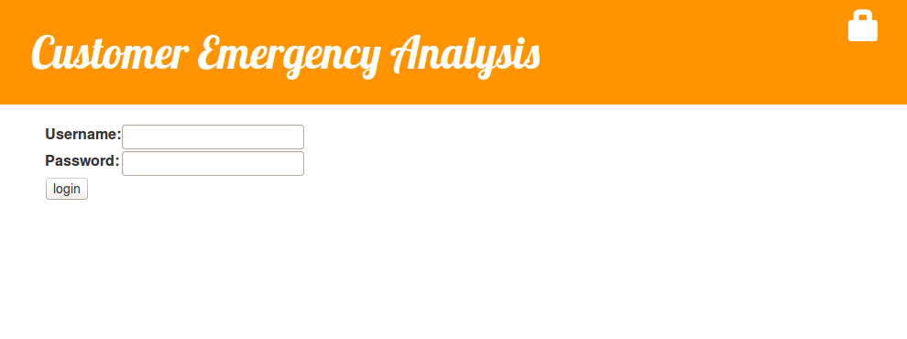
Figure 1 – Login Screen
  - Home Page (will contain the recently seen emergencies.)
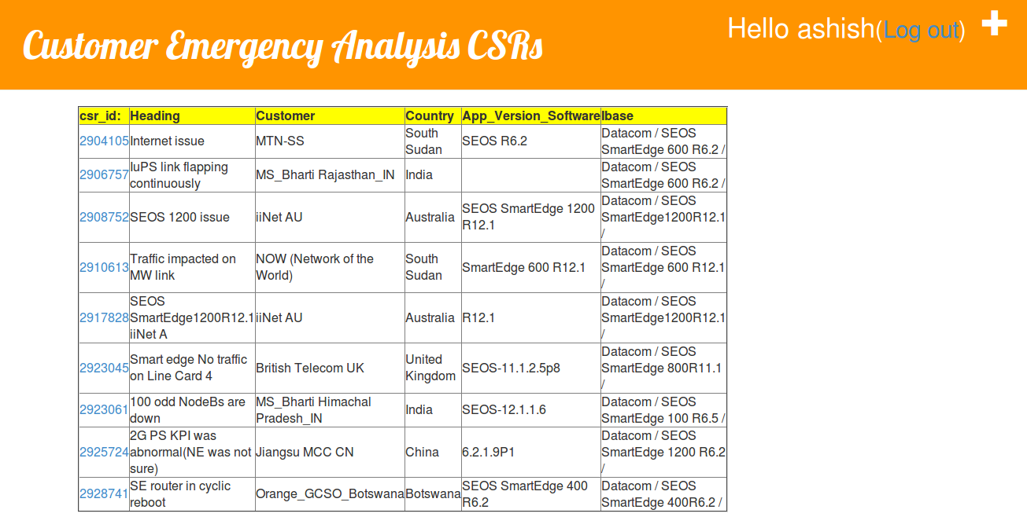
Figure 2 – Home Page

  - Search Page
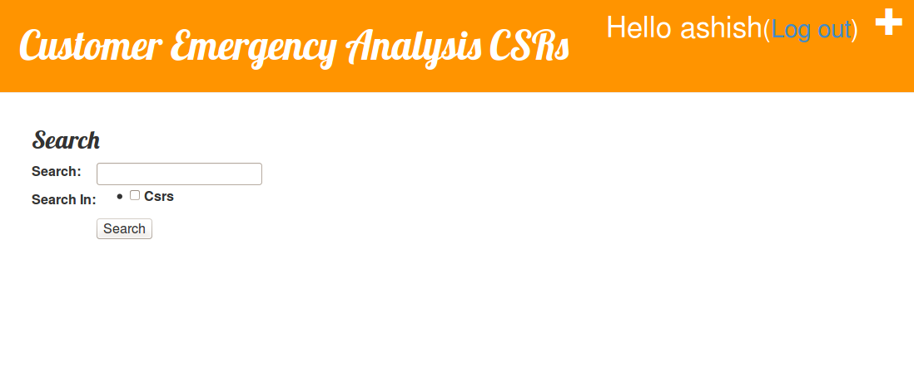
Figure 3 – Search Page
- Result Page
Figure 4 – Result Page

- CSR Detail Page
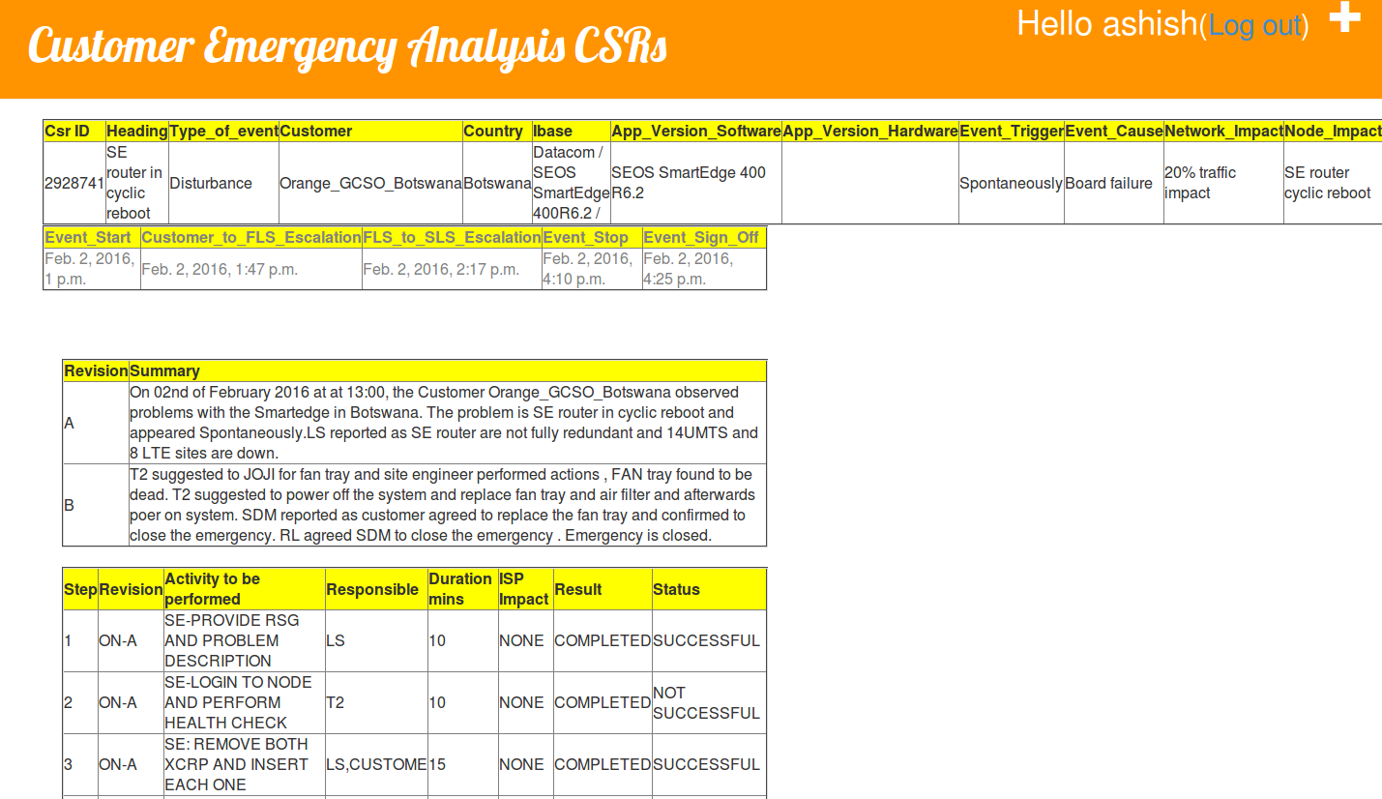
Figure 5 – CSR Details

Chapter 9- Plan

Design |  | No Of Days | Start Date | End Date
 | Brainstorming on requirements | 5 | 14-Jan | 19-Jan
 | Technical stack selection | 2 | 19-Jan | 21-Jan
 | High Level design | 5 | 21-Jan | 26-Jan
 | Process set up | 5 | 26-Jan | 31-Jan
 | Low Level design | 10 | 31-Jan | 10-Feb
 | Design review rework | 5 | 10-Feb | 15-Feb
 | Test case preparation | 10 | 15-Feb | 25-Feb
Coding
 | NTLK Algorithm to be chosen | 3 | 25-Feb | 28-Feb
 | UI Layers | 7 | 28-Feb | 07-Mar
 | CLI Architecture | 5 | 07-Mar | 12-Mar
 | Server Layer | 5 | 12-Mar | 17-Mar
 | Review and rework | 5 | 17-Mar | 22-Mar
ST and Fix
 | Testing | 5 | 22-Mar | 27-Mar
 | Fixes and rework | 3 | 27-Mar | 30-Mar
 | Testing Sign off | 2 | 30-Mar | 01-Apr
Deployment
 | Deployment Strategy | 1 | 01-Apr | 02-Apr
 | Documentation | 2 | 02-Apr | 04-Apr
Table 1- Development Plan

Chapter 10- Design

Brainstorming on requirements
Since the subject requires technical expertise in NLTK and Python, Django, Databases and Search Engines it was challenging to get in house help hence approached experts through online forums and did research on my own.
In the presence of supervisor, couple of brainstorming sessions were done to baseline the requirements and break the project in to different manageable stages.

Technical stack selection:
- Natural Language Processing was required to breakdown the emails into useful information. NLTK was readily available in Python.

- Python based technical stack was finalized as it is platform independent and lot of NLTK and AI related open source api are available in Python.

- Development would be faster with PyCharm tool and it’s integration with many tools like virtual environment, Python Console and debugging applications etc.

- SQLLite data base is used for storing the data.

- Django MVC based framework is used for UI development.

- Haystack was used to integrate the Search Engine with Django based upon below comparison.

- Elasticsearch engine was selected because of its advanced features. Engine considered were Solr Lucene, Ealsticsearch and Watson.

Search Engine Selection:
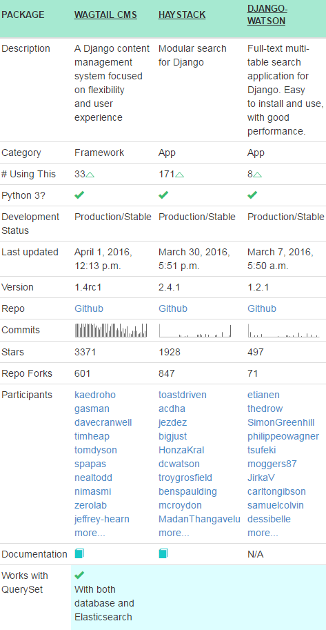
Table 2- Search Engine Comparison
Project steps:
- Creation of the Virtual Environment:
virtualenv is a tool to create isolated Python environments. virtualenv creates a folder which contains all the necessary executables to use the packages that a Python project would need.

Install virtualenv via pip:

$ pip install virtualenv

Create a virtual environment for a project:
$ cd <BITS>
$ virtualenv BITSvenv
virtualenv venv will create a folder in the current directory which will contain the Python executable files, and a copy of the pip library which you can use to install other packages. The name of the virtual environment (in this case, it was venv) can be anything; omitting the name will place the files in the current directory instead.

To begin using the virtual environment, it needs to be activated:
$ source BITSvenv/bin/activate

The name of the current virtual environment will now appear on the left of the prompt (e.g. (venv)Your-Computer:your_project UserName$) to let you know that it’s active. From now on, any package that you install using pip will be placed in the venv folder, isolated from the global Python installation.

Install packages as usual, for example:
$ pip install requests

(If you are done working in the virtual environment for the moment, you can deactivate it:
$ deactivate)

- Setting up the required packages.
Contents of the pip frozen requirements (pip freeze > requirements.txt)
certifi==2016.2.28
Django==1.9.3
django-haystack==2.4.1
elasticsearch==1.9.0
elasticutils==0.10.3
pyelasticsearch==1.4
pysolr==3.4.0
requests==2.9.1
simplejson==3.8.2
six==1.10.0
urllib3==1.14

Install the above Python packages by executing the below:
pip install -r requirements.txt

- Creation of the Django project:
Before we actually start the project, make sure we have git installed. It's available via package installation on most systems. If it isn't for yours, follow the directions on git-scm to install via source (not that difficult).

We start the project via django-admin:

$ django-admin.py startproject CEASite
This creates the CEASite directory.

- Install elasticsearch on Ubuntu 14.04:
sudo apt-get update
sudo apt-get install openjdk-7-jre-headless -y
wget https://download.elasticsearch.org/elasticsearch/elasticsearch/elasticsearch-0.90.0.deb
sudo dpkg -i elasticsearch-0.90.0.deb

- Creation of the csr App
It will create a csr folder and all the app related files will be saved here.
Update django settings CEASite/settings.py

INSTALLED_APPS = (
'django.contrib.auth',
'django.contrib.contenttypes',
'django.contrib.sessions',
'django.contrib.sites',
'django.contrib.messages',
'django.contrib.staticfiles',
'django.contrib.admin',
'south',
'haystack',
'csr',
)

HAYSTACK_CONNECTIONS = {
'default': {
'ENGINE': 'haystack.backends.elasticsearch_backend.ElasticsearchSearchEngine',
'URL': 'http://127.0.0.1:9200/',
'INDEX_NAME': 'haystack',
},
}

HAYSTACK_SIGNAL_PROCESSOR = 'haystack.signals.RealtimeSignalProcessor'

The last line will enable signal processor that for every change in the models will run

- Create search_indexes.py

from django.utils import timezone
from haystack import indexes
from .models import Csr

class NoteIndex(indexes.SearchIndex, indexes.Indexable):
text = indexes.CharField(document=True, use_template=True)
title = indexes.CharField(model_attr='Heading')
action = indexes.CharField(model_attr='action')

def get_model(self):
return Note

def index_queryset(self, using=None):
"""Used when the entire index for model is updated."""
return self.get_model().objects.filter(timestamp__lte=timezone.now())

The text field here is the most important.
To add them to the text field, we need to edit notes_text.txt.

{# templates/search/indexes/csr/csr_text.txt #}
{{ object.title }}
{{ object.action }}

- Use haystack forms or views

This form accepts query from request.GET['q'].

SearchForm returns no results if query was not specified:

# forms.py
from haystack.forms import SearchForm

class csrSearchForm(SearchForm):

def no_query_found(self):
return self.searchqueryset.all()

# views.py
from django.shortcuts import render_to_response

from .forms import csrSearchForm

def csr(request):
form = csrSearchForm(request.GET)
csr = form.search()
return render_to_response('csr.html', {'csr': csr})

5. Add the form to search page template

{% extends 'base.html' %}

{% block content %}
<form type="get" action=".">
<input type="text" name="q">
<button type="submit">Search</button>
</form>

{% for note in csr %}
<h1>{{ note.title }}</h1>
<p>
{{ note.body }}
</p>
{% endfor %}
{% endblock %}

6. Before using search we need to create index

python manage.py rebuild_index

After every data update should be launched:
python manage.py update_index

High Level design:

Raw Mail
Data
Sanitized
Data
Corpus Creation
Tokenizing of Symptoms and Actions
Create
Database
Populate Database
Create Frontend
Get
uery
Publish
Res

t
Database
s

Pre-Processing

Figure 6- High Level Design

As shown in the above diagram the raw mail is pre-processed.

- The emergency mails are exported in the text format.
- Following information is stripped off from the mails:
  - Header
  - Footer
  - Disclaimer
  - Other non-essential fields.
- With this sanitized data a NLTK Corpus is made.
- From the Corpus the tokenized information is extracted.
  - Symptoms
  - Actions taken
    - Their outcomes(success/failure)
- These tokenized information along with the static information required to uniquely identify the CSR is stored in the SQLLite database tables.
- The Django models are created to correspond with the aforesaid tables in the database.
- Django forms are created to be able to take the input from user and search the database.

- The UI is created using HTML to
  - Show the search page
  - Show the search results
  - Show the detailed results
  - Show required Analysis results.

- The parsing procedure of the mail follows the following state machine.
states = ['init',
'forward',
'mail_header',
'csr_detail',
'action',
'revision',
'timeline',
'teams',
'footer',
'restart',
]

machine = Machine(None, states, initial='init', ordered_transitions=True)
For each mail the state machine starts from state init and loops through all the stages.
Each stage has its special handling of the data in natural language format.

Process set up:
  - Project followed on fast track with minimum process setup.
  - Using PIP with requirements.txt it becomes easy to bring up the virtual environment very fast.
  - Code reviews were done with help of the static analysis and code walk through.

Following main Database tables are identified-

Table name='csr',
fields=[
('csr_id', IntegerField(primary_key=True, serialize=False)),
('Heading', CharField(max_length=50)),
('Type_of_event', CharField(max_length=50)),
('Customer', CharField(max_length=50)),
('Country', CharField(max_length=50)),
('Ibase', CharField(max_length=50)),
('App_Version_Software', CharField(max_length=50)),
('App_Version_Hardware', CharField(max_length=50)),
('Event_Trigger', CharField(max_length=50)),
('Event_Cause', CharField(max_length=50)),
('Network_Impact', CharField(max_length=50)),
('Node_Impact', CharField(max_length=50)),
('Event_Start_Date_Time', DateTimeField()),
('Customer_to_FLS_Escalation_Date_Time', DateTimeField()),
('FLS_to_SLS_Escalation_Date_Time', DateTimeField()),
('Event_Stop_Date_Time', DateTimeField()),
('Event_Sign_Off_Date_Time', DateTimeField()),
],

Table name='Actions',
fields=[
('id', AutoField(auto_created=True, primary_key=True, serialize=False, verbose_name='ID')),
('Step', IntegerField()),
('Revision', CharField(max_length=100)),
('Activity_to_be_performed', CharField(max_length=100)),
('Responsible', CharField(max_length=100)),
('Duration_mins', IntegerField()),
('ISP_Impact', CharField(max_length=100)),
('Result', CharField(max_length=100)),
('Status', CharField(max_length=100)),
],

Table name='CSRRevision',
fields=[
('id', AutoField(auto_created=True, primary_key=True, serialize=False, verbose_name='ID')),
('revision', CharField(max_length=100)),
('summary', CharField(max_length=100)),
('csr_id', ForeignKey(on_delete=django.db.deletion.CASCADE, to='csr.csr')),
],

Code structure
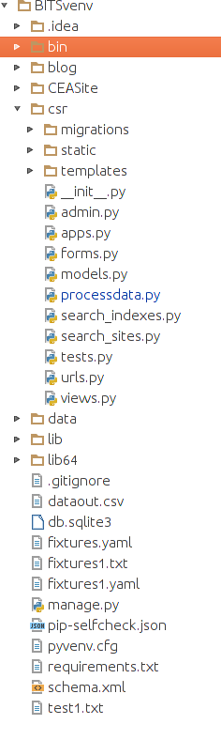
Figure 7 – Code Structure

Chapter 12- Coding

Virtual Environment
  - Virtual Environment was created for this project to have easy migration to other nodes and location/OS.
  - Project was created inside the virtual environment
  - Apps were added in the Project

GIT repository
  - GIT was used manage the code repository.

Algorithm
  - State Machine was used to break the emails into useful information.
  - NLTK was used to process the Emails and pull out the required information to be stored in the Database.
  - Initially all mails were sanitized to remove all the un-necessary data.
  - These set of mails were then stored in tokenized text format to be used as Corpora in NLTK.
  - Using NLTK Symptoms and Actions with their outcomes were pulled out and stored for each case in the database.

Query Processing:

Query parser
NLP + Context Search
Search Engine
Text Indexing
Machine Learning, Indexing, NLP
Query

Figure

Figure 8- Query Processing

Data Processing:

Figure 9- Data Processing

UI Layer
  - Django and HTML used for UI layer design.
  - Django Models were created as below:
    - Csr
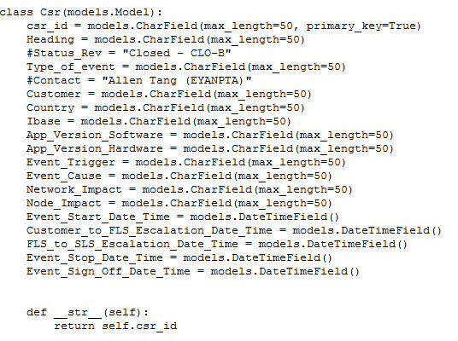
    - Csr_actions
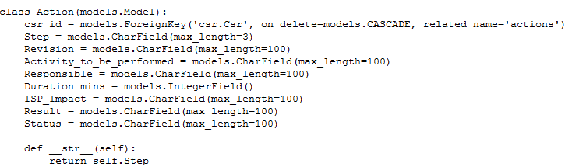
    - Csr_revisions
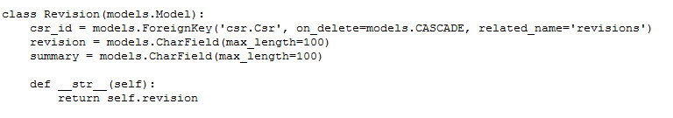

  - CSS was used to beautify the HTML.

Database Layer
  - SQLlite database is used to store the data.

Search Engine: Elasticsearch engine was employed to respond to the user queries.
It could be run in cloud and instances can be increased at will owing the name Elasticsearch.

Chapter 13- Testing

Testing
  - Unit testing is done.
  - Manual testing is performed by supervisor as per test cases.
  - Testing of the Search Functionality and accuracy of the data was randomly tested after.
  - Testing for authorization for getting the Case details was also tested.

Fixes and rework
Some the bugs which got fixed is as below-
Sr no | Bug Summary
1 | Data format was not consistent as the cases were from across the globe and people used different  data formats.
2 | Some of the values were coming as blank due to the international characters used in the Emails.
3 | There was incompatibility between some data types so had to do appropriate data conversions.
4 | UI was not very pleasant so the CSS template was used to make the site more beautiful
5 | Sometimes the resulting query threw errors, some cases were not handled.
6 | Browser got distorted when the window was resized.
7 | Error messages were not shown for some of the cases.
8 | Some error handling was not in places
9 | Corner conditions and time conversions was required.
10 | Error messages needed to be made more user friendly
Table 3- Bugs found
Testing and Sign off
After closing above bugs we run the regression test and given sign off.

Chapter 14- Deployment

Deployment Strategy
The web application would be deployed on an Ubuntu node in Ericsson location where Support Engineers can familiarize with it and access it during Customer Emergency Situations.
Documentation
Minimum documentation is in place for the application. Documentation also includes all dissertation related document as well.

Chapter 15- Conclusion/Summary

- This was first technical development project in this area done by Product Support Engineering team.
- We used best practices currently available for development NLTK, Django for UI, Haystack for Search integration with Django, Elasticsearch as search engine, Manual unit and functional testing
- Since there was challenge with respect to NLTK expertise, lot of Research and Development activity done to draw a roadmap for the project.
- Tool is deployed on Python virtual environment on a Ubuntu box and given to product support engineering team for demo.
- Currently it caters to the support of two devices made by Ericsson SmartEdge and Smart Service Router.
- Phase II will be targeted for additional Ericsson Devices.

Bibliography

1. BOOK

Natural Language Processing with Python
Steven Bird, Ewan Klein, and Edward Loper Publisher: O'Reilly, 2016.

Reference Websites

- NLTK:
http://www.nltk.org/book/

- Deep Search:
http://streamhacker.com/2014/06/10/deep-search/

- Activating the virtual environment:
https://gist.github.com/twidi/049c1eb6ed359d3e9e7f
http://stackoverflow.com/questions/22288569/how-do-i-activate-a-virtualenv-inside-pycharms-terminal

- Database SQL-lite3:
https://docs.python.org/2/library/sqlite3.html
https://www.sqlite.org/cli.html

- Django Framework:
http://django-haystack.readthedocs.org/en/v2.4.0/installing_search_engines.html#solr
https://www.djangopackages.com/grids/g/search/
http://django-haystack.readthedocs.org/en/latest/views_and_forms.html
- GIT:
http://tutorial.djangogirls.org/en/deploy/index.html

- Elastic Search Engine:
https://www.elastic.co

- State machine:
http://www.talyarkoni.org/blog/2014/10/29/yet-another-python-state-machine-and-why-you-might-care/
https://github.com/tyarkoni/transitions

- PyCharm:
https://www.jetbrains.com/pycharm/

Abbreviations

Acronyms | Description
API | Application Programming Interface
BITS | Birla Institute of Technology and Science
CEA | Customer Emergency Analysis
DB | Database
EBS | Elastic Block Store
ER | Entity Relationship
ES | Elastic Search Engine
FLS | First Line Support
HTTP | Hyper Text Transfer Protocol
IE | Internet Explorer
IO | Input Output
LS | Local Support
M.Tech | Master Of Technology
MVC | Model View Controller
OS | Operating System
PDF | Portable Document Format
RL | Recovery Leader
SDM | Service Delivery Manager
SIT | System Integration Testing
T2 | Tier 2 support Engineer
UI | User Interface

Tables
Table 1- Development Plan
Table 2- Search Engine Comparison
Table 3- Bugs Found

Figures

Figure 1 – Login Screen
Figure 2 – Home Screen
Figure 3 – Search Page
Figure 4 – Result Page
Figure 5 – CSR Detail Page
Figure 6 – High Level Design
Figure 7 – Code structure
Figure 8 – Query Processing
Figure 9 – Data Processing

