CHATBOT APPLICATION

This is an automated chat robot design to answer users frequently asked questions, earlier natural language processing techniques were using to design this robots but its accuracy of giving correct answer was less and now due to Deep Learning algorithms accuracy of giving correct answer increase, so here using python deep learning project we are building CHATBOT application to answer users questions.

To implement this technique first we train deep learning models with the train data (all possible question’s answers) and whenever users give any question then application will apply this test question on train model to predict exact answer for given question.

Earlier companies were hiring humans to answer user’s queries but by using this application we can answer user’s question without using any man power.

Chabot can be described as software that can chat with people using artificial intelligence. Chabot’s are generally used to respond quickly to users. Chabot’s, a common name for automated conversational interfaces, present a new way for individuals to interact with computer systems. Traditionally, to get a question answered by a software program involves using a search engine, or filling out a form. A Chabot allows a user to simply ask questions in the same manner that they would address a human. There are many well-known voice-based catboats currently available in the market: Google Assistant, Alexa and Siri. Chabot’s are currently being adopted at a high rate on computer chat platforms.

To implement this project we are using python deep learning neural networks and NLTK (natural Language Processing API) to process train and test text data.

**Technologies**

Web technology: HTML, CSS, Java scripts, AJAX

Python Web Server: Django

Programming Language: Python

Algorithm: Deep Neural Network

Database: MYSQL

**Modules**

This application consists of 4 modules

New user Registration: Using this module users can signup with the application.

Login: Using this module user can login to application

Chabot: Using this module users can interact with Chabot

Logout: Using this module users can exit from the application

**Screen shots**

To run this project we need to install python and MYSQL and then deploy application on python DJANGO server. After setting up application we need to run on browser to get below screen

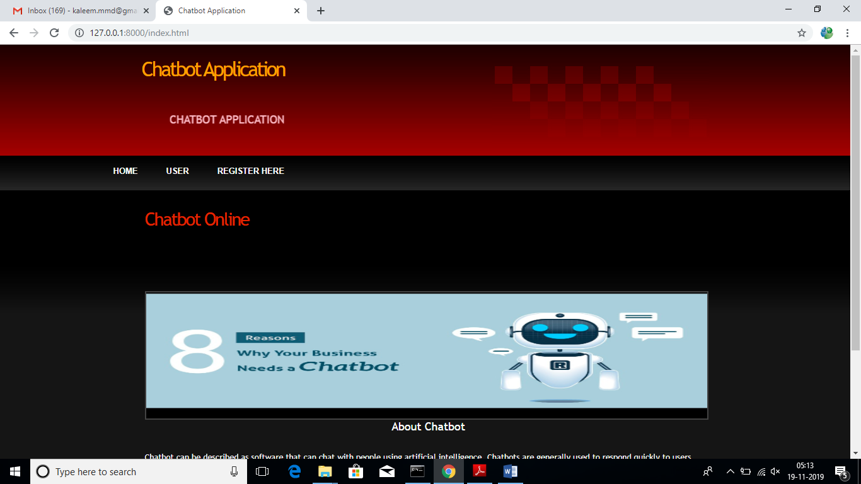

In above screen click on ‘Register Here’ link to add sign up with application

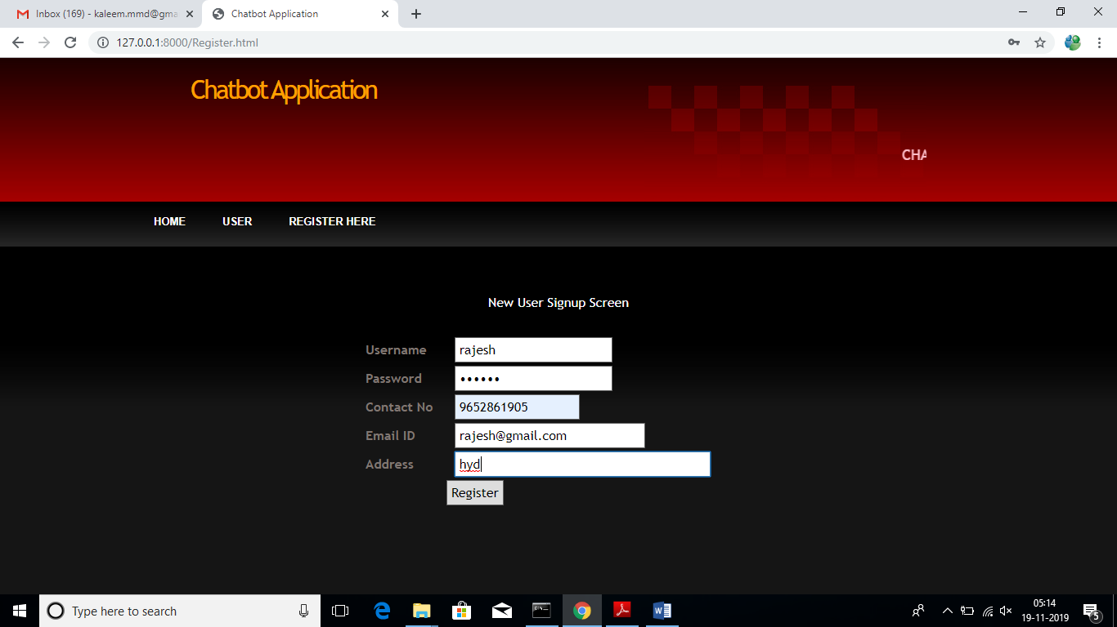

After signup will get below confirmation screen

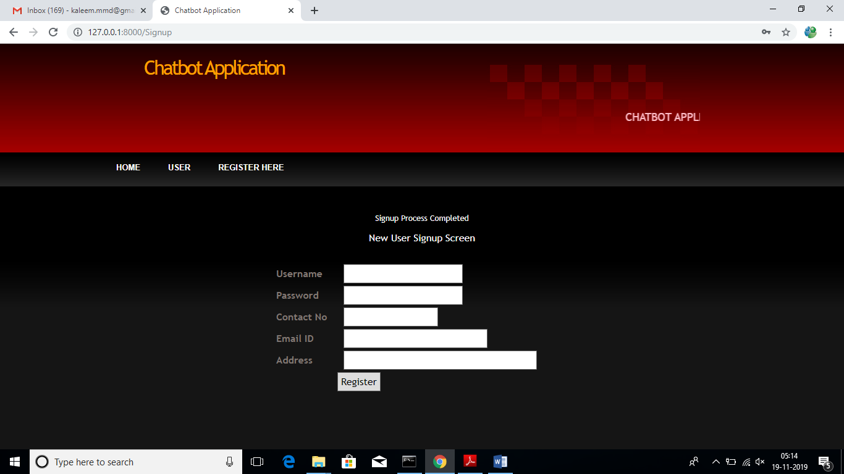

Now click on ‘User’ link to login to application

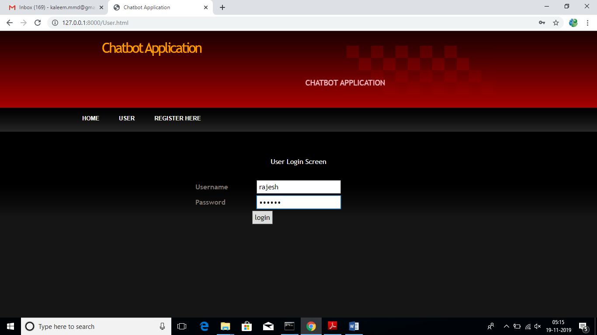

After login will get below user chat bot screen

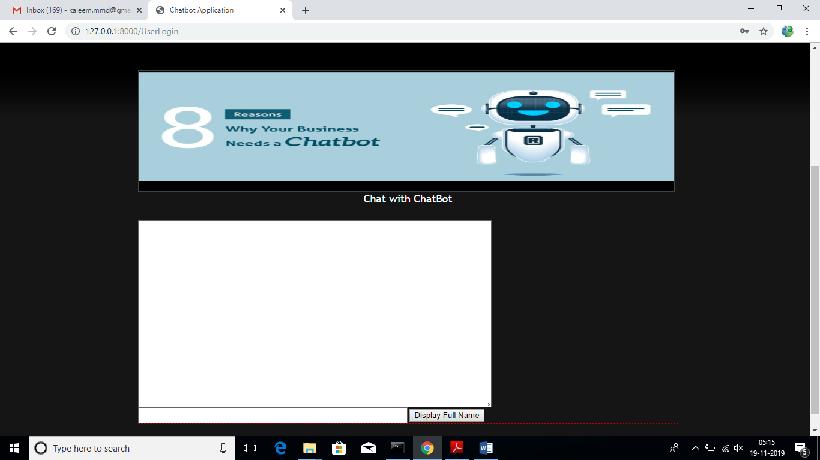

In above screen user can enter questions and chat bot replies to that questions. See below screen

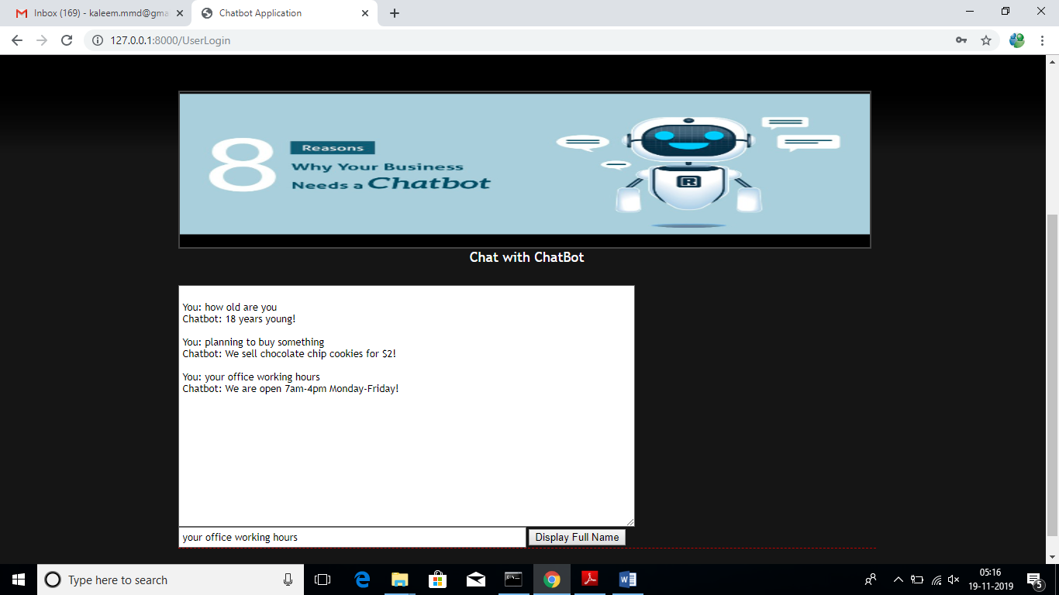

In above screen we can see I asked 3 questions and chat bot answer them correctly. Similarly we can ask any question and chat bot can answers those questions as long as those question answers are available inside training model of deep learning object.