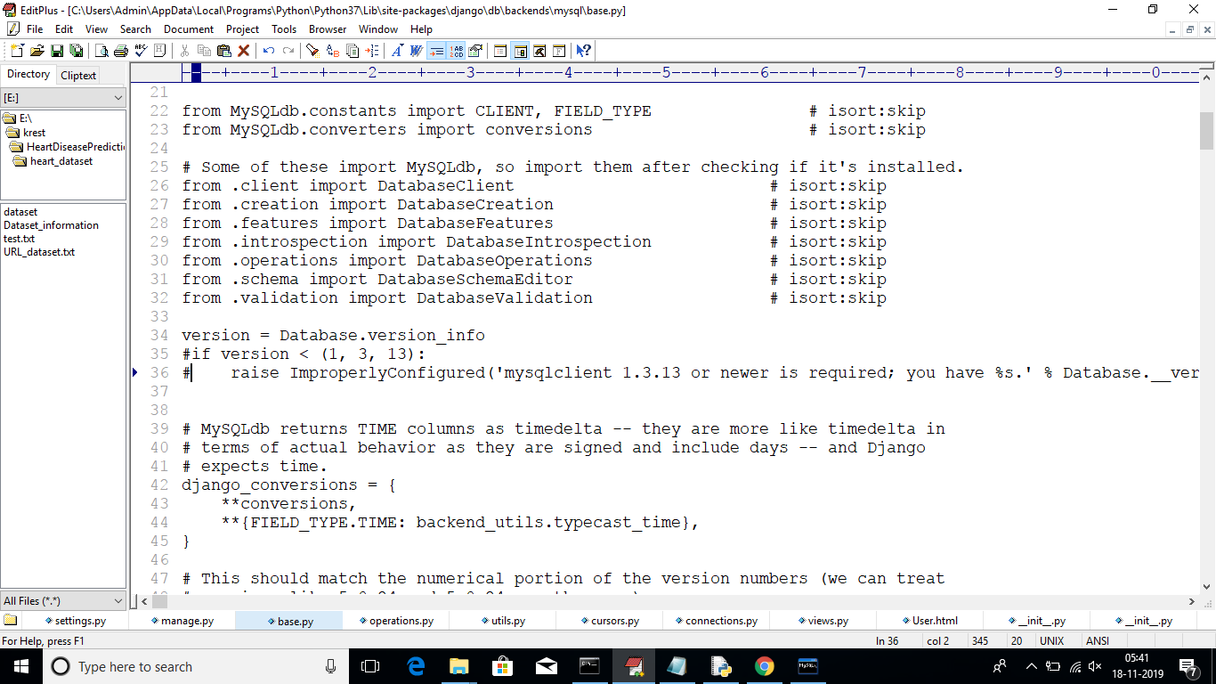

Comment 35 and 36 lines

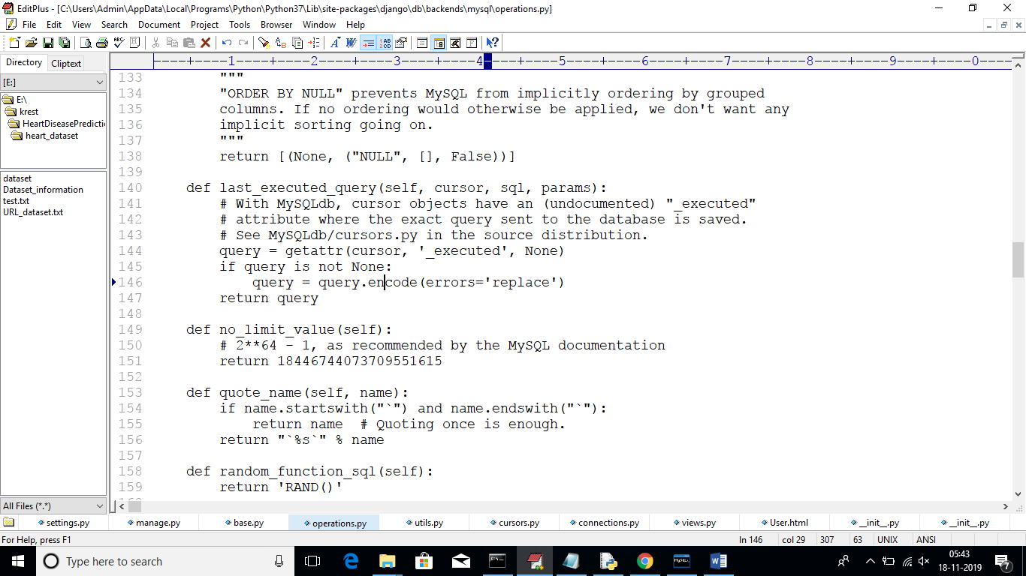

Change line at 146 from decode to encode

Those files will be below location

C:\Users\Admin\AppData\Local\Programs\Python\Python37\Lib\site-packages\django