Practical Experiment 4

Question 1:
Code:
#include <stdio.h>
#include <unistd.h>
#include <sys/wait.h>

int main()
{
char command[50];

printf("Enter command: ");
scanf("%s", command);

int pid = fork();

if (pid == 0)
{
printf("Child PID: %d\n", getpid());
execlp(command, command, NULL);
}
else
{
printf("Parent PID: %d\n", getpid());
printf("Child PID: %d\n", pid);
wait(NULL);
printf("Child completed\n");
}

return 0;
}

Output :

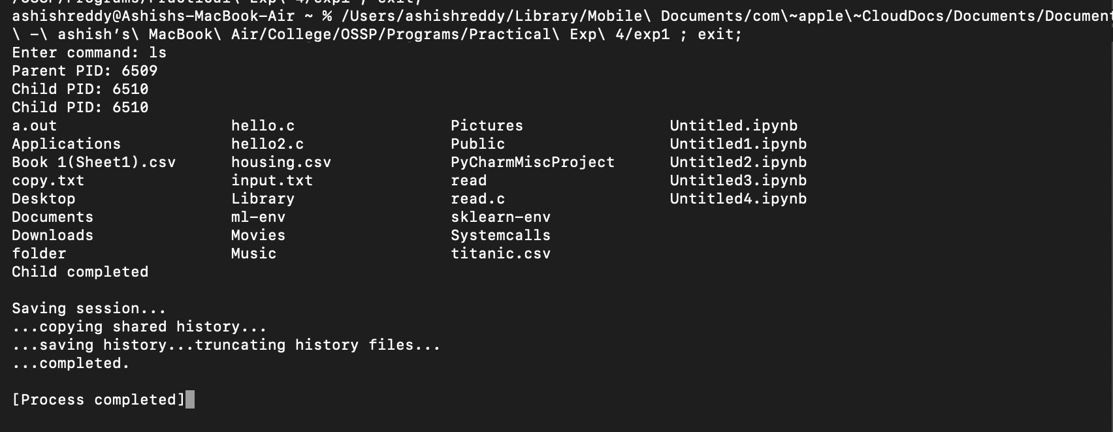

Question 2:
Code:
#include <stdio.h>
#include <unistd.h>
#include <sys/wait.h>

int main()
{
char command[50];

printf("Enter command: ");
scanf("%s", command);

int pid = fork();

if (pid == 0)
{
printf("Child PID: %d\n", getpid());
execlp(command, command, NULL);
}
else
{
printf("Parent PID: %d\n", getpid());
printf("Child PID: %d\n", pid);

wait(NULL);

printf("Child completed\n");
}

return 0;
}

Output:

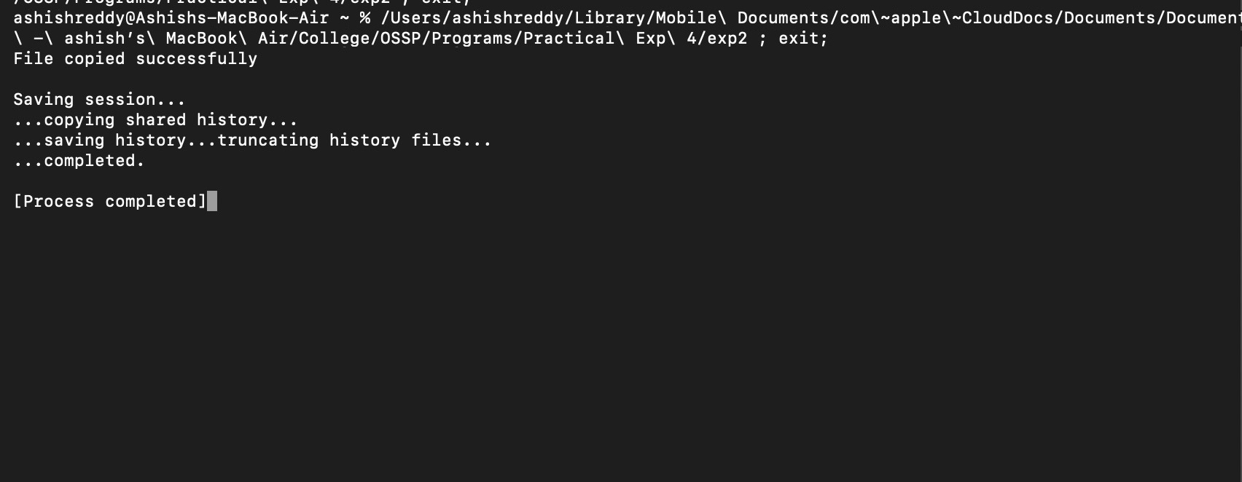

Question 3:
Code:
#include <stdio.h>
#include <fcntl.h>
#include <unistd.h>

int main()
{
int source, destination;
char buffer[100];
int n;

source = open("source.txt", O_RDONLY);
destination = open("copy.txt", O_WRONLY | O_CREAT | O_TRUNC, 0644);

n = read(source, buffer, sizeof(buffer));

write(destination, buffer, n);

close(source);
close(destination);

printf("File copied successfully\n");

return 0;
}

Output:
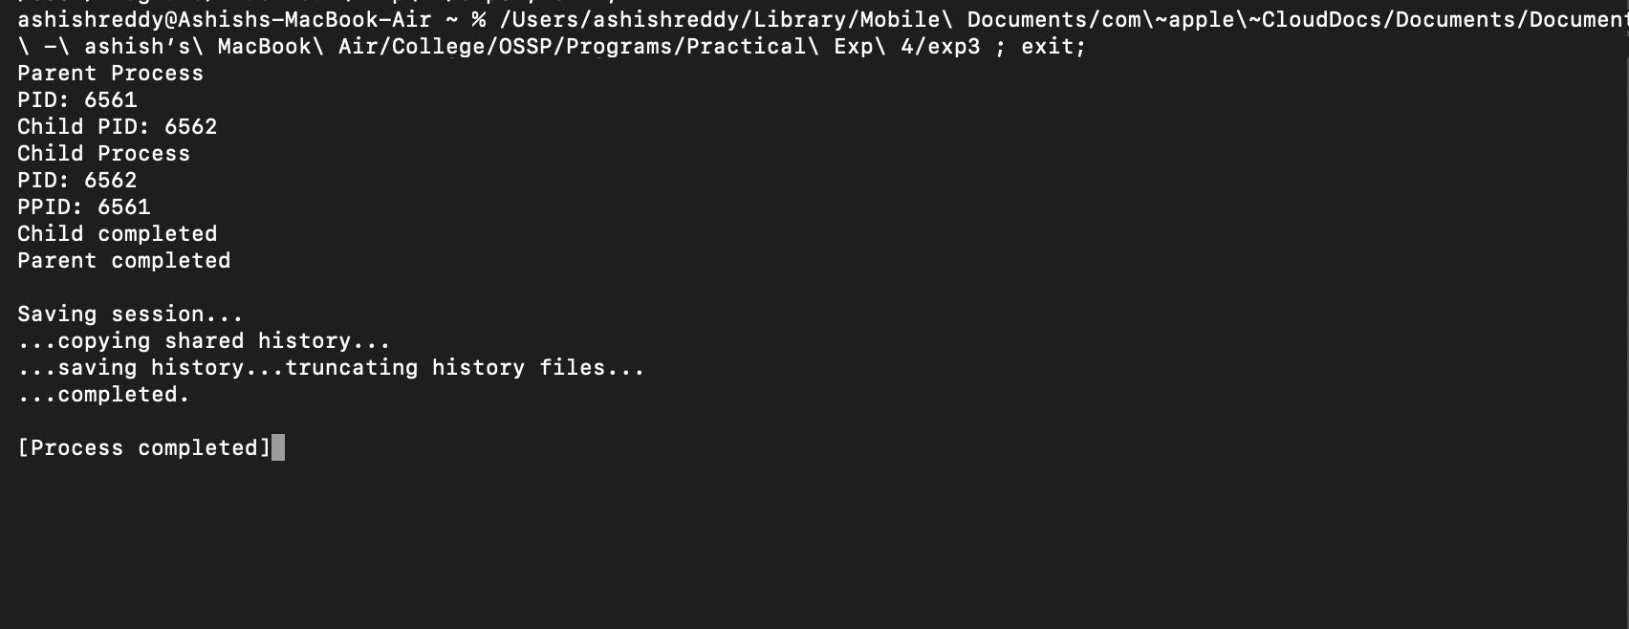

Question 4:
Code:
#include <stdio.h>
#include <unistd.h>
#include <sys/wait.h>

int main()
{
int pid = fork();

if (pid == 0)
{
printf("Child Process\n");
printf("PID: %d\n", getpid());
printf("PPID: %d\n", getppid());

sleep(5);

printf("Child completed\n");
}
else
{
printf("Parent Process\n");
printf("PID: %d\n", getpid());
printf("Child PID: %d\n", pid);

wait(NULL);

printf("Parent completed\n");
}

return 0;
}
Output:
