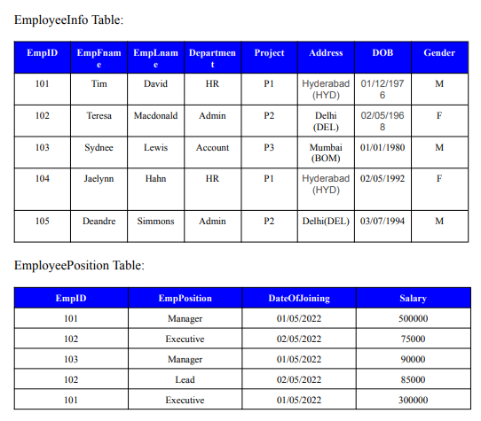

Q. Write a query find number of employees whose DOB is between 02/05/1970 to 31/12/1975 and are grouped according to gender.

Q. Write a query to fetch all the records from the EmployeeInfo table ordered by EmpLname in descending order and Department in the ascending order.

Q. Write a query to fetch details of employees whose EmpLname ends with an alphabet ‘S’ and contains five alphabets.

Q. Write a query to fetch details of all employees excluding the employees with first names, “Teresa” and “Jaelynn” from the EmployeeInfo table.

Q. Write a query to fetch details of employees with the address as “DELHI (DEL)”.

Q. Write a query to fetch all employees who also hold the managerial position.

Q. Write a query to fetch the department-wise count of employees sorted by department’s count in ascending order.

Q. Write a query to calculate the even and odd records from a table.

 Q. Write a SQL query to retrieve employee details from EmployeeInfo table who have a date of joining in the EmployeePosition table.

Q. Write a query to retrieve two minimum and maximum salaries from the EmployeePosition table.

Q. Write a query to find the Nth highest salary from the table without using TOP/limit keyword. Q. Write a query to retrieve the last 3 records from the EmployeeInfo table.

Q. Write a query to find the third-highest salary from the EmpPosition table.

 Q. Write a query to display the first and the last record from the EmployeeInfo table.

Q. Write a query to retrieve Departments who have less than 2 employees working in it.

Q. Write a query to retrieve EmpPostion along with total salaries paid for each of them.

Q. Write a query to fetch 50% records from the EmployeeInfo table.