**Assignment No: 07**

**Title:** Mini Project-II.

**Objectives:**

To know the basics of cryptography.

To acquire knowledge of standard algorithms and protocols employed to provide confidentiality, integrity and authenticity.

**Problem Statement:** This task is to demonstrate insecure and secured website. Develop a web site and demonstrate how the contents of the site can be changed by the attackers if it is http based and not secured. You can also add payment gateway and demonstrate how money transactions can be hacked by the hackers. Then support your website having https with SSL and demonstrate how secured website is.

**Outcome:** Build appropriate security solutions against cyber-attacks.

**Software & Hardware Requirments:**

1. Mozilla Firefox

2. Php

3. Notepad/ Notepad++ Editor

**Theory:**

**1. Introduction:**

A websiteor Web site is a collection of related network [web resources](https://en.wikipedia.org/wiki/Web_resource), such as [web pages](https://en.wikipedia.org/wiki/Web_page), [multimedia](https://en.wikipedia.org/wiki/Multimedia) content, which are typically identified with a common [domain name](https://en.wikipedia.org/wiki/Domain_name), and published on at least one [web server](https://en.wikipedia.org/wiki/Web_server). Notable examples are [wikipedia.org](https://en.wikipedia.org/wiki/Wikipedia), [google.com](https://en.wikipedia.org/wiki/Google), and [amazon.com](https://en.wikipedia.org/wiki/Amazon_(company)). Websites can be accessed via a public [Internet Protocol](https://en.wikipedia.org/wiki/Internet_Protocol) (IP) network, such as the [Internet](https://en.wikipedia.org/wiki/Internet), or a private [local area network](https://en.wikipedia.org/wiki/Local_area_network) (LAN), by a [uniform resource locator](https://en.wikipedia.org/wiki/URL) (URL) that identifies the site.

Websites can have many functions and can be used in various fashions; a website can be a [personal website](https://en.wikipedia.org/wiki/Personal_website), a corporate website for a company, a government website, an organization website, etc. Websites are typically dedicated to a particular topic or purpose, ranging from entertainment and [social networking](https://en.wikipedia.org/wiki/Social_networking) to providing news and education. All publicly accessible websites collectively constitute the [World Wide Web](https://en.wikipedia.org/wiki/World_Wide_Web), while private websites, such as a company's website for its employees, are typically part of an [intranet](https://en.wikipedia.org/wiki/Intranet).

Web pages, which are the [building blocks](https://en.wikipedia.org/wiki/Building_block) of websites, are documents, typically composed in [plain text](https://en.wikipedia.org/wiki/Plain_text) interspersed with formatting instructions of Hypertext Markup Language ([HTML](https://en.wikipedia.org/wiki/HTML), [XHTML](https://en.wikipedia.org/wiki/XHTML)). They may incorporate elements from other websites with suitable [markup anchors](https://en.wikipedia.org/wiki/HTML_anchor). Web pages are accessed and transported with the [Hypertext Transfer Protocol](https://en.wikipedia.org/wiki/Hypertext_Transfer_Protocol) (HTTP), which may optionally employ encryption ([HTTP Secure](https://en.wikipedia.org/wiki/HTTP_Secure), HTTPS) to provide security and privacy for the user. The user's application, often a [web browser](https://en.wikipedia.org/wiki/Web_browser), renders the page content according to its HTML markup instructions onto a [display terminal](https://en.wikipedia.org/wiki/Computer_monitor).

[Hyperlinking](https://en.wikipedia.org/wiki/Hyperlink) between web pages conveys to the reader the [site structure](https://en.wikipedia.org/wiki/Site_map) and guides the navigation of the site, which often starts with a [home page](https://en.wikipedia.org/wiki/Home_page) containing a directory of the site [web content](https://en.wikipedia.org/wiki/Web_content). Some websites require user registration or [subscription](https://en.wikipedia.org/wiki/Subscription) to access content. Examples of [subscription websites](https://en.wikipedia.org/wiki/Paywall) include many business sites, news websites, [academic journal](https://en.wikipedia.org/wiki/Academic_journal) websites, gaming websites, file-sharing websites, [message boards](https://en.wikipedia.org/wiki/Internet_forum), web-based [email](https://en.wikipedia.org/wiki/Email), [social networking](https://en.wikipedia.org/wiki/Social_networking) websites, websites providing real-time [stock market](https://en.wikipedia.org/wiki/Stock_market) data, as well as sites providing various other services. [End users](https://en.wikipedia.org/wiki/End_user)can access websites on a range of devices, including [desktop](https://en.wikipedia.org/wiki/Desktop_computer) and [laptop computers](https://en.wikipedia.org/wiki/Laptop_computer), [tablet computers](https://en.wikipedia.org/wiki/Tablet_computer), [smartphones](https://en.wikipedia.org/wiki/Smartphone) and [smart TVs](https://en.wikipedia.org/wiki/Smart_TV).

**2. Secured and Insecure Websites**

Website security covers many areas, but for the purposes being discussed here, it means that the website utilizes SSL, which stands for Secure Socket Layer, a standard security technology that establishes an encrypted connection between a web server and a browser, with the URL being prefixed with "HTTPS" rather than the standard and unsecure "HTTP" (with that extra "S" standing for "Secure").Any information that you normally submit to a website (or retrieve from a site) is sent as plain text and can be viewed if an attacker is able to intercept the information to read the data. It’s not hard to understand why SSL has historically been considered a best practice for any website that is processing transactions with sensitive data such as social security numbers, credit card numbers, personal health records, or login credentials. Now, SSL is becoming a best practice standard for all websites, including those that do not necessarily process sensitive data.

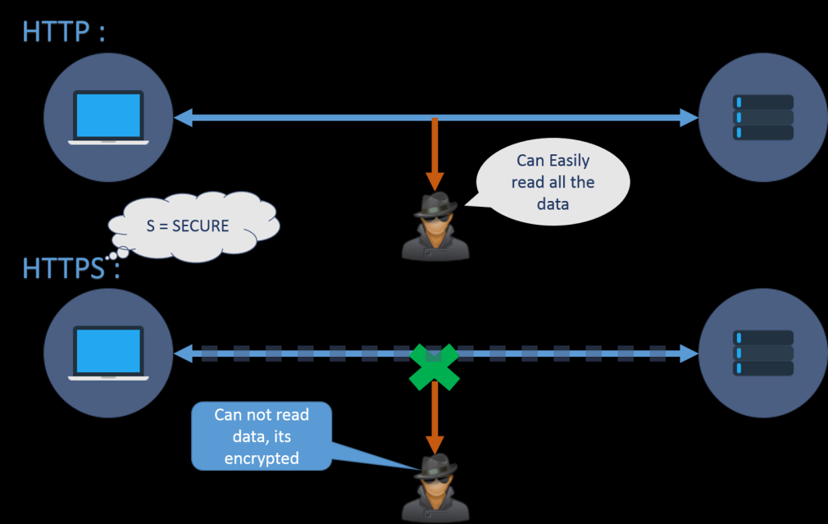

Fig 1. **Secured and Insecure Websites**

**Conclusion**We have demonstrated security of a website that is http based while comparing it with https based website with demo payment gateway and successfully applied Cross Site Scripting on basic website. Data is observed using wire shark tool.

**OutPut:**

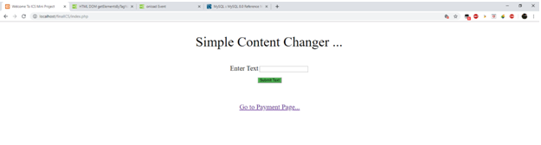

**Fig 2: Before Content Change Page**

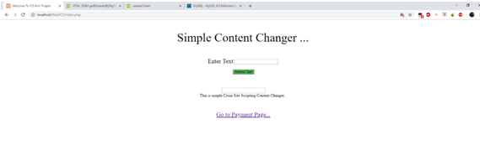

**Fig 3:After Content Change Page**

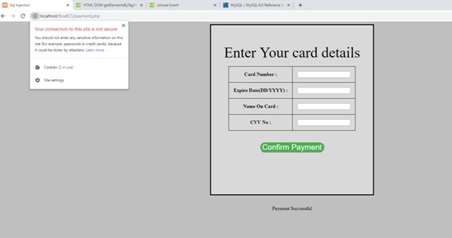

**Fig 4: Payment Page HTTP**

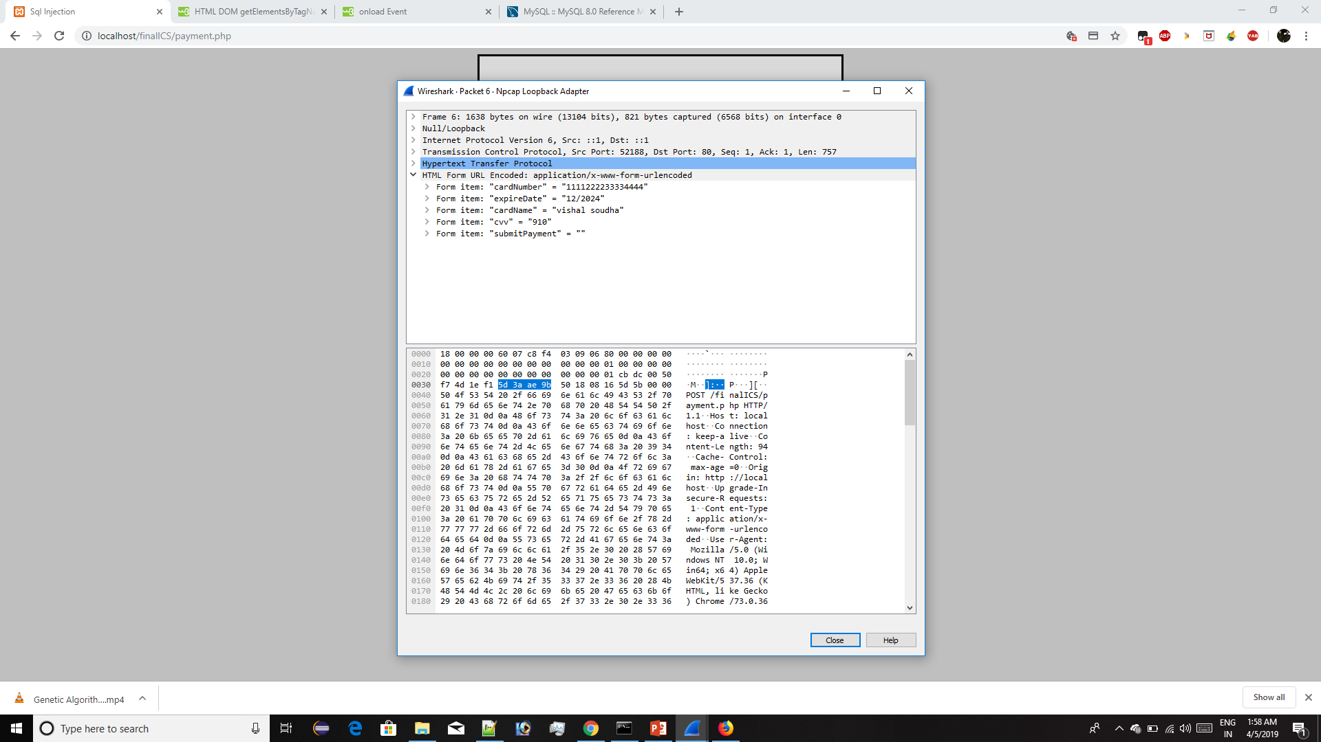

**Fig 7: WireShark HTTP details**

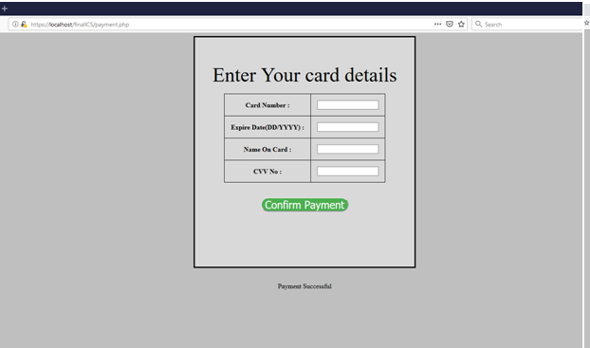

**Fig 8: Payment Page HTTPs**

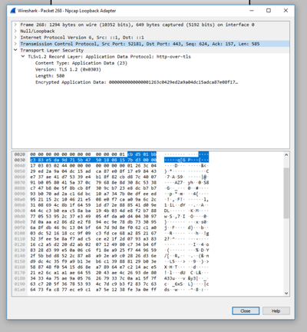

**Fig 9: WireShark HTTPs details**