**Portfolio Maker**



**FEE-I(22CS004)**

A MINI PROJECT REPORT

*Submitted by*

Ashish Sharma: 2210991403 (Team Lead)

Ashish Jadon: 2210991400

Ashish Kumar: 2210991401

Ashish Ranjan: 2210991402

Submitted to :- Dr. Anshu Singla

(Professor DCSE)



**CONTENT**

|  |  |  |
| --- | --- | --- |
| **Sr.no** | **Section** | **Page no** |
| 1 | Introduction | 1 |
| **2** | Problem Statement | 2 |
| 3 | Technical Details | 3 |
| 4 | Key Features | 4 |
| 5 | Advantages | 5 |
| 6 | Code | 6-7 |
| 7 | Output | 8-9 |
| 8 | Conclusion and references | 10-11 |



**INTRODUCTION**

**Goal:** A portfolio website is a unique way to showcase your work and let others know about yourself. It's like an evergreen platform for your projects, case studies, and information about you.



**Technical Details**

**Application used:-** Visual Studio Code.

**Programming Languages used:**1. HTML

2. CSS

3. JavaScript (J Query Framework).



**PROBLEM STATEMENT**

The problem statement of a Portfolio maker page refers to the issue or challenge that a user faces while creating his/her portfolio for professional purposes. The aim here is to design and build website which allows the user to create their own portfolio with some attractive and professional templates/layouts that are already there on our webpage so that the user will be able to select them according to his preference.



**KEY FEATURES:**

* Design
* Logo With Tagline
* High Quality images
* Testimonials
* Information about yourself
* Contact Information



**Advantages of Portfolio Maker:**

Portfolio maker allows you to create your own portfolio which a user can use for his respective purpose.

Our Portfolio Maker will help such users to create their own portfolios by suggesting them some attractive layouts of the portfolio which they can use for their own.

This will save time of the user , all they will have to do is fill their information and then it will be applied to the selected layout.

Therefore, its making so easy for the user.

Benefits of Creating an Online Portfolio:-

* Professional Way To Showcase Your Work.
* It's A Great First Impression For Employers.
* Increases Your Visibility And Online Presence.
* Shows You're More Than Just A Resume.
* Flexibility.



**Code:**

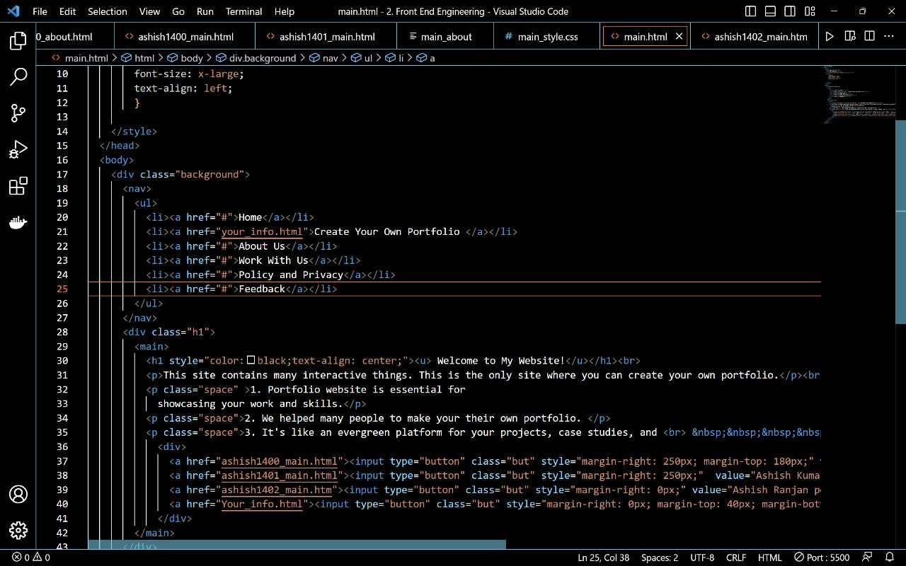

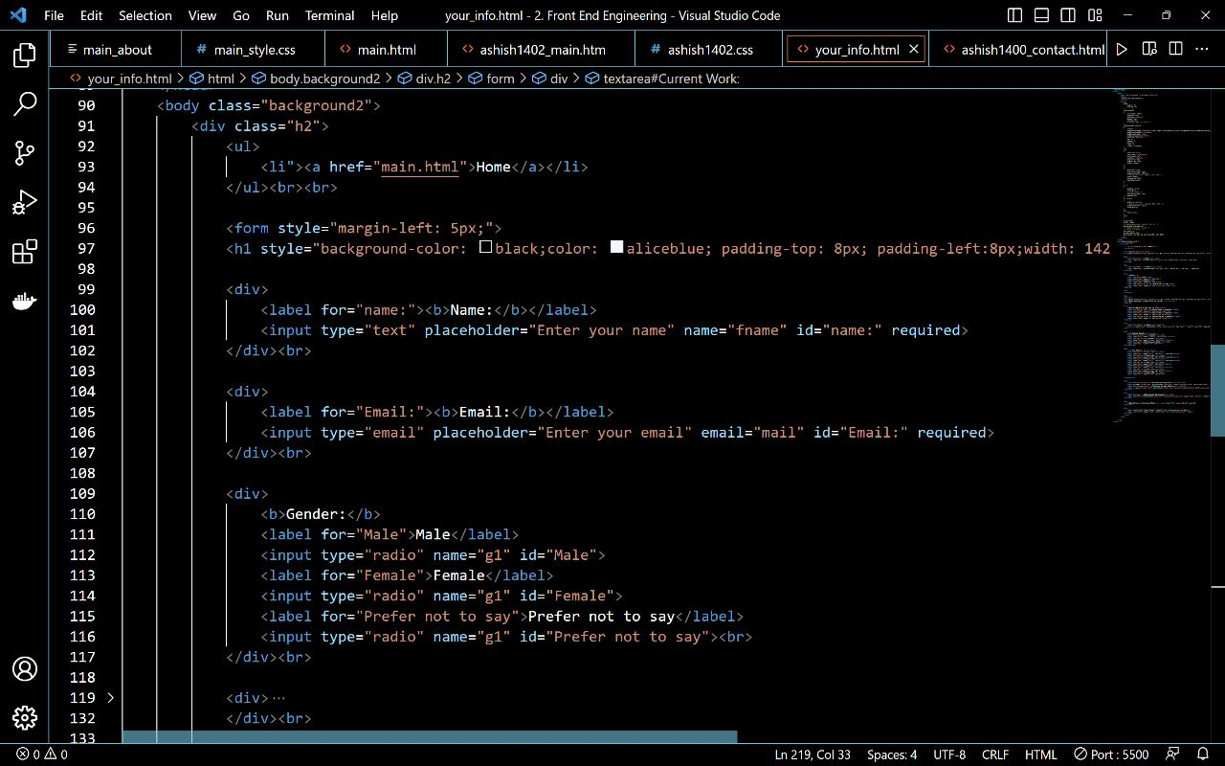



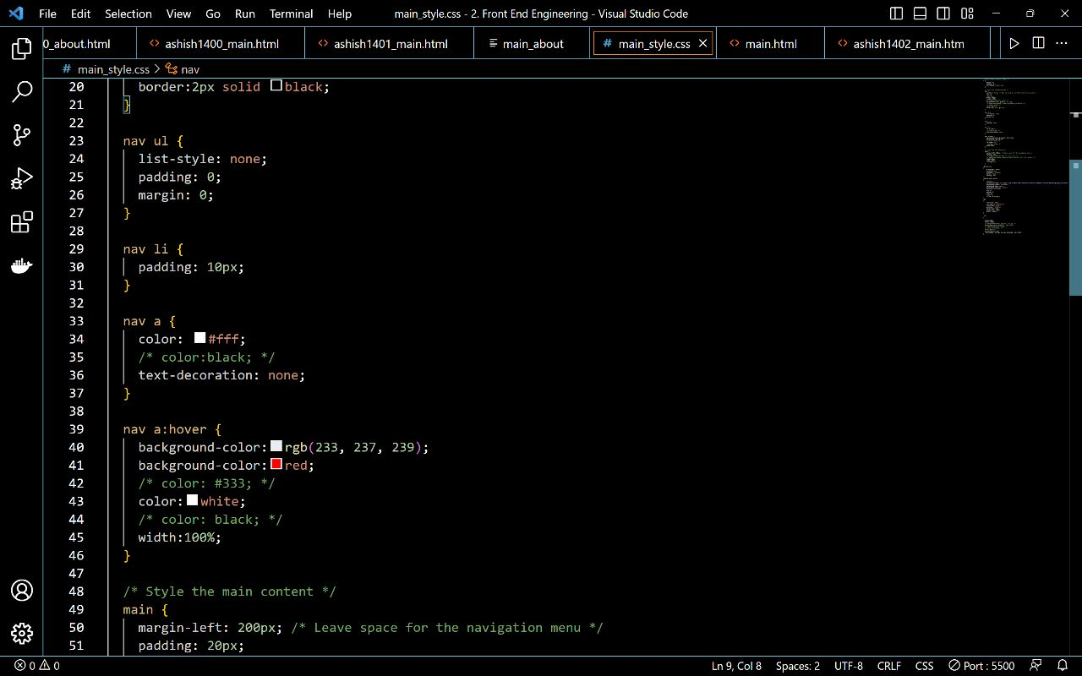

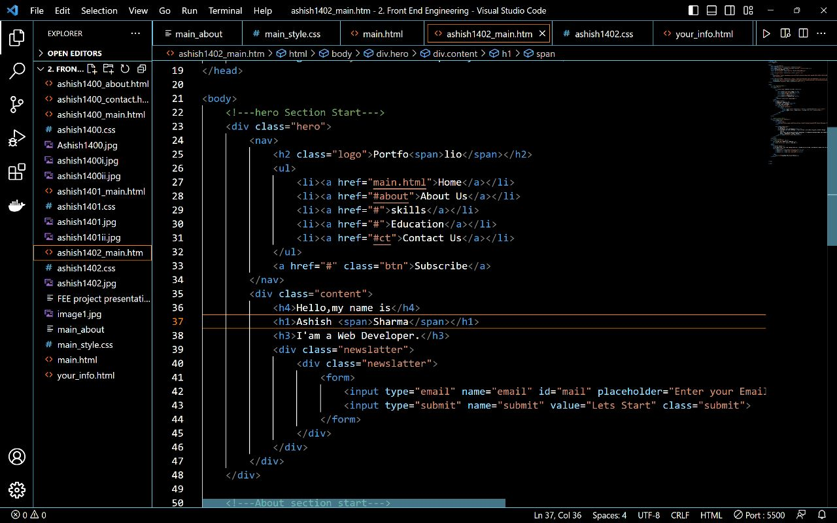



**Output**

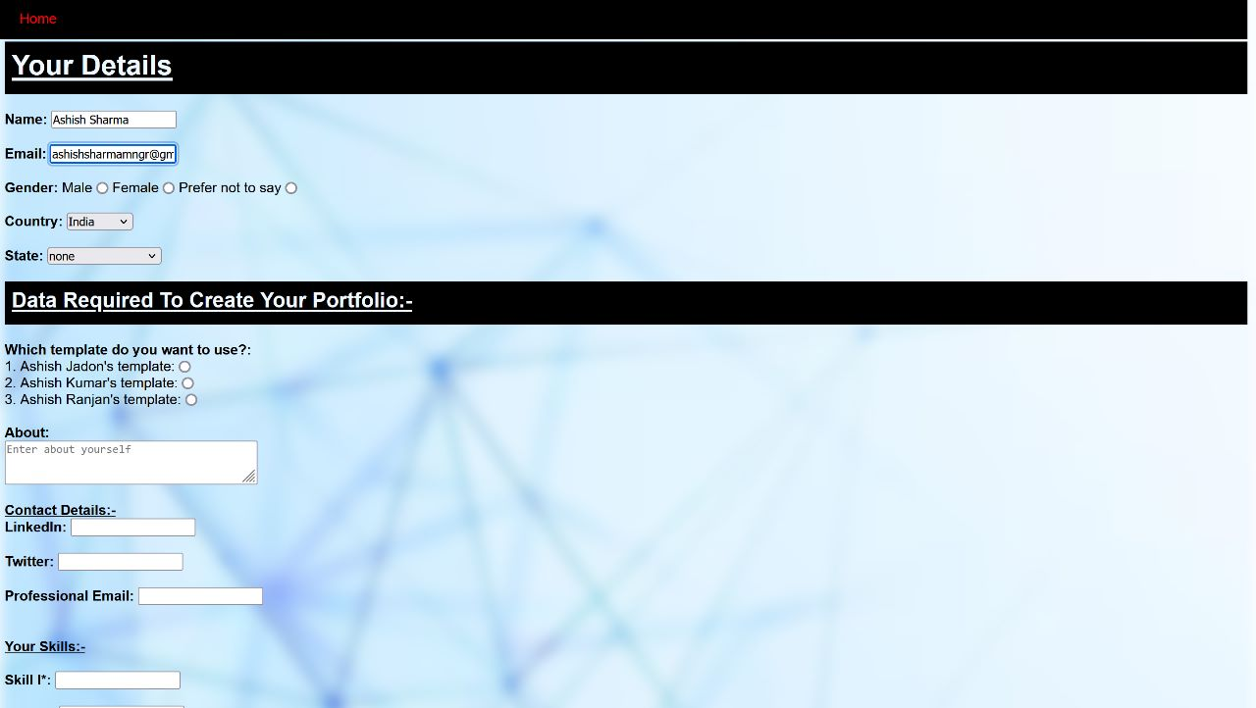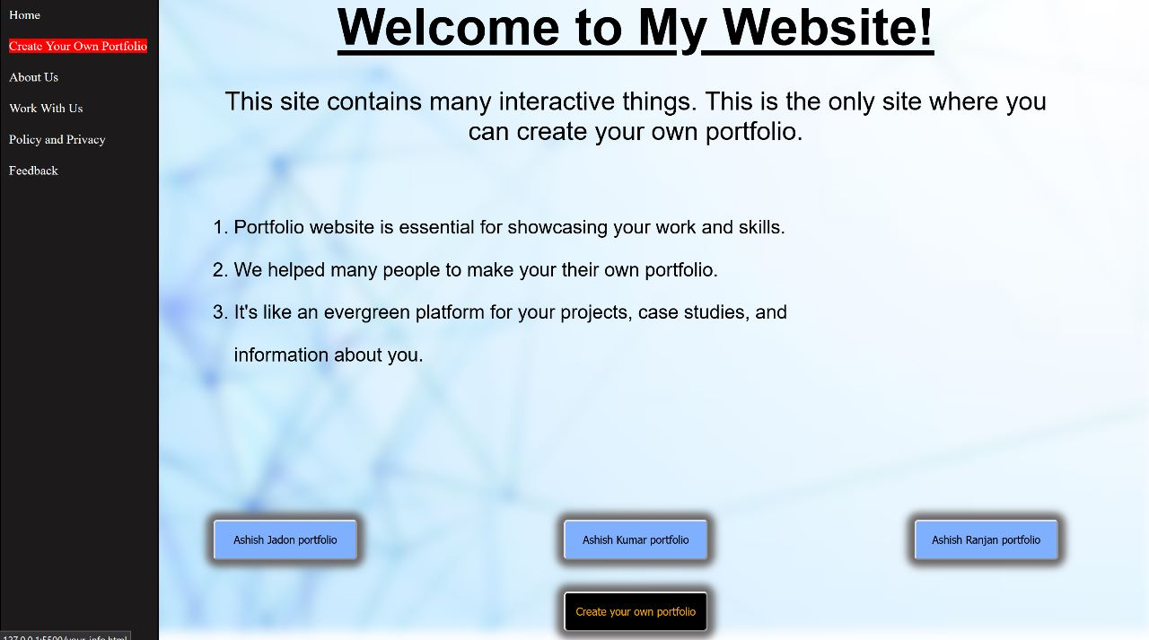

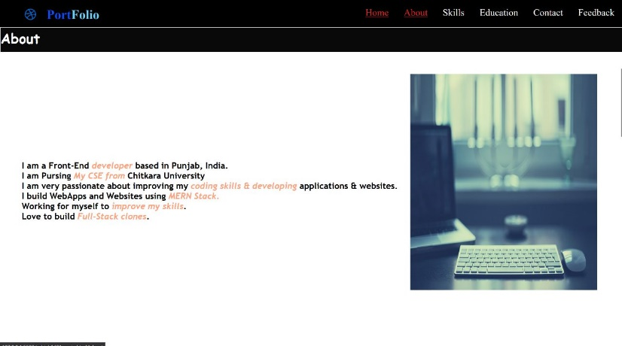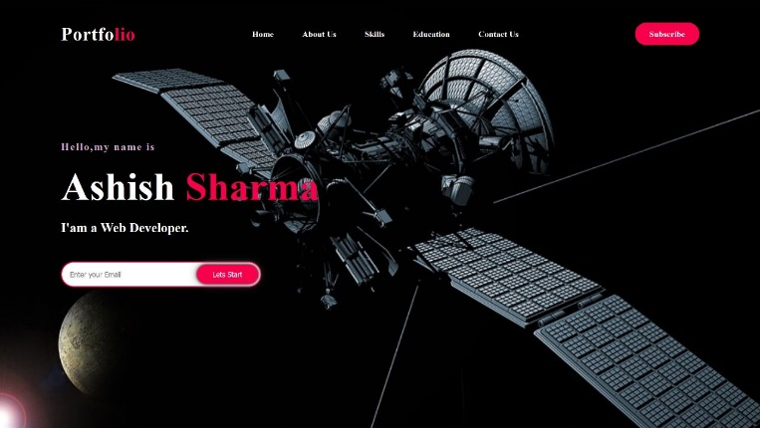



**CONCLUSION:**

Portfolio is a very valuable and meaningful evaluation tool that effectively assesses student learning. Along with the student reflection the data provides the valuable information about how each student learns and what is important to him or her in the learning process.



**References:**

* The main Reference for this project is:- **w3schools.**

<https://www.w3schools.com/> .

Link**:-** [To Do List](https://www.w3schools.com/howto/howto_js_todolist.asp) or [https://www.w3schools.com/howto/howto portfolio.asp](https://www.w3schools.com/howto/howto_css_notes.asp) .

* The Other Main source of reference for this project is:-

<https://youtu.be/AkIUtUWpyZs> .

* The other important source used by us for this project is:-

<https://code-projects.org/portfolio-web-application-in-javascript-with-source-code/> .



**Work Divisions:**

Ashish Sharma (2210991403) – Team lead, main webpage and ppt

Ashish Jadon (2210991400)- Portfolio layout and project report

Ashish Kumar (2210991401)- Portfolio layout

Ashish Ranjan (2210991402)- Portfolio layout

Everyone in the team has done their respective part of the work on their own and with sincerity. We are a good team.