Detecting Heating and cooling load of Building

Revision Number: 1.0

Last date of revision: 20/07/2022

# Document Version Control

|  |  |  |  |
| --- | --- | --- | --- |
| Date Issued | Version | Description | Author |
| 20/07/2022 | 1 | Initial HLD — V1.0 | Ashish Shukla |
|  |  |  |  |
|  |  |  |  |
|  |  |  |  |
|  |  |  |  |
|  |  |  |  |
|  |  |  |  |

Contents

Document Version Control. 2

Abstract. 4

1. Introduction 5
   1. Why this High-Level Design Document?. 5
   2. Scope. 5
   3. Definitions 5
2. General Description. 6
   1. Product Perspective 6
   2. Problem statement 6
   3. PROPOSED SOLUTION. 6
   4. Data Requirements 7
   5. Tools used. 8
   6. Constraints. 9
   7. Assumptions. 9
3. Design Details 10
   1. Process Flow. 10
   2. Event log 11
   3. Error Handling 11
   4. Performance. 12
   5. Reusability. 12
   6. Application Compatibility 12
   7. Resource Utilization 12
   8. Deployment. 12

Conclusion 14

# Abstract

This study looked into assessing the heating load and cooling load requirements of buildings (that is, energy efficiency) as a function of building parameters. Heating and cooling load for a building is the rate at which heat must be supplied to or removed from it in order to keep the temperature within a specified range.

## Introduction

#### Why this High-Level Design Document?

The purpose of this High-Level Design (HLD) Document is to add the necessary detail to the current project description to represent a suitable model for coding. This document is also intended to help detect contradictions prior to coding, and can be used as a reference manual for how the modules interact at a high level.

The HLD will:

* + - Present all of the design aspects and define them in detail
    - Describe the user interface being implemented
    - Describe the hardware and software interfaces
    - Describe the performance requirements
    - Include design features and the architecture of the project
    - List and describe the non-functional attributes like: o Security
      * Reliability
      * Maintainability a Portability

a Reusability

* + - * Application compatibility
      * Resource utilization
      * Serviceability

##### Scope

The HLD documentation presents the structure of the system, such as the database architecture, application architecture (layers), application flow (Navigation), and technology architecture. The HLD uses non-technical to mildly-technical terms which should be understandable to the administrators of the system.

#### 

Unmanned Ground Vehicle

1. General **Description**

#### Product Perspective

The Heating and cooling load predictor is machine learing based solution which will be used to predict the heating and cooling load.

* 1. **Problem statement**

To create a solution for predicting the Heating and cooling load requirement for building to maintain the acceptable temperature

###### PROPOSED SOLUTION

The solution proposed is to perform energy analysis using 12 different building shapes simulated in Ecotect. The buildings differ with respect to the glazing area, the glazing area distribution, and the orientation, amongst other parameters. We simulate various settings as functions of the afore-mentioned characteristics to obtain 768 building shapes. The dataset comprises 768 samples and 8 features, aiming to predict two real valued responses. We would first predict heating load then using HL as input for predicting the CL

##### Data Requirements

Data requirement completely depend on our problem statement.

The dataset contains eight attributes (or features, denoted by X1...X8) and two responses (or outcomes, denoted by y1 and y2). The aim is to use the eight features to predict each of the two responses.  
  
Specifically:

X1 = Relative Compactness,

X2 = Surface Area,

X3 = Wall Area,

X4 = Roof Area,

X5 = Overall Height,

X6 = Orientation,

X7 = Glazing Area,

X8 = Glazing Area Distribution,

y1 = Heating Load,

y2 = Cooling Load

##### Tools used

Python programming language and frameworks such as NumPy, Pandas, Scikit-learn, and Heroku are used to build the whole model.





* + - PyCharm is used as IDE.
    - For visualization of the plots, Matplotlib, Seaborn and Plotly are used.
    - Heroku is used for deployment of the model.
    - MongoDB is used to store the logs of the database.
    - Front end development is done using HTML/CSS
    - Python Flask is used for backend development.
    - GitHub is used as version control system.

High Level Design (HLD)

### Design Details

iNeur‹¿›n

* 1. Process Flow

For identifying the different types of anomalies, we will use a deep learning base model. Below is the process flow diagram is as shown below.

Proposed methodology

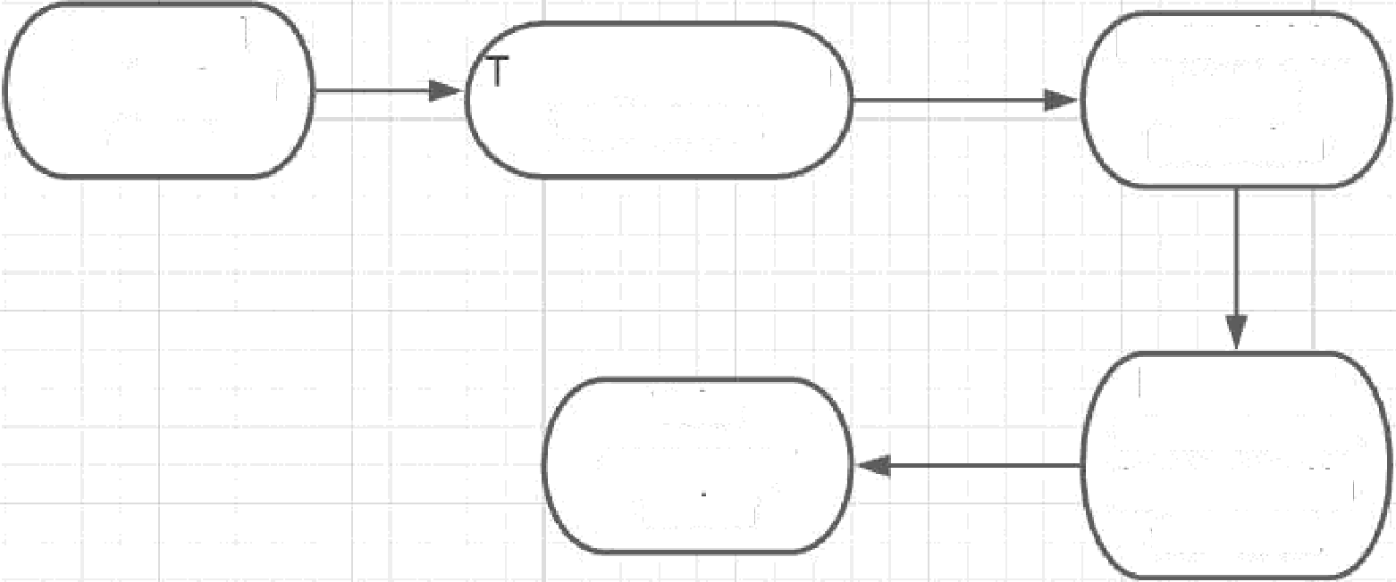Downoad data from source

raining/Validation

on Dataset

Show the o/p

ML Model for HL

predictor

ML Model for CL

predictor

##### Event log

The system should log every event so that the user will know what process is running internally.

Initial Step-By-Step Description:

1. The System identifies at what step logging required
2. The System should be able to log each and every system flow.
3. Developer can choose logging method. You can choose database logging/ File logging as well.
4. System should not hang even after using so many loggings. Logging just because we can easily debug issues so logging is mandatory to do.

#### Error Handling

Should errors be encountered, an explanation will be displayed as to what went wrong? An error will be defined as anything that falls outside the normal and intended usage.

### Performance

This solution will help to maintain the Heating and cooling load of building to maintain the require temperature

#### Reusability

The code written and the components used should have the ability to be reused with no problems.

#### Application Compatibility

The different components for this project will be using Python as an interface between them. Each component will have its own task to perform, and it is the job of the Python to ensure proper transfer of information.

###### Resource Utilization

When any task is performed, it will likely use all the processing power available until that function is finished.

* 1. **Deployment**



### Conclusion

1. This solution will help to maintain the Heating and cooling load of building to maintain the require temperature