Low Level Design

Food Recommendation System

|  |  |
| --- | --- |
| Written By | Ashish Shukla |
| Document Version | 0.1 |
| Last Revised Date | 20 July 2022 |

Document Control

Change Record:

|  |  |  |  |
| --- | --- | --- | --- |
| Version | Date | Author | Comments |
| 0.1 | 20— July -  2022 | Ashish Shukla | Introduction & Architecture defined |
|  |  |  |  |
|  |  |  |  |
|  |  |  |  |
|  |  |  |  |

Approval Status:

|  |  |  |  |  |
| --- | --- | --- | --- | --- |
| Version | Review Date | Reviewed By | Approved By | Comments |
|  |  |  |  |  |

Contents

1. Introduction. 1
   1. What is Low-Level design document? 1
   2. Scope. 1
2. Architecture. 2
3. Architecture Description. 3
   1. Data Description. 3
   2. Data Ingestion. 3
   3. Data Validation. 3
   4. Data Transformation. 3
   5. Data Pre-processing 3
   6. Model Building for HL predictor 3
   7. Model Building for CL Predictor

Model building………………………………………………………………………..

# Introduction

#### What is Low-Level design document?

The goal of LLD or a low-level design document (LLDD) is to give the internal logical design of the actual program code for Food Recommendation System. LLD describes the class diagrams with the methods and relations between classes and program specs. It describes the modules so that the programmer can directly code the program from the document.

##### Scope

Low-level design (LLD) is a component-level design process that follows a step-by-

step refinement process. This process can be used for designing data structures, required software architecture, source code and ultimately, performance algorithms. Overall, the data organization may be defined during requirement analysis and then refined during data design work

### Architecture

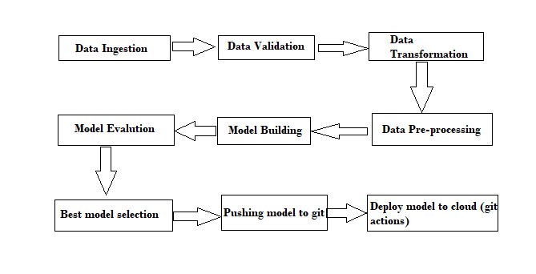

# Architecture Description

##### Data Description

We perform energy analysis using 12 different building shapes simulated in Ecotect. The buildings differ with respect to the glazing area, the glazing area distribution, and the orientation, amongst other parameters. We simulate various settings as functions of the afore-mentioned characteristics to obtain 768 building shapes. The dataset comprises 768 samples and 8 features, aiming to predict two real valued responses. It can also be used as a multi-class classification problem if the response is rounded to the nearest integer.

##### Data Transformation

In the Transformation Process, we will convert our original dataset which is in JSON format to CSV Format. And will merge it with the Scrapped dataset.

##### Data Insertion into Database

1. Database Creation and connection - Create a database with name passed. If the database is already created, open the connection to the database.
2. Table creation in the database.
3. Insertion of files in the table

#### Export Data from Database

Data Export from Database - The data in a stored database is exported as a CSV file to be used for Data Pre-processing and Model Training.

##### Data Pre-processing

Data Pre-processing steps we could use are Null value handling, Imbalanced data set handling, Handling columns with standard deviation zero or below a threshold, etc.

#### Model Building

After clusters are created, we will find the best model for each cluster. For each cluster, algorithms will be passed with the best parameters derived from Grid-Search. We will calculate the MSE,RMSE scores for models and select the model with the best score..

##### Data from User

Here we will collect building parameter

#### Data Validation

Here Data Validation will be done, given by the user

##### User Data Inserting into Database

Collecting the data from the user and storing it into the database Mongo DB.

##### Deployment

We will be deploying the model to Heroku.