India AQI Analysis and Prediction

Author: Ashish Singh
IBM SkillsBuild Data Analytics with AI Academic Internship (BharatCares + AICTE)

Abstract
This report presents an end-to-end data analytics and machine learning pipeline for analyzing and predicting the Air Quality Index (AQI) in 26 major Indian cities from 2015 to 2020. Severe air pollution is a critical health hazard in India, featuring strong geographic and seasonal variations. We cleaned the dataset (handling significant missing values), performed exploratory data analysis to identify key patterns, and quantified the impact of the 2020 COVID-19 lockdown. Finally, we engineered time-series lag features and trained machine learning models (Linear Regression, Random Forest, XGBoost) to predict next-day AQI, achieving an R-squared of 0.830 with the Random Forest model.

1. Introduction
Air pollution in Indian cities is among the worst globally. The Air Quality Index (AQI) aggregates various pollutant concentrations (PM2.5, PM10, NOx, etc.) into a single metric representing health risks. This project aims to clean historical daily pollutant data, uncover insights about the spatial and temporal distribution of air pollution in India, and build predictive models to forecast next-day AQI. Accurate short-term forecasting is crucial for public health planning and policy enforcement.

2. Dataset
The dataset 'Air Quality Data in India (2015-2020)' was sourced from Kaggle. It contains daily recordings for 26 cities, yielding 29,531 total rows across 16 columns. Key columns include Date, City, various pollutants (PM2.5, PM10, NO, NO2, NOx, NH3, CO, SO2, O3, Benzene, Toluene, Xylene), and the target variable, AQI. Data sparsity was a major challenge: Xylene was dropped due to >61% missing data, while remaining columns were imputed using a per-city forward-fill and back-fill strategy.

3. Methodology
1. Data Cleaning: Date parsing, dropping heavily missing columns, per-city imputation, and IQR-based outlier clipping.
2. Exploratory Data Analysis (EDA): Visualizing city rankings, seasonal heatmaps, and pollutant correlations.
3. Insight Generation: Comparative analysis of the 2020 COVID lockdown and Delhi's winter anomaly.
4. Feature Engineering: Extracting date features (Month, Season), categorical encoding (City), and 3-day lag features for AQI and Particulate Matter.
5. Modeling: A chronological train/test split (Train: 2015-2019, Test: 2020) was used. We trained a Persistence Baseline, Linear Regression, Random Forest, and XGBoost.
6. Explainability: SHAP values and feature importance scores were computed to interpret model predictions.

4. Results and Insights

4.1 City-wise AQI Ranking
Ahmedabad and Delhi consistently recorded the worst average AQI over the 5-year period.
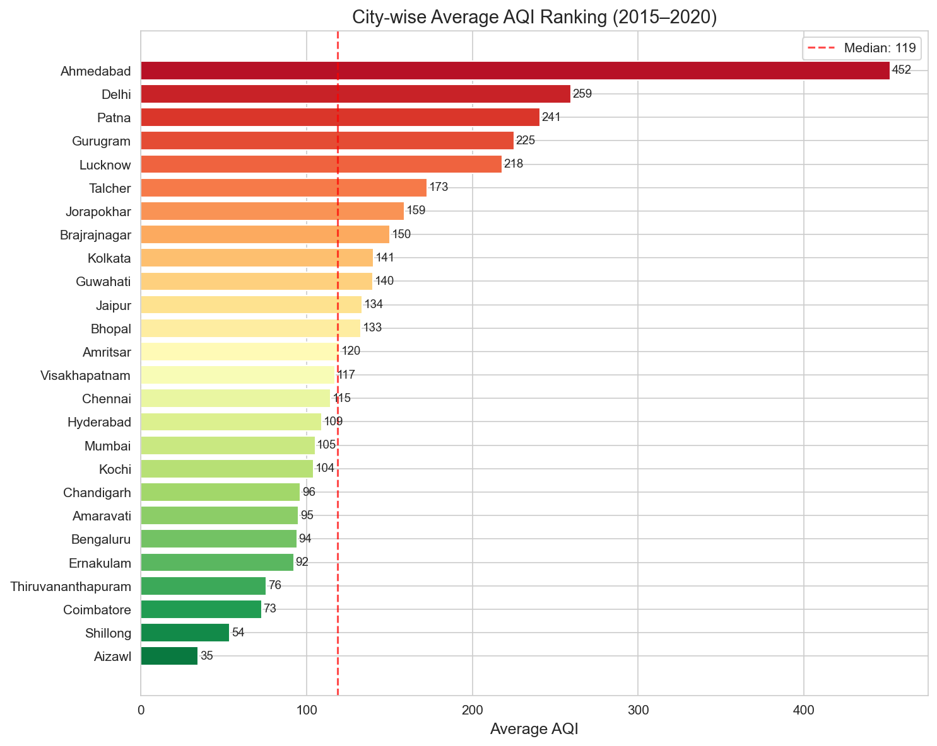

4.2 Seasonal Patterns and the Winter Spike
North Indian cities (especially Delhi) experience a dramatic AQI spike in winter (Nov-Jan), whereas southern and coastal cities maintain a much flatter, cleaner profile year-round.
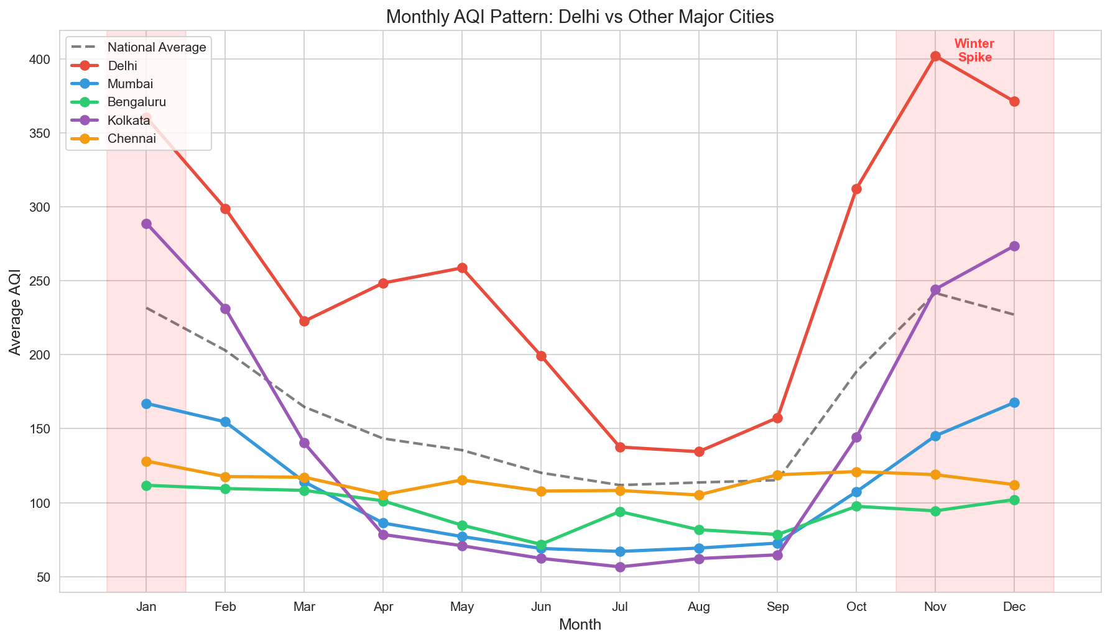

4.3 Impact of the COVID-19 Lockdown
Comparing March-June 2019 to the same period in 2020 revealed a drastic drop in AQI across almost all cities, quantifying the massive reduction in vehicular and industrial emissions.
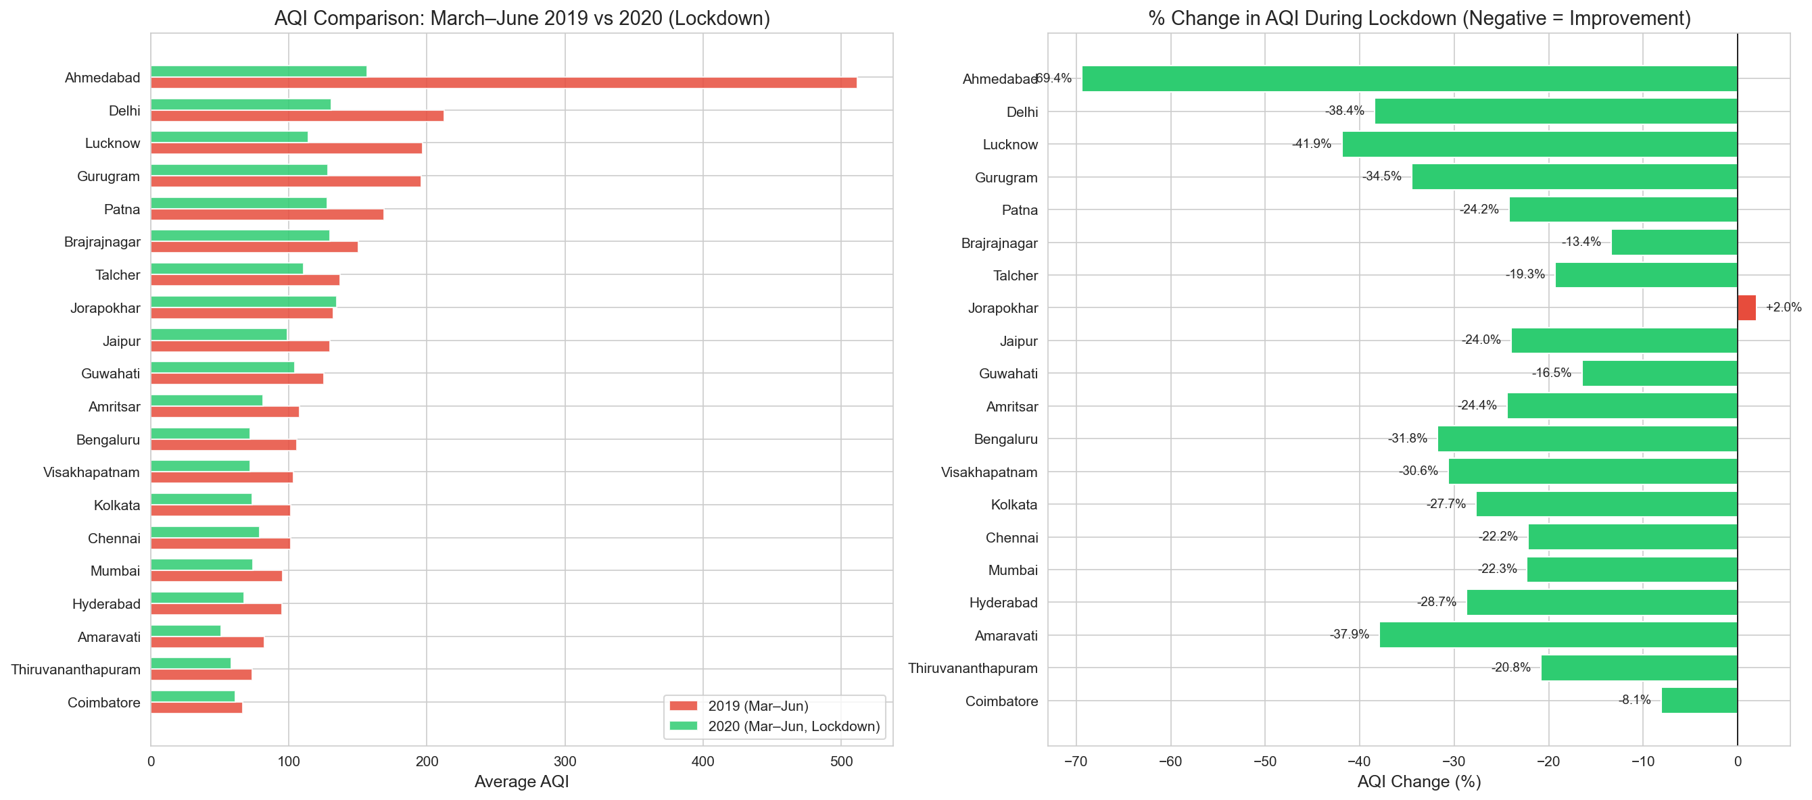

4.4 Next-Day AQI Prediction
The models were evaluated on the 2020 test set. The Random Forest model achieved the best performance:
- Persistence Baseline: MAE = 19.20, RMSE = 41.10, R2 = 0.754
- Linear Regression: MAE = 18.60, RMSE = 37.34, R2 = 0.797
- Random Forest: MAE = 16.78, RMSE = 34.14, R2 = 0.830
- XGBoost: MAE = 19.98, RMSE = 37.19, R2 = 0.799
Tree-based models successfully captured general AQI trends, though they tended to slightly underestimate extreme peaks.
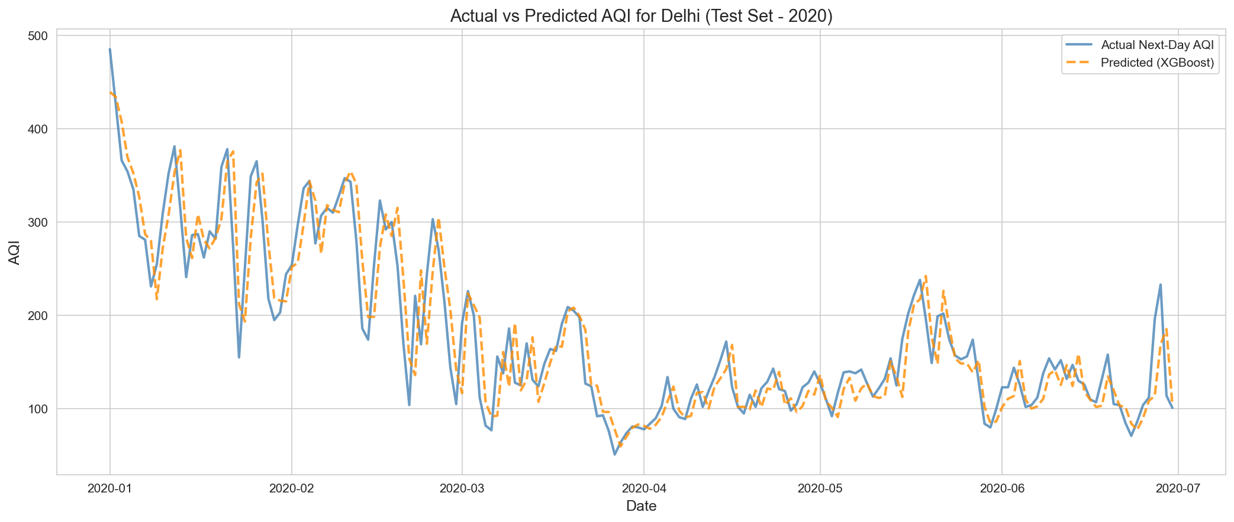

4.5 Model Explainability
SHAP analysis indicates that the most recent AQI reading (AQI) and the 1-day lag (AQI_lag1) are the strongest predictors of tomorrow's AQI. The encoded city feature is also highly critical, capturing the varying geographical baseline pollution.
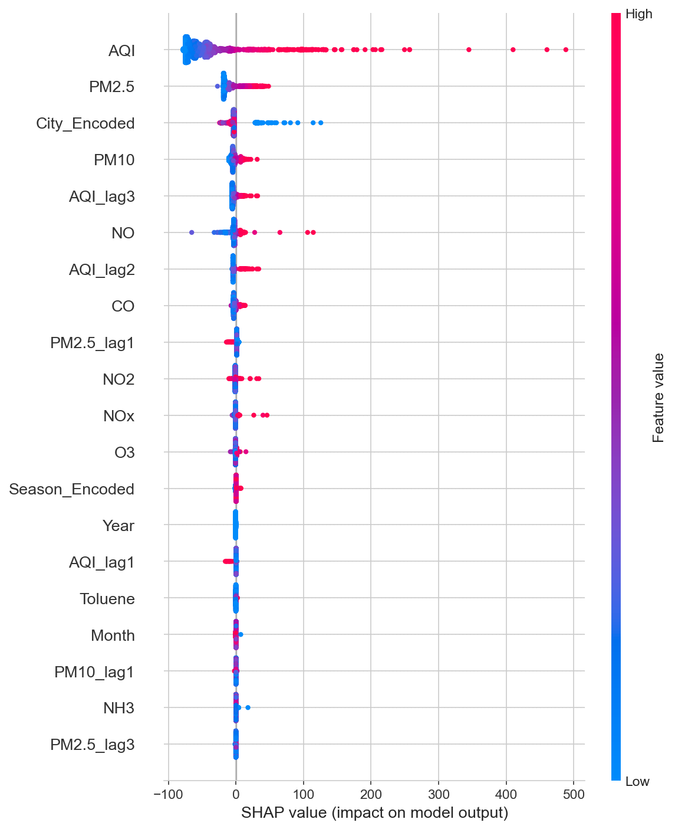

5. Conclusion
This project successfully analyzed 5 years of daily Indian air quality data, quantifying structural geographical inequalities and temporary environmental reprieves (lockdown). Next-day AQI prediction was highly effective using lagged features and Random Forest models. Future work should integrate meteorological data (temperature, wind speed) and explore sequence models like LSTMs to better anticipate extreme pollution spikes.

6. References
1. Kaggle - Air Quality Data in India (2015-2020).
2. Scikit-learn, XGBoost, and SHAP documentation.
3. Pandas and Matplotlib/Seaborn documentation.

