|  |  |  |
| --- | --- | --- |
| NAME | ROLL NO. | REGISTRATION NO. |
| ASHISH SINGH | 1 | 12321359 |
| SHASHANK SINGH | 25 | 12317304 |
| GUDALA NITHEESH | 50 | 12319967 |

**INTERNET PROGRAMMING LABORATORY**

**(CSE-326)**

**PROJECT REPORT ON BLOOD DONATION WEBSITE**

BY: -

**TABLE OF CONTENTS: -**

1. **Introduction.**
2. **Technologies Used.**
3. **Features of Website.**
4. **Screenshots of Website.**
5. **Flow of Project.**
6. **Conclusion.**
7. **References.**

**INTRODUCTION**

In the pursuit of health and well-being, the act of blood donation stands as a cornerstone of compassionate community engagement. As we culminate our efforts in this final report, we reflect on the journey we embarked upon with the creation and implementation of our blood donation website. This platform serves as more than just a digital space; it symbolizes a collective commitment to saving lives, fostering connections, and building a community of altruistic individuals.

Our venture began with a vision – a vision to bridge the gap between those in urgent need of blood and the generous souls willing to donate. Through meticulous planning, technological innovation, and a deep understanding of the significance of this life-saving act, we aimed to create a seamless and impactful experience for both donors and recipients.

This final report serves as a comprehensive documentation of our blood donation website's inception, development, and the outcomes achieved. From the intricacies of designing an intuitive user interface to the implementation of robust security measures, each aspect of the platform is scrutinized and presented here. Moreover, the report delves into the societal impact of our initiative, shedding light on the lives touched, the communities strengthened, and the broader implications of fostering a culture of giving.

As we explore the pages of this report, we invite you to witness the collective impact of our endeavors. Through the testimonials of donors and the stories of those who have received the gift of life, we aim to convey not only the quantitative success of our platform but also the profound and immeasurable human connections forged through the act of blood donation.

We extend our deepest gratitude to all the donors, recipients, and stakeholders who have played a pivotal role in the realization of this project. Each drop of blood donated, every connection made, and every life saved is a testament to the collaborative spirit that fuels our mission.

Join us on this reflective journey as we celebrate the milestones, acknowledge the challenges, and pave the way forward for a future where the act of blood donation continues to be a beacon of hope, unity, and compassion. Welcome to the final report of our Blood Donation Website – a testament to the power ofhumanity coming together to make a lasting impact on the world.

**TECHNOLOGIES USED: -**

HTML (Hypertext Markup Language):

1. **Structure:**
   * Utilized HTML tags to structure the content of the website, including headings, paragraphs, lists, and images.
2. **Semantic Elements:**
   * Incorporated semantic HTML5 elements like **<article>**, **<section>**, **<header>**, and **<footer>** to enhance the document structure and improve accessibility.
3. **Hyperlinks:**
   * Created hyperlinks (**<a>** tags) to connect different pages or link to external resources, promoting navigation and external references.

CSS (Cascading Style Sheets):

1. **Styling:**
   * Applied CSS styles to enhance the visual presentation of HTML elements, including fonts, colors, margins, and paddings.
2. **Layout:**
   * Utilized CSS for layout design, employing techniques like Flexbox or Grid to create a responsive and visually appealing structure.
3. **Transitions:**
   * Added CSS transitions to enhance user experience, making the website more engaging and dynamic.
4. **Classes and IDs:**
   * Assigned classes and IDs to HTML elements for targeted styling and efficient CSS organization.

**Results**

We have designed a website that spreads awareness in society, persuades knowledge by addressing the importance of donation of blood, this initiative directly contributes to several major goals. The website serves as a digital advocate for educational impact, emergency response, community building, environmental resilience, and community well-being, aligning with the global agenda for positive change.

**FEATURES OF WEBSITE: -**

A well-designed blood donation website should incorporate a range of features to facilitate the donation process, engage donors, and provide valuable information. Here are some essential features for a blood donation website:

1. **User Registration and Profile Management:**
   * Secure registration for donors to create profiles.
   * Profile management tools for donors to update personal information, preferences, and donation history**.**
2. **Search and Scheduling:**
   * Search functionality for donors to find donation centers and events.
   * Online scheduling system for donors to book appointments for blooddonation.
3. **Real-Time Availability:**
   * Display of real-time availability of donation slots at various centers.
   * Notifications for donors about upcoming events or urgent needs.
4. **Educational Resources:**
   * Informational content about the importance of blood donation.
   * FAQs and educational materials regarding the donation process, benefits, and impact.
5. **Social Media Integration:**
   * Social sharing buttons to encourage donors to share their donation experiences.
   * Integration with social media platforms for broader outreach and awareness.

By incorporating these features, a blood donation website can enhance user experience, encourage regular donations, and contribute to the overall success of blood donation initiatives**.**

**SCREENSHOTS OF WEBSITE: -**

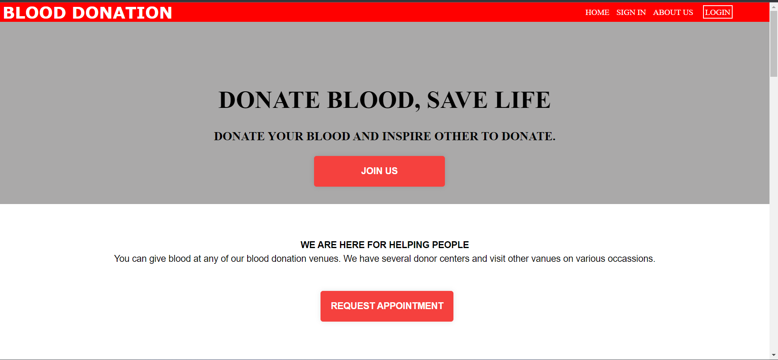

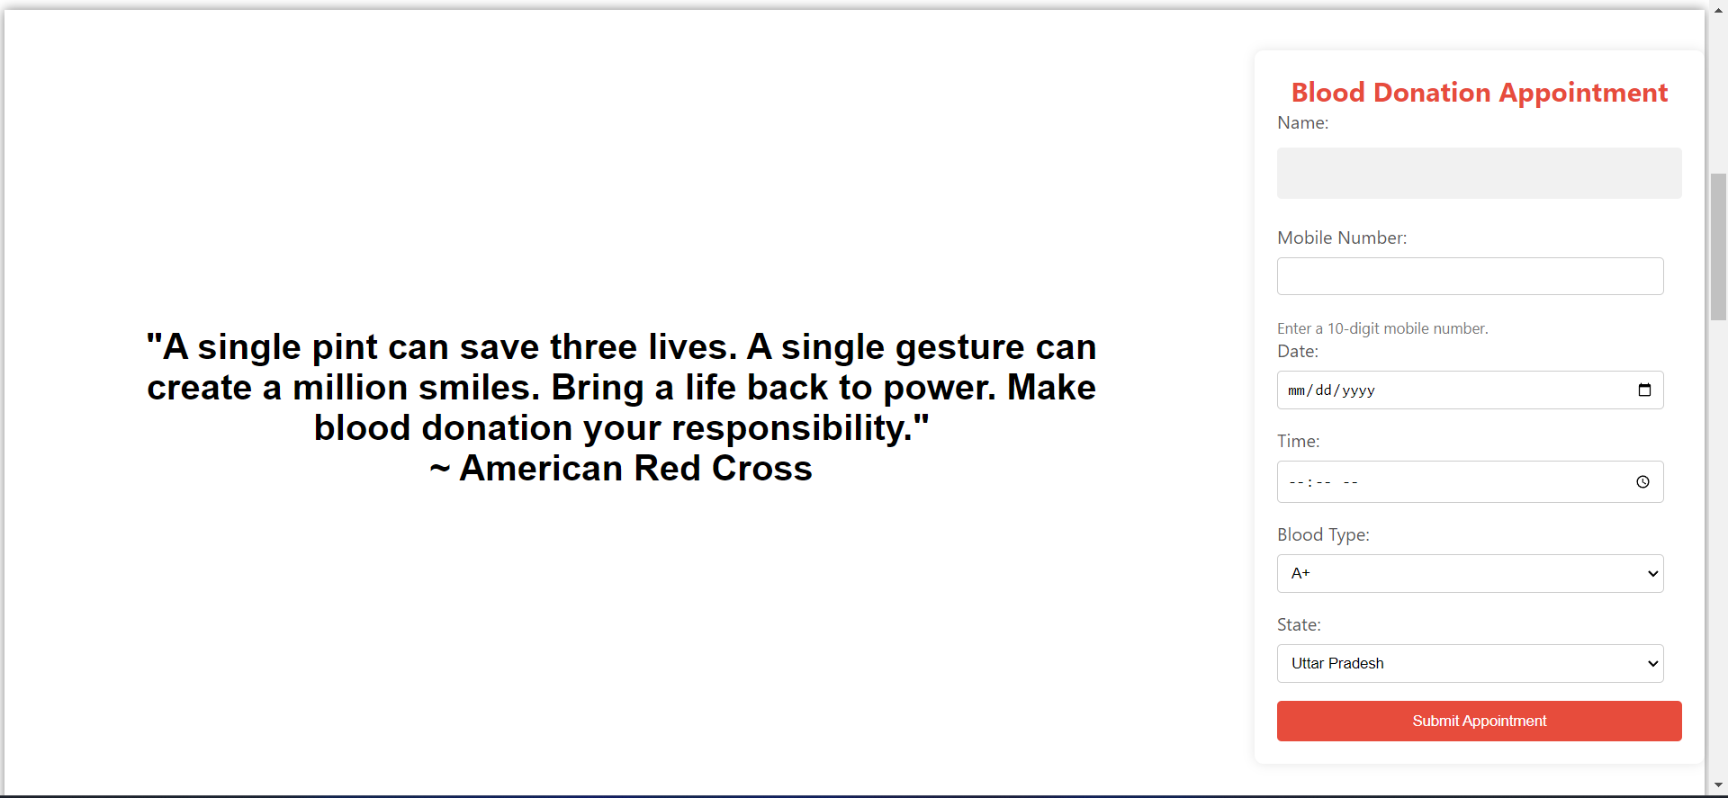

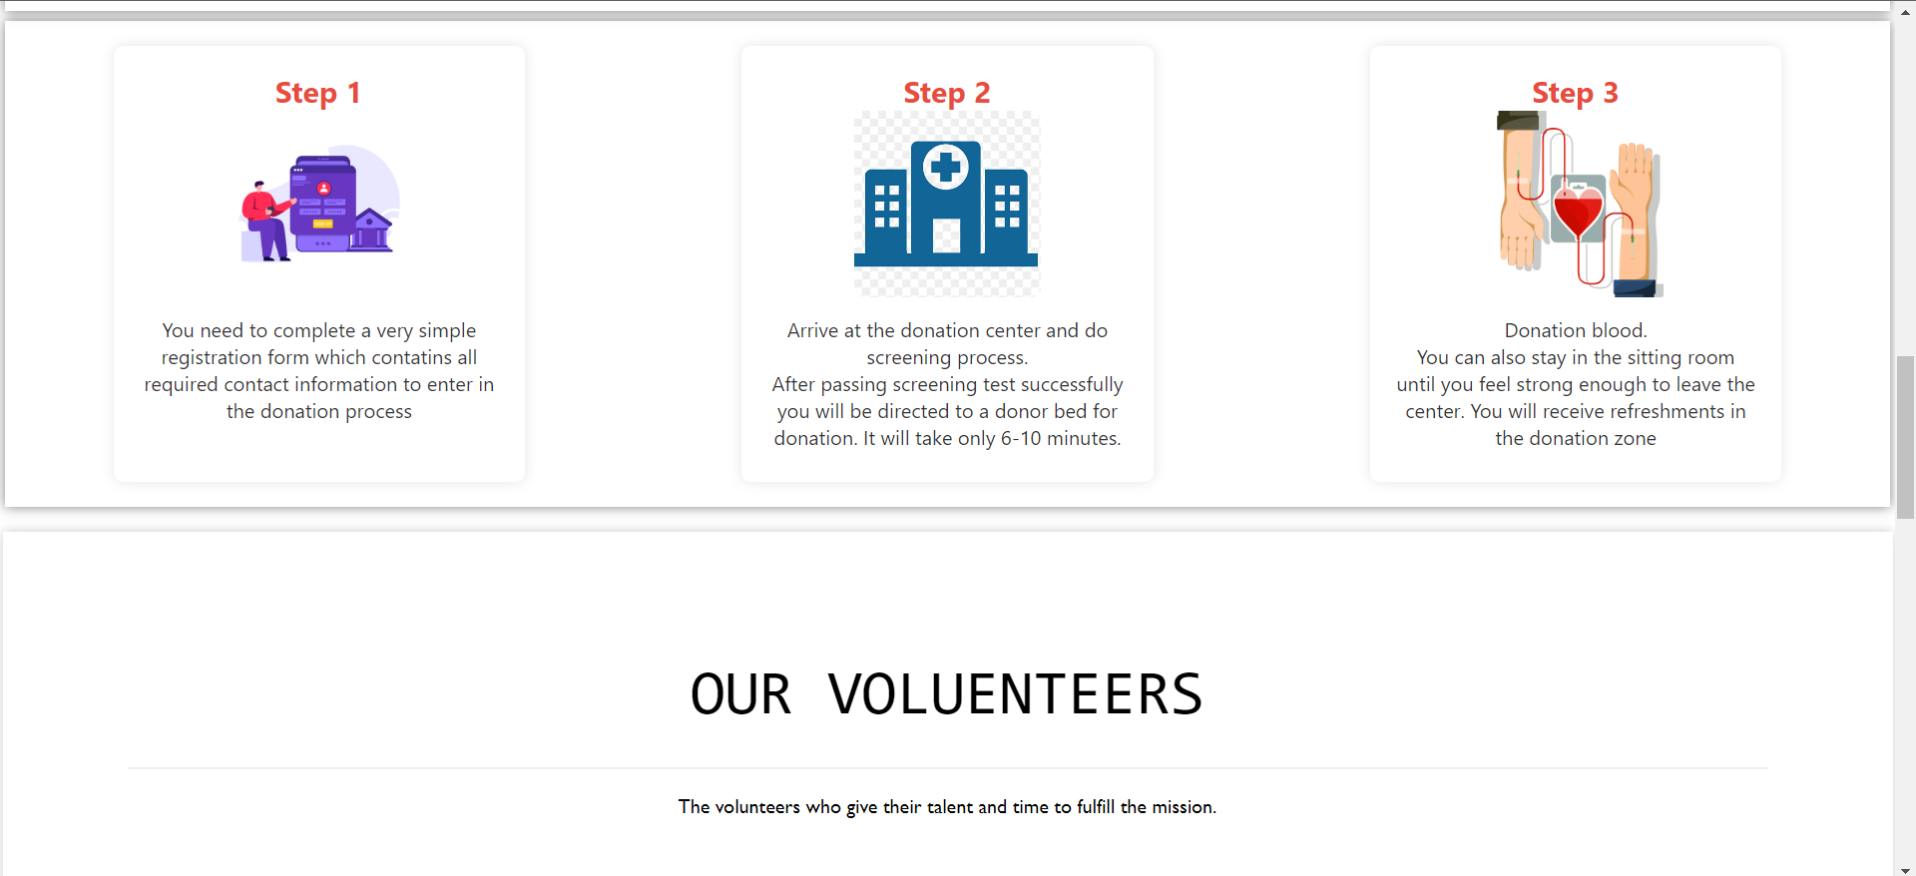

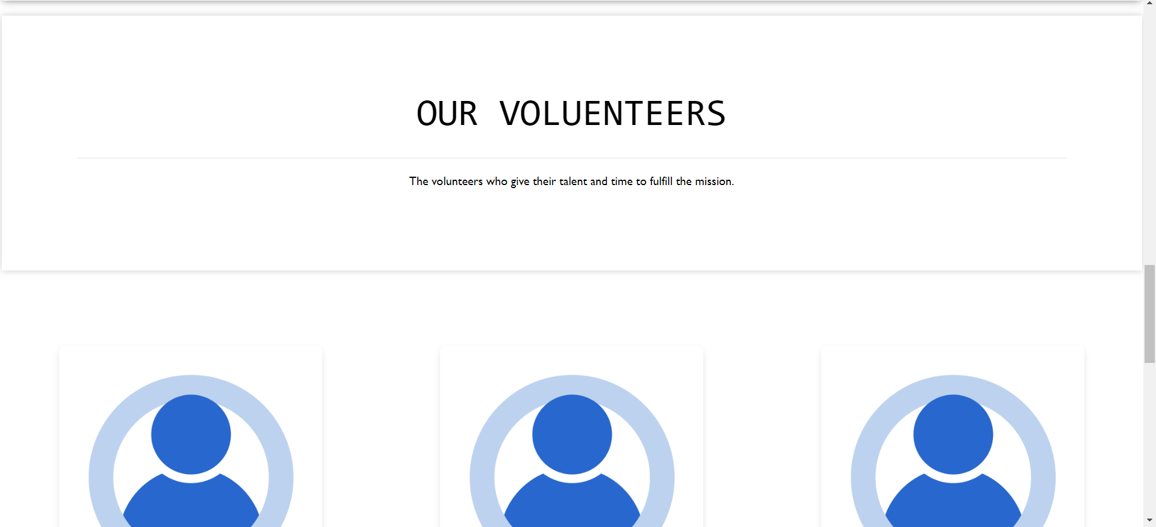

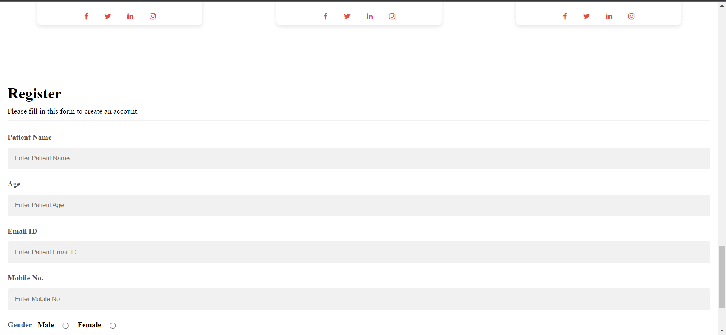

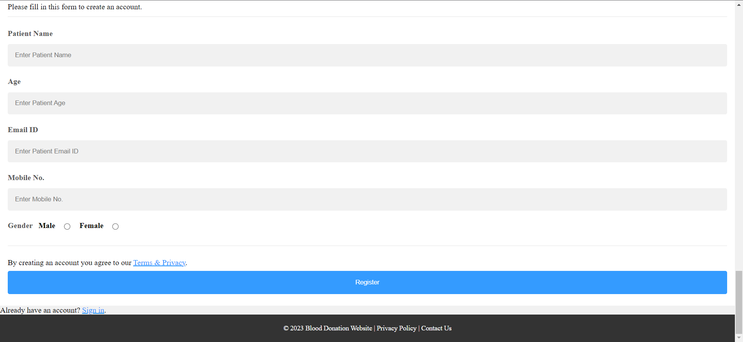

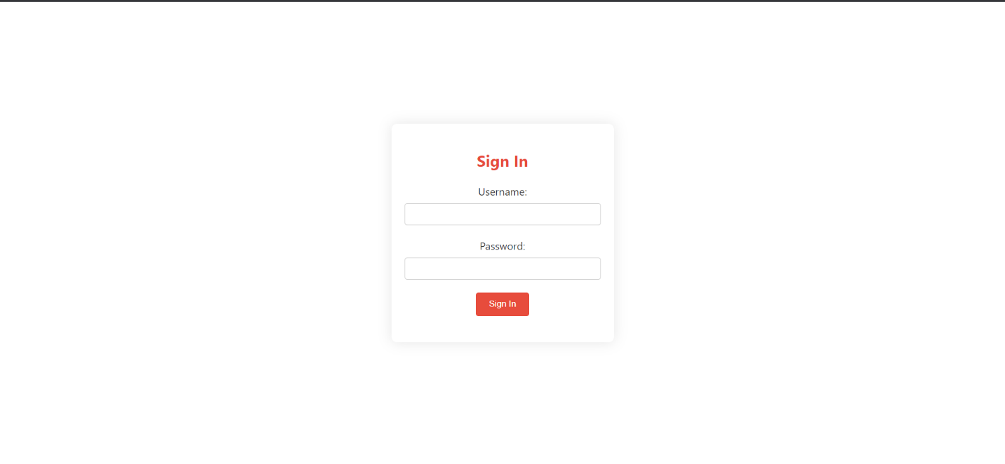**FLOW OF PROJECT: -**

1. SHASHANK SINGH (12317304) – I handled the CSS and some sections of HTML part. I have made the front page, navigation bar, Blood Donation Appointment box and the registration page.

**Conclusion: -**

The creation and implementation of the blood donation website stands as a testament to the transformative power of technology, community engagement, and human compassion. Through this initiative, we have forged a digital platform that not only facilitates the life-saving act of blood donation but also cultivates a sense of solidarity and collective responsibility within our community.

The journey from conception to execution has been marked by milestones, challenges, and, above all, the unwavering commitment of donors, recipients, and stakeholders. The impact of the blood donation website extends beyond the digital realm, reaching into the lives of individuals who have received the gift of life and the broader community that has rallied together in support.

As we reflect on the results presented in this final report, the blood donation website has become a vital tool in addressing critical blood shortages, raising awareness about the importance of donation, and fostering a culture of giving. The user engagement metrics, success stories, and community-building initiatives all underscore the positive outcomes achieved through this endeavor.

The success of the blood donation website can be attributed to the collaboration and dedication of a diverse range of individuals, from donors and recipients to developers, administrators, and community partners. The impact of each blood donation resonates far beyond the confines of the virtual platform, creating a ripple effect of hope, healing, and human connection.

While celebrating the achievements documented in this report, we recognize that the journey does not end here. The insights gained and the lessons learned will inform future enhancements and expansions of the blood donation website. Our commitment to saving lives and making a lasting impact on the well-being of our community remains steadfast, and we look forward to evolving and growing in our mission.

In the grand tapestry of healthcare and humanitarian efforts, the blood donation website stands as a shining thread, weaving together the stories of generosity, resilience, and compassion. It is a beacon of hope, a symbol of unity, and a reminder that, together, we can make a profound and lasting difference in the lives of those in need. As we close this chapter, we express gratitude to all who have contributed to the success of this initiative and look ahead to a future where the spirit of giving continues to flourish.

**Top of Form**

**REFERCENCES: -**

1. American Red Cross. (2022). Blood Donation Guidelines.

[Link: - <https://www.redcross.org/>]

1. World Health Organization. (2021). Blood Transfusion Safety.

[Link: - <https://www.who.int/health-topics/blood-transfusion-safety>]

1. GitHub.

[Link: - <https://github.com/>]

1. CHATGPT

[Link: - <https://chat.openai.com/>]

**LINK FOR WEBSITE: -** <https://ayndrome.github.io/Blooddonation/>