**What is MySQL?**

MySQL is a database management system.

**Database?**

It is a collection of data stored in a format that can be easily accessible.

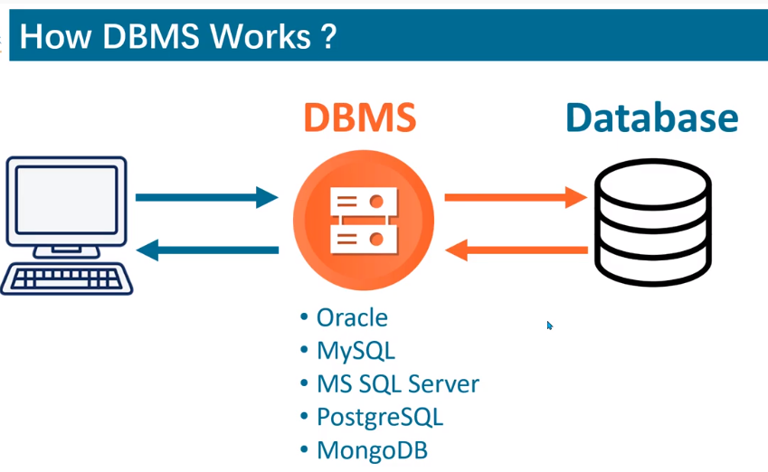

Here this computer is a client and it want to save his data in database, so he can do it using DBMS[oracle, mysql, mondoDB etc.]

Types of Database:

* [**Centralised database**](https://www.tutorialspoint.com/Centralised-database)**.**
* [**Distributed database**](https://www.tutorialspoint.com/Distributed-database)**.**
* [Personal database](https://www.tutorialspoint.com/Personal-database).
* [End-user database](https://www.tutorialspoint.com/End-User-Database).
* [Commercial database](https://www.tutorialspoint.com/Commercial-Database).
* [**NoSQL database**](https://www.tutorialspoint.com/NoSQL-Databases)**.**
* [Operational database](https://www.tutorialspoint.com/Operational-Database).
* [**Relational database**](https://www.tutorialspoint.com/Relational-Databases).
* [Cloud database](https://www.tutorialspoint.com/Cloud-Databases).
* [Object-oriented database](https://www.tutorialspoint.com/Object-Oriented-Databases).
* [Graph database](https://www.tutorialspoint.com/Graph-Databases).

[**Relational database**](https://www.tutorialspoint.com/Relational-Databases) **[RDBMS]:**

**MySQL** is a relational database, it stores data in form of tables and each table is related with each other.

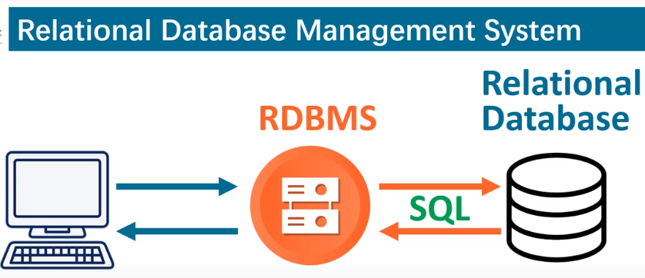

As we know to add or retrieve any data from the Database we need DBMS and if our database is Relational database then we needs RDBMS to add and retrieve data

RDBMS use SQL for Retrieval and addition operation.

**NoSQL database:**

In this data is not stored in tabular form.

Data stored in the form of document.

For ex: MongoDB, Redis, Cassendra etc.

**Adv of MySQL:**

* Cross platform
* Open source
* It is rdbms, i.e each table is related to other
* It is fast

**Types of data types in MySQL?**

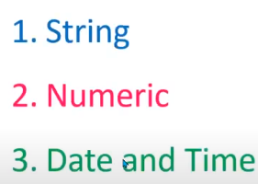

**String datatype consist of following:**

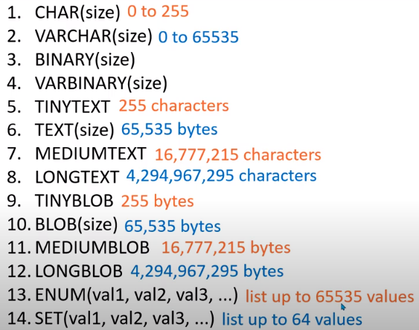

**Example of enum:**

**Enum(red, orange, blue, green)** we canselect any value from the defined value in enum

Set is same as Enum, where we can select any value from the defined values.

**Numeric datatype consist of following:**

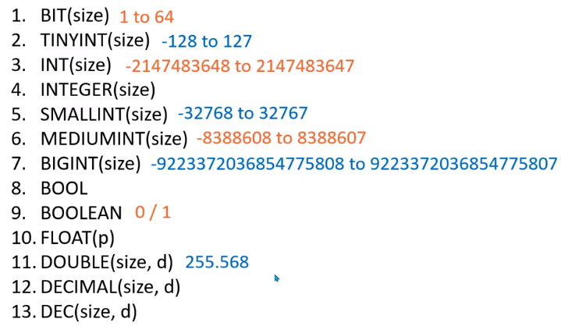

**Date and Time datatype consist of following:**

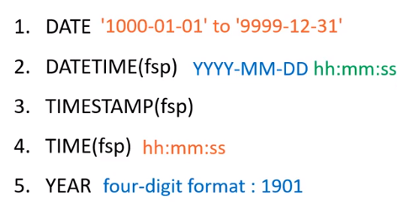

**Create database?**

create database databasename;

**Use database?**

use databasename;

**Create table?**

Create table product (

id int,

name varchar(20),

dob date,

mobile varchar(20),

gender varchar(8)

);

**Insert into table?**

insert into school (id, name, dob, mobile, gender) values (1, "Ashish", "1996-09-09", 1111111111, "Male");

**Insert multiple rows in a table?**

insert into school (id, name, dob, mobile, gender)

values (2, "Raman", "1992-02-01", 2222222222, "Male"),

(3, "Sachin", "1994-12-12", 3333333333, "Male"),

(4, "Neeraj", "1993-02-04", 4444444444, "Male");

**Constraints in MySQL?**

Constraints mean restriction.

**Types of constraints in MYSQL?**

**NOT NULL**

**UNIQUE**

**DEFAULT**

**CHECK**

FOREIGN KEY

PRIMARY KEY

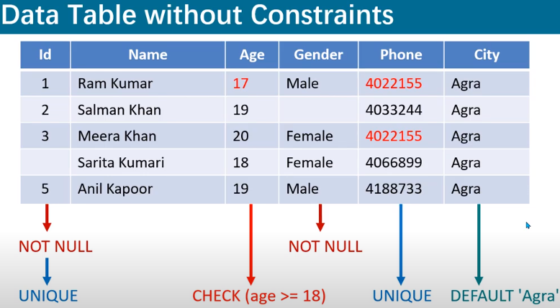

In the above table we don’t have any constraint or restriction.

For Example: in the above table we should have following restrictions:

1. Id must be unique and not null.
2. Age must be greater than 18.
3. Gender must be not null.
4. Phone number should be unique.
5. If city is null than it should be auto completed.

create table school(

id int not null unique,

name varchar(20) not null,

age int not null check(age>=18),

gender varchar(8) not null,

mobile varchar(15) not null unique,

city varchar(10) default 'Delhi'

);

**Drop in mysql?**

drop table tablename;

whole table is deleted even the heading of table won’t exist.

**Where in MYSQL?**

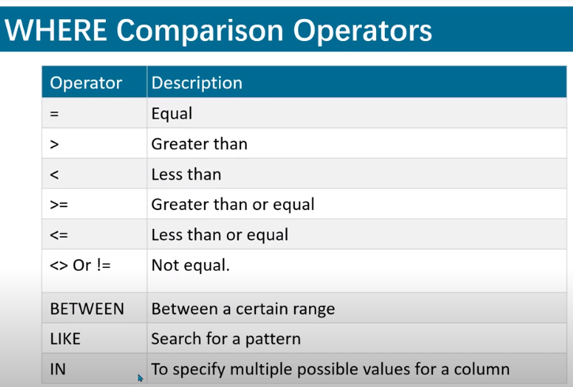

Select * from school where age! =23;

|  |  |  |  |  |  |
| --- | --- | --- | --- | --- | --- |
| 1 | Ashish | 23 | Male | 1111111111 | Delhi |
| 2 | Mahesh | 18 | Male | 2222222222 | Delhi |
| 3 | Raman | 22 | Male | 3333333333 | Delhi |
| 4 | Geeta | 23 | Female | 4444444444 | Delhi |
| 5 | Saurav | 28 | Male | 5555555555 | Delhi |

**AND, OR, NOT, IN, NOT IN, BETWEEN, NOT BETWEEN Operators?**

select * from school where (age < 23 **or** name = "Ashish") **and** id=2;

|  |  |  |  |  |  |
| --- | --- | --- | --- | --- | --- |
| 2 | Mahesh | 18 | Male | 2222222222 | Delhi |

Select cityname from city where cid in(2,5); //display records with cid 2,5

Select cityname from city where (cid=2 or cid=5);



select * from school where not age =19 and not city='Delhi';

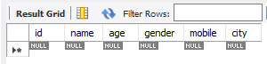

select * from school where age **in**(18,22);

|  |  |  |  |  |  |
| --- | --- | --- | --- | --- | --- |
| 2 | Mahesh | 18 | Male | 2222222222 | Delhi |
| 3 | Raman | 22 | Male | 3333333333 | Delhi |

select * from school where age not in(18,22);

|  |  |  |  |  |  |
| --- | --- | --- | --- | --- | --- |
| 1 | Ashish | 23 | Male | 1111111111 | Delhi |
| 4 | Geeta | 23 | Female | 4444444444 | Delhi |
| 5 | Saurav | 28 | Male | 5555555555 | Delhi |

select * from city where cid between 3 and 5; //it include nums from 3 to 5

select * from school where name between 'a' and 'n'; //it include chars from a to m

|  |  |  |  |  |  |
| --- | --- | --- | --- | --- | --- |
| 1 | Ashish | 23 | Male | 1111111111 | Delhi |
| 2 | Mahesh | 18 | Male | 2222222222 | Delhi |
| 4 | Geeta | 23 | Female | 4444444444 | Delhi |

select * from school where age not between 22 and 28; //not include 22 and 28

|  |  |  |  |  |  |
| --- | --- | --- | --- | --- | --- |
| 2 | Mahesh | 18 | Male | 2222222222 | Delhi |

**Two types of wildcard characters are given below:**

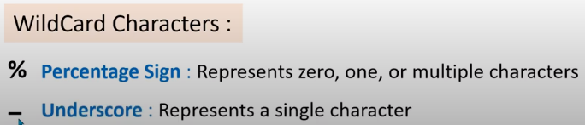

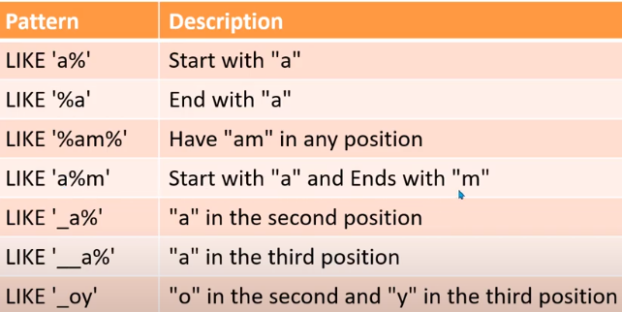

**Like, Not Like operator in MYSQL:**

select * from school where name like "_s_i%";

|  |  |  |  |  |  |
| --- | --- | --- | --- | --- | --- |
| 1 | Ashish | 23 | Male | 1111111111 | Delhi |

select * from school where age like "2%";

|  |  |  |  |  |  |
| --- | --- | --- | --- | --- | --- |
| 2 | Mahesh | 18 | Male | 2222222222 | Delhi |

select * from school where name not like "_s_i%";

|  |  |  |  |  |  |
| --- | --- | --- | --- | --- | --- |
| 2 | Mahesh | 18 | Male | 2222222222 | Delhi |
| 3 | Raman | 22 | Male | 3333333333 | Delhi |
| 4 | Geeta | 23 | Female | 4444444444 | Delhi |
| 5 | Saurav | 28 | Male | 5555555555 | Delhi |

select * from school where name like "_s_i%" or gender like "__m%";

|  |  |  |  |  |  |
| --- | --- | --- | --- | --- | --- |
| 1 | Ashish | 23 | Male | 1111111111 | Delhi |
| 4 | Geeta | 23 | Female | 4444444444 | Delhi |

**Regular Expression in MYSQL?**

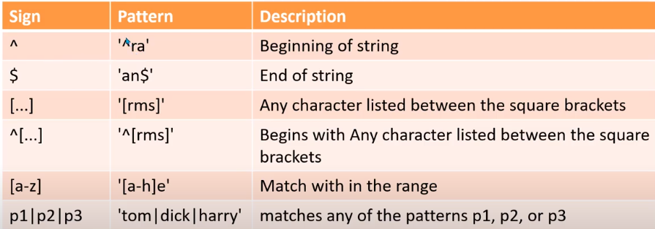

select * from school where name regexp 'as'; //print any name which contains ‘as’ anywhere

select * from school where name regexp '^ra'; // print any name which starts from ‘ra’

select * from school where age regexp '3$'; // print any age which ends from ‘3’

select * from school where name regexp 'es|et|u'; // print any name which contains any of these three 'es|et|u'

select * from school where name regexp '[is]'; //print all records which contains either i or s.

select * from school where name regexp '[is]a'; //print all records which contains either ia or sa.

select * from school where name regexp '[a-l]a';// print aa, ba,ca….la.

**ORDERBY in MYSQL?**

select * from school order by age; //it is in AESC order by default

|  |  |  |  |  |  |
| --- | --- | --- | --- | --- | --- |
| 2 | Mahesh | 18 | Male | 2222222222 | Delhi |
| 3 | Raman | 22 | Male | 3333333333 | Delhi |
| 1 | Ashish | 23 | Male | 1111111111 | Delhi |
| 4 | Geeta | 23 | Female | 4444444444 | Delhi |
| 5 | Saurav | 28 | Male | 5555555555 | Delhi |

Select * from school where gender ='male' order by age desc;

|  |  |  |  |  |  |
| --- | --- | --- | --- | --- | --- |
| 5 | Saurav | 28 | Male | 5555555555 | Delhi |
| 1 | Ashish | 23 | Male | 1111111111 | Delhi |
| 3 | Raman | 22 | Male | 3333333333 | Delhi |
| 2 | Mahesh | 18 | Male | 2222222222 | Delhi |

**DISTINCT in MYSQL?**

select distinct age from school; //show all duplicate data only once.

|  |
| --- |
| 23 |
| 18 |
| 22 |
| 28 |
| select distinct city from school;  Delhi |

**IS NULL, IS NOT NULL in MYSQL?**

Select * from school where age is null;

|  |  |  |  |  |  |
| --- | --- | --- | --- | --- | --- |
|  |  |  |  |  |  |

select age from school where age is not null;

|  |
| --- |
| 23 |
| 18 |
| 22 |
| 23 |
| 28 |

**LIMIT in MYSQL?**

select **\*** from school limit 3; //print the first 3 records of the table

select **\*** from school where city='Delhi' order by age desc limit 3;

**OFFSET in MYSQL?**



select * from school limit 3,3; // print 3(limit) rows of the table from the 4th row(offsetr)

select distinct(salary)from school order by salary desc limit n-1,1;

select * from school where city='Delhi' order by age desc limit 3,3; //print 3 rows from 4th row

|  |  |  |  |  |  |
| --- | --- | --- | --- | --- | --- |
| 3 | Raman | 22 | Male | 3333333333 | Delhi |
| 2 | Mahesh | 18 | Male | 2222222222 | Delhi |

**Count Sum Min Max Avg in MYSQL?**

select count(age) from school where age=23;

2

select sum(age) from school where gender='male';

91

select min(age)from school;

18

select max(age) as 'maximum age' from school ; //**as** written temperory age

28

select avg(age)from school;

22.8000

**UPDATE in MYSQL?**

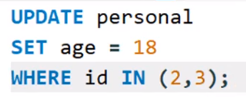

Update school set mobile=1111111111 where mobile=8888888888 or mobile=3333333333;

update school set mobile=1111111111 where mobile IN(8888888888 ,3333333333);

**COMMIT and ROLLBACK in MYSQL?**

Commit and rollback works only with three commands i.e:

1. INSERT
2. UPDATE
3. DELETE

update product set pprice=78 where pid=2;

commit;

update product set pprice=225 where pname='chicken';

rollback;

In above example if we price update price of pid2 i.e ‘78’ and chicken i.e ‘225’ and do a rollback then the price of chicken will change to previous one and price of pid i.e ‘78’ wil remain same.

If we do a commit after updating both the[pid and chicken] then do a rollback then no change will happen.

**DELETE in MYSQL?**

delete from product where pid=5;

**DELETE vs TRUNCATE?**

**Delete** is a DML command whereas **truncate** is DDL command.

**Truncate** can be used to **delete** the entire data of the table. On the other hand , **delete** statement can be used for **deleting** the specific data.

**What is a key?**

Key is the attribute of a table like in student table we have sname, srollno, sage etc so key can be anything it may be sage, sname, srollno

**CANDIDATE key**

**PRIMARY key**

**ALTERNATRE key**

**SUPER key**

**COMPOSITE key**

**FOREIGN key**

**CANDIDATE key in MYSQL?**

It is a column or set of columns in a table that qualifies/defines uniqueness of each row.

A table can have more than one 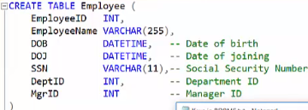candidate key.

In above image EmployeeID and SSN is unique for each employee so both are candidate key

**PRIMARY key in MYSQL?[it is a constraint]**

It is the candidate key which is most suited to maintain uniqueness in a table.

1. Primary key always contains unique data

**What is the difference between the Primary key and the Unique key?**

1. Primary key cannot have a null value but unique constraint can have a null value

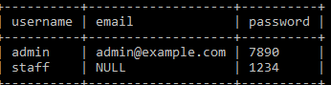// here username is primary key and email is unique key.

1. We can set only one table as primary key, but we make more than one column unique.

create table City(

cid int auto_increment,

cityname varchar(20) not null,

primary key(cid)

);

We can add primary key in an existing table using ALTER

alter table product add primary key(pid);

**ALTERNATRE key in MYSQL?**

They are other candidate keys which we are not chosen as primary key.

**SUPER key in mysql?**

It is the superset of candidate key, if we add any other column to candidate key then it will become candidate key.

**SSN+ DOJ** it become super key because we add one more key in candidate key

**COMPOSITE key in mysql?**

If a table don’t have a single column that qualifies for candidate key, then we have to select 2 or more columns to make a row unique.

**FOREIGN key in MYSQL? [it is a constraint]**

A foreign key is use to link two tables together.

A foreign key in one table use to point PRIMARY key in another table.

FOR ex: suppose we have two tables T1 and T2 in T2 we have a column name ‘City’ we want to make it foreign and in table T1 we have ‘CID’ which is PRIMARY key so, we can make ‘City’ as foreign key using primary key of T1.

create table personal(

id int auto_increment ,

name varchar(20) not null,

percentage double not null,

age int not null,

gender varchar(8) not null,

city int not null,

primary key(id),

foreign key(city) references city(cid)

);

Means FOREIGN key k andar vhi value hoti hai jo dusre table k andar primary key hoti hai.

We can add foreign key in existing table using alter

alter table product

add foreign key(pid) references student(id);

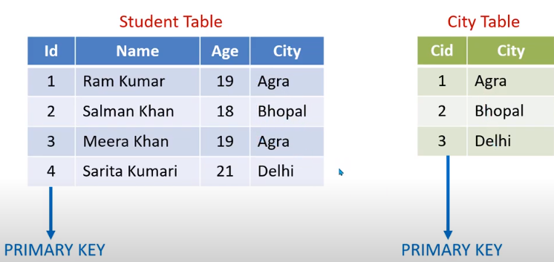

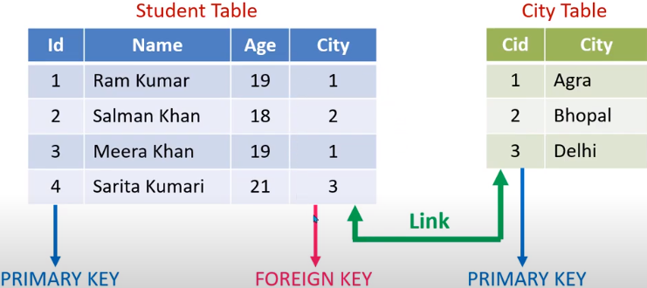

Adv of foreign key:

Table become fast as data storage is less.

**Can we make foreign key null and unique?**

Yes

**What is a join?**

The SQL statement that is used to make a connection between two or more tables based on the matching columns is called a join.

**Types of JOINS in MYSQL?**

INNER JOIN/ JOIN

LEFT JOIN

RIGHT JOIN

CROSS JOIN

INNER JOIN/ JOIN: select * from personal inner join city on personal.city= city.cid;

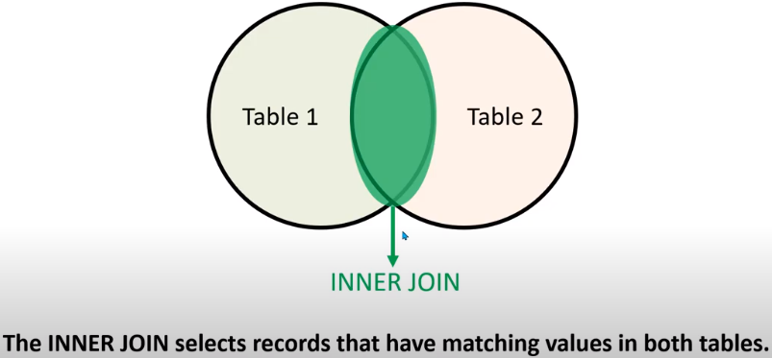

**LEFT JOIN:**

select personal.name, personal.percentage,city.cityname from personal left join city on personal.city = city.cid;

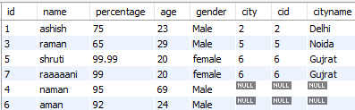

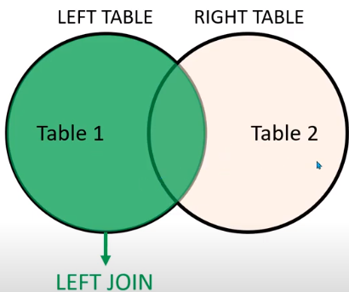



**RIGHT JOIN in MYSQL?**

select personal.name, personal.percentage,city.cityname

from personal right join city on personal.city = city.cid;

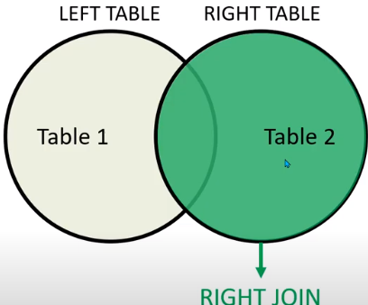



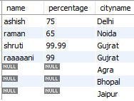

**CROSS JOIN in MYSQL?**

select * from personal cross join city;

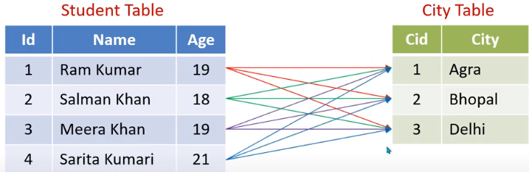

**JOIN Multiple Tables in MYSQL?**

The below syntax is same for LEFT and RIGHT join just change INNER to RIGHT or LEFT.

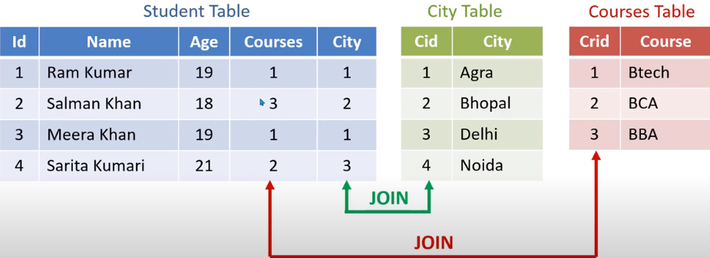

Student = Personal

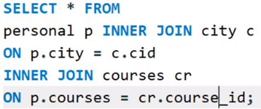

**GROUP BY in MYSQL?**

select age, count(age) from school group by age;

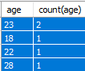

select age, count(age) from school where age>18 group by age ;

select age, count(age) from school group by age **having age>18**;

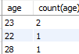

**SubQuery/Nested query in mysql?**

select gender from school where city in (select cityname from city where cid in(2)) ;

select gender from school where city=(select cityname from city where (cid=2));



select gender from school where exists (select cityname from city where cid in(2,3)) ;

print all gender if query after exist show result

select gender from school where not exists (select cityname from city where cid in(2,3)) ;

print all gender if query after not exist don’t show result

**UNION and UNION ALL in MYSQL?**

all selected tables should have same number of columns

UNION don’t show the duplicate results

select city from school union select cityname from city;



**UNION All** shows the duplicate results

select city from school union all select cityname from city;



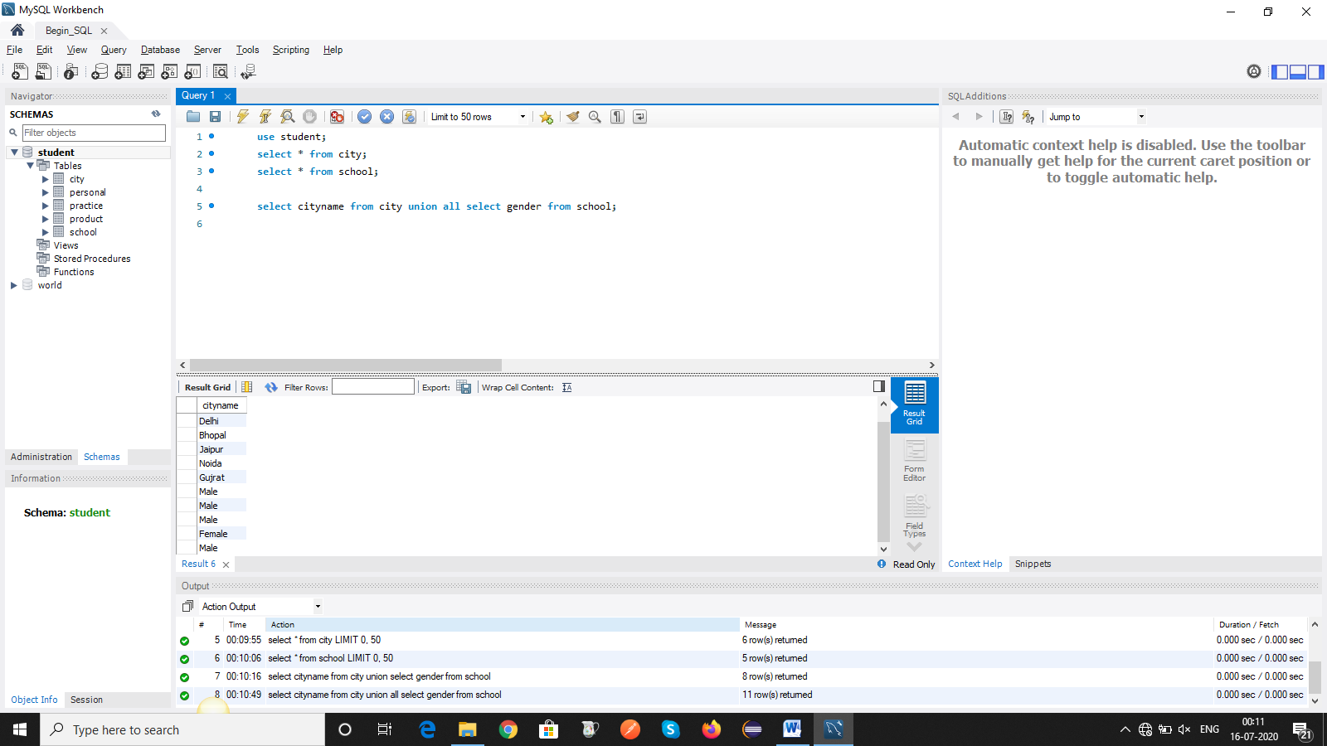

**IF statement in MYSQL?**

select name, percentage,

if(percentage>90, 'scholar', 'not scholar') as result from personal;

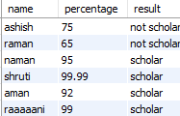

**CASE statement in MYSQL?**

select name, percentage,

case

when percentage>=80 and percentage<=100 then 'scholar'

when percentage>=75 and percentage<80 then '1st division'

else 'Not Correct %'

end as result

from personal;

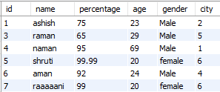

**Arithmetic Functions in MYSQL?**

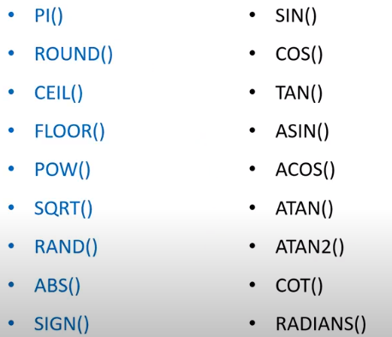

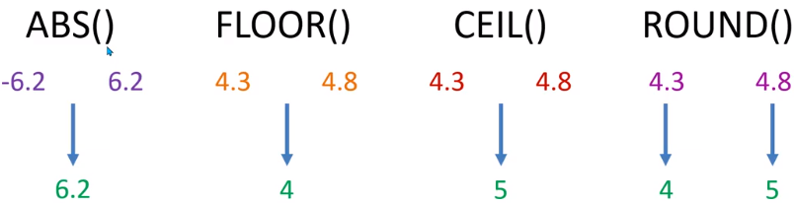

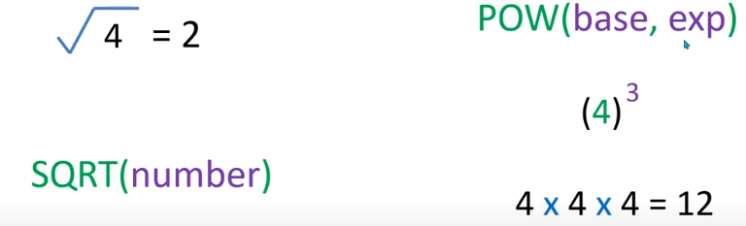

Select RAND(); //prnt any value in between 0 and 1



Also use to print list in a random order

**Select current Date?**

Select CURRENT_DATE(); or Select CURDATE(); //print current date of server

Select SYSDATE(); //print current date and time of the system

select now(); //print current date and time of the system

**Select current Time?**

select current_time(); or select curtime(); //print current time of server

select current_timestamp();// print current time and name

**ALTER in MYSQL?**

1. **Using alter command we can change the name of table.**

**How can you change the name of any existing table by using the SQL statement?**

alter table personal rename new_personal;

1. Modify datatype of a column.

alter table personal modify email int(25); //previously it was varchar

1. Change name of a column.

alter table personal change email emailid varchar(20);//changing email to emailid

1. Add constrains to column.

alter table personal add unique(email);//add constraint in a table

1. Repositioning the columns.

alter table personal modify email varchar(25) after percentage;// email add after percentage

1. Delete a column.

alter table personal drop emailid;

1. Add new column in a table

alter table personal add email varchar(25); // add new column in table

**Drop and Truncate command in table?**

DROP delete whole table whereas TRUNCATE delete only data inside a table

drop table tablename;

truncate table tablename;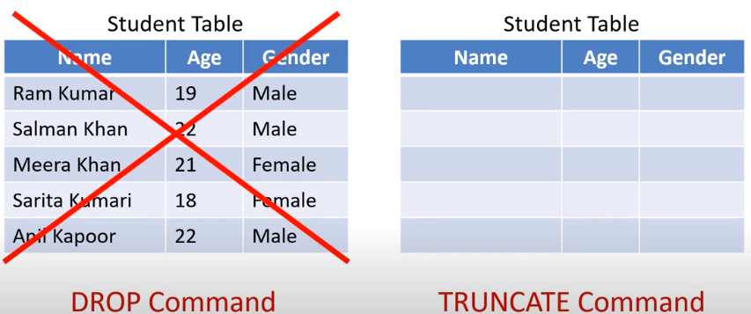

**INDEX in MYSQL?**

Indexing is used to make searching fast in tables

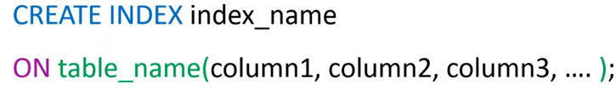

Create index indexname on tablename(columnname);

**Delete index from a table?**



Guidelines to make a index:

1. Primary key and UNIQUE is by default an index.
2. Only those columns should be in index that we use frequently to retrieve data.
3. Small table do not require index because we wont see the effects of indexing on small table .

Creation of index at the time of table creation

CREATE TABLE users(

        username VARCHAR(50) PRIMARY KEY,

        email VARCHAR(50) NOT NULL,

        password VARCHAR(50) NOT NULL,

        INDEX (username, email));

**What is the difference between CHAR and VARCHAR?**

* CHAR uses static memory allocation whereas VARCHAR uses dynamic memory allocation.



In above image we define the length of char and varchar 15 but we store 3 characters only so here char will occupy all 15 space whereas varchar occupy 3 space only

* CHAR can hold upto 255 character while VARCHAR can hold up to 4000 character.
* CHAR is 50% faster than VARCHAR.

### What is DDL, DML, DCL and TCL?

### DDL(data definition language): we define the data using DDL.

### EX: create , alter, drop, truncate

### DML(Data manipulation language): we modify the data using this.

### Ex: retrieve(select), insert, update, remove(delete)

### DCL(data control language): it is use to control the access of data store in database and provide security.

### Ex: grant, revoke

### 

### Grant: for ex: dba gives the permission to a user to select the data from the table not give the permission to insert/update or anything else

### Revoke: for ex: dba revoke the permission of select from the table so, user wont able to do anything in table

### 

### What is the difference between FLOAT and DOUBLE?

FLOAT stores floating point numbers with accuracy up to 8 places and allocates 4 bytes, on the other hand DOUBLE stores floating point numbers with accuracy up to 18 places and allocates 8 bytes.

### What is MySQL default port number?

MySQL default port number is 3306.

**Select Nth highest salary from table?**

SELECT TOP 1 salary FROM (SELECT DISTINCT TOP N salary FROM school ORDER BY salary DESC) ORDER BY salary; **// top works in sql not in mysql**

select distinct(salary)from school order by salary desc limit n-1,1;

(**LIMIT starting_number, number_of_rows**)

### ****How can you retrieve a particular number of records from a table?****

### **LIMIT** clause is used with the SQL statement to retrieve a particular number of records from a table.

**Syntax:**

LIMIT starting_number, number_of_rows

|  |
| --- |
| SELECT * FROM products; |
| SELECT * FROM products LIMIT 1, 2; //display 2nd and 3rd record |

### What is the difference between NOW() and CURRENT_DATE()?

Now():display current date and time

'2020-06-22 20:13:01'

Current date():display current date only

'2020-06-22'

### What is the query to display top 20 rows?

SELECT * FROM school LIMIT 20;

SELECT * FROM school order by id LIMIT 20;

### Write a query to count the number of rows of a table in MySQL.

select count(name) from school;

### Write a query to retrieve a hundred books starting from 20th.

**SELECT** book_title FROM books LIMIT 19, 100;[it will include 20]

### Write a query to select all teams that won either 1, 3, 5 or 7 games.

**SELECT** team_name FROM team WHERE team_won IN (1, 3, 5, 7);

### What is the usage of ENUMs and Set in MySQL?

### ENUM data type is used in the MySQL database table to select any one value from the predefined list.

The SET data type is used to select one or more or all values from the predefined list. This data type can also be used to restrict the field for inserting only the predefined list of values like ENUM.

CREATE TABLE clients (

id INT AUTO_INCREMENT PRIMARY KEY,

name VARCHAR(50),

membership **ENUM**('Silver', 'Gold', 'Diamond'),

interest **SET**('Movie', 'Music', 'Concert'));

INSERT INTO clients (name, membership,interest)

VALUES ('Sehnaz','Gold', **'Music'**),

('Sourav', 'Diamond', **'Movie,Concert'**);

### Which command is used to view the content of the table in MySQL?

The SELECT command is used to view the content of the table in MySQL.

### What is the usage of "i-am-a-dummy" flag in MySQL?

In MySQL, the "i-am-a-dummy" flag makes the MySQL engine to deny the UPDATE and DELETE commands unless the WHERE clause is present.

**What is the purpose of using the TIMESTAMP data type?**

A TIMESTAMP data type is used to store the combination of date and time value.

The format of TIMESTAMP is YYYY-MM-DD HH:MM: SS.

**Which statement is used in a select query for partial matching?**

**LIKE**

**Which MySQL function is used to concatenate string?**

**CONCAT()** function is used to combine two or more string data.

SELECT CONCAT('Welcome ',to ','SoftwareTestingHelp','.',’com');

#### Write an SQL query to print the FIRST_NAME and LAST_NAME from Worker table into a single column COMPLETE_NAME. A space char should separate them.

Select CONCAT(FIRST_NAME, ' ', LAST_NAME) AS 'COMPLETE_NAME' from Worker;

**How can you retrieve a portion of any column value by using a SELECT query?**

**Or**

#### Write an SQL query to print the first five characters of  name from product table

**Answer: SUBSTR()** function is used to retrieve the portion of any column.

SELECT SUBSTR (name, 1,5) FROM products;

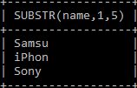

It will display first five characters of name

**How can you add and remove any column of a table?**

ALTER TABLE products DROP COLUMN brand;

**How can you calculate the sum of any column of a table?**

**Answer: SUM()** function is used to calculate the sum of any column.

SELECT SUM(price) as total FROM products;

**How can you count the total number of records of any table?**

**Answer: COUNT()** function is used to count the total number of records of any table.

select count(*) from schsool;

**What is a transaction? Describe MySQL transaction properties.**

When a group of database operations is done as a single unit then it is called a transaction. If any task of the transactional tasks remains incomplete then the transaction will not succeed.

start transaction;

update school set age=19 where age=18;

select * from school where age < 30;

rollback;

There are 4 properties of transaction

ACID(**Atomicity, Consistency, Isolation, Durability**)

**HAVING vs WHERE?**

select name, max(age) from school group by city having max(age)>25;

Having can be use with aggregates (max(age), sum(age), count(age))

Where can’t use with aggregates

**Can we use where and having in same query?**

Select name, sum(age) from school where city in('Delhi', 'Bhopal') group by city having sum(age)>50;

**Write an SQL query to fetch the names of workers who earn the highest salary.**

SELECT FIRST_NAME, SALARY from Worker WHERE SALARY=(SELECT max(SALARY) from Worker);

#### Write an SQL query to fetch departments along with the total salaries paid for each of them.

Select department, sum(salaries) from school group by department;

#### Write an SQL query to fetch three min salaries from a table.

Select distinct salary from employee order by salary limit 3;

// for max sal change **order by** to **order by desc**

#### Write an SQL query to print the name of employees having the highest salary in each department.

Select name, max(salary) from employee group by department;

#### Write an SQL query to fetch the last five records from a table.

select * from school order by id desc limit 5; // here id is a primary key

#### Write an SQL query to show all gender along with the number of people in there.

Select gender, count(gender) from school group by gender;

#### Write an SQL query to fetch the first 50% records from a table.

Select * from school where id <= (select count(id)/2 from school);

#### Write an SQL query to show the second highest salary from a table.

Select max(Salary) from Worker

where Salary not in (Select max(Salary) from Worker);

**Write a query to find second minimum salary employee from Employee.**

**select** * **from** EMPLOYEE

**where** salary = (**select** **min**(salary) **from** EMPLOYEE

**where** salary > (**select** **min**(salary) **from** EMPLOYEE));

select * from school

where age = (select min(age) from school

where age > (select min(age) from school

where age > (select min(age) from school)));**//Third highest age**

#### Write an SQL query to clone a new table from another table.

Select * into table2 from table1;

Create table table2 like table1;

#### Write an SQL query to fetch the no. of students for each gender in the descending order.

select gender, count(id) as no_of_students from school group by gender order by no_of_students desc;

#### Write an SQL query to fetch student names with age >= 17 and <= 22

select name,age from school where age between 17 and 22;

#### Write an SQL query to fetch the count of employees working in the department ‘Admin’

Select count (emp_name) from school where department='Admin;

#### Write an SQL query to print all Worker details from the Worker table order by FIRST_NAME Ascending and DEPARTMENT Descending.

Select * from Worker order by FIRST_NAME asc,DEPARTMENT desc;

#### Write an SQL query to print the FIRST_NAME from Worker table after removing white spaces from the right side.

Select RTRIM(FIRST_NAME) from Worker;

//use LTRIM to remove space from left side

**Remove h from helloworld.**

Select trim (h, ‘helloworld’) from tablename;

#### 

#### Write an SQL query to fetch “FIRST_NAME” from Worker table in upper case.

Select upper(FIRST_NAME) from Worker;

//lower for smallcase

// INITCAP only first letter is in caps

**Print odd/even record from table?**

Select * from school where id%2=0;

Select * from school where id%2<>0;