### There are 5 lanes on a race track. One needs to find out the 3 fastest horses among total of 25.

* The approach entails conducting 5 races where each race group would involve 5 horses.
* a sixth race is conducted between winners of first 5 races to determine the 3 fastest

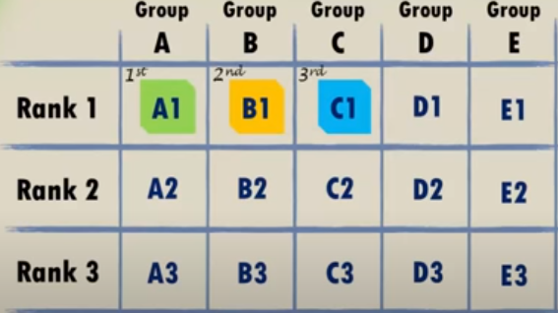

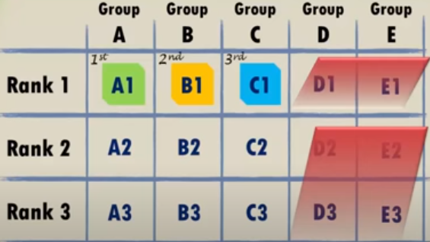

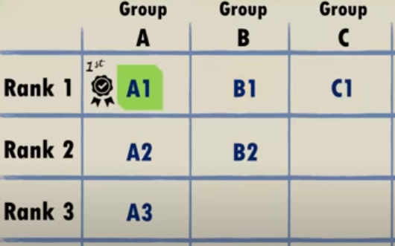

**3 mislabelled jars?**

A+O 🡪apple 🡪 apple(A+O me se apple nikla to sahi jawab hai apple)

Apple🡪A/O🡪O🡪 O(A me se apple yaan orange nikal skta hai suppose orange nikal gya to sahi jawab hai orange)

O🡪A+O

### There are 8 batteries, but only 4 of them work. You have to use them for a flashlight which needs only 2 working batteries.

Total attempts are 7.

We have to make the combination of 3+3+2

### You pull out 2 balls, one after another, from a bag which has 20 blue and 13 red balls in total. If the balls are of similar colour, then the balls are replaced with a blue ball, however, if the balls are of different colours, then a red ball is used to replace them. Once the balls are taken out of the bag, they are not placed back in the bag, and thus the number of balls keep reducing. Determine the colour of last ball left in the bag.

Observe that red ball maintains the odd order so it would be the last ball that left in bag

### There are 10 stacks of 10 coins each, where each coin weighs 10gms. However, one of the stacks is defective, and that stack contains coins which weigh 9gms. Determine the minimum number of weights needed to identify the defective stack.

We have to measure the coins only one time.

Took 1 coin from pile 1, 2 coins from pile 2….. 10 coin from pile 10

If the difference is of 1gm then 1st pile is defective, if the difference is of 5gm then 5th pile is defective.

**You have two identical length wires which take an hour to burn. But, they don’t burn at the same speed. How do you measure 45 minutes based on the burning?**

You first light up three ends of the two wires. The remaining end you can light up once the first wire is completely burnt. When the second wire is completely burnt, the time is 45 minutes.

**Arun has three sons and his friend Shakti wants to know their ages. Arun gives him three hints as Shakti couldn’t answer till the third hint –**

* **The product of their ages is 72**
* **The sum of their ages is the same as my house number**
* **The oldest of sons love chocolate icecream**

First, you will get 12 possibilities for the equation XxYxZ = 72. Next, the sum of each of the numbers is added. You get a variety of numbers but there are two possibilities where the sum is 14. 2+6+6 and 3+3+8. Arun mentioned that his oldest like chocolate icecream, which meant there is only one older child and hence, the sons ages are 3,3 and 8.

**A contract employee needs to be paid everyday but the employer has only one rod of 7 units of gold. He can make only at max 2 cuts. How does he manage to pay him?**

The employer makes two cuts so that he has units of 1, 2 and 4.

Day 1, the employer gives him 1 unit. On day 2, the employer takes back the 1 unit and gives him 2. On day 3, he gives him 1 unit. On day 4, he takes back the 1 and 2 units and gives him a 4 unit. So on until day 7 when he gives him all the units.

**You have two bowls which will hold 50 balls each. Now you have 50 blue balls and 50 red balls and you cannot place all balls of same color in each bowl. Now you have to pick a random ball from a random bowl. How do you maximize the probability of getting a red ball?**

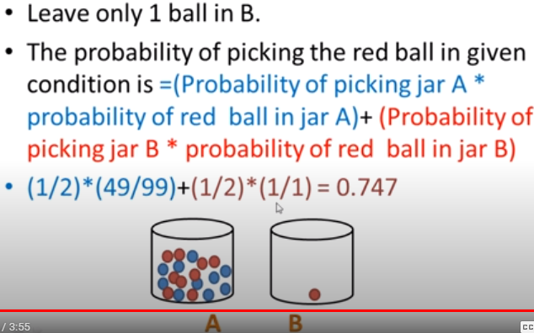

**Your task is to place 10 coconuts in 5 lines such that each line has 4 coconuts.**

You have to place them in a star shape(bachpan vala star) with the centre being a pentagon. Each coconut will be placed at the intersection and meeting point of 2 lines.

**Three people are in a room. Rahul looks at Nisha. Nisha looks at Sahil. Rahul is married but Sahil is not married. At any point, is a married person looking at an unmarried person? Yes, No or Cannot be determined.**

Yes, at every point there is a married person looking at an unmarried person. The only person whose information we don’t know is Nisha. Assume Nisha is married, she is looking at Sahil. So, married person is looking at unmarried person. Now assume Nisha is unmarried, Rahul is looking at Nisha. So even then married person is looking at an unmarried person.

**Three ants are located on an equilateral triangle. Now each ant picks a random direction and starts to move along the triangle. What is the probability that they don’t collide?**

0.25. This is because the ants will not collide only if they all move in the same direction. Now, each ant has two choices, to move either side – clock wise or anti-clockwise. Hence,

P(No collision) = P(All ants go in clockwise direction) + P(All ants go in anti-clockwise direction)

P = 0.5*0.5*0.5 + 0.5*0.5*0.5 = 0.25

**Crossing the Bridge Puzzle?**

Times for each person: 1 min, 2 mins, 7 mins and 10 mins

First 1 and 2 go =2

Then 1 come and 7 & 10 go=1+10=11

Then 2 come and 1 & 2 go=2+2=4 **total time** taken is **17**

**Heaven’s Gate Probelm**

Agar me saamne vale se puchunga ki heaven ki taraf konsa gate jaata hai to uska answer kya hoga

**100 door puzzles**

Only doors which are at perfect square remains open

### Sand timers puzzle

From 4 and 7 minutes calculate 9 minutes

Start with 4 and 7🡪 in 7, 3 minutes remaining

Start with 4 again 🡪 3 minutes completed and 1 minute remain in 4

Start with 7🡪 1 minute is completed in 4 and 1 min completed in 7

Now turn the 7 which complete 1 minute only, then we are able to calculate 9 minutes

4+3+1+1

Puzzles: 2 JARS puzzle.

* Fill the 5 litre can from the tap
* Empty the 5 litre can into the 3 litre can - leaving 2 litres in the 5 litre can.
* Pour away the contents of the 3 litre can.
* Fill the 3 litre can with the 2 litres from the 5 litre can - leaving 2 litres in the 3 litre can.
* Fill the 5 litre can from the tap.
* Fill the remaining 1 litre space in the 3 litre can from the 5 litre can.  
  Leaving **4 litres** in the 5 litre can.

9 balls puzzle find heaviest ball

* Divide ball in 3-3 group each
* Weight the ball if weight equal heavy ball is in group 3
* Again weight the ball

**Number of weights needed is 2**

**We have container full of milk, people buy milk in range of 1 lit to 40 lit, we have only 4 jars to draw milk out of the container what should be the capacity of jar so that we can withdraw any amount of milk from 1 lit to 40 lit?**

* 1 lit jar– use to draw 1 lit milk
* 3 lit jar- use to draw 2 lit milk(fill 3 lit and pour 1 lit in 1 lit jar), 3,4 lit can be calculated
* 9 lit jar- 5 lit can be calc(fill 9 lit jar and pour in 3+1 lit jar)
* 27 lit jar…..

It makes 30, 31, 32, 33….3n

also 27+9+3+1= 40

**Place 8 queens in such a way so that they can’t cross each other?**

Total ways to place queens on a chessboard:

64!/54!*8!

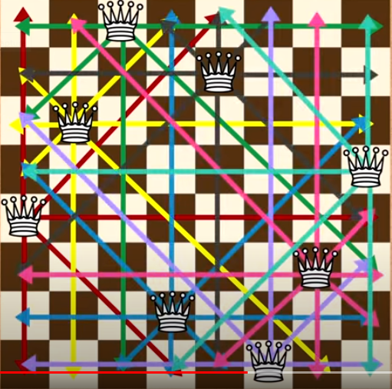

**Find the poisonous wine bottle among the 1000 bottles, the person died after 24 hr of drinking poisonous wine?**

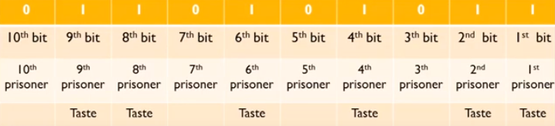

**Binary representation of 1000 is: 1111101000**

**Place 10 persons in a row**

**p p p p p p p p p p**

**suppose poisonous bottle is 427 i.e 0110101011 so the persons at position 1,2,4,6,8,9 will die after 24 hrs**

**One person has some money in his pocket, He visits four temple on the way. As soon as he enters a temple, his money gets double and he offers Rs. 100 in each temple thus his pocket gets empty after he returns from the fourth temple. Now the question is how much money he had initially**

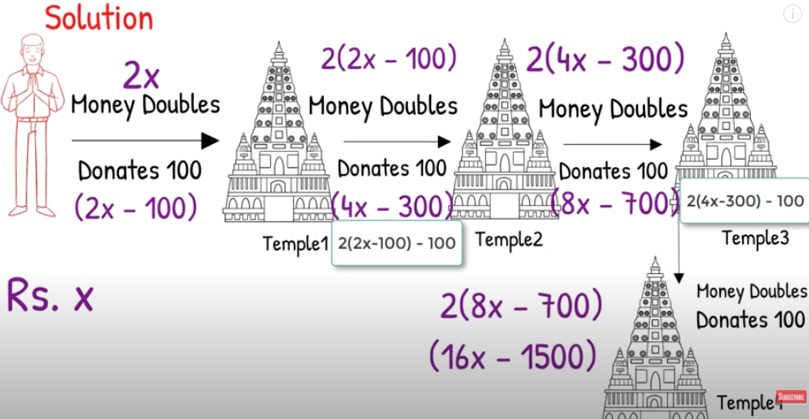

**After visiting all 4 temples he left with ‘0’ rupees so:**

16X-1500=0

X= 1500/16=93.75

**3 lion and 3 deer need to cross a river deer should not < lion at any point?**

1st 1 lion 1 deer

2nd deer come

3rd 2 lion

4th 1 lion come

5th 2 deer

6th 1 lion 1 deer

7th 2 deer

8th lion

9th 2 lion

10th 1 lion

11th 2 lion

Lion, Goat and Grass Puzzle

He should first crossed the goat and leave the lion and and the grass since Lion would not eat the grass the he would crossed the lion and returned with the goat then he should crossed the grass and come back and crossed the goat that is all.

6 water glass puzzle

Full Full Full Empty Empty Empty

Make arrangement like F E F E F E

**Ans. Pour second full glass into 5th empty glass.**

If the statement is held true by Policeman, the Prisoner will be hanged to death and if the statement is held false, the Prisoner will be shot dead.

Answer:  
The Prisoner said, ‘I will be shot dead’  
If Policeman says the statement is true, the Prisoner will be hanged to death which will make his statement false.  
If Policeman says the statement is false, the Prisoner will be shot dead which will make the statement true.

Three men and 5 hat problem?

3 black, 2 blue i have to find that which hat I wear.

Logic 1: if hat of other 2 persons are blue then my hat is black

Logic 2: if 1 man have black hat and 1 man have blue hat then I have black hat otherwise man with black hat will announce the result.

Logic 3: if both man wear black hat then I must wear black hat otherwise other man announce the result using logic 2

There is 10 litre milk in a 10 litre Can. How to separated 5 lit each using 7 litre & 3 litre Can?

A car has 4 tyres and 1 spare tyre. Each tyre can travel a maximum distance of 20000 miles before wearing off. What is the maximum distance the car can travel before you are forced to buy a new tyre? You are allowed to change tyres (using the spare tyre) an unlimited number of times.

25000 kms

Fill numbers from 1to8 so that no corresponding numbers are on adjacent sides?