**What all I have solved:**

1. Challenge 0 is solved as I have created an API which gives the latest power level of Character.

(<http://localhost:10000/ReturnPower>). As per the user input on console.

1. Called the APIs in parallel and store the list of characters and power level in map (mapdata) data structure. Where name of character is key and power level is set as value.
2. Challenge 1- Delete the Characters to free space. If there are more than 15 characters in map then I have deleted the least used character.

* For implementing this I have used another map (newmap) to store name of characters as keys and initial value should be 0.
* When a user enters the character name then the character in map (newmap) value should be incremented by 1.
* This way we get to know the least used character as their value will be small as compare to others.
* After this I have sort the map by value (for this I have used another map hack) and stored values in hack.
* Created a array to store hackkey (Which is sorted)
* Finally deleted the character from map (mapdata) to free some space.

1. Challenge 2- Delete the Characters to free space according to their minimum power level.

* For implementing this I have sort map by value (mapdata)
* For sorting I have used another map hack and after sorting stored values in hack.
* After this I have created a array to store all sorted hackkey.
* As I have calculate there are total 18 characters and our data structure allows only 15
* Therefore I have deleted 3 characters to maintain free space .

1. Used an array to store all the characters name and print it at console (Just for user reference). List of characters name are taken before deletion. Therefore it has all character’s name available.
2. Deletion statement will also print the character’s name which is being deleted.

**Note:** Power level changes every 10 sec. Tried using time.Tick(10*time.second) in loop to refresh data but faced some issues. Therefore I have not implemented it.

**Input and Output:**

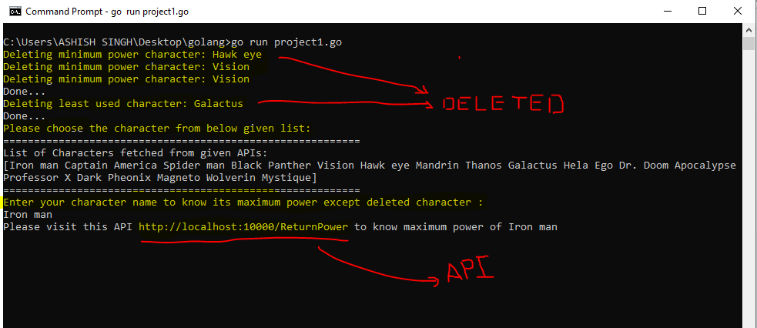

(Input.fig)

* As shown in (input.fig) first three lines are deleting minimum power characters
* After that deleting least used characters
* Then its asking to choose a character from below list
* List is created before deletion therefore deleted characters are also present in this list. This list is just for reference of user to choose characters.
* At last user input is required but make sure not to enter deleted characters because that will not be present in map.
* Finally we get the API link which I have created to show the maximum power of character choose by user.

**Note:** User needs to open the API link url in browser to get the output (<http://localhost:10000/ReturnPower>)

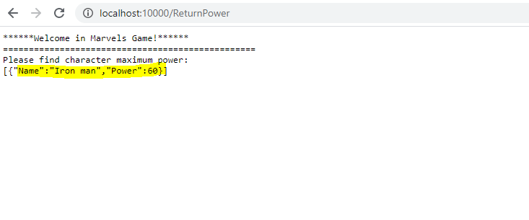

(API output.fig)

* At API link user will get the maximum power of level choose by him.