System Design Master (Senior Engineer / Tech Lead)

How to Use This Document
- Use this file as the single source of truth.
- For each question, fill all template sections.
- Diagrams are referenced as images under diagrams/.

Export (DOCX/PDF)
See the Export Commands section at the end of this file.

Table of Contents

A. Foundations / Infra
- Design a URL Shortener
- Design a Rate Limiter (per-user + per-IP)
- Design an API Gateway + AuthN/AuthZ (JWT/OAuth2)
- Design a Feature Flag / Config Service
- Design a Logging Platform (collection → storage → search)
- Design a Metrics/Monitoring Platform (ingestion + aggregation)

B. Kafka / Event-Driven Systems
- Design a Notification System (email/SMS/push; retries/DLQ)
- Design an Event Ingestion Platform (Kafka + schema + consumers)
- Design an Order Processing Pipeline (Kafka choreography)
- Design Outbox + CDC Integration Pattern
- Design Payment Events + Reconciliation Pipeline
- Design a Fraud Detection Stream (near real-time scoring)

C. Transactional / Consistency-Heavy
- Design an E-commerce Checkout + Order System (Saga)
- Design a Wallet / Ledger System
- Design a Ticket Booking System (avoid oversell)
- Design an Inventory System (reservations)
- Design a Subscription Billing System
- Design a Password Reset / Account Recovery System

D. Real-time / Low Latency
- Design a Chat System (WebSocket)
- Design a Presence/Last-Seen System
- Design a Real-time Collaboration System (high-level)
- Design Ride Dispatch/Matching (geo + scaling)
- Design a Real-time Leaderboard

E. Product Scale Systems
- Design a Feed/Timeline
- Design Media Upload + CDN Serving
- Design Search for Marketplace
- Design Recommendation Serving (high-level)
- Design Location-based Nearby Search (geo index)
- Design Analytics Clickstream Pipeline
- Design Multi-tenant SaaS Platform Baseline

Appendices
- Cross-cutting Cheat Sheets
- Diagram Conventions
- Export Commands

Standard Template (Use for Every Question)

1) Problem Statement

2) Features / Functional Requirements

3) Non-Functional Requirements
- Availability:
- Latency (p95/p99):
- Scale (DAU/MAU, peak QPS):
- Consistency:
- Durability:
- Cost constraints:

4) Assumptions + Back-of-the-envelope Sizing
- Peak QPS:
- Storage/day:
- Bandwidth:
- Hot keys / hotspots:

5) High-Level Architecture

6) APIs

7) Data Model

8) Kafka / Async Design (if applicable)
- Topics (names, partitions, retention):
- Ordering guarantees:
- Consumer groups:
- Retry strategy:
- DLQ:
- Idempotency/dedup:
- Schema evolution:

9) Diagrams
- Architecture diagram:
- Key flow diagram (sequence):

10) Key Flows
- Write path:
- Read path:
- Async path:

11) Advantages

12) Disadvantages / Risks

13) Tradeoffs + Alternatives

14) Failure Modes + Mitigations

15) Observability (SLIs/SLOs)
- Metrics:
- Logs:
- Traces:
- Alerts:

16) Security + Compliance
- AuthN/AuthZ:
- PII handling:
- Encryption:
- Auditing:

17) Kubernetes Deployment View
- Workloads:
- HPA:
- Requests/limits:
- Probes:
- Rollout strategy:
- PDB:

18) Capacity Planning + Cost

19) Evolution Plan (v1 → v2 → v3)

Questions

Q01: Design a URL Shortener

[Fill using the Standard Template]
Diagrams
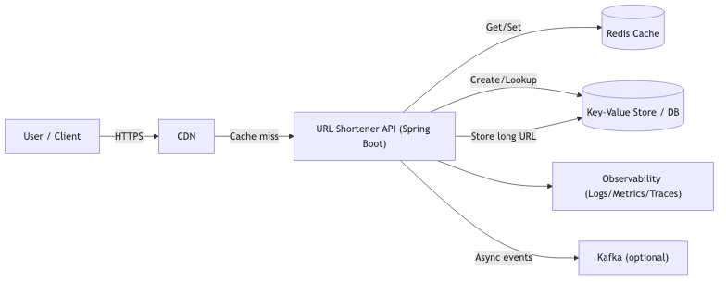
Q01 Architecture
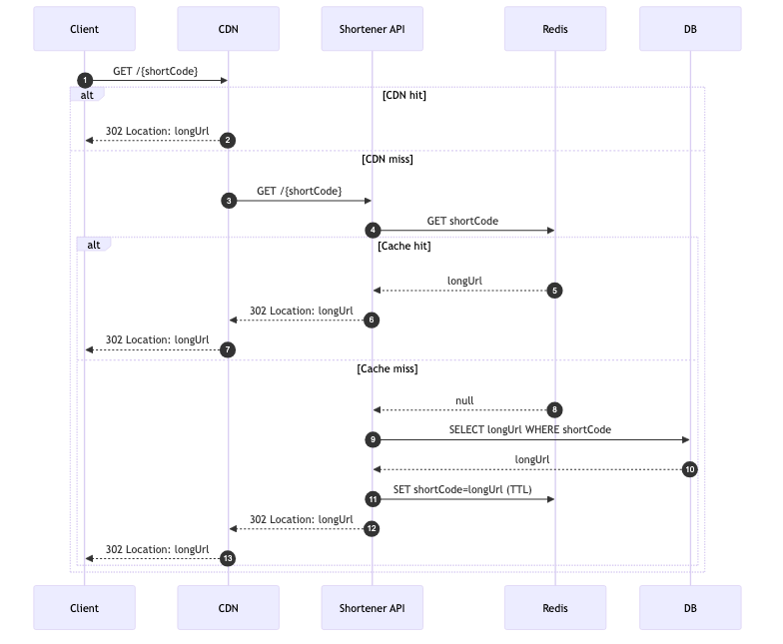
Q01 Key Flow

Q02: Design a Rate Limiter (per-user + per-IP)

[Fill using the Standard Template]
Diagrams
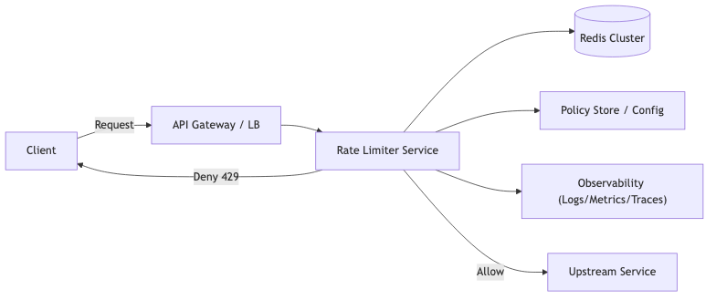
Q02 Architecture
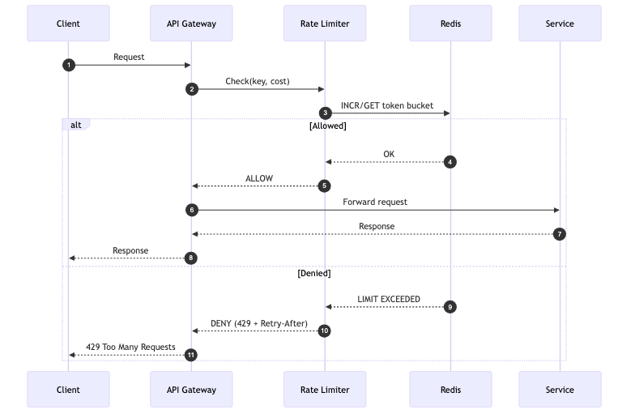
Q02 Key Flow

Q03: Design an API Gateway + AuthN/AuthZ (JWT/OAuth2)

[Fill using the Standard Template]
Diagrams
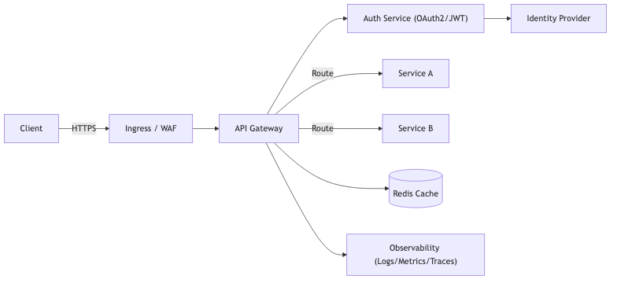
Q03 Architecture
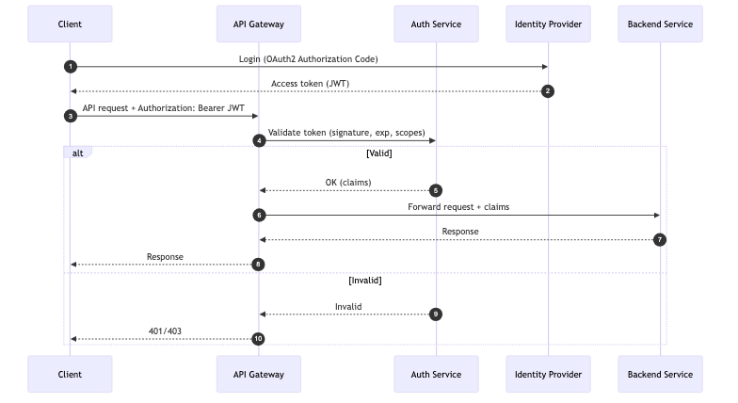
Q03 Key Flow

Q04: Design a Feature Flag / Config Service

[Fill using the Standard Template]
Diagrams
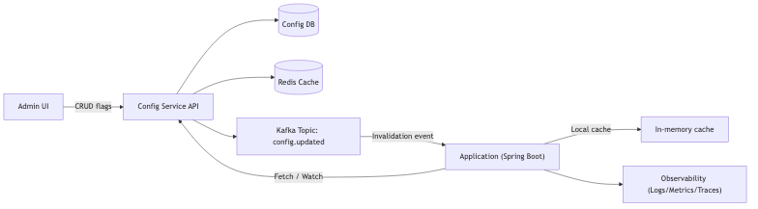
Q04 Architecture
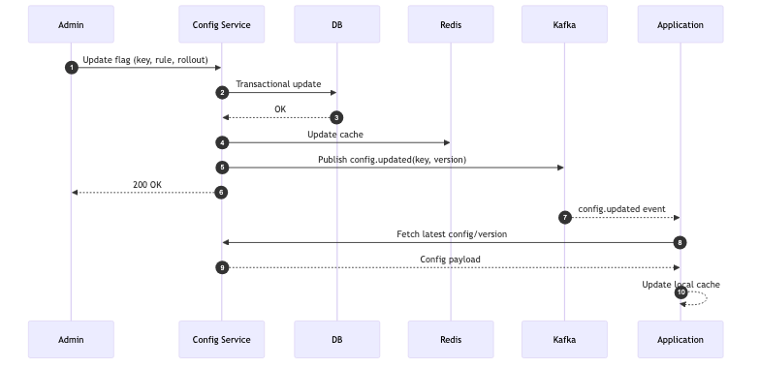
Q04 Key Flow

Q05: Design a Logging Platform (collection → storage → search)

[Fill using the Standard Template]
Diagrams
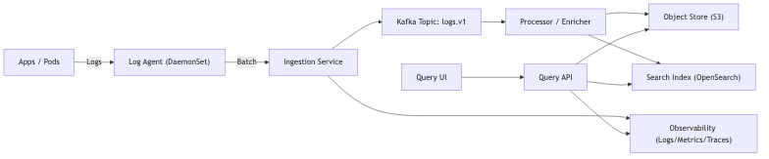
Q05 Architecture
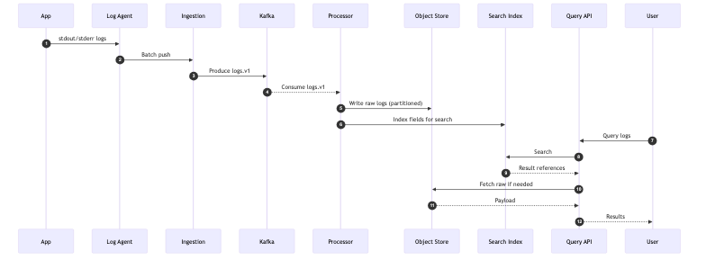
Q05 Key Flow

Q06: Design a Metrics/Monitoring Platform (ingestion + aggregation)

[Fill using the Standard Template]
Diagrams - diagrams/q06_arch.png - diagrams/q06_seq.png

Q07: Design a Notification System (email/SMS/push; retries/DLQ)

[Fill using the Standard Template]
Diagrams - diagrams/q07_arch.png - diagrams/q07_seq.png

Q08: Design an Event Ingestion Platform (Kafka + schema + consumers)

[Fill using the Standard Template]
Diagrams - diagrams/q08_arch.png - diagrams/q08_seq.png

Q09: Design an Order Processing Pipeline (Kafka choreography)

[Fill using the Standard Template]
Diagrams - diagrams/q09_arch.png - diagrams/q09_seq.png

Q10: Design Outbox + CDC Integration Pattern

[Fill using the Standard Template]
Diagrams - diagrams/q10_arch.png - diagrams/q10_seq.png

Q11: Design Payment Events + Reconciliation Pipeline

[Fill using the Standard Template]
Diagrams - diagrams/q11_arch.png - diagrams/q11_seq.png

Q12: Design a Fraud Detection Stream (near real-time scoring)

[Fill using the Standard Template]
Diagrams - diagrams/q12_arch.png - diagrams/q12_seq.png

Q13: Design an E-commerce Checkout + Order System (Saga)

[Fill using the Standard Template]
Diagrams - diagrams/q13_arch.png - diagrams/q13_seq.png

Q14: Design a Wallet / Ledger System

[Fill using the Standard Template]
Diagrams - diagrams/q14_arch.png - diagrams/q14_seq.png

Q15: Design a Ticket Booking System (avoid oversell)

[Fill using the Standard Template]
Diagrams - diagrams/q15_arch.png - diagrams/q15_seq.png

Q16: Design an Inventory System (reservations)

[Fill using the Standard Template]
Diagrams - diagrams/q16_arch.png - diagrams/q16_seq.png

Q17: Design a Subscription Billing System

[Fill using the Standard Template]
Diagrams - diagrams/q17_arch.png - diagrams/q17_seq.png

Q18: Design a Password Reset / Account Recovery System

[Fill using the Standard Template]
Diagrams - diagrams/q18_arch.png - diagrams/q18_seq.png

Q19: Design a Chat System (WebSocket)

[Fill using the Standard Template]
Diagrams - diagrams/q19_arch.png - diagrams/q19_seq.png

Q20: Design a Presence/Last-Seen System

[Fill using the Standard Template]
Diagrams - diagrams/q20_arch.png - diagrams/q20_seq.png

Q21: Design a Real-time Collaboration System (high-level)

[Fill using the Standard Template]
Diagrams - diagrams/q21_arch.png - diagrams/q21_seq.png

Q22: Design Ride Dispatch/Matching (geo + scaling)

[Fill using the Standard Template]
Diagrams - diagrams/q22_arch.png - diagrams/q22_seq.png

Q23: Design a Real-time Leaderboard

[Fill using the Standard Template]
Diagrams - diagrams/q23_arch.png - diagrams/q23_seq.png

Q24: Design a Feed/Timeline

[Fill using the Standard Template]
Diagrams - diagrams/q24_arch.png - diagrams/q24_seq.png

Q25: Design Media Upload + CDN Serving

[Fill using the Standard Template]
Diagrams - diagrams/q25_arch.png - diagrams/q25_seq.png

Q26: Design Search for Marketplace

[Fill using the Standard Template]
Diagrams - diagrams/q26_arch.png - diagrams/q26_seq.png

Q27: Design Recommendation Serving (high-level)

[Fill using the Standard Template]
Diagrams - diagrams/q27_arch.png - diagrams/q27_seq.png

Q28: Design Location-based Nearby Search (geo index)

[Fill using the Standard Template]
Diagrams - diagrams/q28_arch.png - diagrams/q28_seq.png

Q29: Design Analytics Clickstream Pipeline

[Fill using the Standard Template]
Diagrams - diagrams/q29_arch.png - diagrams/q29_seq.png

Q30: Design Multi-tenant SaaS Platform Baseline

[Fill using the Standard Template]
Diagrams - diagrams/q30_arch.png - diagrams/q30_seq.png

Cross-cutting Cheat Sheets

Kafka Cheat Sheet

Kubernetes Cheat Sheet

Databases Cheat Sheet

Caching Cheat Sheet

SLO/SLI + Observability Cheat Sheet

Security Cheat Sheet

Diagram Conventions

Naming
- qNN_arch.png for architecture
- qNN_seq.png for key flow/sequence

Recommended Diagram Types
- Architecture: component diagram
- Flow: sequence diagram

Export Commands

Folder Structure
- system-design-master.md
- diagrams/
- assets/
- exports/

Pandoc (DOCX)
- Input: system-design-master.md
- Output: exports/System_Design_Master.docx

Pandoc (PDF)
- Input: system-design-master.md
- Output: exports/System_Design_Master.pdf

Diagram Generation (Mermaid → Images)
- Keep Mermaid source files under diagrams-src/ (optional)
- Export images into diagrams/

