Market Layer for the Adaptive Risk Engine
Professional Ebook Edition
Beginner-friendly concepts, metric computation, data sources, pipelines, architecture, validation, and UI handoff
Prepared for practical implementation by traders, product teams, and developers
This manuscript combines sourced data-source guidance with implementation suggestions clearly labeled as recommendations.

Table of Contents
1. Introduction and purpose of the Market Layer
2. Original Market Layer concept and expanded professional model
3. Price Structure & Volatility
4. Liquidity & Execution Quality
5. Macro & Cross-Asset Context
6. Positioning & Flow
7. Sentiment & Narrative
8. Free vs Paid Data Sources
9. Data Pipelines and System Architecture
10. Implementation Blueprint
11. UI/UX Concepts and Developer Handoff
12. Score Validation and Monitoring
13. Glossary of Attributes
14. Source Appendix and Practical Recommendations

1. Introduction and purpose of the Market Layer
The Market Layer exists to answer one practical question before a trade is sized: “Is the outside environment supportive enough for this trade?” Many traders see a breakout or pullback and focus only on the chart. That approach misses an important truth: good-looking setups can fail because the surrounding environment is hostile. A clean chart can still break down if volatility is too high, if liquidity is poor, if a macro event is minutes away, or if money is rotating away from the part of the crypto market you are trading. The Market Layer prevents the trader from treating all green candles as equal opportunities.
This ebook is written for two audiences at once. The first audience is the novice or intermediate trader who needs plain-English explanations of concepts such as volatility, bond yields, BTC dominance, or funding rates. The second audience is the builder — the backend developer, data engineer, analyst, or product manager — who needs practical implementation guidance. That means every major metric in this manuscript is explained in terms of what it means, why it should be considered, how it affects decision quality, what happens if it is ignored, how to compute it, which data sources are available, and how developers can fetch and operationalize the data.
Whenever a section proposes formulas, weights, thresholds, or architecture patterns that are not directly part of an official vendor specification, those items should be read as design recommendations rather than sourced requirements. The sourced parts of this document focus on where data can be obtained, what providers officially document, and which access models are free versus paid. The implementation layer then turns that raw availability into a practical buildable system.

2. Original Market Layer concept and expanded professional model
The original concept for the Market Layer is a strong starting point: it measures volatility, market regime, liquidity, and event risk. In plain terms, volatility describes how violent price action is, market regime tells you if price is trending, ranging, or noisy, liquidity tells you whether you can execute cleanly, and event risk warns you when outside shocks can suddenly invalidate a good-looking setup. That original concept is valuable because it is intuitive and easy for beginners to grasp.
- Volatility — measures uncertainty and likely stop behavior.
- Market Regime — classifies the structure as trending, ranging, or noisy.
- Liquidity — measures execution quality, spread, depth, and slippage risk.
- Event Risk — captures the destabilizing effect of macro, exchange, or regulatory catalysts.
For a more professional market-intelligence system, that core should be expanded rather than replaced. A practical expanded Market Layer can be organized into four subsystems: Price Structure & Volatility, Macro & Cross-Asset Context, Positioning & Flow, and Sentiment & Narrative. This gives the system a more realistic picture of what is happening outside the chart. Price Structure & Volatility captures the local trading environment. Macro & Cross-Asset Context introduces bond yields, inflation, economic events, and broader “risk-on / risk-off” background. Positioning & Flow measures whether leverage, ETF demand, or stablecoin liquidity are supporting the move. Sentiment & Narrative captures crowd mood and headline pressure. One practical scoring model is: Market Score = 0.30 × Price Structure & Volatility + 0.30 × Macro & Cross-Asset + 0.25 × Positioning & Flow + 0.15 × Sentiment & Narrative. This specific weighting is a design recommendation intended to balance execution reality with broader market forces.
Because the user of the final trading application may be a beginner, the application should display both the original four building blocks and the expanded four-subsystem professional view. In other words, the dashboard should remain human-readable even while the scoring engine becomes more sophisticated underneath.
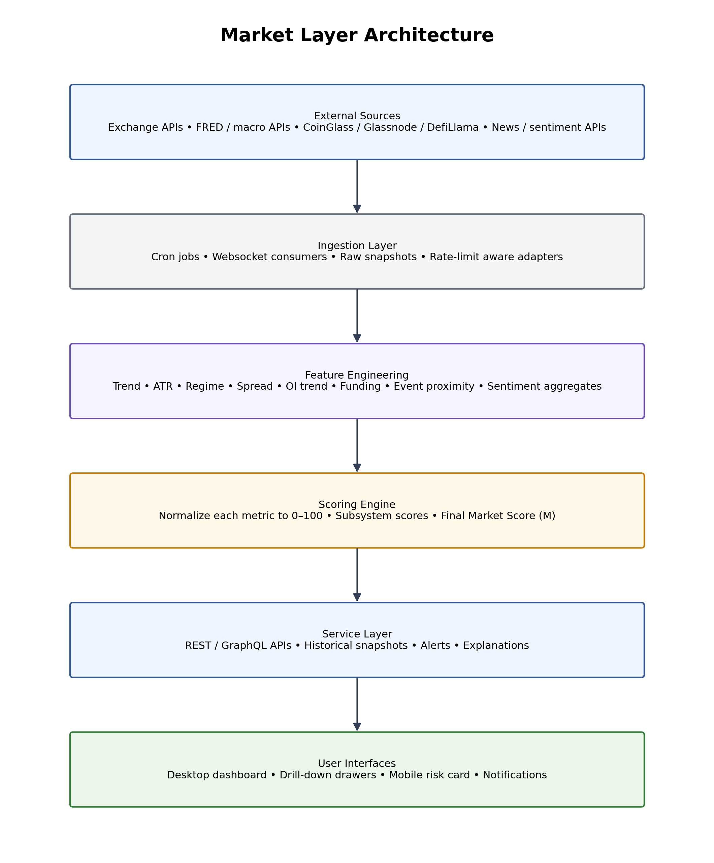
Figure 1. Suggested Market Layer architecture from sources to UI.

3. Price Structure & Volatility

3.1 BTC price trend
BTC price trend is the first market signal most crypto traders should watch. In simple language, BTC trend answers: “Is the leader of the crypto market moving up, down, or sideways?” Bitcoin is not the whole crypto market, but it is still the dominant reference asset. Many altcoins follow its broader direction, especially during stressed or highly directional periods. If Bitcoin is weak, many altcoin setups become more fragile. If Bitcoin is strong and stable, the probability of healthy follow-through in the rest of the market improves.
BTC trend matters because it provides directional context. A trader who ignores it may buy a strong-looking altcoin while Bitcoin is rolling over. That often leads to a trade that looked good “on the local chart” but failed because the market leader was not supporting it. The beginner-friendly takeaway is simple: BTC is the first chart, not the only chart. A stronger system pairs BTC trend with BTC dominance and at least one broader market-breadth or flow signal. Bitcoin dominance is commonly explained as Bitcoin market capitalization divided by total crypto market capitalization, and beginner resources from Binance Academy and Gemini both describe it as a way to track how much of the total crypto market is sitting in BTC versus altcoins. Those beginner explanations explicitly say that rising dominance often means investors are favoring Bitcoin over altcoins, while falling dominance often points to more interest in altcoins. Those educational explanations are useful for a novice reader because they transform an abstract ratio into a simple money-flow concept.
A practical way to compute BTC trend inside a Market Layer is to combine moving averages, slope, and optional trend-strength indicators. A beginner version can simply compare price against EMA20 and EMA50. A richer version can also use ADX or a simple structure score based on higher highs and higher lows. The formulas below are recommendations for implementation, not official vendor rules:
Trend Strength = w1 × EMA slope + w2 × ADX + w3 × structure score
Beginner heuristic: if price > EMA20 > EMA50 → bullish; if price < EMA20 < EMA50 → bearish; else → mixed
The raw data needed to compute BTC trend is standard OHLCV candles. Binance’s official developer documentation provides public kline/candlestick data for its futures market data APIs, and Binance’s public spot API documentation also lists market-data endpoints such as klines and order-book information. This makes Binance exchange-native data a practical free source for developers who need current candles rather than generalized aggregator data. CoinGecko also documents endpoint categories for demo/public access and paid plans, which can be useful for historical and unified-market views, but exchange-native data is usually the cleanest for execution-oriented trend and regime calculations. For developers, the simplest programmatic pattern is to fetch or stream BTC candles on the timeframes you care about, compute EMA stacks and trend strength at a regular cadence, and persist the results in a `market_features` table.

3.2 BTC dominance
BTC dominance is one of the most important flow indicators in crypto because it helps answer: “Is money concentrating in Bitcoin, or is it rotating into altcoins?” In beginner-friendly terms, dominance is Bitcoin’s market share within crypto. Binance Academy explicitly describes BTC dominance as Bitcoin market cap as a percentage of the total cryptocurrency market cap, and notes that changing altcoin trends and stablecoin flows can influence it. Gemini explains the same concept in user-friendly language: rising dominance usually means investors are favoring Bitcoin, while falling dominance often signals increased interest in altcoins. These explanations are valuable because they help novices connect a single ratio to capital rotation and market phase analysis.
Dominance matters because BTC alone is not enough. A trader can see Bitcoin going up and wrongly conclude that “all of crypto is healthy,” when in reality only Bitcoin is strong while many altcoins are underperforming. If dominance is rising while BTC is rising, the market may be BTC-led but not broadly supportive for altcoin risk. If dominance is falling while BTC is stable or rising, conditions for altcoin expansion may be improving. If dominance is ignored, traders often misread which part of the crypto market deserves attention.
The conceptual formula is straightforward:
BTC Dominance (%) = BTC Market Cap / Total Crypto Market Cap × 100
Programmatically, you can either consume dominance from a market-data vendor or compute it yourself if you have reliable Bitcoin market cap and total crypto market cap feeds. In practice, many teams consume BTC dominance from chart/data vendors because exchange candles alone do not provide total market capitalization. In the final application, dominance should not just be shown as a number. It should be explained as a money-flow indicator, for example: “Rising BTC dominance suggests capital is favoring Bitcoin over altcoins.”

3.3 Volatility
Volatility is how fast and how far price is moving. Beginners often think high volatility automatically means opportunity. That is only partially true. Volatility can create opportunity, but it also increases stop distance, emotional strain, false breaks, and damage from poor execution. The right question is not simply “Is volatility high?” but “Is volatility healthy and structured, or unstable and chaotic?”
Volatility deserves to be considered because it changes the size and nature of the risk you are taking. A normal breakout trade in low-to-moderate volatility may behave smoothly. The same breakout during wildly expanding volatility can rip through levels, reverse suddenly, and hit stops far more easily. If a trader ignores volatility, position sizing and stop placement become disconnected from actual market behavior.
A practical way to measure volatility is by using the Average True Range (ATR) relative to a baseline. This creates an ATR ratio, which tells you how unusual current movement is compared with normal conditions. A suggested implementation is:
ATR Ratio = Current ATR / Baseline ATR
Volatility Score = clamp(100 − 40 × (ATR Ratio − 1), 0, 100)
In this recommended transformation, volatility near normal keeps the score relatively healthy, while unusually high ATR reduces the score. The data needed to compute this comes directly from OHLCV candles, so the same free Binance candle data used for trend can also power volatility calculations. If a broader data vendor is already part of your stack, CoinGecko’s demo and paid API ecosystem also documents historical chart and OHLC-style endpoints, which can be used for market-history views. In the UI, volatility should be explained to beginners in plain language such as: “Price is moving faster than normal, so stop behavior is less predictable.”

3.4 Market regime
Market regime tells you what type of market you are in: trending, ranging, or choppy. This matters because no strategy works equally well in all regimes. Breakout logic performs best in clean trends; mean-reversion logic performs better in ranges; choppy markets often punish both. Beginners frequently lose money by applying one strategy everywhere and assuming the chart should behave the same way in all conditions.
You should consider regime because it acts as a strategy-fit filter. If your strategy requires follow-through and the market is choppy, the probability of false breakouts rises sharply. If you ignore regime, you are effectively turning a strategy problem into a psychology problem: you keep taking technically valid signals that belong in the wrong environment.
A practical regime engine can combine moving-average slope, trend-strength measures such as ADX, and simple structure logic based on higher highs / higher lows. Recommended implementation:
Regime Score = f(EMA slope, ADX, structure quality, range compression)
This is not something you buy from an external source; it is a feature you compute internally from the market data already being ingested. That makes it easy to build and easy to explain. In the final dashboard, regime should be displayed as a human-readable label plus a score: “Trending — Strategy fit high,” “Range — Suitable for mean reversion,” or “Choppy — Avoid aggressive entries.”

4. Liquidity & Execution Quality
Liquidity is the bridge between the trade you planned and the trade you actually get. Price charts alone do not tell you whether execution will be clean. For implementation and user education, the most useful liquidity metrics are spread, depth, and slippage.

4.1 Spread
Spread is the difference between the best price buyers are willing to pay and the best price sellers are willing to accept. In plain terms, it is the tiny gap you often lose instantly when you enter a trade. Spread matters because it is a real execution cost. When spreads are wide, the market is often less efficient, more stressed, or less liquid. If you ignore spread, your performance on paper will look cleaner than your performance in reality.
Spread % = (Ask − Bid) / Mid Price × 100
A recommended implementation is to store current spread, rolling average spread, and spread spikes by symbol and session. Binance’s public market-data documentation lists order-book and book-ticker style endpoints in its spot documentation and broader market-data pages, making exchange-native bid/ask information a practical free source. A beginner-facing explanation in the UI can simply say: “Spread is wider than usual, so entering now may cost more than normal.”

4.2 Depth
Depth describes how much order-book size exists near the current price. If a market has good depth, moderately sized trades can be executed with less disruption. If a market has poor depth, price can move sharply even on modest size. Traders should consider depth because it affects whether their planned position size is realistic. Ignoring depth can cause serious discrepancies between ideal fills and real fills. A simple recommended depth metric is to sum resting book size within a fixed distance from the mid-price, such as ±0.5% or ±1%. Binance’s order-book market-data endpoints are a free source for raw depth. CoinGlass also documents richer market-data coverage including order-book and derivatives data in its official learning-center and API-doc ecosystem, making it a paid-lift option for teams that want a broader analytics layer beyond just exchange-native snapshots.

4.3 Slippage
Slippage is the gap between the fill price you expected and the price you actually received. It is one of the most important practical metrics because it tells you whether the market translated your trading plan honestly into execution. A system that ignores slippage can look excellent in backtests and disappointing in live use. The computation is straightforward:
Slippage (basis points) = (Actual Fill − Expected Mid) / Expected Mid × 10,000
Programmatically, developers should log the expected mid-price when the order is sent and the actual average fill price when the order completes. Then the application can show both symbol-level and strategy-level slippage statistics. This also gives the Market Layer a way to punish situations where execution quality is degrading even if the chart still looks acceptable.

5. Macro & Cross-Asset Context
The Macro & Cross-Asset subsystem is the natural extension of your original “Event Risk” attribute. It introduces the broader environment that shapes risk appetite and liquidity. For beginners, the most important macro element is the bond market — especially the US 10-year Treasury yield — because it is one of the clearest signals of whether money is moving toward safety or toward risk.

5.1 Bond yields (US 10Y as the anchor)
A US Treasury bond is essentially a loan to the US government. The yield is the return investors receive. Why should a crypto trader care? Because higher bond yields increase the attractiveness of safe returns and raise the opportunity cost of holding non-yielding assets like crypto. Educational market analysis on bond yields and crypto repeatedly explains that rising yields can reduce risk appetite and pressure crypto, while low yields can encourage capital to search for risk and higher returns. This is one of the most important beginner macro concepts to understand.
In practice, the first macro rule to teach novice users is: “Rising yields are often a headwind for crypto; falling yields are often supportive.” That statement is not a guarantee, but it is directionally useful. It should be followed by a second important nuance: not all yield increases mean the same thing. Yields can rise because growth expectations are improving, which may not be as harmful, or because inflation and fiscal stress are worsening, which is more dangerous. That is why the application should not only show the current yield but also the short-term change and a short explanation of what the move may represent.
Yield Change = Current 10Y Yield − 5-day Average Yield
For data collection, the strongest official free source identified in the research is the FRED API from the St. Louis Fed. FRED documents its API, including `fred/series/observations`, and explicitly states that users can retrieve observations or data values for an economic data series. That makes it a very practical free macro source for developers. The Federal Reserve’s broader data-download pages also exist, but FRED’s series-observation interface is especially useful for pipelines. The application can run a macro-ingestion job every 5 to 60 minutes, store current yields, and compute rolling changes and slope. For production use, this can be augmented by a commercial macro data provider, but a novice-friendly build can absolutely start on FRED.

5.2 CPI / inflation
CPI, or consumer price inflation, measures how fast prices are rising. Beginners often hear “CPI matters” without understanding the full chain. The practical chain is this: inflation affects interest-rate expectations; interest-rate expectations affect bond yields; bond yields affect risk appetite; risk appetite affects crypto. That is why inflation belongs in the Market Layer even though it feels far away from a price chart.
If CPI is ignored, traders can be blindsided by large repricing events. A chart that looked constructive can break violently if inflation data is far above expectations and forces markets to reprice rates upward. The easiest beginner-facing way to use CPI inside the system is not to over-model the data itself but to treat major inflation releases as event-risk amplifiers and to persist the actual / forecast / previous values when available. As with yields, FRED is an official free source for time-series economic data, and it can serve inflation-series observations programmatically through its documented API interface.

5.3 Economic calendar / event proximity
Macro data does not only matter when it is released; it also matters in the time leading up to a release. This is why the Market Layer needs a calendar subsystem. Forex Factory’s calendar page visibly displays scheduled events, currency tags, impact indicators, and actual / forecast / previous data points. The source results clearly show items such as central-bank speeches, industrial-production releases, and policy-rate entries along with their timing and market-impact presentation. For human users, this makes Forex Factory a useful operational calendar reference. However, what the research did not surface is a clearly documented official Forex Factory API. Therefore, for a production-grade data pipeline, the ebook should advise developers to use a source with documented programmatic access if they need structured event feeds, or otherwise treat website calendars as human-reference tools rather than guaranteed machine interfaces.
The implementation recommendation is simple: maintain an `economic_events` table with fields for event time, country, currency, impact, actual, forecast, previous, and time-to-event. Then create an Event Risk score that worsens as a high-impact event approaches. The novice-facing explanation can read: “A high-impact macro event is approaching, so market behavior may become unstable.”

5.4 DXY, NASDAQ, S&P, gold, oil — how much should a beginner care?
One of the most common questions beginners ask is whether looking at Bitcoin alone is enough. The short answer is no — but Bitcoin should still be the starting point. BTC trend tells you what the market leader is doing. BTC dominance tells you where money is flowing inside crypto. Macro cross-asset inputs such as DXY, Nasdaq, S&P, and optionally gold or oil help explain the broader “risk-on / risk-off” environment and whether global capital is embracing or rejecting risk. Educational articles on Bitcoin dominance repeatedly frame BTC and altcoin rotation as a capital-flow problem rather than only a price problem, while cross-asset commentary on commodities and crypto makes clear that these assets can all react to shared macro drivers such as inflation, real yields, and geopolitical fear.
For the ebook’s practical recommendation, beginner users should focus first on BTC, BTC dominance, 10Y yields, and calendar events. Nasdaq or S&P can be added as a helpful second-tier cross-asset signal. Gold and oil are optional contextual overlays rather than must-haves. If a development team wants one cross-asset API that can cover multiple indicator families, Alpha Vantage’s official documentation states that it provides stock, index, forex, commodity, crypto, economic-indicator, and even market-news API categories, and that users can get a free API key. That makes it a practical candidate for a “good-enough” starter macro/cross-asset data source for apps that do not require elite institutional depth.

6. Positioning & Flow
Crypto is not moved by price and macro alone. A great deal of behavior comes from leverage, crowded positions, ETF demand, and available on-chain liquidity. This subsystem introduces funding rates, open interest, ETF flows, and stablecoin market cap.

6.1 Funding rates
Funding rate is the fee exchanged between longs and shorts in perpetual futures. The beginner-friendly meaning is simple: it tells you whether one side of the futures market is crowded. If longs are crowded, the funding rate tends to be positive and expensive for longs. If shorts are crowded, the reverse can happen. Traders should consider funding because crowded markets are fragile. A stretch of strongly positive funding can mean that lots of traders are already leaning the same way, which increases squeeze risk.
If funding is ignored, a trader can blindly join an overcrowded long setup right before a flush. Programmatically, the official Binance documentation provides a public `Get Funding Rate History` endpoint for futures funding-rate history and describes the related request parameters and responses. That means a beginner or intermediate development team can start with Binance funding history for free. For richer analytics such as OI-weighted funding or broader multi-exchange views, CoinGlass’s official learning-center guide explicitly lists funding-rate and OI-weighted funding endpoints as part of its API ecosystem.
Suggested implementation: persist raw funding value, rolling 30-day mean, rolling 30-day standard deviation, and compute a z-score to detect crowding extremes.

6.2 Open interest
Open interest is the total amount of active futures positions. In plain terms, it tells you how much leverage is sitting in the futures market. This matters because some price moves are healthy participation and some are just fragile leverage building up. If open interest is rising while price is rising, participation may be expanding. If open interest is rising while price is flat, a squeeze setup may be forming. If open interest collapses while price falls, deleveraging may be underway.
Open interest should be considered because it helps separate sustainable moves from crowded, fragile ones. If ignored, traders miss whether a market is being driven by stable participation or high-risk leverage. For free exchange-native access, Binance documents its current open-interest endpoint and its open-interest history/statistics endpoint. For teams that want richer analytics, CoinGlass’s official API materials also cover open-interest history and exchange-level lists. In the implementation layer, store both current OI and OI history so you can compute OI trend, OI-price relationships, and crowding alerts.

6.3 BTC ETF flows
BTC ETF flows estimate how much money is moving into or out of spot Bitcoin ETFs. For beginners, the easiest explanation is: ETF flows are a rough proxy for institutional demand. Positive inflows suggest demand; sustained outflows can signal distribution or lack of appetite. This should be considered because ETFs have become one of the clearest interfaces between traditional capital and Bitcoin. If ignored, a trader may miss the difference between a market that is going up on real demand and one that is floating up on weak internal leverage alone.
The research did not surface a single official regulator-run API endpoint that aggregates all spot Bitcoin ETF daily net flows into one neat developer payload. In practice, developers often rely on specialist data providers or public flow tables. CoinGlass visibly publishes ETF flow pages and its broader API ecosystem mentions ETF flow history endpoints in derivative data contexts, making it a practical provider path. Farside also publishes public Bitcoin ETF flow tables and is widely used as a public reference. For the ebook, the most honest phrasing is: “ETF flow data is commonly sourced from specialist market-data providers rather than from one single official regulator endpoint.”

6.4 Stablecoin market cap
Stablecoin market cap tracks how much value is parked in stablecoins. In beginner-friendly terms, it is a rough measure of crypto-native liquidity — often described as “dry powder” that could potentially rotate into risk. This should be considered because broad crypto bull phases are easier to support when stablecoin liquidity is healthy or expanding. If ignored, users lose a useful gauge of whether the ecosystem’s internal liquidity is growing or shrinking.
A very useful free source identified in the research is DefiLlama. Its official API docs explicitly differentiate between the free and pro APIs and map free stablecoin endpoints such as `/stablecoins` and `/stablecoincharts/all`. That means a beginner-friendly build can fetch total stablecoin universe information without paying for a pro-only institutional provider. For teams that want on-chain, premium, or more proprietary metric layers, Glassnode has stablecoin metric guides and offers paid analytics ecosystems with API access on higher plans or add-ons. A practical implementation stores total stablecoin market cap, 7-day change, 30-day change, and optional chain or issuer composition.

7. Sentiment & Narrative
Sentiment and narrative are softer than exchange data or macro series, but they still matter — especially during transitions and shock periods. A complete Market Layer should include at least a simple mood gauge and a lightweight headline-sentiment layer.

7.1 Fear & Greed index
A Fear & Greed index is a simple mood gauge that tries to summarize whether the crowd is fearful, neutral, or greedy. This belongs in a beginner-friendly Market Layer because it is easy to explain and easy to consume. It should not dominate the score, but it can be useful as a contextual layer. Alternative.me provides a public Fear & Greed JSON endpoint and its crypto API documentation page explicitly points users to the Fear & Greed API. This is a rare example of a useful beginner metric that is also easy to fetch for free.
For implementation, the easiest path is to ingest the current value and historical values, classify the current state (e.g., extreme fear, fear, neutral, greed, extreme greed), and apply modest penalties or warnings at extreme ends. The UI should explain it in plain language: “Crowd sentiment is stretched toward greed; expect greater reversal risk if the move becomes crowded.”

7.2 News sentiment
News sentiment measures whether recent headlines are mostly positive, negative, or neutral. The reason beginners should care is not because every headline matters, but because some narratives — wars, trade disputes, banking crises, election uncertainty, debt fears, or large regulatory actions — can suddenly change behavior across all assets. If news sentiment is ignored entirely, the system may be slow to recognize narrative pressure building outside the chart.
NewsAPI documents its `/v2/everything` endpoint with keyword search, phrase logic, date filters, domain filters, language, sorting, page size, and pagination. Its official pricing page explicitly says the Developer plan is free for development and testing, includes 100 requests/day, 24-hour delay, and is not for staging or production/commercial use. That makes NewsAPI a viable developer/testing source and a poor long-term production source unless the project upgrades. A practical implementation would define keyword baskets such as “bitcoin,” “crypto regulation,” “Fed,” “war,” “banking crisis,” and “trade dispute,” fetch article sets on a schedule, score the tone with a simple NLP pipeline or rules-based classifier, and persist aggregated sentiment and article-volume counts.

8. Free vs Paid Data Sources
A common mistake in product planning is assuming that the best architecture must start expensive. In reality, a very useful Market Layer can be built with mostly free sources, then upgraded selectively where richer coverage or stricter SLAs are needed. The main decision is not “free vs paid” in the abstract — it is “what data quality, latency, and production rights does the application need?”
Category | Free / low-cost source | Paid / richer source | Notes
BTC candles / book / funding / OI | Binance official APIs | CoinGlass, multi-exchange vendors | Exchange-native data is best for execution metrics
Macro yields / CPI | FRED official API | Commercial macro data vendors | FRED is strong for official free economic series
Cross-asset helper | Alpha Vantage free key / demo usage | Dedicated financial data vendors | Useful for indices, forex, commodities, and indicators
Stablecoin market cap | DefiLlama free API | Glassnode paid ecosystem | DefiLlama is excellent for basic stablecoin market-cap tracking
Fear & Greed | Alternative.me public endpoint | N/A or custom sentiment stack | Very easy to integrate
News sentiment | NewsAPI developer plan (dev/testing only) | Paid NewsAPI plan or another production provider | Official pricing says free developer use is not for production
ETF flows | Public pages / tables (e.g., Farside) or provider pages | CoinGlass / specialist ETF data vendors | No single official one-stop regulator API was identified here
CoinGecko’s official pricing also makes it clear that it offers a Demo plan and paid plans with higher limits, more history, and richer access. DefiLlama’s official API docs explicitly distinguish between a free API with no auth and a paid pro tier with higher limits and more endpoints. Glassnode’s official pricing states that API access is not included in the lower advanced studio tier and is available as an add-on or on higher access configurations. CoinGlass’s learning-center guide presents it as a paid API ecosystem with pricing starting as low as $35/month. Those distinctions should be made explicit in the ebook so developers do not discover licensing or rate-limit constraints too late in the build.

9. Data Pipelines and System Architecture
The Market Layer is easiest to build when the system is split into clearly separated stages. Developers should not fetch external data directly inside the UI or inside score-calculation endpoints. Instead, the architecture should separate ingestion, feature engineering, scoring, and presentation. This improves reliability, reduces external latency in user-facing requests, and makes debugging far easier.
A practical architecture contains: an ingestion layer that polls or streams external data, a raw storage layer for snapshots and events, a feature-engineering service that computes trend, volatility, spread, slippage, OI trend, funding context, event proximity, and sentiment aggregates, a scoring engine that converts raw features into bounded scores, a service/API layer that serves the current market state and history, and a UI layer that visualizes the score and explains it in plain language. The architecture diagram earlier in this manuscript illustrates a recommended flow from external sources to UI.
For developers, the cadence of each pipeline should match the nature of the data. Exchange data such as price, order book, funding, and open interest often deserves near-real-time or 15-to-60-second updates depending on use case and cost. Macro series such as 10Y yields and CPI do not need sub-second updates; every few minutes may be sufficient. News sentiment and calendar events can usually refresh every 5 to 30 minutes. Stablecoin market cap and ETF flow metrics can often be updated at lower frequency unless the application needs event-style responsiveness.
Recommended tables include `raw_market_ticks`, `raw_orderbook_snapshots`, `macro_series_observations`, `calendar_events`, `news_articles`, `positioning_metrics`, `market_features`, and `market_scores`. That separation lets the team inspect raw inputs, computed features, and final scores independently. In production, developers should also add source health metadata, timestamp freshness checks, and source-level error logs so score degradation can be linked to upstream data issues rather than silently confusing users.

10. Implementation Blueprint
The easiest way to implement the Market Layer is to build it in maturity stages rather than trying to ship everything at once. Stage 1 is the deterministic core: BTC candles, trend, ATR, regime, spread, and a simple event calendar. Stage 2 adds positioning and flow: funding, open interest, BTC dominance, stablecoin market cap, and optionally ETF flows. Stage 3 adds sentiment and richer macro/cross-asset overlays. This staged approach keeps the first working version transparent and debuggable.
A recommended scoring pipeline is: compute raw features, normalize each feature to a 0–100 range, combine features into subsystem scores, then combine subsystem scores into the final Market Score. Normalization can use clamped linear mappings, z-score-to-range methods, or threshold mappings. For example, spread can be turned into a worse score as it widens beyond a baseline; volatility can be penalized as ATR ratio expands; event risk can be penalized as a high-impact release approaches.
Pseudo-flow:
1) Fetch BTC candles, book, funding, OI, macro series, event data, sentiment data
2) Compute features: EMA slope, ATR ratio, regime label, spread %, depth, slippage, yield change, event proximity, OI trend, funding z-score, stablecoin 7d change, sentiment average
3) Normalize each feature to 0–100
4) Build subsystem scores
5) Final Market Score = weighted sum of subsystem scores
6) Store explanation chain and publish API snapshot
Developers should also preserve a short human-readable explanation for every score. The application should not only output “Market Score = 62”; it should also output messages like: “Macro is mildly restrictive because yields are rising; BTC dominance is stable; funding is elevated; execution quality remains acceptable.” This explanation chain is crucial for trust.

11. UI/UX Concepts and Developer Handoff
A beginner-friendly Market Layer dashboard should not feel like a wall of statistics. It should feel like a guided risk readout. The top of the page should show a single Market Score and a mode label such as Constructive, Balanced, or Defensive. Beneath it, the user should see four subsystem cards: Price Structure & Volatility, Macro & Cross-Asset, Positioning & Flow, and Sentiment & Narrative. Each card should surface only the 2 to 4 most important current sub-metrics and a one-sentence interpretation.
Every card should be clickable. Clicking a card should open a metric drawer or detail panel that includes: the plain-English definition, the raw formula or calculation concept, the current value, the baseline or comparison window, the data source, and a short explanation of why the metric matters. This is especially important for novice users because it teaches them while giving them confidence in the application. It also helps developers test whether the outputs make sense.
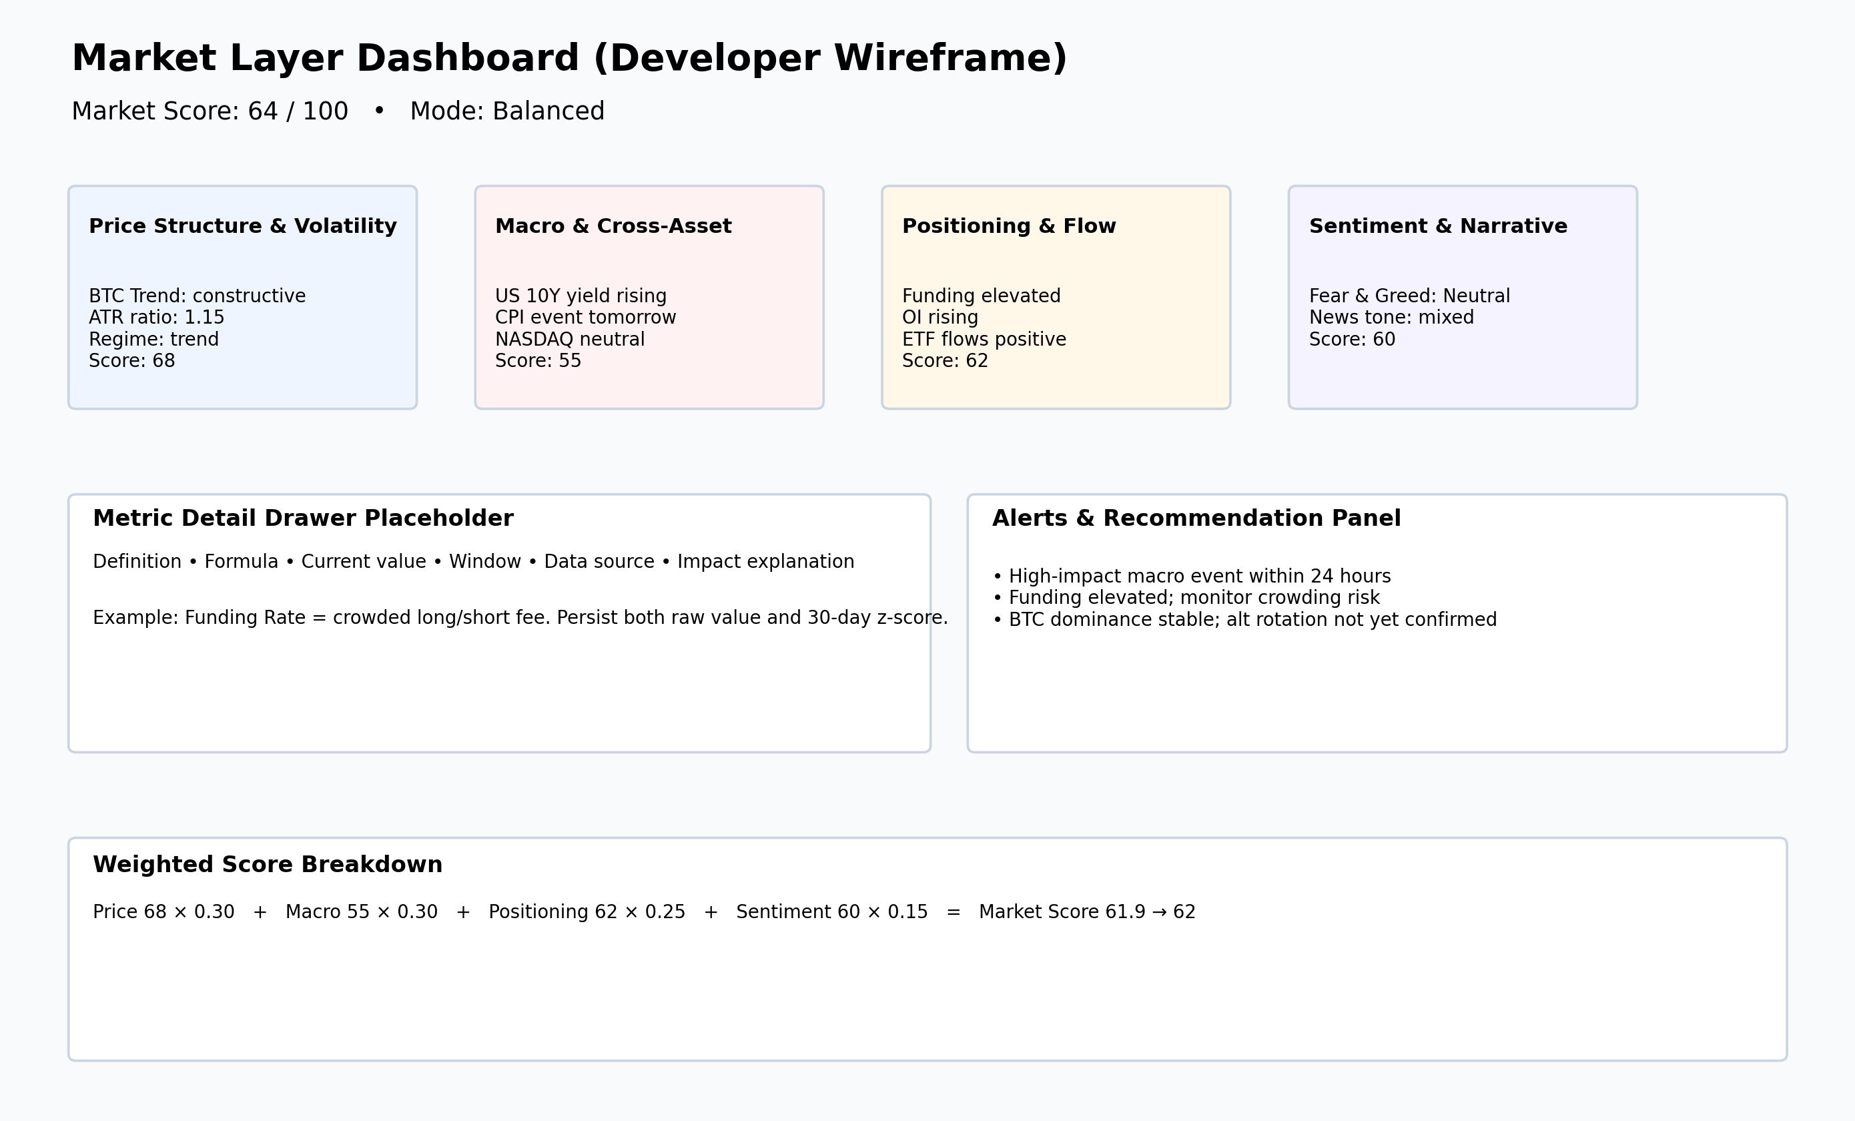
Figure 2. Example developer wireframe for the Market Layer dashboard.
On desktop, all four subsystem cards should appear above the fold with a weighted-breakdown panel and alerts strip. On tablet, cards can be arranged into two columns. On mobile, the application should switch to a single-column list of cards with drill-down navigation. Alerts should be plain and actionable, for example: “High-impact macro event within 24 hours,” “Funding elevated; monitor crowding risk,” or “Spread widening; execution quality degrading.”
Component | Purpose | Required fields
MarketHeader | Show final Market Score and mode | marketScore, mode, updatedAt, explanationShort
SubsystemCard | Summarize one subsystem | subsystemScore, 2–4 headline metrics, explanation
MetricDrawer | Teach and explain metric | definition, formula, currentValue, baseline, dataSource, explanation
BreakdownPanel | Transparency | weights, contributions, total score
AlertsPanel | Action guidance | alerts[], severity, recommended action

12. Score Validation and Monitoring
A Market Score is only useful if it behaves sensibly. Validation should therefore happen on at least five levels. First is face validity: does the score behave intuitively? If spreads blow out, does the liquidity score worsen? If a major CPI release is two hours away, does event risk rise? If BTC trend improves and volatility normalizes, does the Price Structure score recover? These are basic but essential checks.
Second is historical validation. Store Market Score history and compare different score environments with actual trading or strategy outcomes. Do high-score environments produce better follow-through for the strategy category you care about? Do low-score environments produce more failed breakouts or worse realized slippage? The goal is not to prove that the score predicts all returns; it is to prove that the score usefully distinguishes better environments from worse ones.
Third is event-study analysis. Review windows around major CPI releases, rate decisions, leverage squeezes, ETF flow shocks, or large risk-off macro days. Did the Market Layer become more defensive before or during those conditions? Fourth is out-of-sample testing. The score should be tested across trend periods, bear phases, and low-liquidity choppy phases instead of only one friendly historical window. Fifth is explainability auditing: every score should be traceable to raw inputs, computed features, normalized values, and weighted contributions. If the system cannot explain itself, users will not trust it and developers will struggle to maintain it.
- Face validity: does the score move in the expected direction?
- Historical validation: do better scores align with better trade conditions?
- Event studies: does the score react around CPI / Fed / leverage events?
- Out-of-sample testing: does it hold outside a single market phase?
- Explainability audit: can every score be traced to its raw inputs?

13. Glossary of Attributes
Attribute | Definition
Volatility | How fast and how far price is moving. Higher volatility usually means more uncertainty and wider stop behavior.
Market Regime | The type of market behavior: generally trending, ranging, or choppy/noisy.
Liquidity | How easily positions can be entered or exited without causing major price impact.
Event Risk | The chance that scheduled or unscheduled events suddenly disrupt normal market behavior.
BTC Trend | The direction and quality of Bitcoin’s recent price movement.
BTC Dominance | Bitcoin’s share of the total crypto market value.
Spread | The difference between best bid and best ask prices.
Depth | The amount of order-book size available near the current price.
Slippage | The difference between expected fill and actual fill.
Funding Rate | A fee exchanged between longs and shorts in perpetual futures markets.
Open Interest | The total amount of active derivative/futures positions.
10Y Yield | The return on the US 10-year Treasury bond, commonly used as a macro signal.
CPI | Consumer Price Index — a common inflation measure.
ETF Flows | Estimated money moving into or out of Bitcoin ETFs.
Stablecoin Market Cap | The total value of stablecoins in circulation, often used as a liquidity proxy.
Fear & Greed | A simplified market-mood gauge ranging from fear to greed.
News Sentiment | A simplified tone score derived from headlines and article sets.

14. Source Appendix and Practical Recommendations
This document combines sourced provider guidance with implementation recommendations. The sourced guidance used in drafting this ebook includes: Binance developer documentation for futures and spot market data such as klines, funding-rate history, current open interest, and open-interest history/statistics; FRED documentation for series observations and free economic data retrieval; Alpha Vantage documentation for index, forex, commodity, crypto, economic-indicator, and technical-indicator APIs; NewsAPI documentation and pricing for article search and free developer limits; Alternative.me public Fear & Greed endpoint and crypto API documentation; CoinGlass official API documentation and learning-center guidance; Glassnode documentation and pricing pages; DefiLlama official API documentation for free and pro stablecoin endpoints; and beginner educational explanations of BTC dominance from sites such as Binance Academy and Gemini.
If you are building the first version of this Market Layer, the most practical starter stack is: Binance for exchange-native market data, FRED for macro time series, DefiLlama for stablecoin market cap, Alternative.me for Fear & Greed, and NewsAPI for development-stage headline sentiment. If you later need richer depth, broader derivatives analytics, exchange-normalized historical datasets, or explicit commercial-use rights with stronger SLAs, then consider paid upgrades such as CoinGlass, CoinGecko higher tiers, commercial macro vendors, or Glassnode add-ons depending on the subsystem where the free stack becomes limiting.
The main recommendation of this ebook is simple: build the deterministic core first, explain every metric in plain language, preserve every computation step for auditability, and only add richer providers or model complexity when the product clearly needs them. Beginners will trust a system that explains itself. Developers will trust a system that can be inspected. A good Market Layer should satisfy both groups at once.

