Performance Layer for the Adaptive Risk Engine
Professional eBook Edition with Figma-Style UI Mockups
Deep formulas, scoring, charts, examples, and developer implementation guidance
Author: Shreyansh · Final Performance Layer Handoff Edition

This eBook fully expands the Performance Layer so designers, frontend engineers, backend developers, product teams, and analytics/ML teams can build practical dashboards and risk scores step by step.

Table of Contents
1. Introduction
2. What the Performance Layer Does
3. Performance Layer Diagram
4. Winrate
5. Loss Streak
6. PnL Trend
7. Trade Quality
8. Expectancy
9. Combining Performance Metrics into Score P
10. Dashboard Design for the Performance Layer
11. Figma-Style UI Mockups
12. Data Model and APIs
13. Build Guide for Developers
14. Practical Examples
15. Summary and Next Steps

1. Introduction
The Performance Layer answers one question before any trade is sized: Is the trader’s edge working well enough right now to justify risk? It does this by turning recent trade outcomes, process integrity, and economic value into a structured confidence score. The layer is useful because traders often size positions based on memory or emotion rather than a measured view of recent edge quality.
In a real product, the Performance Layer should be transparent, fast to compute, and easy to audit. The formulas must be simple enough for users to understand, but structured enough for developers to implement consistently across dashboards, APIs, and alerts.

2. What the Performance Layer Does
The Performance Layer converts raw trade history into a single score, usually called P, that represents recent strategy confidence. It should not be based on one metric alone. Good trading systems can have a low winrate but strong profitability, and high-winrate systems can still lose money if losses are too large. The layer therefore combines several attributes that measure different aspects of edge health.
- Winrate measures accuracy over a rolling sample.
- Loss Streak measures consecutive failed trades and psychological/structural stress.
- PnL Trend measures whether average trade profitability is improving or deteriorating.
- Trade Quality measures whether recent performance came from clean execution or luck.
- Expectancy combines winrate and payoff ratio to estimate the value of the strategy per trade.

3. Performance Layer Diagram
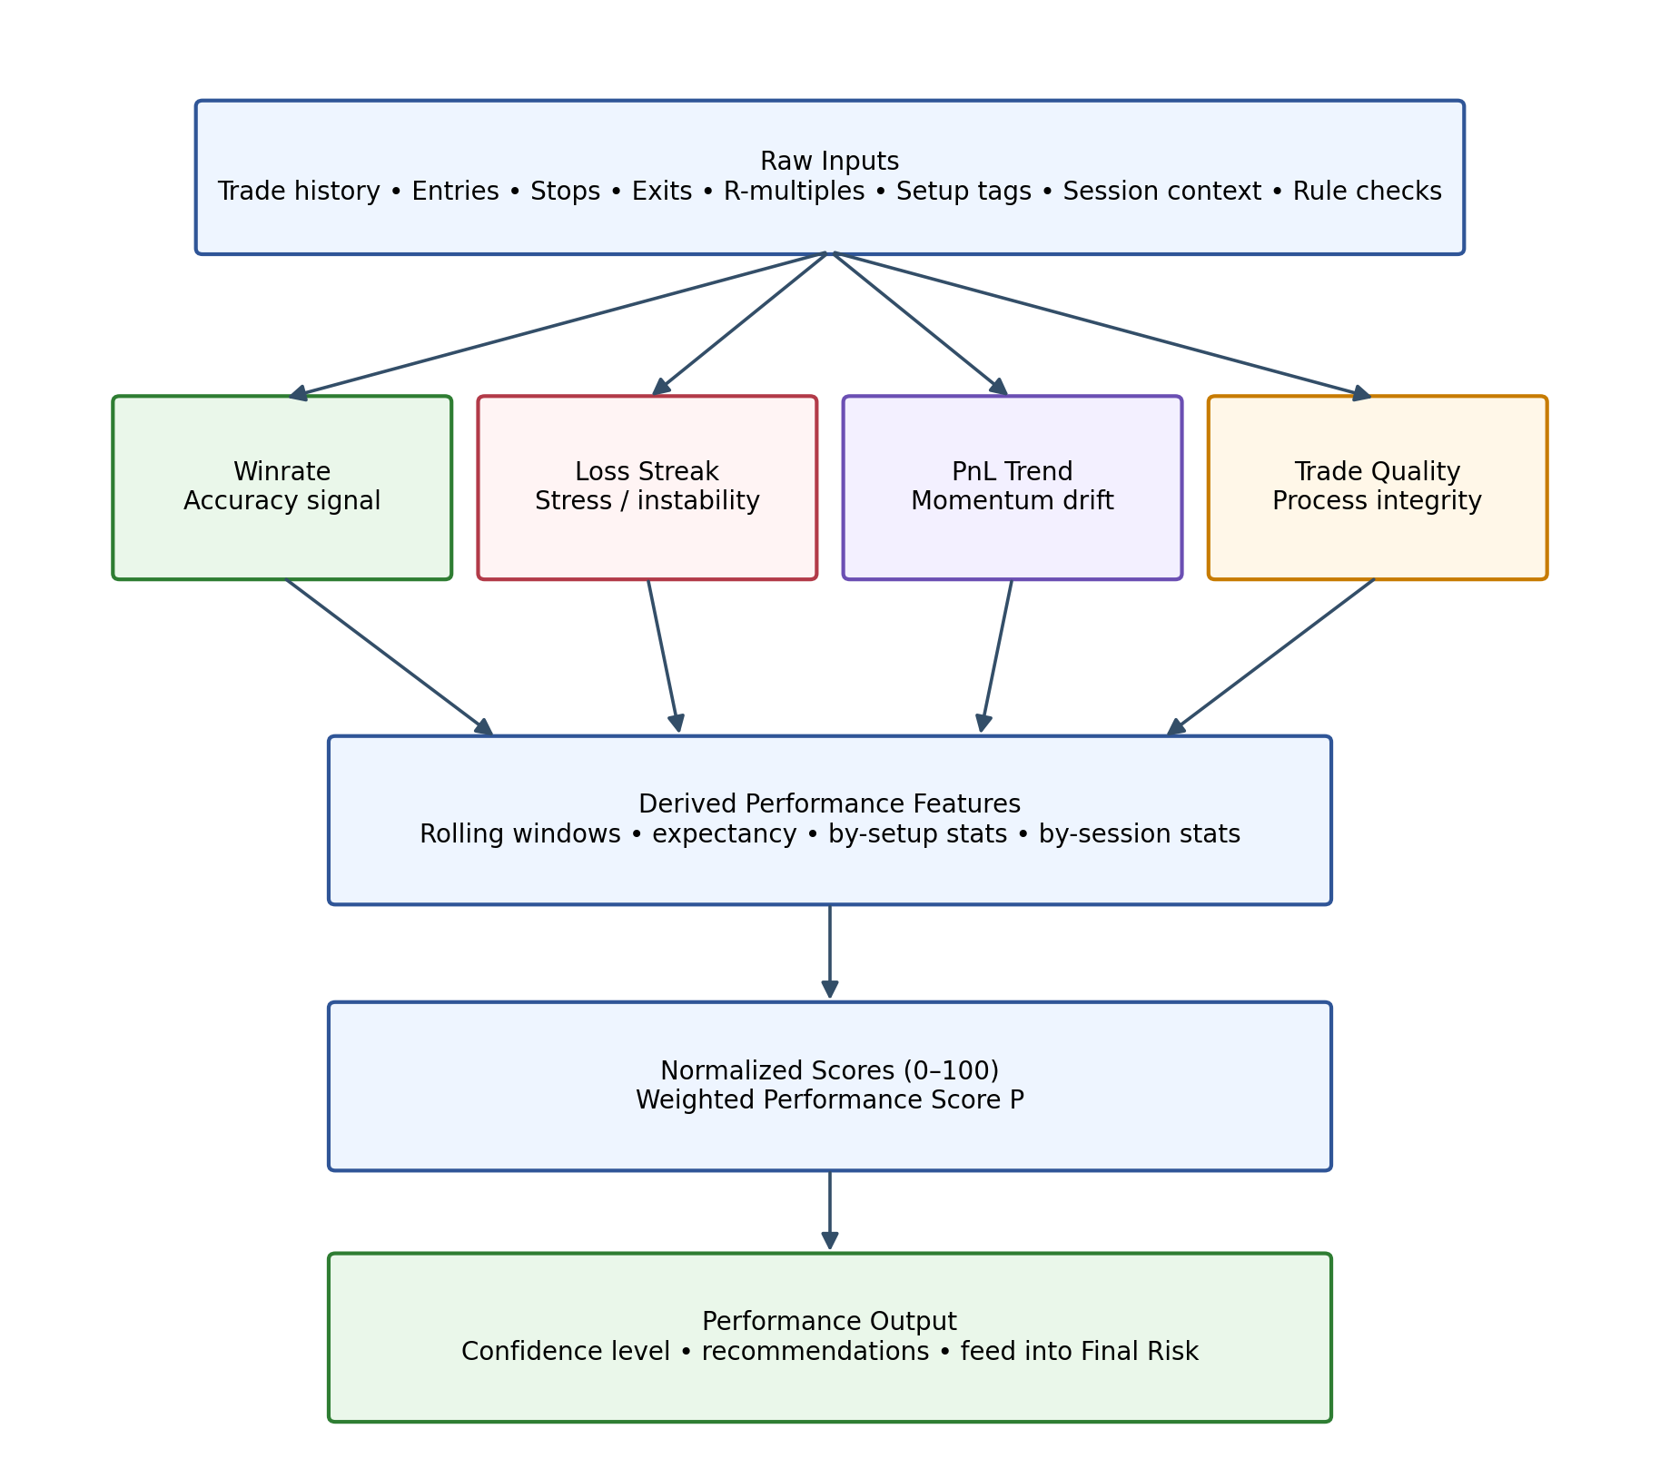
Figure 1. Suggested flow of the Performance Layer from raw trading data to the final Performance score P.

4. Winrate

4.1 Definition
Winrate is the percentage of completed trades that close in profit. It reflects trade accuracy, not profitability by itself. The metric is best understood as an observed estimate of the probability of success under recent conditions.
Winrate = (Winning Trades / Total Trades) × 100

4.2 Why it matters
Winrate tells the system whether the strategy is landing often enough to deserve confidence. A breakdown in winrate may indicate that market structure has changed, execution quality has slipped, or the trader is taking lower-quality setups.

4.3 Sub-attributes that drive winrate
Sub-attribute | Definition | How to measure | Why it matters
Entry Quality | Distance between actual entry and ideal planned entry | Entry Error = |Actual Entry − Ideal Entry| | Late or poor entries lower the probability of success
Stop Placement Accuracy | How appropriately the stop is placed relative to invalidation and volatility | Stop Ratio = Stop Distance / ATR | Stops that are too tight reduce winrate; stops that are too wide may hide poor structure
Trend Strength | Strength of directional movement | MA slope, ADX, higher-high/higher-low structure | Trend-following setups typically win more when trend strength is higher
Market Regime Alignment | Match between strategy type and market state | Classify regime as trend, range, or chop | A breakout strategy behaves differently in trend vs chop
Liquidity Quality | Cleanliness of execution conditions | Spread, depth, average slippage | Poor liquidity can reduce realized winrate through bad fills
Execution Timing | Delay from signal to order fill | Latency = entry time − signal time | In fast crypto markets delayed execution can materially lower success probability
Discipline Context | Whether recent rules were followed | Derived from trade-quality checklist and journal | Bad discipline reduces realized winrate even when the signal process is valid

4.4 Rolling windows
- Short-term window: last 20 trades — useful for responsiveness.
- Steadier window: last 50 trades — useful for avoiding overreaction to a tiny sample.
- Optional segmented windows: by symbol, setup, timeframe, session, or regime.

4.5 Normalization and score
Winrate Score = min(100, max(0, 2 × Winrate − 50))
With a 65% winrate, the score becomes 80. This gives the engine an intuitive confidence value rather than a raw ratio.
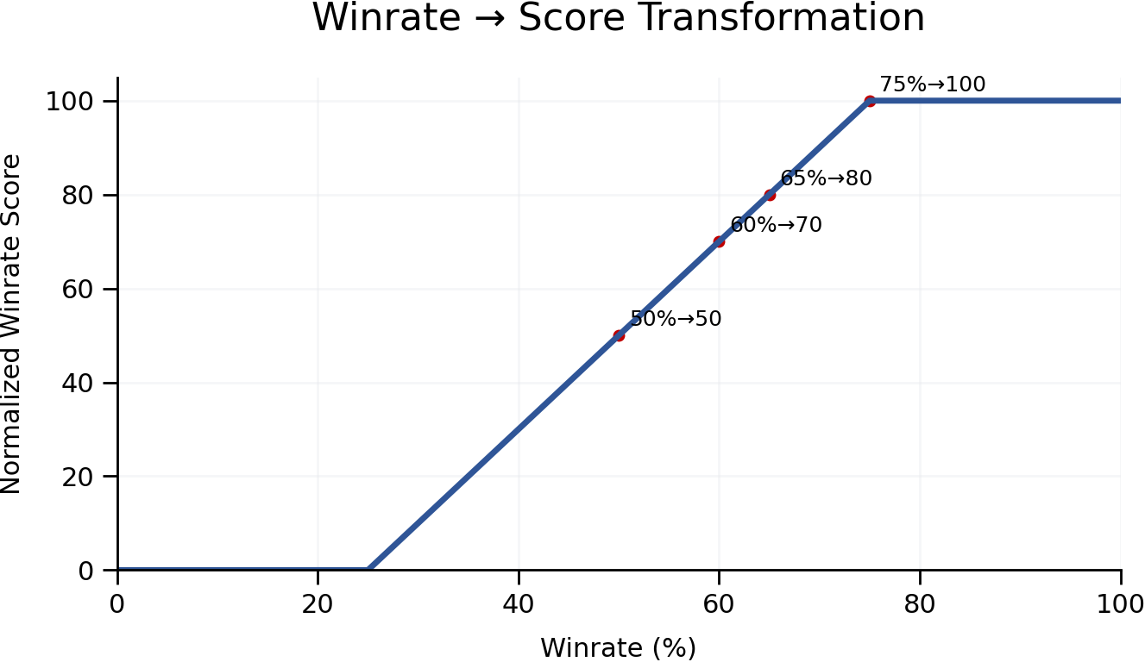
Figure 2. Example transformation from winrate to normalized score.

4.6 Example
If the trader won 13 of the last 20 trades, the rolling winrate is 65% and the normalized score is 80. That is a strong signal, but it still needs confirmation from expectancy and trade quality before the product recommends more aggression.

5. Loss Streak

5.1 Definition
Loss Streak is the number of consecutive losing trades. It is a protection metric because it captures both strategy stress and the increased probability of emotional degradation after repeated losses.
Loss Streak = count of consecutive losing trades

5.2 Sub-attributes and measurement
Sub-attribute | Definition | How to measure | Why it matters
Streak Length | Number of losses in a row | Simple count until a win resets the streak | Longer streaks increase stress and overreaction risk
Loss Severity | Average size of losses during the streak | Average R-multiple or average % loss over the streak | Three small losses differ from three oversized losses
Setup Consistency | Whether the losing trades came from the same setup type | Tag each trade by setup and count streaks within setup | A concentrated streak may indicate a setup-specific problem
Behavioral Deviation | Whether rules were broken during the streak | Use trade-quality checklist and notes | Poor behavior during a streak justifies stronger penalties
Market Context | Whether regime/volatility changed during the streak | Join streak sequence with market features | A streak caused by a regime shift may resolve differently from a behavior-driven streak

5.3 Penalty and score
Loss Penalty = a × Loss Streak
Loss Streak Score = max(0, 100 − Loss Penalty)
With a = 8 and a 3-trade loss streak, the score becomes 76. The coefficient a controls how aggressively the product reacts.
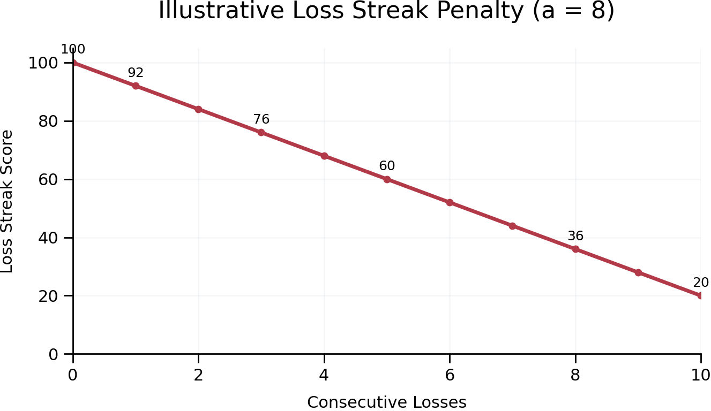
Figure 3. Illustrative loss-streak penalty curve.

6. PnL Trend

6.1 Definition
PnL Trend measures whether average profitability is improving or deteriorating over time. This is valuable because a strategy can keep winning often enough to feel healthy while quietly paying less per trade.
PnL Trend = Recent Avg PnL − Long-Term Avg PnL

6.2 Sub-attributes and measurement
Sub-attribute | Definition | How to measure | Why it matters
Recent Avg PnL | Average profitability over shorter lookback | Mean R-multiple or mean % return over last 10–20 trades | Captures the current profitability regime
Long-Term Avg PnL | Average profitability over longer lookback | Mean R-multiple or mean % return over last 50–100 trades | Provides a baseline
Expectancy Drift | Change in expected value per trade | Recent expectancy − long-term expectancy | Tracks changes in both accuracy and payoff ratio
Variance of Outcomes | Dispersion around average PnL | Standard deviation of trade outcomes | Helps determine whether a change is meaningful or noisy
Setup Mix Shift | Change in traded setup composition | Share of trades by setup type over each window | A drop in profitability may come from weaker setup mix

6.3 Score transformation
PnL Trend Score = clamp(50 + k × (Recent Avg PnL − Long-Term Avg PnL), 0, 100)
If Recent Avg PnL is +35 and Long-Term Avg PnL is +60, the drift is −25. With k = 0.5, the score becomes 37.5.
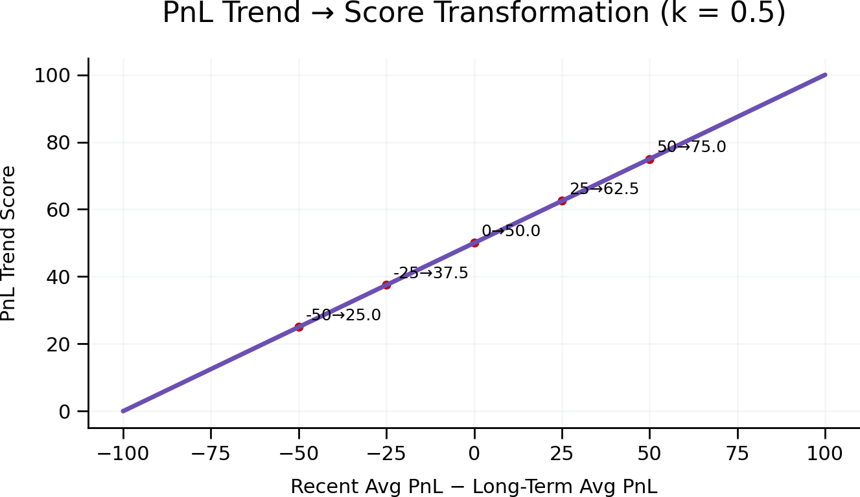
Figure 4. Example transformation from PnL drift to normalized score.

7. Trade Quality

7.1 Definition
Trade Quality measures how well recent trades adhered to the intended process. This is critical because profitable trades can still come from poor behavior, and a risk engine should not reward luck as if it were skill.
Trade Quality Score = (Points Earned / Max Points) × 100

7.2 Recommended rule checklist
Checklist Item | Illustrative Points | How to measure
Valid setup matched playbook | 20 | Rule-based setup tag or manual confirmation
Entry followed the plan | 20 | Compare planned entry zone vs executed entry
Stop was placed correctly | 20 | Ensure stop aligns with invalidation + volatility rules
Position size respected rule | 20 | Compare executed size to engine-approved size
Exit followed process | 20 | Planned target / management rules vs actual exit behavior

7.3 Sub-attributes and measurement
Sub-attribute | Definition | How to measure | Why it matters
Setup Validity | Whether the trade matched a defined playbook | Boolean or score from setup engine | Separates planned trades from improvisation
Entry Precision | How close execution was to plan | Distance from planned zone or optimal level | Late or impulsive entries usually reduce edge
Stop Integrity | Whether the stop respected invalidation and was not moved improperly | Check initial stop vs final stop history | Protects against hidden tail-risk
Size Integrity | Whether executed size matched allowed size | Executed risk ÷ allowed risk | Oversizing distorts both performance and psychology
Exit Discipline | Whether the exit followed plan rather than emotion | Planned exit logic vs actual fills | Captures chasing, panic exits, and target abandonment

8. Expectancy

8.1 Definition
Expectancy estimates the expected value of the strategy per trade. It is often the most important performance metric because it combines both accuracy and payoff ratio.
Expectancy = (Winrate × Avg Win) − ((1 − Winrate) × Avg Loss)
If outcomes are recorded in R-multiples and the average loss is normalized to 1R, the formula becomes easier to compare across time.

8.2 Sub-attributes and measurement
Sub-attribute | Definition | How to measure | Why it matters
Winrate | Probability of a winning trade | Rolling winrate over chosen window | One half of expectancy
Average Win | Mean positive outcome | Average R of winning trades | Measures reward efficiency
Average Loss | Mean negative outcome | Average absolute R of losing trades | Measures loss containment
Payoff Ratio | Average Win / Average Loss | Derived from avg win and avg loss | Shows whether the strategy needs high accuracy or not
Outcome Variance | Dispersion of results around mean expectancy | Standard deviation of trade R values | Tells you how stable expectancy is
Example A: Winrate 60%, average win 1.2R, average loss 1.0R. Expectancy = 0.32R, which is healthy positive expectation. Example B: Winrate 70%, average win 0.5R, average loss 2.0R. Expectancy = −0.25R despite a high hit rate.
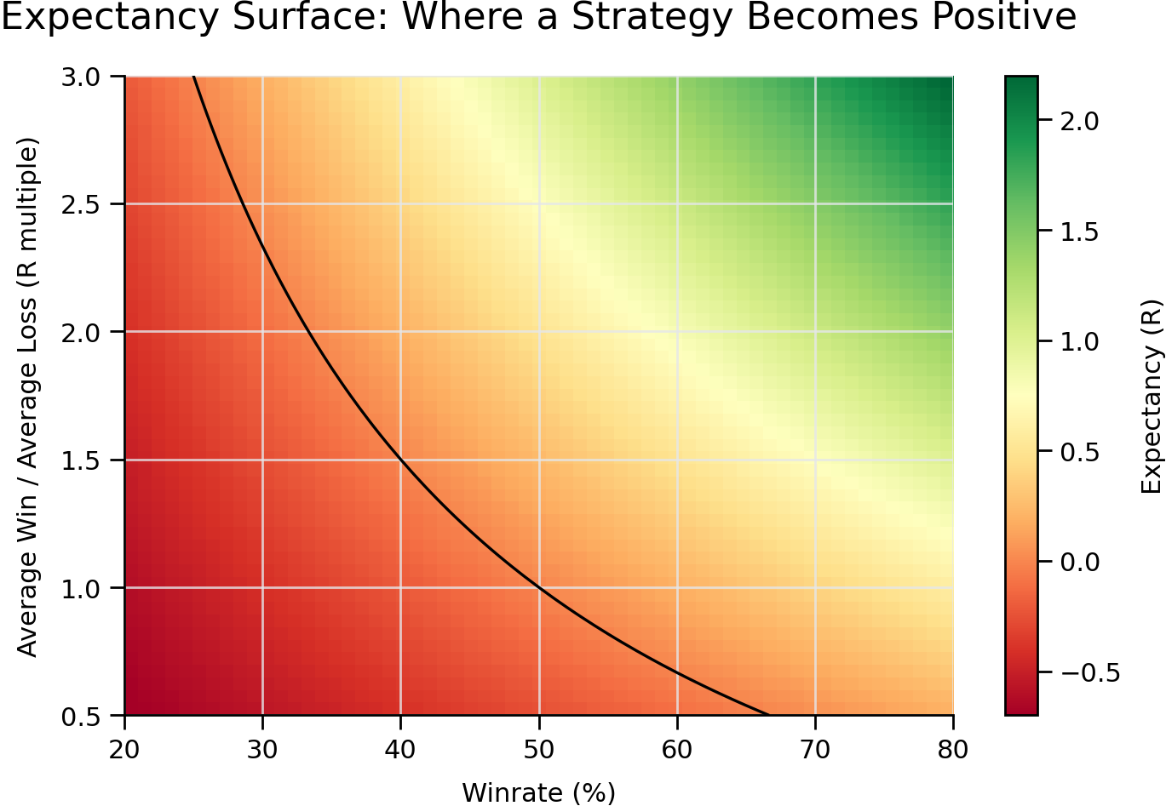
Figure 5. Expectancy surface showing combinations of winrate and payoff ratio that produce positive or negative expectation.

9. Combining Performance Metrics into Score P
P = w1×WinrateScore + w2×LossStreakScore + w3×PnLTrendScore + w4×TradeQualityScore + w5×ExpectancyScore
An illustrative weighting scheme is 25% Winrate, 15% Loss Streak, 20% PnL Trend, 20% Trade Quality, and 20% Expectancy. This preserves accuracy as an important signal while ensuring that economic quality and process quality matter as much.

10. Dashboard Design for the Performance Layer
A strong dashboard should let a trader interpret performance quickly without hiding important detail. The default view should be concise, and drill-down views should expose formulas, windows, sub-attributes, and explanations.
- Performance score gauge with mode label such as Strong / Balanced / Weak.
- Winrate card with current value, window length, score, and sparkline or chart.
- Loss streak card with streak length, penalty score, and recommendation.
- PnL trend card with recent vs long-term averages and drift score.
- Trade quality checklist summary with recent violations.
- Expectancy card showing current expectancy in R, payoff ratio, and strategy health label.

11. Figma-Style UI Mockups
The following screens are intended as readable handoff assets for developers and designers. They convert the formulas, scoring logic, and dashboard guidance into concrete layouts that can be built in a web or mobile application.

11.1 Desktop Overview Mockup
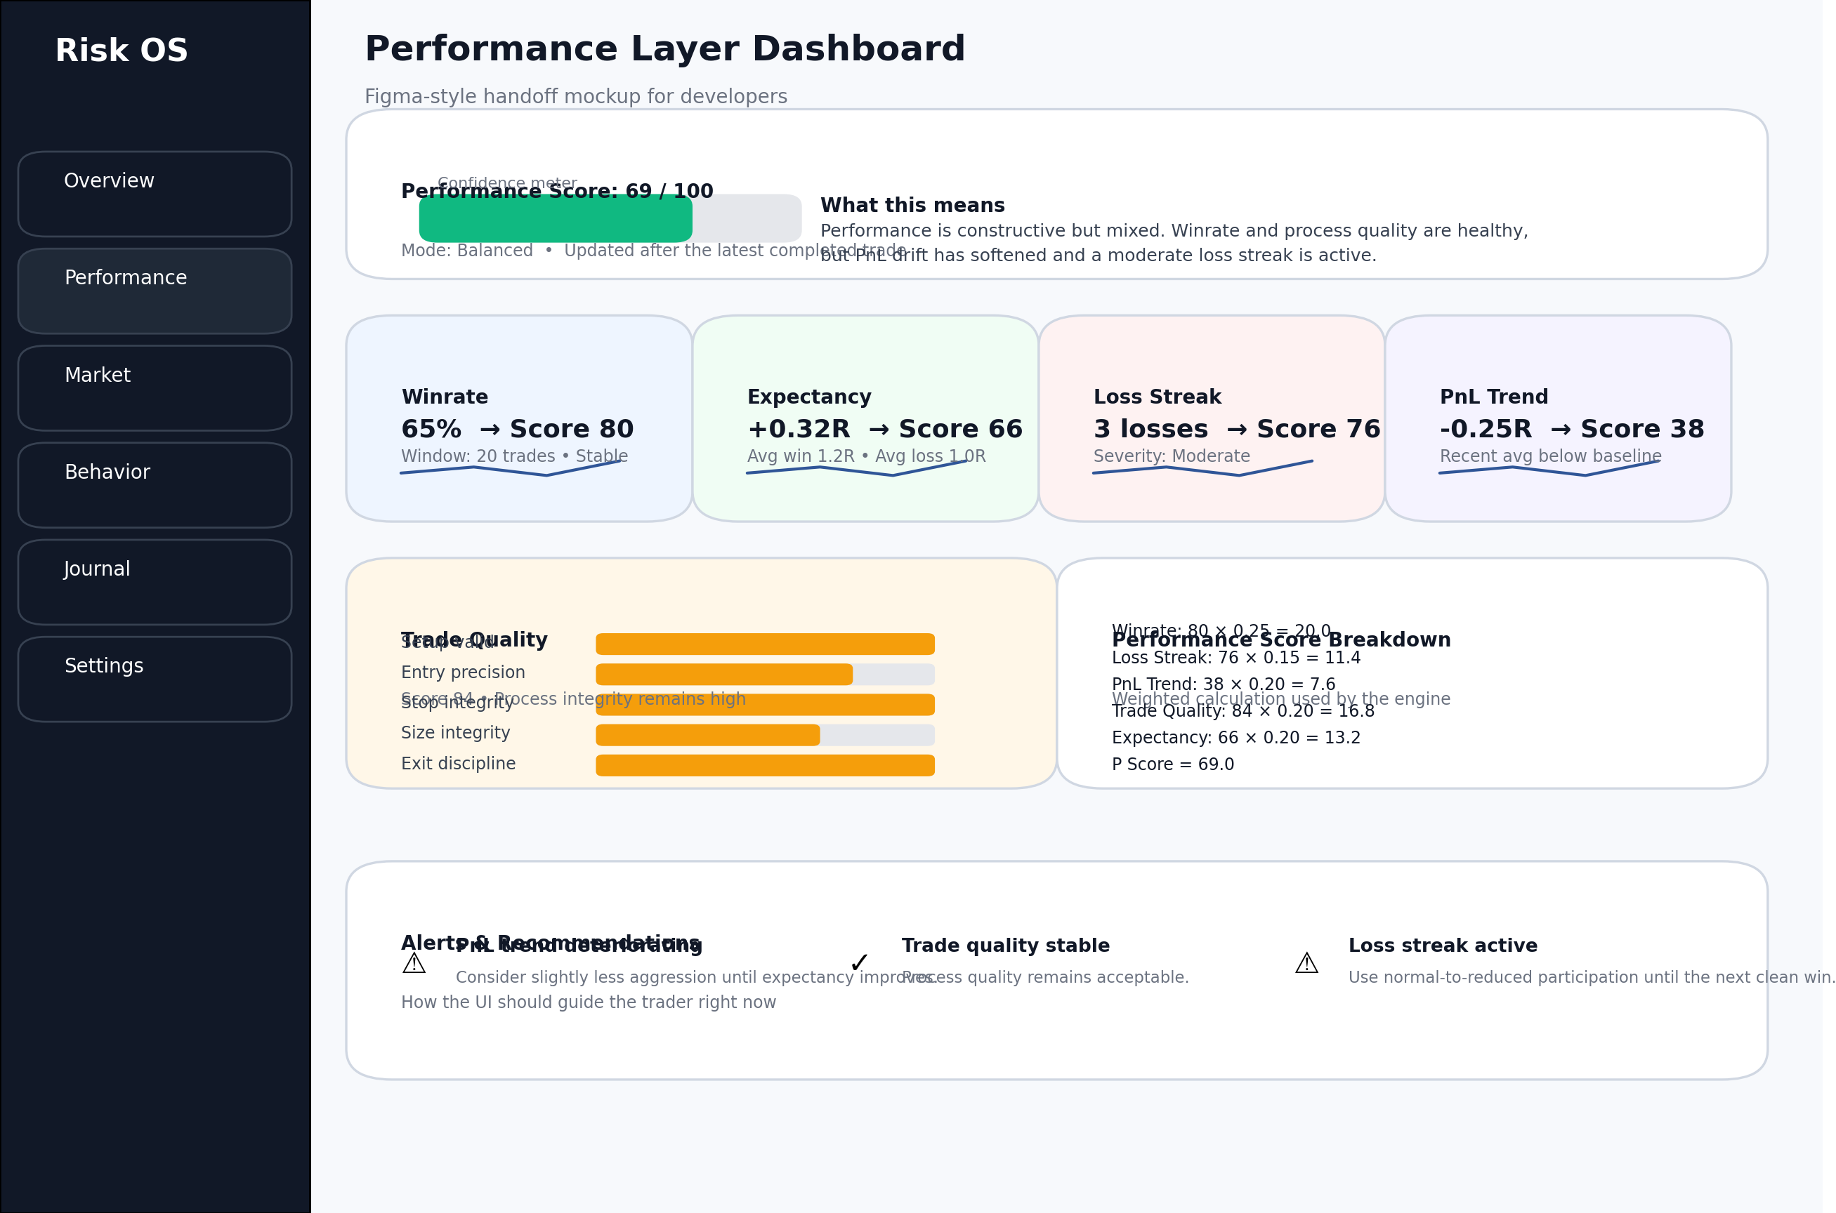
Figure 6. Figma-style desktop overview mockup showing a production-friendly layout for the Performance Layer dashboard.
This main screen surfaces the Performance score, each major metric card, the weighted-breakdown panel, and the recommendation strip. The goal is to answer one question instantly: how strong is the recent edge, and what should the trader do about it?
- Header should show P Score, mode label, and last-updated state.
- Primary cards should include Winrate, Expectancy, Loss Streak, and PnL Trend above the fold.
- Trade Quality should use a wider diagnostic card with checklist progress bars.
- The breakdown panel should display the exact weighted contributions so the score is explainable.
- An alerts strip should turn metrics into action-oriented guidance such as Reduce aggression slightly or Quality stable.

11.2 Attribute Deep-Dive Drawer
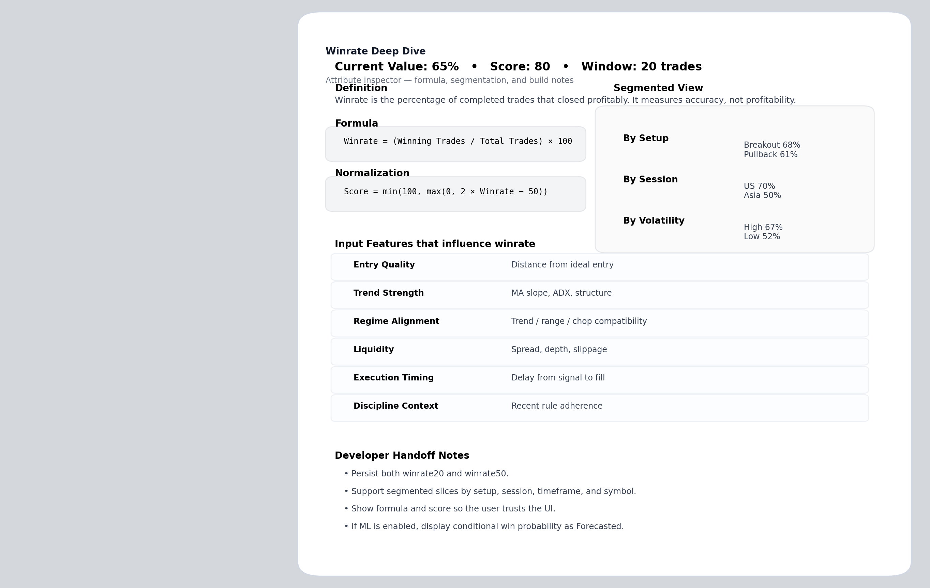
Figure 7. Deep-dive side panel for a metric such as Winrate, including formulas, segmentation, and implementation notes.
Each metric card should open a detail drawer or modal that explains the metric in plain English, shows the raw formula, the score transformation, the active rolling window, segmented slices, input features, and model labels such as Measured, Analytical, or Forecasted.
- Definition: one-sentence explanation of the metric.
- Formula: raw calculation and score transformation exactly as implemented.
- Windowing: show 20-trade / 50-trade or similar context.
- Segments: expose by setup, session, timeframe, symbol, volatility bucket, or regime where available.
- Input features: list the sub-attributes that influence the metric.
- Developer notes: highlight what is persisted, derived, or forecasted.

11.3 Mobile / Live Risk Card
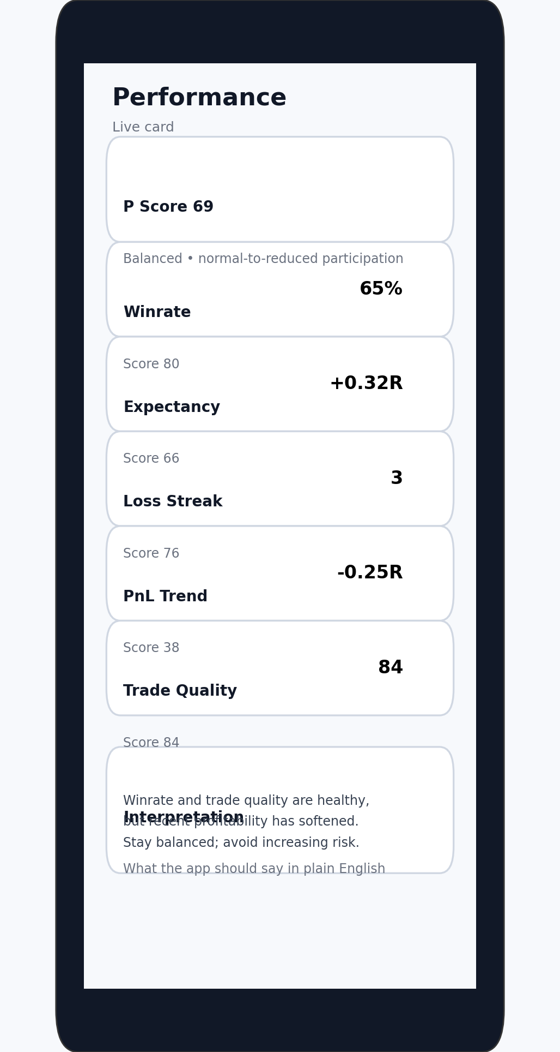
Figure 8. Responsive mobile-style risk card for the Performance Layer.
The mobile card prioritizes clarity over density. It shows the Performance score, each headline metric, and a short explanation telling the trader what to do. Use mobile for quick checks before placing a trade or when reviewing recent edge quality away from the desktop.
- Desktop: show all cards plus the weighted-breakdown panel.
- Tablet: stack cards in two columns and keep the explanation box visible.
- Mobile: show a single-column list of metric cards with drill-down navigation for deeper inspection.

12. Data Model and APIs
Developers need the ebook to translate into data structures, not just concepts. The Performance Layer is easiest to implement when the product persists raw trades, derived features, and scored outputs separately.

12.1 Core entities
Entity | Suggested fields
Trade | id, symbol, side, setup_tag, entry_price, stop_price, exit_price, size, pnl_raw, pnl_r, session, notes
TradeQuality | trade_id, setup_valid, entry_ok, stop_ok, size_ok, exit_ok, total_score
PerformanceFeatures | timestamp, winrate20, winrate50, loss_streak, recent_avg_r, long_avg_r, expectancy_r, avg_win_r, avg_loss_r
PerformanceSnapshot | timestamp, winrate_score, streak_score, pnl_trend_score, trade_quality_score, expectancy_score, P_score, explanation

12.2 Example API payload
{
"timestamp": "2026-06-14T13:22:00+02:00",
"performance": {
"winrate": {"window": 20, "value": 65.0, "score": 80},
"lossStreak": {"value": 3, "score": 76},
"pnlTrend": {"recentAvgR": 0.35, "longAvgR": 0.60, "score": 38},
"tradeQuality": {"value": 84, "score": 84},
"expectancy": {"valueR": 0.32, "avgWinR": 1.2, "avgLossR": 1.0, "score": 66},
"PScore": 69,
"message": "Performance is constructive but mixed: winrate and quality are strong, expectancy is positive, recent profitability has softened."
}
}

12.3 UI component specification
Component | Purpose | Required data fields | Interaction
PerformanceHeader | Shows current P score and interpretation | PScore, mode, updatedAt, explanationShort | Static + link to full explanation
WinrateCard | Accuracy signal | winrate20, winrate50, score, tradeCount, trendDirection | Click opens deep dive
ExpectancyCard | Economic value per trade | expectancyR, avgWinR, avgLossR, payoffRatio, score | Hover shows expectancy formula
LossStreakCard | Protection signal | currentStreak, avgLossDuringStreak, score, cooldownHint | Click opens streak history
PnLTrendCard | Momentum/drift signal | recentAvgR, longAvgR, trendDelta, score | Toggle between chart windows
TradeQualityCard | Process integrity | checklist item scores, total score, recent violations | Click opens audit checklist
BreakdownPanel | Weighted calculation transparency | metric score, weight, contribution, PScore | Expandable
AlertsPanel | Action guidance | alerts[], severity, recommendation | Dismiss / learn more

13. Build Guide for Developers
- Persist each completed trade with normalized PnL in both raw currency and R-multiples.
- Compute rolling features after each trade or on a schedule: winrate, streak, recent/long-term averages, expectancy, and quality aggregates.
- Transform each feature into a bounded 0–100 score using deterministic formulas.
- Compute the final P score, store the explanation string, and publish the snapshot to the dashboard, API, and alerts layer.
Recommended rollout order: first ship deterministic formulas and dashboards, then add segmented analytics, and only after that add ML forecasts such as conditional win probability or expected next-trade R.

13.1 Front-end component tree
PerformanceLayerPage
├── PerformanceHeader
├── MetricGrid
│ ├── WinrateCard
│ ├── ExpectancyCard
│ ├── LossStreakCard
│ ├── PnLTrendCard
│ └── TradeQualityCard
├── BreakdownPanel
├── AlertsPanel
└── MetricDetailDrawer

13.2 Pseudocode
def compute_performance_layer(trades, config):
feats = derive_performance_features(trades)
winrate_score = clamp(2 * feats.winrate20 - 50, 0, 100)
streak_score = max(0, 100 - config.loss_penalty * feats.loss_streak)
pnl_trend_score = clamp(50 + config.pnl_k * (feats.recent_avg_r - feats.long_avg_r), 0, 100)
trade_quality_score = feats.trade_quality_avg
expectancy_score = clamp(50 + config.exp_m * feats.expectancy_r, 0, 100)
P = (config.w_winrate * winrate_score + config.w_streak * streak_score +
config.w_pnl * pnl_trend_score + config.w_quality * trade_quality_score +
config.w_expectancy * expectancy_score)
return {"features": feats, "scores": {"winrate": winrate_score, "loss_streak": streak_score,
"pnl_trend": pnl_trend_score, "trade_quality": trade_quality_score,
"expectancy": expectancy_score, "P": P}}

14. Practical Examples
Example 1: Healthy BTC continuation system — 65% rolling winrate, no active loss streak, +0.30R expectancy, and 86 average quality score. The Performance Layer should conclude that confidence is healthy and allow the higher-level engine to consider moderate scaling if Market and Behavior also support it.
Example 2: Accuracy good, economics weak — 68% winrate, but average winners are only 0.4R and average losers are 1.2R. Expectancy is weak or negative, so the dashboard should show an attractive hit rate but a weak expectancy card. This prevents the product from recommending aggressive scaling.
Example 3: Quality deteriorates before outcomes do — the trader keeps winning, but late entries, stop changes, and size drift become frequent. Trade Quality falls from 88 to 62 before winrate collapses. The Performance Layer notices degradation early and keeps confidence from rising purely because recent outcomes were favorable.

15. Summary and Next Steps
The Performance Layer is strongest when it measures accuracy, protection, profitability drift, process integrity, and economic value together. Winrate, Loss Streak, PnL Trend, Trade Quality, and Expectancy each contribute a different type of evidence, and the developer’s job is to preserve that nuance instead of collapsing everything into raw PnL.
This edition now includes Figma-style dashboard mockups so your team can hand the screens, formulas, and API payloads directly to developers. The next logical step is to build the Market Layer in the same depth and style so the final combined risk-engine manual becomes consistent across all layers.

