**A short report on Lab 1**

The task for the first lab was to write a program to search for data in the list. For this, we use two searching algorithms: linear and binary search.

**Procedure**

At first, code for both linear and binary search was written. This was then tested using python unittest library. Tests ran successfully and the algorithm was validated. Then I move onwards to test the performance of both algorithms.

For linear search, 10000 to 300000 data points with an increment of 10000 each step were randomly generated in random order and simulated three cases: Best Case, Average Case and Worst-Case. For Best Case, we gave the algorithm to search for the first element in the list. For the average case, we randomly generated the data to be searched. For the worst case, we gave it the last data on the list.

For binary search, 10000 to 10000000 data points were used as this algorithm is significantly faster than previous algorithm and time measurements were done in nano seconds for the same reason. Since for binary search requires data to be sorted in ascending order, we generated numbers in ascending order. Similar to previous method, three tests were conducted. For Best Case, list’s middle element was given as search value. For average case, we generated random value to be searched. For worst case, we generated data as complete binary tree and fed the last leaf node as search value.

**Results**

**Linear Search** (In Seconds):

**Worst Case**

Elapsed Time for 10000 datas: 0.000798

Elapsed Time for 20000 datas: 0.001988

Elapsed Time for 30000 datas: 0.002228

Elapsed Time for 40000 datas: 0.003177

Elapsed Time for 50000 datas: 0.00331

Elapsed Time for 60000 datas: 0.003926

Elapsed Time for 70000 datas: 0.004514

Elapsed Time for 80000 datas: 0.007507

Elapsed Time for 90000 datas: 0.013666

Elapsed Time for 100000 datas: 0.013993

Elapsed Time for 110000 datas: 0.056185

Elapsed Time for 120000 datas: 0.017898

Elapsed Time for 130000 datas: 0.02367

Elapsed Time for 140000 datas: 0.055672

Elapsed Time for 150000 datas: 0.028391

Elapsed Time for 160000 datas: 0.032385

Elapsed Time for 170000 datas: 0.036983

Elapsed Time for 180000 datas: 0.029536

Elapsed Time for 190000 datas: 0.026411

Elapsed Time for 200000 datas: 0.037

Elapsed Time for 210000 datas: 0.035892

Elapsed Time for 220000 datas: 0.0309

Elapsed Time for 230000 datas: 0.032893

Elapsed Time for 240000 datas: 0.059181

Elapsed Time for 250000 datas: 0.060668

Elapsed Time for 260000 datas: 0.066853

Elapsed Time for 270000 datas: 0.03909

Elapsed Time for 280000 datas: 0.040097

Elapsed Time for 290000 datas: 0.050133

**Best Case**

Elapsed Time for 10000 datas: 1e-05

Elapsed Time for 20000 datas: 2.3e-05

Elapsed Time for 30000 datas: 1.9e-05

Elapsed Time for 40000 datas: 1.6e-05

Elapsed Time for 50000 datas: 2.1e-05

Elapsed Time for 60000 datas: 1.7e-05

Elapsed Time for 70000 datas: 1.5e-05

Elapsed Time for 80000 datas: 3.8e-05

Elapsed Time for 90000 datas: 1.2e-05

Elapsed Time for 100000 datas: 1.4e-05

Elapsed Time for 110000 datas: 1.3e-05

Elapsed Time for 120000 datas: 1.4e-05

Elapsed Time for 130000 datas: 1.3e-05

Elapsed Time for 140000 datas: 1.3e-05

Elapsed Time for 150000 datas: 1.6e-05

Elapsed Time for 160000 datas: 1.7e-05

Elapsed Time for 170000 datas: 1.3e-05

Elapsed Time for 180000 datas: 1.5e-05

Elapsed Time for 190000 datas: 1.4e-05

Elapsed Time for 200000 datas: 1.2e-05

Elapsed Time for 210000 datas: 1.5e-05

Elapsed Time for 220000 datas: 1.4e-05

Elapsed Time for 230000 datas: 1.3e-05

Elapsed Time for 240000 datas: 1.3e-05

Elapsed Time for 250000 datas: 1.4e-05

Elapsed Time for 260000 datas: 1.3e-05

Elapsed Time for 270000 datas: 1.5e-05

Elapsed Time for 280000 datas: 1.3e-05

Elapsed Time for 290000 datas: 1.3e-05

**Average Case**

Elapsed Time for 10000 datas: 0.001105

Elapsed Time for 20000 datas: 0.003032

Elapsed Time for 30000 datas: 0.004094

Elapsed Time for 40000 datas: 0.007881

Elapsed Time for 50000 datas: 0.002101

Elapsed Time for 60000 datas: 0.009247

Elapsed Time for 70000 datas: 0.004724

Elapsed Time for 80000 datas: 0.000818

Elapsed Time for 90000 datas: 0.003721

Elapsed Time for 100000 datas: 0.033262

Elapsed Time for 110000 datas: 0.027192

Elapsed Time for 120000 datas: 0.024303

Elapsed Time for 130000 datas: 0.006267

Elapsed Time for 140000 datas: 0.005651

Elapsed Time for 150000 datas: 0.00846

Elapsed Time for 160000 datas: 0.003054

Elapsed Time for 170000 datas: 0.010056

Elapsed Time for 180000 datas: 0.011632

Elapsed Time for 190000 datas: 0.022023

Elapsed Time for 200000 datas: 0.017633

Elapsed Time for 210000 datas: 0.001985

Elapsed Time for 220000 datas: 0.026751

Elapsed Time for 230000 datas: 0.023426

Elapsed Time for 240000 datas: 0.03277

Elapsed Time for 250000 datas: 0.017235

Elapsed Time for 260000 datas: 0.017954

Elapsed Time for 270000 datas: 0.038151

Elapsed Time for 280000 datas: 0.021099

Elapsed Time for 290000 datas: 0.013775

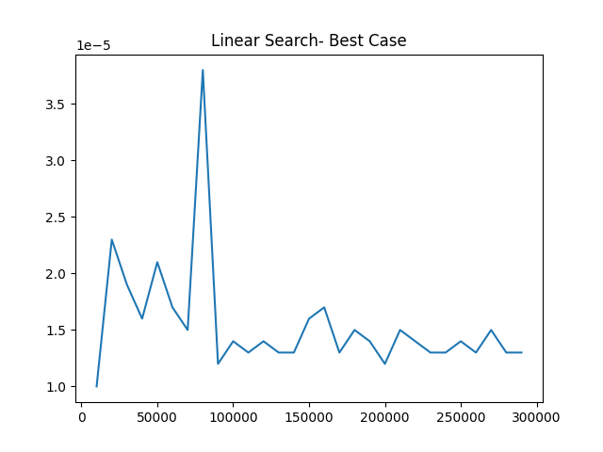

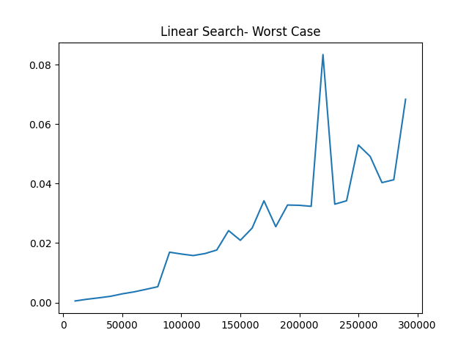

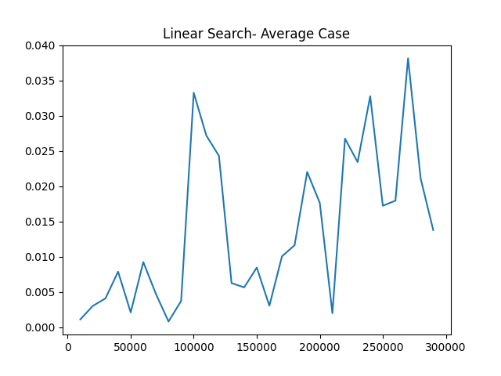

**Binary Search** (In ns):

As there are too many time points, we’ll only show plots of the result.

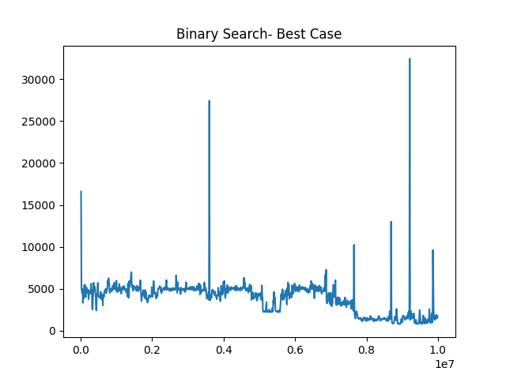

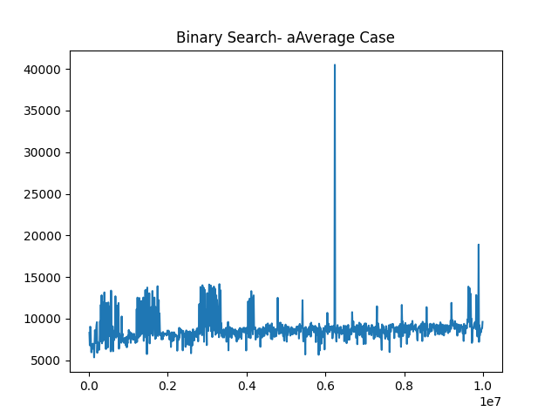

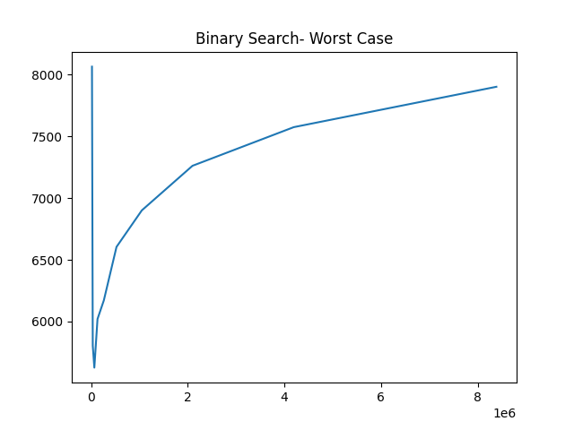

**Conclusion**

From the above time measurements as well as graphs we can see that, in linear search, for worst case the results grows linearly as number of points increases. So the time complexity can be interpreted as O(n). For binary search, it can be seen that time increases logarithmitically. So the time complexity is O(log(n)).