**SYNOPSIS**

**Project Group No: B3**

**Register No: Name:**

1. 221003064 Nag Ashish S V
2. 221003080 Ranga Satya Viswa Pavan
3. 221003117 Pramodh Sairam P V

**Project Title:** Handwriting Recognition and Writer Identification on text independent data

**Name of the Guide**: Durga Karthik/AP-III/CSE/SRC/SASTRA

**Abstract:**

Identification of a person from his handwriting is one of the challenging problems, however, it is not new. No one can repudiate its applications in a number of domains, such as bio-metrics, forensic analysis, historical documents, and ancient manuscripts. Handwriting plays a key role in presentation of learned behaviour of the person. It is the main identity of a person. Deep learning-based approaches have proved as the best feature extractors from massive amounts of heterogeneous data and provide promising and surprising predictions of patterns as compared with traditional approaches. Automatic writer identification system helps in determining and identifying whether the given handwriting is truly matched and assigned to the claimed writer of handwriting.

**Specific Contribution:**

1. Created a Convolutional Neural Network based on AlexNet architecture and configured the appropriate parameters like optimizer, loss function, activation functions, epochs, no of filters and strides etc. Implemented training, testing and validation of the model.
2. Designed the entire workflow of the project and resolved issues occurred in various stages of the project.

**Specific Learning:**

1. Learnt various concepts involved in CNN like convolution, pooling, flattening, batch normalization, ANN, back propagations along with the mathematics lying behind them.

2. Understood various insights about AlexNet architecture and its implementation.

**Technical Limitations & Ethical Challenges faced**

1. To train a deep learning model with more than 300k trainable parameters, it is highly time consuming and requires a high-end GPU. Hence, we restricted the number of writers to only 10 because of these hardware limitations.

2. Linking the three main stages (CNN model, backend API and UI) is quite challenging.

**Keywords:** Handwriting Recognition, Writer Identification, AlexNet, Convolutional Neural Networks, Artificial Neural Networks, Image Augmentation

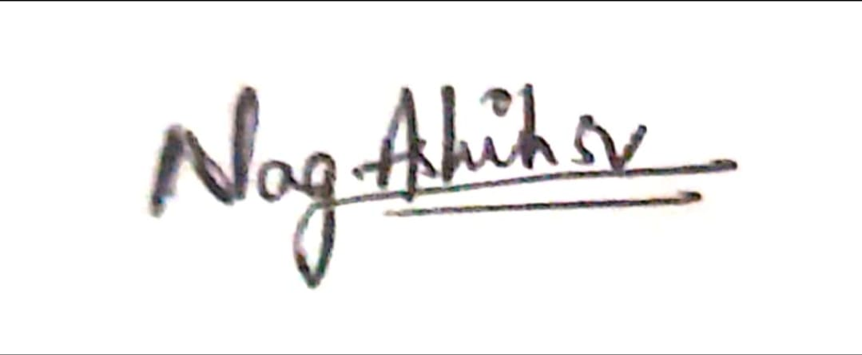 

(NAG ASHISH S V)

**Name & Signature of the Student Signature of Guide**

**Date:** 28.12.2020