**SYNOPSIS**

**Project Group No: B3**

**Register No: Name:**

1. 221003064 Nag Ashish S V
2. 221003080 Ranga Satya Viswa Pavan
3. 221003117 Pramodh Sairam P V

**Project Title:** Handwriting Recognition and Writer Identification on text independent data

**Name of the Guide**: Durga Karthik/AP-III/CSE/SRC/SASTRA

**Abstract:**

Identification of a person from his handwriting is one of the challenging problems, however, it is not new. No one can repudiate its applications in a number of domains, such as bio-metrics, forensic analysis, historical documents, and ancient manuscripts. Handwriting plays a key role in presentation of learned behaviour of the person. It is the main identity of a person. Deep learning-based approaches have proved as the best feature extractors from massive amounts of heterogeneous data and provide promising and surprising predictions of patterns as compared with traditional approaches. Automatic writer identification system helps in determining and identifying whether the given handwriting is truly matched and assigned to the claimed writer of handwriting.

**Specific Contribution:**

1. Implemented Image pre-processing pipeline in the project, where I applied gaussian blur filter to remove noises and canny edge detector to extract edges from handwritings.

2. Designed the Backend REST API for the web application with appropriate routing endpoints, ensuring proper communication between the Image output generator (IOG) method which gives result string and Frontend UI calls. The API is designed using flask.

**Specific Learning:**

1. Learnt about various image filtering techniques like gaussian blur, grayscale, canny edge detection which are useful to remove unwanted noises and extract useful information.
2. Learnt how to create a backend REST API using flask and communicate with the UI.

**Technical Limitations & Ethical Challenges faced**

1. Choosing the appropriate configuration levels while applying filters on the image is highly experimental and ensuring uniformity in capturing the image while uploading for testing in the web app by user, is at most important and equally affects the output.
2. Minimizing the turnaround time and increasing response time in the API is challenging.

**Keywords:** Handwriting Recognition, Convolutional Neural Networks, Artificial Neural

Networks, Image Pre-processing, REST API, flask

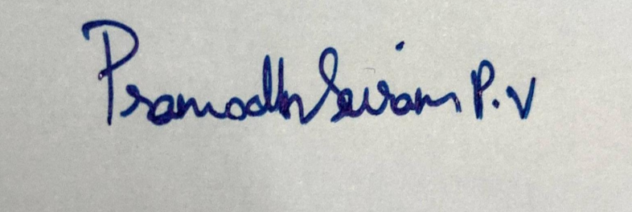 

(PRAMODH SAIRAM P V)

**Name & Signature of the Student Signature of Guide**

**Date:** 28.12.2020