**MongoDB -Aggregation Exercises**

1. use db.zipcodes.find() to filter results to only the results where city is ATLANTA and state is GA.  
  
  
  
  
  
2. use db.zipcodes.aggregate with $match to do the same as above.

3. use $group to count the number of zip codes in Atlanta.



. 4. use $group to find the total population in Atlanta.

1. use aggregate to calculate the total population for each state
2. sort the results by population, highest first

. limit the results to just the first 3 results. What are the top 3 states in population?

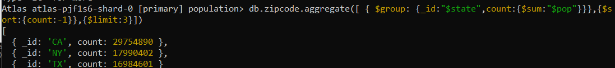

use aggregate to calculate the total population for each city (you have to use city/state combination). You can use a combination for the _id of the $group: { city: '$city', state: '$state' }  
  
sort the results by population, highest first 3. limit the results to just the first 3 results. What are the top 3 cities in population?  
  
  
  
4. What are the top 3 cities in population in Texas?

1. Write a query to get the average city population for each state.

2. What are the top 3 states in terms of average city population?  
  
