Assignment – 12

1) Write a query that selects all customers whose ratings are equal to or greater than
ANY of Serres’.

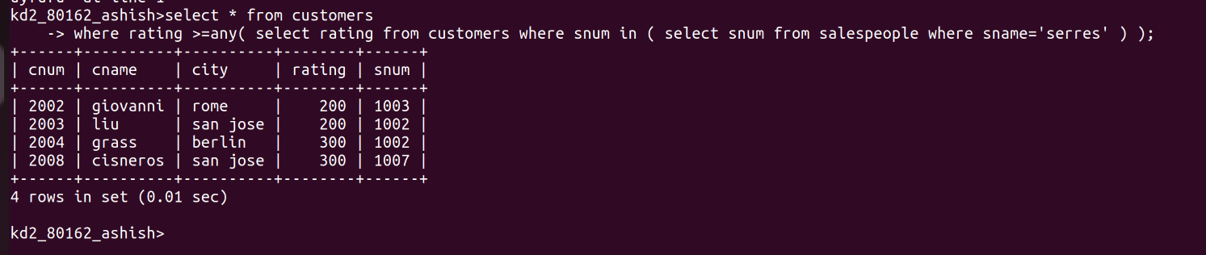

2) Write a query using ANY or ALL that will find all salespeople who have no
customers located in their city.

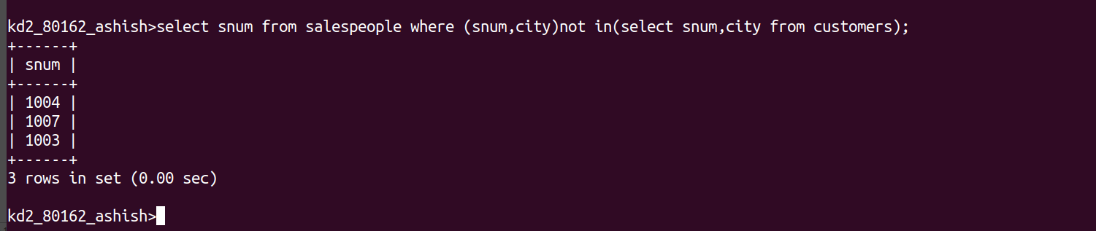
3) Write a query that selects all orders for amounts greater than any for the
customers in London.
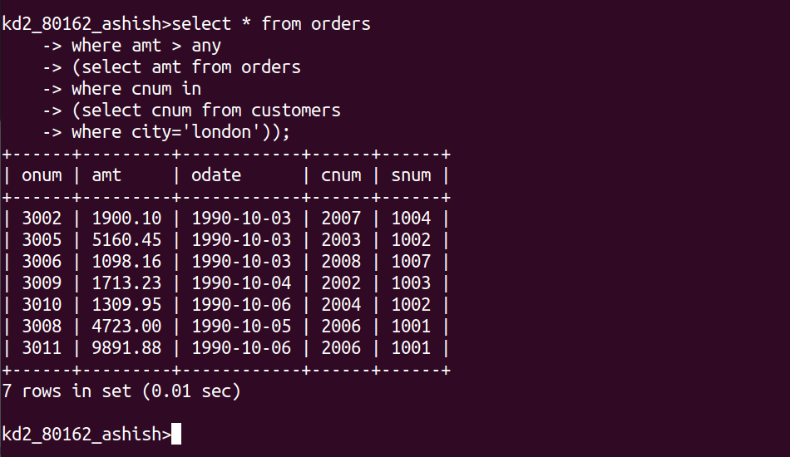
4) Write the above query using MIN or MAX.

