**DEVOPS TASK**

**Dockerfiles creation**

* Created 3 Dockerfiles for shopfront, product catalogue, stock manager.

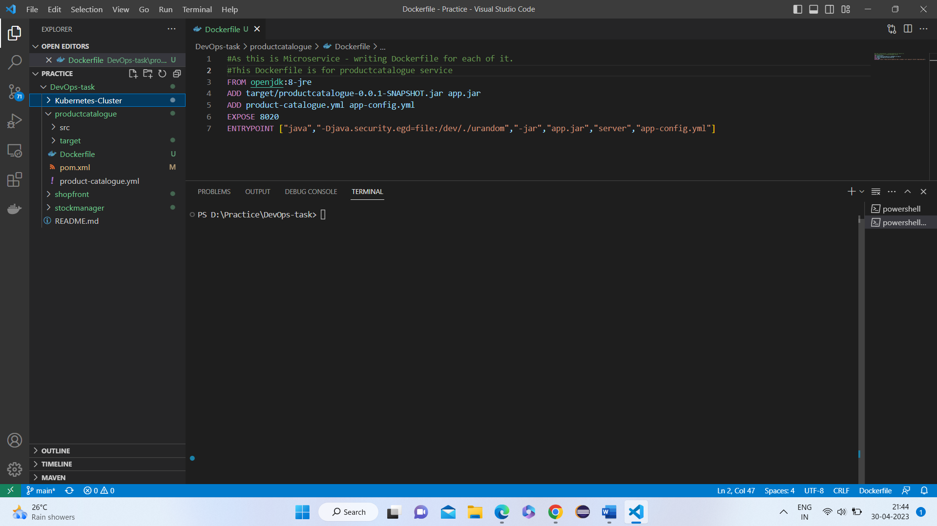

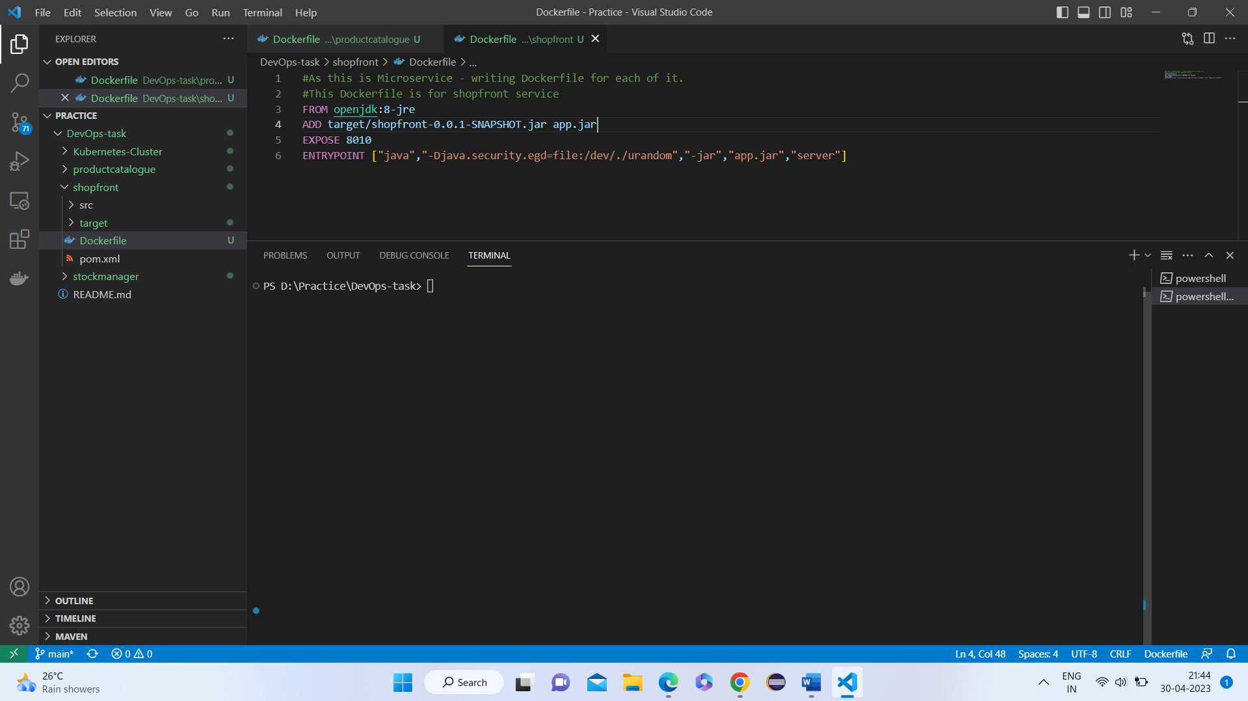

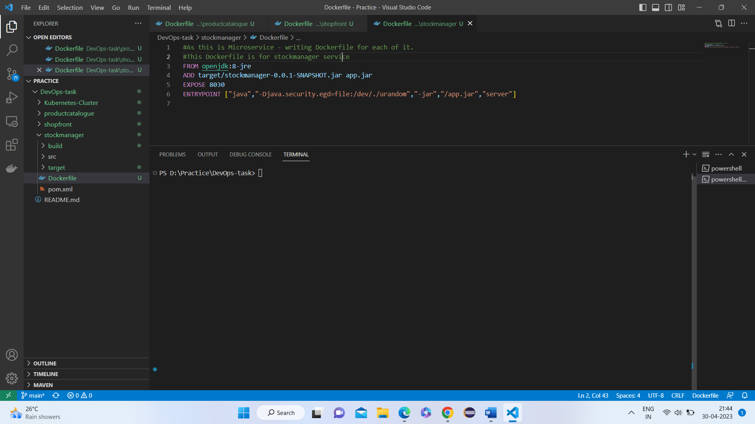

=============================================================================

**Maven build process** [creation of target using mvn clean install cmd at each of the service]

* Navigating to the respective folder of service [shopfront]

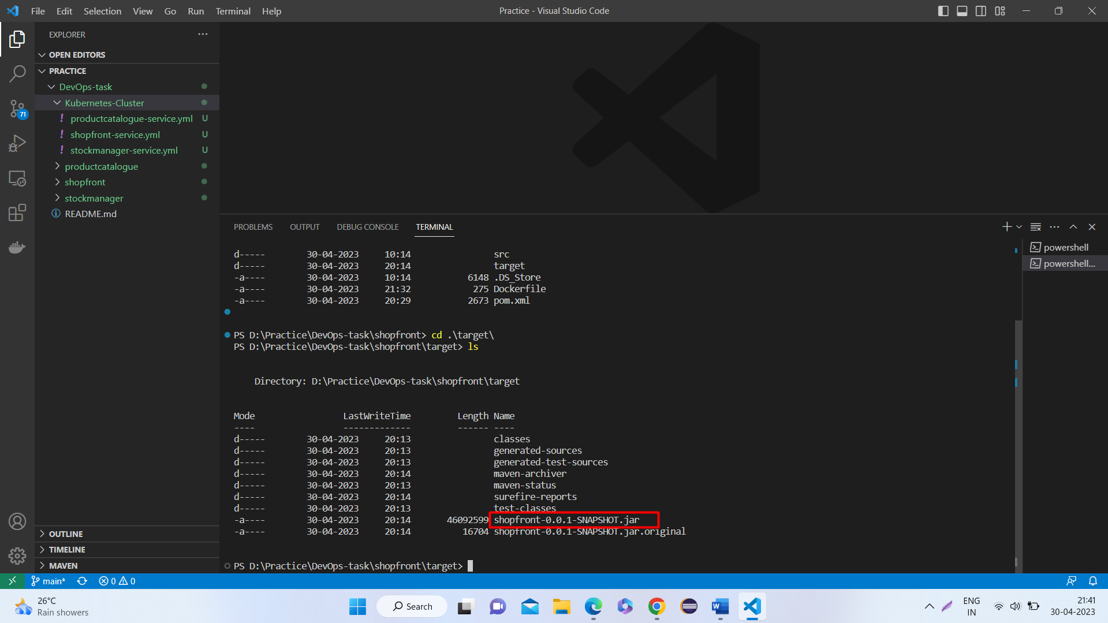

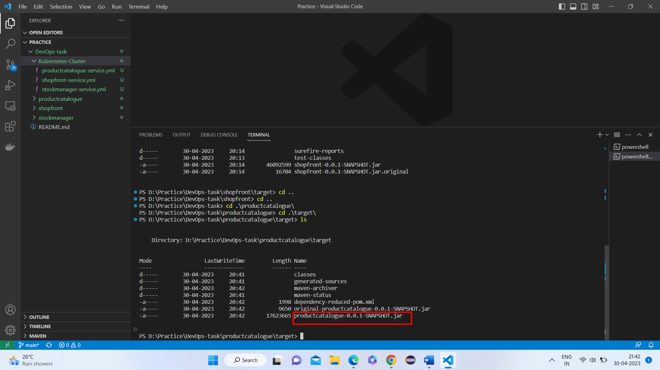

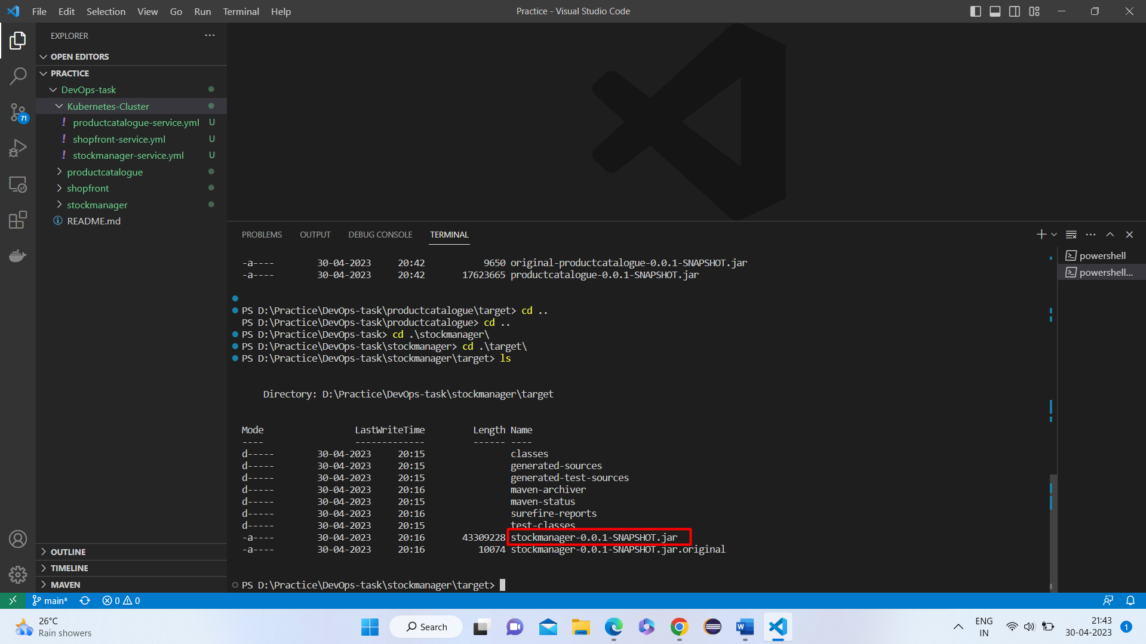

=================================================================================

**Running the Dockerfiles**

* To run dockerfile – use cmd: docker build -t repositoryname/servicename:tag
* Docker build -t ashishdockerhub/shopfront:latest **[For GCP gcr.io/reponame/servicename:tag]**
* Run the 3 services dockerfiles
* Docker images are generated

**Pushing the Images to DockerHub** [Instead of GCP Container Registry -used DockerHub registry]

* To push dockerImage – use cmd: docker push ImageName
* Here we used as cmd: docker push ashishdockerhub/shopfront:latest **[For GCP createdImagename:tag]**
* Pushed the 3 images to hub

==================================================================================

**Creation of Kubernetes cluster manifest files**

* Created 3 files (.yml) for deployment purpose

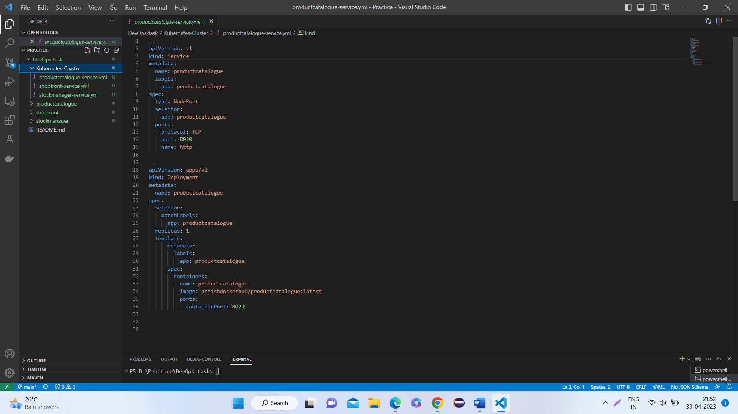

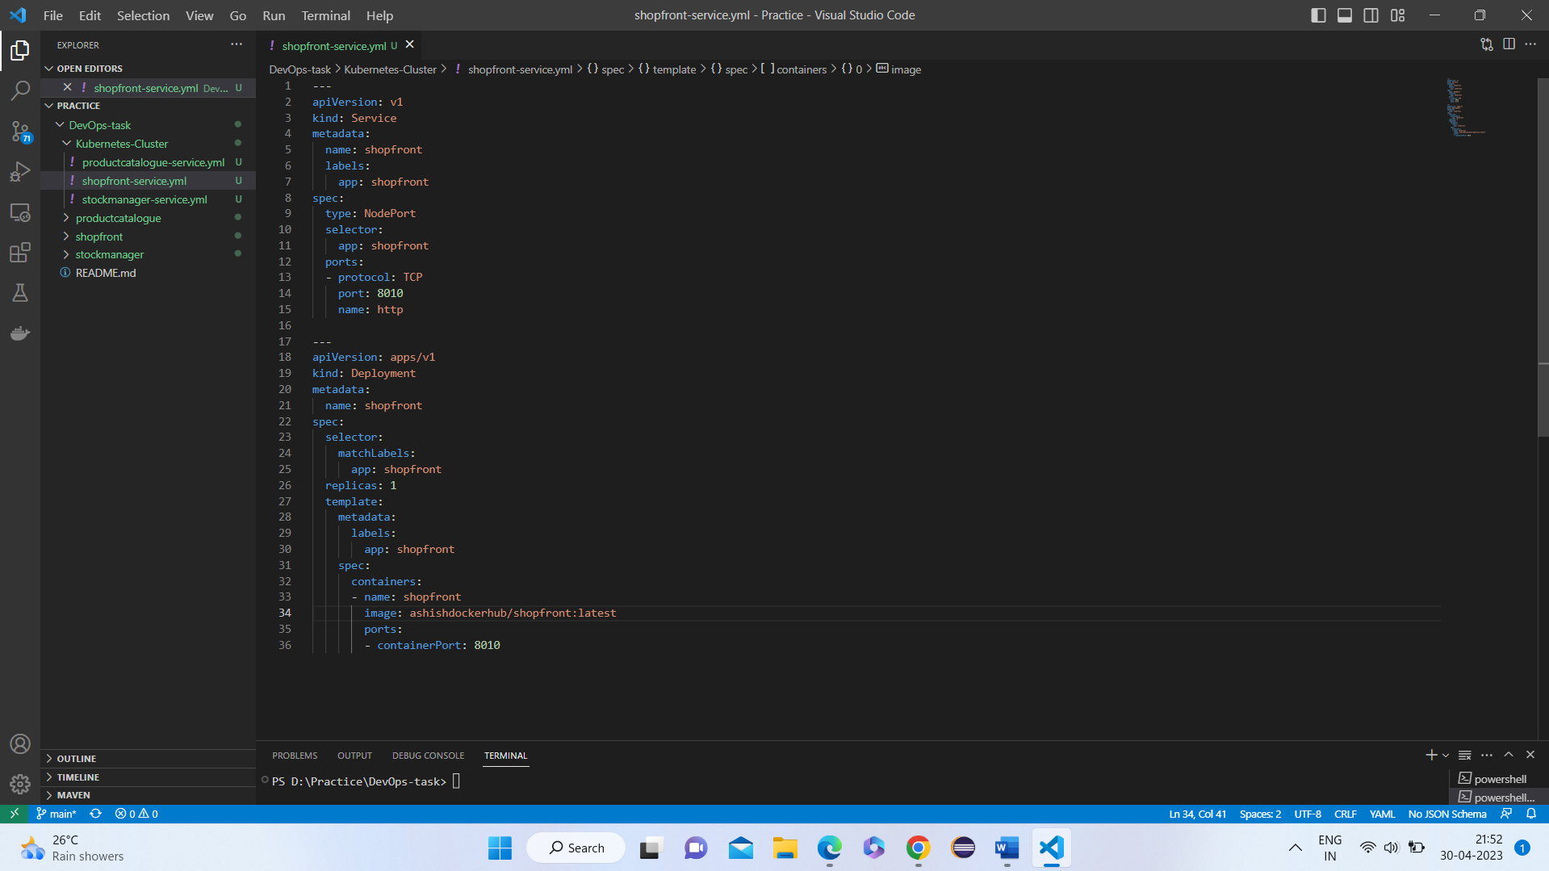

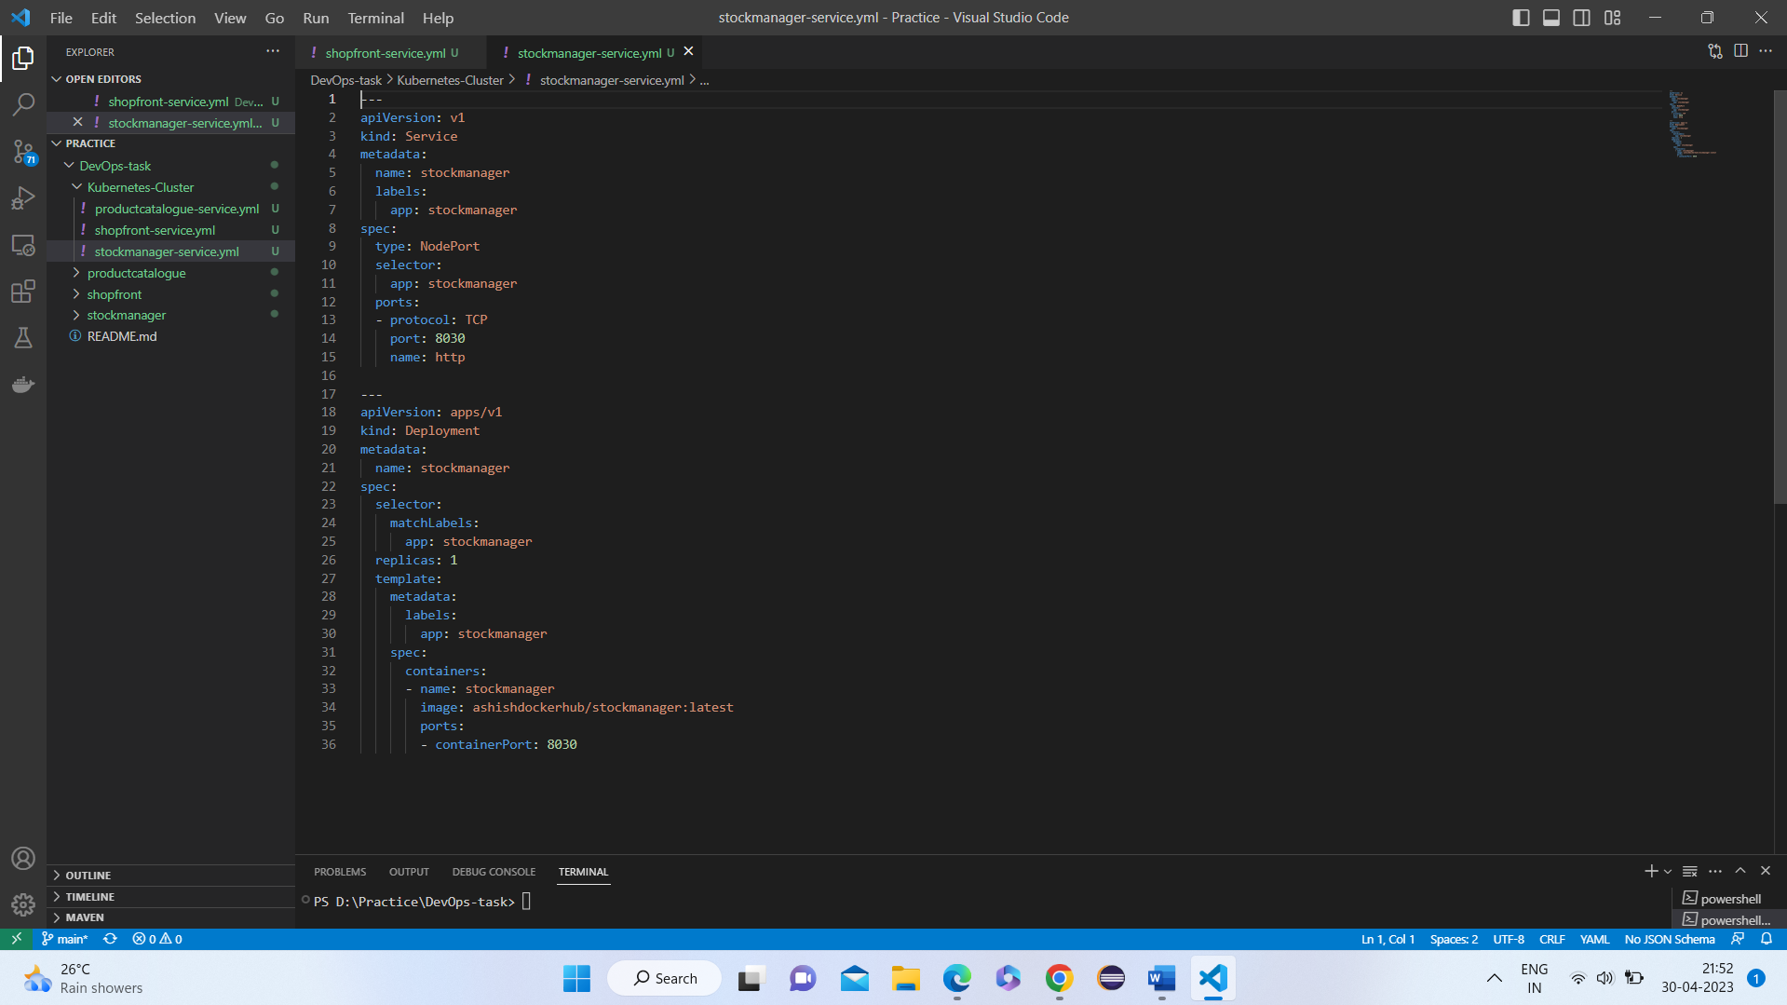

===============================================================================

**Run the Kubernetes files**

* Navigated to kubernetes created folder and then run the cmd
* Cmd: kubectl apply -f filename
* Here, kubectl apply -f shopfront-service.yml
* Ran the 3 files using kubectl apply -f filename
* Pods are created.

=============================================================================

**To visualise these – used minikube**

**Minikube start:**

* To start minikube use cmd: minikube start

**run the service [this is pod]**

* To run the service Cmd: minikube service serviceName
* Here, cmd: minikube service shopfront [podname]

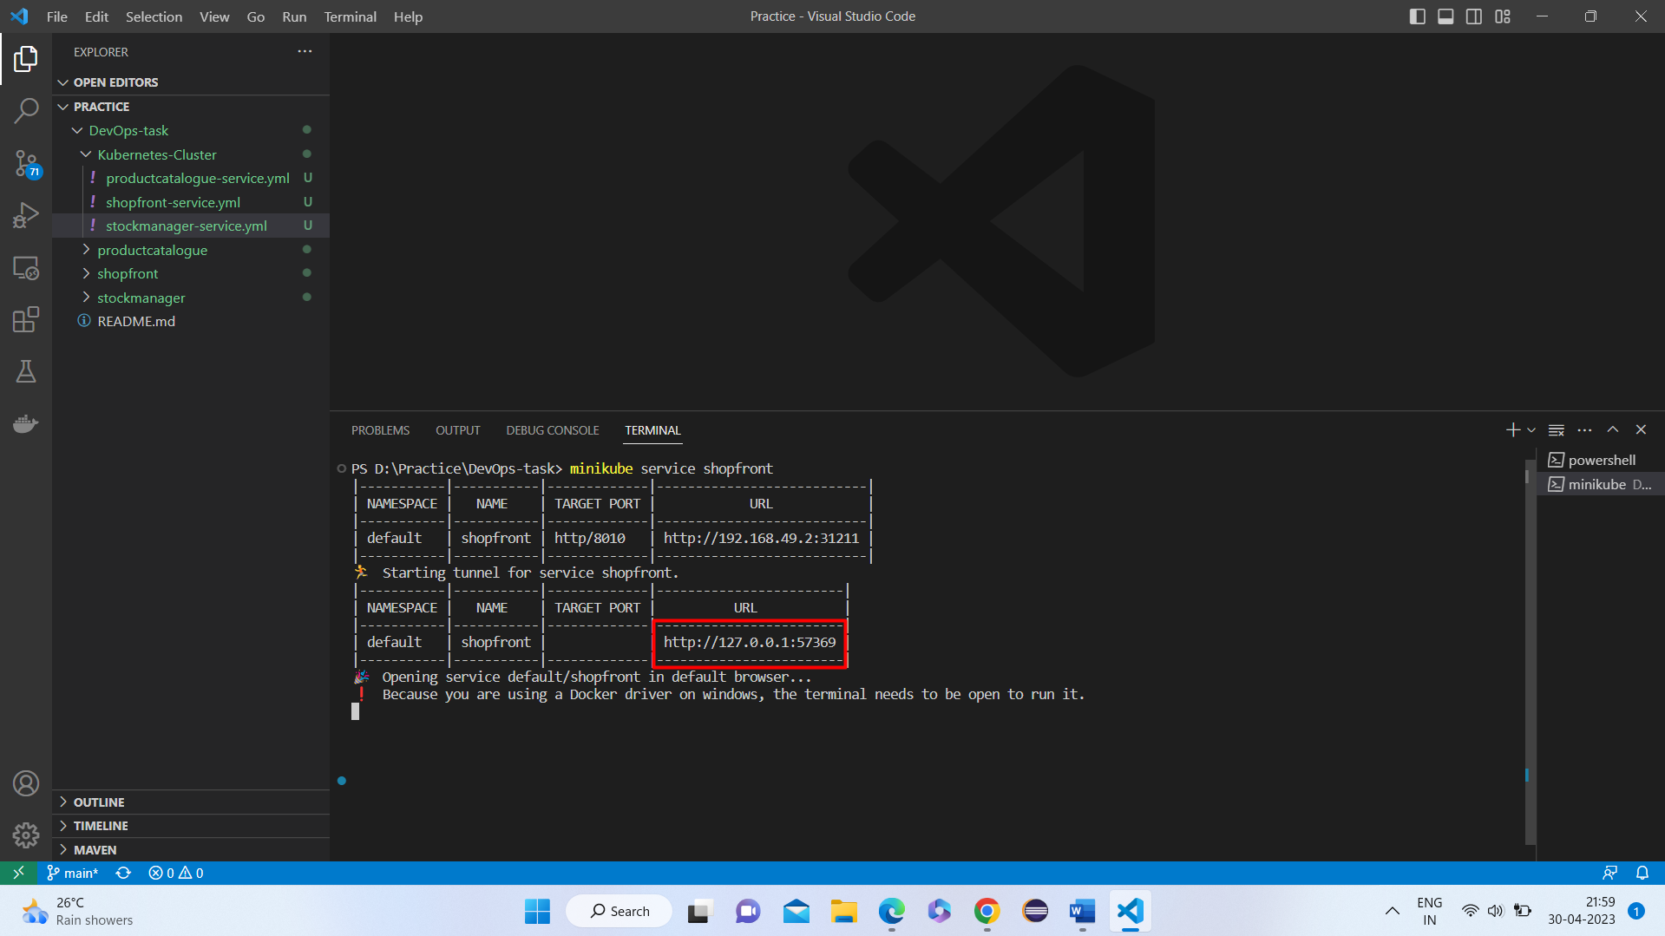

Finally, we can view the page.

