Name ____________________________
Backtracking and branch and bound.

Given the following 0\1 integer knapsack problem. C=11. The items are:
(1, 2, $12), (2, 8, $16), (3, 3, $9).

Part I
Show the state space tree using backtracking. Every node should show the current profit, weight and bound. Show also the maxprofit values each time they are updated, and put an X under every node which is not promising.

knapsack(i, profit, weight)
if ( weight <= C && profit > maxprofit)
maxprofit=profit; //save new profit
numbest= i; bestset = include;//save solution
if promising(i)
include [i + 1] = “ yes”;
knapsack(i+1, profit + p[i+1], weight + w[i+1]);
include[i+1] = “no”;
knapsack(i+1, profit, weight);

promising(i)
if weight >= C return false
//Initialize
j = i + 1; //next item
bound = profit;
totweight = weight;
//Compute upper bound
while( j ≤ n && totweight + w[j]<= C) {
totweight = totweight + w[j];
bound = bound + p[j];
j++; }
if (j ≤ n) //fill knapsack
bound = bound + (C – totweight)*p[j]/w[j]
return bound > maxprofit;

Part II

Given the pseudo code for best-first branch and bound knapsack:
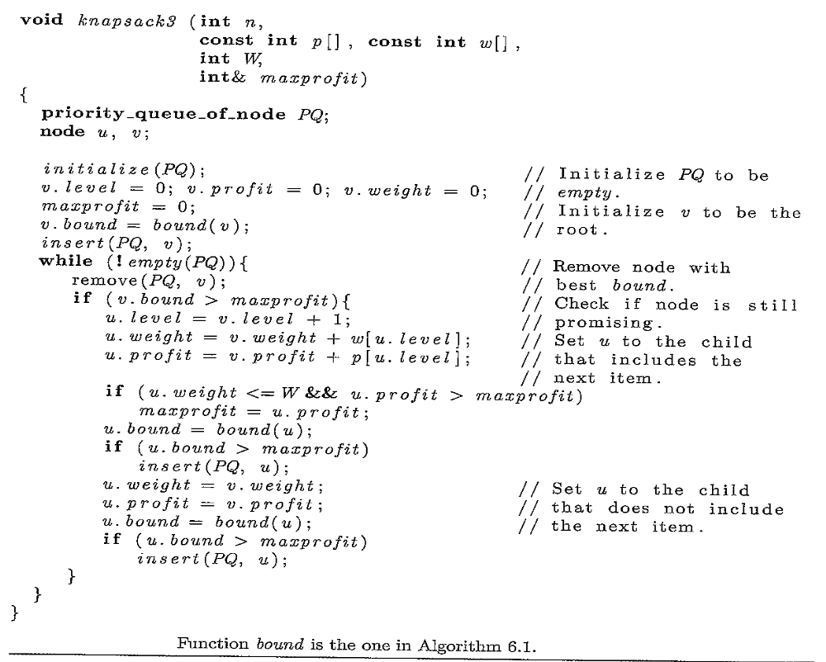

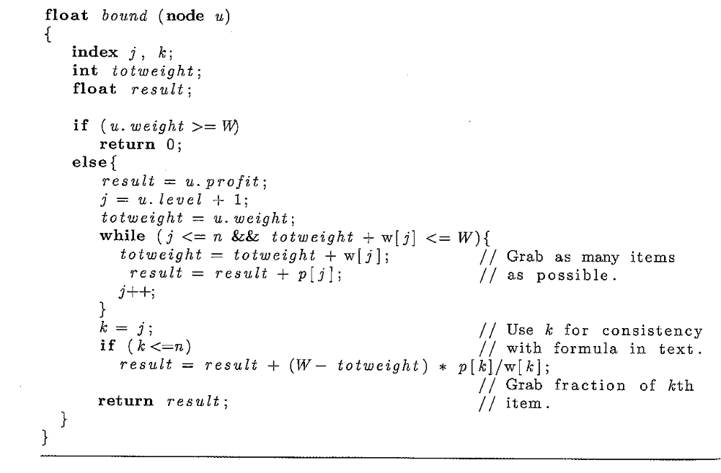

Show the state space tree. Discuss the algorithm after each node is removed or added to the state space tree. In particular discuss the bound, weight and profit of each node, as well as the changes to maxprofit, and the priority queue. For example:

- Node (0, 0) has profit of 0$, weight of 0, and a bound of $25. The maxprofit is $0. PQ = {(0, 0)}.
- Node (0, 0) is removed from the priority queue. PQ= {}. Since the bound $25 > $0, the 2 children will be generated.
- First node (1, 1) is generated. Node (1. 1) has profit of $9, weight of 3, and a bound of $25. The maxprofit is updated to $9. Since $25 >$9 (1, 1) is added to PQ. PQ = {1, 1)}.
- Then, node (1, 2) is generated. Node (1, 2) has profit of 0$, weight of 0, and a bound of $28. Since $28 > $9, the node is added to PQ. PQ = {(1, 1), (1, 2)}.
- Node (1, 2) with the higher bound of $28 is removed from PQ. PQ={(1, 1)}

