**Aim: Explore forensics tool for acquiring, analyzing and duplicating data (dd).**

**Theory:** Data Duplication/Dump/Definition dd is a command-line tool primarily used in Unix Operating Systems. In the context of digital forensic investigation; the **dd** tool and its derivatives can be used to read data from the device file of an attached drive and write this data to a raw image file. This raw image file can then be easily imported into an appropriate analysis suite or interrogated with other command-line tools.

**D:\mehta\nilesh>dd --list OR D:\mehta\nilesh>dd --version**

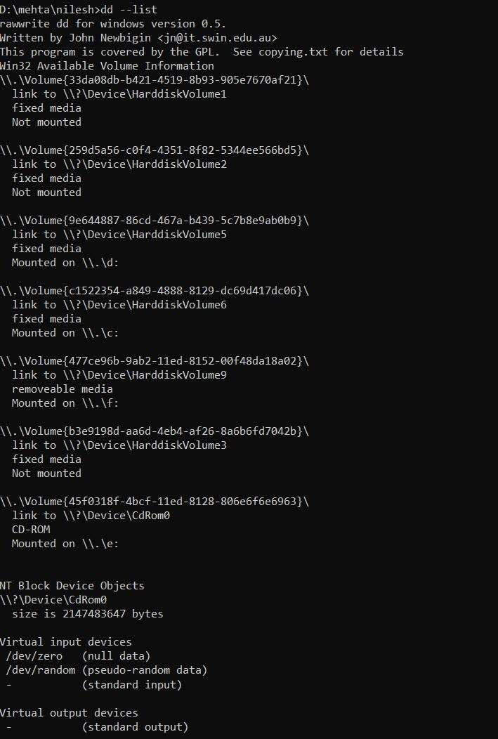

**D:\mehta\nilesh>dd –help**

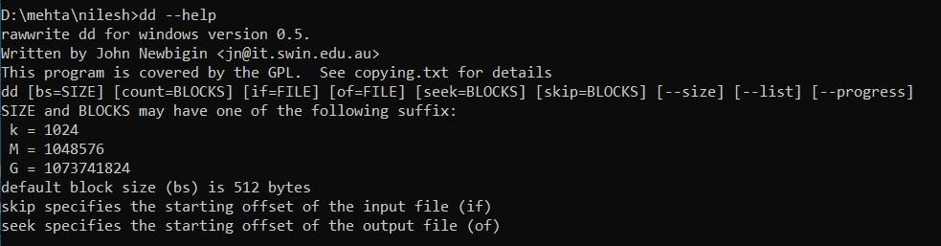

**D:\mehta\nilesh>dd bs=512 count=10 if=\\.\f: of=d:\mehta\nilesh\rollno73.dd --progress**

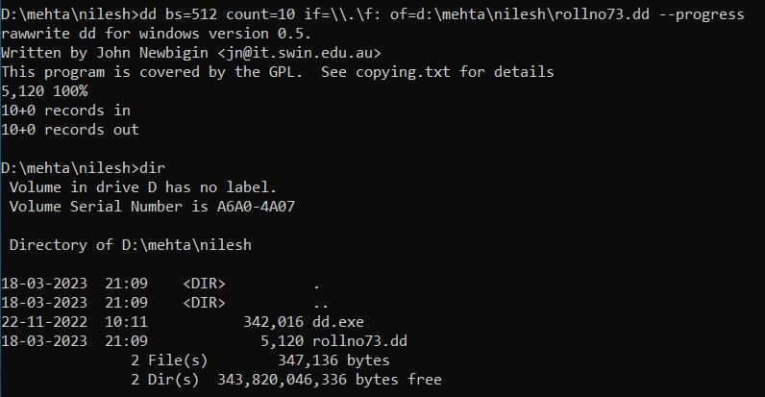

**D:\mehta\nilesh>dd bs=1024 count=10 if=\\.\f: of=d:\mehta\nilesh\rollno73.dd --progress**

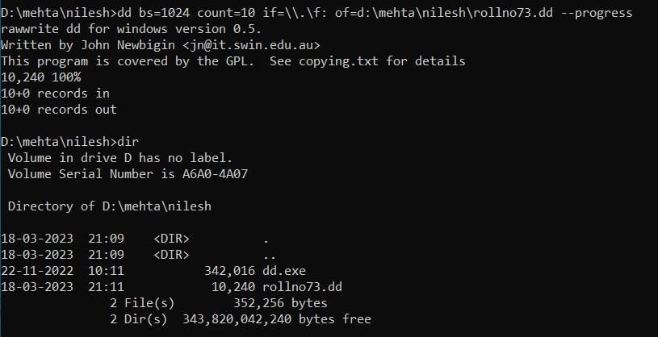

**D:\mehta\nilesh>dd bs=1024 count=10 skip=5 if=\\.\f: of=d:\mehta\nilesh\rollno73.dd --progress**

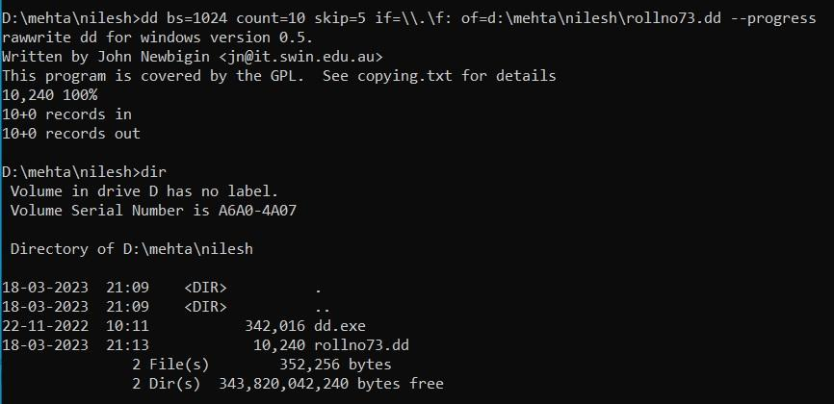

**D:\mehta\nilesh>dd bs=1024 count=10 seek=5 if=\\.\f: of=d:\mehta\nilesh\rollno73.dd --progress**

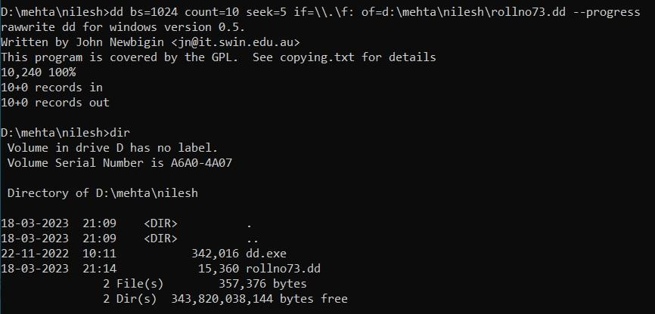

**D:\mehta\nilesh>dd if=\\.\f: of=d:\mehta\nilesh\rollno73.dd --progress**

