CREATE TABLE RESTAURANT_DIM (

REST_ID VARCHAR(10) NOT NULL,

REST_NAME VARCHAR(30) NOT NULL,

CONTACT_NUMBER INT(10) NOT NULL,

ADDRESS VARCHAR(50) NOT NULL,

CUISINE VARCHAR(15) NOT NULL,

PRIMARY KEY (REST_ID)

);

INSERT INTO RESTAURANT_DIM VALUES (9884,'Curry in a Hurry',9838962087,'Jhundpura, Awana Market, Main Road, Noida,201301','North Indian');

INSERT INTO RESTAURANT_DIM VALUES (3391,'Delhi in Minutes',9854962077,'44-b, Central Market, Lajpat Nagar,Delhi-110024','Punjabi');

INSERT INTO RESTAURANT_DIM VALUES (6444,'Spice is Nice',9838962023,'B/103, Asmita Cres, Nr Asmita Club, Naya Nagar, Mira Road East','Maharashtrian');

INSERT INTO RESTAURANT_DIM VALUES (1261,'Bengaluru Bites',9838914087,'58, Shirdi Sai Baba Mandir Road,Bengaluru','South Indian');

INSERT INTO RESTAURANT_DIM VALUES (8725,'Mumbai Tummy',9838966787,'2, Sai Sagar Apt, Mulund Bridge Rd,Airoli','North Indian');

INSERT INTO RESTAURANT_DIM VALUES (6240,'The Paneer Pot',9838122087,'18/4, Arya Samaj Road, Karol Bagh,Bangalore','North Indian');

INSERT INTO RESTAURANT_DIM VALUES (8833,'Oh! Calcutta',9838962867,'2/69A Dum Dum Road,Kolkata','Bengali');

INSERT INTO RESTAURANT_DIM VALUES (9022,'Curry Kitchen',9838962387,'Vinoba Bhave Road, Salatwada,Gujarat','Gujarati');

INSERT INTO RESTAURANT_DIM VALUES (7198,'Spice ‘N’ Rice',9838962077,'7/4, Parthasarathy Naidu St, Triplican,Tamil Nadu','Italian');

INSERT INTO RESTAURANT_DIM VALUES (2601,'Khana Khazana',9801962087,'Tower-C, 3rd Floor, DLF IT Park,Chandigarh','Punjabi');

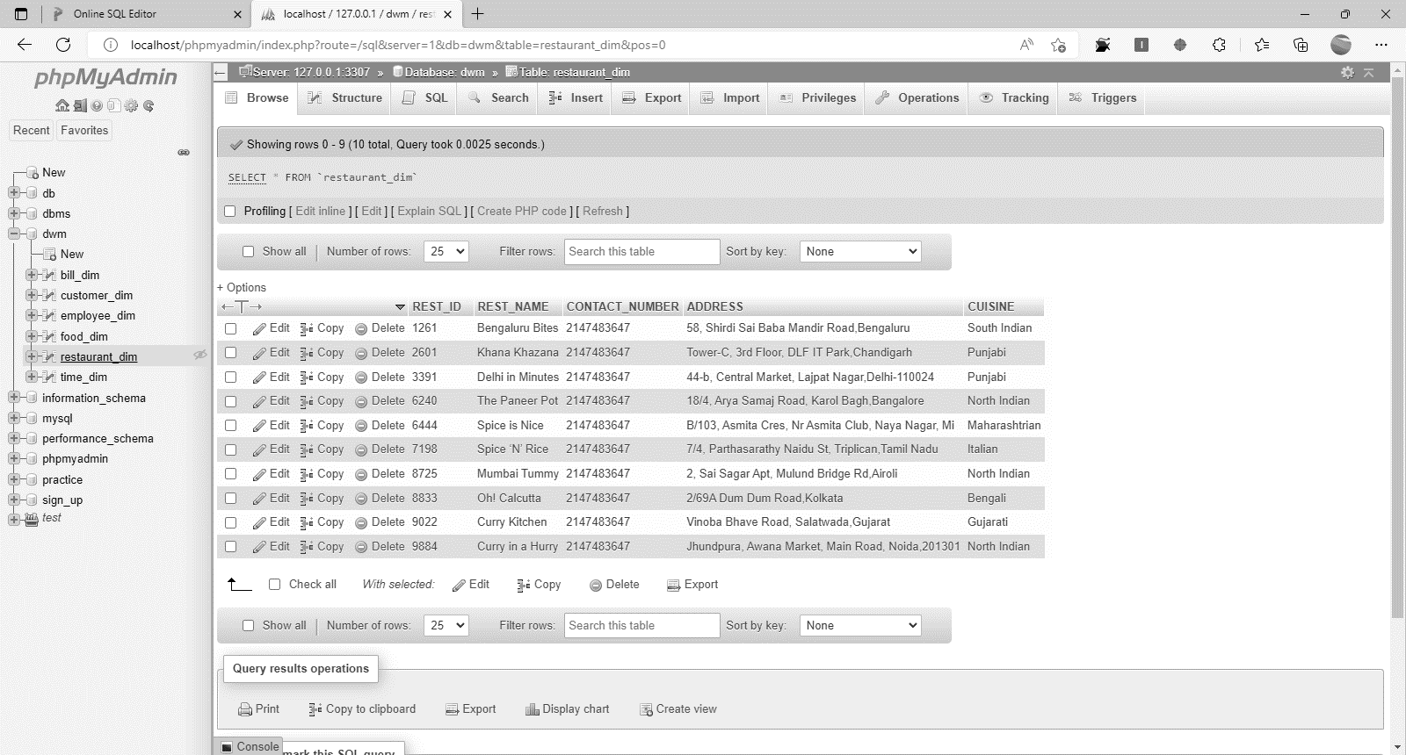

CREATE TABLE FOOD_DIM (

FOOD_ITEM_ID VARCHAR(10) NOT NULL,

NAME VARCHAR(15) NOT NULL,

QUANTITY INT(4) NOT NULL,

PRICE INT(4) NOT NULL,

PRIMARY KEY (FOOD_ITEM_ID)

);

INSERT INTO FOOD_DIM VALUES('9508','Chole Bhature',3,920);

INSERT INTO FOOD_DIM VALUES('7934','Biryani',2,530);

INSERT INTO FOOD_DIM VALUES('3091','Paneer',8,250);

INSERT INTO FOOD_DIM VALUES('7997','Dosa',3,430);

INSERT INTO FOOD_DIM VALUES('8193','Obbattu',2,690);

INSERT INTO FOOD_DIM VALUES('6903','Paneer',4,850);

INSERT INTO FOOD_DIM VALUES('7750','Biryani',7,620);

INSERT INTO FOOD_DIM VALUES('2584','Paneer',7,760);

INSERT INTO FOOD_DIM VALUES('1201','Dosa',1,270);

INSERT INTO FOOD_DIM VALUES('9647','Obbattu',2,930);

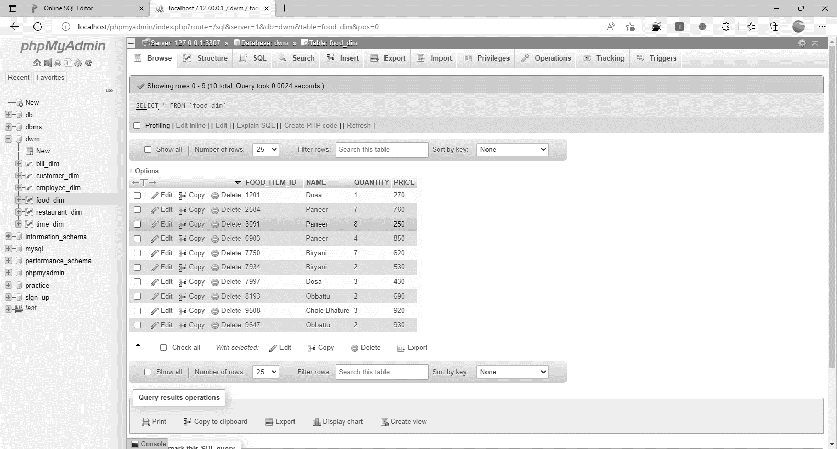

CREATE TABLE BILL_DIM (

BILL_ID VARCHAR(10) NOT NULL,

ORDER_DETAIL VARCHAR(50) NOT NULL,

PRIMARY KEY (BILL_ID)

);

INSERT INTO BILL_DIM VALUES('5897','Chole Bhature');

INSERT INTO BILL_DIM VALUES('7602','Biryani');

INSERT INTO BILL_DIM VALUES('1595','Paneer');

INSERT INTO BILL_DIM VALUES('2919','Dosa');

INSERT INTO BILL_DIM VALUES('5257','Obbattu');

INSERT INTO BILL_DIM VALUES('5387','Paneer');

INSERT INTO BILL_DIM VALUES('9629','Biryani');

INSERT INTO BILL_DIM VALUES('9252','Paneer');

INSERT INTO BILL_DIM VALUES('3335','Dosa');

INSERT INTO BILL_DIM VALUES('3567','Obbattu');

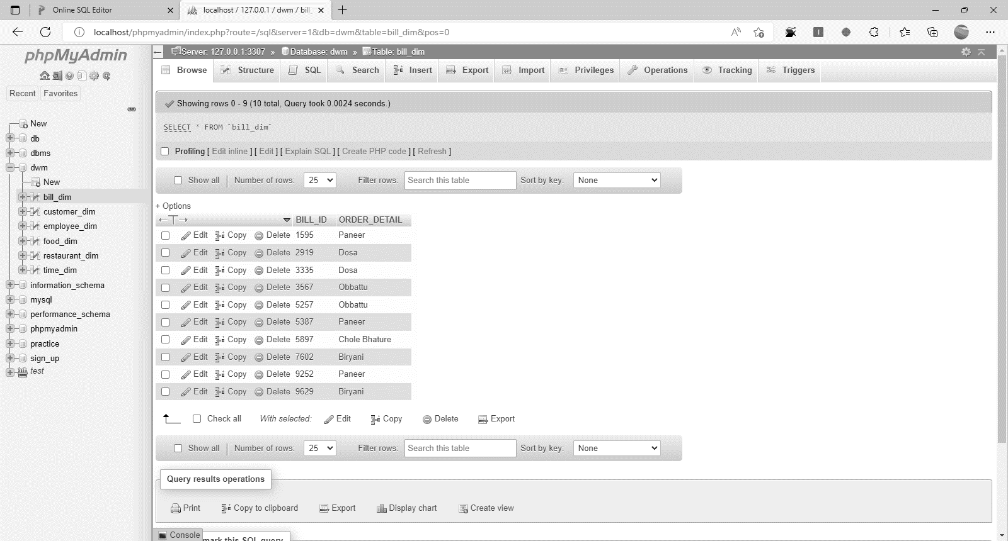

CREATE TABLE TIME_DIM (

CURR_DATE VARCHAR(10) NOT NULL

);

INSERT INTO TIME_DIM VALUES('22-11-2020');

INSERT INTO TIME_DIM VALUES('25-6-2020');

INSERT INTO TIME_DIM VALUES('15-6-2020');

INSERT INTO TIME_DIM VALUES('19-9-2020');

INSERT INTO TIME_DIM VALUES('5-7-2020');

INSERT INTO TIME_DIM VALUES('16-8-2020');

INSERT INTO TIME_DIM VALUES('21-1-2020');

INSERT INTO TIME_DIM VALUES('10-5-2020');

INSERT INTO TIME_DIM VALUES('3-2-2020');

INSERT INTO TIME_DIM VALUES('8-3-2020');

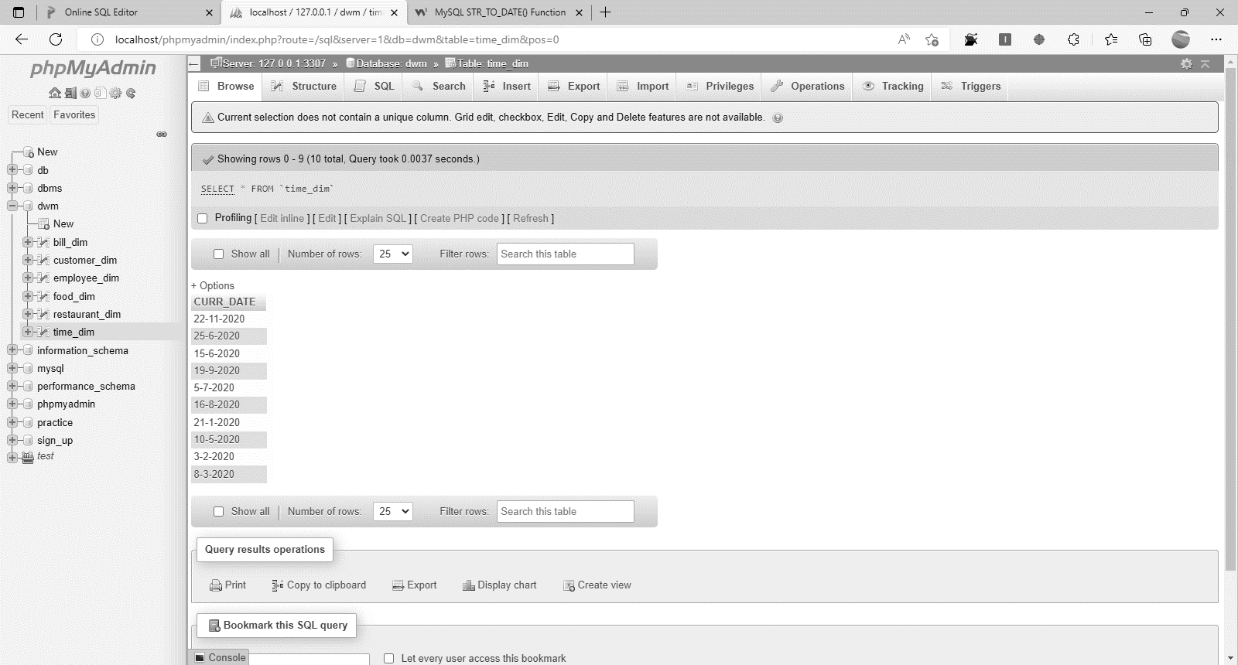

CREATE TABLE CUSTOMER_DIM (

CUST_ID VARCHAR(10) NOT NULL,

CUST_NAME VARCHAR(10) NOT NULL,

CONTACT_NUMBER INT(10) NOT NULL,

ADDRESS VARCHAR(50) NOT NULL,

PRIMARY KEY (CUST_ID)

);

INSERT INTO CUSTOMER_DIM VALUES('9844','Todd Curtis','9933847771','202-203, 2, Millennium Park, Sector 3, Vashi');

INSERT INTO CUSTOMER_DIM VALUES('9199','Elizabeth Perez','9812588894','237, Shop No 3, Prabhu Niwas, Sane Guruji Rd, Nr Church, Jacob Circle');

INSERT INTO CUSTOMER_DIM VALUES('2264','Matthew Lyons','9831607723',' 5-8-496/1, Chirag Ali Lane');

INSERT INTO CUSTOMER_DIM VALUES('4174','Darlene Anderson','9831456229','137, Shastriamrket');

INSERT INTO CUSTOMER_DIM VALUES('5143','Cheryl Glenn','9929122154',' A/17, 224, Nandan, Savarkar Road, Mahim');

INSERT INTO CUSTOMER_DIM VALUES('8352','Tamara Brown','9824549407','B-10, Dalamal Towers, Nariman Point');

INSERT INTO CUSTOMER_DIM VALUES('8033','Thomas Mclaughlin','9939083188','B-10, Dalamal Towers, Nariman Point');

INSERT INTO CUSTOMER_DIM VALUES('3962','Roger Anderson','9975406061',' S No 208 A/3, Savitri Nagar, Sheikh Sarai');

INSERT INTO CUSTOMER_DIM VALUES('8111','Joseph Perez','9960720307','13, Amar Kunj, Sawarkar Marg, Shiwaji Udyan');

INSERT INTO CUSTOMER_DIM VALUES('9738','Timothy Black','9957922790','Kambali Wadi, 148 Nehru Road, Vile Parle (east)');

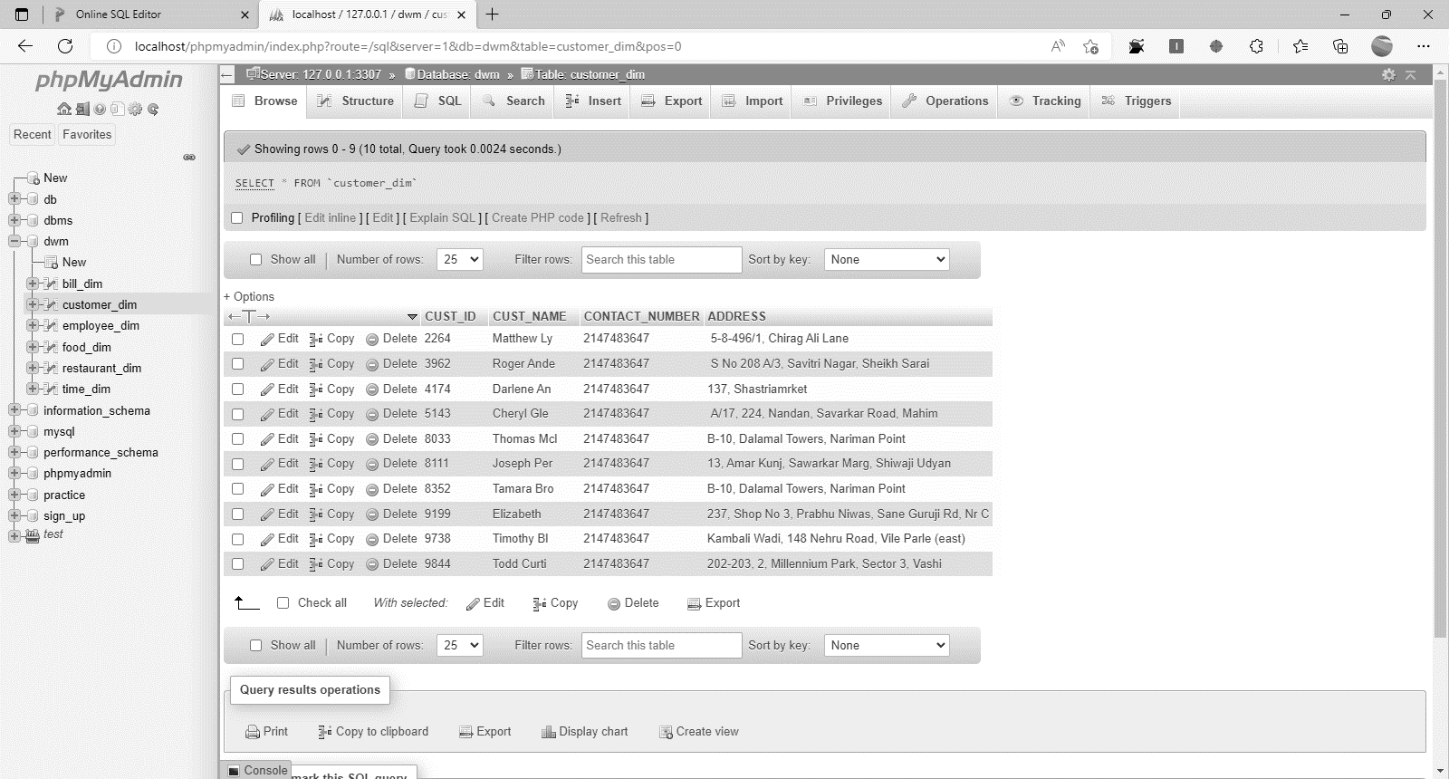

CREATE TABLE EMPLOYEE_DIM (

ADMIN_ID INT(10) NOT NULL,

WAITER_ID INT(10) NOT NULL,

CHEF_ID INT(10) NOT NULL,

WAITER_NAME VARCHAR(15) NOT NULL,

CHEF_NAME VARCHAR(15) NOT NULL,

PRIMARY KEY (ADMIN_ID)

);

INSERT INTO EMPLOYEE_DIM VALUES('5639','9660','4130','Tucker Lowe','Damarion Massey');

INSERT INTO EMPLOYEE_DIM VALUES('5432','1370','4350','Dominick Landry','Rebecca Dodson');

INSERT INTO EMPLOYEE_DIM VALUES('6572','5628','1201','Leroy Forbes','Luke Sheppard');

INSERT INTO EMPLOYEE_DIM VALUES('2339','3473','2705','Juliette Snyder','Diya Goodwin');

INSERT INTO EMPLOYEE_DIM VALUES('7598','7183','4375','Maritza Glass','Kaitlyn Byrd');

INSERT INTO EMPLOYEE_DIM VALUES('6107','3329','3200','Ivy Becker','Kendal Hahn');

INSERT INTO EMPLOYEE_DIM VALUES('2098','2430','9108','Gerardo Strickland','Zachery Duarte');

INSERT INTO EMPLOYEE_DIM VALUES('7649','1634','1613','Gauge Edwards','Ayden Brady');

INSERT INTO EMPLOYEE_DIM VALUES('1778','9525','3196','Laylah Blackburn','Shania Eaton');

INSERT INTO EMPLOYEE_DIM VALUES('6845','9353','5874','Tania Fischer','Maritza Gates');

