**Automation:**

* + Performing any task by using a tool or machine is called as automation.

**Advantages:**

1. Save the time.
2. Faster
3. Requires less manual effort
4. Restless.
5. Accuracy will be more
6. Multi-task
7. Requires less human resources

**Dis Advantages:**

1. Initial investment will be more.
2. It requires constant maintenance
3. It requires additional skill sets.

**Automation testing:**

* + Testing an application by using any automation tools is called as automation testing.

**Automation Tool:**

* + It’s a software or an application which is used to automate any applications.
    - Ex: Selenium, QTP, Appium, AutoIT etc,IBM RFT(Rational Functional Tester)

**Selenium:**

* + It’s a free and open source automation tool which is used to automation any web based applications.

**Advantages of selenium:**

* + It is freely available automation tool. To make use of selenium for commercial purpose we don’t have to buy any license. It is available in below website.
    - <https://www.seleniumhq.org/download/>
  + Anyone can view source code of selenium which is available in below website.
    - <https://github.com/SeleniumHQ/selenium>
  + Using selenium we can automate any web based applications such as gmail, facebook, flipkart,amazon, mintra etc…
  + It supports for 14 programming languages.
  + It supports for multiple platforms such as Windows, Mac, Linux.
  + It supports all most all the browsers such as chrome, firefox, ie, safari, opera.

**Selenium WebDriver Architecture Simplified:**

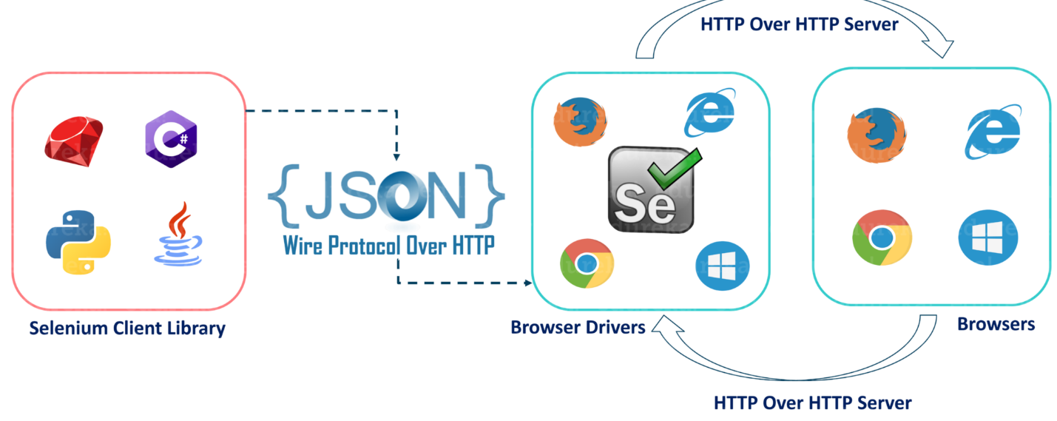

* After you trigger the Test, complete Selenium code (Client) which we have written will be converted to Json format
* Generated Json is sent to Browser Driver (Server) through http Protocol

Note: Each browser contains a separate browser driver

* Browser drivers communicate with its respective browser and executes the commands by interpreting Json which It received on the browser.
* Browser Driver receives responses back from the browser and it sends Json response back to Client.

**Java selenium Architecture:**

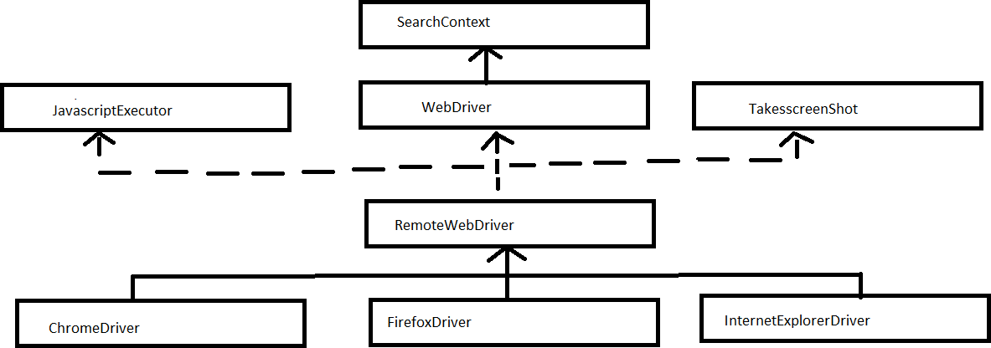

**Interface:**

* 1. SearchContext
  2. JavaScriptExecutor
  3. WebDriver

**Classes:**

1. RemoteWebDriver
2. ChromeDriver
3. InternetExplorerDriver
   * SearchContext is the super most interface which contains 2 methods,
     1. findElement()
     2. findElements()
   * SearchContext interface is inherited by another interface called WebDriver which contains 13 methods including findELement() and findElements()
   * There are other 2 interfaces such as
     1. JavascriptExeutor:- which is used to execute javascript statements
     2. TakesscreenShot:- which is used to take screenshots of webpage
   * All these interfaces are implemented in a class called RemoteWebdriver(Super most class in selenium)
   * All the methods of RemoteWebdriver class are overridden in respective browser classes such as, ChromeDriver, FirefoxDriver , InternetExplorerDriver.

**WebDriver methods:**

|  |  |
| --- | --- |
| 1 | get() |
| 2 | getTitle() |
| 3 | getCurrentUrl() |
| 4 | getPageSource() |
| 5 | findElement() |
| 6 | findElements() |
| 7 | getWindowHandle() |
| 8 | getWindowHandles() |
| 9 | switchTo() |
| 10 | manage() |
| 11 | navigate() |
| 12 | close() |
| 13 | quit() |

**JavascriptExecutor methods:**

|  |  |
| --- | --- |
| 1 | executeScript() |
| 2 | executeAsyncScript() |

**TakesscreenShot methods:**

|  |  |
| --- | --- |
| 1. | getScreenShotAs() |

Note:

1. ChromeDriver class is used to work with chrome browser.
2. FirefoxDriver class is used to work with firefox browser.
3. InternetExplorerDriver class is used to work with ie browser.

**Tools Required:**

* + jdk[1.8 & above]
  + Eclipse[Mars, Neon, Oxygen]
  + Selenium jar file
  + Latest version of browsers
  + Application Under Testing

**Starting New Maven Project**

**Create project**

1. File 🡪 New Project 🡪Maven 🡪 Maven Project
2. Click on Next
3. Click on Check box (Create simple project)
4. Click on next
5. Give name in artifact id and group id, (give same name)
6. Click on finish

**Adding POM repository in project**

1. Open site <https://mvnrepository.com/>
2. Search selenium in search box
3. Take latest repository / <https://mvnrepository.com/artifact/org.seleniumhq.selenium/selenium-java/4.33.0> -->Copy Dependency
4. Paste in POM.xml
   1. Inside <project> ---- </project>
   2. create

<dependencies> paste your dependency copied from mvn site here

</dependencies>

