Run testing script from terminal

1.**Download maven from** <https://maven.apache.org/download.cgi>

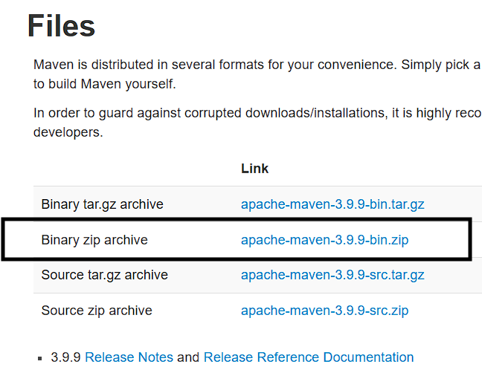

2. Unzip it and place in

Create “Maven” folder in program files

C:\Program Files\Maven

3. Set evn variable

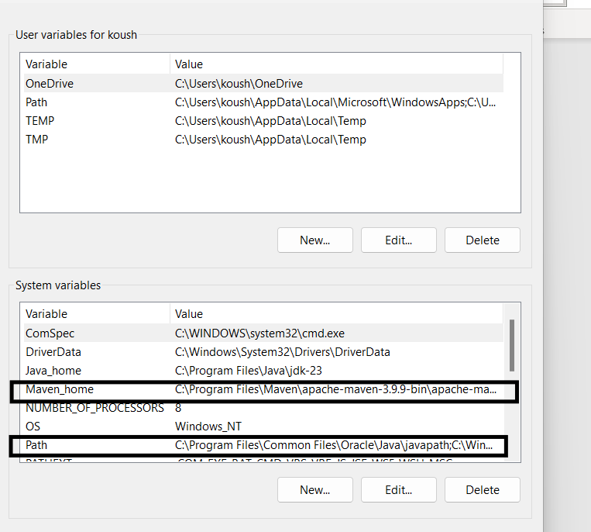

3. Use command to check

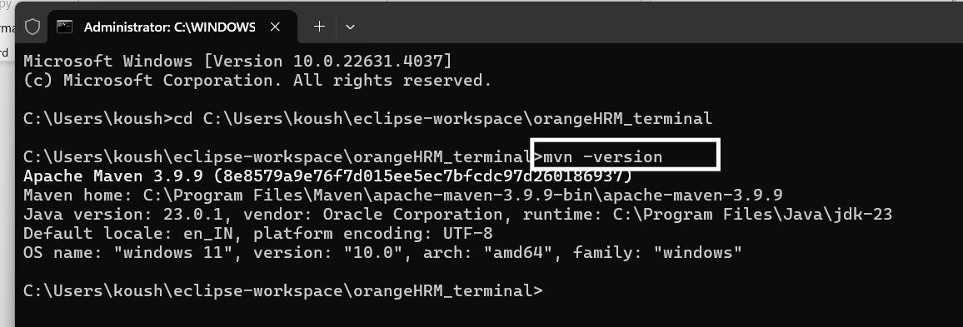

Integrate Maven with TestNG

1.Copy mvn testing plugin from <https://maven.apache.org/surefire/maven-surefire-plugin/examples/testng.html/>

1. <plugins>
2. [...]
3. <plugin>
4. <groupId>org.apache.maven.plugins</groupId>
5. <artifactId>maven-surefire-plugin</artifactId>
6. <version>3.5.2</version>
7. <configuration>
8. <suiteXmlFiles>
9. <suiteXmlFile>testng.xml</suiteXmlFile>
10. </suiteXmlFiles>
11. </configuration>
12. </plugin>
13. [...]
14. </plugins>

2. Create multiple profile as per need /regression suit

<profiles>

<profile>

<id>profileName</id>

</profile>

</profiles>

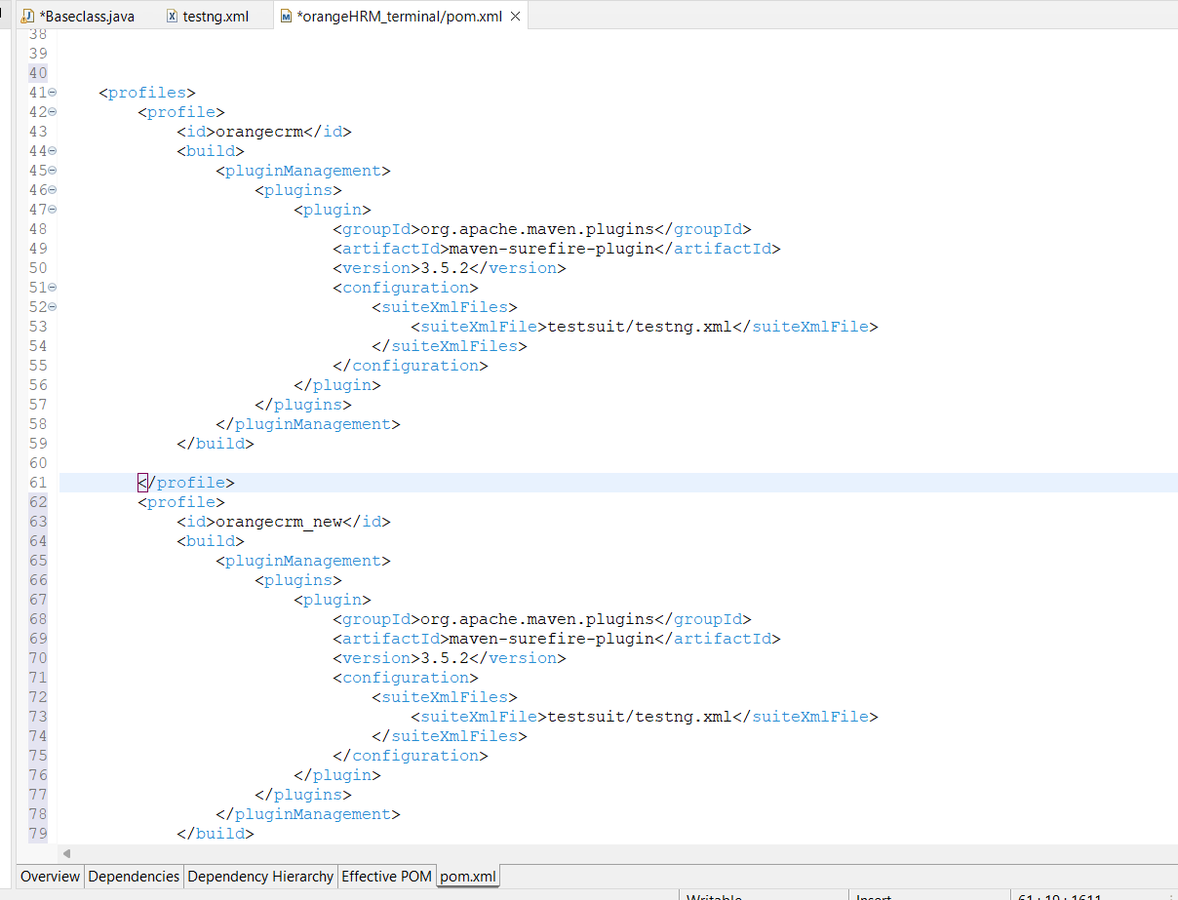

To Run program

1.Open CMD and navigate to path where your POM is located



Mvn test 🡪 will run all test cases if there is no profile specified.

Mvn test -PpropertyName 🡪 will run testng file specified in that profile.

To Run browser which is entered in terminal

