Cucumber – elecipse –selenium n

1. Get the dependencies /cucumber-java and cucumber-testng
2. Install cucmber plugin from eclips market place

Need to run Cucumber runner ,depends on testing or Junit

Cucumber – VS code – cypress

1. Download cucmber pluging

<https://github.com/badeball/cypress-cucumber-preprocessor/>

Use command npm install @badeball/cypress-cucumber-preprocessor

1. Download cucumber plug in VS code – cucumber
2. Use function keyword so that we can share states across the code ()=> anoynomous operation won’t be able to share state.
3. Create Feature file for Code

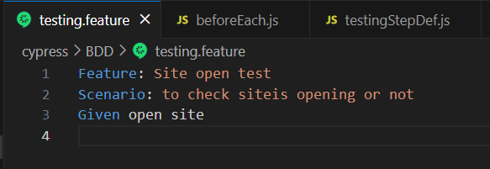

1. Create step definition file

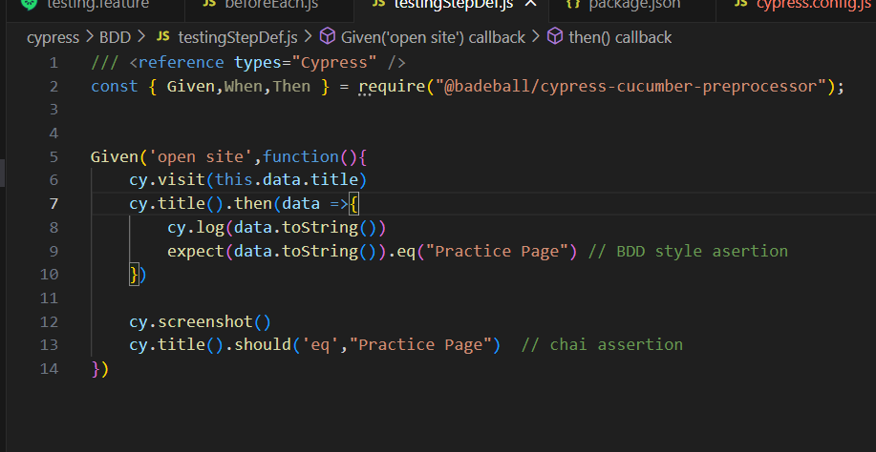

1. Create BeforeEach hook file for loading data from fixture and others

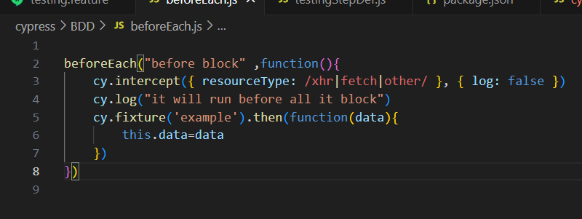

1. Modificy cypress.config file from documantaion.

<https://github.com/badeball/cypress-cucumber-reprocessor/blob/master/examples/browserify-cjs/cypress.config.js/>

1. Crate SetupNodeEvent outside and call it in e2e function

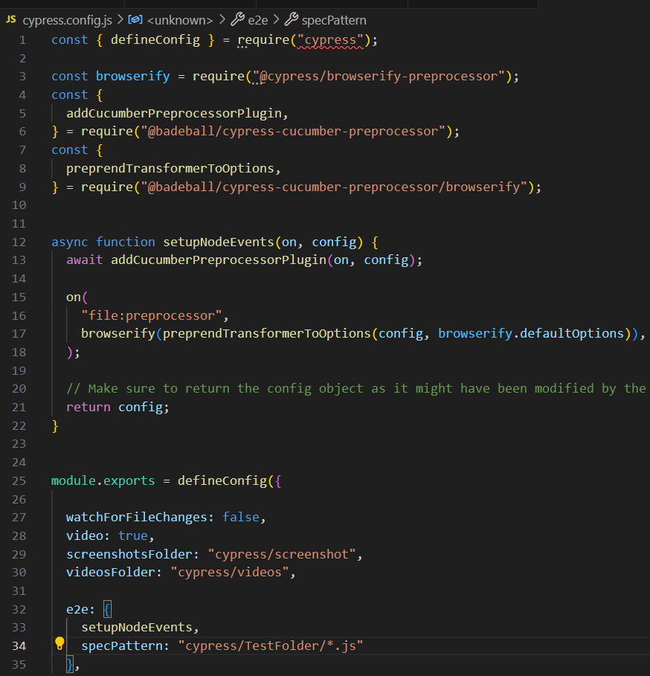

1. Add dependency in package.json

