Cypress – BrowserStack integration

1.Install Browserstack node package

npm install -g browserstack-cypress-cli

2.Create and configure the browserstack.json file which contains configurations, such as BrowserStack credentials, capabilities, etc.,

browserstack-cypress init

Give access key and password from browserstcak account. 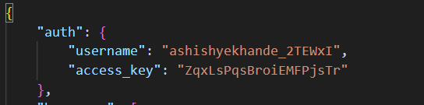

Do some run settings

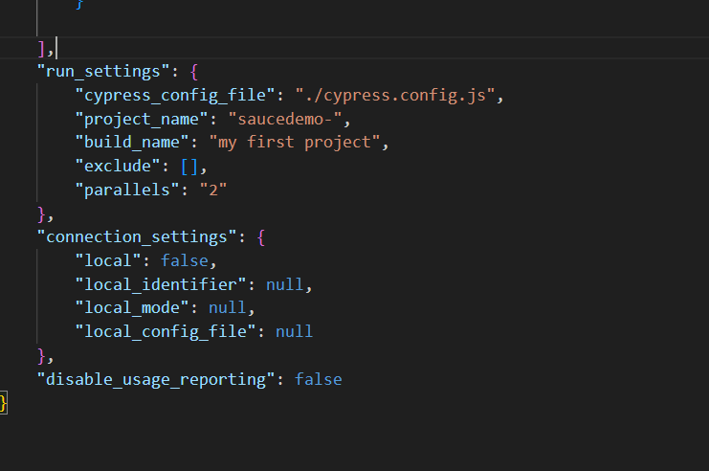

Use command in terminal to run

browserstack-cypress run

You can also create specific command in package.json file

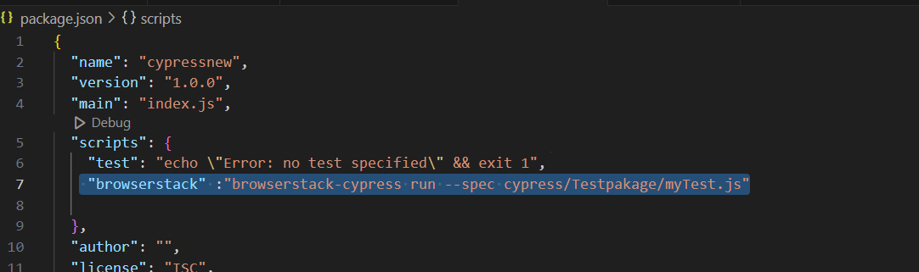

Run using command

npm run <Tagname> ex, npm run browserstack

https://www.browserstack.com/docs/automate/cypress/run-your-first-test