Jenkins – Eclipse –selenium

* Download Jenkins war from site <https://www.jenkins.io/download>

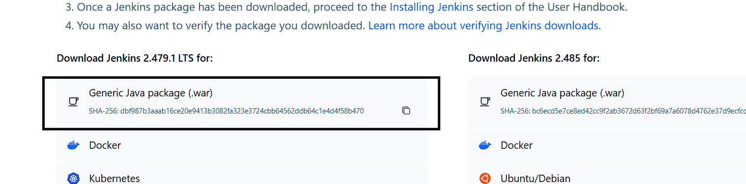

* Need java version 21
* Run from cmd
* Open directory where Jenkins.war is present
* Directory/java -jar Jenkins.war
* it will start Jenkins at localhost:8080 port

Note : to get password 1str time you can delete .jenkins folder from C:\Users\userName and again follow the steps to run war from cmd

To create build

1. create new item – give name -free style project.
2. Select advance and give project path (path till your Pom.xml) 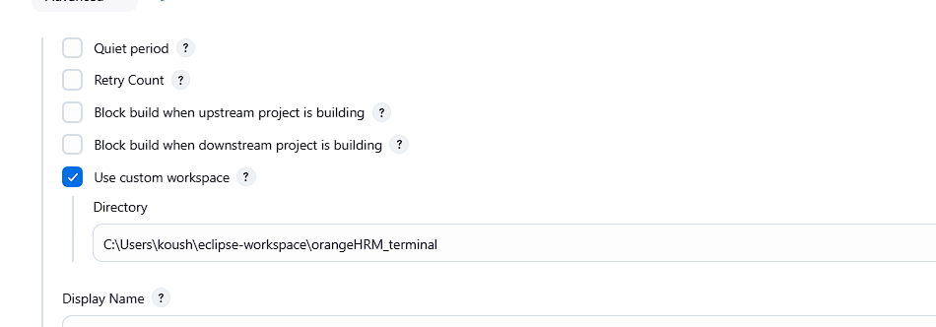
3. Give parameters

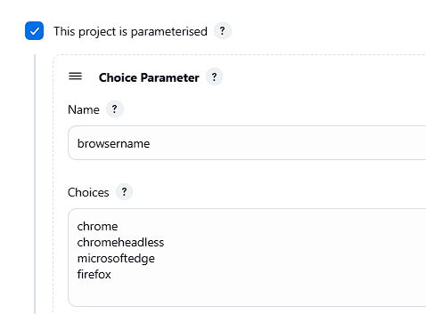

1. Select build step “invoke top-leven maven target”
   1. Provide Maven command to jenkin which will triggers the testng.xml file In command “$paramenterName” is user to pass parameter from above step

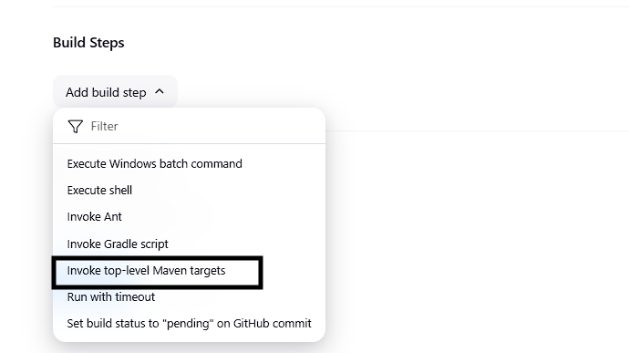

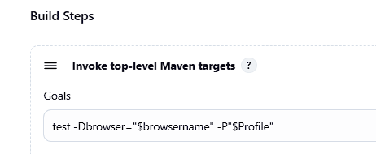

1. Click on build with parameter to run build.

Jenkins schedule trigger

Depending upon need of the job we need to run.

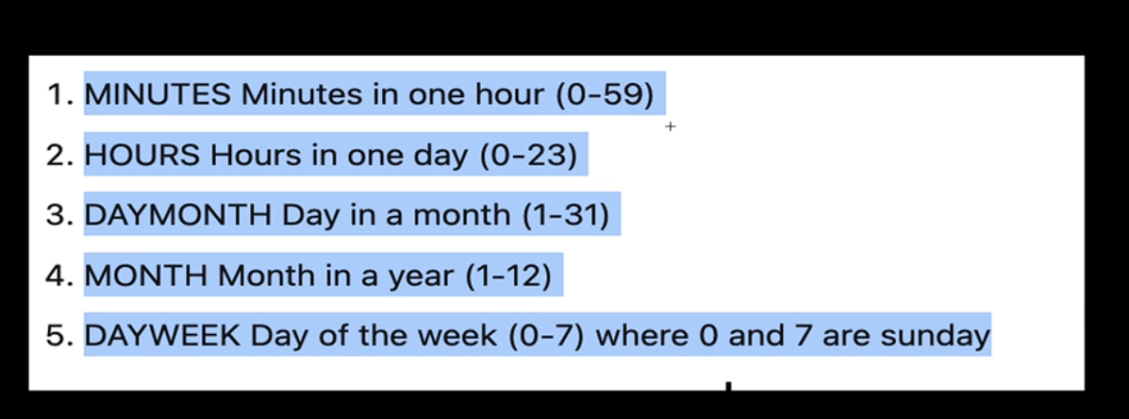

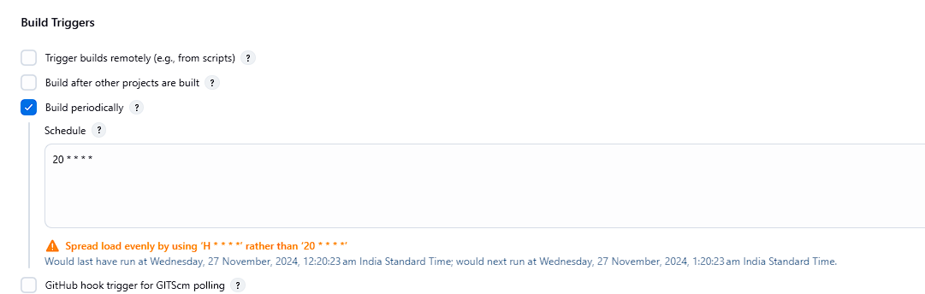

Jenkins – Cypress –VS code

1. Install Jenkins as above And open
2. Add NodeJS plugin as we need NodeJS to run our cypress code.
   * + - 1. Click on manage Jenkins 🡪 Plugins

From available plugins search NodeJS plugin and install.

* + - * 1. Click on manage Jenkins 🡪 Tools

NodeJS Installation 🡪 Add NodeJS

Select version and give name and save.

* Give project path in advance

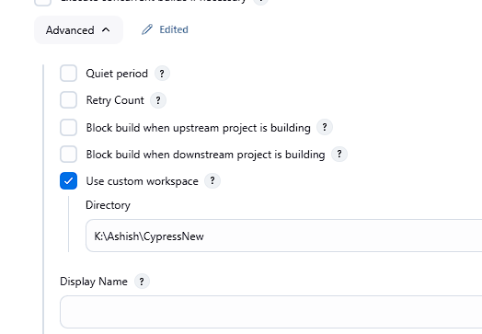

1. Give parameters

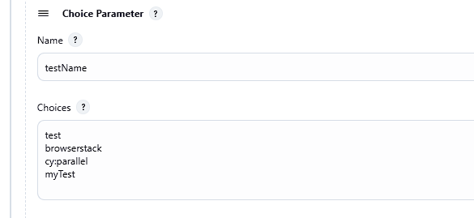

1. Select build step “Execute window batch command”

Provide terminal command to jenkin which will trigger . Use “%paramenterName%” is user to pass parameter from above step

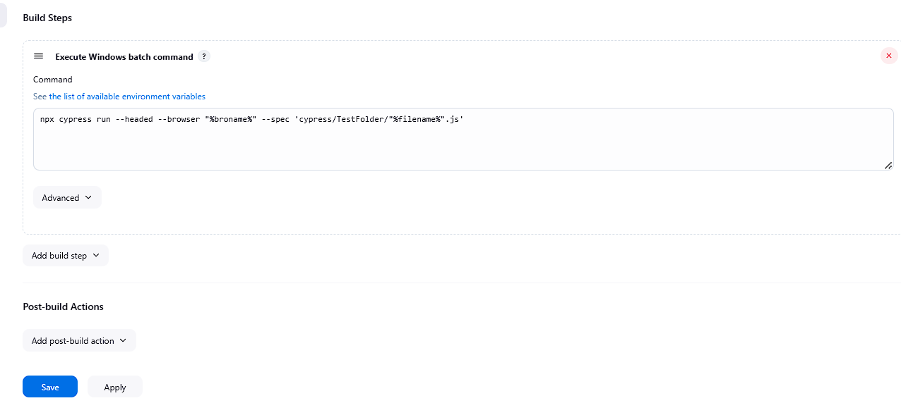

Select “Build Environment” 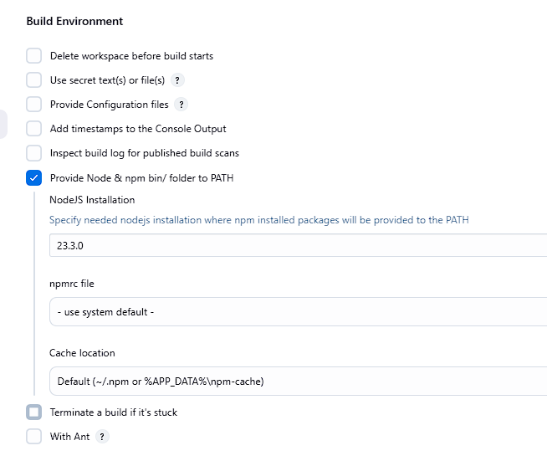

Click on build with parameters to run build.