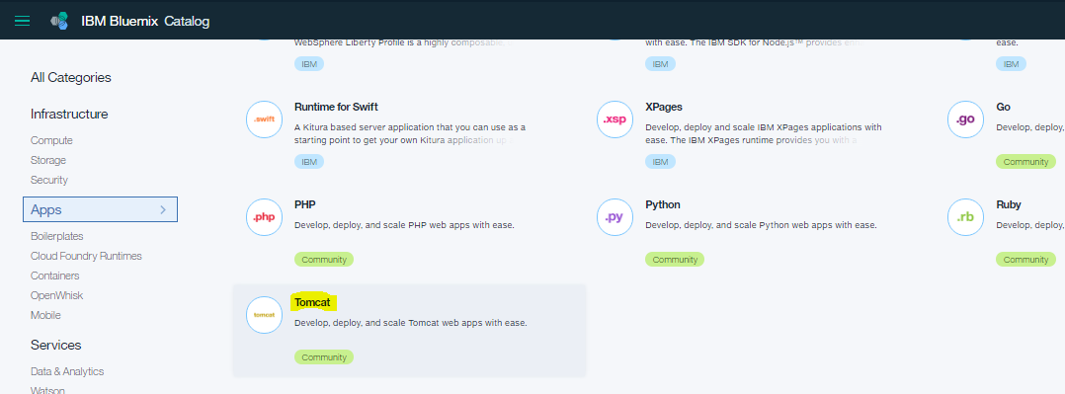

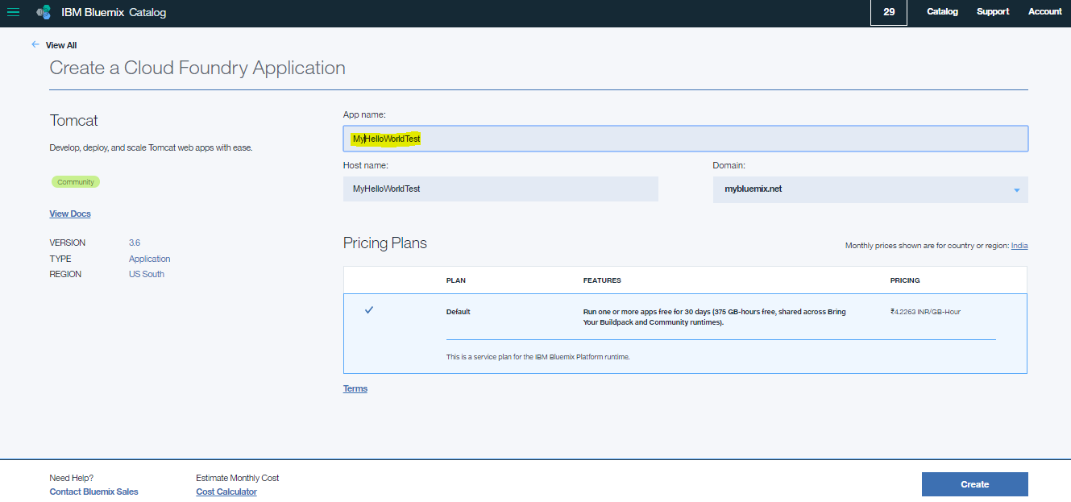

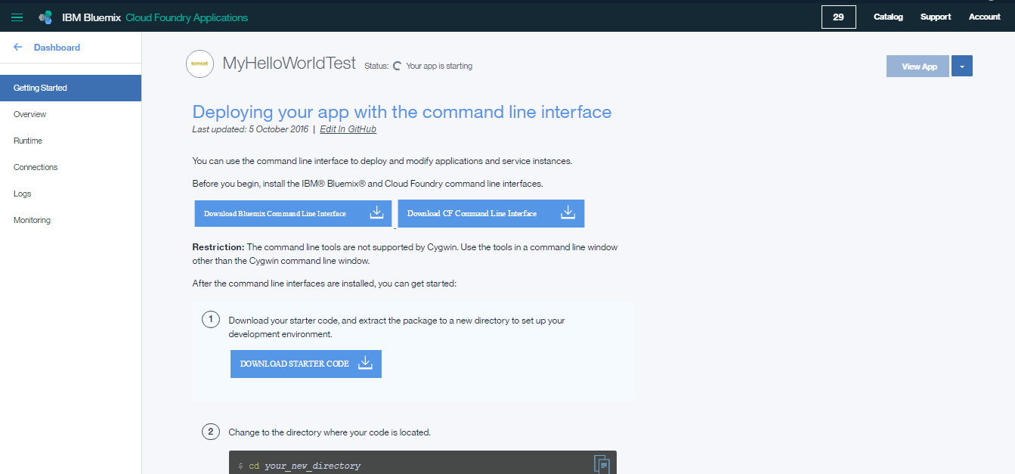

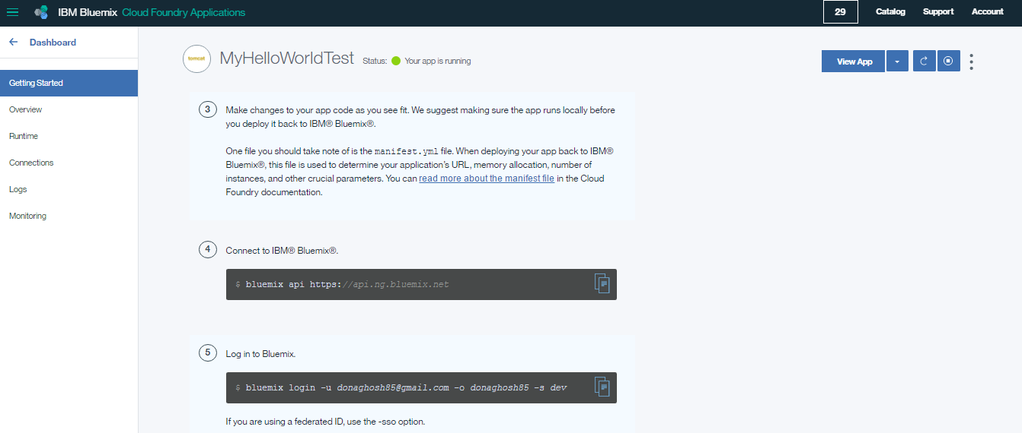

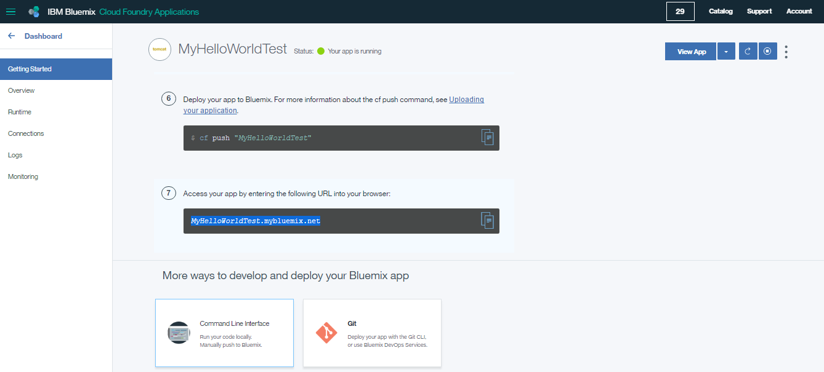

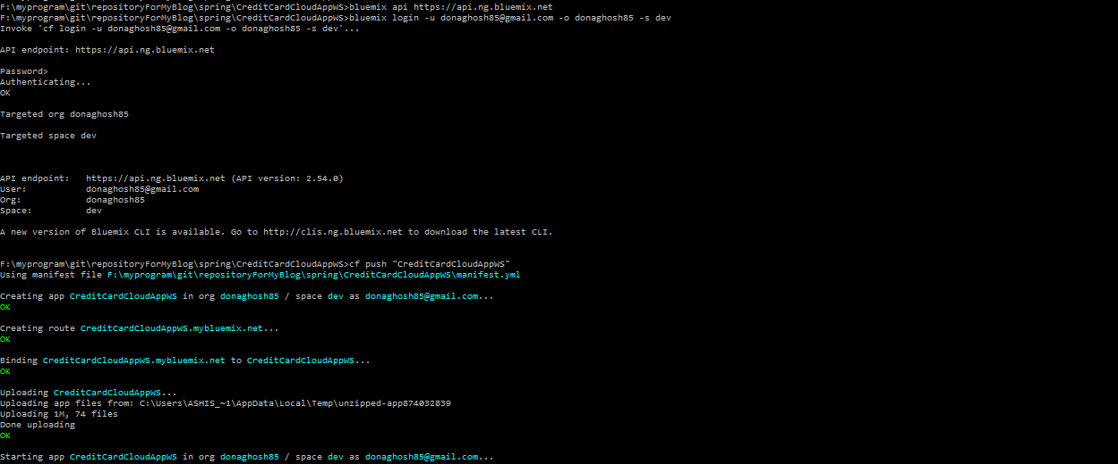

1. Change to the directory where your code is located.
2. Make changes to your app code as you see fit. We suggest making sure the app runs locally before you deploy it back to IBM® Bluemix®.  
     
   One file you should take note of is the manifest.yml file. When deploying your app back to IBM® Bluemix®, this file is used to determine your application’s URL, memory allocation, number of instances, and other crucial parameters. You can [read more about the manifest file](https://docs.cloudfoundry.org/devguide/deploy-apps/manifest.html) in the Cloud Foundry documentation.
3. Connect to IBM® Bluemix®.

bluemix api [https:*//api.ng.bluemix.net*](https://api.ng.bluemix.net)

1. Log in to Bluemix.

bluemix login -u donaghosh85@gmail.com -o donaghosh85 -s dev

If you are using a federated ID, use the -sso option.

bluemix login -u *donaghosh85@gmail.com* -o "*donaghosh85*" -s "*dev*" -sso

1. Deploy your app to Bluemix. For more information about the cf push command, see [Uploading your application](https://console.ng.bluemix.net/docs/starters/upload_app.html).

cf push "*MyHelloWorldTest*"

1. Access your app by entering the following URL into your browser:

*MyHelloWorldTest*.mybluemix.net