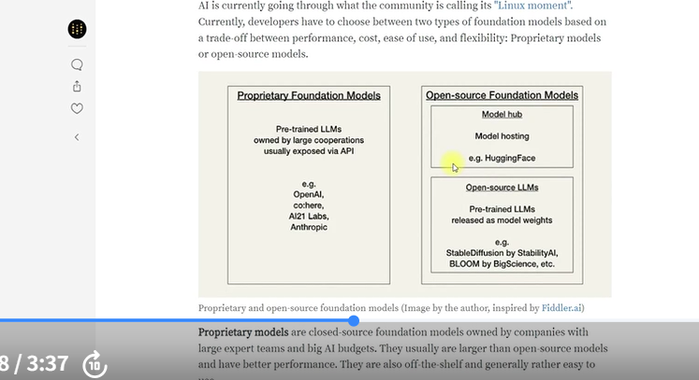

When we talk about models in LangChain, there are mainly three types that we work with:
- LLMs (Large Language Models)
- Chat Models
- Text Embedding Models
Let’s start with LLMs.
These models take a prompt as input and generate an output, which is usually a continuation or completion of the given text.
Since LLMs are trained on a massive amount of data, they can produce both accurate (deterministic) and creative responses. This makes them powerful tools for building applications that perform complex tasks.
For example, your input prompt could be:
- “What are the benefits of eating an apple a day?”
- “How are bags manufactured?”
- “How is a laptop assembled?”
There are many LLMs available in the market — both proprietary (like OpenAI’s GPT models) and open-source ones.
Choosing the right model depends on factors such as performance, cost, ease of use, and flexibility.
One popular open-source platform is Hugging Face — a community and data science platform that allows users to build, train, and deploy machine learning models using open-source technologies.
You can think of Hugging Face as a hub for data scientists and researchers who share ideas, collaborate, and contribute to open-source projects.
On Hugging Face, you’ll find many pre-trained models that are free to use.
To get started, simply:
- Visit the Hugging Face website.
- Create an account.
- Go to Settings → Access Tokens to generate your personal token.
- Use this token to access and experiment with models via LangChain or directly on the site.
Now, coming back to our discussion on LLMs — let’s understand how they work.
For example, if you open ChatGPT, sign in, and type “What is the currency of India?”, it will respond:
“The currency of India is the Indian Rupee.”
This is how a typical user interacts with an LLM — through a simple chat interface.
However, as a developer, you can build similar functionality into your own applications so that your users can ask questions or generate content through your system.
And the best way to do that is by using LangChain, which provides all the tools needed to integrate LLMs easily into your applications.

LANGCHAIN MODULES
A>MODELS

- Large Language Models (LLMs): At their core, LLMs are powerful AI models trained on vast amounts of text data. Their primary function is to predict the next word in a sequence. This seemingly simple task allows them to perform a wide range of natural language processing (NLP) tasks, such as:
- Text Generation: Creating coherent and contextually relevant text, like articles, stories, or code.
- Summarization: Condensing long texts into shorter, key points.
- Translation: Converting text from one language to another.
- Question Answering: Providing answers to factual questions based on their training data.
- Text Completion: Finishing sentences or paragraphs.
Think of an LLM as a highly knowledgeable text predictor. It doesn't inherently "understand" in the human sense, but it's incredibly good at recognizing patterns and relationships in language.
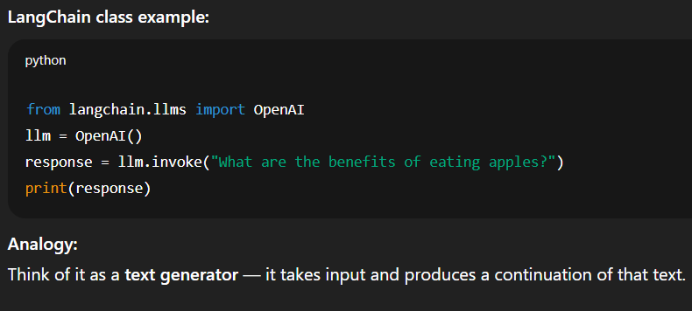

- Chat Model
Chat models are advanced types of language models that generate human-like responses, similar to how we chat with our friends and receive replies. However, in this case, the responses are generated by an AI-powered system.
Chat models are also known as conversational AI models. As mentioned earlier, these models are designed to generate human-like responses in a conversational manner. You ask something, they respond; you ask a follow-up question, they understand the context and continue the conversation accordingly. They are capable of doing this because they are trained on vast amounts of text data and use deep learning techniques, which enable them to provide highly accurate and context-aware responses.
You can find such models in chatbots, virtual assistants like Alexa and Siri, and customer support applications. For example, when a customer asks a question, the system attempts to answer it, and if it cannot, it forwards the query to a human agent who can resolve the issue.

Purpose:
Handle conversational input — messages with roles (like user, assistant, system).
How it works:
- Chat models are built on top of LLMs but are optimized for back-and-forth dialogue.
- They understand context across multiple messages in a chat.
Example use case:
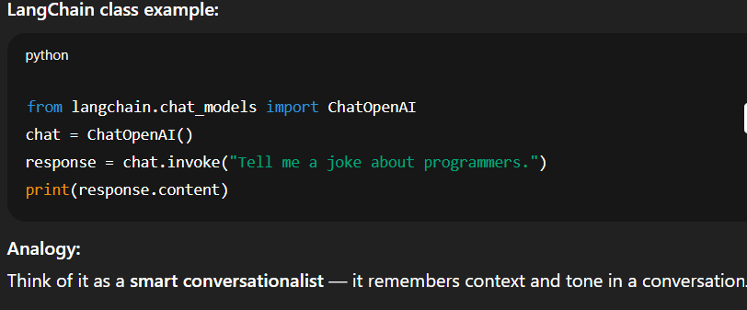
- Chatbots, customer support agents, virtual assistants.

- Embedding Models:

Text or word embeddings are simply numerical representations of words, sentences, or characters. Since computers only understand numbers (0s and 1s), we convert natural language into numerical vectors. This allows machine learning models to process and understand text.
Word embeddings have become very popular in NLP, and many embedding techniques exist today. Their core purpose is to help us capture semantic similarity—that is, how closely related different words are. For example, words like student, school, and college cluster together because their vector representations lie close to each other in the embedding space. Similarly, food-related words form one cluster, sports-related words another, and so on.
To illustrate this, consider words like man, woman, king, and queen. When converted into vectors, the model identifies underlying features such as living being, gender, and royalty. Each word gets a numerical value for these features, forming a vector. Words with similar characteristics—like cat and kitten—end up close together, while unrelated words like house appear farther away.
In simple terms:
Word embeddings = text converted into meaningful numeric vectors.
If you are a researcher, you may need to study how embeddings are generated internally. But if you want to use them in projects, you can directly rely on pre-trained embedding models.

Why embeddings are useful:
- Dimensionality Reduction – They represent words compactly and efficiently.
- Similarity Detection – They help identify how closely words are related.
- Semantic Understanding – They capture meaning, context, and relationships between words.
- Model Compatibility – Machine learning models require numeric inputs, so embeddings make text usable.

Now that we understand the concept, let’s move ahead and use OpenAI to convert words into their numeric representations.

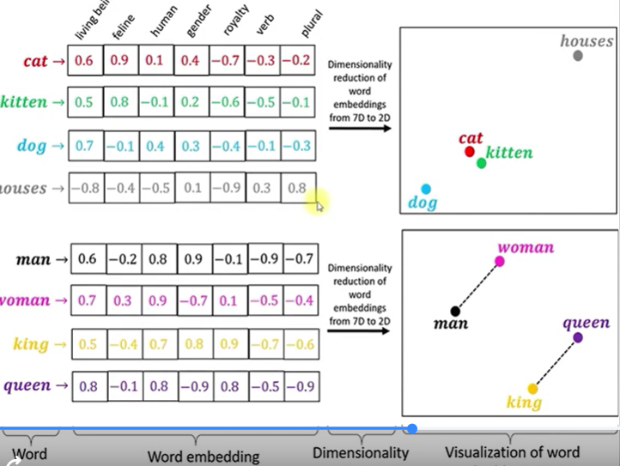

Embedding models are a bit different. Their main purpose isn't to generate text or engage in conversation, but rather to convert text (words, sentences, paragraphs, or even entire documents) into numerical representations called "embeddings" or "vectors."
Here's why embeddings are crucial:
- Meaning Representation: These numerical vectors capture the semantic meaning of the text. Words or phrases with similar meanings will have embedding vectors that are close to each other in a multi-dimensional space.
- Machine Readability: Computers don't understand text directly. By converting text into numbers, embedding models make it possible for machine learning algorithms to process and understand language.
- Applications: Embeddings are fundamental for tasks like:
  - Semantic Search: Finding documents or passages that are conceptually similar to a query, even if they don't share exact keywords.
  - Recommendation Systems: Recommending similar items based on text descriptions.
  - Clustering and Classification: Grouping similar texts together or categorizing them.
  - Retrieval-Augmented Generation (RAG): This is where embeddings often work with LLMs. An embedding model can find relevant information from a large knowledge base, and then an LLM can use that information to generate a more informed and accurate answer.

  - 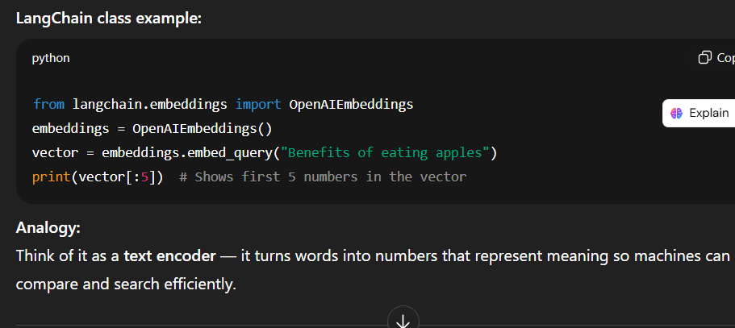
So, to summarize:
- LLMs are for generating and understanding human-like text.
- Chat Models are LLMs specifically fine-tuned and optimized for multi-turn, contextual conversations.
- Embedding Models are for converting text into numerical representations that capture meaning, enabling various downstream NLP tasks, often in conjunction with LLMs.

LangChain makes it easy to build apps or agents that use large language models (LLMs) like ChatGPT, Claude, or Gemini.
- With less than 10 lines of code, you can connect to these AI models and start building.
- It gives you ready-made tools and templates (called agent architectures) so you don’t have to start from scratch.
- If you just want to build a chatbot, assistant, or AI app quickly — LangChain is perfect.
Now, LangGraph is a more advanced tool that works under the hood of LangChain.
- You’d use LangGraph when you want more control — for example, to build systems that mix rule-based steps with AI reasoning, need fast responses, or have complex workflows.
- LangChain agents are actually built on top of LangGraph, which means they automatically get features like:
  - Saving progress (durable execution)
  - Live updates (streaming)
  - Letting humans step in when needed (human-in-the-loop)
  - Saving data for later (persistence)
So in short:
- 🧩 LangChain = easy, quick way to build LLM-based apps.
- ⚙️ LangGraph = advanced version for power users who want full control.
You can use LangChain without learning LangGraph — but LangGraph powers what’s happening behind the scenes.

INSTALLATION
PIP
pip install -U langchain
# Requires Python 3.10+
# Installing the OpenAI integration
pip install -U langchain-openai

# Installing the Anthropic integration
pip install -U langchain-anthropic

UV
uv add langchain
# Requires Python 3.10+

A>PROMPT MODULE

In this module, we will learn about the Prompts module, the second major module in LangChain. This module helps us design effective prompts, which is extremely important because the performance of large language models (LLMs) heavily depends on how we structure our prompts.
Earlier, different NLP tasks required different models—for example, one model for summarization and another for question answering. But with modern LLMs, a single model can perform many tasks. The key is how we instruct the model through prompts, which is why prompt design has become a crucial skill.
LangChain provides a complete module dedicated to prompt engineering. It includes tools that help us create structured, reusable, and high-quality prompts that guide the model to produce accurate and relevant responses.
There are three main components in the Prompts module:
- Prompt Templates – Help you construct prompts with placeholders and dynamic values.
- Example Selectors – Allow you to add examples to your prompts so the model can learn patterns and respond more accurately.
- Output Parsers – Ensure the model’s output follows a required format, such as JSON, lists, or custom structured text.
We will explore each of these components in detail with examples. Mastering prompt engineering is essential for leveraging the full power of LLMs.

Why do we need Prompt Templates?
When building real applications, hard-coding values inside prompts becomes inefficient. Inputs often come dynamically from users or other sources, and prompts need to adapt accordingly. Without a template, manually injecting values into a string repeatedly is prone to errors and difficult to maintain.
To illustrate this problem, we first demonstrate how Python f-strings allow dynamic text construction. An f-string replaces placeholders using variable values. This works well for simple formatting, but as prompts grow more complex, f-strings alone become harder to manage.
LangChain’s PromptTemplate provides a cleaner and more scalable solution.

Using PromptTemplate
We import the PromptTemplate class from LangChain and define:
- input_variables → the variables that will be replaced inside the prompt
- template → the structure of the prompt with placeholders
After creating the template, we use the .format() method to inject actual values. This produces a final prompt string that can then be passed to the LLM.
The output generated using the template is identical to what we achieved using an f-string. However, PromptTemplate offers several advantages:
- Cleaner structure
- Easier maintainability
- Better integration with LangChain pipelines
- Support for more advanced functionality (chaining, parsing, selectors, etc.)
Even though f-strings seem simpler at the beginning, Prompt Templates become extremely useful when your project scales or when multiple templates are required.

- Why Do We Need Examples in Prompts?

LLMs like GPT are trained on massive datasets and are generic by default.
To make them behave according to our specific needs—such as:
- summarization
- question answering
- entity extraction
- role-based answering
- stylistic control
—we need to guide the model using instructions and examples.
This technique is called few-shot prompting.
👉 Good examples → good outputs
👉 Bad examples → bad outputs (and wasted tokens & money)

What is Few-Shot Prompting?
Few-shot learning means:
Teaching the model how to respond by showing it a few question–answer pairs.
The LLM then learns the pattern and applies it to new queries.
Examples add:
- domain knowledge
- context
- style
- persona
For instance, if we want the model to answer as a funny, mischievous 5-year-old girl, we must show examples of how such a child talks.

Basic Prompt Without Examples
We create a simple prompt:
“You are a 5-year-old funny, mischievous and sweet girl.
My question is: What is a house?”
The output is correct but not very funny or childlike.
Why?
Because we did not give examples showing how a 5-year-old actually talks.

Adding Manual Few-Shot Examples
We add Q&A pairs like:
- Q: What is a mobile?
A: It's a magic box with cartoons and games!
- Q: What are your dreams?
A: I want a pet dragon named Sparkles!
Now, when we ask “What is a house?” the model responds in a much more playful, sweet tone.

Using LangChain’s FewShotPromptTemplate
Manually writing one long prompt becomes unmanageable for complex apps.
LangChain solves this through:
FewShotPromptTemplate
Steps:
- Define the examples as a list of dictionaries
- Define an example template (how examples should appear in the final prompt)
- Define:
  - prefix → instruction
  - suffix → final question
- Assemble everything into a reusable prompt template
This gives us a clean, modular structure.

Why Not Add Too Many Examples? (Token Costs)
If we add many examples (50–100), the prompt becomes huge and:
- might exceed the model’s max tokens
- costs more money
- slows down response time
So we need a smart way to select only the right examples.

Introducing: Length Based Example Selector
LangChain provides:
LengthBasedExampleSelector
This selector:
- chooses examples based on the total text length
- stops adding examples once the max length limit is reached
Usage steps:
- pass your examples
- pass the example template
- set max_length
Example:
- With max_length=25 → no examples included
- With max_length=50 → 1 example included
- With max_length=200 → several examples included
Benefits:
- prevents token overflow
- saves money
- keeps output consistent

Dynamically Adding New Examples
LangChain allows adding examples on the fly:
example_selector.add_example(new_example)
The updated example list gets used whenever the prompt is built again.
This is useful for:
- user-generated examples
- interactive learning
- custom style training

OUTPUT PARSERS
Now we move to output parsers, also under LangChain’s prompts module.
Sometimes we need responses in:
- CSV format
- JSON format
- custom text formats
Parsers help convert raw LLM output into structured data.

CSV Output Using CommaSeparatedListOutputParser
We use LangChain’s:
CommaSeparatedListOutputParser
It returns instructions like:
“Your response should be a list of comma separated values.
Example: foo, bar.”
We inject this into our prompt using:
- partial_variables={"format_instructions": ...}
Then we ask:
“Provide five examples of currencies.”
Output is in CSV:
Dollar, Euro, Yen, Rupee, Pound
That’s how easily LangChain ensures structured output.

JSON Output Using StructuredOutputParser
For more complex use-cases, we need JSON.
LangChain provides:
**StructuredOutputParser + ResponseSchema`
We define schemas like:
{
"currency": "<name of currency>",
"abbreviation": "<short form>"
}
LangChain automatically generates:
- JSON format instructions
- validation structure
- correct schema with leading/trailing braces
Example output:
{
"currency": "Indian Rupee",
"abbreviation": "INR"
}
No need to manually format anything — the parser does it.

