YUVA INTERNSHIP
Telecom Data Science Analyst
WEEK 2 TASK
Python Scripting for Data Wrangling and Visualization in Telecom
Detail | Value
Name | Ashith B
Internship | Yuva Internship – Telecom Data Science Analyst
Dataset | Synthetic telecom customer-usage dataset
Tools | Python, Pandas, NumPy, Matplotlib, Seaborn, Jupyter

1. Introduction
Week 2 moves the project from strategic planning into practical Python execution. The task demonstrates how a raw telecom-style dataset can be inspected, cleaned, transformed, visualized, and interpreted before advanced analytics or machine learning.
Because no mandatory dataset was supplied, a synthetic telecom customer-usage dataset was generated for educational purposes. Controlled quality issues were introduced so that the cleaning workflow could be demonstrated transparently. The dataset does not represent real subscribers or a real telecom operator.

2. Dataset Structure
The raw dataset contains 503 records, including three intentionally duplicated customer records. After duplicate removal, 500 unique customer records remain.
Variable | Type | Purpose
Customer_ID | Categorical | Unique customer identifier
Age | Integer | Customer age
Gender | Categorical | Customer gender
Region | Categorical | Geographic segment
Plan | Categorical | Basic, Standard or Premium
Tenure_Months | Integer | Customer tenure
Monthly_Data_GB | Numeric | Monthly data usage
Call_Minutes | Numeric | Voice usage
SMS_Count | Numeric | SMS usage
Download_Speed_Mbps | Numeric | Download speed
Latency_ms | Numeric | Network latency
Dropped_Calls_pct | Numeric | Dropped-call rate
Monthly_Bill_INR | Numeric | Monthly bill
Support_Calls | Integer | Support contacts
Satisfaction_Score | Numeric | 1–5 satisfaction score
Churn | Categorical | Churn outcome

3. Data Quality Issues
- Missing values in usage, satisfaction and plan fields.
- Duplicate customer records.
- Inconsistent category capitalization such as 'female' and 'south'.
- Impossible negative network measurements.
- Column names containing units/symbols that require standardization.
- Different numeric ranges requiring normalization when appropriate.

4. Step-by-Step Data Cleaning

4.1 Load and inspect
import pandas as pd
df = pd.read_csv("data/raw/telecom_customer_usage_raw.csv")
print(df.shape)
print(df.head())
print(df.info())
Reasoning: Pandas provides direct CSV loading and inspection. Shape, head and info help establish the starting structure before transformations.

4.2 Standardize column names
df.columns = (
df.columns.str.strip()
.str.lower()
.str.replace("%", "pct", regex=False)
.str.replace(r"[^a-z0-9]+", "_", regex=True)
.str.strip("_")
)
Reasoning: Consistent snake_case names make the pipeline easier to read and reproduce.

4.3 Remove duplicates
duplicate_count = df.duplicated("customer_id").sum()
df = df.drop_duplicates(subset="customer_id")
Reasoning: Customer-level analysis should not count the same customer multiple times.

4.4 Convert types and standardize categories
for col in numeric_cols:
df[col] = pd.to_numeric(df[col], errors="coerce")
df["gender"] = df["gender"].astype("string").str.strip().str.title()
df["region"] = df["region"].astype("string").str.strip().str.title()
df["plan"] = df["plan"].astype("string").str.strip().str.title()
Reasoning: Explicit conversion prevents text-formatted numbers from breaking calculations, while category normalization avoids false categories.

4.5 Handle invalid and missing values
df.loc[df["latency_ms"] < 0, "latency_ms"] = np.nan
df.loc[df["download_speed_mbps"] < 0, "download_speed_mbps"] = np.nan
for col in numeric_cols:
df[col] = df[col].fillna(df[col].median())
for col in ["gender", "region", "plan", "churn"]:
df[col] = df[col].fillna(df[col].mode()[0])
Reasoning: Negative network measurements are physically implausible in this context, so they are treated as missing. Median/mode imputation preserves records while reducing the influence of extreme values.

4.6 Normalize selected variables
for col in ["monthly_data_gb", "call_minutes",
"download_speed_mbps", "latency_ms"]:
df[col + "_norm"] = (
(df[col] - df[col].min()) /
(df[col].max() - df[col].min())
)
Reasoning: Min-max normalization maps selected continuous variables to a 0–1 range. It is useful when comparable scales are required.

5. Cleaning Results
Measure | Before | After
Records | 503 | 500
Duplicate customer records | 3 | 0
Missing values | Present | 0 in final dataset
Invalid negative network values | Present | 0
Category inconsistencies | Present | Standardized

6. Visualization and Interpretation

Figure 1
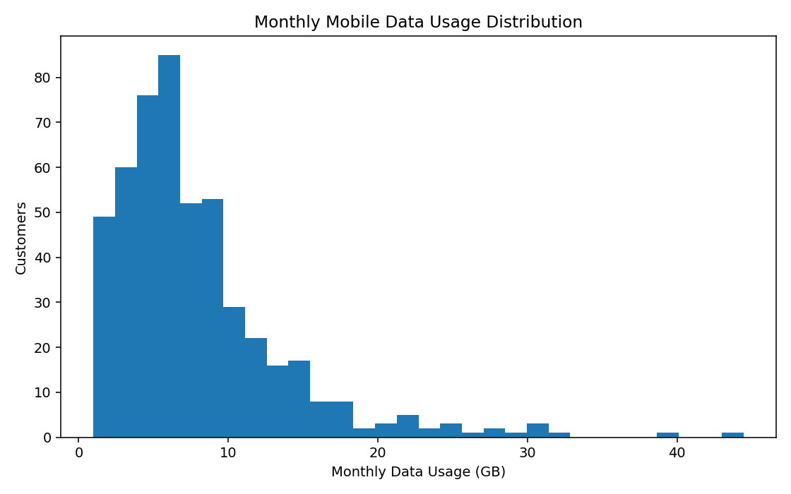
Interpretation: Usage distribution: The distribution is right-skewed, with most customers using moderate data and a smaller high-usage group. This suggests possible usage-based segmentation.

Figure 2
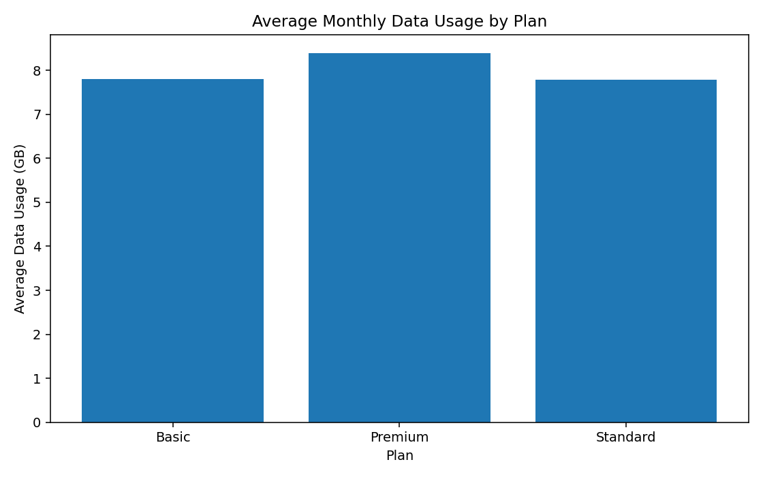
Interpretation: Usage by plan: The simulated Premium segment has higher average data usage than lower-tier plans. This is an illustrative result and should not be generalized to real customers.

Figure 3
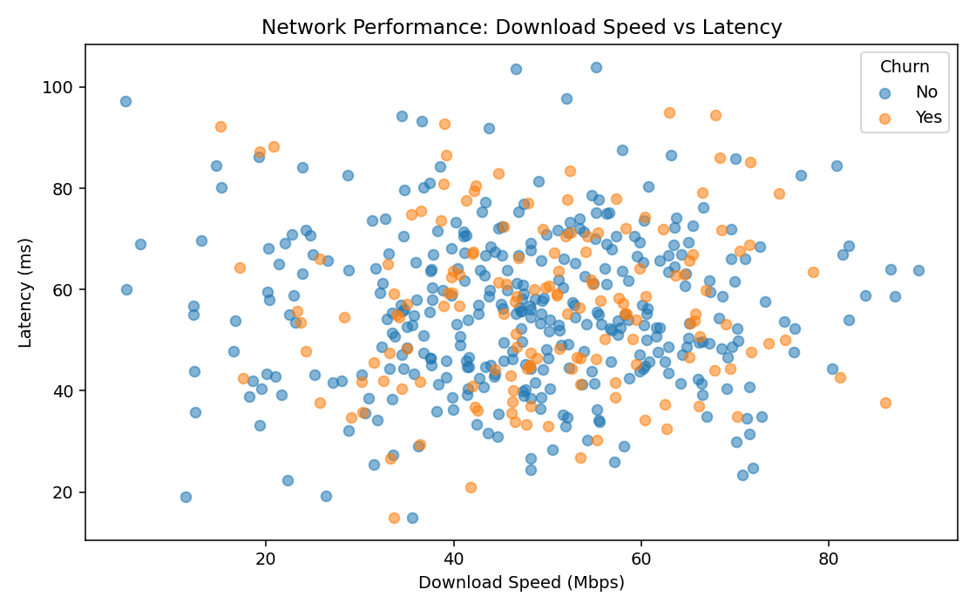
Interpretation: Speed vs latency: The scatter plot compares two network performance indicators and separates churn outcomes visually. Patterns require statistical testing before strong conclusions.

Figure 4
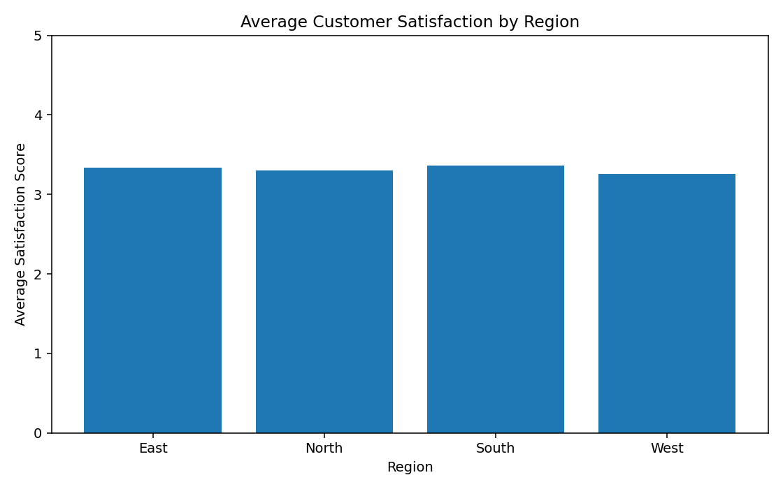
Interpretation: Regional satisfaction: Regional averages allow analysts to identify geographic differences that may justify deeper investigation into network or customer factors.

Figure 5
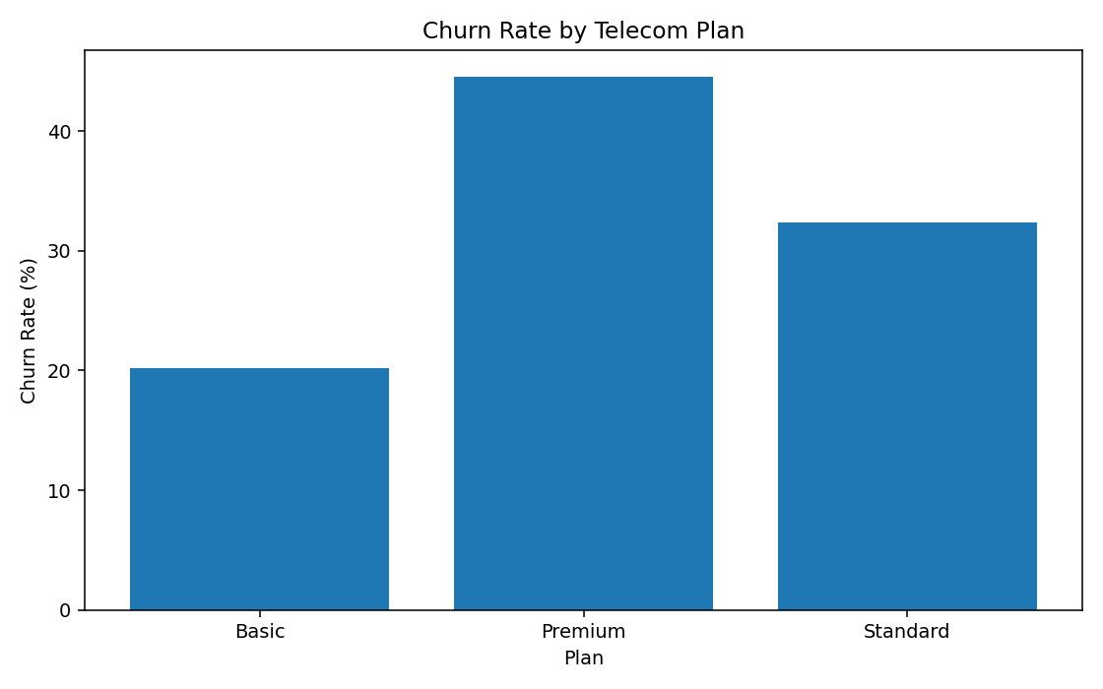
Interpretation: Churn by plan: Plan-level churn rates provide a direct visual check of whether churn varies by service plan and support the hypothesis-driven approach from Week 1.

7. Why These Visualizations Were Selected
Chart | Question Answered
Histogram | How is customer data usage distributed?
Plan bar chart | Do usage levels differ by plan?
Scatter plot | How do speed and latency vary together?
Regional bar chart | Does satisfaction differ by region?
Churn bar chart | Does churn vary across plans?

8. Challenges and Alternative Solutions
- No mandatory dataset was provided, so synthetic data was used instead of claiming access to private telecom records.
- Deletion of every row containing a missing value was considered but rejected because it could unnecessarily reduce the dataset; median/mode imputation was used for this educational workflow.
- Invalid network values were not clipped to arbitrary limits; they were converted to missing and then imputed.
- Case normalization was used instead of manually editing individual records, making the process scalable.
- Multiple visualization types were used because one chart cannot answer all telecom questions.
- Synthetic results are clearly labelled as illustrative and are not presented as real telecom industry findings.

9. Python Project Files
File | Purpose
data/raw/telecom_customer_usage_raw.csv | Intentionally imperfect raw dataset
data/processed/telecom_customer_usage_clean.csv | Cleaned analysis-ready dataset
src/telecom_data_wrangling.py | Reproducible cleaning and visualization script
notebooks/Week_2_Telecom_Wrangling_and_Visualization.ipynb | Notebook workflow
figures/ | Generated visualizations
reports/Week_2_Telecom_Data_Wrangling_Report.docx | This report

10. 30–35 Hour Work Plan
Activity | Hours
Dataset design and telecom variable research | 4
Python setup and raw-data preparation | 3
Data inspection and quality profiling | 4
Cleaning and transformation coding | 7
Visualization development | 6
Interpretation and alternatives | 3
Documentation, review and GitHub organization | 5–8
Total | 32–35

11. Conclusion
This Week 2 exercise demonstrates the transition from a telecom analytics strategy to practical Python execution. The workflow converts imperfect raw records into a consistent dataset through duplicate removal, type conversion, category standardization, missing-value treatment, invalid-value handling and normalization. The resulting visualizations provide different perspectives on usage, plans, network performance, regional satisfaction and churn.
The exercise also demonstrates that data preparation and visualization are analytical activities, not merely coding steps. Every transformation needs a reason, and every chart needs context. The same workflow can be adapted to real public telecom datasets in later stages of the internship.

12. Appendix – Reproducible Script
The complete executable script is stored in the GitHub project under src/telecom_data_wrangling.py. It reads the raw CSV, cleans the data, writes the processed CSV, and generates the five figures.

