YUVA INTERNSHIP
Telecom Data Science Analyst
WEEK 3 TASK
Predictive Modeling and Machine Learning for Telecom Customer Churn
Detail | Value
Name | Ashith B
Internship | Yuva Internship – Telecom Data Science Analyst
Modeling dataset | 500 unique customer records
Target | Churn (Yes/No)
Models | Logistic Regression; Decision Tree
Validation | 80/20 stratified split + 5-fold stratified CV
Python stack | Pandas, NumPy, Scikit-learn, Matplotlib

1. Objective
The objective of Week 3 is to develop and evaluate a predictive machine-learning workflow that estimates whether a telecom customer is likely to churn. The workflow continues from Week 2 by using the cleaned telecom-style dataset and applying preprocessing, feature engineering, model training, validation, and evaluation.
The model is intended as a decision-support prototype. It is not a production churn engine and should not be used for real customer decisions without validation on representative operational data.

2. Business Scenario and Hypothesis
Scenario: A telecom operator wants to identify customers who may leave so that retention teams can prioritize appropriate, non-discriminatory interventions.
Hypothesis: churn likelihood is associated with shorter tenure, higher support activity, lower satisfaction, weaker network performance, and selected billing/plan characteristics.
The model tests this hypothesis by learning patterns in the simulated dataset. Model associations should not be interpreted as proof of causation.

3. Dataset and Target
The modeling dataset contains 500 unique synthetic customer records. The target variable is Churn, encoded as 1 for Yes and 0 for No. There are 18 predictor features after feature engineering: 15 original analytical variables plus 3 engineered continuous/flag variables.
Category | Variables
Customer | age, gender, tenure_months
Service | plan, monthly_data_gb, call_minutes, sms_count
Network | download_speed_mbps, latency_ms, dropped_calls_pct
Commercial | monthly_bill_inr, support_calls
Experience | satisfaction_score
Engineered | total_contact_activity, network_stress_index, bill_per_tenure_month, high_support_flag
Target | churn

4. Preprocessing
- Duplicate customer IDs were removed, leaving 500 unique records.
- Numeric fields were converted with pd.to_numeric and invalid negative network values were treated as missing.
- Numeric missing values were filled using medians; categorical values used the most frequent category.
- Categorical predictors were one-hot encoded using OneHotEncoder(handle_unknown='ignore').
- Numeric predictors were standardized with StandardScaler inside a Scikit-learn pipeline.
- The preprocessing steps are fitted only within the training folds/pipeline to reduce data leakage risk.

5. Feature Engineering
Feature | Formula / Rule | Purpose
total_contact_activity | support_calls + call_minutes/100 | Combines support and voice activity into a simple contact-intensity measure.
network_stress_index | latency_ms / download_speed_mbps | Captures poorer network conditions when latency is high relative to speed.
bill_per_tenure_month | monthly_bill_inr / (tenure_months + 1) | Provides a simple normalized billing indicator.
high_support_flag | 1 if support calls are at or above the 75th percentile | Identifies relatively high support-contact activity.

6. Train/Test Strategy
The data was split into 80% training and 20% testing using train_test_split with stratify=y and random_state=42. Therefore, 400 records were used for training and 100 records for final hold-out testing. Stratification preserves the approximate churn-class proportion in both partitions.
Stage | Records | Purpose
Full dataset | 500 | Modeling population
Training set | 400 | Model fitting and cross-validation
Test set | 100 | Final unseen evaluation

7. Model Selection
Model | Reason for Selection | Strength | Limitation
Logistic Regression | Strong baseline for binary churn prediction and interpretable coefficients. | Simple, fast, probability-oriented. | Assumes a linear relationship in transformed feature space.
Decision Tree | Captures nonlinear interactions and threshold effects. | Easy to explain and handles mixed patterns. | Can overfit without depth/leaf controls.

Both models use class_weight='balanced' so that the model gives additional importance to the minority class when appropriate. The Decision Tree was constrained to max_depth=5 and min_samples_leaf=8 to limit overfitting.

8. Training Code
X_train, X_test, y_train, y_test = train_test_split(
X, y, test_size=0.20, stratify=y, random_state=42
)
model = Pipeline([
("prep", preprocessor),
("model", LogisticRegression(
max_iter=2000, class_weight="balanced", random_state=42
))
])
model.fit(X_train, y_train)
pred = model.predict(X_test)
prob = model.predict_proba(X_test)[:, 1]
The same preprocessing pipeline is used with the Decision Tree model, making the comparison consistent.

9. Evaluation Metrics
Metric | Meaning in Churn Analysis
Accuracy | Overall proportion of correct predictions.
Precision | Among customers predicted to churn, proportion who actually churned.
Recall | Among customers who actually churned, proportion correctly identified.
F1-score | Harmonic mean of precision and recall.
ROC-AUC | Measures ranking/discrimination across probability thresholds.

Recall is especially important for a retention-screening use case because missing a true churner can represent a missed opportunity. However, precision must also be considered to avoid unnecessarily targeting too many customers.

10. Hold-out Test Results
Model | Accuracy | Precision | Recall | F1 | ROC-AUC
Logistic Regression | 0.640 | 0.417 | 0.500 | 0.455 | 0.639
Decision Tree | 0.540 | 0.265 | 0.300 | 0.281 | 0.519

Selected model for churn-screening emphasis: Logistic Regression, because it achieved the stronger hold-out recall among the tested models while also providing a usable overall performance profile. The exact metric values above are calculated from the 100-record unseen test set.

11. Five-Fold Cross-Validation
Model | CV Accuracy | CV Precision | CV Recall | CV F1 | CV ROC-AUC
Logistic Regression | 0.633 | 0.425 | 0.549 | 0.476 | 0.618
Decision Tree | 0.570 | 0.375 | 0.533 | 0.433 | 0.567

Five-fold stratified cross-validation was performed on the training set. Each fold uses a different validation partition while preserving the churn class ratio. Comparing the cross-validation means with the final test metrics helps identify whether performance is reasonably stable rather than dependent on one split.

12. Confusion Matrix
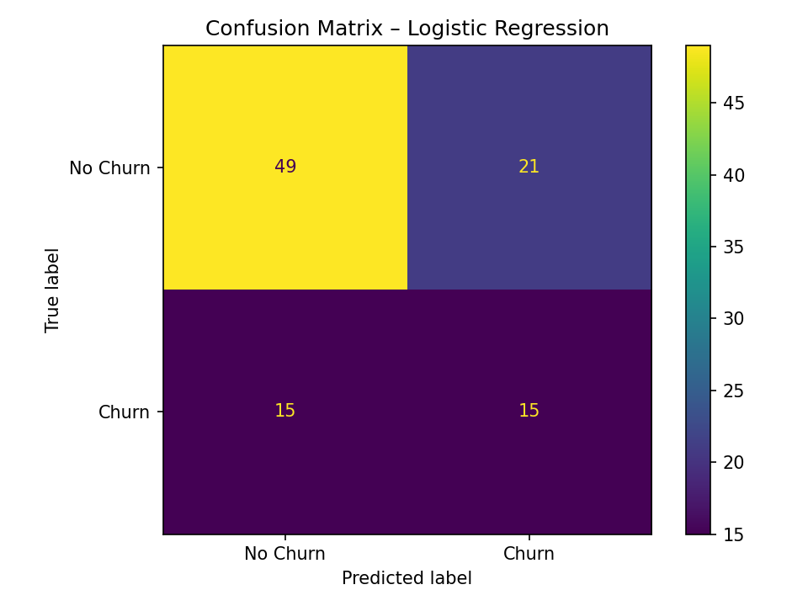
For the selected Logistic Regression model, the confusion matrix shows true negatives, false positives, false negatives, and true positives on the 100-record test set. In a churn application, false negatives represent churners that the model failed to flag, while false positives represent customers flagged unnecessarily.

13. Supporting Analysis Visualizations

Figure 2
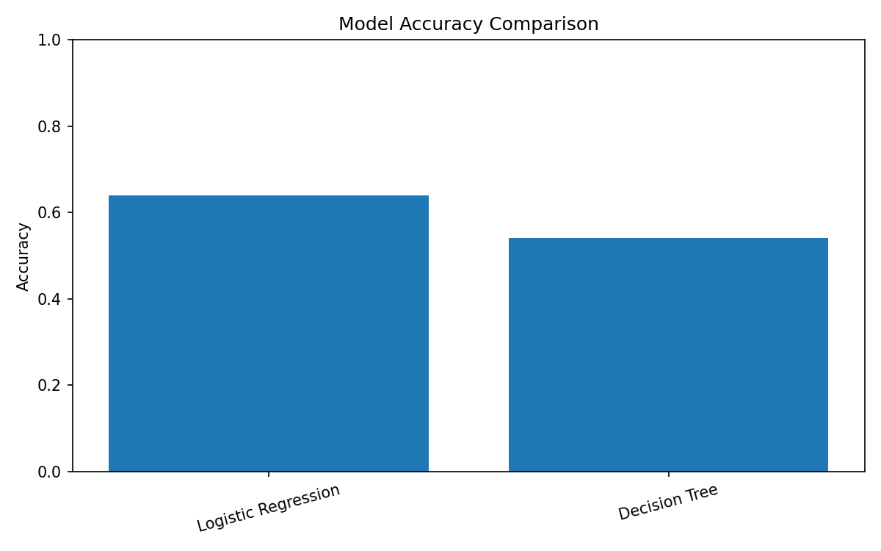
Model accuracy comparison provides a direct high-level view of the two classifiers.

Figure 3
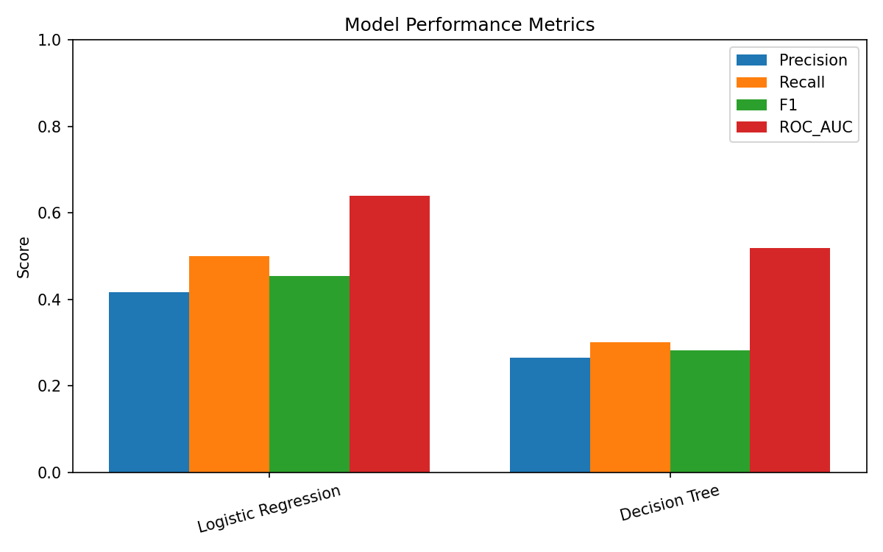
Precision, recall, F1 and ROC-AUC compare the models using several perspectives rather than relying on accuracy alone.

Figure 4
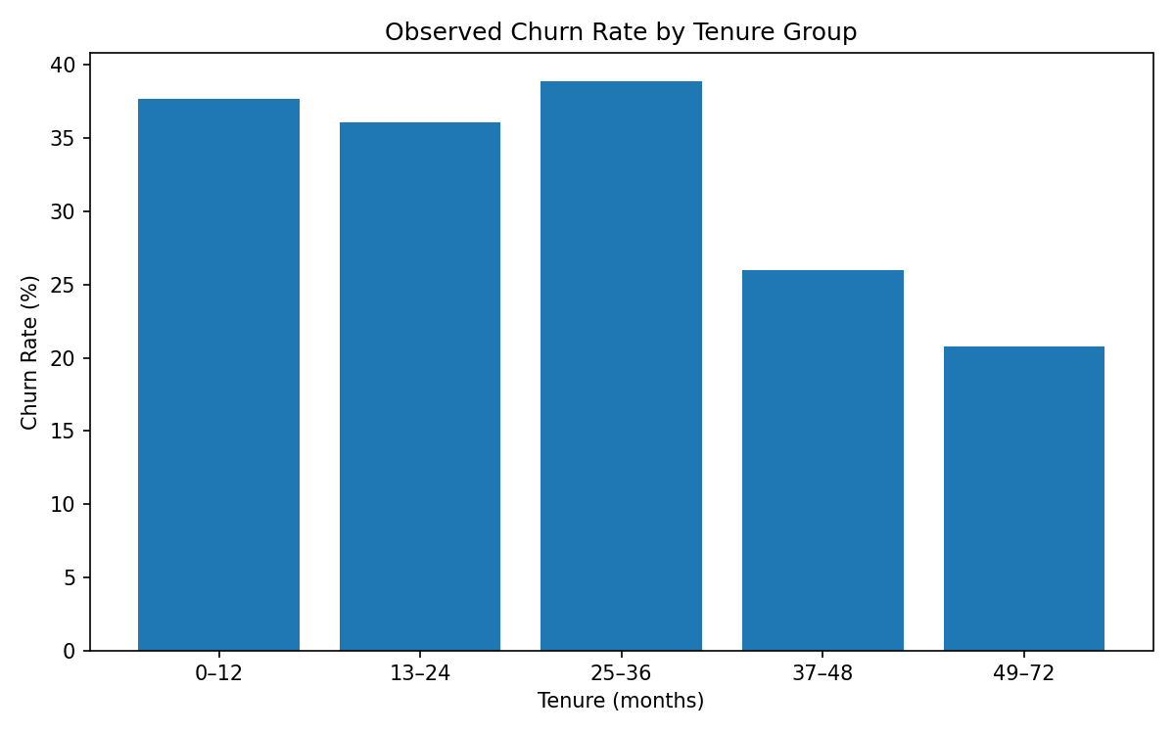
Observed churn by tenure group is a descriptive analysis supporting the Week 1 hypothesis about customer tenure.

Figure 5
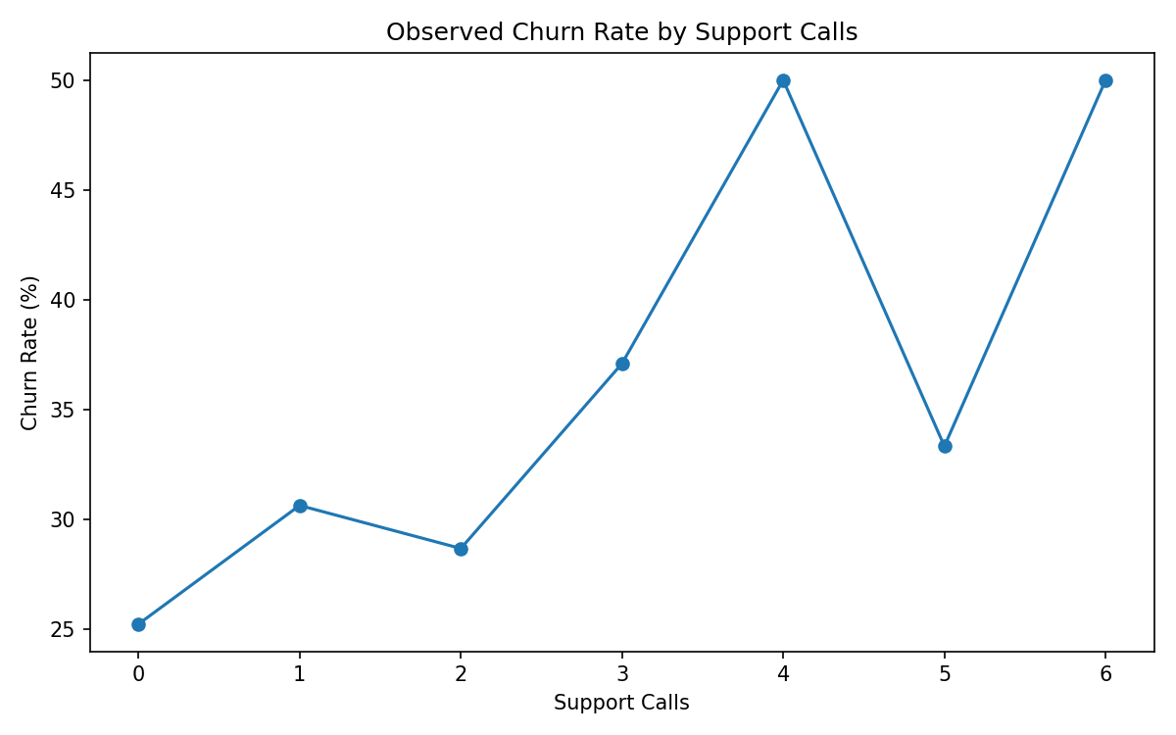
Observed churn by support-call count shows how churn varies descriptively with customer support activity.

14. Pseudocode
LOAD telecom dataset
REMOVE duplicate customers
CLEAN invalid and missing values
CREATE churn target
ENGINEER relevant features
SPLIT data into stratified train/test sets
BUILD preprocessing pipeline
TRAIN Logistic Regression
TRAIN Decision Tree
CALCULATE accuracy, precision, recall, F1 and ROC-AUC
RUN 5-fold stratified cross-validation
COMPARE models
SELECT model according to business objective
INTERPRET results and document limitations

15. Challenges and Mitigation
- Class imbalance: class_weight='balanced' and recall/F1 are considered instead of accuracy alone.
- Data leakage: preprocessing is embedded inside Scikit-learn pipelines and evaluated through cross-validation.
- Overfitting: the Decision Tree is depth- and leaf-constrained and cross-validated.
- Small synthetic dataset: results are treated as educational and require external validation before real-world use.
- Correlation and causality: predictive association is not treated as causal evidence.
- Threshold choice: default classification threshold is used for this prototype; production use should tune the threshold according to retention-team capacity and business cost.

16. Ethical and Privacy Considerations
The dataset is synthetic and contains no real subscriber identities. A production implementation should minimize personal data, restrict access, document model purpose, monitor disparate error rates where legally and ethically appropriate, and avoid using sensitive attributes for discriminatory targeting. Customers should not be penalized solely because a model assigns a high churn probability.

17. Reproducibility and GitHub Files
Path | Purpose
data/raw/telecom_customer_usage_raw.csv | Week 2 raw input carried into Week 3.
data/processed/telecom_churn_modeling_dataset.csv | Cleaned and feature-engineered modeling dataset.
data/processed/model_evaluation_results.csv | Hold-out test metrics.
data/processed/cross_validation_results.csv | Five-fold cross-validation metrics.
src/telecom_churn_model.py | Complete modeling script.
notebooks/Week_3_Telecom_Churn_Modeling.ipynb | Notebook entry point.
figures/ | Model and descriptive analysis charts.
reports/Week_3_Telecom_Churn_Modeling_Report.docx | This report.

18. 30–35 Hour Work Plan
Activity | Hours
Understand churn scenario and define target/features | 4
Prepare and validate modeling dataset | 5
Feature engineering | 5
Build preprocessing and baseline models | 6
Cross-validation and evaluation | 5
Visualizations and interpretation | 3
Documentation, GitHub organization and review | 4
Total | 32

19. Conclusion
This Week 3 project demonstrates an end-to-end telecom churn prediction workflow using Python and Scikit-learn. The process connects the Week 1 hypothesis and Week 2 cleaned data to a supervised-learning task. Two complementary models were trained, evaluated on an unseen 100-record test set, and checked with five-fold stratified cross-validation. Multiple evaluation metrics were used because a churn model should balance identifying genuine churners with avoiding excessive false alarms.
The resulting workflow is reproducible and ready for further improvement. Future work should test the approach on a larger real-world or officially licensed telecom dataset, tune classification thresholds, compare additional algorithms, perform calibration and feature-importance analysis, and evaluate business costs before any production deployment.

