WEEK 4 – FINAL TELECOM ANALYTICS REPORT
Evaluation, Insight Generation, and Reporting
Yuva Internship – Telecom Data Science Analyst
Prepared by: Ashith B
B.E. Computer Science and Engineering
Srinivas Institute of Technology, Mangaluru
Final integrated analysis covering Weeks 1–4

1. Executive Summary
This final report consolidates the four-week Telecom Data Science Analyst internship workflow into a single decision-oriented narrative. The project progressed from strategic planning and data acquisition in Week 1, through Python-based data cleaning and visualization in Week 2, to predictive churn modeling in Week 3, and finally to evaluation, insight generation, business recommendations, limitations, and future analysis in Week 4.
The practical analysis uses a clearly labelled synthetic telecom customer dataset with 500 unique customer records. The cleaned dataset contains 152 churned customers (30.4%) and 348 retained customers (69.6%). Key descriptive findings include an average tenure of 35.9 months, average monthly bill of ₹663, average download speed of 48.3 Mbps, and average satisfaction of 3.31/5.
Week 3 showed that Logistic Regression was the stronger of the two tested baseline models. On the holdout set it achieved 64.0% accuracy, 50.0% recall, 45.5% F1-score and 63.9% ROC-AUC, compared with the Decision Tree's 51.9% ROC-AUC.
The final business interpretation is that churn should not be treated as a single-variable problem. The strongest practical signals in this exercise combine customer tenure, satisfaction, support interactions, billing, service-plan characteristics, and network experience. A real telecom operator could use such a model as a prioritization layer for retention campaigns, service-quality intervention, and customer-experience monitoring rather than as an automatic decision-maker.
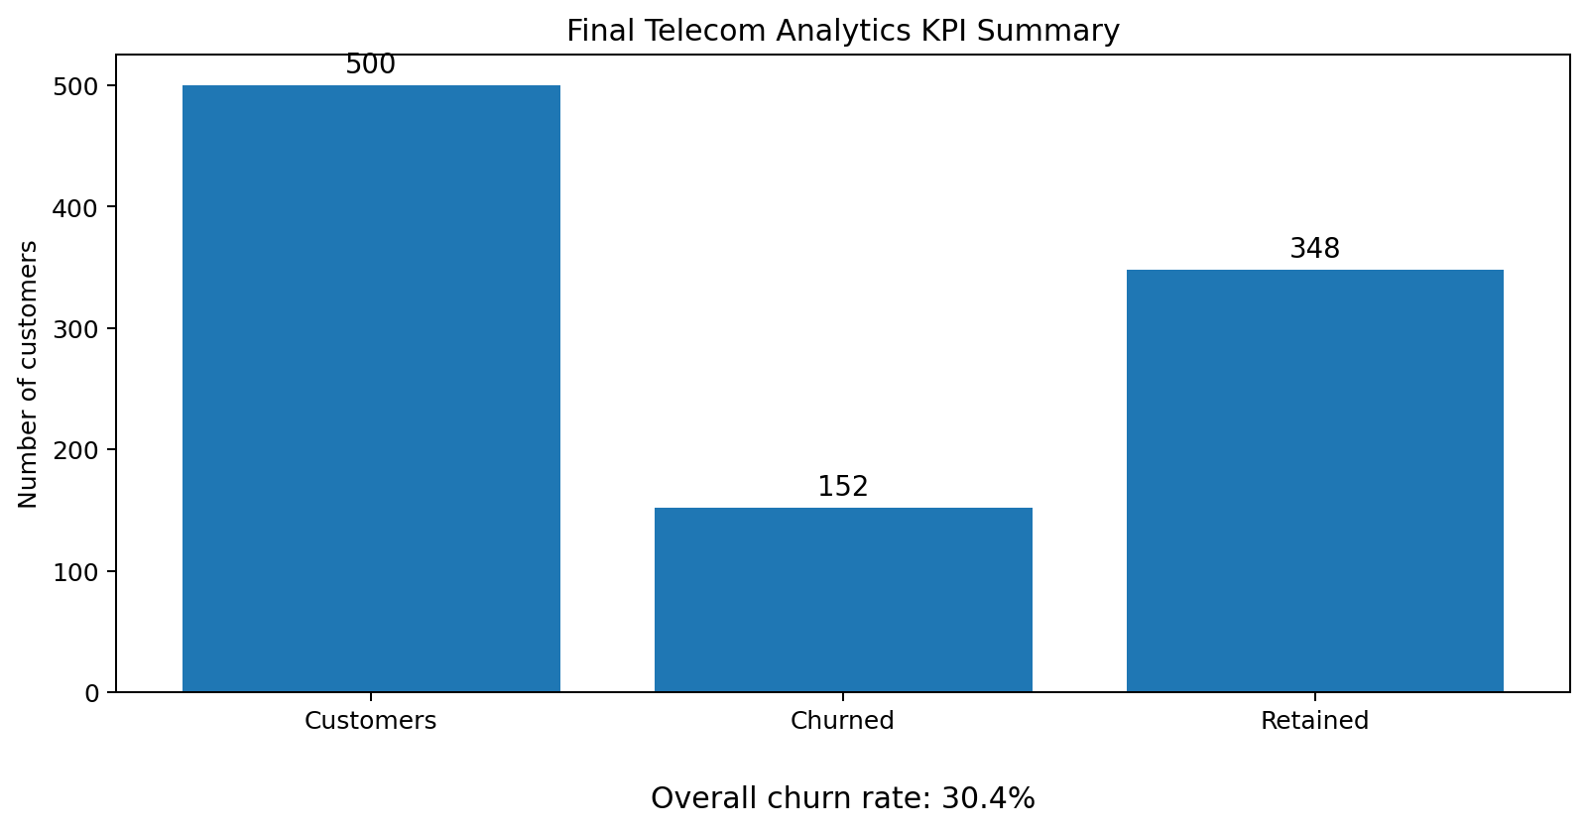
Figure 1. Final KPI summary from the cleaned synthetic telecom dataset.

2. Four-Week Project Journey
Stage | Focus | Major output
Week 1 | Strategic planning and data acquisition | Hypothesis, data sources, acquisition methods, privacy and roadmap
Week 2 | Data wrangling and visualization | Cleaning, validation, normalization, descriptive charts and interpretation
Week 3 | Predictive modeling | Feature engineering, Logistic Regression, Decision Tree, holdout evaluation and cross-validation
Week 4 | Evaluation and reporting | Integrated findings, business interpretation, recommendations, limitations and future work
The workflow was intentionally iterative: outputs from each stage were used as inputs for the next stage. This makes the final report a synthesis rather than four disconnected assignments.

3. Integrated Analysis Methodology

3.1 Data and Scope
The analysis uses a synthetic dataset created for educational and reproducibility purposes because no private telecom customer dataset was supplied for the internship task. The dataset contains demographic, service, usage, network, billing, support, satisfaction and churn fields.
Item | Final value
Records | 500 unique customers after cleaning
Target | Churn (Yes/No)
Categorical variables | Gender, Region, Plan
Usage variables | Monthly data, call minutes, SMS count
Network variables | Download speed, latency, dropped-call percentage
Commercial variables | Monthly bill, plan, tenure
Experience variables | Support calls, satisfaction score

3.2 Week 2 Data Quality Work
- Duplicate records were identified and removed so that repeated rows did not inflate customer counts.
- Column names and categorical values were standardized for consistent analysis.
- Invalid negative network measurements were treated as missing rather than accepted as real observations.
- Missing numerical values were imputed using median values and categorical gaps using the most frequent category.
- Selected numerical variables were normalized for downstream analytical use.
This cleaning approach preserves useful observations while avoiding indiscriminate deletion. It also creates a reproducible foundation for modeling.

3.3 Week 3 Predictive Modeling
- Train/test split: 80/20 with stratification and random_state=42.
- Numerical preprocessing: median imputation followed by standardization.
- Categorical preprocessing: most-frequent imputation followed by one-hot encoding.
- Models: Logistic Regression with balanced class weights and a constrained Decision Tree.
- Validation: five-fold stratified cross-validation on the training set.
- Evaluation: Accuracy, Precision, Recall, F1-score and ROC-AUC.

4. Key Descriptive Results

4.1 Overall Customer Profile
Metric | Mean | Median | Range
Age | 42.2 | 41.0 | 18–69
Tenure (months) | 35.9 | 34.0 | 1–72
Monthly data (GB) | 7.90 | 6.51 | 0.98–44.45
Download speed (Mbps) | 48.28 | 48.20 | 5–89.51
Latency (ms) | 55.86 | 55.25 | 15–104
Monthly bill (₹) | 663 | 669 | ₹296–₹1253
Satisfaction | 3.31 | 3.3 | 1–5

4.2 Plan-Level Churn
- Premium: 92 customers, 41 churned, churn rate 44.6%, average bill ₹1001, average satisfaction 3.27/5.
- Standard: 235 customers, 76 churned, churn rate 32.3%, average bill ₹693, average satisfaction 3.32/5.
- Basic: 173 customers, 35 churned, churn rate 20.2%, average bill ₹442, average satisfaction 3.33/5.
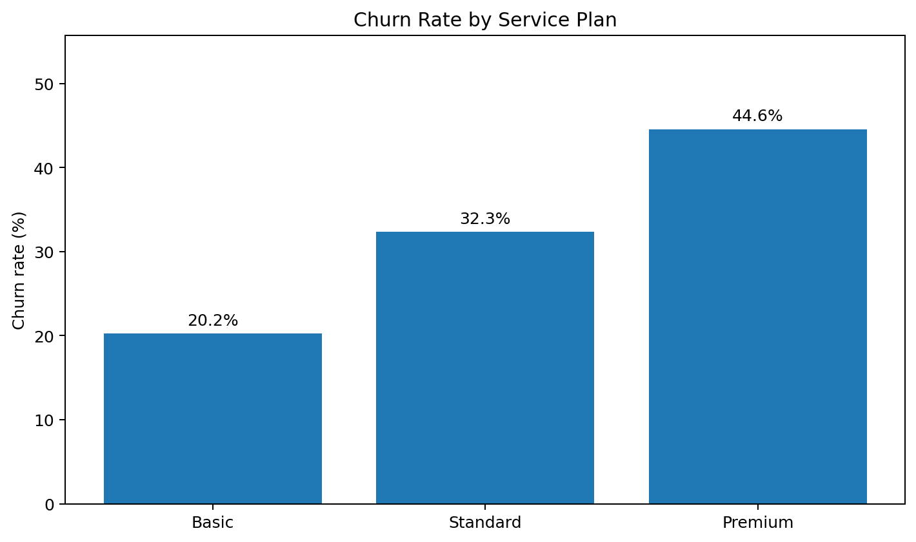
Figure 2. Churn rate differs substantially across the three synthetic service plans.
The Premium plan has the highest observed churn rate at 44.6%, compared with 32.3% for Standard and 20.2% for Basic. This pattern does not prove that plan price causes churn; it indicates where further investigation should be concentrated.

4.3 Churned vs Retained Customers
Metric | Retained | Churned
Average tenure | 37.9 months | 31.2 months
Support calls | 1.40 | 1.62
Satisfaction | 3.34 | 3.25
Download speed | 47.68 Mbps | 49.65 Mbps
Latency | 55.62 ms | 56.43 ms
Monthly bill | ₹633 | ₹732
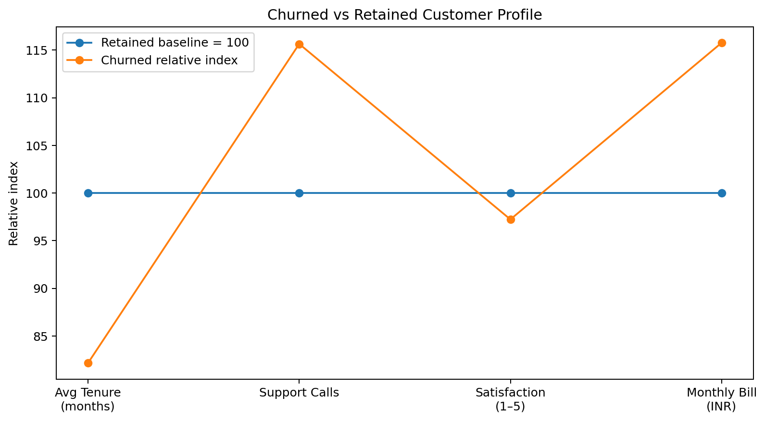
Figure 3. Relative comparison of churned and retained customer characteristics.
Churned customers in the synthetic dataset have shorter average tenure (31.2 vs 37.9 months), slightly more support calls (1.62 vs 1.40), lower satisfaction (3.25 vs 3.34), and higher average bills (₹732 vs ₹633). These are useful diagnostic signals, not causal conclusions.

4.4 Regional Service Experience
- South: 3.36/5 average satisfaction, 47.6 Mbps average speed, 54.2 ms average latency.
- East: 3.34/5 average satisfaction, 47.4 Mbps average speed, 55.3 ms average latency.
- North: 3.30/5 average satisfaction, 49.1 Mbps average speed, 57.1 ms average latency.
- West: 3.26/5 average satisfaction, 48.7 Mbps average speed, 56.9 ms average latency.
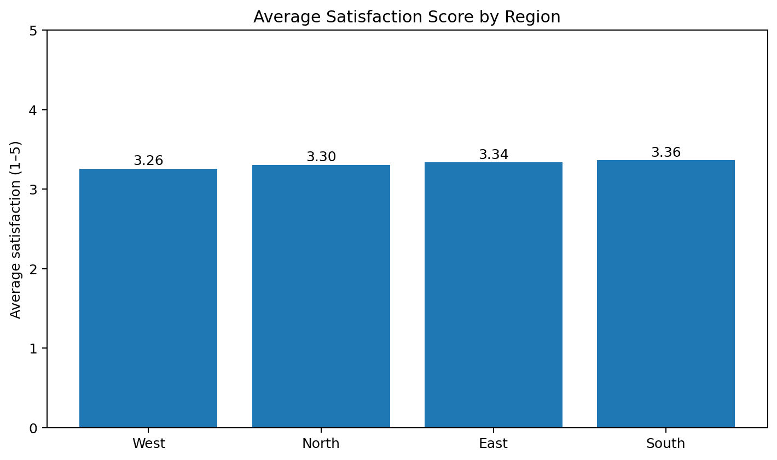
Figure 4. Regional satisfaction comparison.

5. Predictive Modeling Evaluation
Model | Accuracy | Precision | Recall | F1 | ROC-AUC
Logistic Regression | 64.0% | 41.7% | 50.0% | 45.5% | 63.9%
Decision Tree | 54.0% | 26.5% | 30.0% | 28.1% | 51.9%
Logistic Regression is selected as the preferred baseline because its recall, F1-score and ROC-AUC are consistently stronger than the Decision Tree in this experiment. For churn management, recall matters because failing to identify a customer who is likely to leave can mean a missed retention opportunity.

5.1 Cross-Validation
Model | CV Accuracy | CV Precision | CV Recall | CV F1 | CV ROC-AUC
Logistic Regression | 0.633 | 0.425 | 0.549 | 0.476 | 0.618
Decision Tree | 0.570 | 0.375 | 0.533 | 0.433 | 0.567
The cross-validation results support the same ranking as the holdout evaluation: Logistic Regression remains ahead of the Decision Tree. However, the moderate ROC-AUC values show that the model is not sufficiently strong to be deployed without further validation, richer data and calibration.

6. Feature Importance and Interpretation
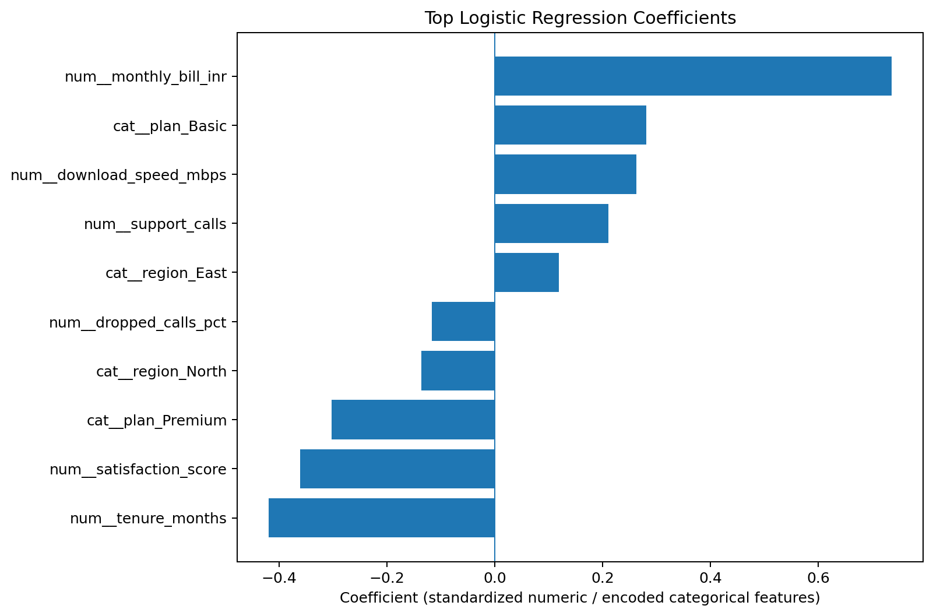
Figure 5. Top Logistic Regression coefficients used to interpret the model.
Feature importance was examined using Logistic Regression coefficients. Because numerical features were standardized and categorical variables were one-hot encoded, coefficient magnitude provides a useful directional diagnostic: positive coefficients increase the model's estimated tendency toward churn, while negative coefficients reduce it, holding other model inputs constant. The analysis should be interpreted as model association rather than causal effect.
- num__monthly_bill_inr: coefficient 0.737, indicating higher churn tendency within the fitted model.
- num__tenure_months: coefficient -0.420, indicating lower churn tendency within the fitted model.
- num__satisfaction_score: coefficient -0.361, indicating lower churn tendency within the fitted model.
- cat__plan_Premium: coefficient -0.303, indicating lower churn tendency within the fitted model.
- cat__plan_Basic: coefficient 0.281, indicating higher churn tendency within the fitted model.
- num__download_speed_mbps: coefficient 0.263, indicating higher churn tendency within the fitted model.
- num__support_calls: coefficient 0.211, indicating higher churn tendency within the fitted model.
- cat__region_North: coefficient -0.137, indicating lower churn tendency within the fitted model.

7. Actionable Telecom Business Insights
Prioritize early-tenure customers: Churned customers have lower average tenure. A real operator should strengthen onboarding during the first 6–12 months, monitor early service issues and offer proactive support before dissatisfaction becomes a cancellation decision.
Treat support activity as an early-warning signal: Churned customers show slightly higher support-call activity. Repeated contacts can be converted into an escalation trigger: unresolved or repeated issues should move to specialist support instead of repeating the same first-line workflow.
Use satisfaction with network KPIs: Customer experience should combine survey scores with operational measures such as speed, latency and dropped calls. This helps distinguish a pricing complaint from a genuine service-quality problem.
Investigate plan-level churn before changing prices: The Premium plan has the highest synthetic churn rate. Rather than immediately reducing price, the operator should test whether premium customers have higher expectations, weaker perceived value, billing friction or service gaps.
Use the model for prioritization, not automatic decisions: A churn score can rank customers for human review. Retention actions should still consider customer value, complaint history, consent, fairness and the actual reason for dissatisfaction.

8. Recommended Telecom Strategy
Priority | Recommendation | Owner
Immediate | Create a churn-risk dashboard combining churn score, tenure, satisfaction, support contacts and service-quality indicators. | Customer Care + Analytics
Immediate | Introduce an early-tenure intervention program for customers showing repeated service issues. | Customer Experience
30–60 days | Test retention offers by customer segment using controlled experiments rather than blanket discounts. | Marketing + Analytics
30–60 days | Link support tickets with network events to identify whether complaints are driven by local service problems. | Network + Care
60–90 days | Retrain and recalibrate the churn model using real historical outcomes and monthly behavioural snapshots. | Data Science
90+ days | Develop a next-best-action system that recommends the most appropriate retention action after churn risk is detected. | Data Science + CRM

9. Evaluation of Techniques

Strengths
- The workflow is reproducible and uses a consistent preprocessing pipeline.
- Data cleaning decisions are explicit and preserve observations where possible.
- Both descriptive and predictive methods are used.
- Holdout evaluation is supported by stratified five-fold cross-validation.
- Model outputs are translated into operational telecom actions rather than reported only as technical metrics.

Limitations
- The dataset is synthetic and therefore cannot establish real customer behaviour or production-level model performance.
- The sample size of 500 customers is suitable for demonstration but small for robust segmentation across many categories.
- The churn outcome is treated as a binary label without a time-to-event framework.
- The baseline model set is limited to Logistic Regression and Decision Tree.
- Feature relationships are observational and should not be interpreted as causal without controlled experiments.
- The current workflow does not include probability calibration, threshold optimization or cost-sensitive business evaluation.

10. Future Analysis Roadmap
- Replace synthetic data with anonymized historical customer records containing monthly snapshots.
- Add tenure-based cohorts and survival analysis to study time-to-churn.
- Evaluate Random Forest, Gradient Boosting and XGBoost-style approaches where permitted.
- Tune model hyperparameters with nested or repeated cross-validation.
- Optimize the probability threshold using the economic cost of false negatives and false positives.
- Calibrate predicted probabilities and monitor model drift over time.
- Use SHAP or comparable explainability methods for customer-level explanations.
- Run A/B tests to determine whether retention interventions actually reduce churn.
- Build a production dashboard with data-quality monitoring, model monitoring and intervention outcomes.

11. Industry Context and Comparison
Telecom analytics is closely connected to service quality, customer protection, subscription trends and network performance. In India, the Telecom Regulatory Authority of India (TRAI) publishes recurring telecom subscription reports and maintains a dedicated Quality of Service framework. TRAI's current publications include monthly subscription data and the Standards of Quality of Service of Access and Broadband services, reinforcing the importance of measuring customer and network outcomes together.
The synthetic project's KPIs—speed, latency, dropped calls, billing, support contacts and satisfaction—therefore reflect the types of operational dimensions that a real telecom analytics program would connect. However, the synthetic averages in this report must not be presented as Indian industry benchmarks. A production study should benchmark the same KPIs against operator-level or regulator-published data for the exact period and service category being analyzed.
Reference: TRAI Telecom Subscription Reports and Quality of Service publications. See the official TRAI sources listed in the submission notes below.

12. Reproducibility and Project Artifacts
Repository area | Contents
data/raw | Raw synthetic telecom customer usage dataset
data/processed | Cleaned/modeling dataset, evaluation results, cross-validation results
notebooks | Week 2 wrangling notebook and Week 3 churn modeling notebook
src | Python data-wrangling and churn-modeling scripts
figures | Python-generated charts used in Weeks 2–4
reports | Weekly reports and final integrated report
The GitHub repository is intended to make the internship work reproducible and auditable. The final report should be read together with the notebooks, scripts, datasets and figures.

13. Conclusion
The four-week project demonstrates a complete telecom analytics lifecycle: define the problem, identify data requirements, clean and explore the data, build predictive models, evaluate results, and convert evidence into business action. The analysis identified a 30.4% synthetic churn rate and meaningful differences in tenure, support activity, satisfaction, billing and plan-level churn. Logistic Regression provided the strongest baseline among the tested models, but its moderate predictive performance means that it should be treated as a starting point rather than a deployment-ready solution.
The most important next step is not simply to select a more complex algorithm. It is to obtain richer longitudinal customer data, define the business cost of missed and unnecessary interventions, validate the model on unseen real-world periods, and measure whether recommended retention actions actually change customer outcomes. This approach connects data science with measurable telecom business value.

Appendix A – Python Evidence
The following Python-generated code evidence illustrates the evaluation stage used to calculate the final model metrics.
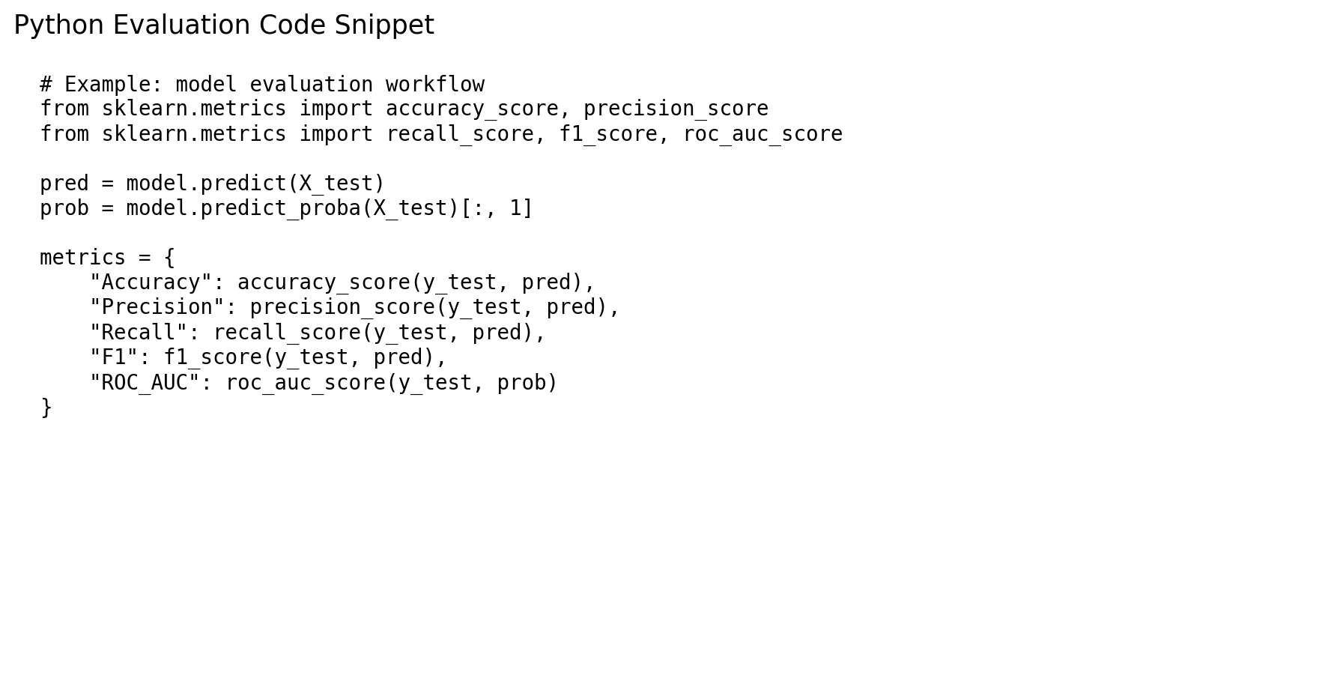
Figure 6. Example Python evaluation code used in the modeling workflow.

Appendix B – External Industry References
- Telecom Regulatory Authority of India (TRAI) – Telecom Subscription Reports: https://trai.gov.in/release-publication/reports/telecom-subscriptions-reports
- TRAI – Quality of Service: https://trai.gov.in/telecom/qos
- TRAI – Standards of Quality of Service regulations and related directions: https://trai.gov.in/release-publication/consolidated-regulations/telecom

