INTEGRATIVE CAPSTONE PROJECT
Data Science with Python
Virtual Data Science with Python Trainee Internship

End-to-End Customer Analytics and High-Value Customer Classification using the UCI Online Retail Dataset

Project Information | Details
Dataset | UCI Online Retail Dataset
Data Period | 01 Dec 2010 to 09 Dec 2011
Initial Records | 541,909
Cleaned Records | 392,692
Unique Customers | 4,338
Countries Represented | 37
Unique Invoices | 18,532
Python Stack | Pandas, NumPy, Matplotlib, Seaborn, Scikit-learn, PyTorch
Internship | Virtual Data Science with Python Trainee

Prepared as the Week 6 Integrative Capstone Project

1. Executive Summary
This capstone project integrates the complete data science workflow developed during the six-week Virtual Data Science with Python Trainee internship. The project uses the publicly available UCI Online Retail dataset to demonstrate data acquisition, data quality assessment, preprocessing, exploratory data analysis, customer segmentation, supervised classification, and deep learning.
The original dataset contains 541,909 transaction records. After removing exact duplicates, cancellation invoices, invalid quantities and prices, and records without required customer or product information, 392,692 usable transaction records remained. The cleaned dataset contains 4,338 unique customers and 37 countries, with total transaction value of approximately £8,887,208.89.
Customer-level behavioural features were engineered from the cleaned transactions. These features were used for K-Means clustering and for a supervised classification problem that identifies high-value customers. A logistic regression model and a feed-forward neural network were implemented and evaluated using accuracy, precision, recall, F1-score, ROC-AUC, confusion matrices, and ROC curves.
The supervised model achieved 92.63% accuracy, 84.54% F1-score, and 0.9827 ROC-AUC. The PyTorch neural network achieved 92.63% accuracy, 84.31% F1-score, and 0.9744 ROC-AUC. The results show how a structured retail dataset can support descriptive, segmentation, predictive, and deep-learning analyses within one reproducible Python workflow.

2. Problem Statement
Retail transaction data contains valuable information about customer behaviour, product demand, purchasing frequency, and revenue generation. However, raw transaction data is often incomplete, duplicated, inconsistent, and difficult to use directly for analytics or machine learning.
The capstone problem is therefore to build an end-to-end data science pipeline that converts raw online retail transactions into reliable analytical data, discovers meaningful customer segments, and develops predictive models that classify customers according to their spending value. The project also investigates whether a small feed-forward neural network can provide comparable predictive performance on the same structured features.

3. Objectives
- Acquire and understand a reliable public retail dataset.
- Inspect missing values, duplicates, invalid transactions, and outliers.
- Clean and preprocess the transaction data using Python.
- Perform exploratory data analysis and communicate major patterns through visualizations.
- Engineer customer-level behavioural features for machine learning.
- Apply K-Means clustering and characterize the resulting customer groups.
- Build a supervised classification model for identifying high-value customers.
- Implement a neural network using PyTorch and compare its results with the classical model.
- Evaluate models using multiple metrics and visual diagnostics.
- Translate analytical findings into practical business recommendations and identify limitations and future improvements.

4. Data Collection and Dataset Description
The project uses the UCI Online Retail dataset, a publicly available transactional dataset containing retail purchases recorded between December 2010 and December 2011. The dataset was downloaded from a reliable public repository and loaded into Python using Pandas.
Variable | Description
InvoiceNo | Unique invoice number; cancellation invoices are identified by a leading C.
StockCode | Product/item code.
Description | Product description.
Quantity | Number of units purchased.
InvoiceDate | Date and time of the transaction.
UnitPrice | Price per unit.
CustomerID | Customer identifier.
Country | Customer country.
After preprocessing, the analytical dataset contained 392,692 transaction lines, 18,532 unique invoices, 4,338 unique customers and 37 countries. The cleaned transaction value totalled approximately £8,887,208.89, with an average line-level transaction value of £22.63.

5. Methodological Approach
The capstone follows a sequential but reusable data science pipeline. Each weekly task contributes one stage to the final workflow.
Stage | Main Techniques | Output
1. Acquisition | Pandas, public UCI dataset | Raw Online Retail.xlsx
2. Cleaning | Duplicate removal, filtering, missing-value handling, date parsing | Clean transaction dataset
3. EDA | Descriptive statistics, aggregation, Matplotlib/Seaborn | Business and data-quality insights
4. Feature Engineering | Customer-level aggregation | Customer behavioural dataset
5. Unsupervised Learning | Log transform, StandardScaler, K-Means, silhouette analysis | Customer clusters
6. Supervised Learning | Logistic Regression, stratified split, 5-fold CV | High-value classifier
7. Deep Learning | PyTorch, dense layers, ReLU, dropout, Adam | Neural-network classifier
8. Evaluation | Accuracy, precision, recall, F1, ROC-AUC, visual diagnostics | Model comparison and recommendations

6. Data Cleaning and Preprocessing
The raw dataset was first profiled to understand its size, data types, missingness, duplicates, and invalid transaction patterns. The initial dataset contained 541,909 records, 5,268 exact duplicate rows, 136,534 missing cells, 135,080 missing CustomerID values, 10,624 non-positive quantities, 2,517 non-positive unit prices, and 9,288 cancellation invoices.
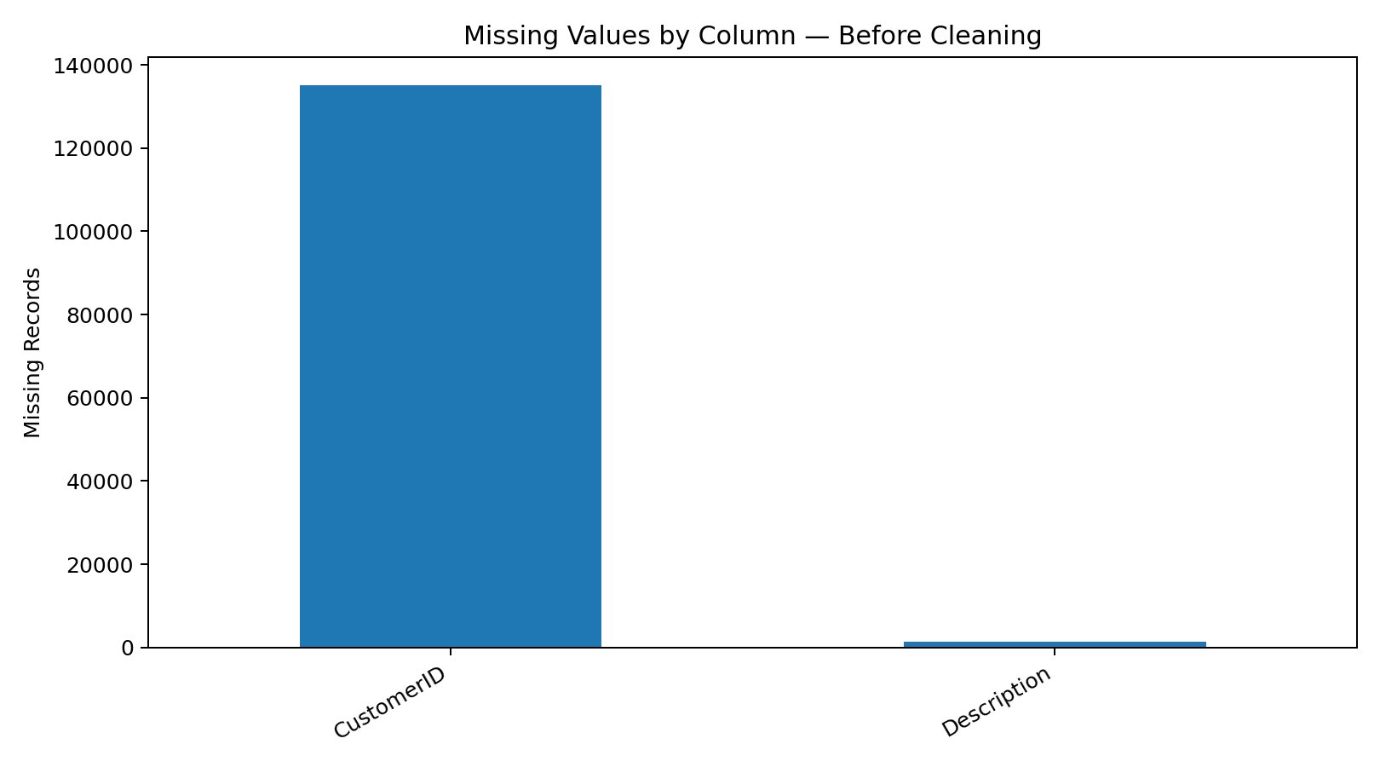
Figure 1. Missing-value profile before cleaning.
The following rules were applied:
- Remove exact duplicate records.
- Remove cancellation invoices identified by InvoiceNo beginning with 'C'.
- Remove rows where Quantity <= 0 or UnitPrice <= 0.
- Remove records missing CustomerID or Description because customer-level analysis requires these fields.
- Parse InvoiceDate as a datetime value and remove invalid dates.
- Standardize CustomerID as an integer-based string.
- Create TotalAmount = Quantity × UnitPrice.
After cleaning, 392,692 records remained. An IQR-based outlier analysis was also performed on TotalAmount. The analysis flagged 31,231 potential outliers. These were retained rather than automatically deleted because large legitimate purchases can represent genuine high-value transactions. This decision reduces the risk of removing meaningful business observations.
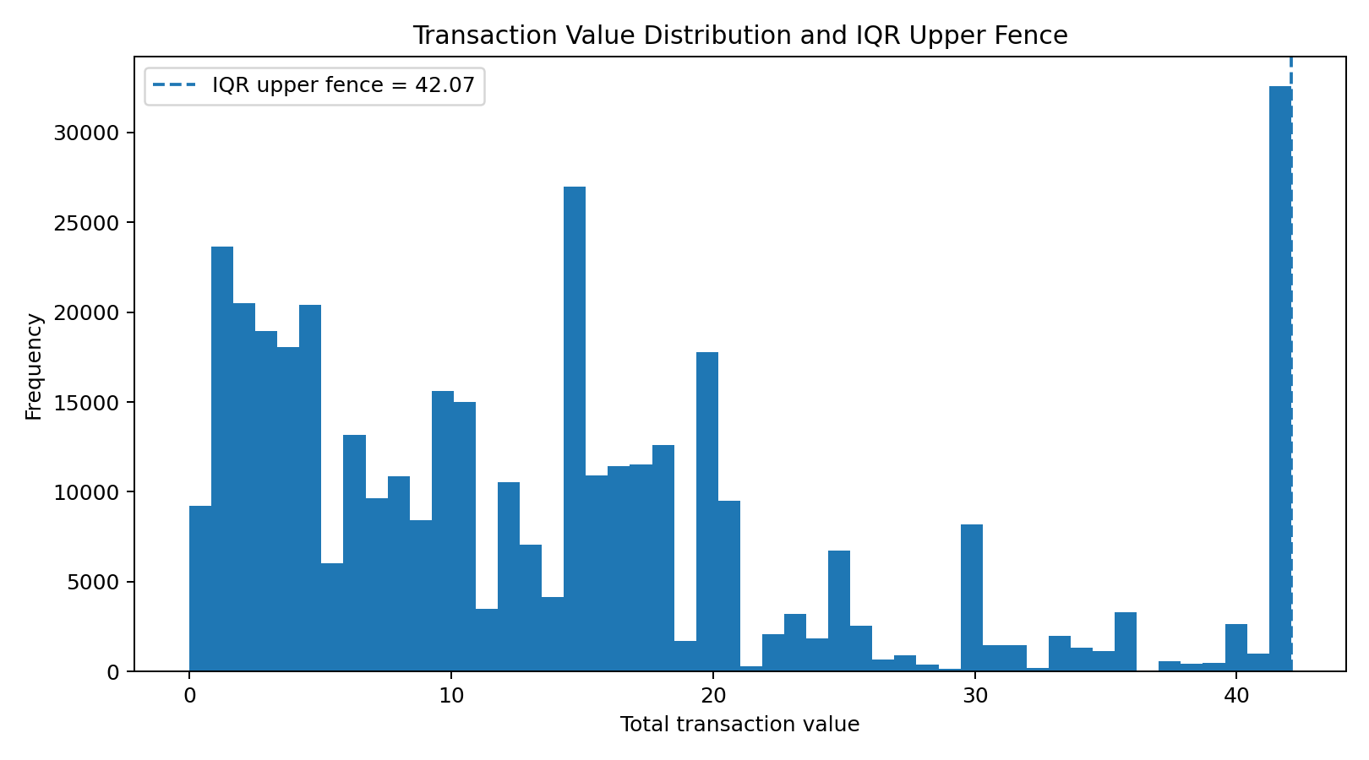
Figure 2. Transaction-value distribution and IQR-based outlier analysis.
Core preprocessing code:
df = df.drop_duplicates()
df = df[~df["InvoiceNo"].astype(str).str.startswith("C")]
df = df[(df["Quantity"] > 0) & (df["UnitPrice"] > 0)]
df = df.dropna(subset=["CustomerID", "Description"])
df["InvoiceDate"] = pd.to_datetime(df["InvoiceDate"], errors="coerce")
df = df.dropna(subset=["InvoiceDate"])
df["CustomerID"] = df["CustomerID"].astype(int).astype(str)
df["TotalAmount"] = df["Quantity"] * df["UnitPrice"]

7. Exploratory Data Analysis
EDA was performed on the cleaned dataset to understand revenue trends, product demand, geographic distribution, transaction-value distributions, correlations, and customer spending. Aggregations were created at monthly, country, product, and customer levels.

7.1 Monthly Sales Trend
Monthly aggregation of TotalAmount showed changing sales intensity across the year. The highest monthly revenue in the cleaned dataset occurred in November 2011, followed by October and September 2011. These patterns can help retailers investigate seasonal demand, promotions, and operational capacity.
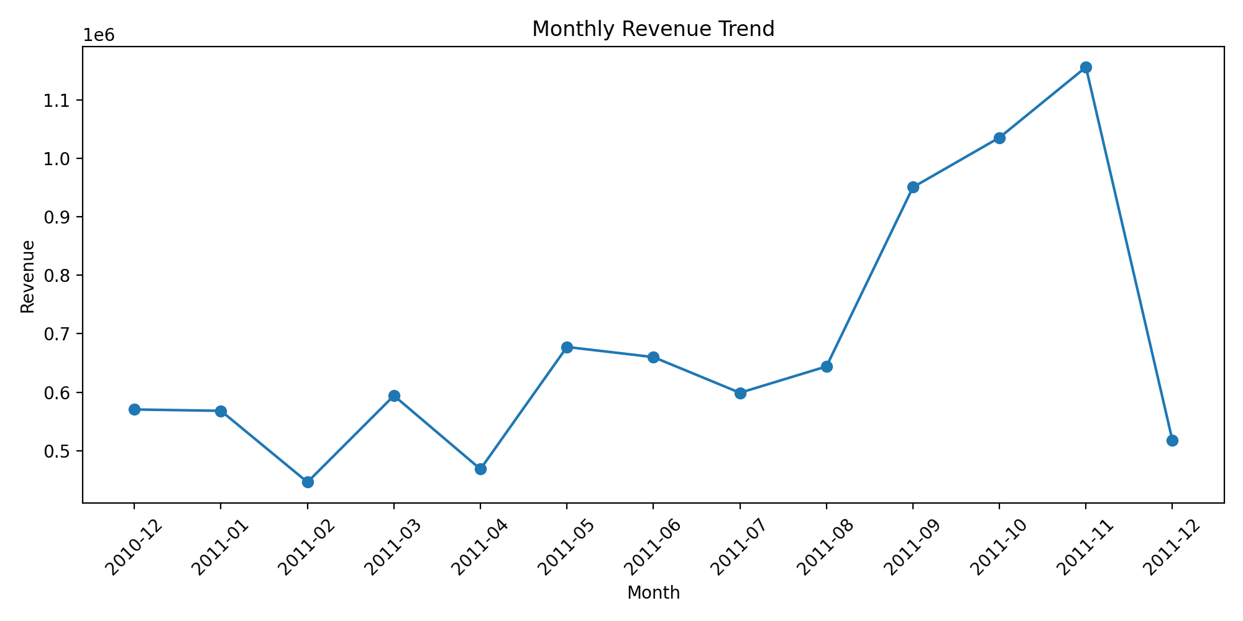
Figure 3. Monthly revenue trend.

7.2 Product and Geographic Analysis
Product-level aggregation identified high-volume and high-value items, while country-level aggregation showed a strong concentration of transaction value in the United Kingdom. The cleaned data contained customers from 37 countries.
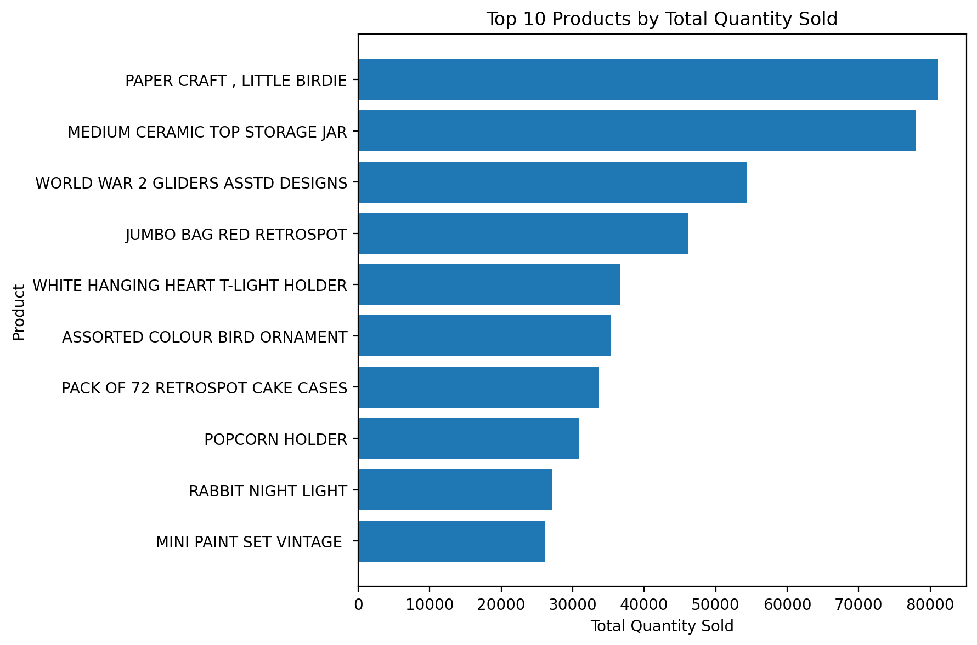
Figure 4. Top products by transaction activity/value.
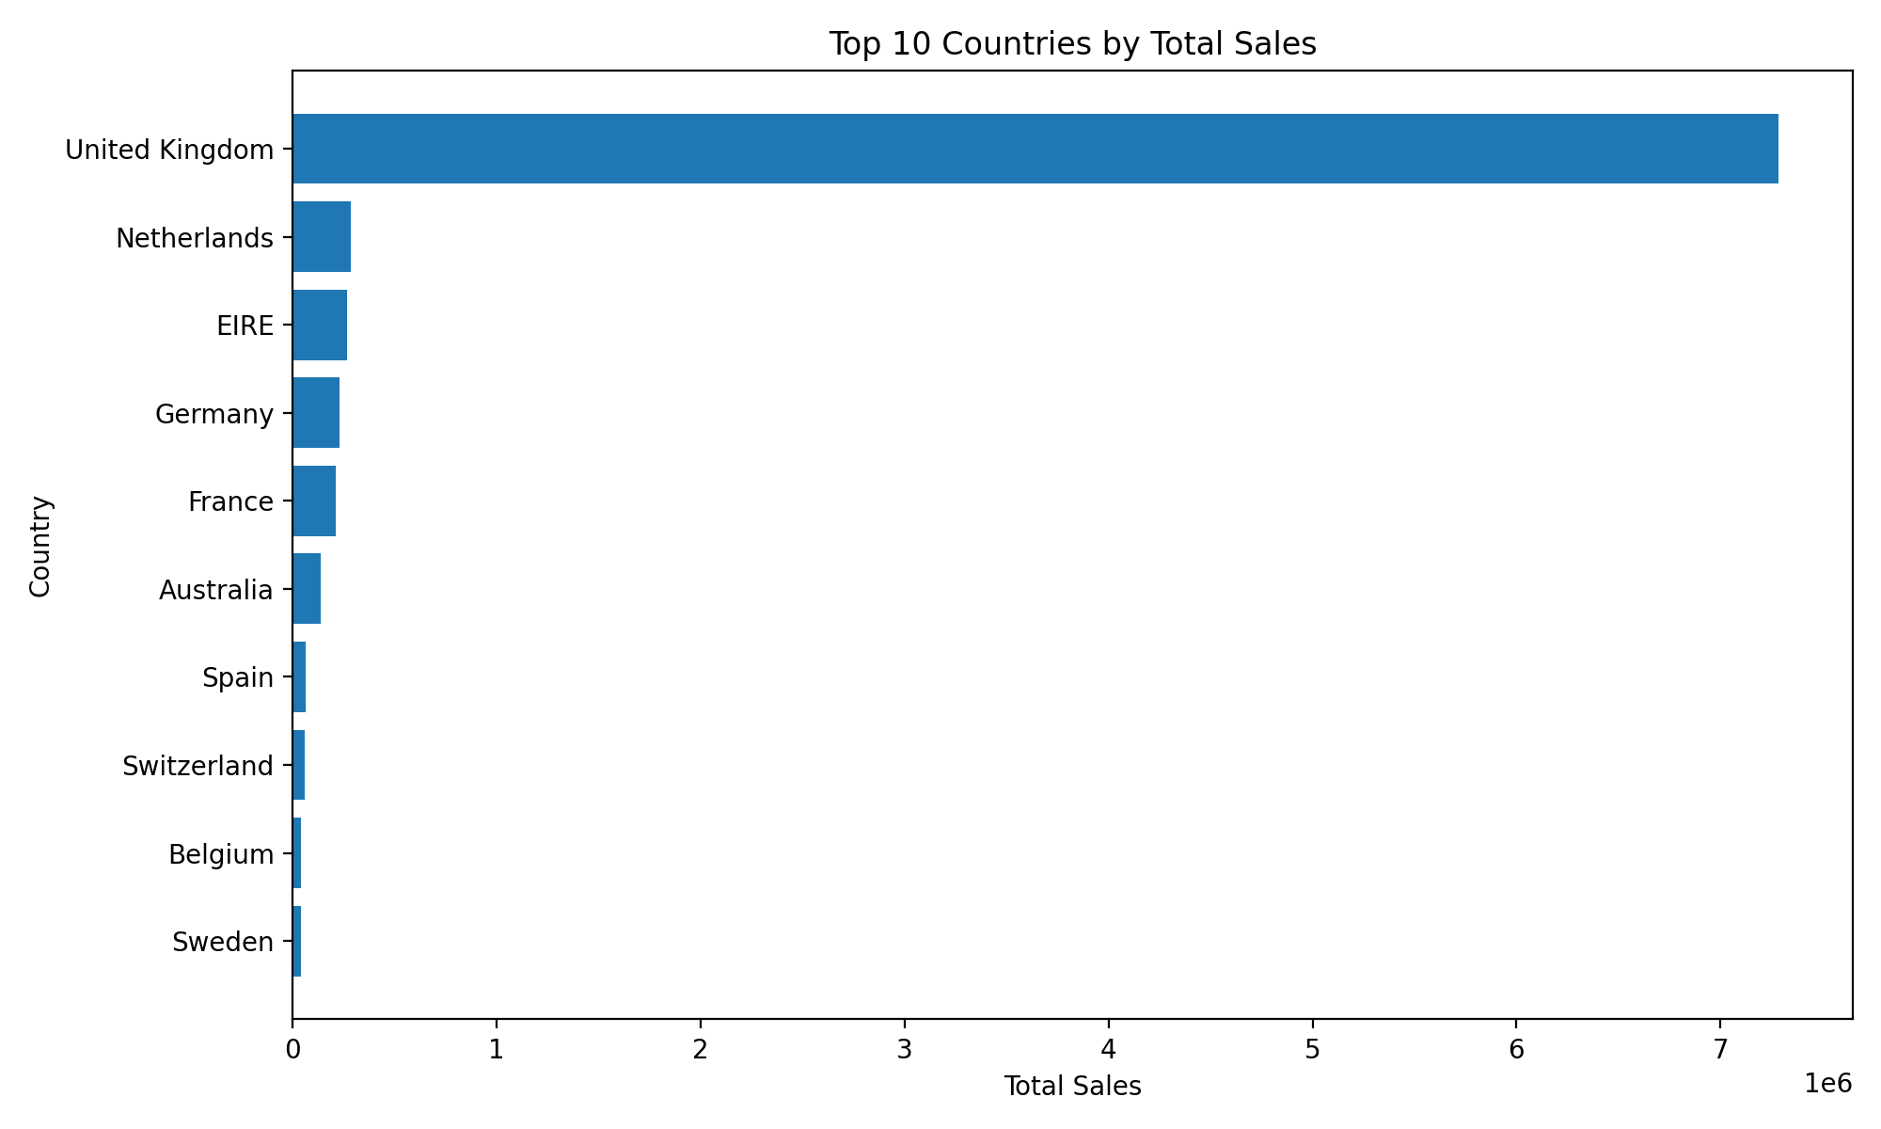
Figure 5. Sales distribution by country.

7.3 Distributions and Correlations
Quantity and unit-price distributions were examined to identify skewness and extreme observations. A correlation heatmap was used to understand relationships among numerical transaction variables. Customer spending was also aggregated to identify the concentration of value across the customer base.
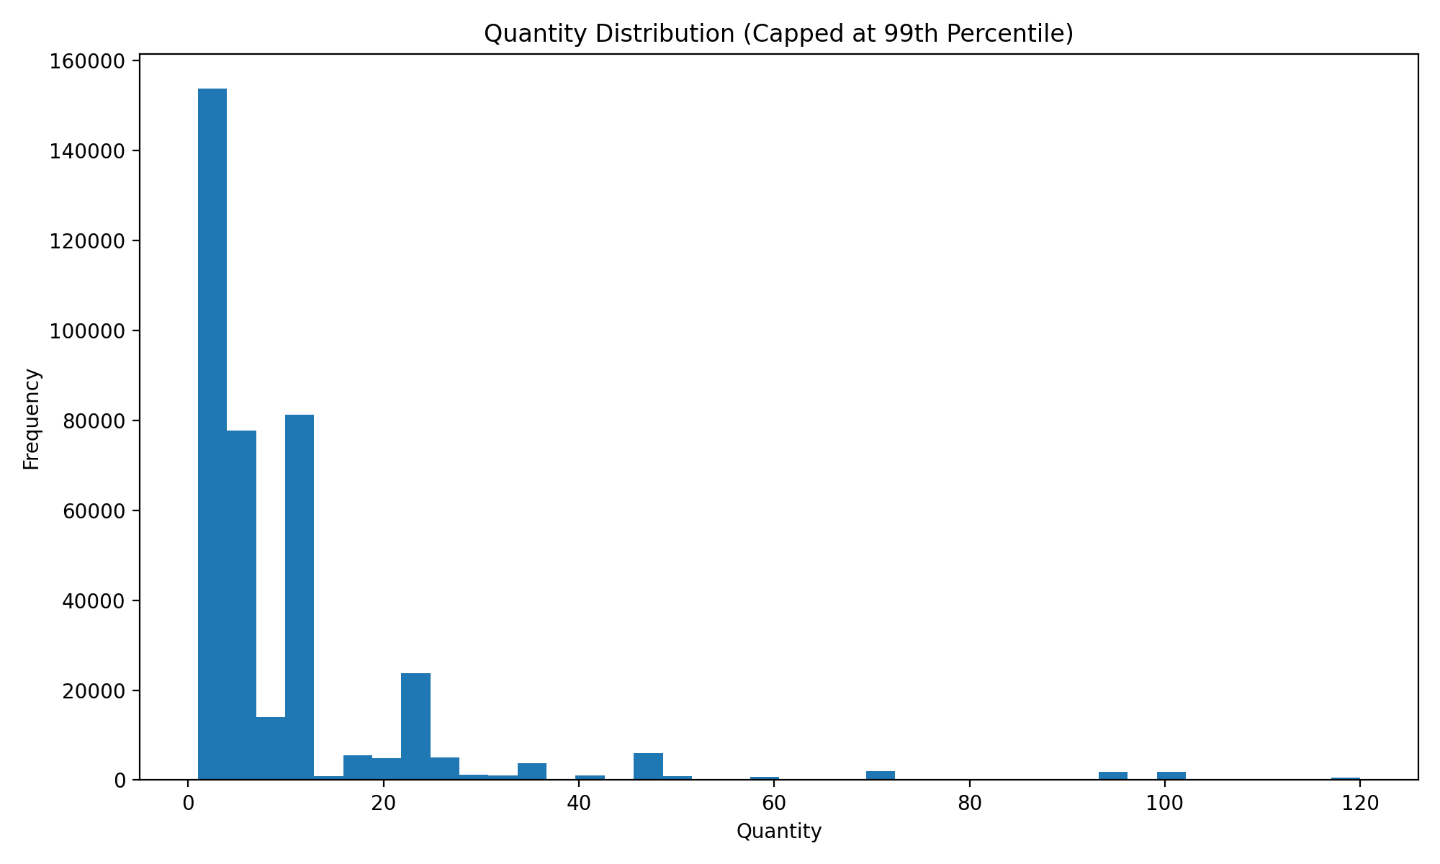
Figure 6. Quantity distribution.
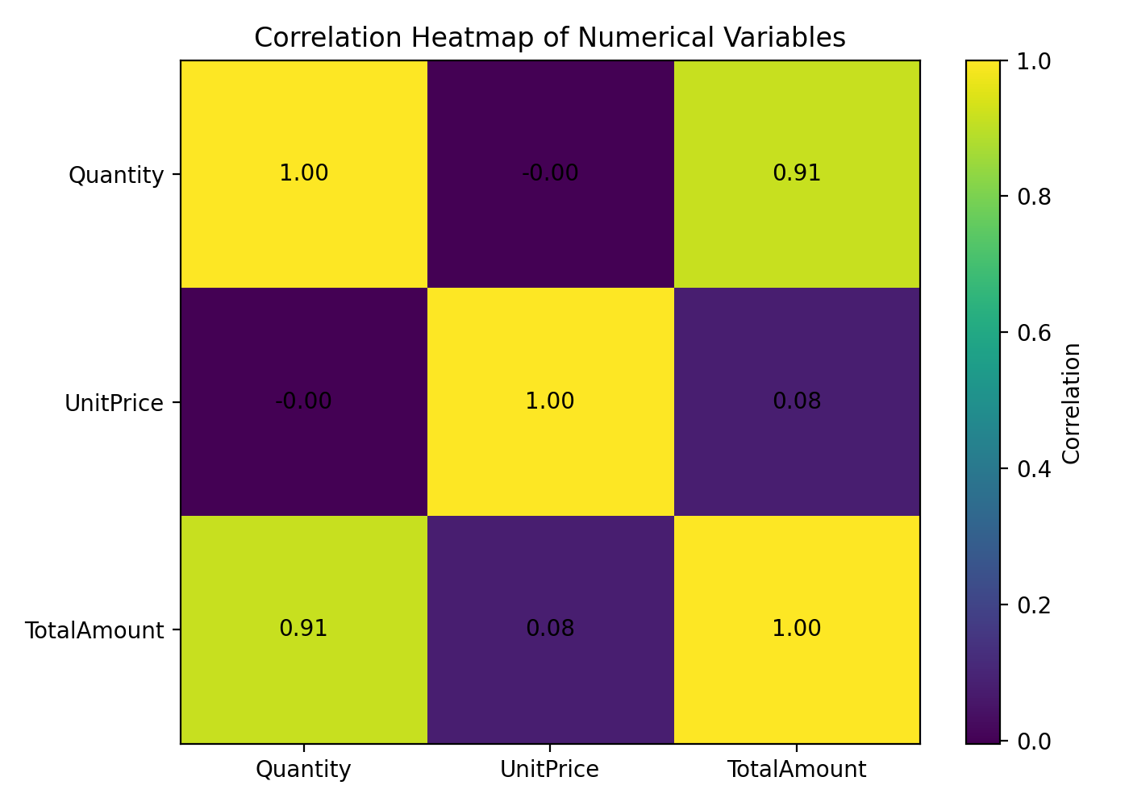
Figure 7. Correlation heatmap.
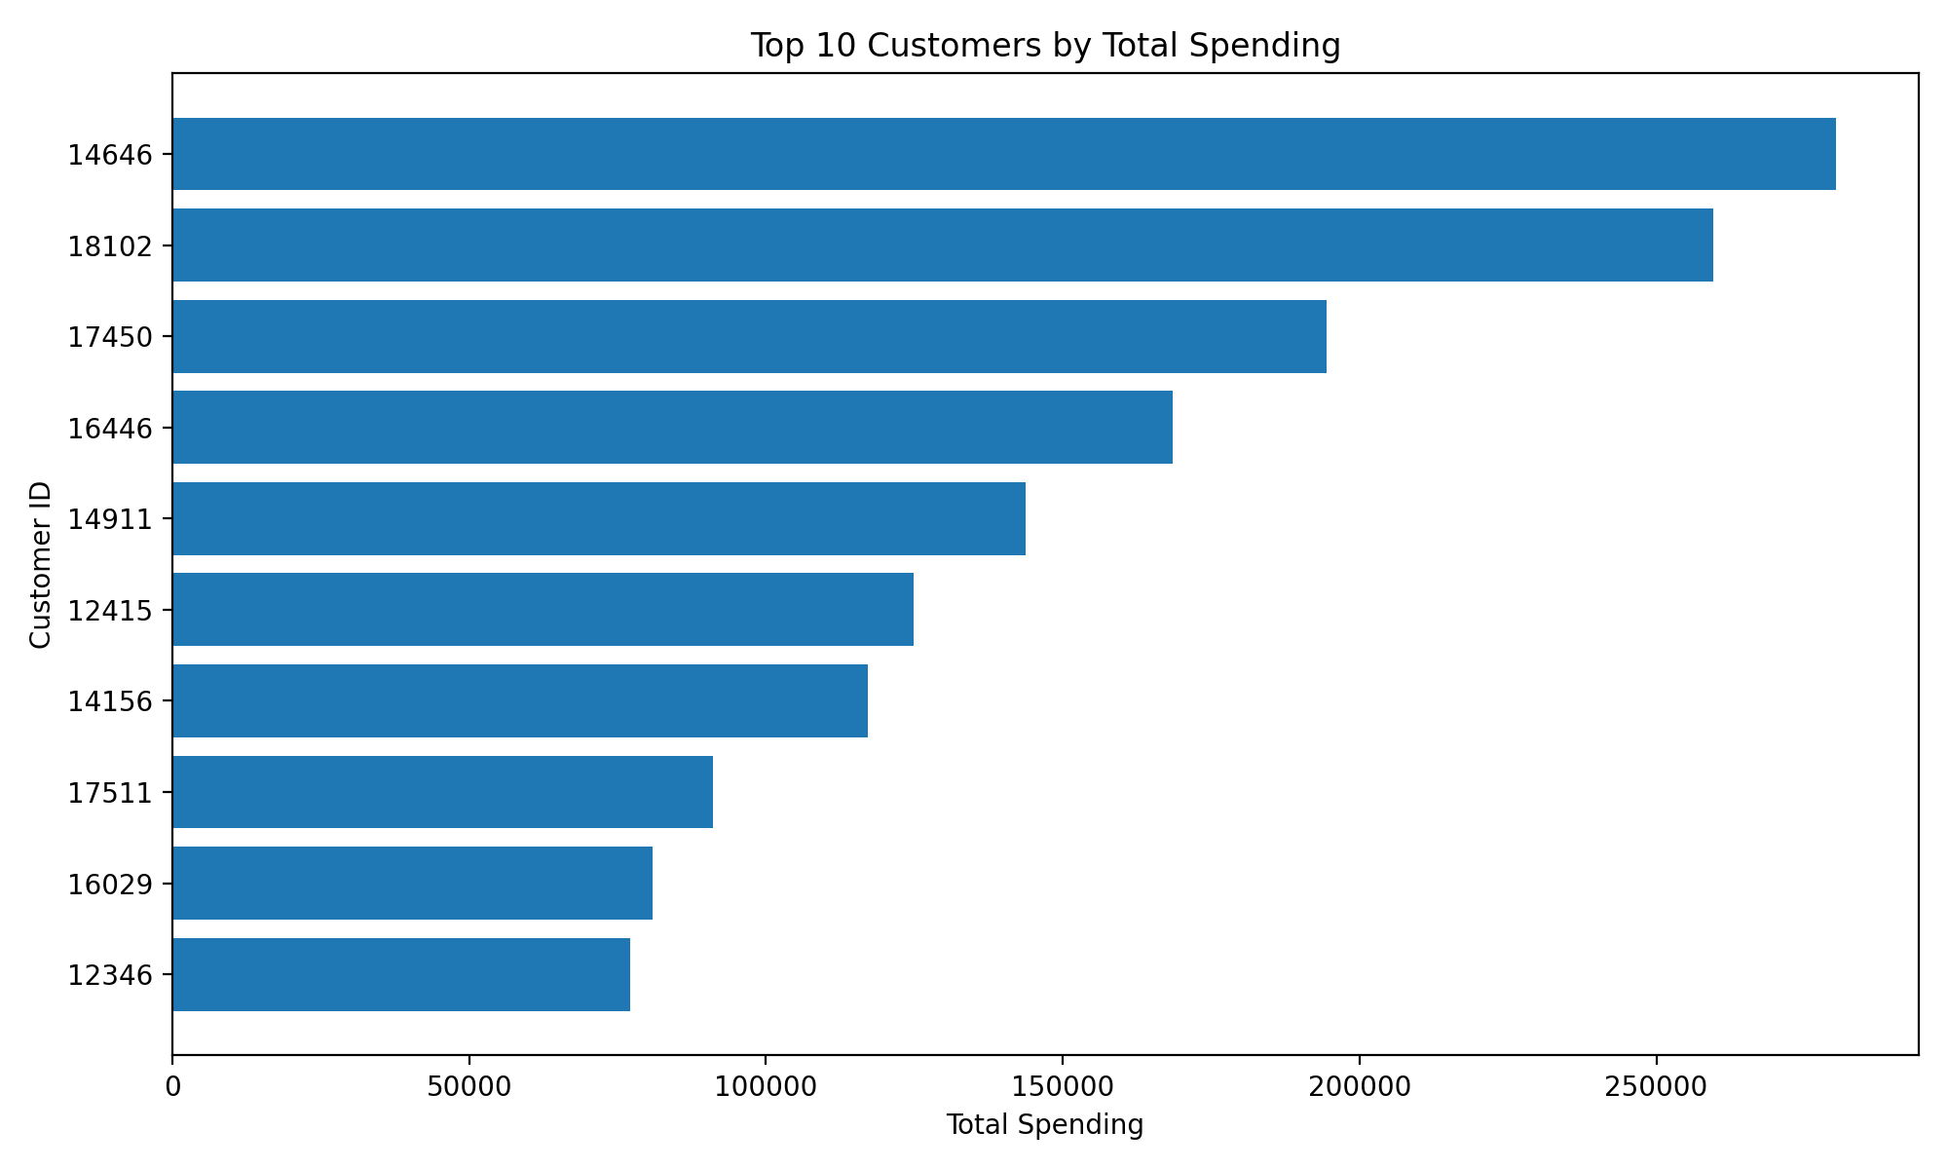
Figure 8. Customer spending distribution.
The EDA stage demonstrated that retail transaction data is highly heterogeneous. A relatively small group of customers contributes substantially more value than the typical customer, motivating customer segmentation and high-value classification.

8. Customer-Level Feature Engineering
For machine learning, transaction-level observations were transformed into customer-level behavioural features. The following five features were calculated for each customer:
Feature | Definition | Purpose
TotalSpending | Sum of TotalAmount | Overall customer monetary value.
NumberOfOrders | Number of unique invoices | Purchase frequency.
AverageOrderValue | Mean transaction value | Typical order value.
TotalQuantity | Sum of purchased units | Purchase volume.
NumberOfProducts | Number of unique descriptions | Product variety.
For clustering, the five behavioural variables were log-transformed where appropriate and standardized using StandardScaler. For supervised learning, TotalSpending was used only to derive the target and was excluded from the model inputs to reduce direct target leakage.

9. Unsupervised Learning: Customer Clustering
K-Means clustering was applied to the customer-level behavioural features. Candidate values of k from 2 to 8 were evaluated using the elbow method and silhouette score. The selected solution used k=2, with a best silhouette score of 0.3876.
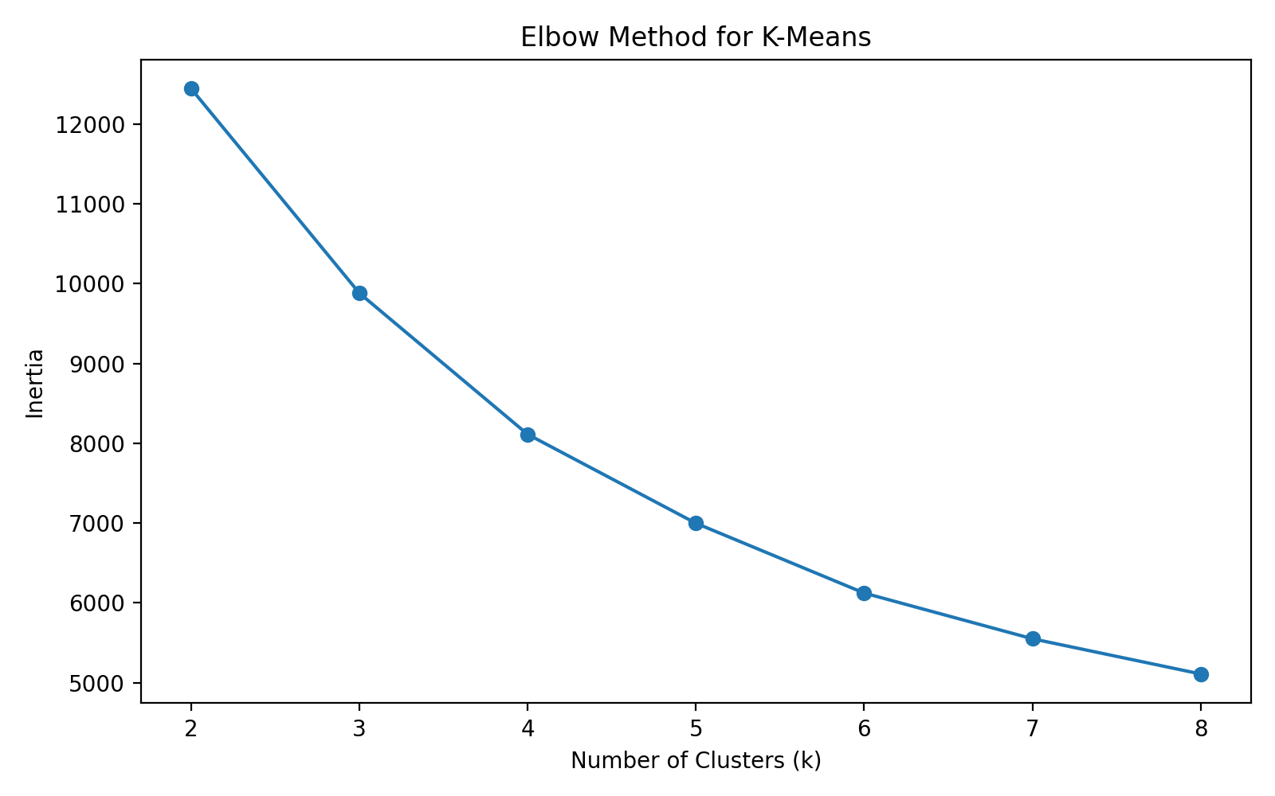
Figure 9. Elbow method for selecting the number of clusters.
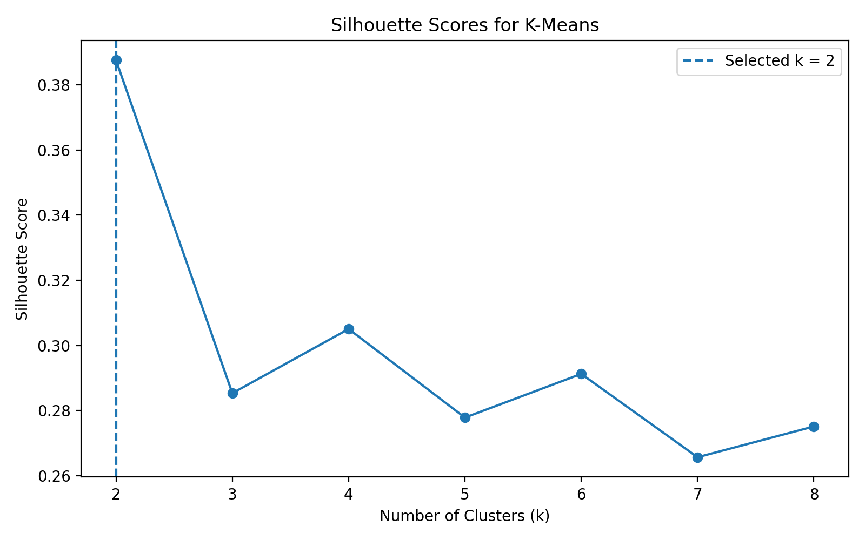
Figure 10. Silhouette scores across candidate cluster counts.
The two clusters can be interpreted as a lower-activity customer segment and a higher-activity/high-value segment. Cluster 0 contained 2,572 customers, while Cluster 1 contained 1,766 customers.
Measure | Cluster 0 | Cluster 1
Customers | 2,572 | 1,766
Mean Total Spending | £422.69 | £4,416.79
Mean Number of Orders | 1.64 | 8.10
Mean Average Order Value | £33.29 | £119.48
Mean Total Quantity | 244.37 | 2,561.43
Mean Number of Products | 25.41 | 114.91
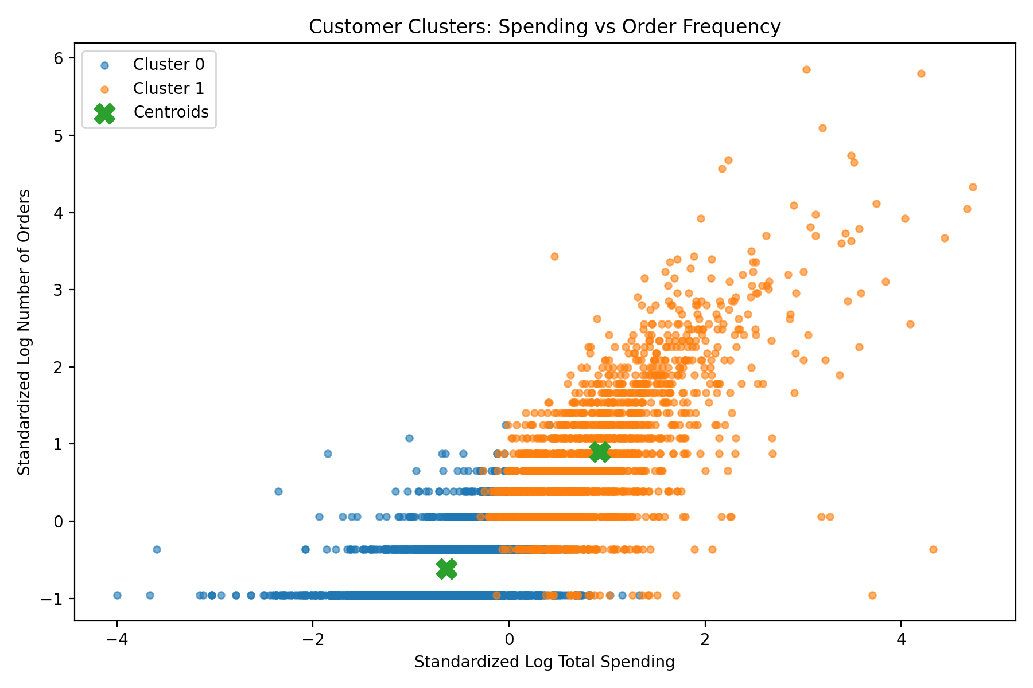
Figure 11. Customer clusters in reduced feature space.
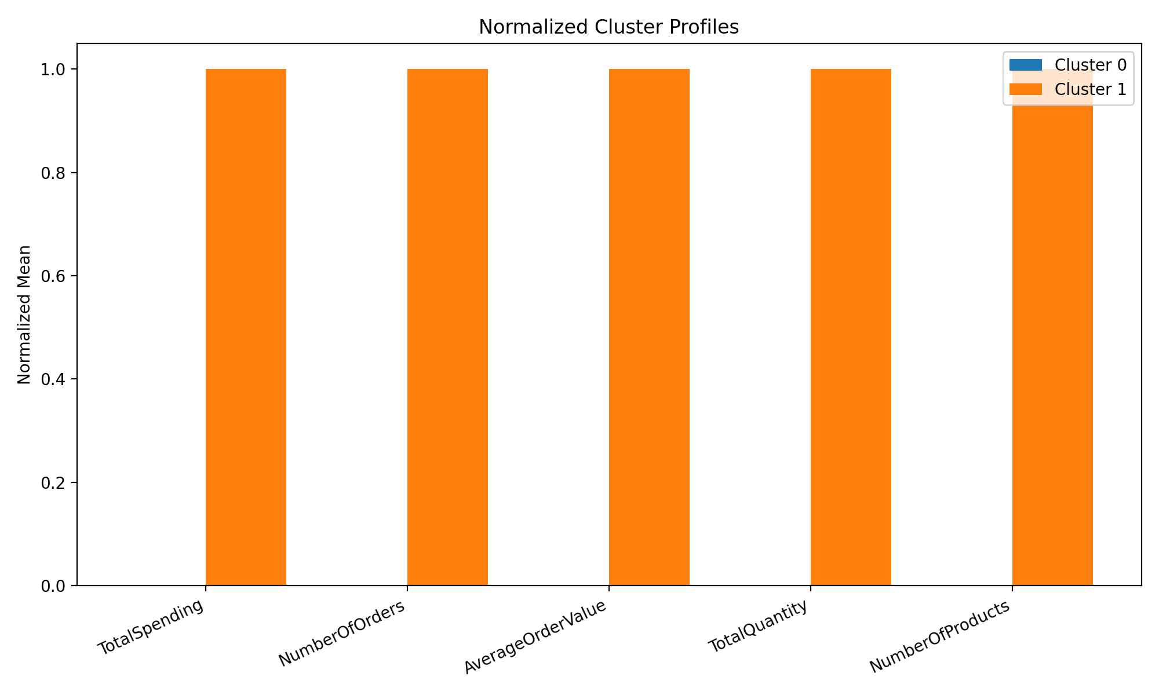
Figure 12. Cluster profile comparison.
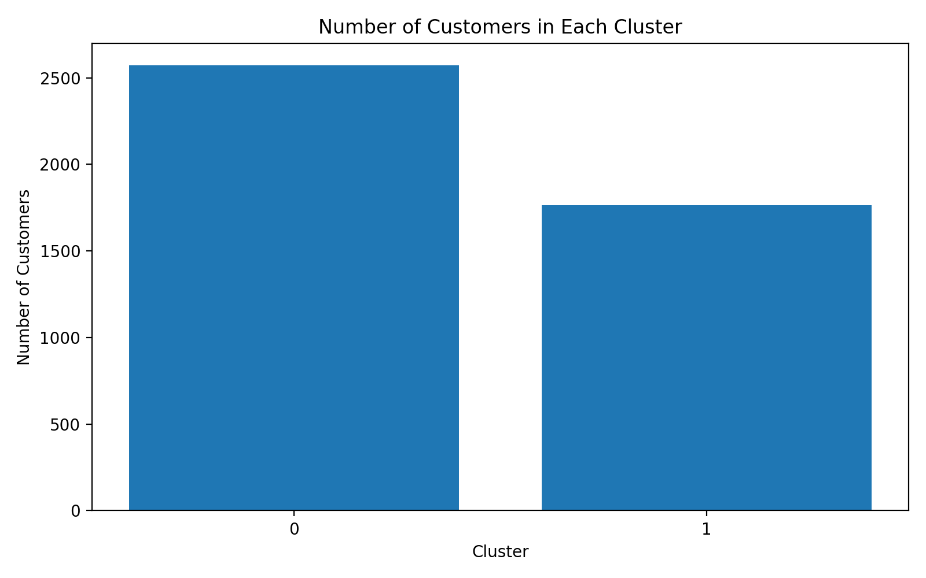
Figure 13. Distribution of customers across clusters.
The clustering results indicate that customer value is associated with multiple behavioural dimensions rather than a single variable. The higher-activity cluster has markedly larger average spending, order frequency, purchase quantity, and product variety. This segmentation can support differentiated retention, loyalty, and campaign strategies.

10. Supervised Learning: High-Value Customer Classification
A binary classification problem was defined to identify high-value customers. The target variable HighValue was set to 1 when a customer's TotalSpending was at or above the 75th percentile and 0 otherwise. The threshold was £1,660.60. Four behavioural features were used as predictors: NumberOfOrders, AverageOrderValue, TotalQuantity, and NumberOfProducts.
A Logistic Regression model was implemented inside a Scikit-learn Pipeline with StandardScaler. The dataset was split into training and test sets using an 80/20 stratified split. Five-fold StratifiedKFold cross-validation was also used to assess the stability of the F1-score.
customer["HighValue"] = (
customer["TotalSpending"] >= customer["TotalSpending"].quantile(0.75)
).astype(int)
features = [
"NumberOfOrders", "AverageOrderValue",
"TotalQuantity", "NumberOfProducts"
]
model = Pipeline([
("scaler", StandardScaler()),
("classifier", LogisticRegression(max_iter=1000, random_state=42))
])
Metric | Logistic Regression
Accuracy | 92.63%
Precision | 88.83%
Recall | 80.65%
F1-score | 84.54%
ROC-AUC | 0.9827
5-fold Mean F1 | 85.96%
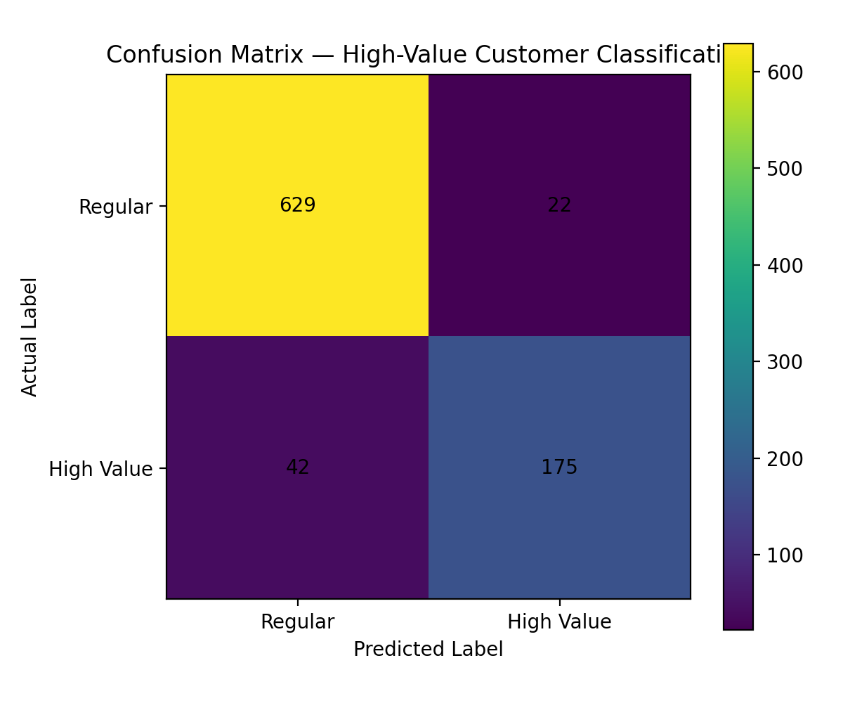
Figure 14. Confusion matrix for the supervised classifier.
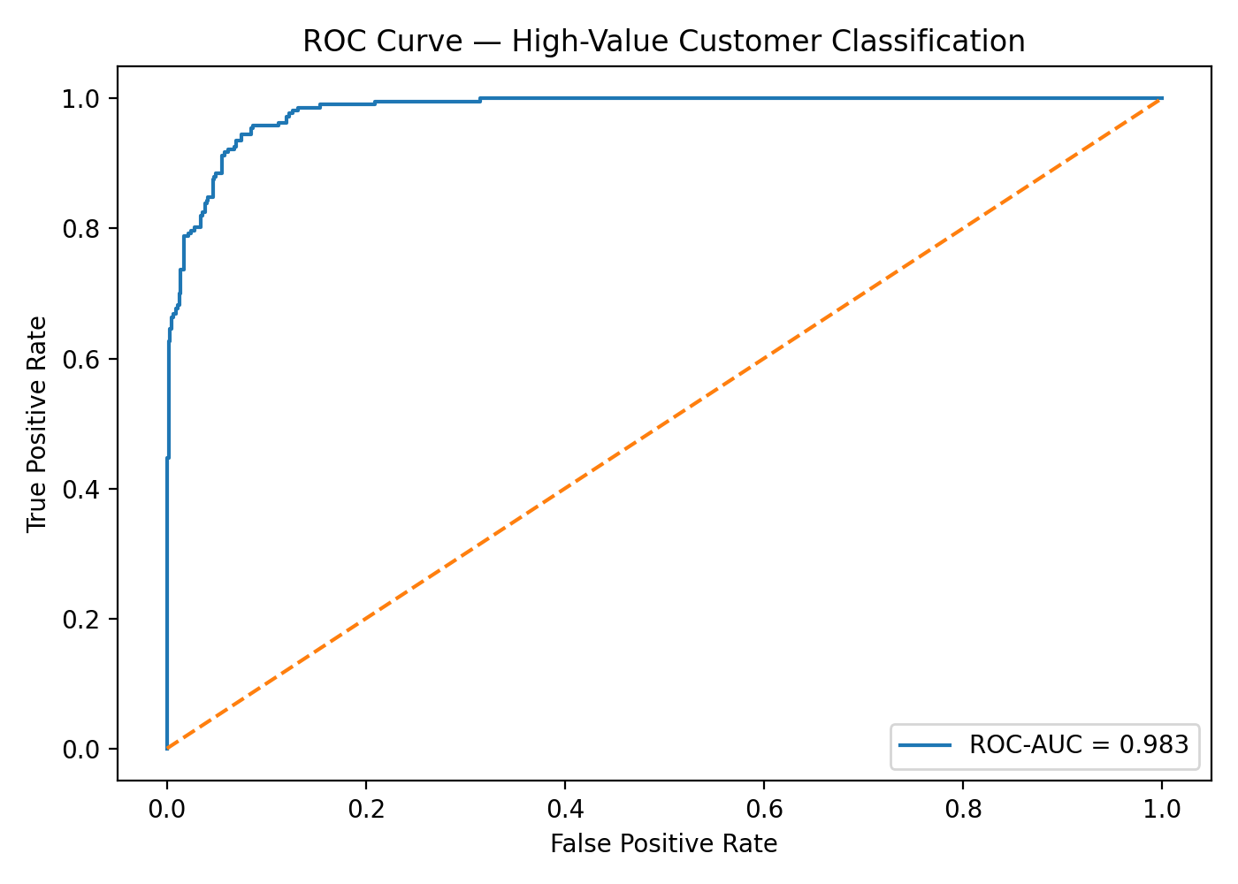
Figure 15. ROC curve for the supervised classifier.
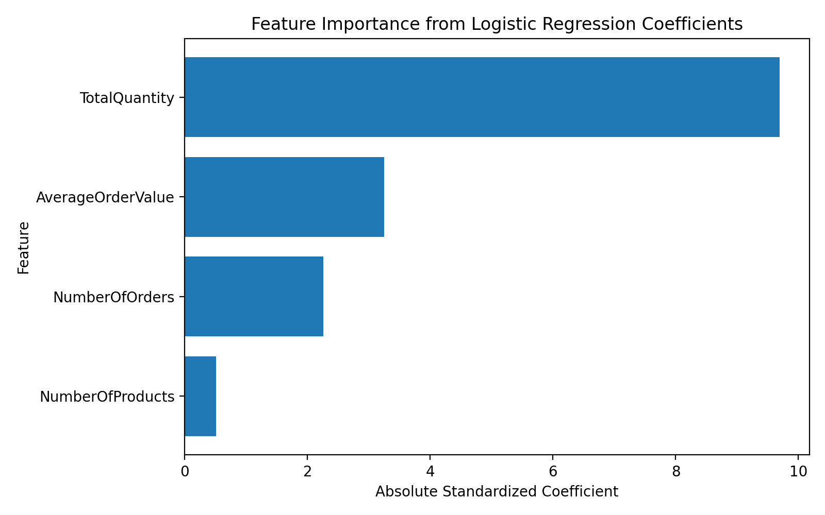
Figure 16. Relative feature importance/coefficients.
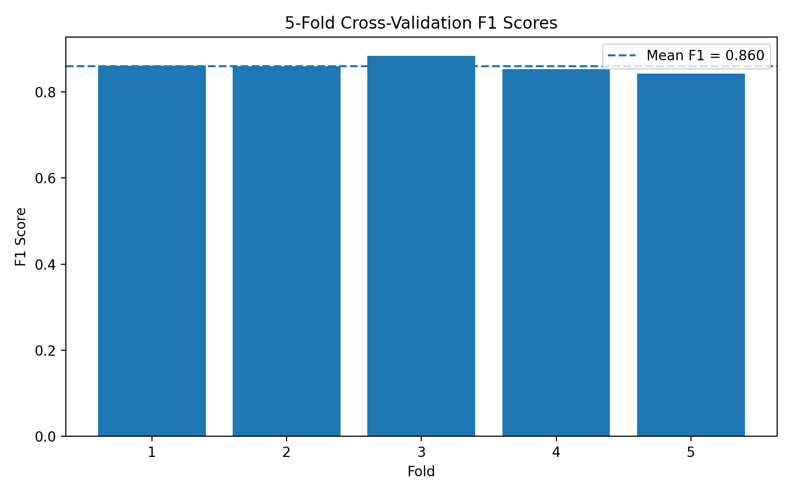
Figure 17. Five-fold cross-validation F1-scores.
The model produced strong discrimination, with ROC-AUC of 0.9827. Precision of 88.83% indicates that most customers predicted as high-value were actually in the high-value class, while recall of 80.65% indicates that some high-value customers were not identified. The mean cross-validation F1-score of 85.96% provides additional evidence that performance was reasonably stable across folds.

11. Deep Learning Application
A feed-forward neural network was implemented using PyTorch to solve the same high-value customer classification problem. The network contains four input features, a 32-neuron dense layer with ReLU activation, 20% dropout, a 16-neuron dense layer with ReLU activation, another 20% dropout layer, and a single output neuron.
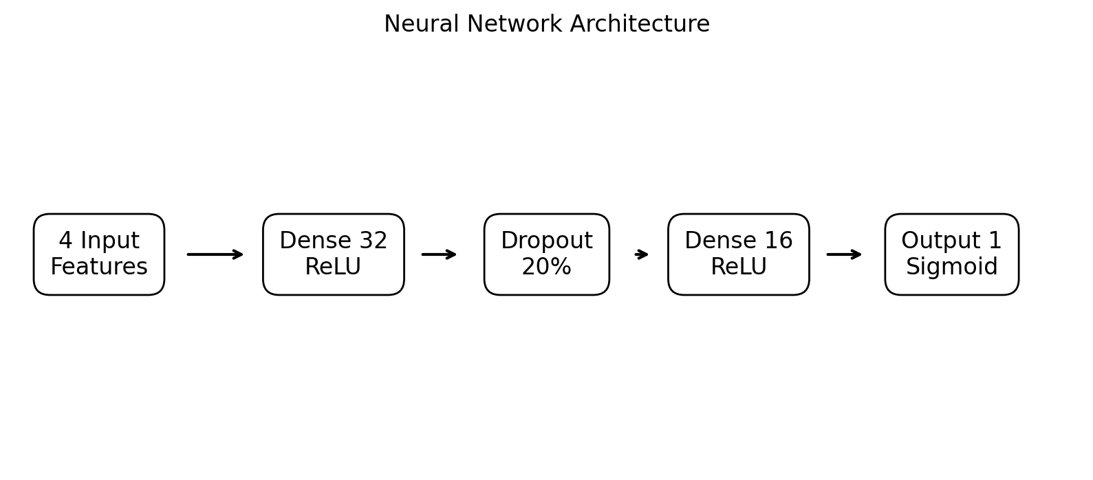
Figure 18. Neural network architecture.
The features were standardized before training. The model used BCEWithLogitsLoss and the Adam optimizer with learning rate 0.001 and weight decay 1e-4. Training was configured for up to 200 epochs. Dropout and weight decay were used as regularization techniques.
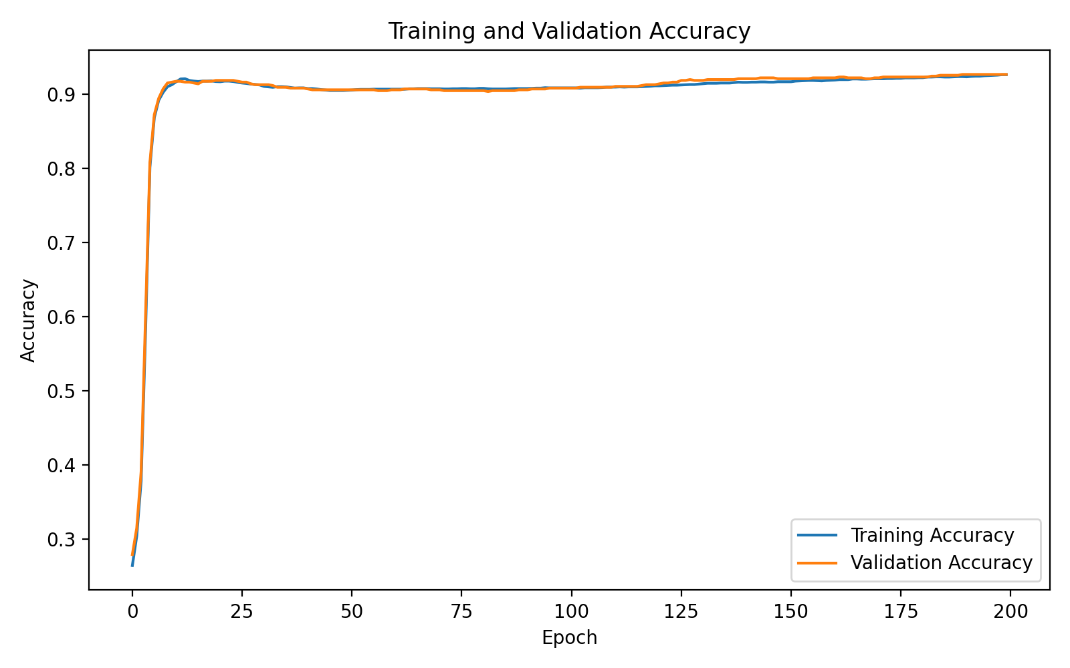
Figure 19. Training/validation accuracy curve.
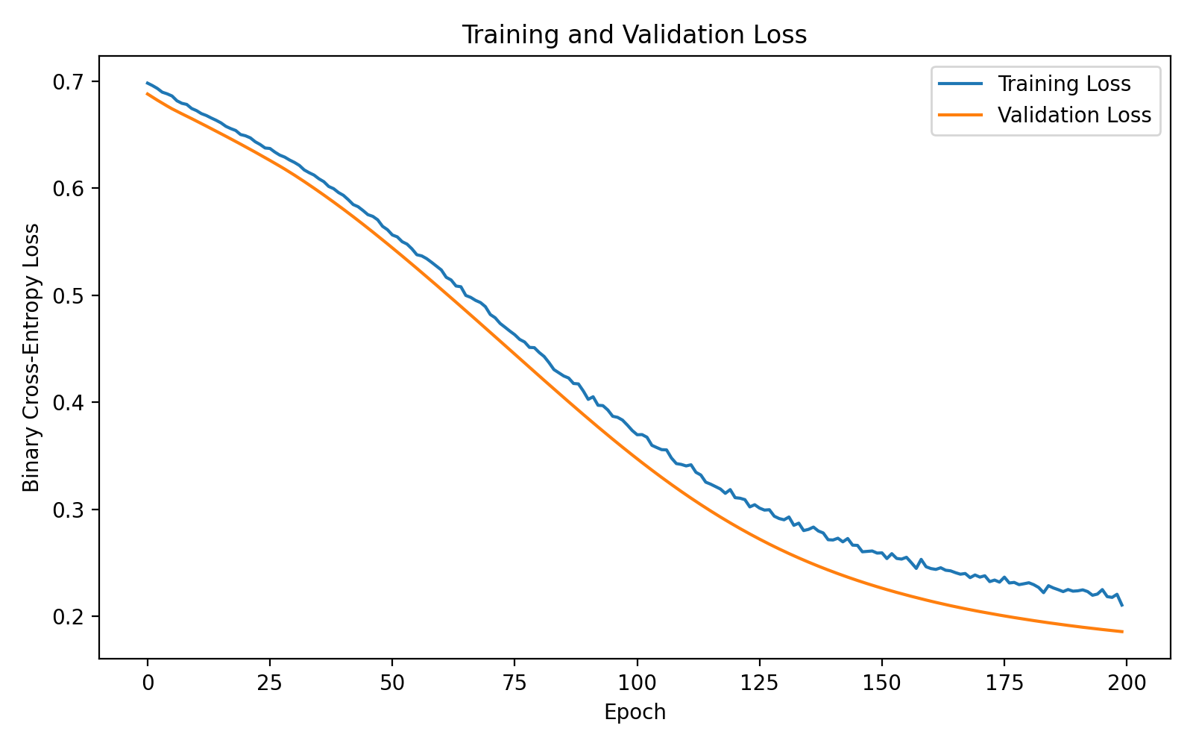
Figure 20. Training/validation loss curve.
Metric | PyTorch Neural Network
Accuracy | 92.63%
Precision | 90.05%
Recall | 79.26%
F1-score | 84.31%
ROC-AUC | 0.9744
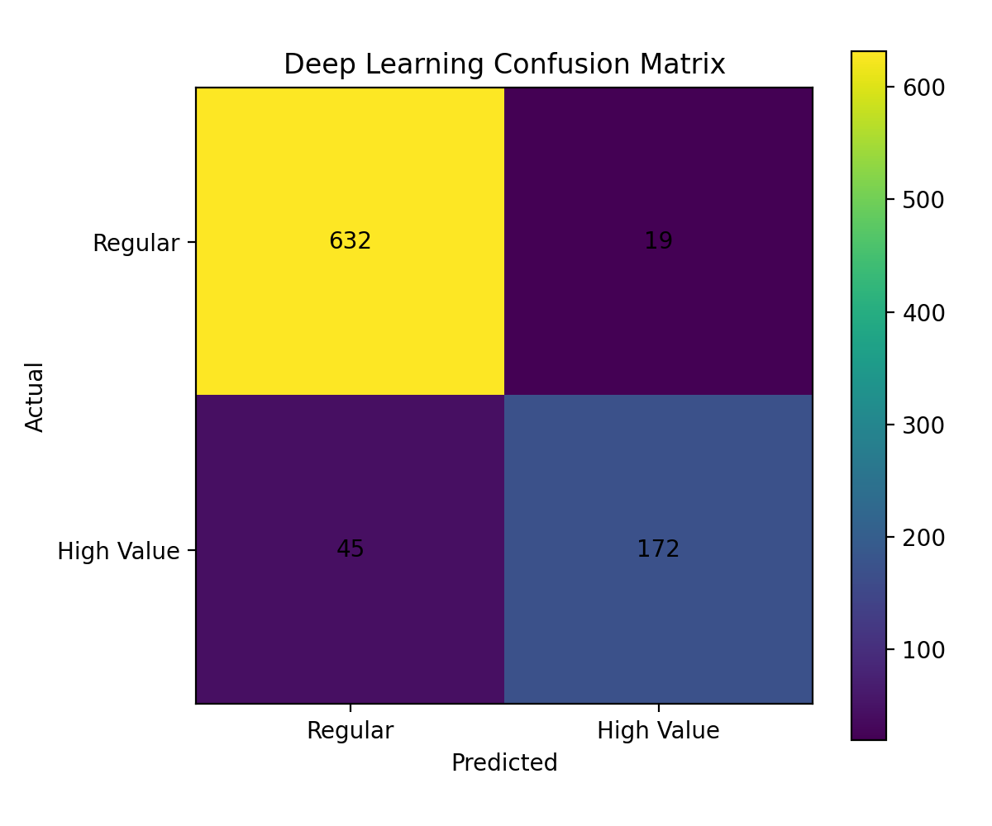
Figure 21. Confusion matrix for the neural network.
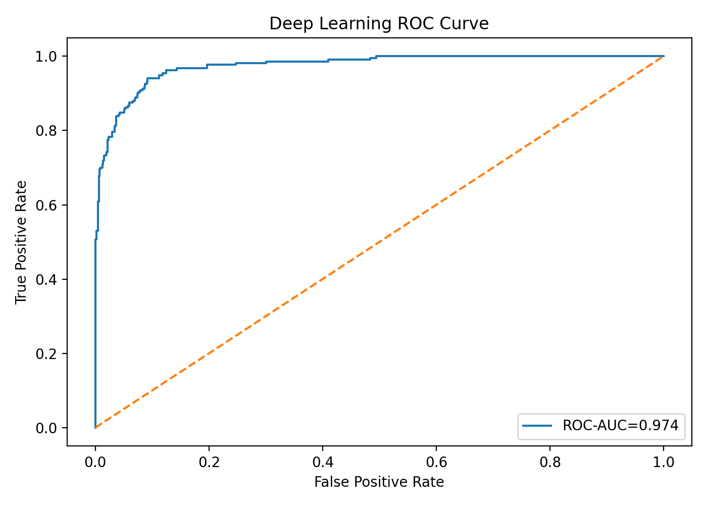
Figure 22. ROC curve for the neural network.
The neural network achieved the same overall accuracy as logistic regression but a slightly lower F1-score and ROC-AUC on the held-out test set. This result is useful because it demonstrates that a more complex model does not automatically produce better performance on small, structured feature sets. For this particular problem, the classical model provides a strong baseline while the neural network demonstrates a practical deep-learning implementation.

12. Model Comparison and Evaluation
Metric | Logistic Regression | PyTorch Neural Network | Observation
Accuracy | 92.63% | 92.63% | Equal on the held-out test set.
Precision | 88.83% | 90.05% | Neural network is slightly higher.
Recall | 80.65% | 79.26% | Logistic regression identifies more positives.
F1-score | 84.54% | 84.31% | Very close; logistic regression is slightly higher.
ROC-AUC | 0.9827 | 0.9744 | Logistic regression shows stronger ranking performance.
The comparison should be interpreted in the context of the project design. Both models use the same four customer-behaviour predictors and the same target definition, so the comparison isolates the effect of model complexity more effectively than changing the data and target simultaneously.

13. Integrated Findings and Business Insights
- Data quality has a major impact on downstream analytics. Removing duplicates, cancellations, invalid quantities/prices, and unusable customer records produced a more reliable modelling base.
- Retail revenue is concentrated geographically, with the United Kingdom contributing the largest share of cleaned transaction value.
- Customer behaviour is highly heterogeneous. A smaller high-activity segment has substantially greater spending, order frequency, purchase quantity, and product variety.
- Unsupervised clustering provides descriptive customer segmentation without requiring a predefined target.
- Supervised classification converts behavioural features into a practical customer-screening tool. The high ROC-AUC values indicate strong separation for the defined target.
- The neural network performed competitively but did not materially improve overall accuracy or F1-score. This illustrates the importance of choosing model complexity based on data characteristics rather than assuming deep learning will always outperform classical machine learning.

13.1 Recommendations
- Use the higher-activity customer segment as a starting point for loyalty, retention, and personalized campaign analysis.
- Investigate high-value customers separately from the general customer population because their purchase patterns differ substantially.
- Use precision and recall together when deciding how to operationalize high-value customer predictions; the preferred threshold depends on campaign cost and business priorities.
- Monitor customer-level metrics over time rather than relying only on aggregate revenue.
- For future deployment, create a time-based target such as whether a customer becomes high-value in the next month or quarter. This would make the prediction problem more forward-looking.

14. Challenges and Solutions
Challenge | Solution Applied
Large raw Excel dataset | Loaded with Pandas and stored a compressed processed CSV for easier version control.
Missing CustomerID values | Removed records that could not support customer-level analysis.
Cancellation and invalid transactions | Filtered cancellation invoices and non-positive quantity/price rows.
Highly skewed transaction values | Used distribution analysis and IQR-based flagging; retained legitimate high-value observations.
Different feature scales | Applied StandardScaler before clustering and supervised/neural models.
Class-dependent model evaluation | Used stratified train/test splitting and precision, recall, F1 and ROC-AUC.
Model complexity vs. performance | Compared logistic regression with a PyTorch neural network using the same predictors.
A practical implementation constraint was that TensorFlow was not available in the working environment, so PyTorch was selected as the permitted deep-learning framework. This allowed the deep-learning task to be completed while keeping the workflow fully Python based.

15. Limitations
- The high-value target is derived from historical TotalSpending, so it is useful for demonstration but is not a fully forward-looking prediction target.
- The clustering solution selected k=2 using the evaluated silhouette scores, but customer behaviour can reasonably support more granular business segmentation.
- The project focuses on transaction behaviour and does not include demographic, marketing-channel, customer-service, or external economic variables.
- The dataset represents a historical period and may not directly reflect current retail behaviour.
- Outliers were flagged rather than automatically removed, which preserves potentially meaningful purchases but may influence aggregate statistics and model behaviour.
- The deep-learning evaluation can be improved in future work by using a dedicated train/validation/test split and systematic hyperparameter tuning.

16. Future Scope
- Develop RFM (Recency, Frequency, Monetary) features and compare them with the current behavioural features.
- Test hierarchical clustering, Gaussian Mixture Models, DBSCAN, or alternative segmentation methods.
- Use time-based validation and a future-period high-value target to create a more realistic predictive system.
- Compare Logistic Regression with Random Forest, Gradient Boosting, XGBoost/LightGBM where available, and calibrated models.
- Tune the neural network architecture, learning rate, batch size, dropout, and number of layers using a dedicated validation set.
- Build a dashboard for customer segments, revenue trends, and predicted high-value customers.
- Deploy the final pipeline as a small Flask/FastAPI service or Streamlit application.
- Add monitoring for data drift and model performance if the system is used with new transaction data.

17. Project Structure and Reproducibility
The project is organized as follows:
telecom-data-science-analyst/
└── Virtual-Data-Science-Python/
├── data/
│ ├── raw/
│ │ └── Online Retail.xlsx
│ └── processed/
│ ├── online_retail_cleaned.csv.gz
│ ├── customer_clusters.csv
│ ├── customer_cluster_profiles.csv
│ ├── customer_supervised_modeling.csv
│ ├── supervised_model_metrics.csv
│ └── deep_learning_metrics.csv
├── figures/
├── reports/
└── src/
├── data_preprocessing.py
├── eda_analysis.py
├── clustering_analysis.py
├── supervised_learning.py
└── deep_learning_model.py
The scripts, processed outputs, figures, and reports are maintained in the GitHub project repository. The raw Excel dataset is retained locally because of its file size; a compressed processed dataset is provided for easier repository sharing.

18. Conclusion
This capstone demonstrates a complete practical data science pipeline using Python, beginning with raw public transaction data and ending with interpretable customer segmentation and predictive modelling. The work combines data cleaning, exploratory analysis, feature engineering, unsupervised learning, supervised learning, and deep learning in a single coherent project.
The cleaning stage reduced the dataset to 392,692 usable records while preserving legitimate high-value transactions. EDA revealed strong variation in customer behaviour and geographic revenue concentration. K-Means identified two broad customer activity segments, while supervised learning produced strong classification performance for the defined high-value target. The PyTorch neural network achieved competitive results but did not materially exceed the logistic regression baseline.
Overall, the project demonstrates practical skills in Python data science, statistical exploration, machine learning, deep learning, model evaluation, visualization, documentation, and reproducible project organization. The pipeline provides a strong foundation for future work involving time-based customer prediction, richer features, advanced models, and deployment.

Appendix A. Key End-to-End Code Pattern
# Load cleaned data
df = pd.read_csv("data/processed/online_retail_cleaned.csv.gz",
compression="gzip")
# Customer-level feature engineering
customer = df.groupby("CustomerID").agg(
TotalSpending=("TotalAmount", "sum"),
NumberOfOrders=("InvoiceNo", "nunique"),
AverageOrderValue=("TotalAmount", "mean"),
TotalQuantity=("Quantity", "sum"),
NumberOfProducts=("Description", "nunique")
).reset_index()
# Supervised target
threshold = customer["TotalSpending"].quantile(0.75)
customer["HighValue"] = (
customer["TotalSpending"] >= threshold
).astype(int)
# Model features exclude TotalSpending
features = [
"NumberOfOrders", "AverageOrderValue",
"TotalQuantity", "NumberOfProducts"
]

Appendix B. Repository
GitHub project: https://github.com/ashithb740-maker/virtual-data-science-python

