Week 3: Unsupervised Learning and Clustering Analysis
Virtual Data Science with Python Trainee Internship
UCI Online Retail Dataset — Customer Segmentation

1. Objective
The objective of Week 3 was to apply an unsupervised learning technique to segment customers into meaningful groups. K-Means clustering was selected to identify customers with similar purchasing behaviour and to interpret the characteristics of the resulting segments.

2. Dataset and Clustering Approach
The cleaned Online Retail dataset from Week 1 was used. The transaction-level data was transformed into a customer-level dataset containing 4,338 customers. Five behavioural features were created: TotalSpending, NumberOfOrders, AverageOrderValue, TotalQuantity, and NumberOfProducts. These features represent monetary value, purchasing frequency, order value, purchase volume, and product variety.

3. Feature Engineering and Preprocessing
Customer-level aggregation was performed using Pandas groupby operations. Because retail variables can be highly skewed, a log1p transformation was applied to the five numerical features. The transformed features were then standardized using StandardScaler so that variables with larger numerical ranges would not dominate the distance calculations used by K-Means.

4. K-Means Methodology
K-Means was selected because it is a widely used unsupervised clustering algorithm for numerical data. It partitions observations into k groups by minimizing within-cluster squared distances to cluster centroids. The analysis tested k values from 2 through 8. Inertia was examined using the Elbow Method and cluster quality was evaluated using the Silhouette Score. The highest observed silhouette score was 0.3876 at k = 2, so two clusters were selected for the final segmentation.

5. Elbow Method
The Elbow Method compares the within-cluster sum of squares, represented by K-Means inertia, across different values of k. Inertia decreases as more clusters are added. The plot was used together with the silhouette analysis rather than as the only selection criterion.
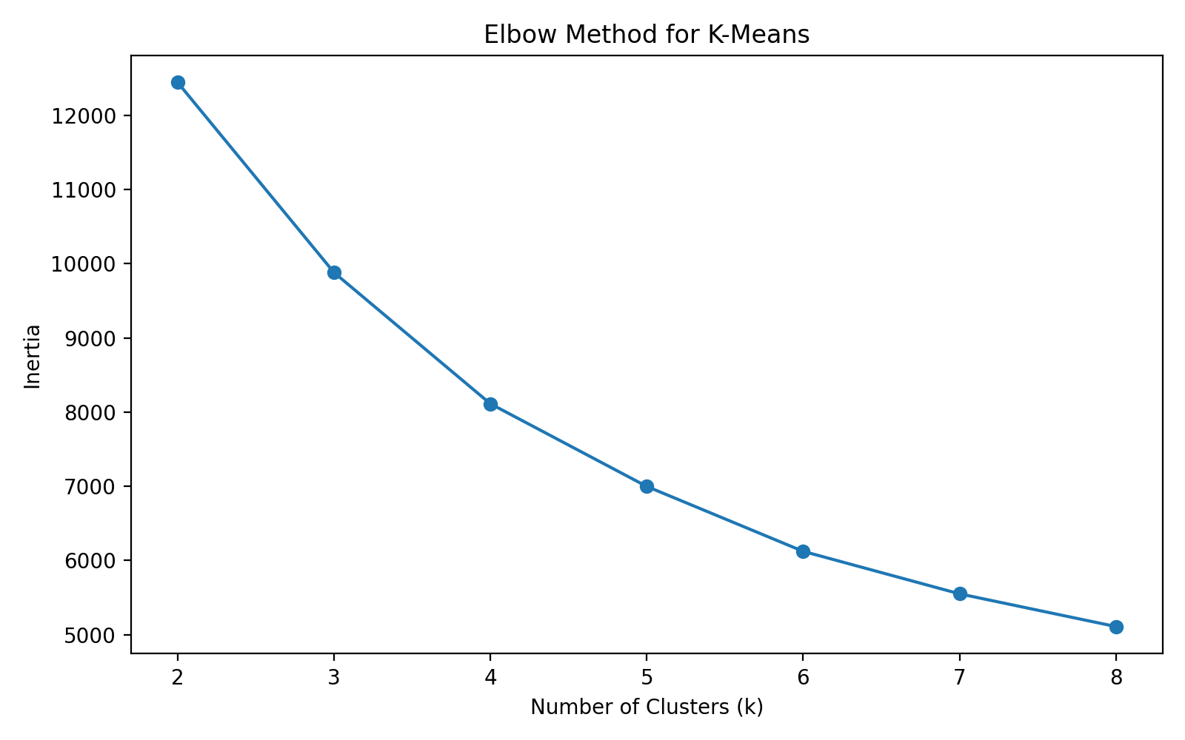
Figure 1. Elbow method for candidate cluster counts.

6. Silhouette Analysis
Silhouette Score measures how similar an observation is to its own cluster compared with other clusters. Among the tested values, k = 2 produced the highest score of approximately 0.3876. This supported using two clusters for the final customer segmentation.
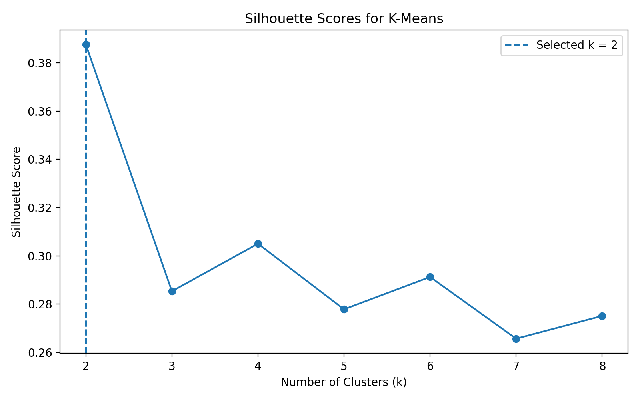
Figure 2. Silhouette scores for k values from 2 to 8.

7. Customer Cluster Visualization
The clusters were visualized using the standardized log-transformed TotalSpending and NumberOfOrders dimensions. The plotted centroids show the central position of each group in this two-dimensional view. Because the actual clustering used five features, this chart is a simplified visualization rather than a complete representation of all clustering dimensions.
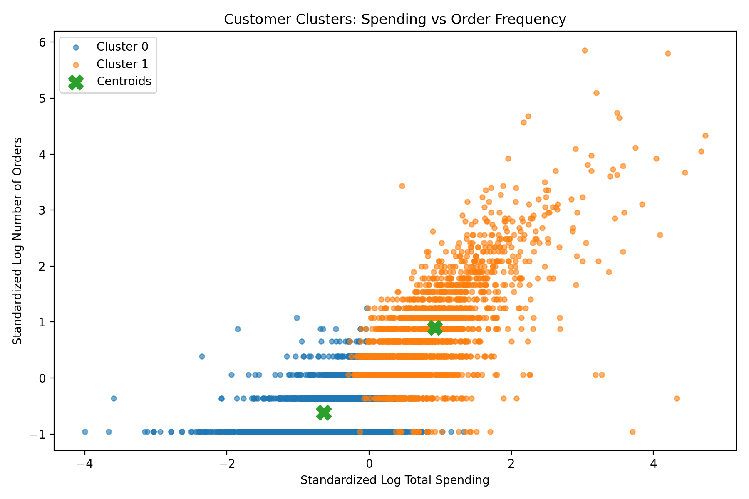
Figure 3. Customer clusters using spending and order frequency.

8. Cluster Profiles
Cluster profiles were compared using the mean values of the five customer-level features. The normalized profile chart allows variables with different scales to be compared visually. The clusters differ in spending, order frequency, average order value, quantity purchased, and product variety.
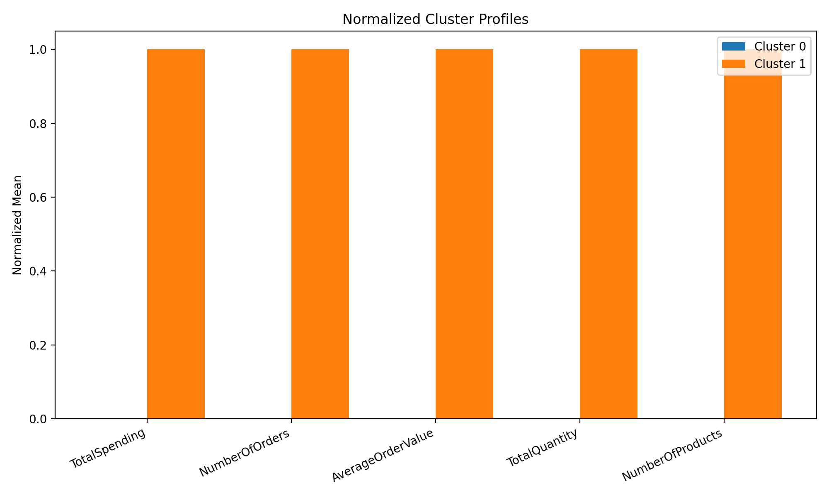
Figure 4. Normalized profiles of the two customer clusters.

9. Cluster Distribution
The final segmentation divides the customer population into two groups. The distribution chart shows the number of customers assigned to each cluster and helps assess whether the segmentation is highly balanced or concentrated in one group.
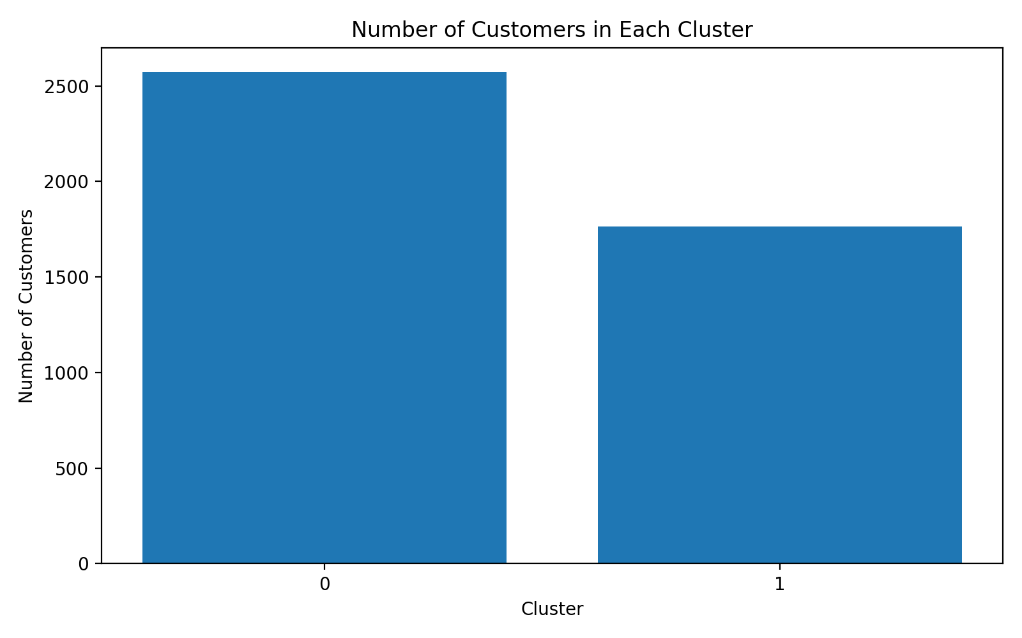
Figure 5. Number of customers in each cluster.

10. Characteristics of the Clusters
Cluster 0: 2,572 customers. Average total spending = 422.69; average orders = 1.64; average order value = 33.29; average quantity = 244.37; average distinct products = 25.41.
Cluster 1: 1,766 customers. Average total spending = 4,416.79; average orders = 8.10; average order value = 119.48; average quantity = 2561.43; average distinct products = 114.91.
The cluster with the higher average spending is Cluster 1, while Cluster 0 has the lower average spending. These differences can be used descriptively to distinguish higher-value and lower-value purchasing groups. The labels do not represent fixed customer identities and should be validated against business objectives before operational use.

11. Business and Research Implications
- Customer segmentation can support differentiated marketing and communication strategies based on purchasing behaviour.
- Higher-spending or more frequent customers can be studied further for retention and loyalty analysis.
- Lower-spending or less frequent customers can be examined to understand barriers to repeat purchasing.
- Product variety and purchase volume provide additional dimensions beyond revenue alone, helping create more informative customer profiles.
- The segments can serve as input features for future predictive modelling or customer lifetime value analysis.

12. Code Snippet
features = [
"TotalSpending", "NumberOfOrders",
"AverageOrderValue", "TotalQuantity",
"NumberOfProducts"
]
X = np.log1p(customer[features])
X_scaled = StandardScaler().fit_transform(X)
model = KMeans(
n_clusters=2,
random_state=42,
n_init=10
)
customer["Cluster"] = model.fit_predict(X_scaled)

13. Limitations
K-Means assumes cluster structure that can be represented reasonably well using distance-based separation. The selected features and transformation choices influence the resulting segments. The analysis also uses historical transaction behaviour and does not include demographic information or customer-level context. Therefore, the clusters should be treated as analytical segments rather than definitive customer categories.

14. Conclusion
This analysis demonstrated the application of unsupervised learning to customer segmentation using K-Means. Transaction data was transformed into customer-level behavioural features, skewed variables were log-transformed, features were standardized, and candidate cluster counts were evaluated using inertia and silhouette scores. The analysis selected two clusters and examined their spending, frequency, order value, quantity, and product variety characteristics. The resulting segmentation provides a practical foundation for further customer analytics and machine learning work.

