Week 4: Supervised Learning Model Implementation
Virtual Data Science with Python Trainee Internship
UCI Online Retail Dataset — High-Value Customer Classification

1. Objective
The objective of this task was to design and implement a supervised machine learning model using Python. A binary classification problem was developed from the cleaned Online Retail dataset to predict whether a customer belongs to the high-value customer segment. The workflow covers feature engineering, preprocessing, training, validation, evaluation, visualization, and discussion of model strengths and limitations.

2. Problem Definition
The prediction problem is to classify customers into two categories: High Value and Regular. A customer was defined as High Value when their total spending was at or above the 75th percentile of customer spending. This creates a reproducible target from the transaction history and provides a practical customer analytics use case.

3. Dataset and Feature Engineering
The cleaned transaction dataset was aggregated into 4,338 customer records. Four behavioural predictor variables were used: NumberOfOrders, AverageOrderValue, TotalQuantity, and NumberOfProducts. TotalSpending was used to define the target and was excluded from the predictors to avoid directly giving the model the information used to create the target.
The high-value threshold was 1,660.60. Customers at or above this threshold were labelled 1, while the remaining customers were labelled 0.

4. Preprocessing
The dataset was split into training and testing subsets using an 80:20 stratified split. Stratification was used to preserve the proportion of high-value and regular customers in both subsets. StandardScaler was used inside a Scikit-learn Pipeline so scaling was learned from the training data and applied consistently during validation and testing.

5. Model Selection
Logistic Regression was selected because the target is binary and the model provides an interpretable baseline for classification. It is computationally efficient, works well with standardized numerical features, and its coefficients provide information about the direction and relative strength of feature relationships. More complex models could be evaluated later as an improvement.

6. Training and Validation
The model was trained on the training portion of the data. Five-fold stratified cross-validation was then used to assess the stability of the F1-score across different data partitions. The mean cross-validation F1-score was approximately 0.8596. This provides an additional validation result beyond the single held-out test set.

7. Confusion Matrix
The confusion matrix compares actual and predicted customer classes. It shows true positives, true negatives, false positives, and false negatives, providing a direct view of classification errors.
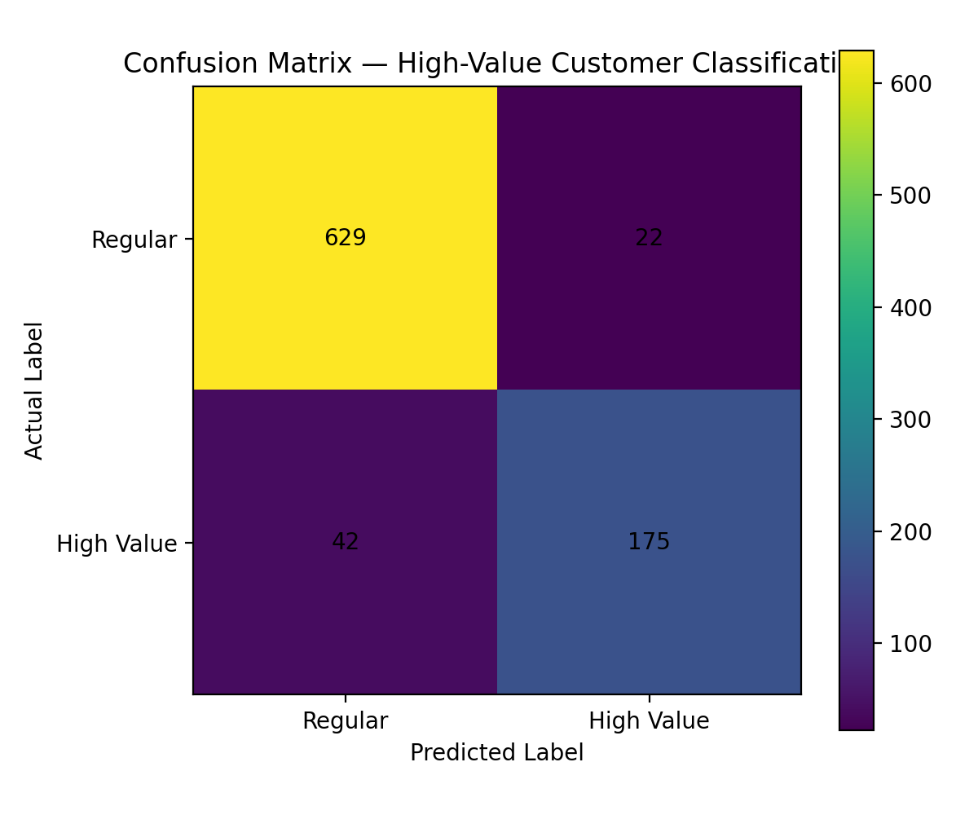
Figure 1. Confusion matrix for high-value customer classification.

8. ROC Curve
The model achieved a ROC-AUC of 0.9827. ROC-AUC measures the model's ability to distinguish between the two classes across different classification thresholds. The ROC curve provides a threshold-independent view of discrimination performance.
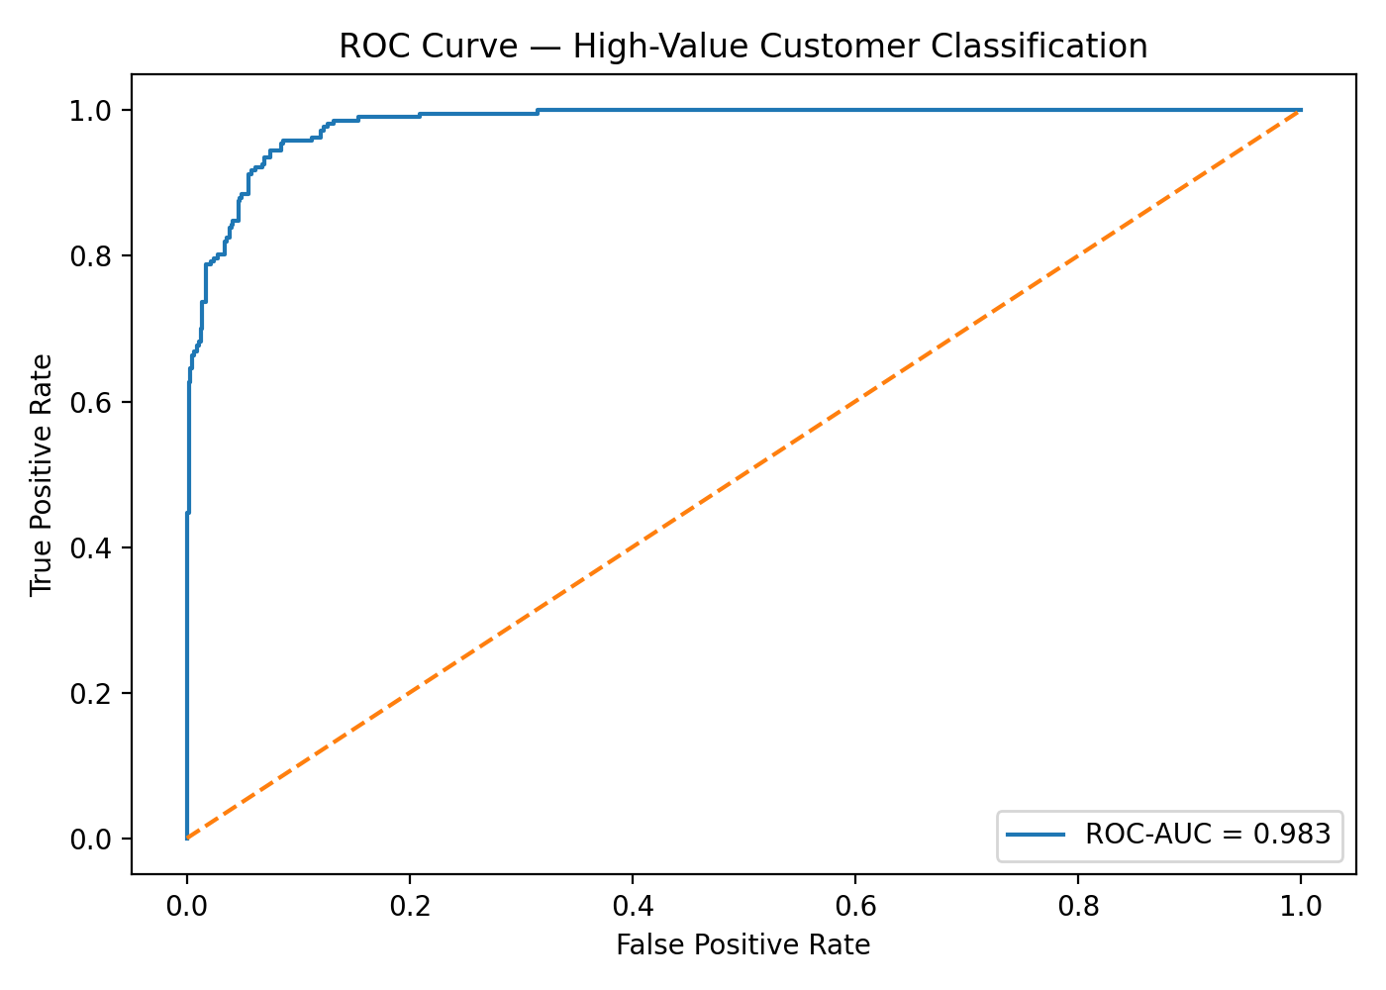
Figure 2. ROC curve for the classification model.

9. Feature Importance
The absolute standardized logistic regression coefficients were used as a simple feature-importance view. Features with larger absolute coefficients have a stronger association with the model's prediction after standardization. This interpretation should be treated as model-specific association rather than proof of causation.
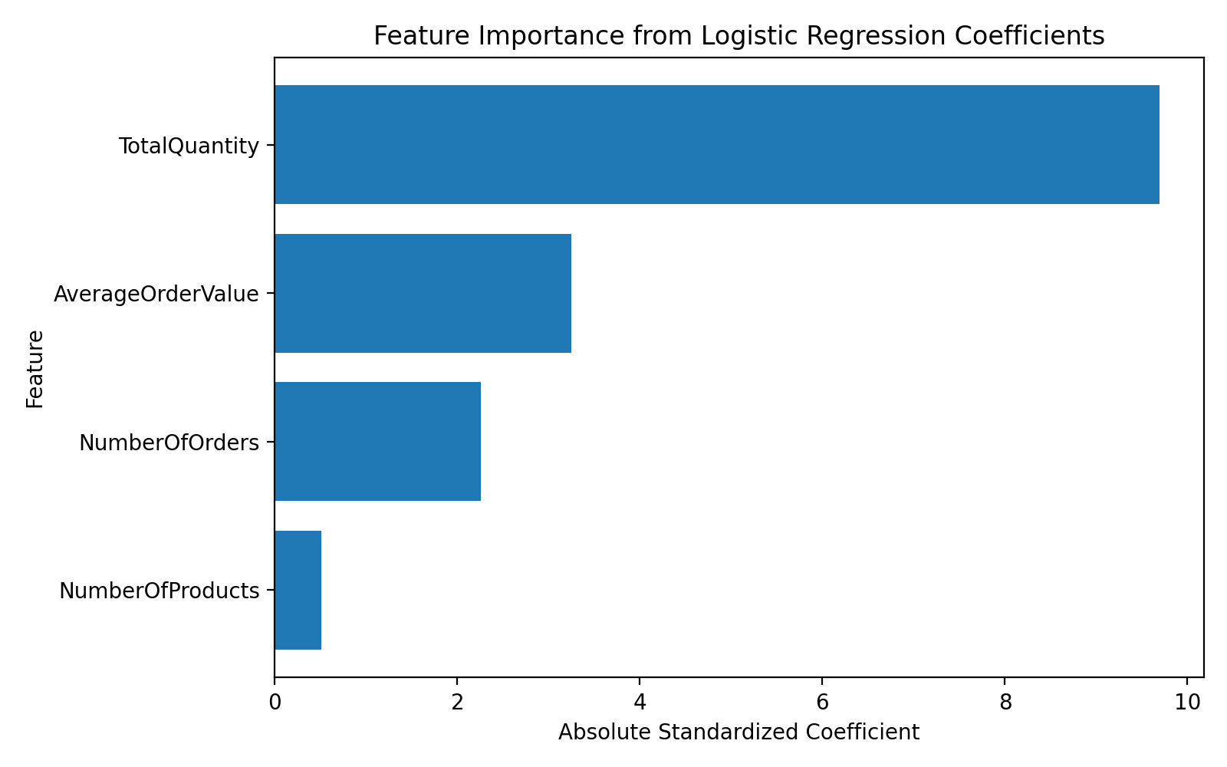
Figure 3. Feature importance based on absolute standardized coefficients.

10. Cross-Validation Performance
The five-fold cross-validation analysis produced an average F1-score of approximately 0.8596. Examining performance across folds helps determine whether the model's results are reasonably consistent rather than depending entirely on one train-test split.
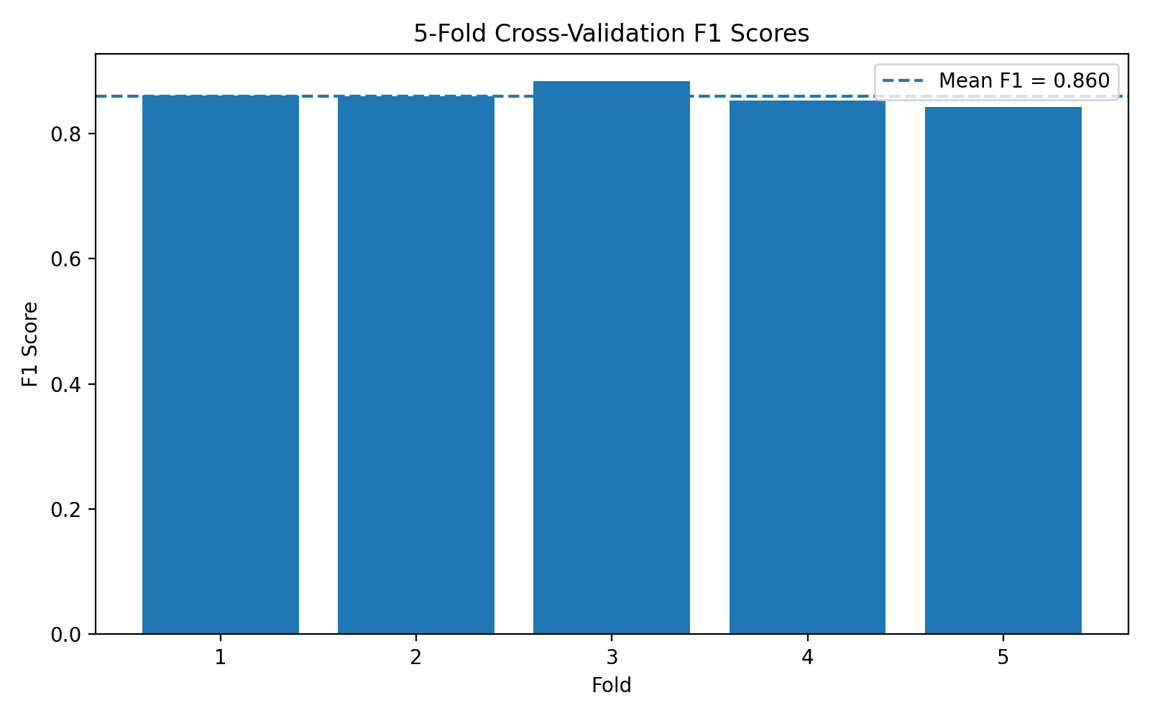
Figure 4. Five-fold cross-validation F1 scores.

11. Model Evaluation
Metric | Test Result
Accuracy | 0.9263 (92.63%)
Precision | 0.8883 (88.83%)
Recall | 0.8065 (80.65%)
F1-score | 0.8454 (84.54%)
ROC-AUC | 0.9827 (98.27%)
The test-set results show strong overall discrimination and a useful balance between precision and recall. The F1-score is particularly relevant when both false positives and false negatives matter. The ROC-AUC also indicates strong separation between the two classes for this dataset and target definition.

12. Code Snippet
model = Pipeline([
("scaler", StandardScaler()),
("classifier",
LogisticRegression(max_iter=1000,
random_state=42))
])
model.fit(X_train, y_train)
pred = model.predict(X_test)
prob = model.predict_proba(X_test)[:, 1]

13. Strengths
- Uses a clearly defined binary classification problem derived from customer behaviour.
- Uses stratified train-test splitting to maintain class proportions.
- Places feature scaling inside a Scikit-learn pipeline to reduce preprocessing leakage risk.
- Uses multiple evaluation metrics instead of relying on accuracy alone.
- Uses five-fold cross-validation to assess performance stability.
- Provides interpretable coefficients for understanding feature relationships.

14. Limitations and Possible Improvements
- The high-value threshold is a dataset-derived rule and could change over time or across businesses.
- The features are based on historical transaction behaviour and do not include demographic or contextual information.
- Logistic Regression provides a useful baseline but may not capture nonlinear relationships.
- Future work could compare Random Forest, Gradient Boosting, or other classification algorithms.
- Hyperparameter tuning and additional feature engineering could be used to improve generalization.
- Time-aware validation could be explored for future versions to better represent real deployment conditions.

15. Conclusion
A complete supervised learning workflow was implemented to classify high-value customers using the UCI Online Retail dataset. Customer-level features were engineered, the target was defined using the 75th spending percentile, data was split using stratification, and Logistic Regression was trained within a standardized pipeline. The model achieved 92.63% accuracy, 84.54% F1-score, and 0.9827 ROC-AUC on the held-out test set, with a mean five-fold F1-score of approximately 0.8596. The results demonstrate a practical baseline for customer-value classification while leaving clear opportunities for testing more advanced models, richer features, and time-aware validation.

