Week 5: Deep Learning Application in Data Science
Virtual Data Science with Python Trainee Internship
PyTorch Neural Network — High-Value Customer Classification

1. Problem Statement
The objective of this project was to apply deep learning to a practical customer classification problem. Using the cleaned UCI Online Retail dataset, customers were classified as either High Value or Regular based on their historical purchasing behaviour. A feed-forward artificial neural network was designed, trained, and evaluated using PyTorch.

2. Dataset and Target Definition
The customer-level dataset contains 4,338 customer records. Four behavioural variables were used as model inputs: NumberOfOrders, AverageOrderValue, TotalQuantity, and NumberOfProducts. The target variable HighValue was created using the 75th percentile of TotalSpending: customers at or above the threshold were labelled 1 and the remaining customers were labelled 0. TotalSpending itself was not supplied to the neural network as an input because it was used to define the target.

3. Data Preparation
The data was divided into training and test sets using an 80:20 stratified split. StandardScaler was fitted on the training data and then applied to both training and test data. Standardization was important because the four input variables have different numerical ranges. The scaled arrays were converted into PyTorch tensors.

4. Neural Network Architecture
The network is a compact fully connected feed-forward neural network. It contains four input features, a first dense layer with 32 neurons and ReLU activation, a 20% dropout layer, a second dense layer with 16 neurons and ReLU activation, another 20% dropout layer, and a single output neuron. The output uses a sigmoid interpretation during prediction. This architecture provides enough nonlinear capacity for the problem while remaining lightweight enough for a small tabular dataset.
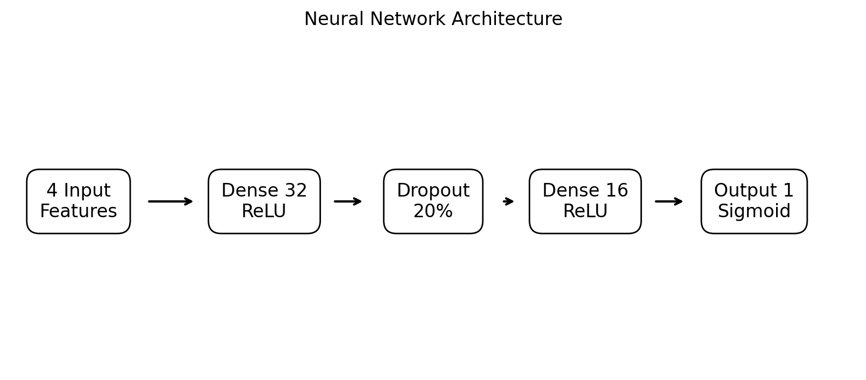
Figure 1. Neural network architecture.

5. Training Process
The model was trained using the Adam optimizer with a learning rate of 0.001. Binary Cross-Entropy with logits was used as the loss function. A small weight-decay value was included as an additional regularization measure, while dropout layers reduced the risk of overfitting. Training was configured for up to 200 epochs.
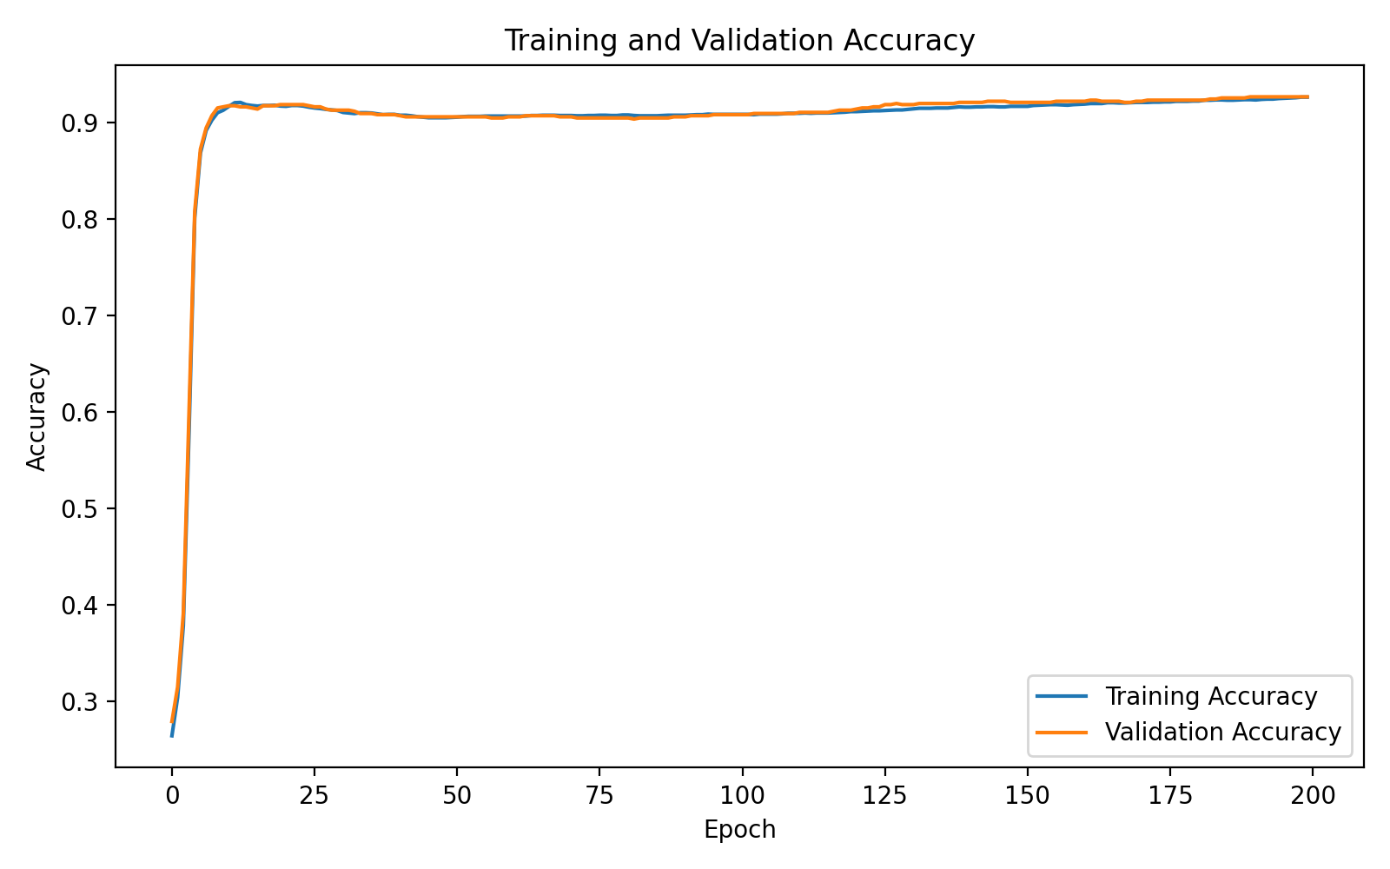
Figure 2. Training and validation accuracy.
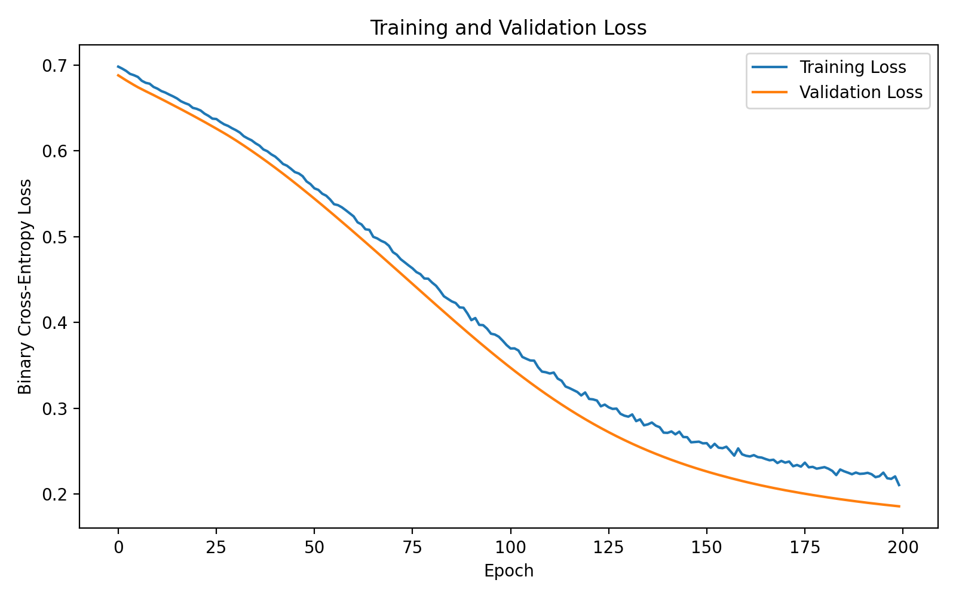
Figure 3. Training and validation loss.
The training curves were monitored to compare learning behaviour on the training and held-out validation/test data. The plots help identify divergence between training and validation performance, which is an important indicator of potential overfitting.

6. Model Evaluation
The trained neural network achieved 92.63% accuracy, 90.05% precision, 79.26% recall, 84.31% F1-score, and 0.9744 ROC-AUC on the held-out test set. These metrics provide a broader assessment than accuracy alone, particularly because both false positives and false negatives are relevant in customer classification.
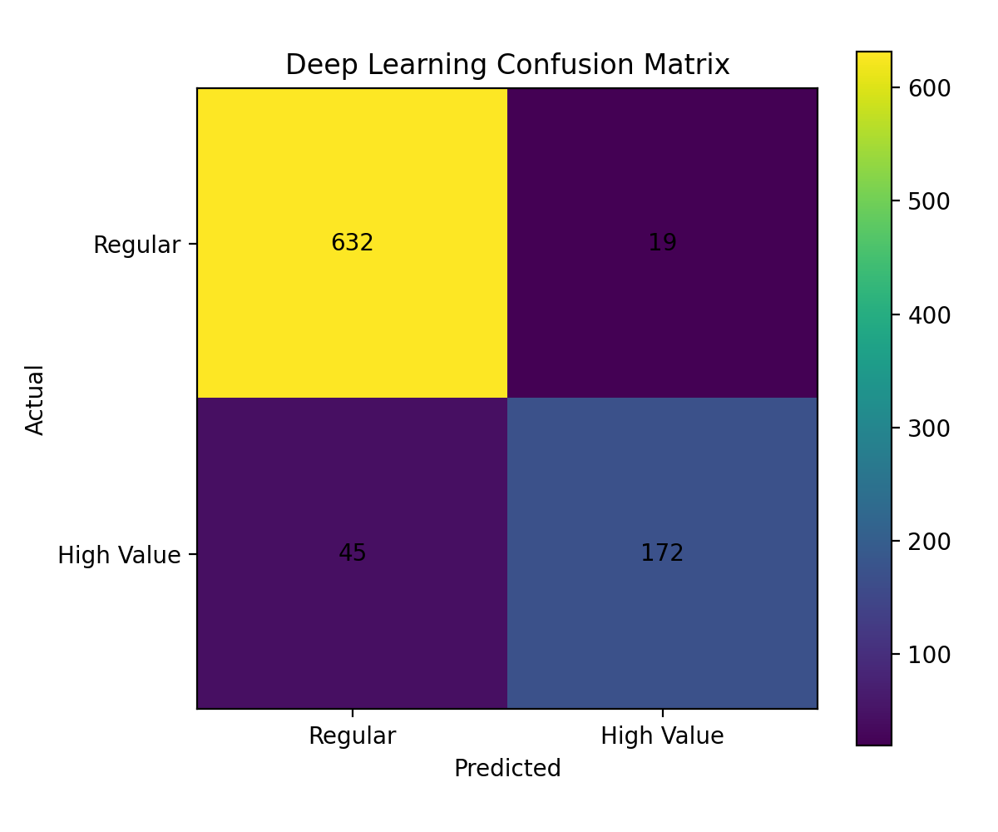
Figure 4. Confusion matrix for the neural network.
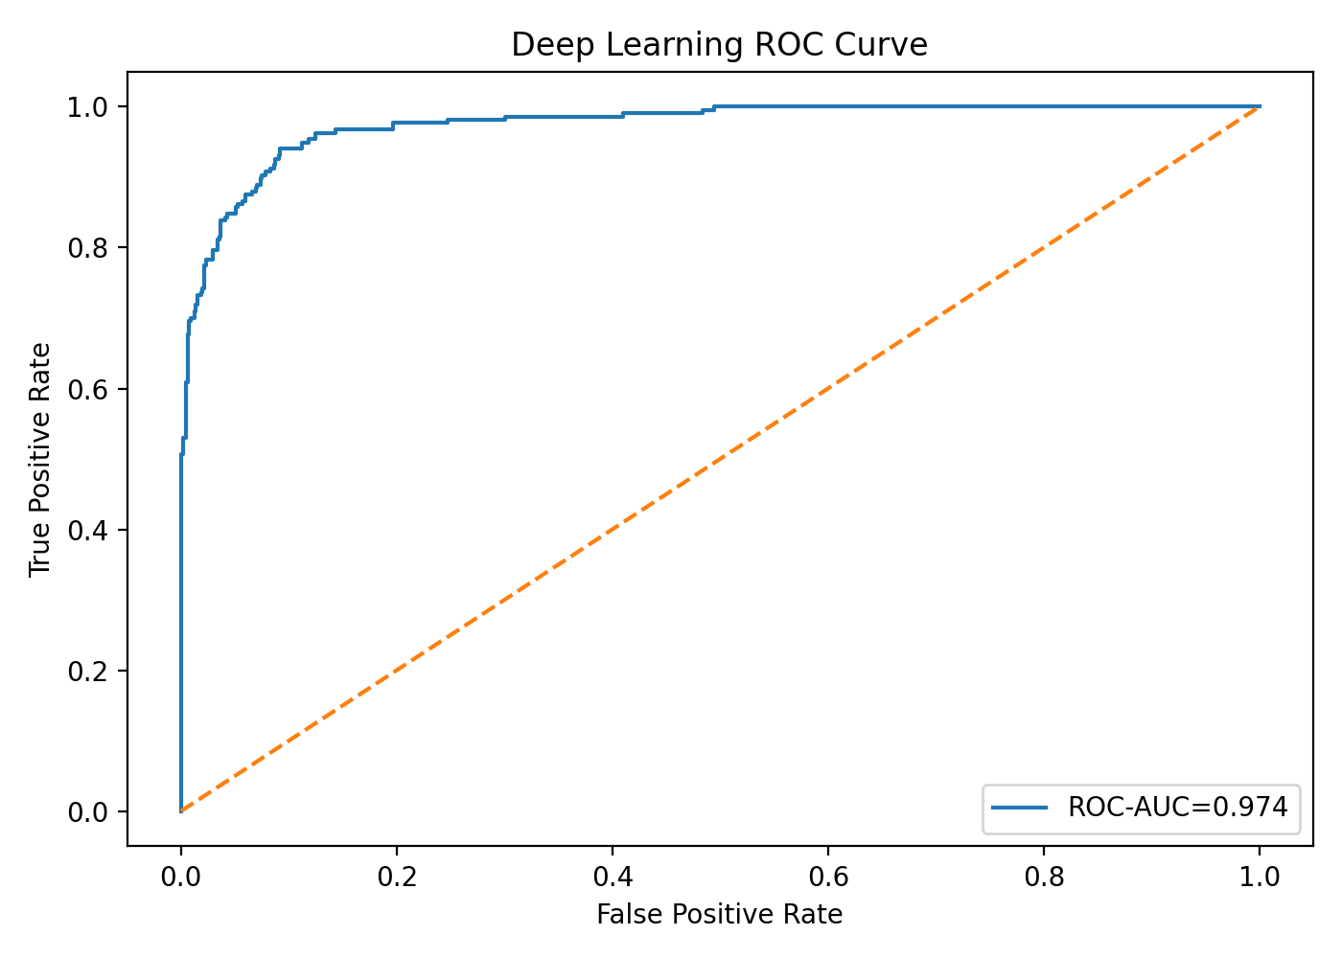
Figure 5. ROC curve for the neural network.

7. Interpretation of Results
The results indicate that the neural network can distinguish the two customer groups effectively on this dataset. The ROC-AUC of approximately 0.9744 indicates strong class separation. Precision of approximately 90.05% means that most customers predicted as high value were actually in the high-value class. Recall of approximately 79.26% shows that some actual high-value customers were not identified, which is an important consideration for applications where missing valuable customers has a business cost.

8. Design Decisions and Hyperparameters
- PyTorch was used as the deep learning framework.
- Two hidden layers (32 and 16 neurons) were selected to provide nonlinear modelling capacity without making the network unnecessarily large.
- ReLU activation was used in hidden layers for efficient nonlinear learning.
- Dropout of 20% was included to reduce overfitting.
- Adam with learning rate 0.001 was selected as a standard optimizer for tabular neural-network training.
- Binary cross-entropy with logits was used because the task has two target classes.
- Standardization was applied before training so all input features contribute on comparable scales.

9. Challenges and Mitigation
Deep learning on tabular data can overfit when the dataset is relatively small or when the network has unnecessary capacity. This was addressed with a compact architecture, dropout, weight decay, and monitoring of training and validation curves. Another challenge is feature-scale differences, which was addressed using StandardScaler. Resource constraints were also considered by using a lightweight fully connected network rather than a computationally expensive architecture.

10. Code Example
model = nn.Sequential(
nn.Linear(4, 32),
nn.ReLU(),
nn.Dropout(0.20),
nn.Linear(32, 16),
nn.ReLU(),
nn.Dropout(0.20),
nn.Linear(16, 1)
)
loss_fn = nn.BCEWithLogitsLoss()
optimizer = torch.optim.Adam(
model.parameters(), lr=0.001, weight_decay=1e-4
)

11. Strengths and Limitations
- Strength: The model captures nonlinear relationships that a simple linear classifier may not represent.
- Strength: Dropout and weight decay provide regularization.
- Strength: Multiple evaluation metrics provide a balanced performance assessment.
- Limitation: The target is derived from historical spending and depends on the chosen percentile threshold.
- Limitation: Only four behavioural features were used.
- Limitation: Deep neural networks may not always outperform tree-based models on small structured/tabular datasets.
- Future improvement: Compare the neural network with Random Forest, Gradient Boosting, and tuned ensemble models.
- Future improvement: Add temporal, recency, frequency, and customer-lifetime features and use time-aware validation.

12. Conclusion
A complete deep learning workflow was implemented using PyTorch for high-value customer classification. The project covered target definition, feature preparation, standardization, neural-network architecture design, training, regularization, evaluation, and interpretation. The model achieved strong test performance, including 92.63% accuracy and 0.9744 ROC-AUC. The work demonstrates how neural networks can be applied to structured customer data while also highlighting the importance of regularization, careful evaluation, and comparison with simpler machine-learning methods.

