Week 2: Exploratory Data Analysis and Visualization
Virtual Data Science with Python Trainee Internship
UCI Online Retail Dataset

1. Objective
The objective of this week was to perform exploratory data analysis (EDA) and visualization on a public dataset using Python. The analysis focused on understanding distributions, trends, country-level patterns, customer spending, product performance, correlations, and potential anomalies. Pandas was used for data manipulation and aggregation, while Matplotlib was used to create clear, annotated visualizations.

2. Dataset and Starting Point
The UCI Online Retail dataset contains transactional records from a UK-based online retailer. Week 1 preprocessing produced a cleaned dataset that was used as the input for this EDA. The analysis contains 392,692 cleaned transaction records and 9 variables. The main fields used were InvoiceNo, StockCode, Description, Quantity, InvoiceDate, UnitPrice, CustomerID, Country, and the derived TotalAmount field.

3. EDA Process
The analysis began with shape, data types, descriptive statistics, and checks of numerical variables. InvoiceDate was converted to datetime format. TotalAmount was used as the main revenue measure. The data was then aggregated by month, product, country, and customer to identify meaningful patterns. For distribution plots, the upper 1% of Quantity and UnitPrice values was capped only for visualization so that extreme values would not dominate the charts. These values were not deleted from the dataset.

4. Descriptive Statistics
Variable | Count | Mean | Median | Maximum
Quantity | 392,692 | 13.12 | 6.00 | 80995.00
UnitPrice | 392,692 | 3.13 | 1.95 | 8142.75
TotalAmount | 392,692 | 22.63 | 12.45 | 168469.60

5. Monthly Revenue Trend
Monthly revenue was calculated by grouping transactions by calendar month and summing TotalAmount. The highest monthly revenue in the cleaned dataset occurred in November 2011 with approximately 1,156,205.61 in transaction value. The chart helps identify seasonal changes and periods of stronger or weaker sales activity.
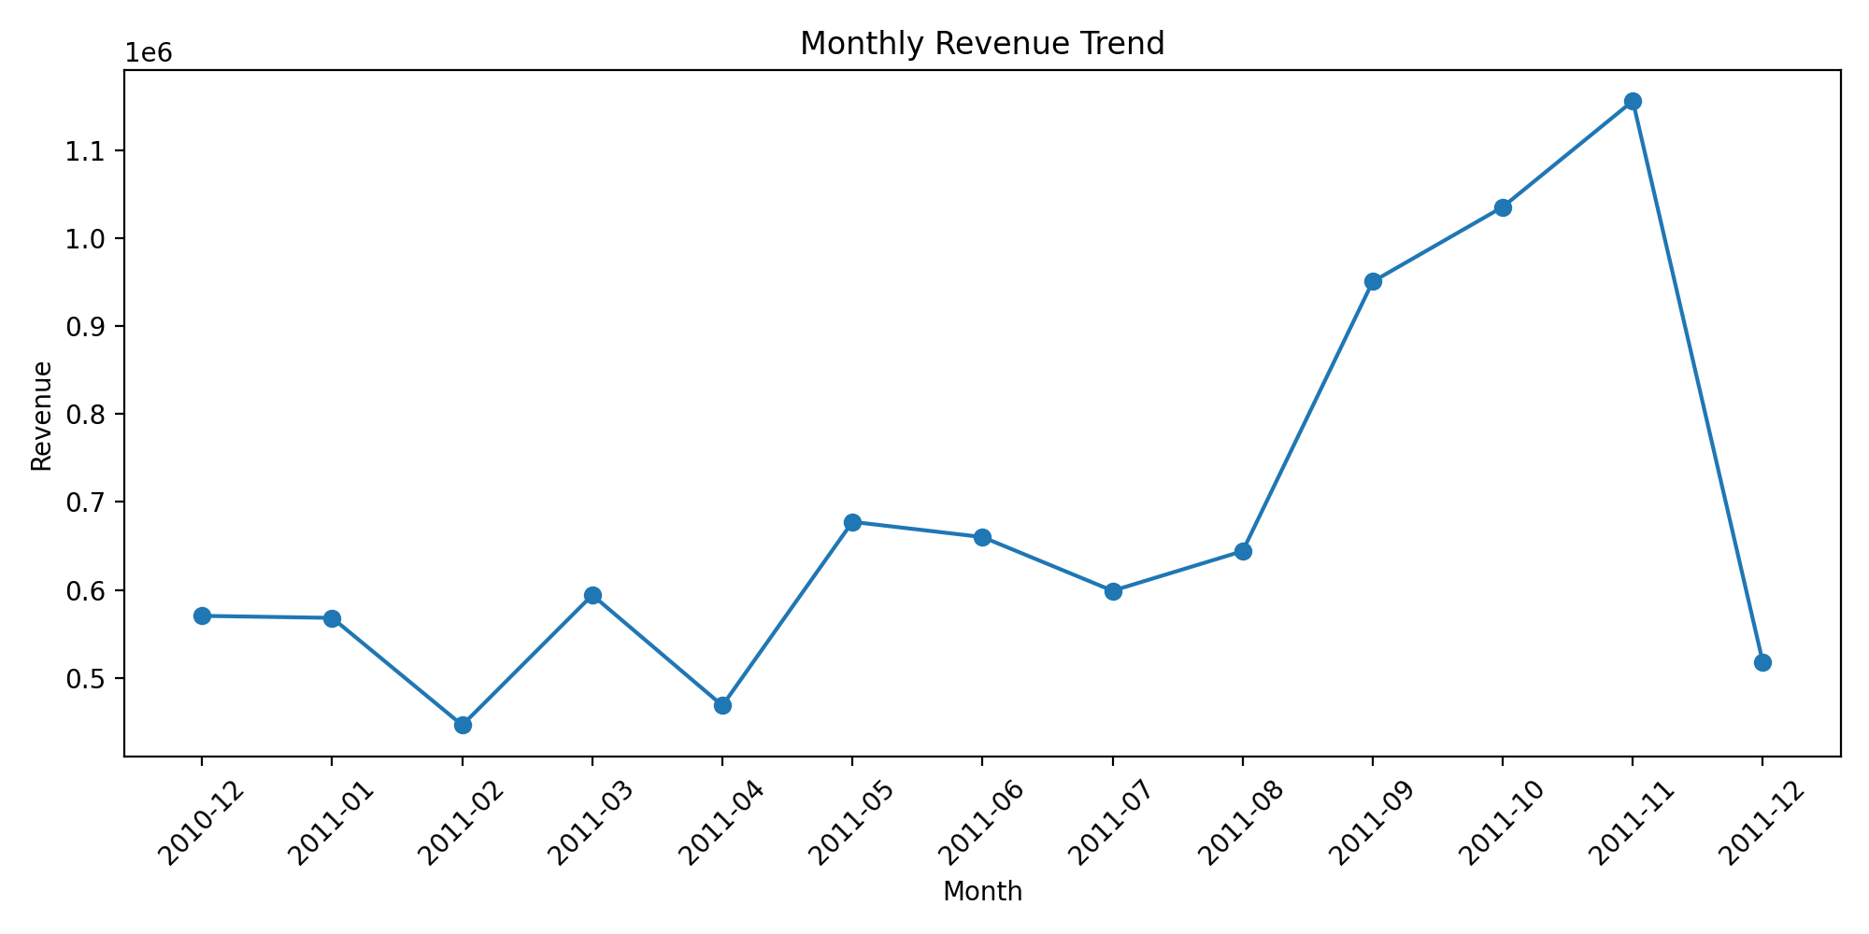
Figure 1. Monthly revenue trend.

6. Product Performance
Products were ranked by total transaction value. The leading products can be identified from the chart, showing that revenue is not distributed equally across all products. High-revenue products may reflect strong demand, higher prices, or a combination of sales volume and price.
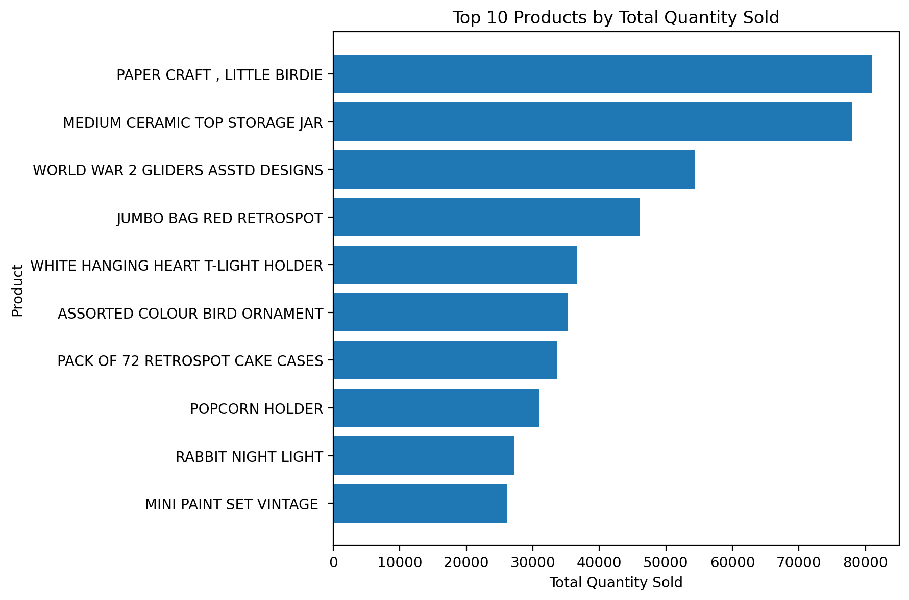
Figure 2. Top 10 products by total revenue.

7. Country-Level Analysis
Country-level aggregation showed that United Kingdom generated the highest total transaction value among the countries in the dataset, at approximately 7,285,024.64. The analysis demonstrates the concentration of sales across markets and can help identify important geographic segments.
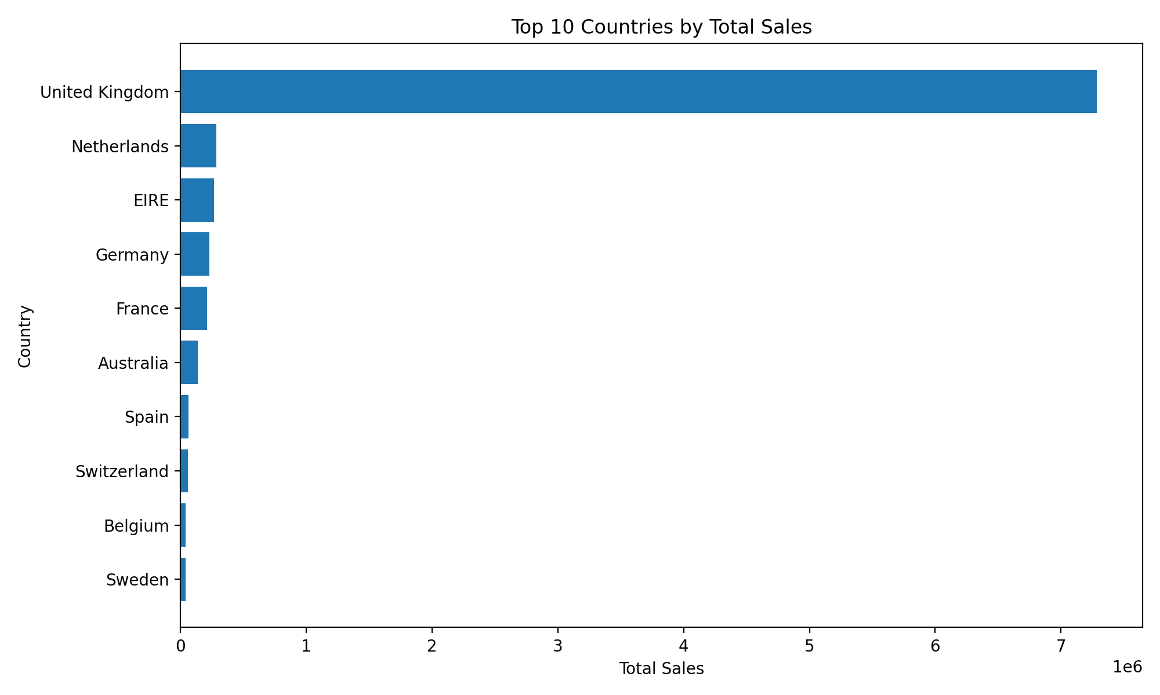
Figure 3. Top 10 countries by total sales.

8. Quantity Distribution
The quantity distribution is highly concentrated toward smaller transaction quantities, while a smaller number of transactions contain much larger quantities. For readability, the visualization is capped at the 99th percentile; this is a display transformation rather than deletion of observations.
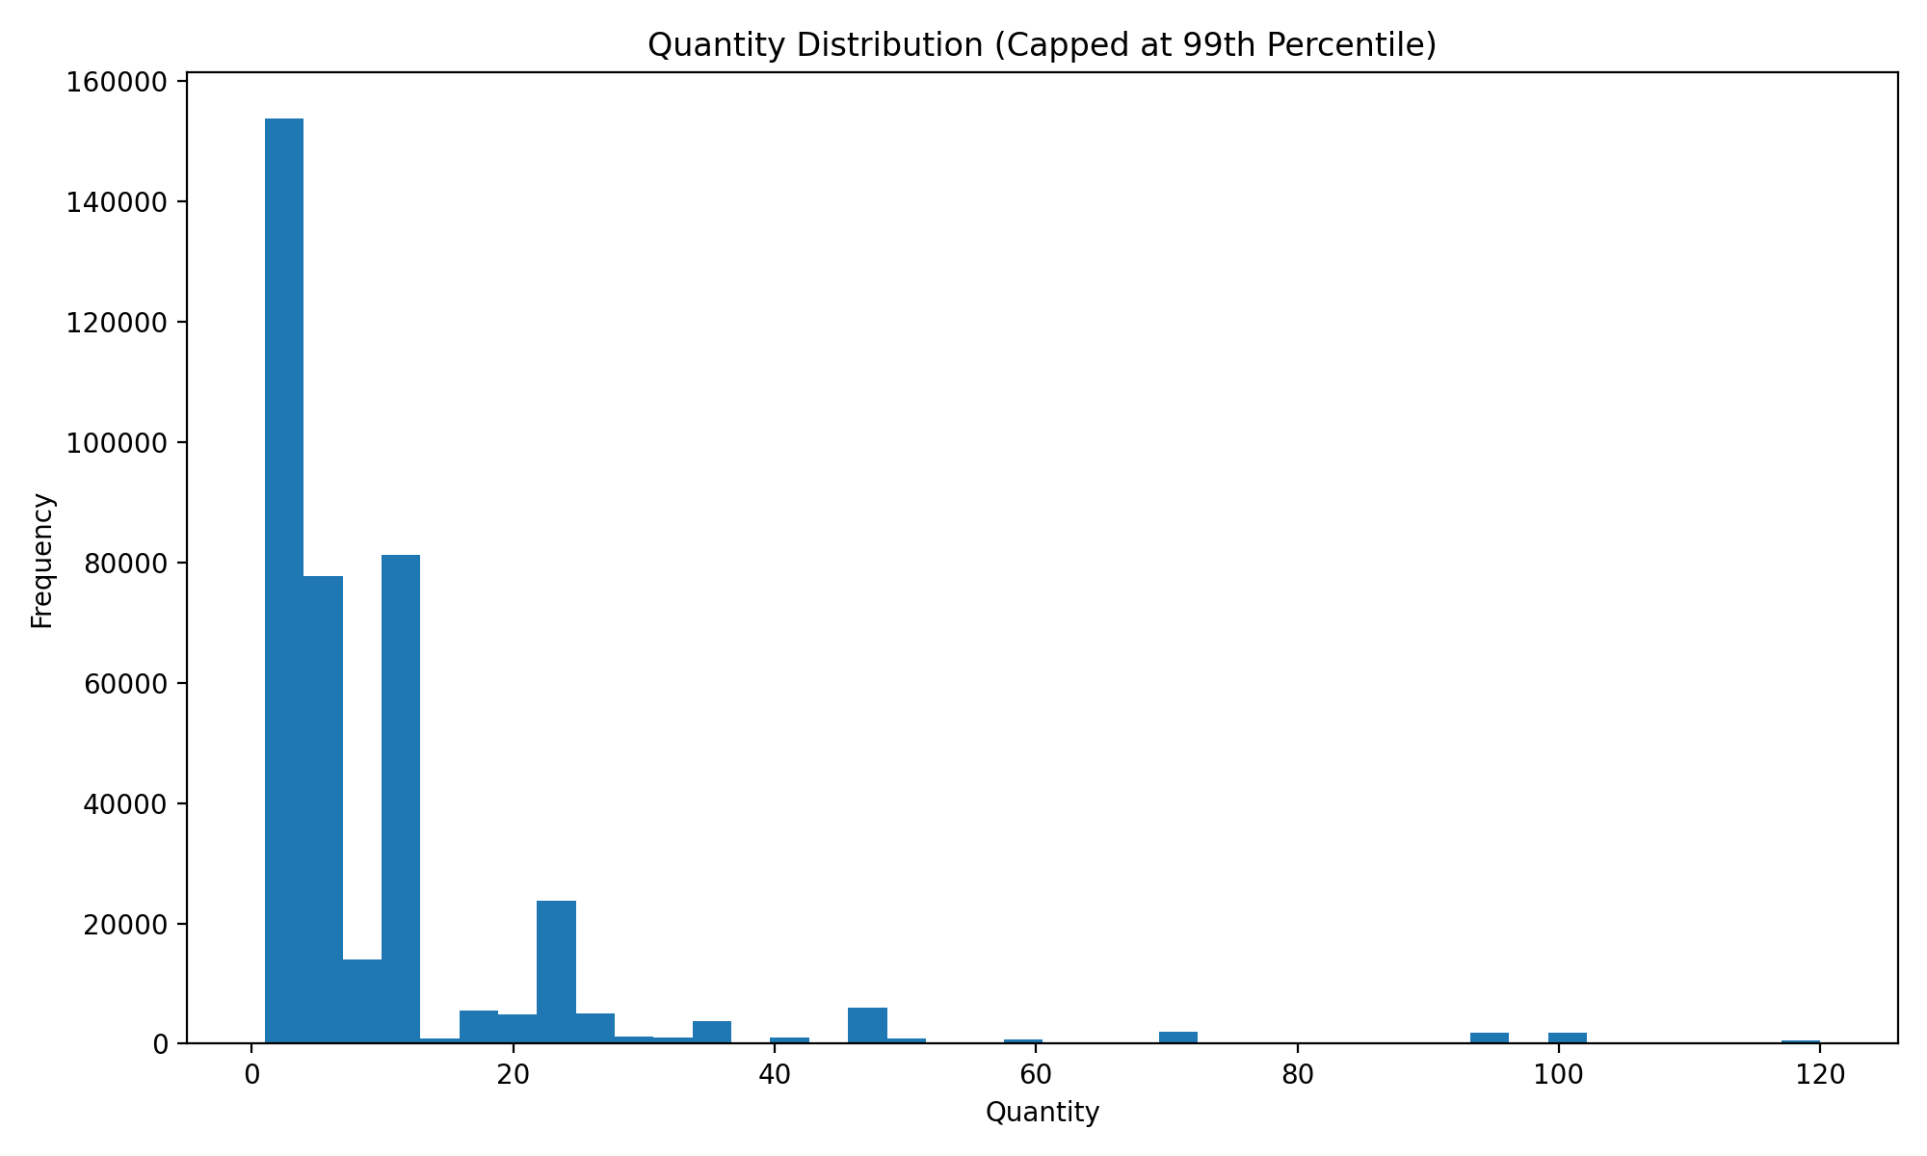
Figure 4. Quantity distribution, capped at the 99th percentile.

9. Unit Price Distribution
Unit prices are also concentrated toward lower values, with a smaller number of higher-priced transactions. The 99th-percentile display cap makes the central distribution easier to interpret while retaining the original data for analysis.
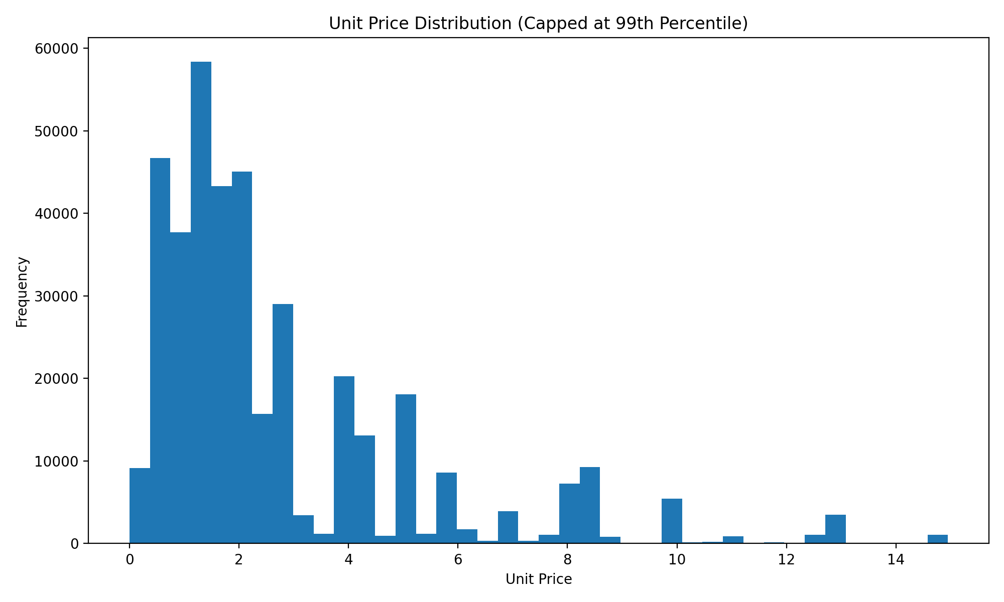
Figure 5. Unit price distribution, capped at the 99th percentile.

10. Correlation Analysis
Correlation analysis was performed for Quantity, UnitPrice, and TotalAmount. TotalAmount is mathematically derived from Quantity multiplied by UnitPrice, so a strong relationship with these variables is expected. The heatmap is therefore interpreted as a descriptive relationship rather than evidence of causation.
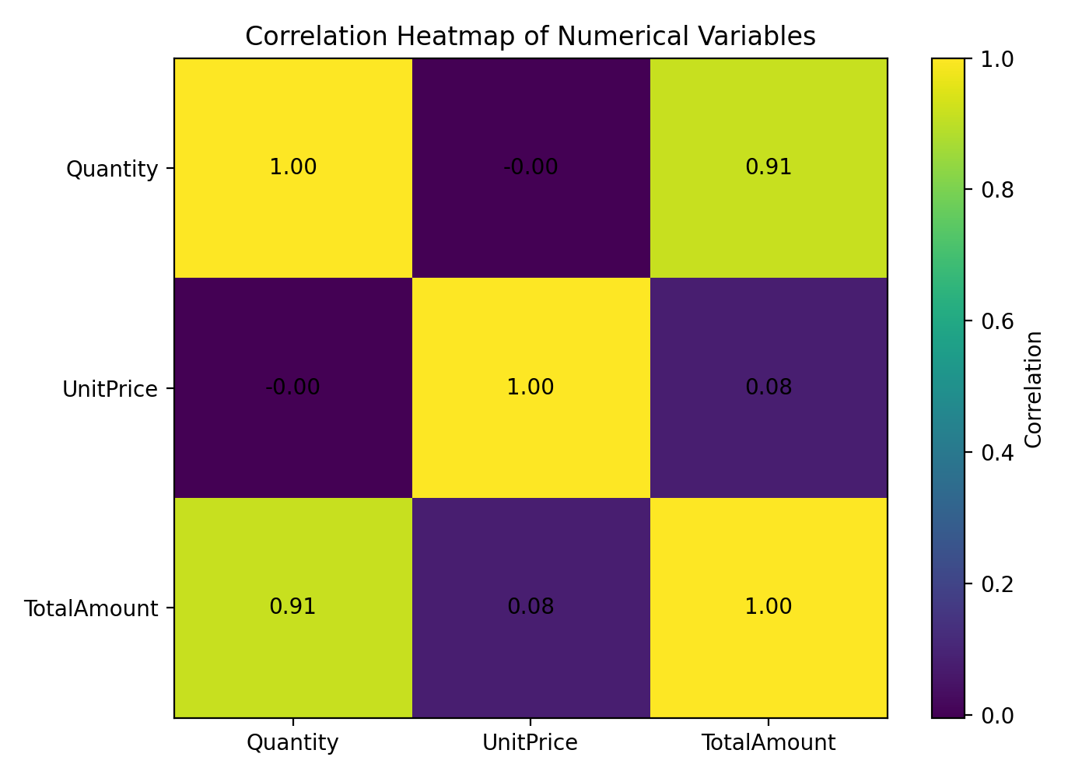
Figure 6. Correlation heatmap of numerical variables.

11. Customer Spending Analysis
Customer-level aggregation showed that the highest-spending customer in the cleaned data had approximately 77,183.60 in total transaction value. Comparing the highest-spending customers helps reveal concentration in customer value and provides a basis for future customer segmentation or RFM analysis.
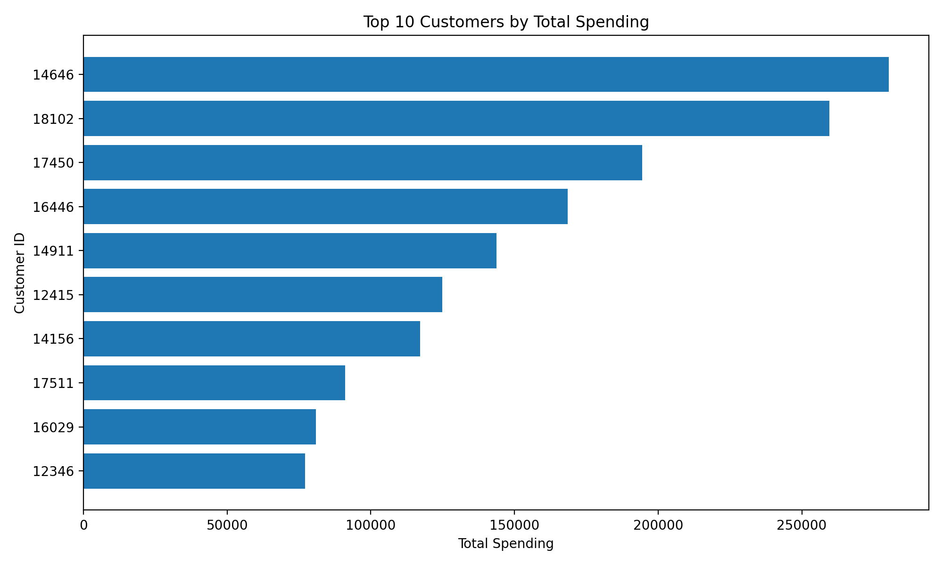
Figure 7. Top 10 customers by total spending.

12. Key Findings and Interpretation
- Revenue varies over time, indicating that sales activity is not uniform across the observation period.
- A relatively small group of products contributes a substantial share of transaction value, highlighting product-level concentration.
- Sales are geographically concentrated, with the leading markets contributing much more transaction value than many smaller markets.
- Quantity and unit price distributions are right-skewed, making percentile-based visualization useful for revealing the main pattern.
- TotalAmount is naturally related to Quantity and UnitPrice because it is calculated from both variables; this should be considered when interpreting correlations.
- Customer spending is uneven, with a small group of customers accounting for much higher transaction value than the typical customer.

13. Data Transformations and Aggregations
The main transformations were datetime conversion for InvoiceDate, numeric conversion for analytical fields, and aggregation using groupby and resampling. Monthly revenue was calculated using monthly resampling. Product, country, and customer analyses used groupby with sum aggregation. For distribution visualizations, the 99th percentile was used as a plotting cap to improve readability without modifying the analytical dataset.

14. Python Code Snippet
monthly_sales = (
df.set_index("InvoiceDate")
.resample("M")["TotalAmount"]
.sum()
)
top_products = (
df.groupby("Description")["TotalAmount"]
.sum()
.sort_values(ascending=False)
.head(10)
)

15. Conclusion
The EDA provided a structured understanding of the cleaned Online Retail dataset. Visualization made it possible to identify temporal trends, product and geographic concentration, skewed numerical distributions, customer spending differences, and relationships among numerical variables. The results provide a useful foundation for subsequent statistical analysis, customer segmentation, forecasting, or machine learning tasks.

