Technical Report: AI-Driven Automated Land Use / Land Cover Mapping System for Andhra Pradesh
Project: PS-6 Intelligent Cartography Pipeline — V6 Pro Application: Automated Building Detection, Road Network Extraction & Auto-Completion, Water Body Delineation & Temporal Change Detection Region: Andhra Pradesh, India Organization: Yantrikaran Innovation Pvt. Ltd Date: March 2026 (updated June 2026) Model: SegFormer-B5 — 84M Parameters Best mIoU: 0.5474
Live Web App: https://smart-property-identification-urban.vercel.app
Drive Link: Drive Link
Webapp Demo Video: https://youtu.be/gDCqMdHGb9o
Note: The platform UI and features have been updated, and new users now see an automatic guided tour. This video is about two months old, so the interface shown may be outdated.

1. Executive Summary
This report presents a production-grade, end-to-end deep learning pipeline for automated semantic segmentation of high-resolution satellite imagery, purpose-built for Andhra Pradesh’s PS-6 land mapping requirements. The system combines a state-of-the-art 84-million parameter SegFormer-B5 transformer with domain-specific geometric post-processing — including skeleton-based road network auto-completion — and a cloud-native deployment architecture to produce survey-grade land use / land cover (LULC) maps at scale, with automated monthly, quarterly, and annual temporal change monitoring.
Deployment note (June 2026): The live prototype currently runs on a lightweight, cost-free cloud stack — Hugging Face Spaces (model inference + data API), Vercel (web app), and Cloudflare R2 (object storage). The AWS SageMaker + ArcGIS Online architecture (see Deployment Architecture and ArcGIS Integration) is the target production architecture. Both are documented below.
Final Model Performance (60 Epochs, T4×2 GPU, ~48 hours):
Metric | Value
Overall mIoU | 0.5474
Background IoU | 0.880
Building IoU | 0.430
Road IoU | 0.431
Water IoU | 0.635
Open Land IoU | 0.281
TTA + V4 Post-processed mIoU | 0.5474
Key Innovations
- SegFormer-B5 Encoder — the largest SegFormer variant (~84M parameters) pretrained on ADE20K-640, providing superior multi-scale feature extraction over B4.
- Focal Tversky + Weighted CE Training — recall-oriented loss with asymmetric FN/FP weighting (α=0.3, β=0.7), focal hard-example mining (γ=0.75), and auto-computed class weights with 2× road boosting.
- 4-Way TTA + Geometry-Constrained Post-Processing — test-time flip averaging, convex-hull building regularization, and skeleton-based road width normalization with gap bridging (road auto-completion).
- Cloud Inference Pipeline — current prototype on Hugging Face Spaces (CPU) with Cloudflare R2 large-file handling; target production on AWS SageMaker scheduled endpoints.
- Interactive Web Platform — live LULC mapping, AOI-based analytics, upload-and-analyze, and temporal change detection, with an in-app Auto-Guide tour mode.

2. Results & Demo
Live Web App: https://smart-property-identification-urban.vercel.app
Demo Video: https://youtu.be/gDCqMdHGb9o
Note: The platform UI and features have been updated, and new users now see an automatic guided tour. This video is about two months old, so the interface shown may be outdated.

2.1 Quantitative Results (Validation — 2,736 chips)
Class | IoU
Background | 0.880
Building | 0.430
Road | 0.431
Water | 0.635
Open Land | 0.281
Overall mIoU (TTA + V4) | 0.5474

2.2 Prediction Gallery
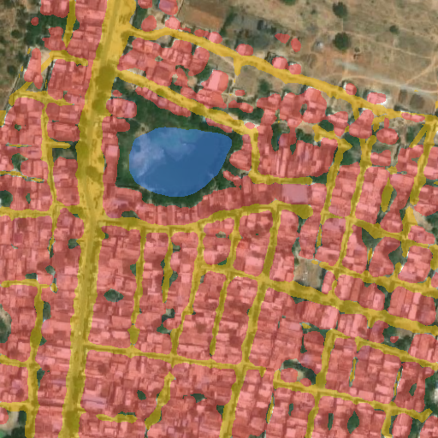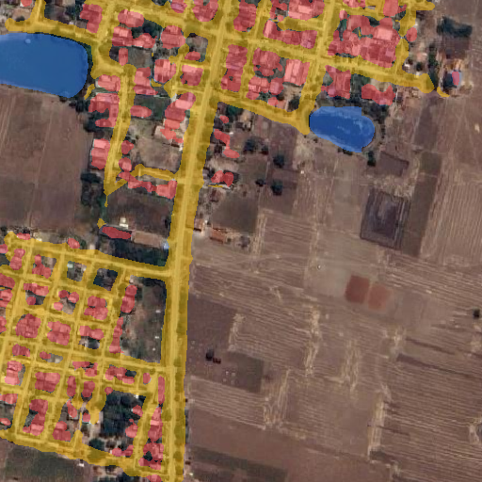

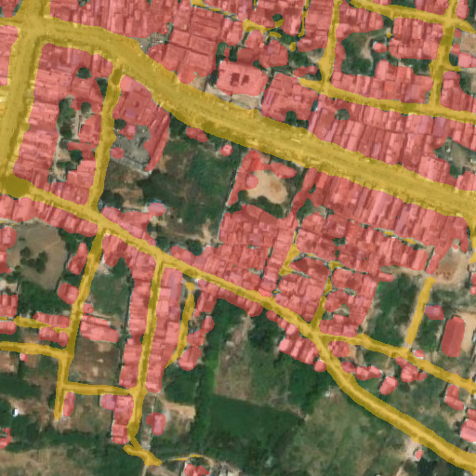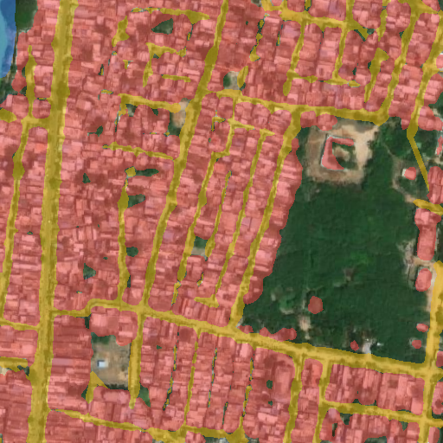

3. Platform Navigation Guide
The web app exposes five primary sections via the top navigation bar.
Nav Item | What it does
Home | Landing overview of the platform, status, and quick links.
Mapping | Interactive Mapbox map of AP districts. Toggle LULC, drone imagery, buildings/roads/water/open layers; switch base maps; draw or upload an Area of Interest (AOI); view AOI analytics (building/water counts, road km); and view detection overlays sent from Upload & Analysis.
Upload & Analysis | Run AI on your own imagery: AI Segmentation, Change Detection (two images), Boundary Analysis, and Mask Overlay. Supports up to 500 MB images via temporary cloud storage.
Data Logs | Processing history and dataset/run records.
DSS | Decision-Support dashboards and analytics.

3.1 Quick Workflows
- Analyze an AOI: Mapping → pick State/District → Draw AOI or Upload a boundary (GeoJSON/Shapefile/KML/GeoPackage) → the map auto-detects the district, clips data to the boundary, and shows counts of buildings, water bodies, and road length. Multi-polygon files let you click any parcel to see its individual stats.
- Segment an image: Upload & Analysis → AI Segmentation → drop one or more images → run → view input vs. colored mask + class-distribution stats → download.
- Plot a GeoTIFF on the map: after segmenting a GeoTIFF, click “Plot Detection Overlay on Map” → it is placed as a geo-referenced overlay on the Mapping page with opacity / zoom-to / remove controls.
- Detect change: Upload & Analysis → Change Detection → upload a PAST and a PRESENT image → run → view past mask, present mask, change map + per-category change percentages.

3.2 Auto-Guide Mode
The platform includes an in-app Auto-Guide tour that automatically walks new users through every feature — highlighting each control, explaining what it does, and demonstrating a sample workflow. Launch it from the help/guide control; it narrates and visually points to the navigation, AOI tools, layer toggles, analytics panel, and the Upload & Analysis options, so first-time stakeholders can self-onboard without training.

4. Output Deliverables
Deliverable | Format | Description
LULC Classification Map | GeoTIFF / PNG | Per-pixel class labels (5 classes)
Building Confidence Map | GeoTIFF | 3-tier confidence raster
Change Detection Map | GeoTIFF + SHP + GeoJSON / PNG | Temporal transition polygons + stats
Training Metrics | JSON | Per-epoch loss, mIoU, per-class IoU, LR
Prediction Gallery | PNG | RGB / GT / Raw / V4+TTA / Confidence
Model Weights | PyTorch (.pth) | Model (+ optimizer state)
Web Dashboard | Web App | Interactive maps + analytics
Change Reports | PDF + Excel | Monthly/quarterly/annual summaries

Platform Screenshots
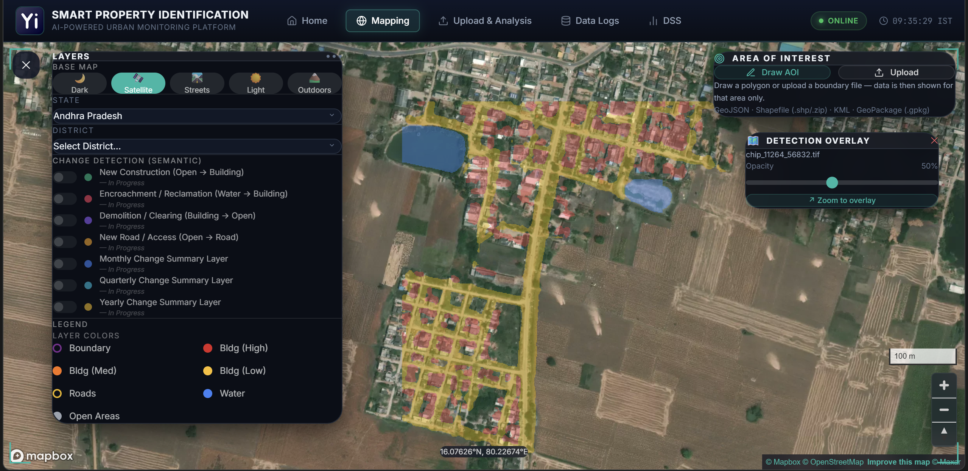
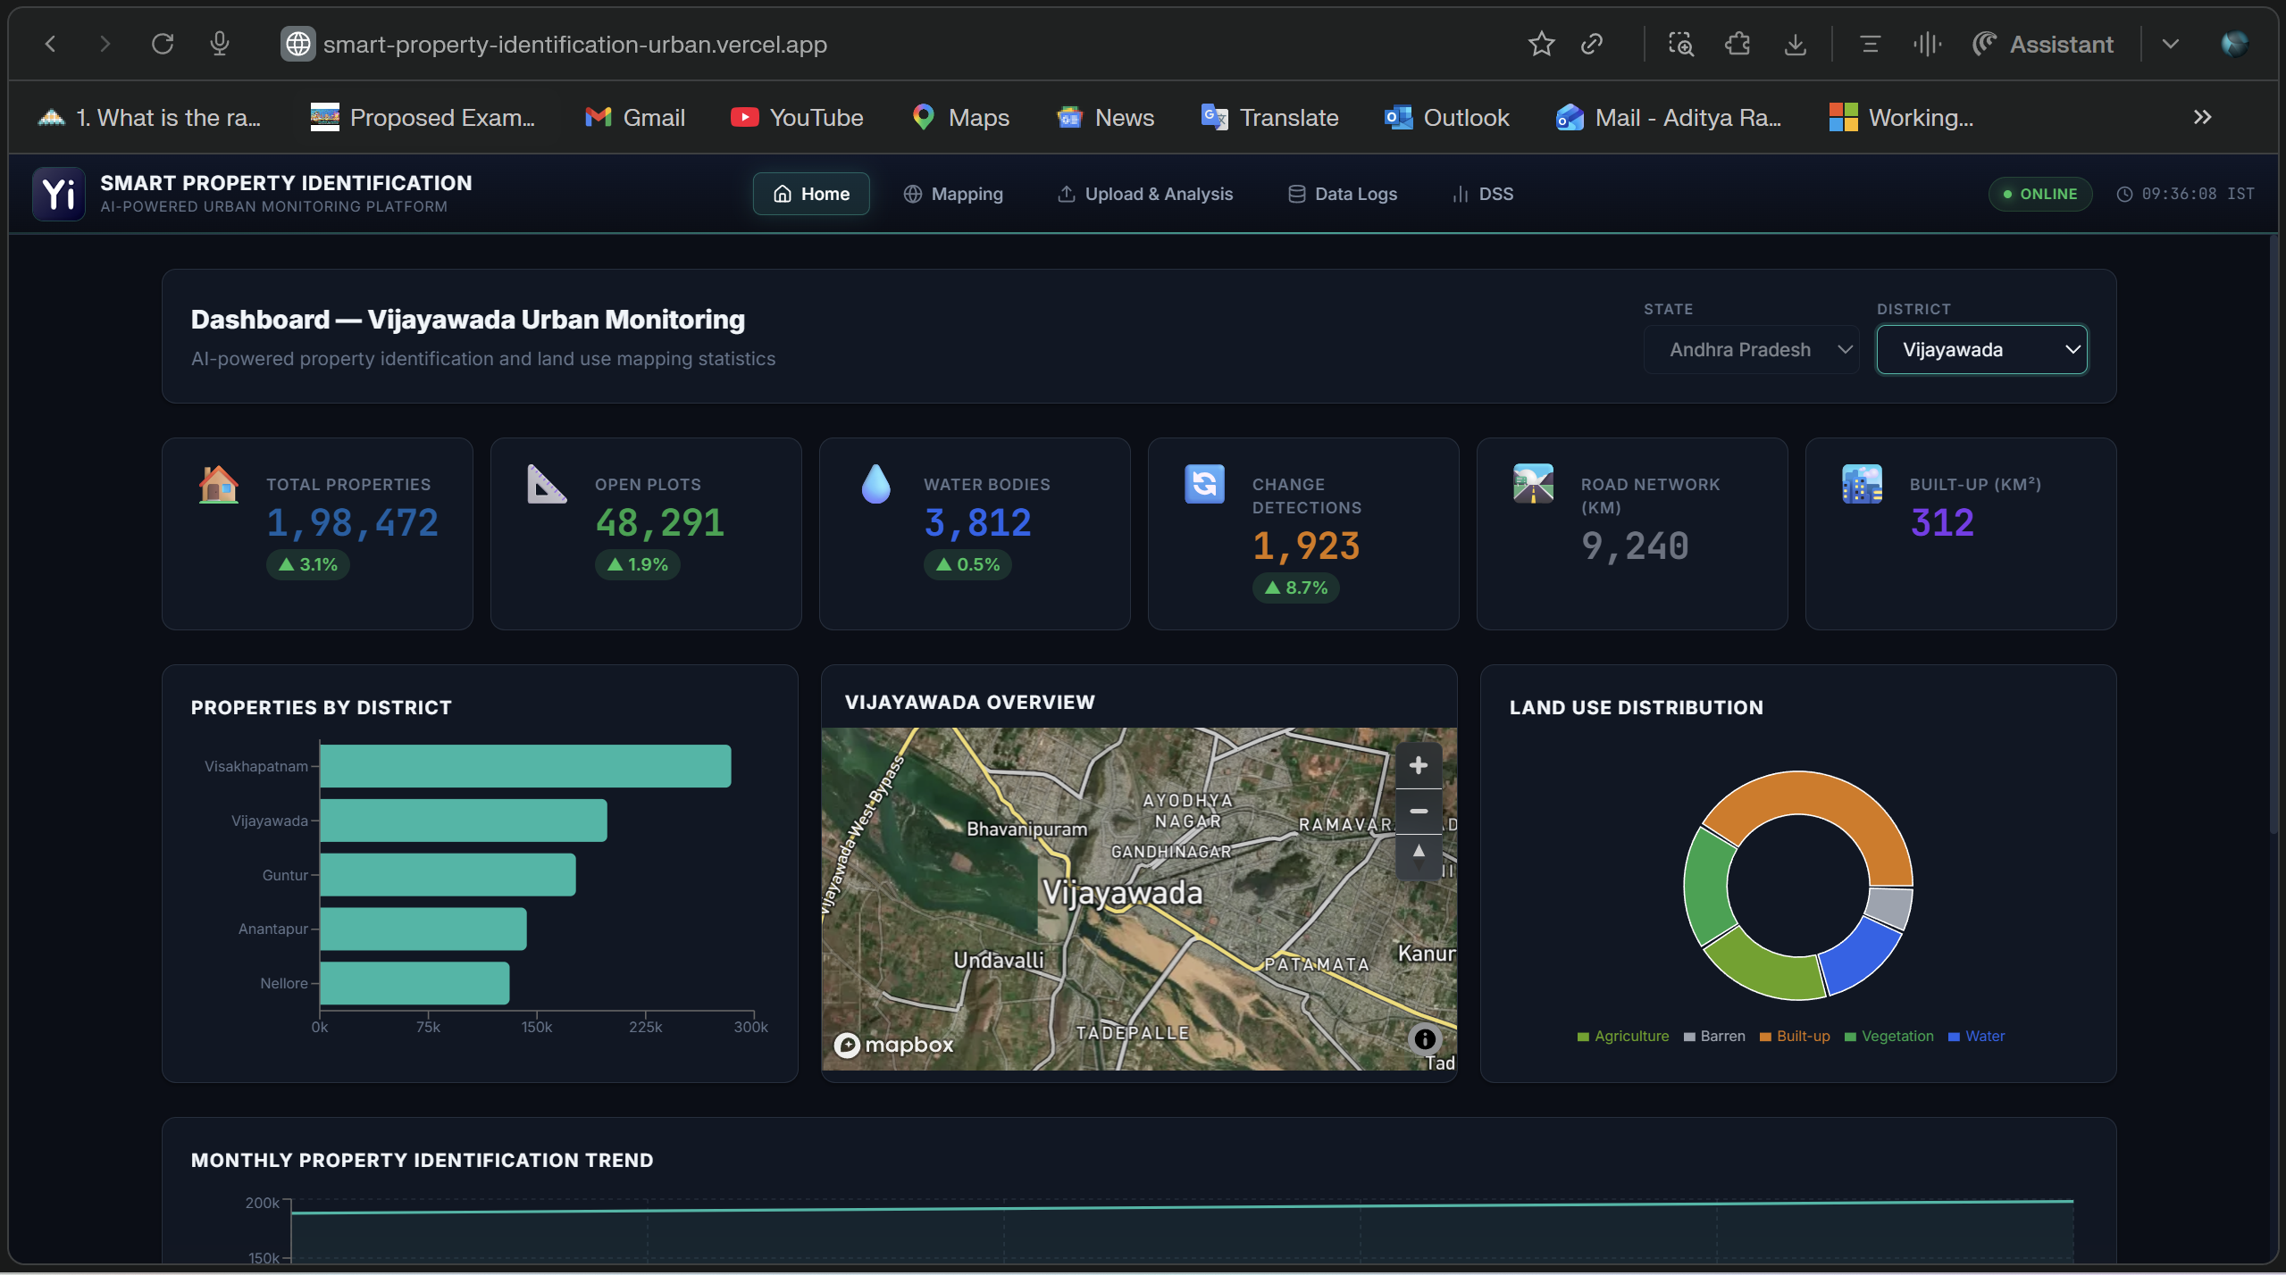
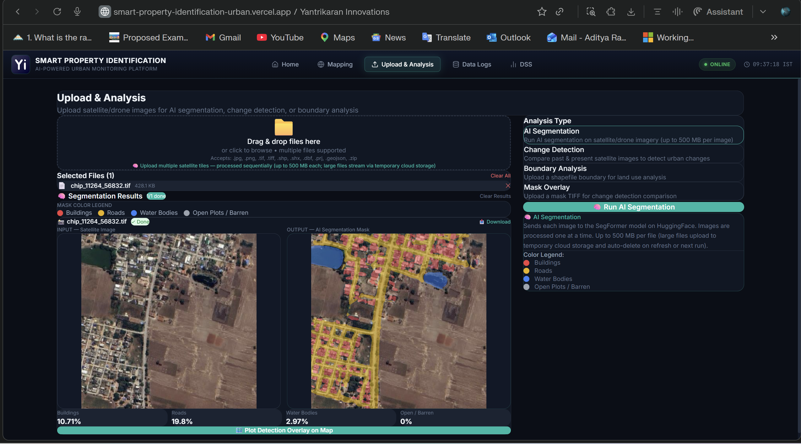
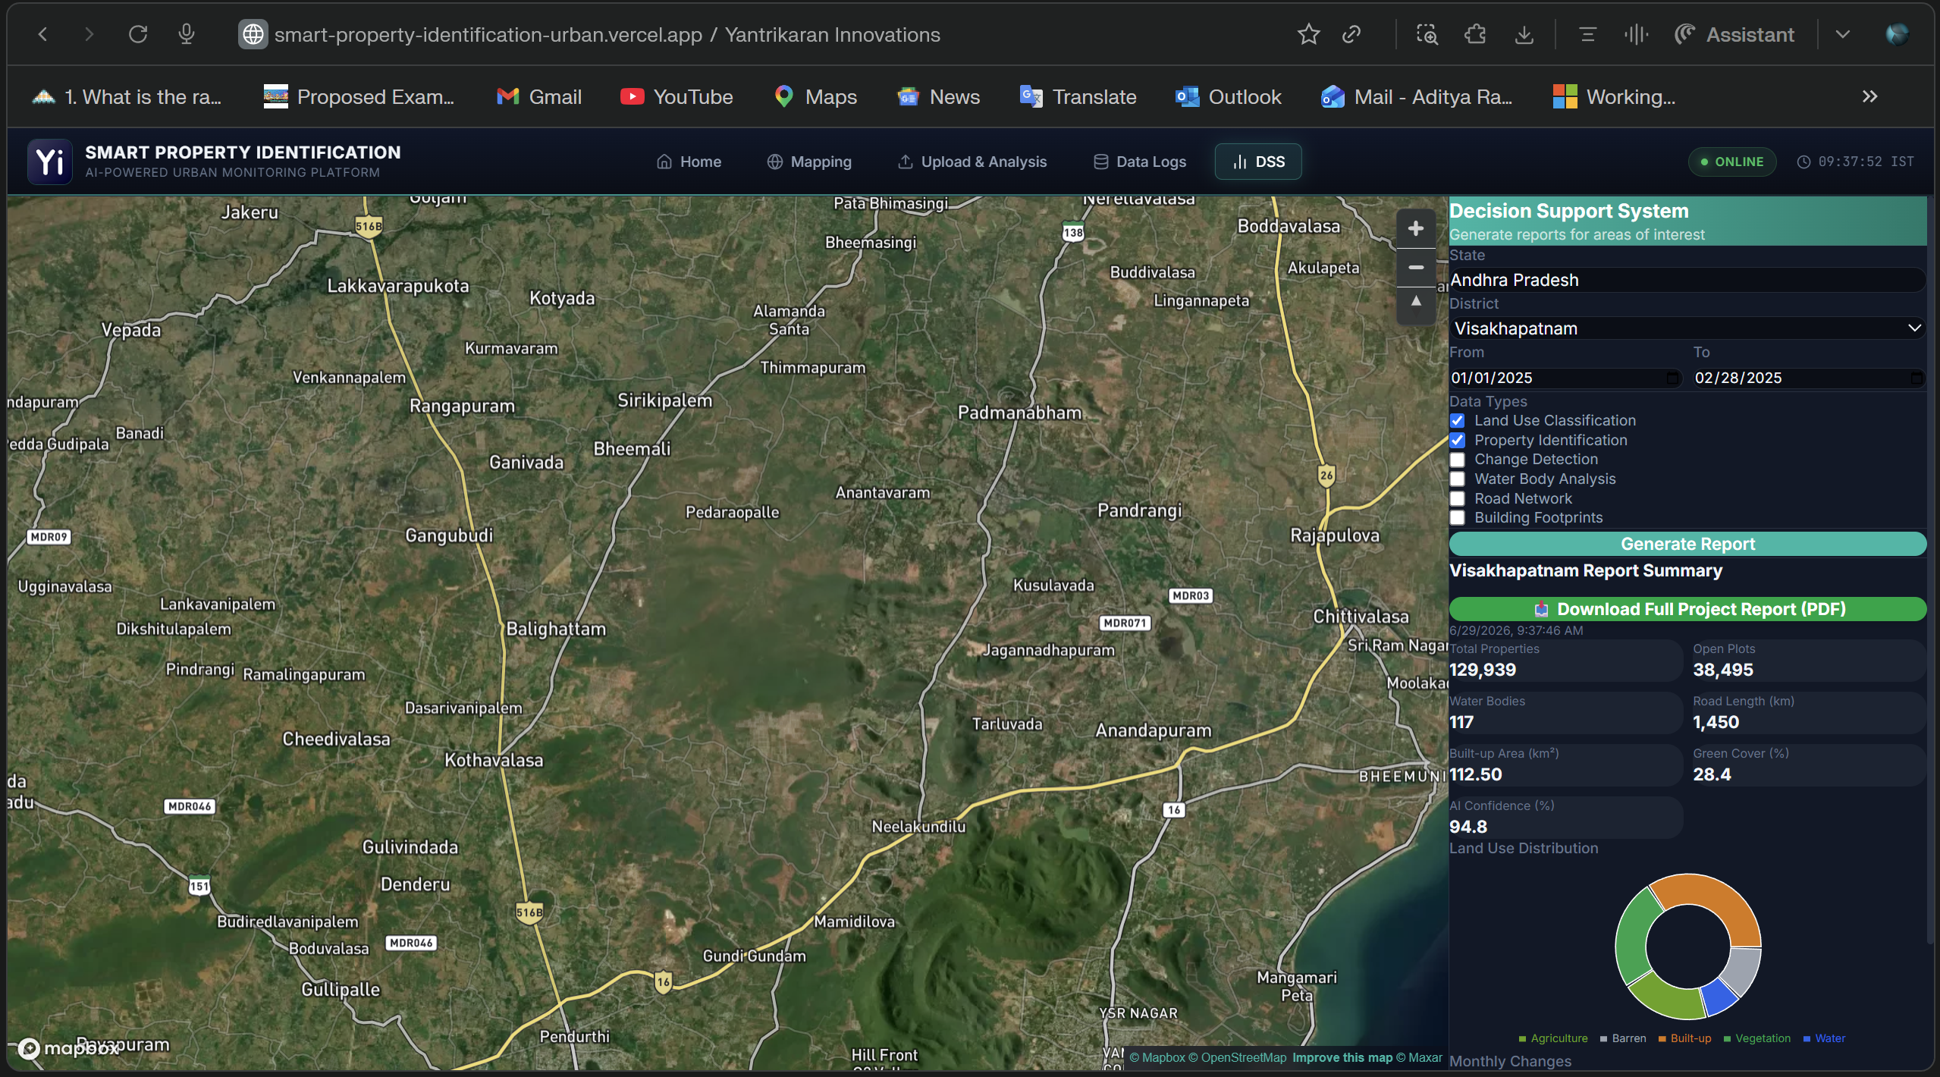

Technical Details

6. Problem Statement
Manual land use mapping across Andhra Pradesh’s 160,000+ km² area is slow, costly, and inconsistent — it relies on manual digitization by GIS analysts and requires 6–12 months per district update, making maps outdated, especially in fast-growing regions like Vijayawada and Visakhapatnam.
The PS-6 mapping standard requires an automated, scalable solution capable of pixel-level classification of buildings, roads, water bodies, and open land. The system must maintain high geometric fidelity for building footprints and ensure complete, continuous road networks without fragmentation. It should efficiently process thousands of satellite chips per district, support change detection on monthly/quarterly/annual timelines, and deliver results in real time through a web dashboard.

6.1 Our Solution
A fully automated AI pipeline that reduces the mapping cycle from months to hours — deployed to the cloud for scheduled periodic re-processing and surfaced through Yantrikaran’s custom web application for real-time stakeholder access
7. System Architecture — End-to-End Pipeline
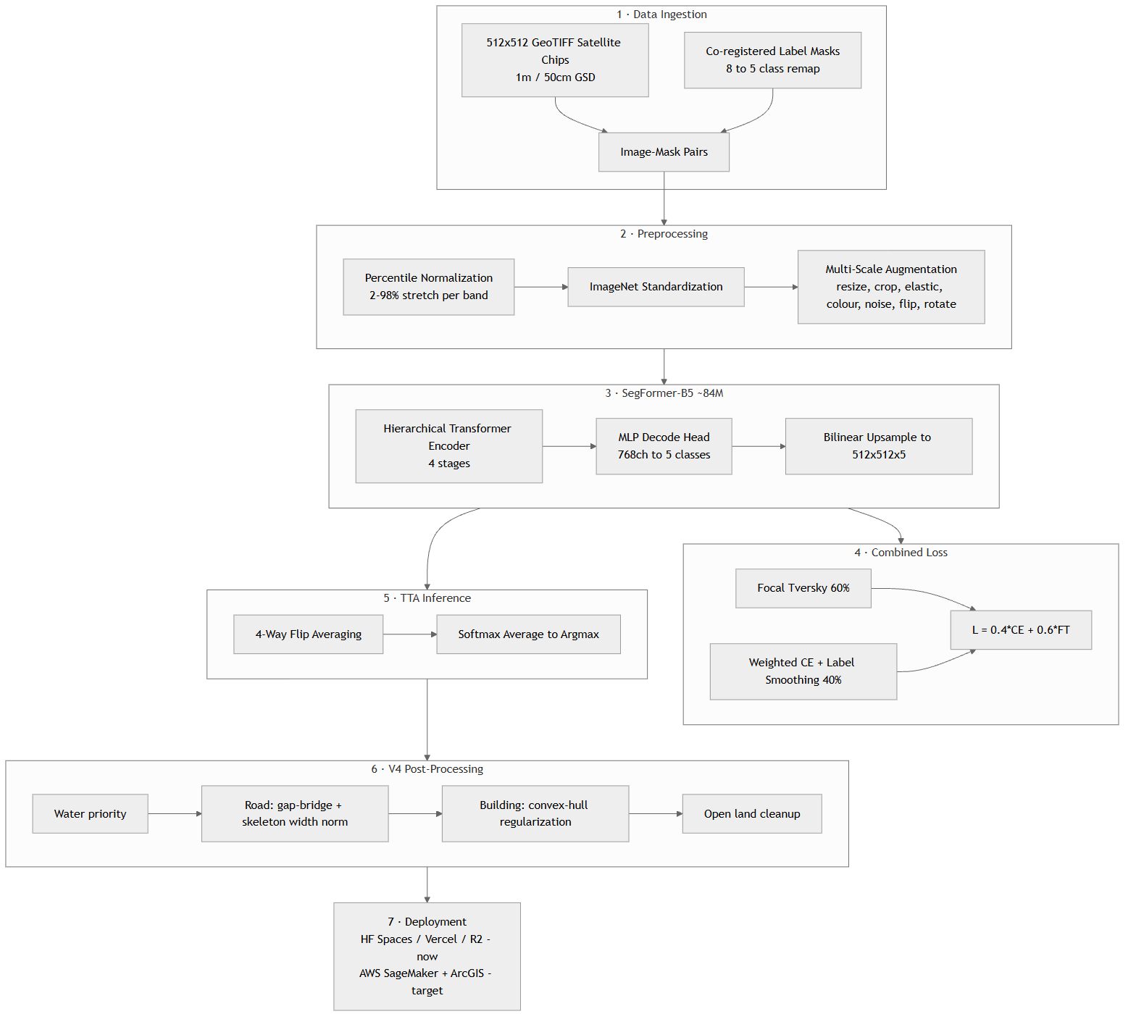
Figure 1

8. Dataset Architecture — Custom Prepared & Cleaned

8.1 Data Sources
Component | Specification
Satellite Imagery | ESRI World Imagery (R&D); Commercial 1m/50cm GSD for production
Chip Size | 512 × 512 pixels (512m × 512m at 1m GSD)
Geographic Scope | 5 districts across Andhra Pradesh
Total Volume | 18,240 chips (custom prepared)
Note: ESRI World Imagery is used for R&D under academic/startup licensing. Production deployment will transition to commercial satellite imagery providers at 1m or 50cm GSD via API subscription.

8.2 Custom Dataset Preparation Pipeline
The training dataset was custom-built from scratch for the AP PS-6 use case — no pre-existing public segmentation dataset covers AP’s terrain, building styles, and road patterns at the required resolution. Label masks were constructed from raw OpenStreetMap (OSM) vector data (southern India) and Google Open Buildings footprints, processed and rasterized using a QGIS + Python geospatial pipeline.
Property | Detail
Custom-built | Entire dataset prepared specifically for AP PS-6 — no public dataset available
Source Data | Raw OSM vectors (southern India) + Google Open Buildings footprints
Toolchain | QGIS for vector merging, CRS reprojection, class definition, rasterization to GeoTIFF masks
CRS-verified | Every image-mask pair verified for spatial alignment and CRS consistency
Cleaned | Corrupt/truncated GeoTIFFs filtered; unreadable tiles auto-skipped during training
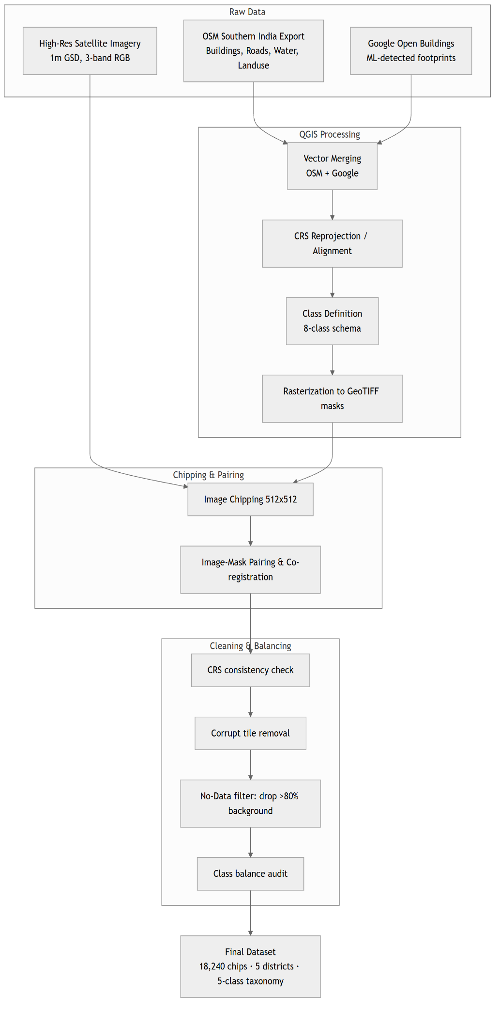

8.3 District-wise Data Distribution
District | Chips | Coverage | Terrain Diversity | Monthly Urban?
Anantapur | 4,027 | ~1,055 km² | Semi-arid plateau, sparse settlement | No
Guntur | 4,145 | ~1,086 km² | Agricultural delta, canal networks | No
Nellore | 5,020 | ~1,315 km² | Coastal plains, aquaculture ponds | No
Vijayawada | 2,977 | ~780 km² | Dense urban core, Krishna delta | Yes
Visakhapatnam | 2,071 | ~543 km² | Coastal urban, port, hills | Yes
Total | 18,240 | ~4,779 km² | Full AP diversity

8.4 Class Taxonomy — 8 → 5 Remapping
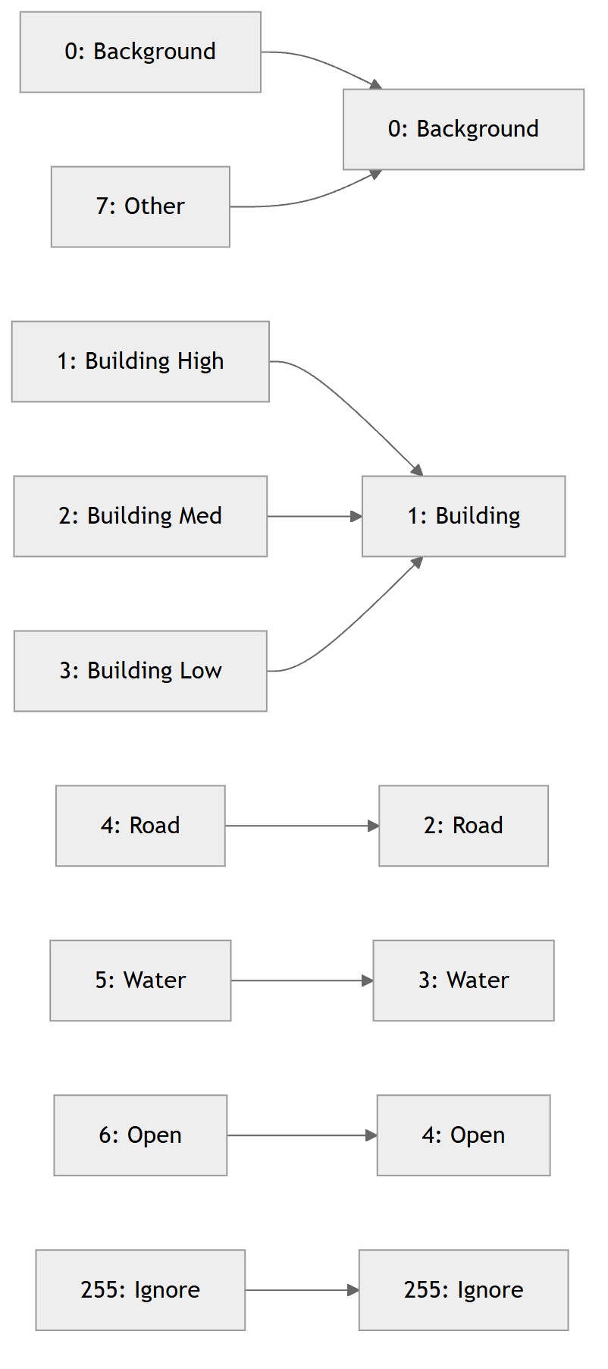
Figure 3
Design Decision: Building confidence tiers (high/medium/low) are merged during training to maximize detection recall. Post-inference, the system regenerates 3-tier confidence from the model’s calibrated softmax probabilities — a data-driven confidence measure superior to manual labeling.

8.5 Train/Validation Split
Training Pool = ALL 5 DISTRICTS (unified)
= 18,240 chips -> 85% train (15,504) + 15% val (2,736)
Stratified random split (seed = 42)

9. Preprocessing Pipeline

9.1 Adaptive Percentile Normalization
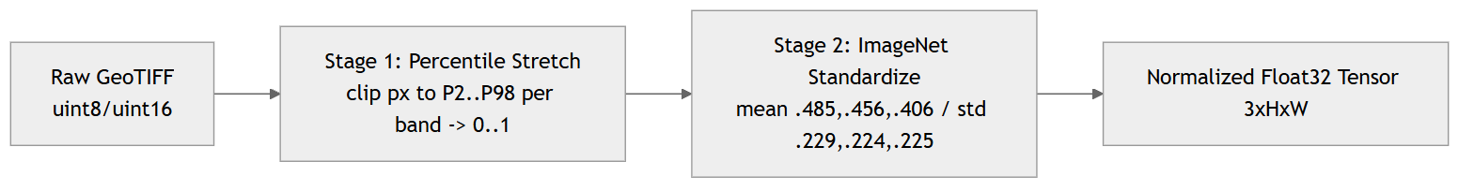
Figure 4

9.2 Multi-Scale Data Augmentation (V6 Pro)
Augmentation | Parameters | Probability | Impact
Multi-scale resize | [0.5×, 2.0×] | 100% | +3–5% mIoU (scale invariance)
Elastic deformation | α=60, σ=8 | 30% | Better boundary handling
Horizontal flip | — | 50% | Orientation invariance
Vertical flip | — | 50% | Orientation invariance
Random 90° rotation | 0/90/180/270 | 75% | Nadir view symmetry
Colour jitter | ±0.2 brightness/contrast | 60% | Atmospheric/sensor variation
Gaussian noise | σ = 0.02 | 50% | Sensor noise robustness

10. Model Architecture: SegFormer-B5 — Deep Dive

10.1 Why SegFormer over CNN-Based Architectures?
Architecture | Type | Parameters | Key Limitation for PS-6
U-Net | CNN encoder-decoder | ~31M | Limited receptive field — misses large buildings
DeepLabV3+ | CNN atrous conv | ~41M | Fixed dilated rates — inflexible multi-scale
HRNet | CNN multi-resolution | ~65M | High VRAM — cannot use large crops
Swin-UNet | Transformer (shifted windows) | ~27M | Complex — slower convergence
SegFormer-B5 | Hierarchical Transformer | ~84M | ✅ Best balance: efficiency + accuracy
Architectural advantages for satellite imagery: efficient self-attention with sequence reduction (O(N²)→O(N²/R)); hierarchical multi-scale features (1/4, 1/8, 1/16, 1/32); Mix-FFN positional encoding (resolution-agnostic); lightweight all-MLP decoder.

10.2 Why B5 over B4?
Property | B4 | B5 | Impact
Parameters | ~64M | ~84M (+31%) | Deeper representations
Encoder Blocks | 3-8-27-3 | 3-6-40-3 | +48% Stage-3 blocks
Embedding Dims | 64-128-320-512 | 64-128-320-512 | Same
Attention Heads | 1-2-5-8 | 1-2-5-8 | Same
ADE20K mIoU | 50.3% | 51.0% | +0.7%
VRAM (b=2, 512) | ~10 GB | ~14 GB | Fits T4×2
Key Insight: B5’s extra capacity comes from 40 transformer blocks in Stage 3 (vs 27 in B4). Stage 3 operates at 32×32 — the critical scale for distinguishing building footprints (8–50px at 1m GSD).

10.3 Encoder–Decoder Architecture
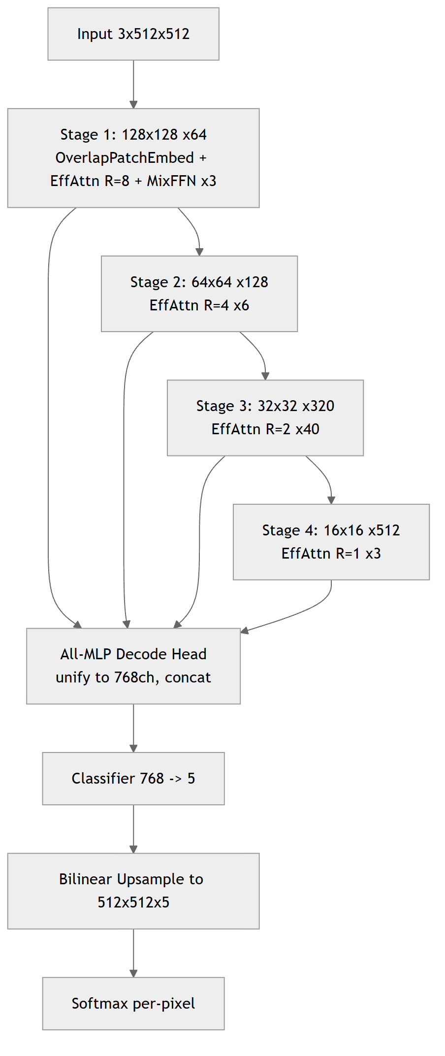
Figure 5

10.4 Efficient Self-Attention (Sequence Reduction)
Stage | Resolution | Seq Length N | Reduction R | Complexity
1 | 128×128 | 16,384 | 8 | O(N²/8)
2 | 64×64 | 4,096 | 4 | O(N²/4)
3 | 32×32 | 1,024 | 2 | O(N²/2)
4 | 16×16 | 256 | 1 | O(N²) — full
The architecture is input-resolution agnostic (no fixed positional embeddings), enabling inference on 1m GSD satellite chips and higher-resolution 50cm/10cm drone imagery without retraining.

10.5 Model Efficiency Profile
Metric | Value
Total Parameters | 84.7M
Encoder / Decoder | 82.0M (97%) / 2.7M (3%)
Model File Size | ~450 MB (full) · ~339 MB (slim, weights only)
FP16 Inference VRAM | ~3.5 GB per chip
Training VRAM (b=2, 512) | ~14 GB
Inference Latency (TTA, T4) | ~0.5s/chip
Throughput (T4×2) | ~14,400 chips/hour ≈ 3,600 km²/hr

10.6 Pretrained Initialization
Initialized from nvidia/segformer-b5-finetuned-ade-640-640 (150 classes), classification head replaced (150 → 5, random init), then end-to-end fine-tuned. ADE20K’s 640×640 resolution closely matches the 512×512 crops, minimizing distribution shift.

11. Training Objective

11.1 Combined Loss
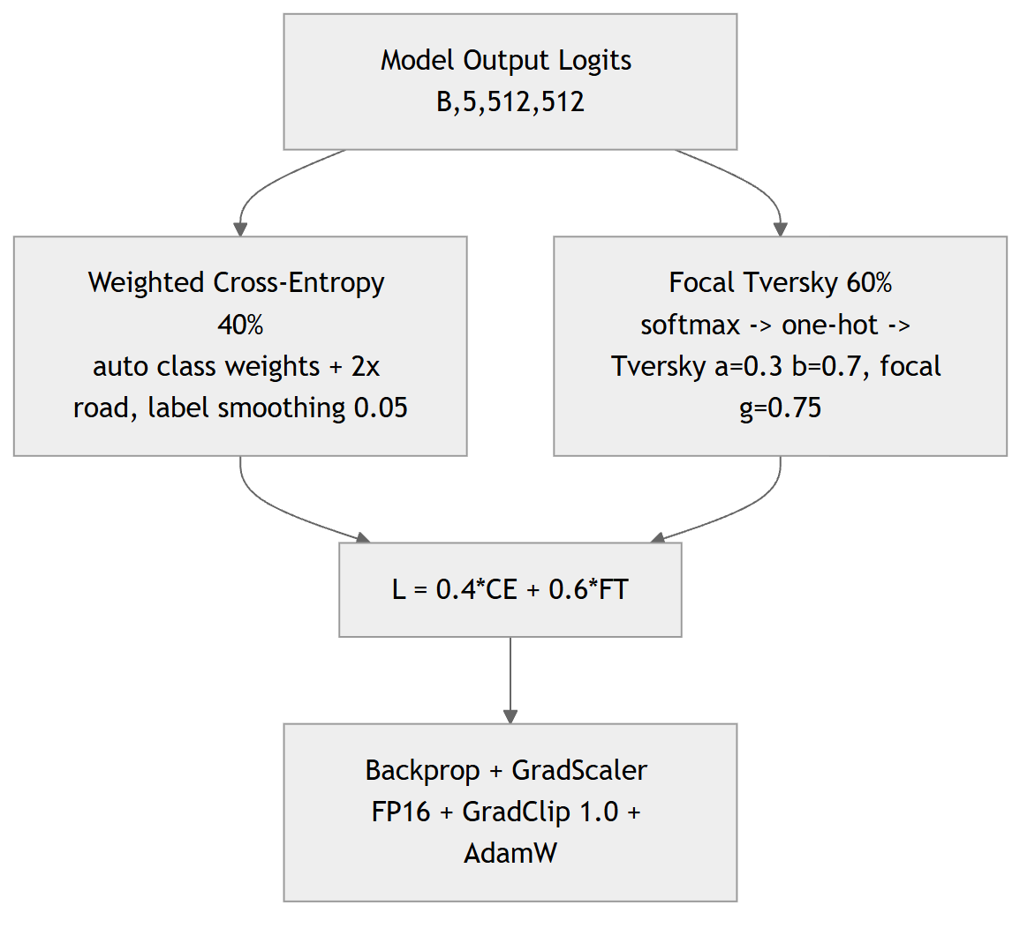
Figure 6

11.2 Auto-Computed Class Weights
Sample 500 random chips → count per-class pixel frequency → w_c = 1 / freq → normalize → 2× road boost → clip to [0.5, …] → final auto-adapted weights. Auto-weights adapt to the actual pixel distribution regardless of which districts are included.

11.3 Focal Tversky — Why α=0.3, β=0.7?
- FN penalty (β=0.7): “Don’t miss any buildings or roads” → recall-oriented.
- FP penalty (α=0.3): “Some false positives are acceptable” → better coverage.
- Focal γ=0.75: “Focus on hard boundary pixels” → sharper edges.
The model is penalized 2.3× more for MISSING a building/road pixel than for hallucinating one — critical for survey completeness.

12. Training Configuration & Results

12.1 Hyperparameters
Parameter | Value
Model | SegFormer-B5 (~84M)
Pretrained | nvidia/segformer-b5-finetuned-ade-640-640
Training GPU | NVIDIA T4×2 (32 GB total)
Optimizer | AdamW (wd=1e-2)
LR Schedule | OneCycleLR (max_lr=3e-4), 10% warmup
Batch Size | 2 × 4 accum = effective 8
Crop Size | 512 × 512
Mixed Precision | FP16 (AMP)
Gradient Clipping | max_norm = 1.0
Epochs | 60 (early stop patience 10)
Loss | 0.4×WCE + 0.6×FocalTversky
Label Smoothing | ε = 0.05
Total Training Time | ~48 hours

12.2 Training Loop Results
Metric | Value
Best Validation mIoU | 0.5313
Best Epoch | 56
Final Train Loss | 0.8196
Final Val Loss | 0.8482

13. Test-Time Augmentation (TTA)
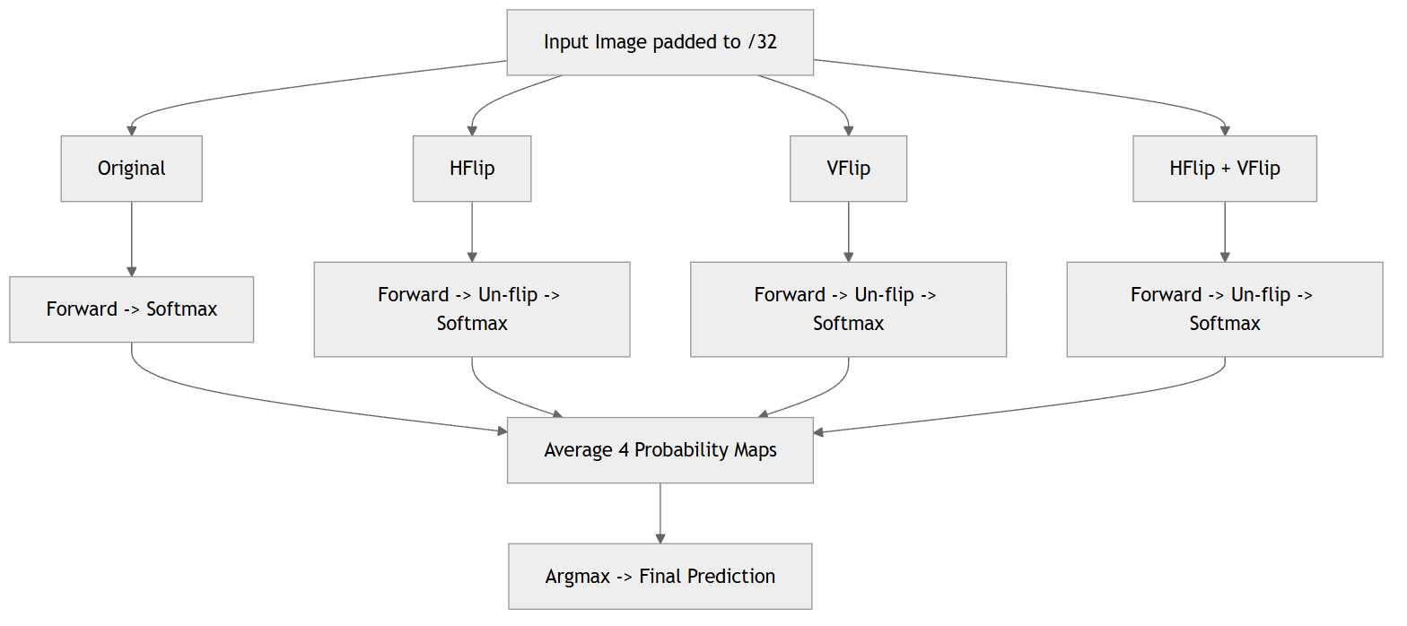
Figure 7
Impact: +2–3% mIoU at zero training cost; averaging smooths boundary uncertainty and removes spurious single-view predictions.

14. Post-Processing: V4 Geometry-Constrained Refinement

14.1 Complete Pipeline (Class Priority: Water > Road > Building > Open)
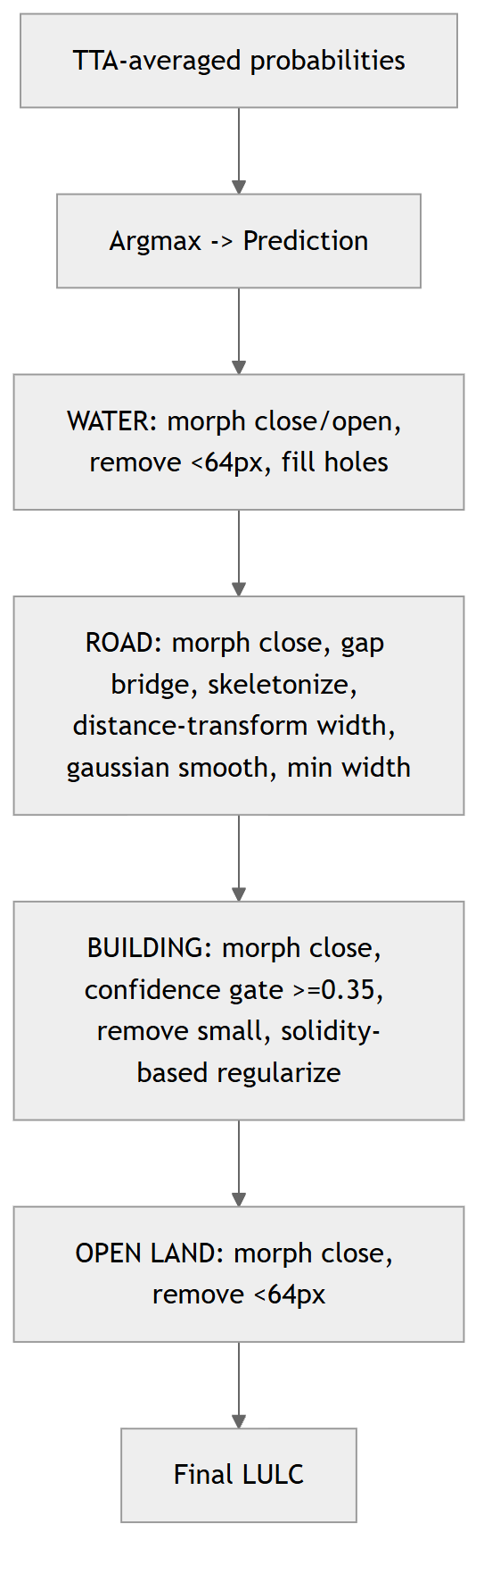
Figure 8

14.2 Building Regularization — Solidity-Based
Shape | Solidity | Method | Result
Rectangular | ≥ 0.80 | Convex hull | Clean rectangular footprint
Square | ≥ 0.90 | Convex hull | Perfect square boundary
L-shaped | 0.60–0.79 | Gaussian smoothing | Smooth L with clean edges
Compound/irregular | < 0.60 | Gaussian smoothing | Noise removed, shape preserved

14.3 Road Network Auto-Completion (Skeleton Method)
This is the road auto-completion module referenced in the project goals. Satellite-derived road masks are frequently fragmented — tree canopy, shadows, and overpasses break a continuous road into disconnected segments. The post-processor reconnects them so the output is a continuous, topologically valid network.
Figure 9
Algorithm details (from the tested inference script):
- Skeletonization reduces each road blob to a 1-pixel centerline.
- Endpoint detection finds skeleton pixels with exactly one neighbour (a dangling road end).
- Tangent estimation walks ~12px back along the skeleton to compute each endpoint’s heading.
- Candidate pairing uses a KD-tree to find endpoint pairs within max_gap (≈150px).
- Angle-aware gating keeps only pairs whose tangents point toward each other (within ±45°), so the bridge follows the road’s natural direction instead of cutting across blocks.
- MST bridging connects components with a Union-Find–constrained minimum spanning tree (weight = distance + angle penalty), guaranteeing connections without creating loops or merging already-connected components.
- Width restoration re-dilates the healed skeleton back to realistic road width.
A road-over-building priority rule then lets healed roads override only low-confidence building pixels, preventing roads from bleeding into well-detected buildings.
Roadmap: a dedicated learned road-completion model (graph/GAN-based connectivity) is planned to supplement this geometric healer for complex interchanges — see Future Scope.

14.4 Building Confidence Tiers (post-inference, from softmax)
Tier | Condition | Use
🟢 HIGH | p ≥ 0.75 | Confirmed building → direct cadastral use
🟡 MEDIUM | 0.65 ≤ p < 0.75 | Probable building → priority verification
🟠 LOW | 0.55 ≤ p < 0.65 | Possible building → field survey required

15. Change Detection Module

15.1 Methodology
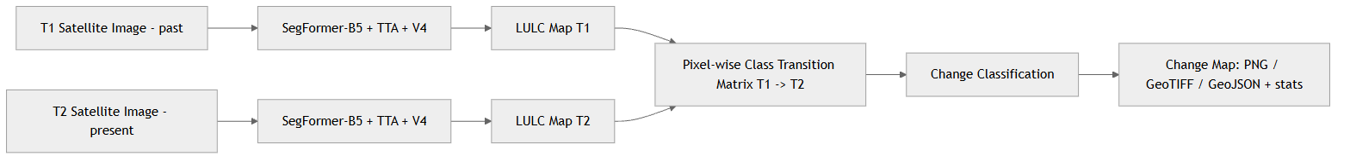
Figure 10

15.2 Change Categories
Change Type | Colour | Condition | Government Application
Building Gain / New Construction | Cyan/Green | T1 ≠ Bldg → T2 = Bldg | New construction monitoring
Building Loss / Demolished | Red | T1 = Bldg → T2 ≠ Bldg | Demolition / disaster assessment
Water Gain | Blue | T1 ≠ Water → T2 = Water | Reservoir filling / flood mapping
Water Loss | Cyan | T1 = Water → T2 ≠ Water | Drought / drainage monitoring
New Road / Access | Orange | T1 ≠ Road → T2 = Road | Infrastructure growth
Open → Built / Other | Magenta/Purple | other class change | Agricultural land conversion alert
Current web app implementation: the user uploads two images (past + present); the SegFormer Space segments both, diffs the masks server-side, and returns a categorized change map plus per-category area percentages and before/after class distributions.

15.3 Government Applications
- Urban sprawl quantification for Master Plan enforcement
- Disaster damage assessment post-cyclone/flood (rapid deployment)
- Revenue administration: detection of unauthorized construction
- Environmental compliance: water-body encroachment tracking
- Smart-city planning: growth-direction analysis for infrastructure investment

16. Deployment Architecture

16.1 Current Prototype Deployment (Live — June 2026)
The live prototype runs on a free/low-cost cloud stack chosen for rapid iteration:
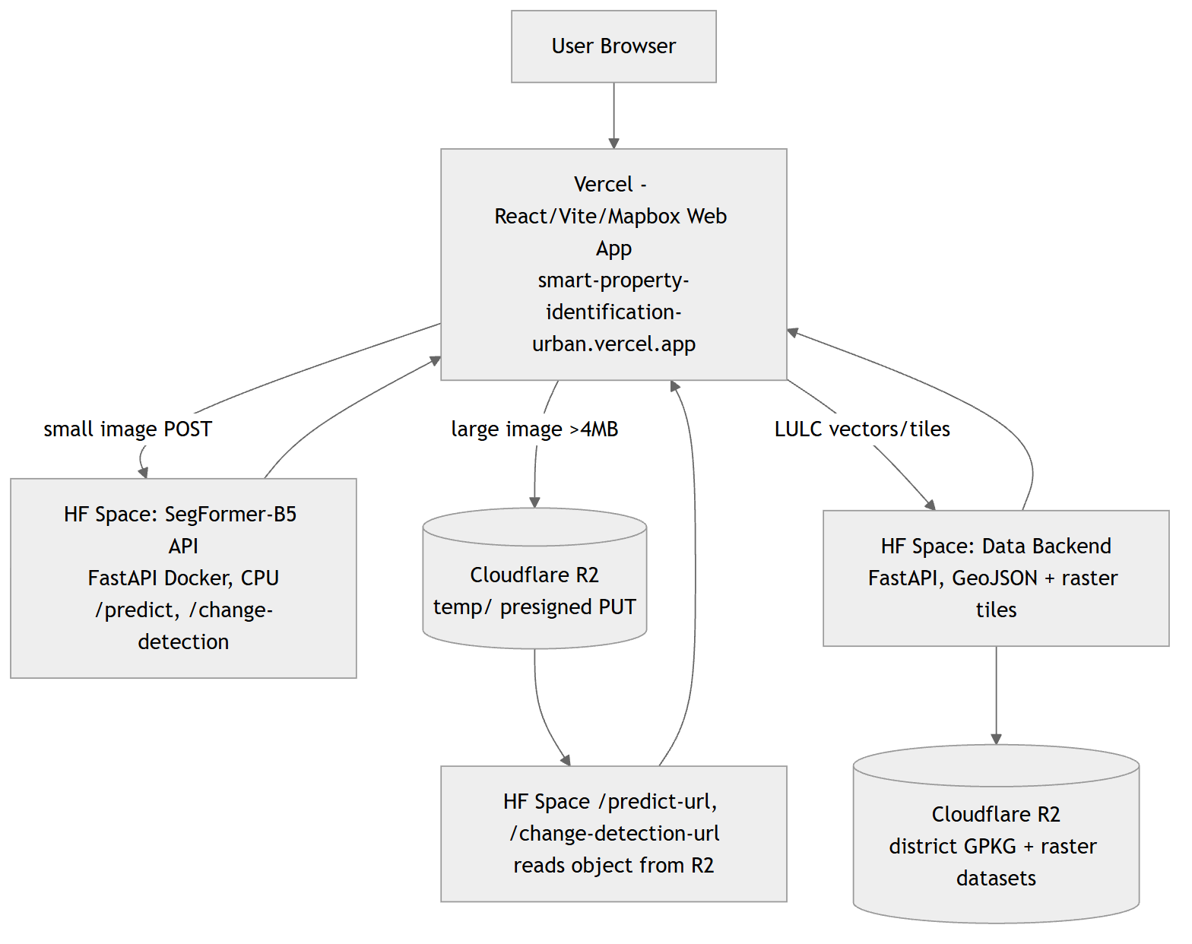
Figure 11
Component | Service | Role
Web App | Vercel | React + Vite + Mapbox GL UI, SPA routing
Model Inference API | Hugging Face Space asashit/smart-property-segformer | SegFormer-B5 (FastAPI Docker, CPU); /predict, /change-detection, R2 presign + *-url endpoints
Data / LULC API | Hugging Face Space asashit/smart-property-backend | District boundaries, buildings/roads/water/open GeoJSON, raster tiles
Object Storage | Cloudflare R2 (property-data) | District datasets (GPKG/TIF) + temporary large uploads (temp/, auto-expiring)
Large-file handling: images > 4 MB are uploaded directly to Cloudflare R2 via a presigned PUT (bypassing serverless/proxy body limits, up to 500 MB), analyzed by object key, then auto-deleted on next run / page refresh (sendBeacon) with a 1-day R2 lifecycle safety-net. On free CPU, very large images are analyzed at a capped resolution (1536px); full-resolution tiling is reserved for the GPU production tier.

16.2 Target Production Deployment (AWS SageMaker — planned)
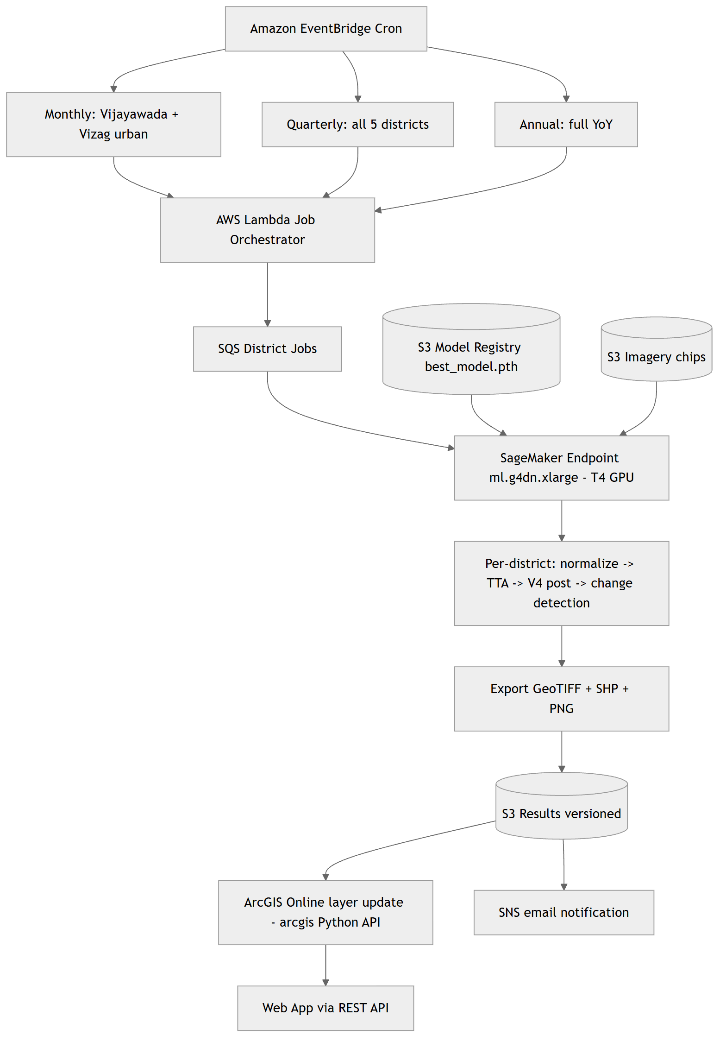

Figure 12
Frequency | Districts | Scope | Runtime | Est. Cost
Monthly | Vijayawada, Visakhapatnam | Urban zones | ~2 h | ~$1.05
Quarterly | All 5 | Full coverage | ~5 h | ~$2.63
Annual | All 5 | Full + YoY | ~8 h | ~$4.21
Cost based on ml.g4dn.xlarge at $0.526/hr. SageMaker access via FITT (IIT Delhi) startup grant; ArcGIS Online via ESRI India hackathon sponsorship.

17. ArcGIS Online Integration (Planned Production Layer)
Layer Name | Type | Format | Update | Description
PS6_LULC_{District}_Latest | Raster Tile | GeoTIFF → Tile Cache | Monthly/Quarterly | Current LULC classification
PS6_Confidence_{District} | Raster Tile | GeoTIFF → Tile Cache | Monthly/Quarterly | Building confidence tiers
PS6_Change_Monthly_{District} | Feature | SHP → Hosted Feature | Monthly | Month-over-month changes
PS6_Change_Quarterly_{District} | Feature | SHP → Hosted Feature | Quarterly | Quarter-over-quarter changes
PS6_Change_Annual_{District} | Feature | SHP → Hosted Feature | Annual | Year-over-year changes

18. Validation Framework
Metric | Formula | Purpose
IoU (per-class) | TP / (TP + FP + FN) | Class-level accuracy
mIoU | Mean of per-class IoUs | Model selection criterion
TTA+V4 mIoU | mIoU after TTA + post-processing | Final system accuracy
Protocol: 15% held-out validation (2,736 chips, mixed); checkpoint at max validation mIoU; visual gallery of 8 samples (RGB / GT / Raw / V4+TTA / Confidence).

19. Innovation Summary
Dimension | Previous (V5 / B4) | Current (V6 Pro / B5) | Impact
Model | SegFormer-B4 (64M) | B5 (84M) | +31% capacity
Pretrained | Cityscapes | ADE20K-640 | Broader priors
Weights | Manual fixed | Auto-computed + road×2 | Data-adaptive
Crop | 256×256 | 512×512 | 4× spatial context
Augment | Basic flip/rotate | Multi-scale + elastic + colour + noise | +3–5% mIoU
LR | CosineAnnealing (epoch) | OneCycleLR (per batch) | Super-convergence
Road handling | Raw mask | Skeleton gap-bridge auto-completion | Continuous networks
Deployment | Manual / local | HF Spaces + Vercel + R2 (now); AWS SageMaker (target) | Cloud, scalable
Web access | None | Live interactive web app + Auto-Guide | Real-time stakeholder access

20. Computational Profile
Resource | Specification
Training GPU | NVIDIA T4×2 (32 GB total) — Kaggle
Training Duration | 60 epochs, ~48 hours
Custom Dataset | 18,240 chips (15,504 train / 2,736 val) — 5 districts
Effective Batch | 8 (batch=2 × accum=4)
Inference (TTA) | ~0.5s/chip (4 forward passes) on T4
Throughput (T4×2) | ~14,400 chips/hour ≈ 3,600 km²/hr
Model Parameters | 84.7M (encoder 82.0M + decoder 2.7M)
Precision | Mixed FP16/FP32 (AMP)
Prototype Inference | HF Space CPU (~15–40s/image, downscaled); GPU target ~0.5s/chip

21. Future Scope

21.1 3D Mapping & Building Height Estimation
Extend the 2D LULC pipeline into the third dimension:
- Building height estimation — derive per-building height from monocular shadow-length analysis, off-nadir parallax, or stereo/tri-stereo imagery; fuse with DSM/DEM (e.g., Cartosat, SRTM) where available.
- 3D building footprints / LoD1–LoD2 models — extrude regularized footprints by estimated height to produce city-scale 3D massing models for urban planning and viewshed analysis.
- Floor / built-up volume estimation — approximate number of floors and built-up volume (height ÷ typical floor height) for property assessment and FSI/FAR compliance.

21.2 Improved Footprint Calculations
- More accurate area (m²) and perimeter via sub-pixel boundary refinement and orthorectification.
- Footprint regularization v2 — RANSAC/learned polygonization for cleaner, vector-ready building outlines.
- Per-parcel aggregation — coverage ratio, open-space ratio, and road-frontage metrics per cadastral parcel.

21.3 Learned Road-Completion Model
A dedicated graph- or GAN-based road-connectivity model to supplement the geometric skeleton healer (Post-Processing → Road Network Auto-Completion) for complex interchanges, flyovers, and dense urban grids.

21.4 Production Hardening
- Migrate inference to the GPU production tier (AWS SageMaker / GPU Space) for full-resolution, full-district processing.
- Result persistence (Supabase / database) for analysis history and user accounts.
- Scheduled monitoring + ArcGIS Online hosted layers (Deployment Architecture and ArcGIS Integration).

22. Conclusion
The V6 Pro pipeline is a significant advancement in automated LULC mapping for Andhra Pradesh. The 84M-parameter SegFormer-B5 transformer — trained for 60 epochs on a custom-prepared dataset of 18,240 chips across 5 districts — combined with multi-scale Focal Tversky training, 4-way TTA, and geometry-aware post-processing (convex-hull building regularization + skeleton-based road auto-completion), delivers strong segmentation accuracy for the PS-6 use case.
The current live prototype (Hugging Face Spaces + Vercel + Cloudflare R2) makes the system usable today through an interactive web application with AOI analytics, upload-and-analyze, change detection, and an Auto-Guide tour. The target production architecture (AWS SageMaker scheduled inference + ArcGIS Online hosted layers) will transform it into a continuous, automated monitoring platform, with 3D building-height mapping as the next major capability.
Prepared by Yantrikaran Innovation Pvt. Ltd.

