Internship Report
On
“Student Result Processing System”

Submitted To
School of Computer Science and Engineering
IILM University, Greater Noida, U.P.
In partial fulfilment of the requirement of degree of
B.Tech CSE

By

Roll Number of Student: 2410030363
Name of Student: SHIVAM SINGH
Batch: 2024-28

CANDIDATE'S DECLARATION
I, Shivam Singh, do hereby declare that the internship report titled “Student Result Processing System” has been completed by me to fulfil the requirement for the award of the degree of Bachelor of Technology in Computer Science and Engineering. All the references have been quoted and I have not taken as such any material from any other source. I affirm that this report is my own work and has not been submitted to any other institute for any degree/diploma requirement, and I shall be solely responsible for any kind of copyright violation in this regard.

Signature
Student Name: Shivam Singh
Roll No.: 2410030363

ACKNOWLEDGEMENT
I take this opportunity to express my sincere gratitude to AICTE and EduSkills for providing me the opportunity to undertake this 8-week online virtual internship on “Student Result Processing System.” I am thankful for their aspiring guidance, invaluable and constructive criticism, and friendly advice throughout the internship.
I am especially grateful to my industry mentor, Ms. Sagarabala Behera, for her valuable guidance, continuous support, and technical insights throughout the internship period. I would also like to thank the Department of Computer Science and Engineering, IILM University, Greater Noida, for their encouragement and support.
Finally, I express my heartfelt gratitude to my parents for their blessings and constant encouragement.

Signature
Student Name: Shivam Singh
Roll No.: 2410030363

INTERNSHIP COMPLETION CERTIFICATE

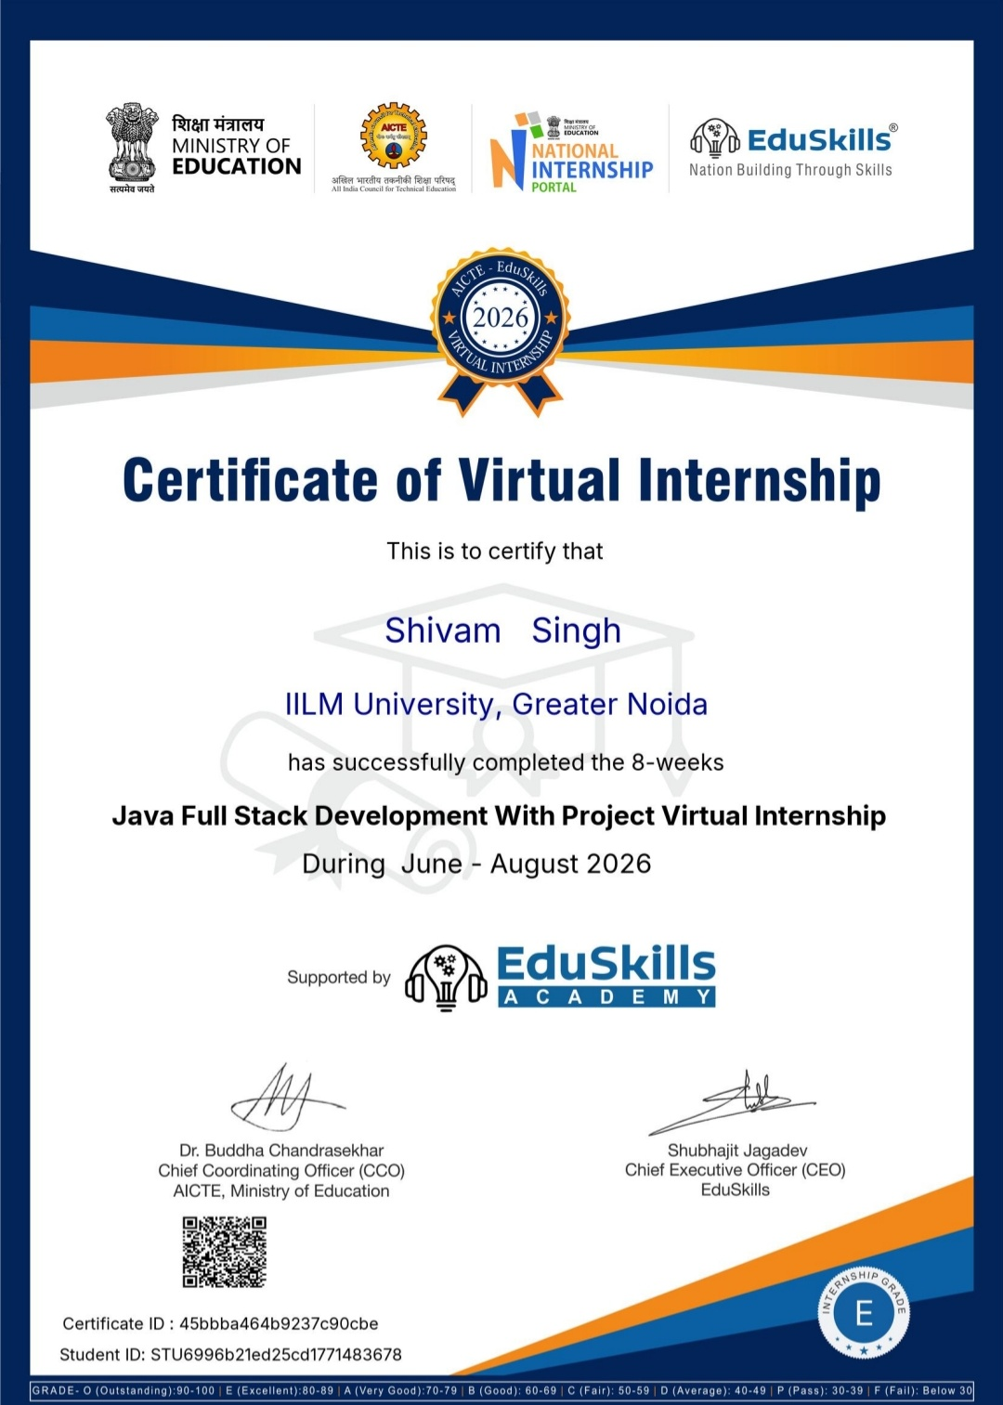

TABLE OF CONTENTS
Chapter No. | Chapter Name | Page Nos.
 | Cover Page | ---
1. | Candidate's Declaration | i
2. | Acknowledgement | ii
3. | Internship Completion Certificate | iii
4. | Project Description  4.1 Introduction  4.2 Organization Profile  4.3 Problem Statement  4.4 Project Objectives  4.5 Scope of the Project  4.6 Technologies and Tools Used  4.7 System Architecture  4.8 Methodology  4.9 Expected Outcomes  4.10 Certificates of completion and other communication mail proof | 1
5. | Bibliography/References

4. PROJECT DESCRIPTION
4.1 Introduction
Industry-oriented learning through internships plays a crucial role in bridging the gap between academic knowledge and real-world application. This 8-week online virtual internship, undertaken under the AICTE – EduSkills Virtual Internship Program, provided hands-on exposure to full-stack development practices and their application in modern software solutions. As part of this internship, the project titled “Student Result Processing System” was undertaken to explore practical approaches to backend academic-data processing.
4.2 Organization Profile
Organization Name: EduSkills Academy
Domain: EdTech & Skill Development
Services: Virtual internship programs delivered in collaboration with AICTE
Vision: To empower students with industry-relevant skills through structured, mentor-guided virtual internships.
4.3 Problem Statement
Academic institutions regularly need to convert raw student performance data into structured, meaningful insights. The Student Result Processing System addresses this need by taking raw student performance data, typically supplied in CSV format, and transforming it into comprehensive analytical results. The system is designed to handle multiple stages of processing: normalizing input data, aggregating subject-wise marks into totals, computing overall percentages, assigning grades based on performance metrics, and generating a ranked list of students. Throughout the pipeline, the system adheres to strict JSON output standards to ensure interoperability with other academic-analytics systems.
4.4 Project Objectives
- To design and implement a backend pipeline that processes raw student CSV data into structured results.
- To apply appropriate parsing, calculation, and sorting logic for accurate result generation.
- To ensure all output conforms to JSON standards for downstream integration.
- To optimize the solution for accuracy, performance, and code quality.
4.5 Scope of the Project
The current implementation covers the core result-processing functions: data parsing, total-marks calculation, percentage computation, grade assignment, and ranking. The modular design allows the system to be extended in future with database integration for storing historical results, a graphical interface for data entry and visualization, subject-wise performance analytics, and support for multiple, configurable grading policies.
4.6 Technologies and Tools Used
Programming Language: HTML • Css & Bootstrap • JavaScript & jQuery • Core Java & Advanced Java • Spring Framework • Spring Boot • Hibernate • MySQL & Git & Version Control
Concepts Applied: Data parsing, string manipulation, mathematical operations, conditional logic, sorting algorithms, and JSON data formatting.
Development Platform: EduSkills LMS (Virtual Internship Environment)
4.7 System Architecture
The system follows a sequential, pipeline-based architecture in which student data moves through five discrete stages, with each stage producing JSON-compliant output that feeds directly into the next:
Raw CSV Input → Data Parsing & Normalization → Total Marks Calculation → Percentage Calculation → Grade Determination → Student Ranking → Final Ranked Output (JSON)
This staged approach keeps each processing responsibility isolated, making the system easier to test, debug, and extend.
4.8 Methodology
The project was developed using a sequential, pipeline-based methodology, with each stage addressing one specific processing requirement:
- Data Parsing: Raw CSV lines containing student names and marks were read and normalized, with extraneous whitespace removed to ensure clean input for later stages.
- Total Marks Calculation: Marks obtained by each student across three subjects were summed to compute the total score.
- Percentage Calculation: The total marks were divided by the predefined maximum possible score (300 for three subjects) and multiplied by 100 to obtain the overall percentage.
- Grade Determination: A grading policy mapped percentage ranges to letter grades (A, B, C, F, etc.).
- Student Ranking: All processed student records were sorted by total marks in descending order to produce the final ranked list.
Each stage was designed to output JSON-compliant data, allowing seamless integration between the stages of the pipeline. Error handling, such as validation checks for missing or malformed input, was incorporated to keep the system stable against unexpected data.
4.9 Expected Outcomes
- A working pipeline capable of converting raw CSV student data into accurate, structured results.
- Correctly computed totals, percentages, and grades for each student record.
- A final, ranked list of students ordered by total marks.
- JSON-compliant output at every stage, ready for integration into larger academic platforms.
- Strengthened practical skills in data parsing, algorithmic design, and structured output formatting.
4.10 Certificates of completion and other communication mail proof
The Internship Completion Certificate and any related offer letter or communication correspondence are to be attached here as proof of completion.

5. BIBLIOGRAPHY / REFERENCES
- Python Software Foundation, “Python Documentation” – official documentation for the Python programming language.
- JSON.org – official website for the JSON data-interchange format, specifications and examples.
- GeeksforGeeks and Towards Data Science – online resources referenced for concepts related to data parsing, sorting algorithms, and data structures.

