Test Plan
- What is the System Under Test (SUT)? Provide a link (if available) and a brief description.
Link to SUT: https://github.com/ashjianda/parkinglotood (includes SUT, tests, JaCoCo report, and this document)
The SUT is an implementation of the common object-oriented design question, Design a Parking Lot. The parking lot has multiple spots, and each spot is either a motorcycle, car, or bus spot. Motorcycles can park in any spot, cars can park in car or bus spots, and buses can park in bus spots. The system supports parking and unparking of vehicles. A vehicle can only be parked in 1 spot at a time. No duplicate license plates are allowed. Motorcycles, cars, and buses all inherit from an abstract Vehicle class.
- Will you test every class in the SUT? If not, which classes will be tested? score: 1pt for 3-5 classes; 2pts for 6+ classes
Yes, every class will be tested. There are 6 classes in total:
- Car
- Bus
- Motorcycle
- Vehicle
- Parking Lot
- Parking Spot
There is also an enum class:
- Vehicle Type

- Will you do manual, automated testing (fuzzing), or both? score: 1pt for each; 2pts for both
I will do both manual and automated testing. Manual testing can ensure I’m exhausting all branches for branch coverage and can test basic functionality of my program, while fuzzing can stress test my program with larger inputs and random interactions.
- What coverage criteria will be used? score: +1 for each different coverage criteria you will compute, not including line coverage
Branch coverage can be used to ensure all if conditions are exercised in methods like park(), unpark(), canFitInSpot(), or canVehicleFit() and for loops are covered in methods like park() and unpark()
- Will you be using any external tools to compute coverage or perform other tasks (outside of JUnit/Java/Python)? – if yes, please list tools and purpose
I used JaCoCo to determine branch and line coverage percentage after running my tests. 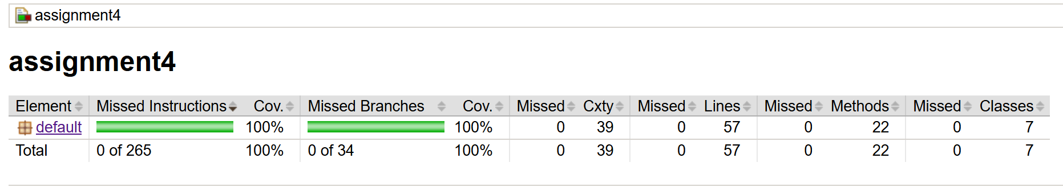

Test Report
Steps I took:
- First, I created a proper directory for my existing “Design a Parking Lot” code so I would be able to properly test it.
- Then, I created my ParkingLotTest.java file to build my tests
- I developed my manual tests first to ensure my basic functionality is working as intended. I had 16 manual tests that I believed covered 100% of my code
- Then I developed my Fuzzer. Originally, I used the following condition for my FAIL:
boolean result = lot.park(vehicle);
if (!result && lot.getOpenSpots() > 0) {
return FuzzerTest.Outcome.FAIL;
}
This condition is checking if a car can be parked. If it can, result is true and the condition is skipped so it can pass. If it can’t, it checks if there is any open spot. If not parked but there was an open spot, then fail. This was giving me problems because it was failing when it wasn’t supposed to. The reason is because my parking lot assigns parking lot sizes in a cycle (i.e. Motorcycle, then car, then bus) and vehicles park in the first available spot that could fit them. But the Fuzzer isn’t creating cars in that order, its random. In other words, motorcycles aren’t smartly looking for motorcycle spots, it just takes anything. Cars aren’t smartly looking for car spots, it takes first available even if it’s a bus spot. So when a bus is currently being fuzzed, it doesn’t park because there are no bus spots open but the code will fail because it sees getOpenSpots is > 0 even though none are compatible with a bus. To fix this, I modified the code to:
boolean result = lot.park(vehicle);
if (!result && hasCompatibleSpot(vehicle, lot)) {
return FuzzerTest.Outcome.FAIL;
}

This new Fuzzer condition accurately asks “If a car didn’t park, was there a compatible spot it could’ve parked in? If so, fail”

- Once my fuzzer was working, I wanted to see if my branch coverage was 100%, so I used JaCoCo. Upon initial execution, my tests covered all but 3 branches. Those 3 branches were in ParkingLot.park() and ParkingSpot.getSpotNumber(). My line coverage was almost 100%, but I wasn’t covering ParkingSpot.getSpotNumber().
- Upon review, I realized I was never using ParkingSpot.getSpotNumber() in my code, so I removed the method and the test from my code. To cover the missing ParkingLot.park() branch, I realized I had two separate if-statements that were doing the same thing but in different ways, so the second condition was never being reached since the first one handled it. So I removed the second condition from my ParkingLot.park() method.
- After these changes, I achieved 100% coverage.

Summary
Performing these tests gave me valuable experience doing real-world tests on my own code, something I’ve never done before. Developing the manual tests helped me confirm my code actually functions correctly, and the Fuzzer helped me determine that it can scale to sizes beyond manual checking without fail. The Fuzzer also helped me think about my logic differently after the first version of my Fuzzer failed. I also used JaCoCo for the first time, a really cool tool that helps us determine our test coverage. At first, I figured I could determine coverage manually since my code isn’t that large. But I decided to use a tool to get experience, and I’m glad I did. I find it cool how JaCoCo outputs a nice summary html page where you can click into any file to see line by line your test coverage, as well as if conditions were executed or not.

