**在可视显示器上提供可动态更改的物理按钮**

Providing Dynamically Changeable Physical Buttons on a Visual Display

【论文内容】：In this paper, we describe a technique for creating dynamic physical buttons using pneumatic actuation. This technique allows aspects of physical form and appearance to be dy-namically modified under program control - buttons can be brought into and taken out of an interface as needed, and it allows a small set of distinct interface elements to occupy the same physical space at different times.

【五个设计目标】：

1）制造成本低廉（即结构简单，材料便宜）。

2）容易启动。

3）能够显示图形，而不会被手或气动/控制元件遮挡。

4）能够感知用户输入（而不遮挡显示）。

5）提供对触觉表达的支持，而不仅仅是简单的开/关状态更改。

【设备设计】：

具体参考论文

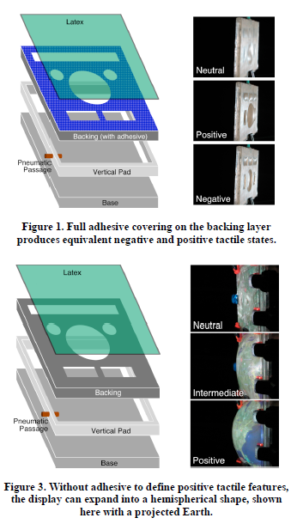 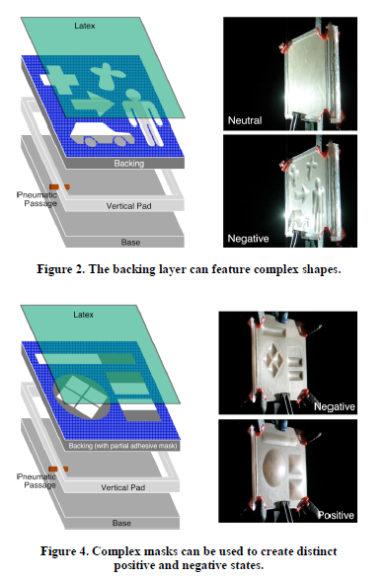

【user study】:

**Four surface:**

**1) Flat – a sheet of acrylic; designed to mimic a touch screen interface.**

**2) Physical Buttons – a sheet of acrylic with physical, protrusions; designed to mimic buttons.**

**3) Negative Pneumatic Buttons – pneumatic tactile display with concave features.**

**4) Positive Pneumatic Buttons – pneumatic tactile display with convex features.**

**Procedure:**

Participants were seated in front of a laptop computer run-ning a custom, full-screen application (Figure 17). A full-sized mouse was provided for input. The right side of the screen featured a layout matching the test surfaces. After a random period of time between 2 and 14 seconds, a button would activate by “lighting up” (see top-right-most button in Figure 17). This indicated to the participant that they should press the corresponding button on the test surface. Each button was activated, in a random order, four times for each of the four test surfaces (which were also presented in a random order).

**Results:**

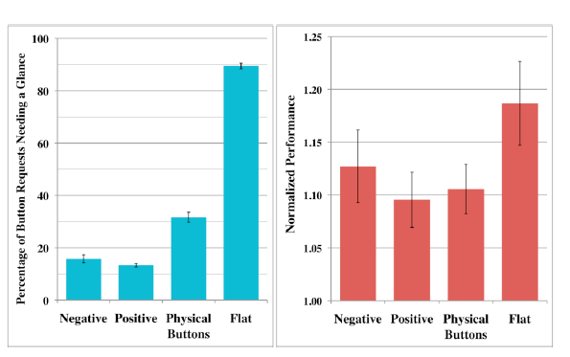 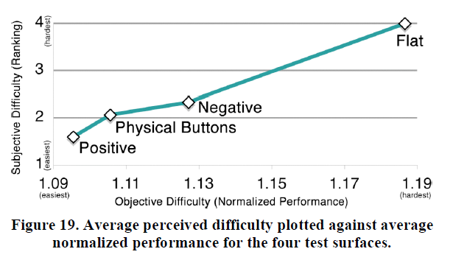

【contribute】：

我们提出了一系列在可视显示器上生产气动，动态，物理按钮的方法。 使用透明的丙烯酸树脂可以使显示器向后投影，避免了用户输入的遮挡。 可以使用基于红外的计算机视觉系统来实现多点触摸感应。

