**project模块:**

project_scene_detail **[GET]**

[URL]:

<http://127.0.0.1/project/project_scene_detail?pro_id=7>

[FUNC]:

获取某个项目的基本详情及他的scene和scene_version

[PARM]:

pro_id

[RETURN]:

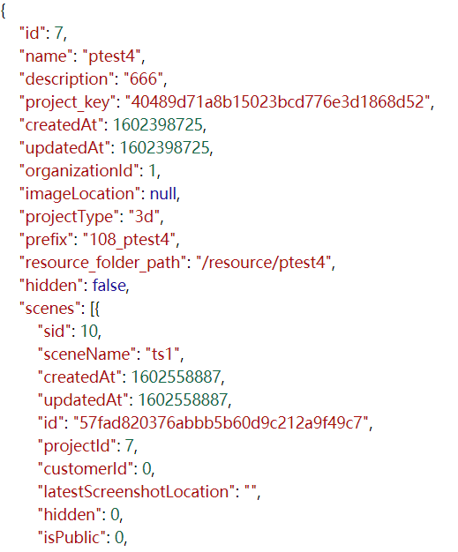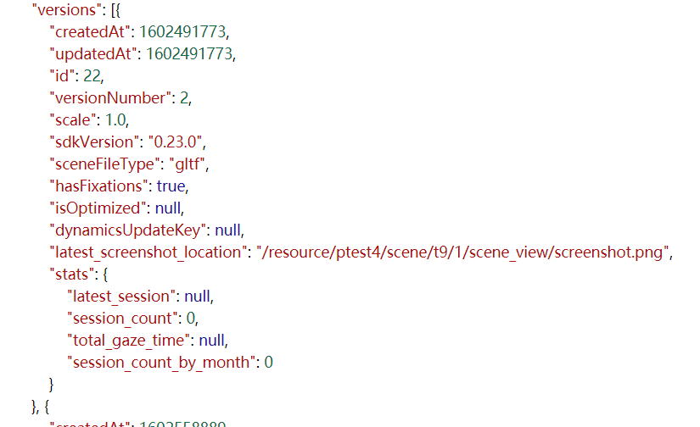

project_list **[GET]**

[URL]:

<http://127.0.0.1/project/project_list?org_id=1>

[FUNC]:

获取项目列表

[PARM]:

org_id

[RETURN]:

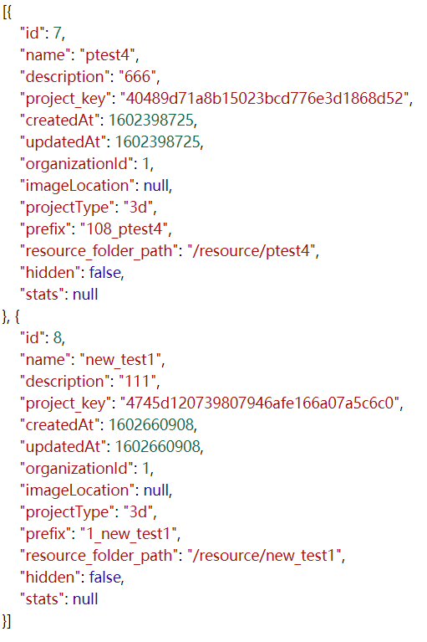

project_key **[GET]**

[URL]:

<http://127.0.0.1/project/project_key?pro_id=7>

[FUNC]:

获取PRO_KEY

[PARM]:

pro_id

[RETURN]:



project_create **[POST]**

[URL]:

<http://127.0.0.1/project/project_create>

[FUNC]:

创建项目

[PARM]:

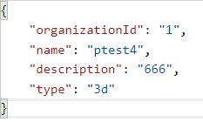

[RETURN]:

project_delete

[FUNC]:

删除某个组织下的用户(不具体实现)

project_edit

[FUNC]:

用户内容更改(不具体实现)

**admin模块:**

organization_regist **[POST]**

[URL]:

<http://127.0.0.1/admin/organization_regist>

[FUNC]:

组织注册

[PARM]:

org_name

org_des

org_account

org_password

[RETURN]:

organization_list **[GET]**

[URL]:

<http://127.0.0.1/admin/organization_list>

[FUNC]:

查询组织列表

[PARM]:

[RETURN]:

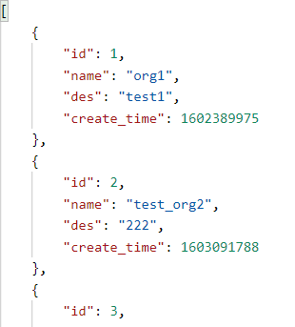

organization_detail **[GET]**

[URL]:

<http://127.0.0.1/admin/organization_detail?org_id=1>

[FUNC]:

查询组织基本信息

[PARM]:

org_id

[RETURN]:

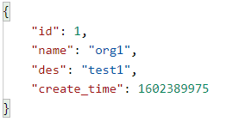

organization_delete

删除组织(不具体实现)

user_regist **[POST]**

[URL]:

<http://127.0.0.1/admin/user_regist>

[FUNC]:

注册用户

[PARM]:

org_id

org_account

org_password

user_name

user_des

user_account

user_password

[RETURN]:

user_org_list **[POST]**

[URL]:

<http://127.0.0.1/admin/user_org_list?org_id=1>

[FUNC]:

查询某个组织下的用户

[PARM]:

org_id

[RETURN]:

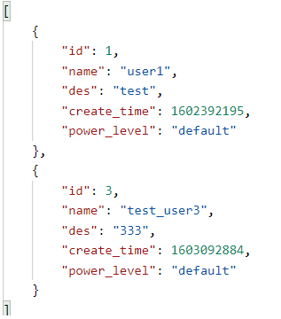

user_detail **[GET]**

[URL]:

<http://127.0.0.1/admin/user_detail?user_id=1>

[FUNC]:

查看用户详情

[PARM]:

user_id

[RETURN]:

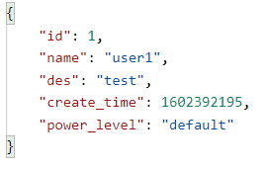

user_delete

删除某个组织下的用户(不具体实现)

user_edit

用户内容更改(不具体实现)

user_login **[POST]**

用户登陆

[略]

**category模块:**

set_obj_category **[POST]**

[URL]:

[http://127.0.0.1/category/set_obj_category/22](http://127.0.0.1/admin/user_detail?user_id=1)

[FUNC]:

创建category和group

[PARM]:

scene_version_id <URL>





[RETURN]:

set_dobj_to_group **[POST]**

[URL]:

[http://127.0.0.1/category/set_dobj_to_group/2/2](http://127.0.0.1/admin/user_detail?user_id=1)

[FUNC]:

向group中设置dobj

[PARM]:

group_id <URL>

dobj_id <URL>



[RETURN]:

get_obj_category_list **[GET]**

[URL]:

[http://127.0.0.1/category/get_obj_category_list/22](http://127.0.0.1/admin/user_detail?user_id=1)

[FUNC]:

获取category详情

[PARM]:

scene_version_id <URL>

[RETURN]:

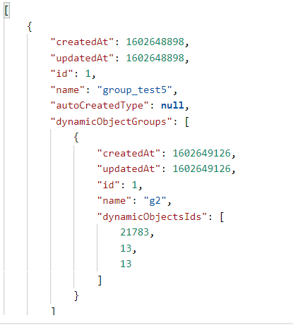

**objective模块：**

objective_create **[POST]**

[URL]:

[http://127.0.0.1/objective/objective_create/22](http://127.0.0.1/admin/user_detail?user_id=1)

[FUNC]:

创建objective（创建objective同时创建新版本）

[PARM]:

scene_version_id <URL>

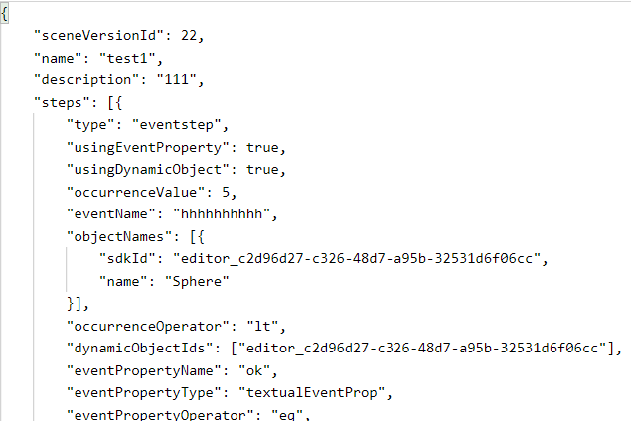

[RETURN]:

objective_create_version **[POST]**

[URL]:

[http://127.0.0.1/objective/objective_create_version/22/4](http://127.0.0.1/admin/user_detail?user_id=1)

[FUNC]:

创建新版本objective

[PARM]:

scene_version_id <URL>

Objective_id<URL>

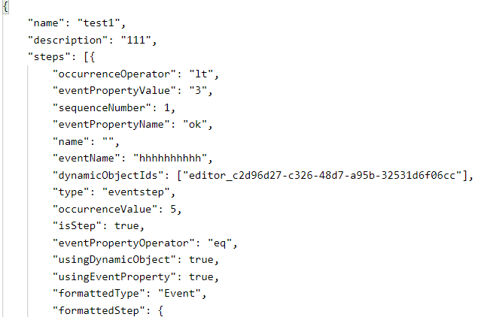

[RETURN]:

objective_detail **[GET]**

[URL]:

[http://127.0.0.1/objective/objective_detail/22/7](http://127.0.0.1/admin/user_detail?user_id=1)

[FUNC]:

objective的各版本的基本步骤

[PARM]:

scene_version_id <URL>

Objective_version_id<URL>

[RETURN]:

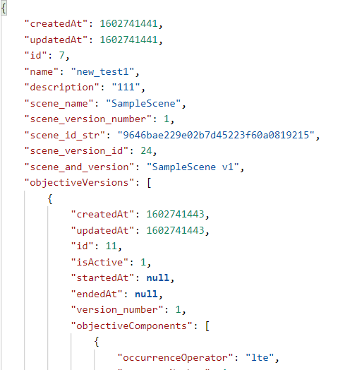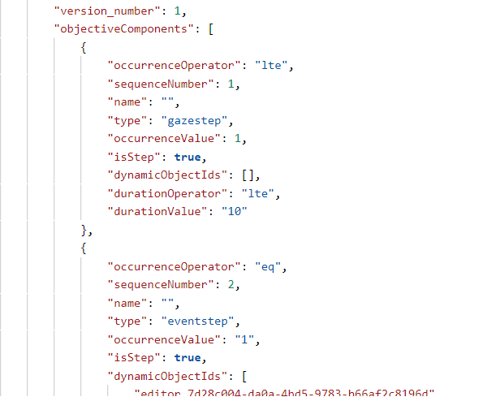

objective_list **[GET]**

[URL]:

[http://127.0.0.1/objective/objective_list/7](http://127.0.0.1/admin/user_detail?user_id=1)

[FUNC]:

objective列表

[PARM]:

Objective_version_id <URL>

[RETURN]:

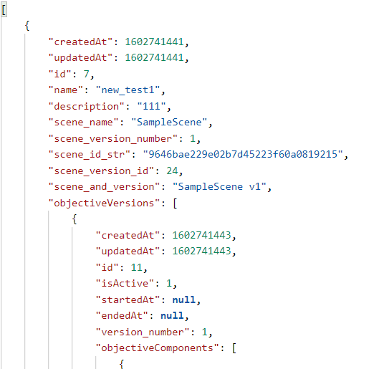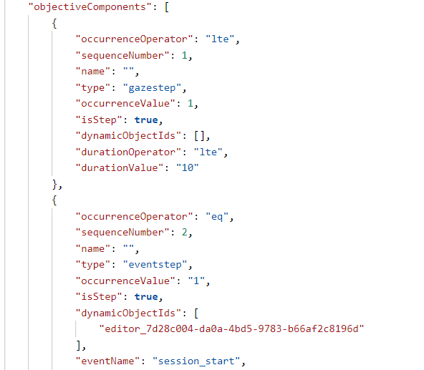

objective_delete 删除某个objective(不具体实现)

objective_version_stepresult **[GET]**

[URL]:

[http://127.0.0.1/objective/objective_version_stepresult/22/9](http://127.0.0.1/admin/user_detail?user_id=1)

[FUNC]:

获取某个版本objective的各步结果

[PARM]:

scene_version_id <URL>

Objective_version_id <URL>

[RETURN]:

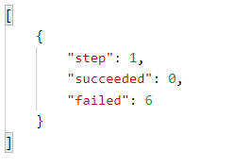

objective_session_result **[GET]**

[URL]:

http://127.0.0.1/objective/objective_session_result/1603030247_aa000a11bb61d33746f791ae40955cfb93618b66

[FUNC]:

获取某个session在其scene_version下的objective的各步结果

[PARM]:

session_id <URL>

[RETURN]:

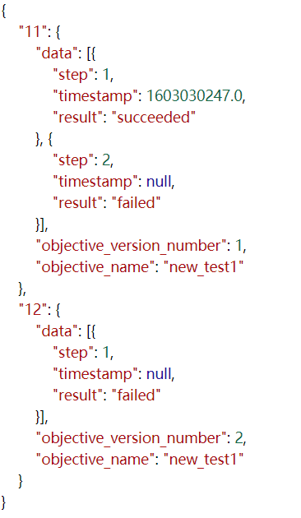

dynamic_obj**模块**:

dynamic_obj_list **[GET]**

[URL]:

http://127.0.0.1/dynamic_obj/dynamic_obj_list/22

[FUNC]:

dynamic obj列表

[PARM]:

scene_version_id<URL>

[RETURN]:

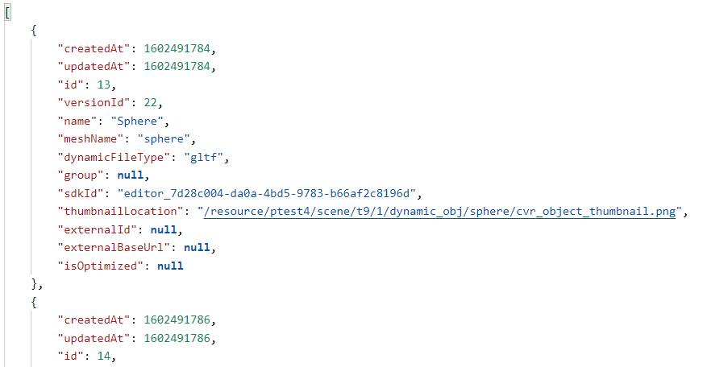

dynamic_obj_detail **[GET]**

[URL]:

http://127.0.0.1/dynamic_obj/dynamic_obj_detail/22/17

[FUNC]:

某个dynamic obj详情

[PARM]:

scene_version_id<URL>

dobj_id<URL>

[RETURN]:

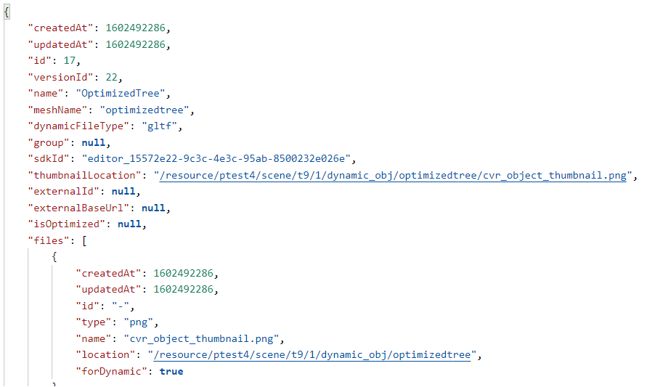

participant**模块**:

participant_list **[GET]**

[URL]:

http://127.0.0.1/participant/participant_list?org_id=1

[FUNC]:

participant列表

[PARM]:

org_id

[RETURN]:

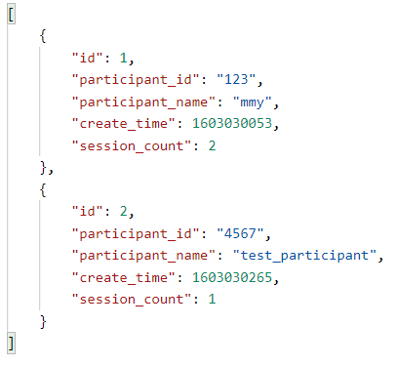

participant_detail **[GET]**

[URL]:

http://127.0.0.1/participant/participant_detail?p_id=1

[FUNC]:

participant详情

[PARM]:

p_id

[RETURN]:

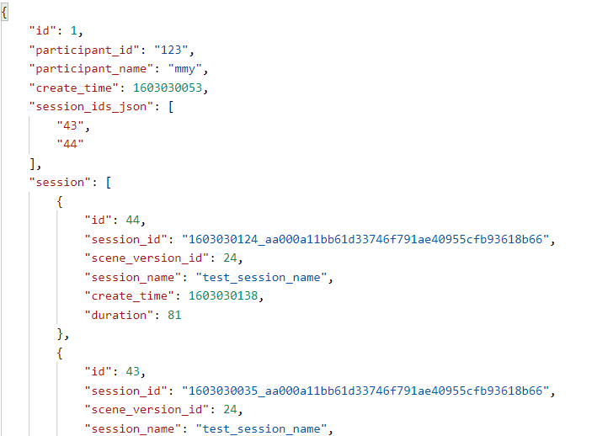

scene**模块**:

scene_detail **[GET]**

[URL]:

http://127.0.0.1/scene/scene_detail/9646bae229e02b7d45223f60a0819215

[FUNC]:

获取场景的基本信息及其各版本的基本信息

[PARM]:

scene_sdk_id<URL>

[RETURN]:

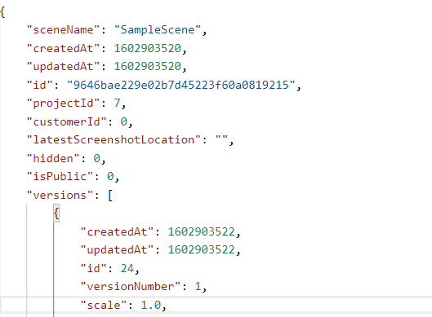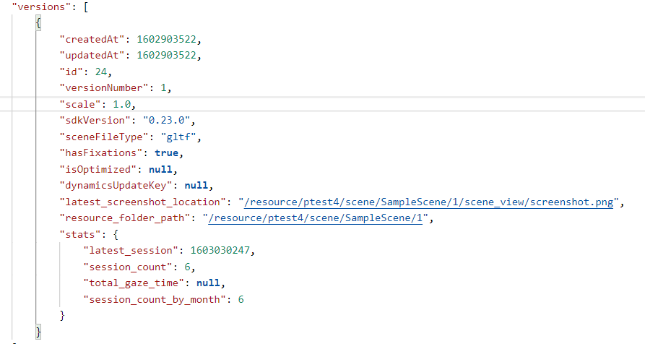

scene_delete 删除某个scene(不具体实现)

scene_edit scene更改(不具体实现)

session**模块**:

session_list **[GET]**

[URL]:

[http://127.0.0.1/session/session_list/23?page=0&limit=20](http://127.0.0.1/admin/user_org_list?org_id=1)

[FUNC]:

获取某个场景版本下的session列表

[PARM]:

scene_version_id<URL>

page

limit

[RETURN]:

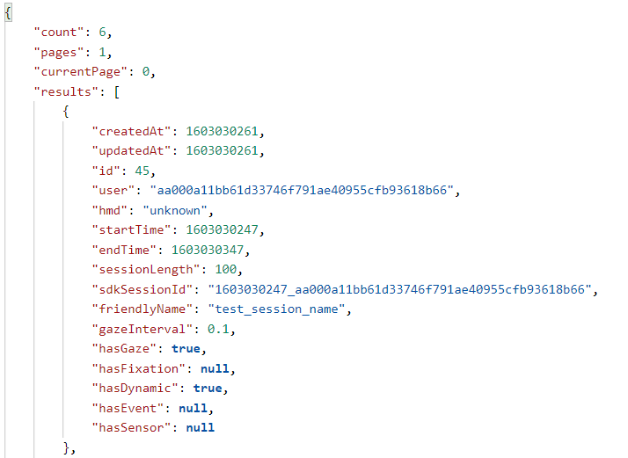

session_metadata **[GET]**

[URL]:

[http://127.0.0.1/session/session_metadata/22/30](http://127.0.0.1/admin/user_org_list?org_id=1)

[FUNC]:

获取某个session的基本信息

[PARM]:

scene_version_id<URL>

sid

[RETURN]:

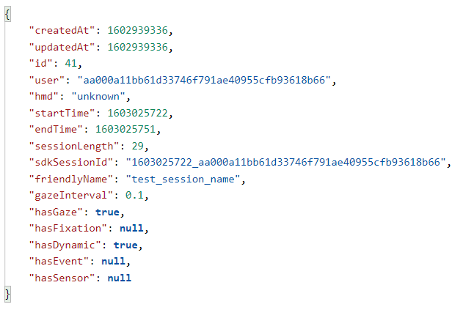

session_single_queries **[POST]**

[URL]:

[http://127.0.0.1/session/session_single_queries](http://127.0.0.1/admin/user_org_list?org_id=1)

[FUNC]:

查询单个session

[PARM]:

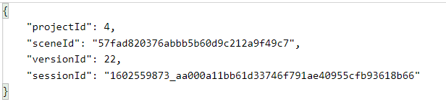

[RETURN]:

session_queries **[POST]**

[URL]:

[http://127.0.0.1/session/session_queries](http://127.0.0.1/admin/user_org_list?org_id=1)

[FUNC]:

查询session

[PARM]:



[RETURN]:

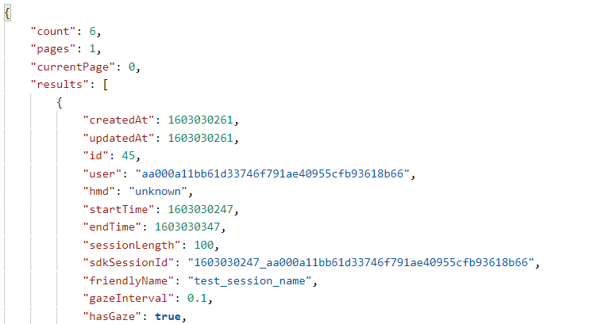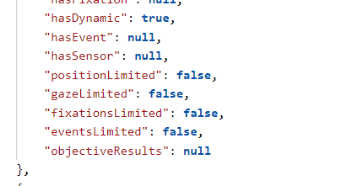

session_gaze_data **[GET]**

[URL]:

[http://127.0.0.1/session/session_gaze_data/23/1602559873_aa000a11bb61d33746f791ae40955cfb93618b66](http://127.0.0.1/admin/user_org_list?org_id=1)

[FUNC]:

获取某个session的gaze数据

[PARM]:

scene_version_id<URL>

session_str<URL>

[RETURN]:

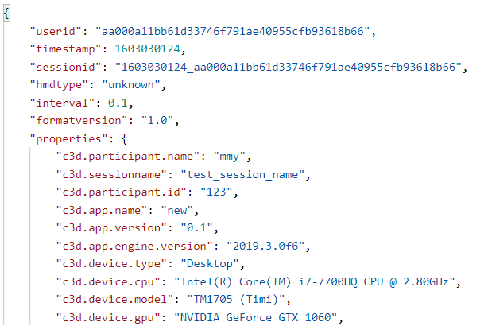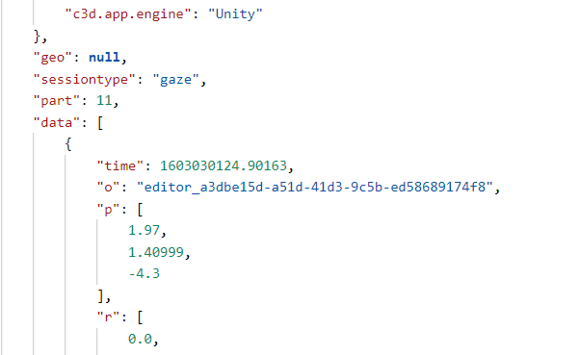

session_fixation_data 获取某个session的fixation数据【同上】

session_event_data 获取某个session的event数据【同上】

session_dynamicobj_data 获取某个session的dynamicobj数据【同上】

session_slicer_field_queries 获取事件/属性，用于筛选[待完善]

[URL]:

<http://127.0.0.1/admin/user_org_list?org_id=1>

[FUNC]:

获取某个场景版本下的session列表

[PARM]:

[RETURN]:

session_slicer_metric_object_queries **[POST]**

[URL]:

[http://127.0.0.1/session/session_slicer_metric_object_queries](http://127.0.0.1/admin/user_org_list?org_id=1)

[FUNC]:

获取某个dynamic obj的计算指标

[PARM]:



[RETURN]:

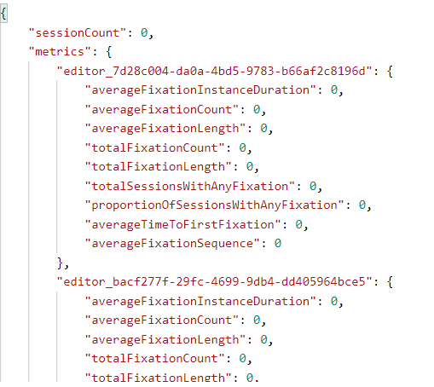

session_slicer_metric_group_queries 获取某个group的计算指标【同上】

dynamic_obj_cube_agg_queries **[POST]**

[URL]:

[http://127.0.0.1/session/dynamic_obj_cube_agg_queries](http://127.0.0.1/admin/user_org_list?org_id=1)

[FUNC]:

获取cube的分析数据

[PARM]:

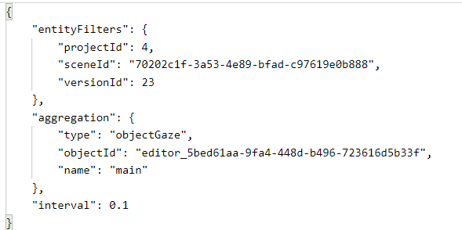

[RETURN]:

